- The DoD Postsecondary Education Complaint Intake is accessed online by visiting the following URL: https://pecs.militaryonesource.mil/pecs/DoDPECS.aspx. Upon accessing the DoD Postsecondary Education Complaint Intake URL users are presented with a Notice and Consent Statement. From the Notice and Consent Statement, complaint filers have the ability to access the User Agreement or click “OK” to advance.
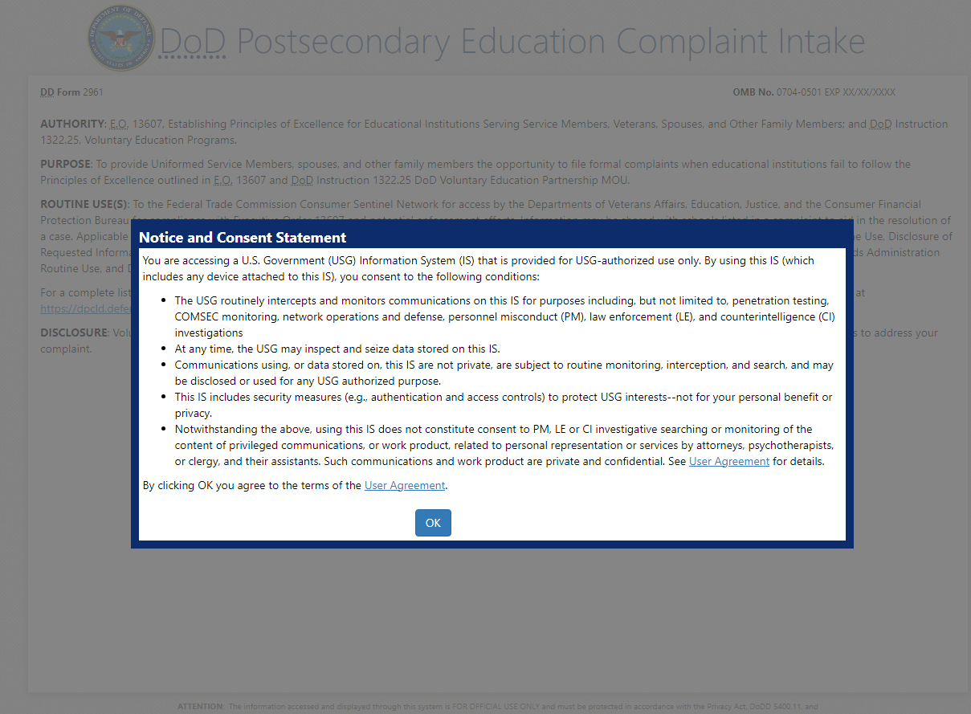

- After agreeing to the Notice and Consent Statement complaint filers are presented with information regarding the Intake’s Authority, Principle Purpose(s), Routine Use(s), and Disclosure.
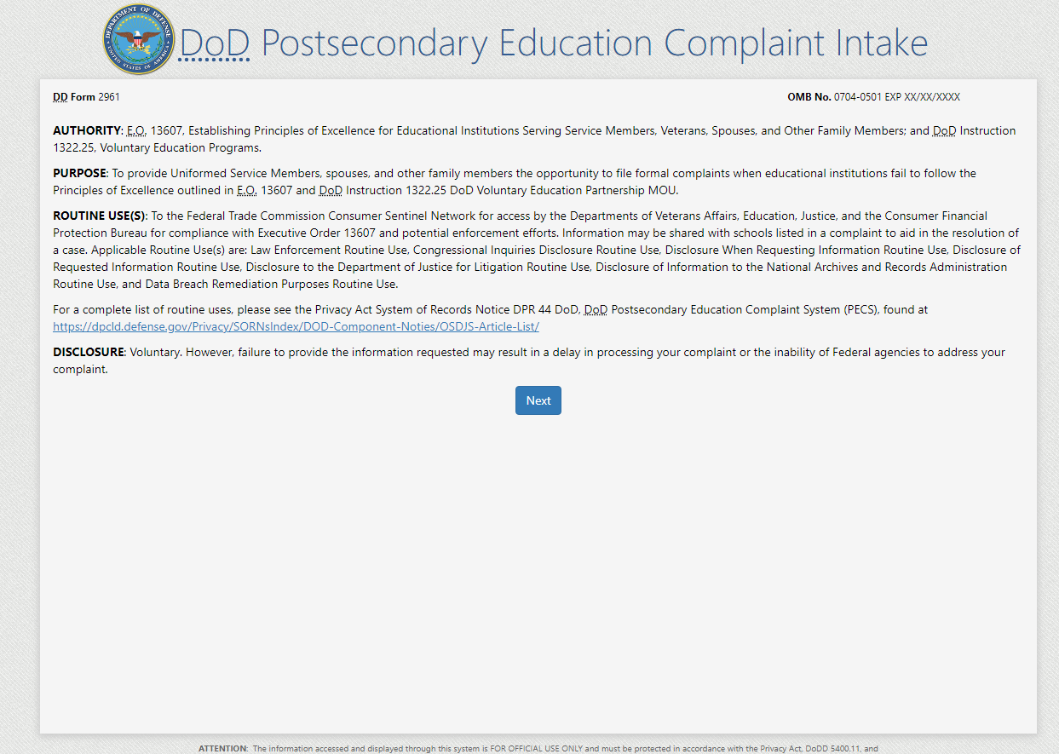

- Upon clicking “Next,” the complaint filer advances to the Welcome Page. This is a content managed page that permits a Level 3 (OSD) user to edit text via the PECS management system.

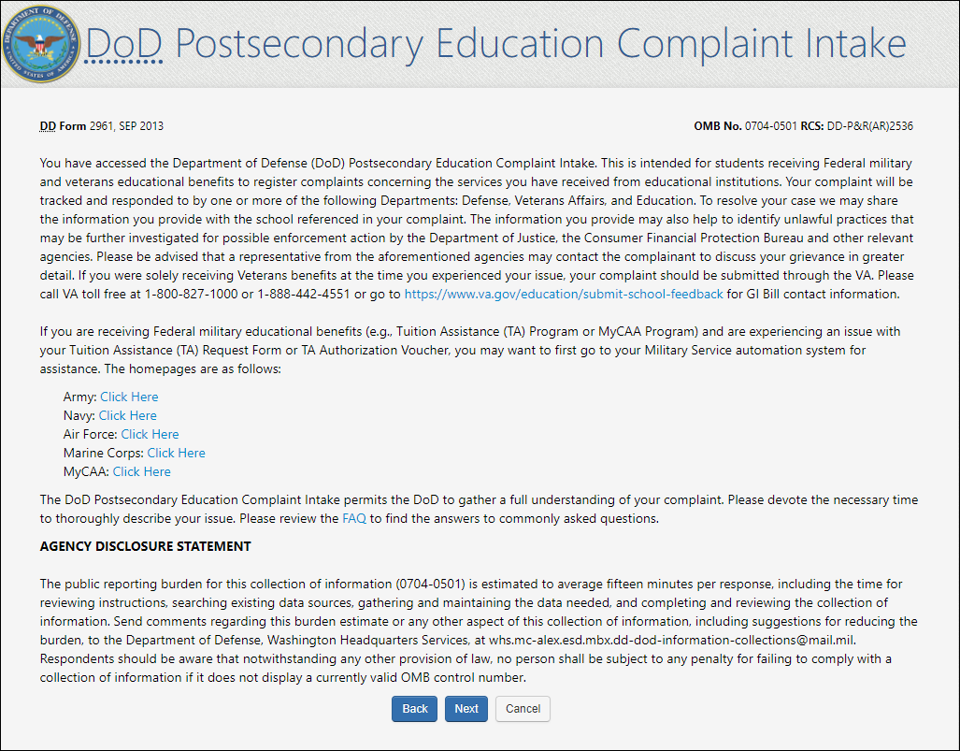
DD Form 2961
OMB No. 0704-0501 Exp. XX/XX/XX

- Upon clicking “Next,” the complainant is presented with a Veterans Benefits question.

- If the complaint filer selects “Yes” to the “Veterans Benefits” question, a message displays on the screen stating they will be navigated to the Veterans Affairs Principles of Excellence Complaint Intake Questionnaire.
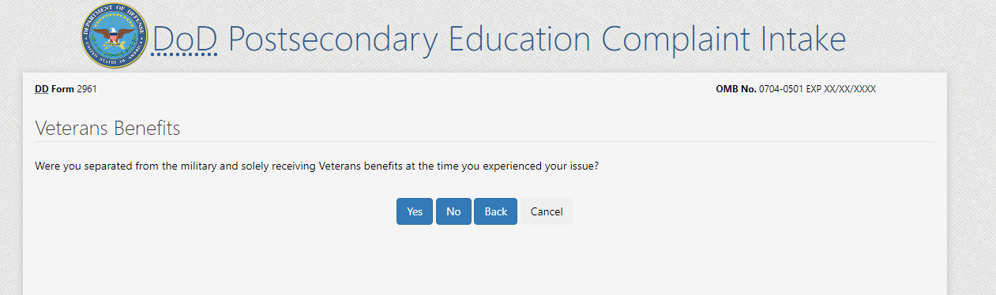
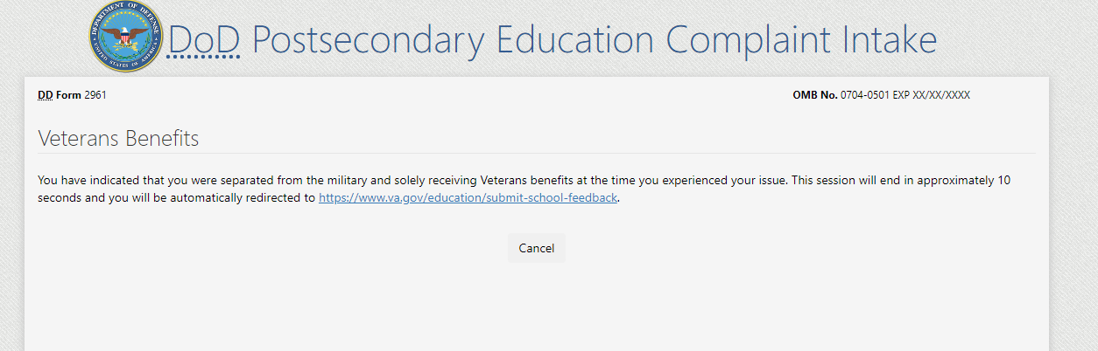

5a. If the complaint filer answers “No” to the Veterans Benefits question, they are required to acknowledge the statement contained in the pop-up regarding content of the complaint being shared with the school in question.
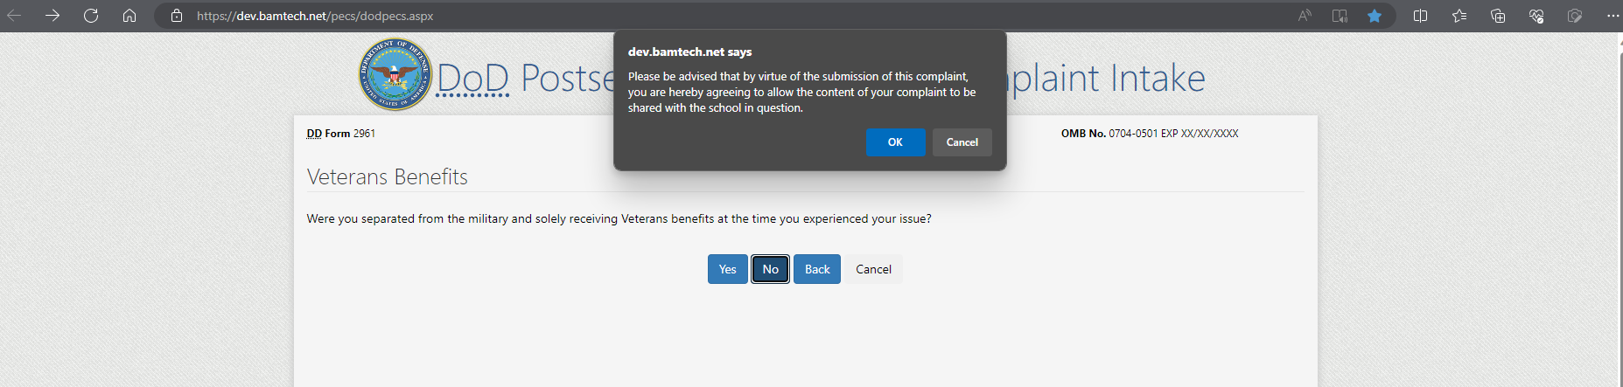
FILER ENTERS COMPLAINT INTAKE INFORMATION

- STEP 1: Complaint data collection begins with “Education Benefit” and “Issue” information.
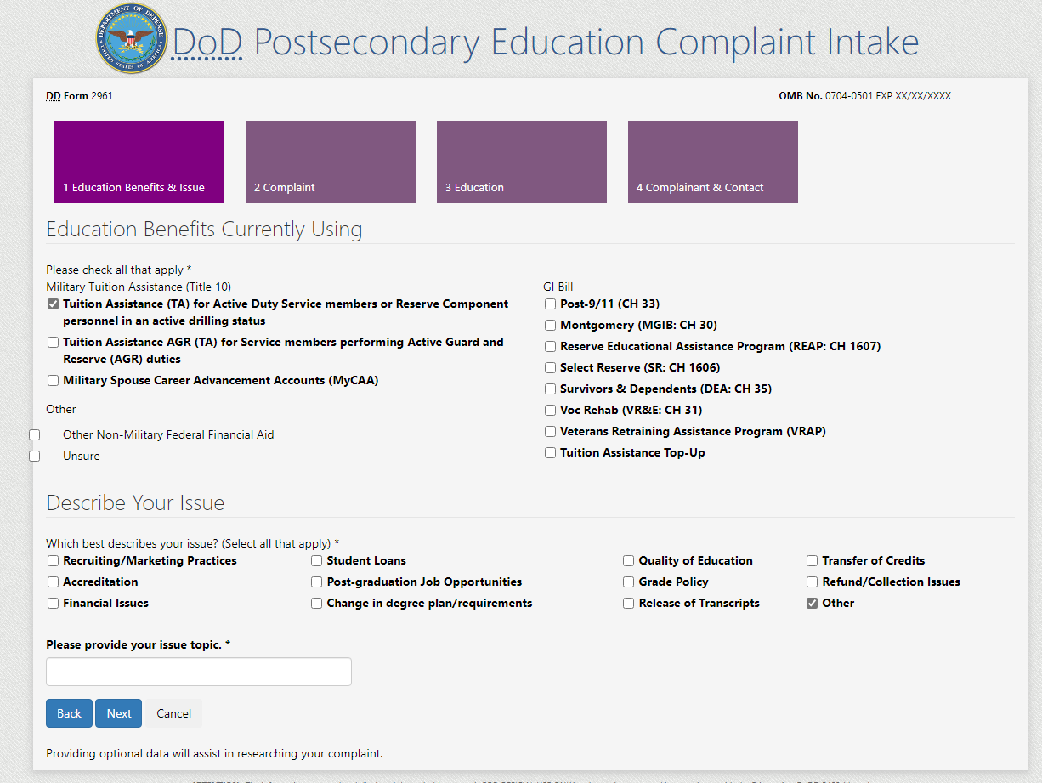
Textbox appears when “Other” is selected
Step 1

- STEP 2: Complaint Information – the complaint filer is required to describe what happened in addition to detailing any steps that have been taken thus far to resolve the issue. Additionally, the complaint filer has the option to suggest a fair resolution. Each STEP 2 textbox is restricted to 1,000 characters.
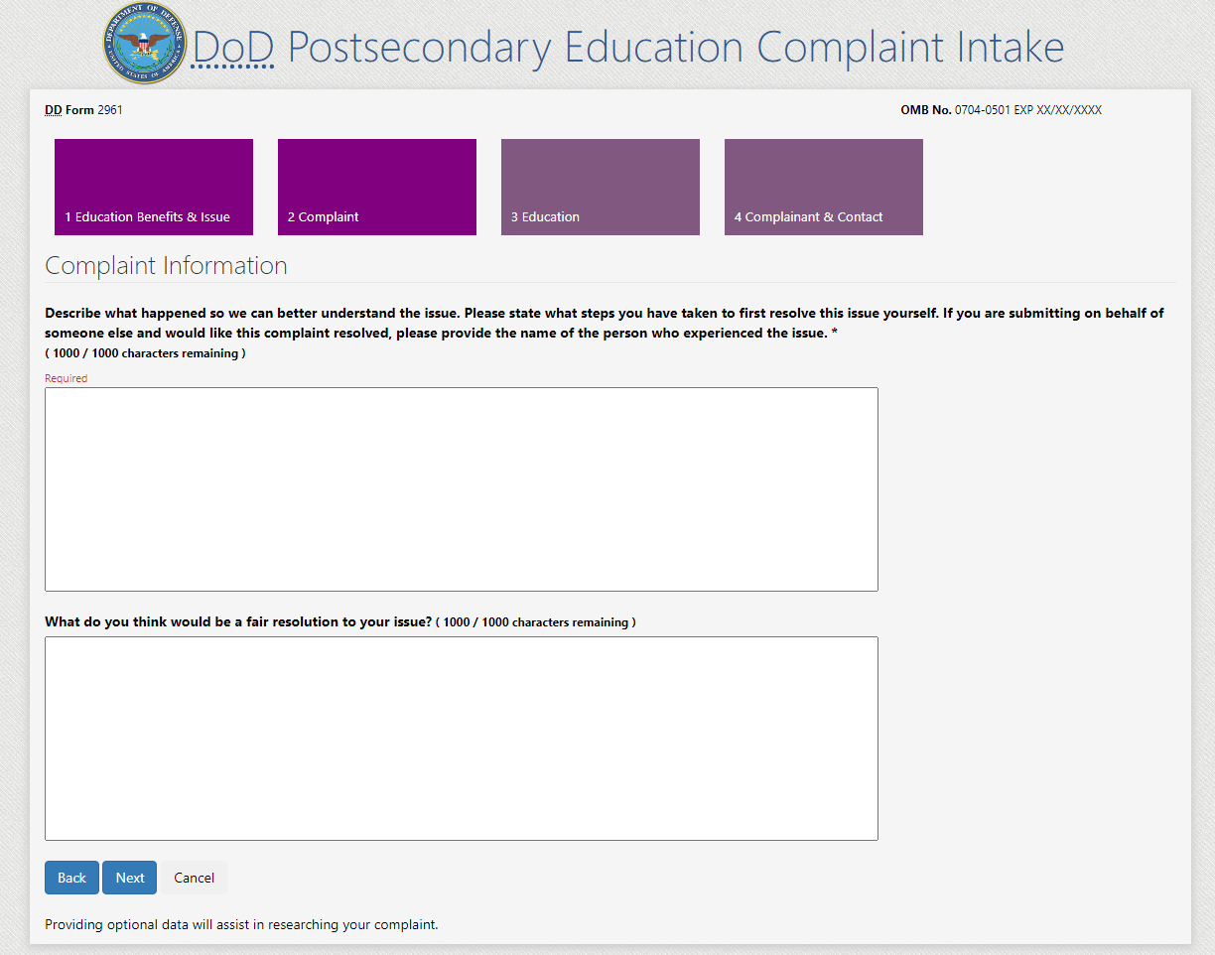
Step 2

- STEP 3: Complaint Filer enters “School” and “Education Information”. If a school name or location is not found in the database, the filer can select “I Can’t Find My School” to manually input their School Name.
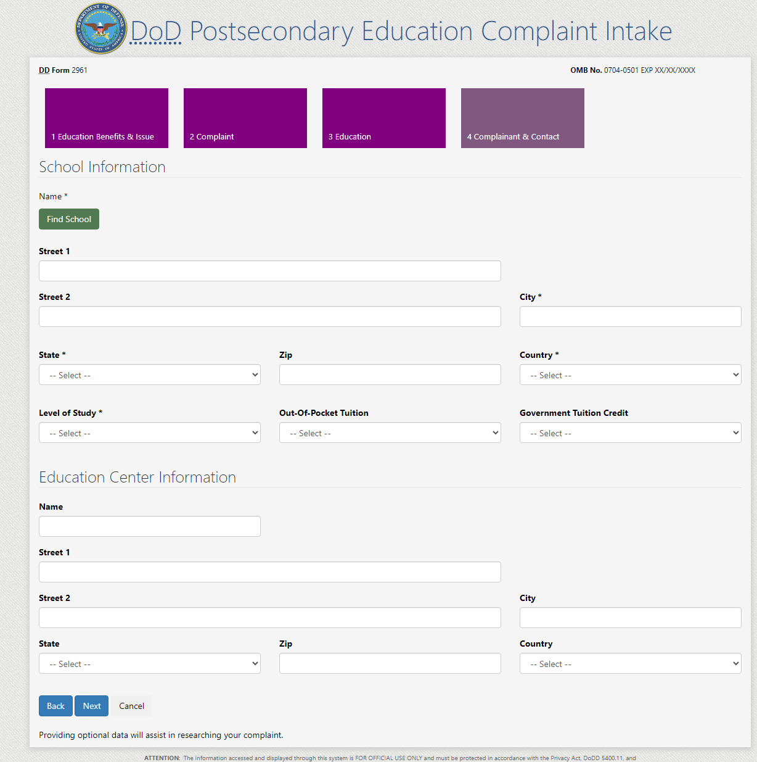
Step 3

8a. Complaint Filer can manually enter a School Name.
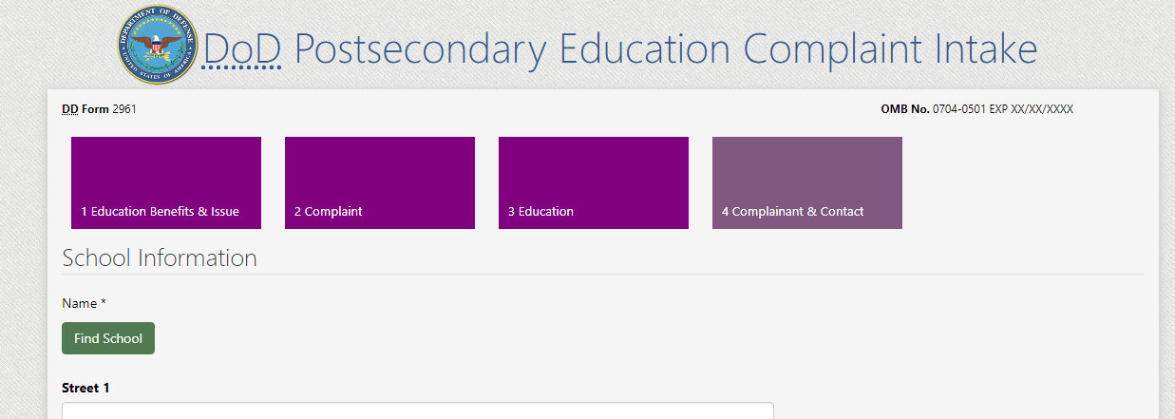
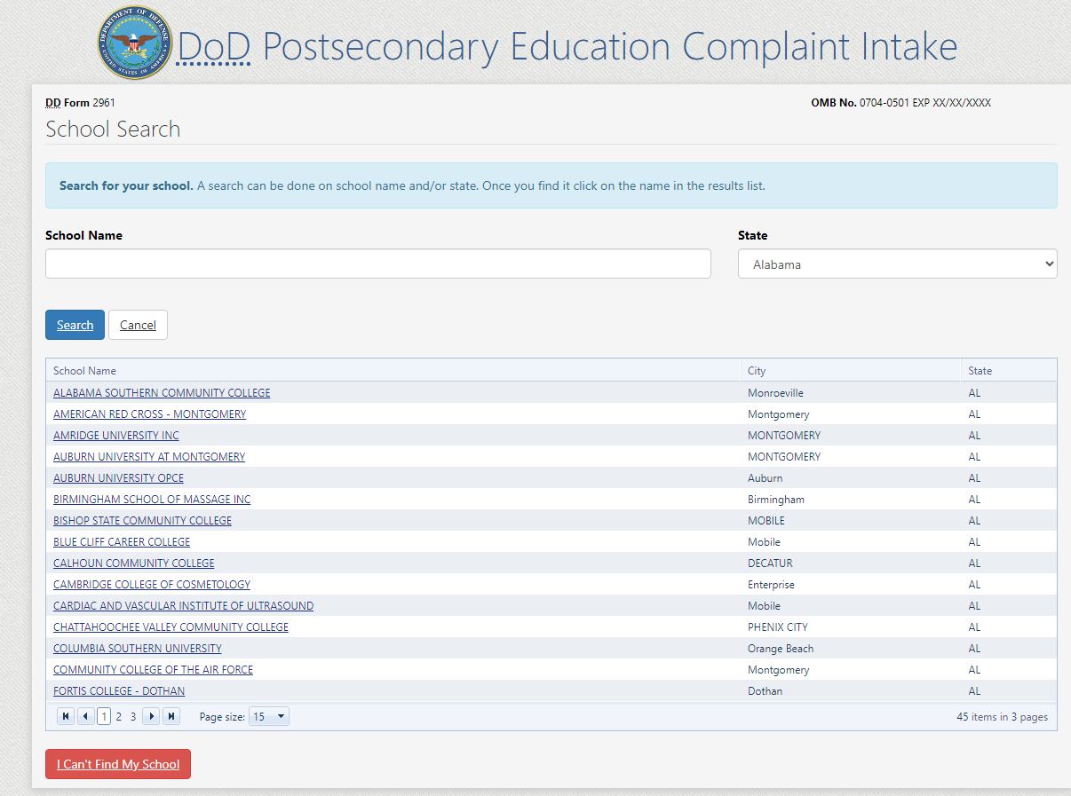

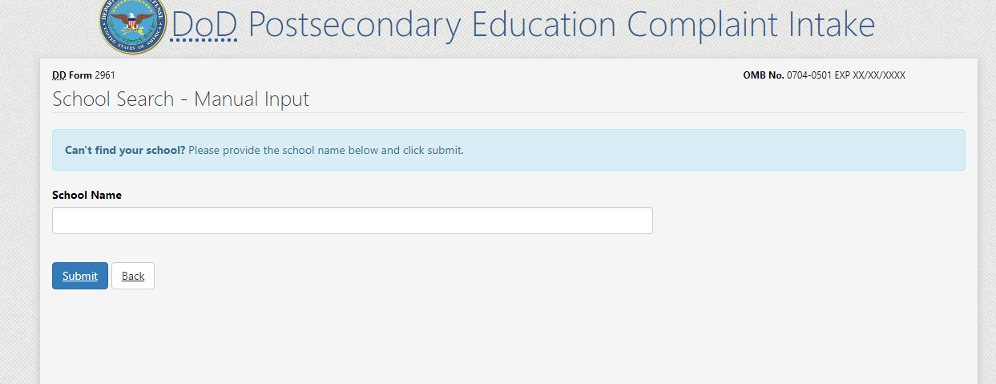

- STEP 4: Complaint Filer enters complainant and contact information. The data collection fields dynamically populate based on the “Service Affiliation” selected. Service Affiliation options follow:
- Service Member
- Spouse or Family Member
- Veteran

COMPLAINT FILER SELECTS “SERVICE MEMBER” AS THEIR SERVICE AFFILIATION
- Service Members must select their “Service Status”. The Service Status selection options follow:
  - Active
  - National Guard
  - Reserve

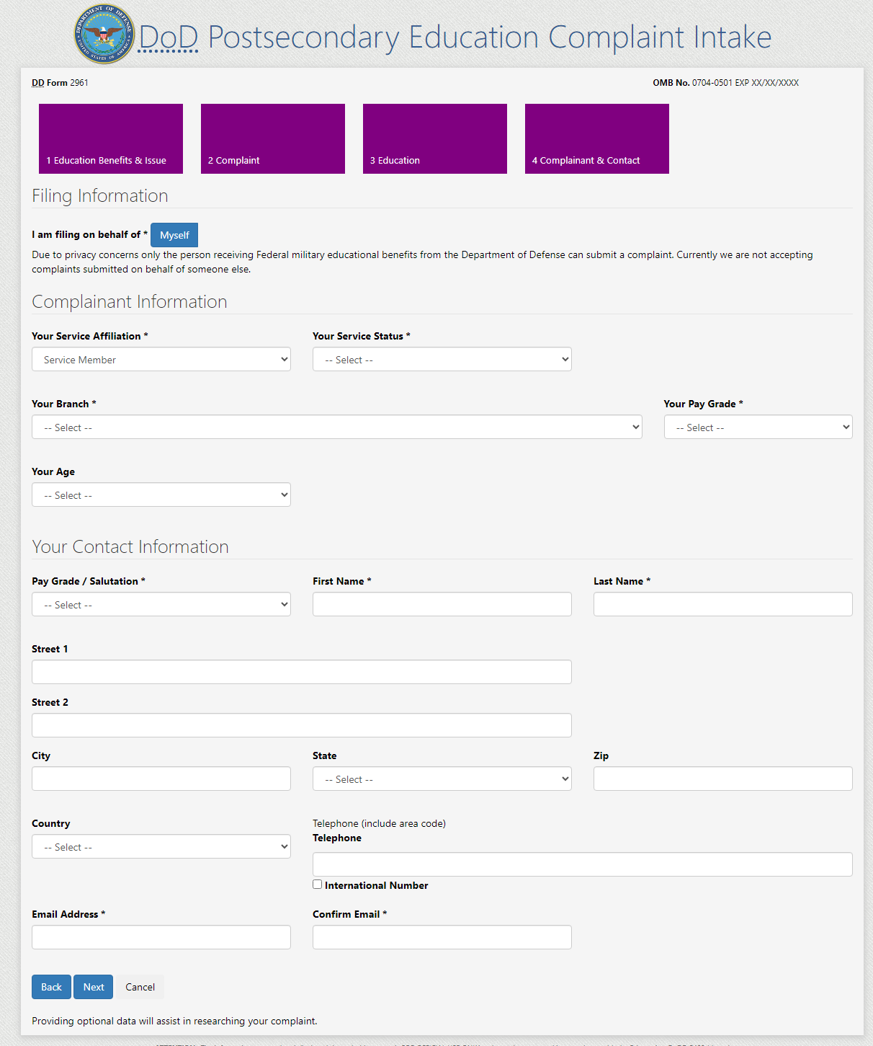
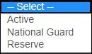
“Service Member” selected
COMPLAINT FILER SELECTS “SPOUSE OR FAMILY MEMBER” AS THEIR SERVICE AFFILIATION
- When “Spouse or Family Member” is selected as the Service Affiliation:
  - Field label’s update from “Your…” to “Your Sponsor’s…”
  - Filer must answer the Military Spouse Career Advancement Account (MyCAA) question
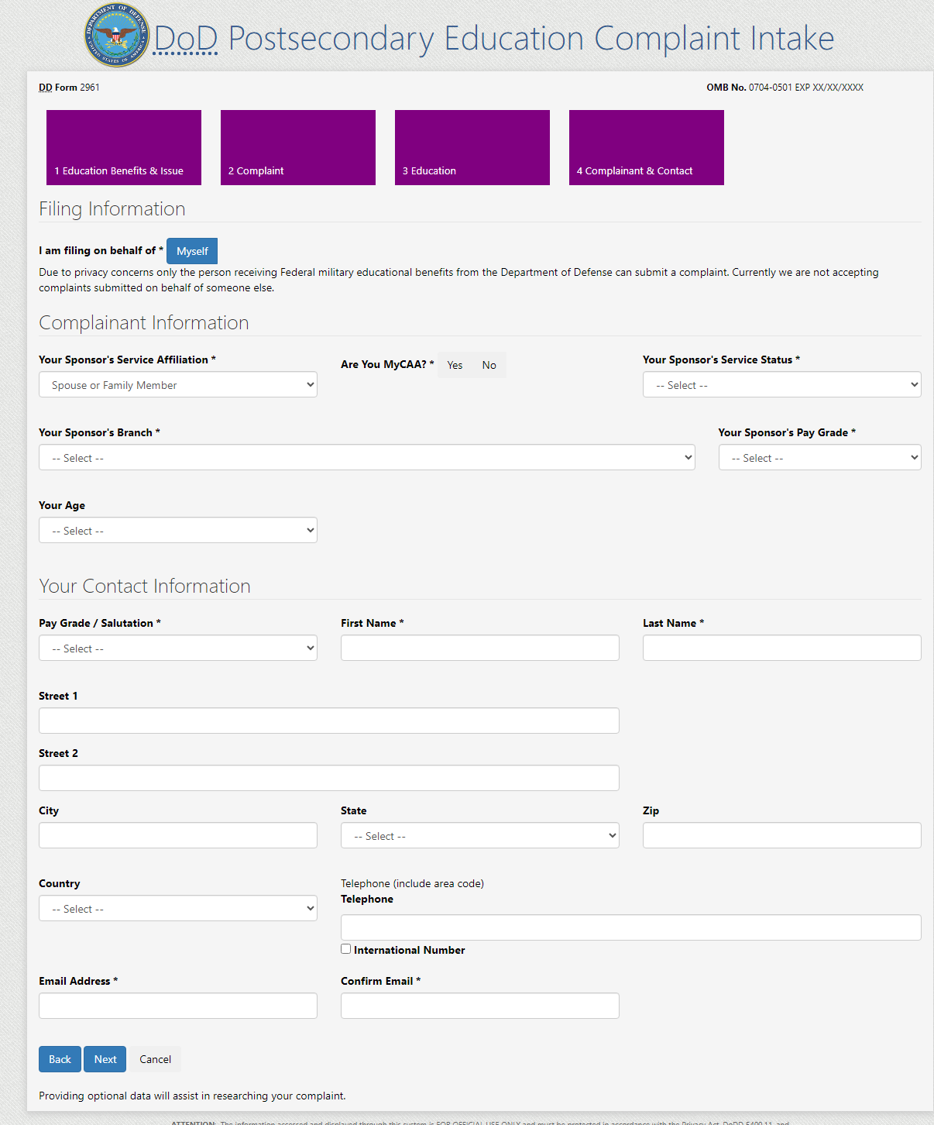
Labels update to “Your Sponsor’s”
MyCAA Question

COMPLAINT FILER SELECTS “VETERAN” AS THEIR SERVICE AFFILIATION
- Complaint Filer can select “Veteran” as their Service Affiliation
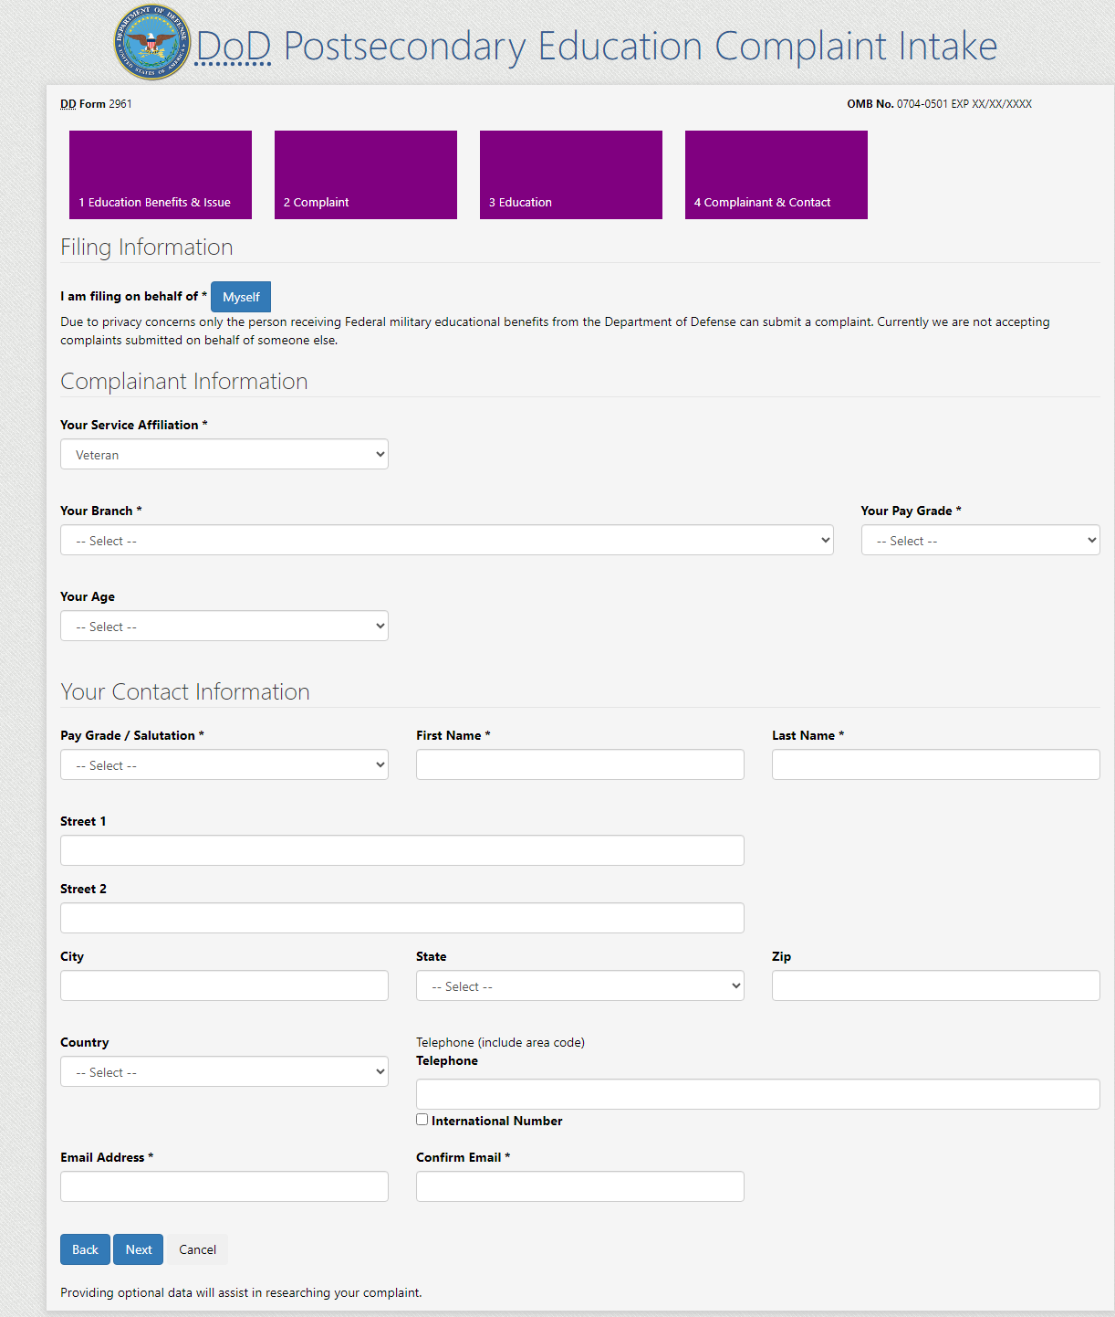

- Summary Page: Complaint Filer is presented with a summary of all the information they’ve entered and can go back to prior steps to make edits or submit the complaint.
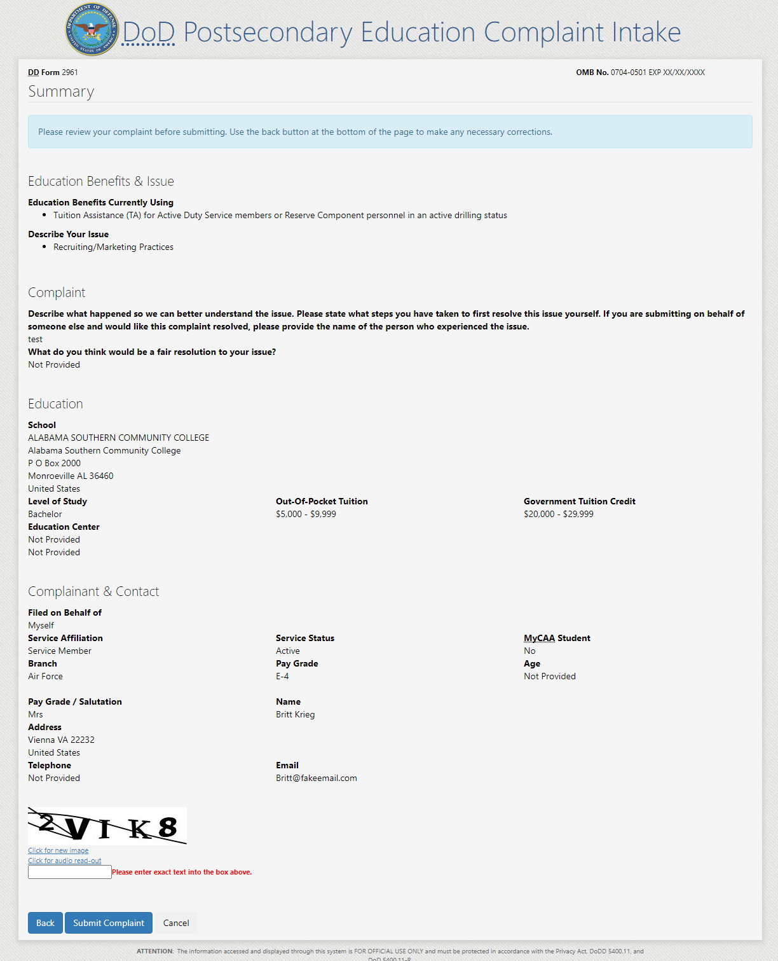
Filer must successfully pass a CAPTCHA
DoD POST SECONDARY EDUCATION COMPLAINT INTAKE DROPDOWN SELECTION VALUES:
STEP 3: EDUCATION
FIELD NAME: Level of Study
Dropdown Values:
- Certificate/Diploma
- Associate
- Bachelor
- Graduate/Professional
- Not Currently Enrolled

FIELD NAME: Out-of-Pocket Tuition
Dropdown Values:
- Less than $1,000
- $1,000 - $4,999
- $5,000 - $9,999
- $10,000 - $19,999
- $20,000 - $29,999
- Greater than $30,000

FIELD NAME: Government Tuition Credit
Dropdown Values:
- Less than $1,000
- $1,000 - $4,999
- $5,000 - $9,999
- $10,000 - $19,999
- $20,000 - $29,999
- Greater than $30,000
STEP 4: COMPLAINANT & CONTACT INFORMATION
FIELD NAME: Service Affiliation
Dropdown Values:
- Service Member
- Spouse or Family Member
- Veteran

FIELD NAME: Branch
Dropdown Values:
- Army
- Navy
- Marines
- Air Force
- Space Force
- Coast Guard
- VA NOAA (National Oceanic and Atmospheric Administration/VA PHS (Public Health Service)

FIELD NAME: Your Age
Dropdown Values:
- Less than 20 years old
- 20 – 29 years old
- 30 – 39 years old
- 40 – 49 years old
- 50 – 59 years old
- 60 years old and over
- Do not wish to disclose

FIELD NAME: Your Pay Grade
Dropdown Values:
- E-1
- E-2
- E-3
- E-4
- E-5
- E-6
- E-7
- E-8
- E-9
- SPE1
- SPE2
- SPE3
- SPE4
- SGT
- W-1
- W-2
- W-3
- W-4
- W-5
- O-1
- O-2
- O-3
- O-4
- O-5
- O-6
- O-7
- O-8
- O-9
- O-10

FIELD NAME: Pay Grade / Salutation
Dropdown Values:
- Mrs
- Ms
- Mr
- Dr
- E-1
- E-2
- E-3
- E-4
- E-5
- E-6
- E-7
- E-8
- E-9
- SPE1
- SPE2
- SPE3
- SPE4
- SGT
- W-1
- W-2
- W-3
- W-4
- W-5
- O-1
- O-2
- O-3
- O-4
- O-5
- O-6
- O-7
- O-8
- O-9
- O-10

REQUIRED DOD POSTSECONDARY EDUCATION COMPLAINT INTAKE FIELDS
SECTION: STEP 1 “EDUCATION BENEFITS & ISSUE”:
REQUIRED FIELDS:
- “EDUCATION BENEFITS CURRENTLY USING”:
- User must select at least one option

- “DESCRIBE YOUR ISSUE”:
- User must select at least one option

SECTION: STEP 2 “COMPLAINT INFORMATION”:
REQUIRED FIELDS:
- User must enter a description of what happened into a text box (restricted to 1,000 characters)

SECTION: STEP 3 “EDUCATION”:
REQUIRED FIELDS:
- School Name
- City (School location)
- State (School location)
- Country (School location)
- Level of Study

SECTION: STEP 4 “COMPLAINANT INFORMATION”:
REQUIRED FIELDS:
- Filing on behalf of Myself
- Service Affiliation
- Are you MyCAA
- Service Status
- Branch
- Pay Grade

SECTION: STEP 4 “CONTACT INFORMATION”:
REQUIRED FIELDS:
- Pay Grade / Salutation
- First Name
- Email Address
- Confirm Email Address

OPTIONAL DOD POSTSECONDARY EDUCATION COMPLAINT INTAKE FIELDS

SECTION: STEP 2 “COMPLAINT INFORMATION”:
OPTIONAL FIELDS:
- User has the option to enter a proposed resolution into a text box (restricted to 1,000 characters)

SECTION: STEP 3 “SCHOOL INFORMATION”:
OPTIONAL FIELDS:
  - Street 1
  - Street 2
  - Zip
  - Out-of-Pocket Tuition
  - Government Tuition Credit

SECTION: STEP 3 “EDUCATION CENTER INFORMATION”:
OPTIONAL FIELDS:
  - Name
  - Street 1
  - Street 2
  - City
  - State
  - Zip
  - Country

SECTION: STEP 4 “COMPLAINANT” INFORMATION:
OPTIONAL FIELDS:
- Your Age

SECTION: STEP 4 “CONTACT” INFORMATION:
OPTIONAL FIELDS:
- Street 1
- Street 2
- City
- State
- Zip
- Country
- Telephone

