**Paperwork Reduction Act Statement:** The public reporting burden for this information collection has been estimated to average 30 minutes per response, including the time to review instructions and respond to questions. Send comments regarding this burden estimate or any other aspect of this collection of information, including suggestions for reducing this burden to NIH, Project Clearance Branch, 6705 Rockledge Drive, MSC 7974, Bethesda, MD 20892-7974, Attn: OMB-PRA 0925-XXXX.

# Why Are We Asking These Questions?

We are talking with parents and caregivers of teens who are aged 17 to 19 to get their perspectives on parts of a research study with other parents and caregivers of teens. This activity is part of your participation in the feedback teams. We are asking for your help because we would like to hear the perspectives of parents and caregivers of teens from different backgrounds from all over the country. Your honest feedback will help the investigators ask questions in the best way possible.

You will be asked for your feedback on questions about health, life experiences, activities, and parts of your identities. Surveys will take no longer than 30 minutes to complete. You will have several days to complete the survey.

Parts of this activity are a little different from other surveys you may have taken. We are interested in your thoughts on *how the questions are written*, instead of your answers to the questions themselves. If something feels uncomfortable or confusing—we want to know. Please don’t worry about being polite or holding back. We value your feedback whether you agree or disagree, as we want to hear a wide range of opinions.

Your responses will be kept private. For open-ended questions, please do not enter any information that could identify you, such as your name or email address.

If you have questions, please email Rachael Picard at [rpicard@iqsolutions.com](mailto:rpicard@iqsolutions.com).

Would you like to participate in this activity?

Yes

No [Exit page]

# ABCD Study Background

Welcome! Thank you for participating in this exciting opportunity to contribute to research on teen health and development! We are so grateful for your commitment to this valuable project. Your role is to give feedback on questions we ask of participants in the Adolescent Brain Cognitive Development (ABCD) StudySM.

In the ABCD Study®, researchers will work with youth for 10 years starting at ages 9 and 10 to understand the different influences that affect brain development and general health. As part of the study, researchers will use questionnaires to ask youth about their physical and mental health; various life experiences such as playing sports, using social media, or trying drugs; and their family, school, and neighborhood environments, among other things.

The youth participating in the ABCD Study are as diverse as the United States. They come from 17 different states, from big cities and small towns, and from different economic backgrounds. The questions are asked of all participants regardless of their race, ethnicity, national origin, religion, sexual orientation, or gender identity. A large and diverse study like this makes it possible to investigate what contributes to differences in brain development, to understand what puts some people at risk for health problems, and to learn what makes some people able to recover from difficult experiences more easily than other people do.

Your feedback will help ensure the success of the ABCD Study in its quest to understand the many experiences that impact teen health and development and may help future generations of teens to live better, healthier lives.

# Questions about Substance Use

Please review the following terms/definitions.

|  |  |  |  |  |  |  |  |  |  |  |  |  |  |  |  |  |  |  |
| --- | --- | --- | --- | --- | --- | --- | --- | --- | --- | --- | --- | --- | --- | --- | --- | --- | --- | --- |
| |  |  | | --- | --- | | Substance | Definition/Examples | | Alcohol | Beer, wine, liquor (rum, vodka, gin, whiskey) | | Tobacco products | Cigarettes, e-cigarettes, pipes, cigars, smokeless tobacco | | Marijuana products | Joints, blunts, bongs, pipes, concentrates (tinctures), edible marijuana | | Inhalants | Liquids, sprays, and gases that people sniff or inhale to get high | | Stimulant prescription drugs | Ritalin, Adderall, ephedrine | | Prescription anxiolytics, tranquilizers or sedatives | Xanax, Ativan, Valium, Rohypnol, or sleeping pills | | Prescription pain relievers | Vicodin, Lortab, Norco, Hydrocodone, Oxycontin or Percocet | | Other illicit drugs | Cocaine, methamphetamine, heroin, hallucinogens, ecstasy/MDMA, ketamine, GHB | |

1. Does the definition and examples under the **Alcohol** section seem complete?

* Yes
* No

1a. [If “Yes”]What would you change or update? [open-ended text box]

1. Is anything in this definition or the examples out of date, offensive, or unclear?

* Yes
* No

2a. [If “Yes”]What would you use instead? [open-ended text box]

1. Does the definition and examples under the **Tobacco products** section seem complete?

* Yes
* No

3a. [If “Yes”]What would you change or update? [open-ended text box]

1. Is anything in this definition or the examples out of date, offensive, or unclear?

* Yes
* No

4a. [If “Yes”]What would you use instead? [open-ended text box]

1. Does the definition and examples under the **Marijuana products** section seem complete?

* Yes
* No

5a. [If “Yes”]What would you change or update? [open-ended text box]

1. Is anything in this definition or the examples out of date, offensive, or unclear?

* Yes
* No

6a. [If “Yes”]What would you use instead? [open-ended text box]

1. Does the definition and examples under the **Inhalants** section seem complete?

* Yes
* No

7a. [If “Yes”]What would you change or update? [open-ended text box]

1. Is anything in this definition or the examples out of date, offensive, or unclear?

* Yes
* No

8a. [If “Yes”]What would you use instead? [open-ended text box]

1. Does the definition and examples under the **Stimulant prescription drugs** section seem complete?

* Yes
* No

9a. [If “Yes”]What would you change or update? [open-ended text box]

1. Is anything in this definition or the examples out of date, offensive, or unclear?

* Yes
* No

10a. [If “Yes”]What would you use instead? [open-ended text box]

1. Does the definition and examples under the **Prescription anxiolytics, tranquilizers or sedatives** section seem complete?

* Yes
* No

11a. [If “Yes”]What would you change or update? [open-ended text box]

1. Is anything in this definition or the examples out of date, offensive, or unclear?

* Yes
* No

12a. [If “Yes”]What would you use instead? [open-ended text box]

1. Does the definition and examples under the **Prescription pain relievers** section seem complete?

* Yes
* No

13a. [If “Yes”]What would you change or update? [open-ended text box]

1. Is anything in this definition or examples out of date, offensive, or unclear?

* Yes
* No

14a. [If “Yes”]What would you use instead? [open-ended text box]

1. Does the definition and examples under the **Other illicit drugs** section seem complete?

* Yes
* No

15a. [If “Yes”]What would you change or update? [open-ended text box]

1. Is anything in this definition or the examples out of date, offensive, or unclear?

* Yes
* No

16a. [If “Yes”]What would you use instead? [open-ended text box]

# Questions about Consent

Now we’re going to ask about a consent form on a different, specific study activity.

|  |
| --- |
|  |

1. Is the goal of the ABCD Study Consent to get Hereditary Disease Risk Results clear to you based on the information presented on this page?

* Yes
* No

1. Did any of these statements use the wrong words or phrases (out of date, not how you would say it, or were confusing)?

* Yes
* No

18a. [If “Yes”] Which ones? *[multi-select list]*

18b. [If “Yes”] What words would you use instead? *[open-ended text box]*

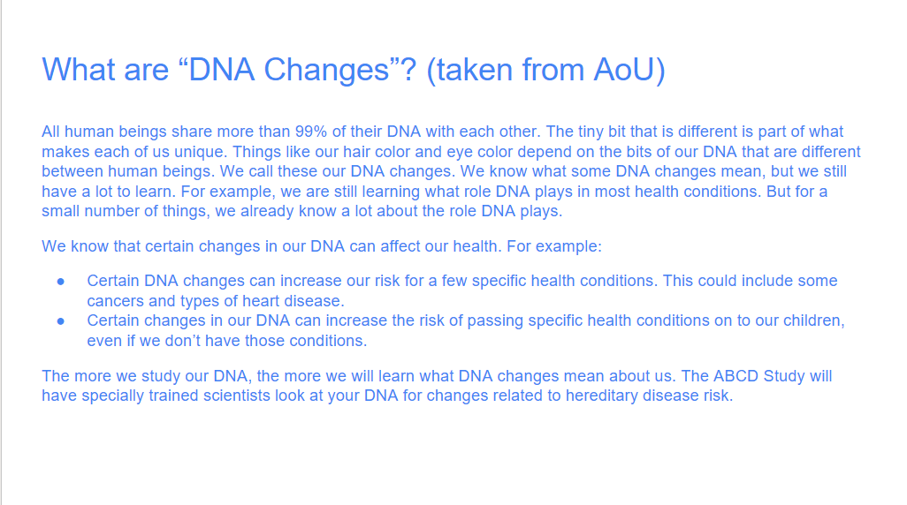

1. Is the information presented on this page clear to you?

* Yes
* No

19a. [If “No”] What questions do you still have about DNA changes? *[open-ended text box]*

1. Did any of these statements use the wrong words (out of date, not how you would say it, or were confusing)?

* Yes
* No

20a. [If “Yes”] Which ones? *[multi-select list]*

20b. [If “Yes”] What words would you use instead? *[open-ended text box]*

1. Do you understand the risks presented to you on this page?

* Yes
* No

1. Did any of these statements use the wrong words (out of date, not how you would say it, or were confusing)?

* Yes
* No

22a. [If “Yes”] Which ones? *[multi-select list]*

22b. [If “Yes”] What words would you use instead? *[open-ended text box]*

1. Do you understand the choices presented to you on this page?

* Yes
* No

1. Did any of these statements use the wrong words (out of date, not how you would say it, or were confusing)?

* Yes
* No

24a. [If “Yes”] Which ones? *[multi-select list]*

24b. [If “Yes”] What words would you use instead? *[open-ended text box]*

Please answer the following questions based on the five pages shown above. *[Insert smaller version of all five above for quick reference]*

1. Were any of these statements offensive?

* Yes
* No

25a. [If “Yes” – offensive]Which ones? [multi-select list]

25b. [If “Yes” – offensive]What parts were offensive, and why? Please share more. [open-ended text box]

1. Your recruiter gave you an ID number containing both a letter and number (such as Q4). Please enter your ID number here so you can get credit for completing this activity*.* [open-ended text box]
2. Before we conclude, we wanted to offer one more space for you to share any additional thoughts about anything you saw in this activity. Remember, please don’t share your full name, contact information, or anything else that would connect you as an individual with your responses. [open-ended text box]

# Thank You Page

Thank you for taking the time to complete this activity! The team greatly appreciates your feedback. What you shared today will help investigators ask questions in the best way possible to understand teens’ experiences and development.

We look forward to your participation in future feedback team activities. If you have additional feedback or questions about your feedback team participation, please contact Rachael Picard by email at [rpicard@iqsolutions.com](mailto:rpicard@iqsolutions.com).

# Exit Page

We thank you for your time spent completing this activity. Your response has been recorded.