Attachments – OWT Screenshots and Pull Downs

I. Screenshots of the Person Profile with Pull-Down Values
II. Screenshots of the Position Screen with Pull-Down Values
III. Screenshots of the Publications Screen with Pull-Down Values
IV. Screenshots of the Supplements Screen with Pull-Down Values
V. Screenshots of the Demographics Screen with Pull-Down Values
VI. Screenshots of Degrees Screen with Pull-Down Values
VII. Screenshots of NIH Grants Screen and Non-NIH AWARDS with Pull-Down Values
VII. OWT Table Columns and Names
VIII. Privacy Information Act (PIA) – to be added

Burden Statement
Public reporting burden for this collection of information is estimated to average 20 minutes per response, including the time for reviewing instructions, searching existing data sources, gathering and maintaining the data needed, and completing and reviewing the collection of information. An agency may not conduct or sponsor, and a person is not required to respond to, a collection of information unless it displays a currently valid OMB control number. Send comments regarding this burden estimate or any other aspect of this collection of information, including suggestions for reducing this burden, to: NIH, Project Clearance Branch, 6705 Rockledge Drive, MSC 7974, Bethesda, MD 20892-7974, ATTN: PRA (0925-XXXX). Do not return the completed form to this address.

PERSONS SCREEN
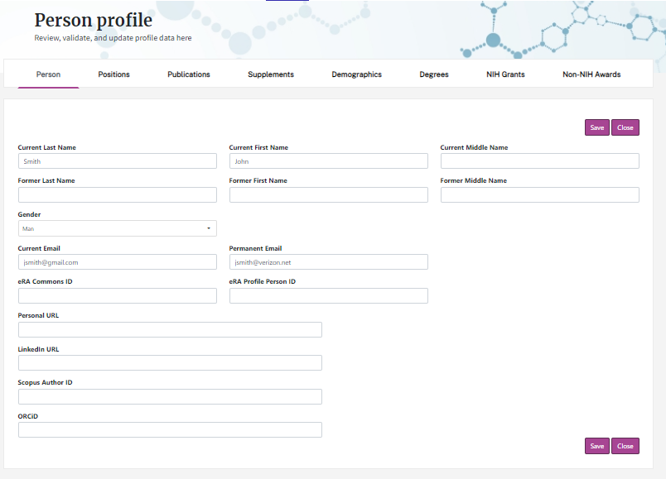
Pull-Down Values
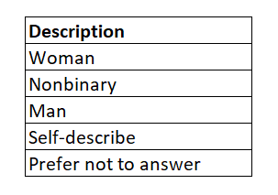

POSITION SCREEN
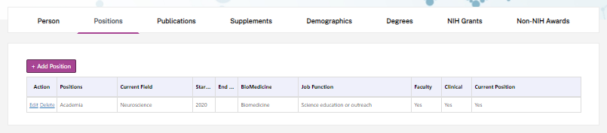
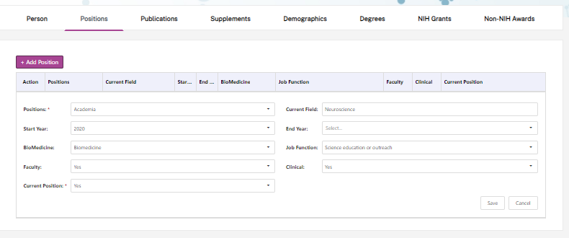
Pull-Down Values
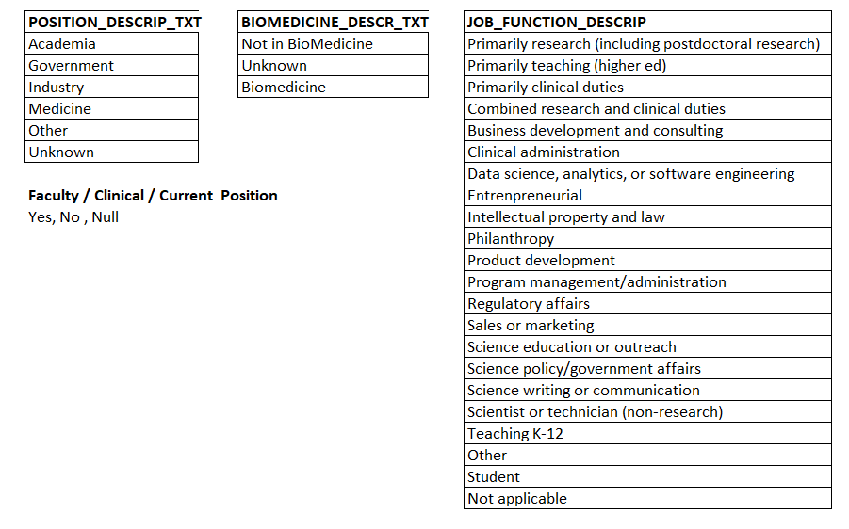

PUBLICATIONS SCREEN
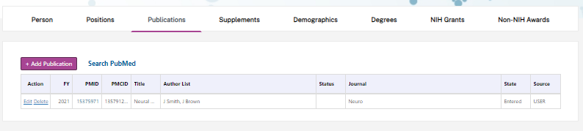
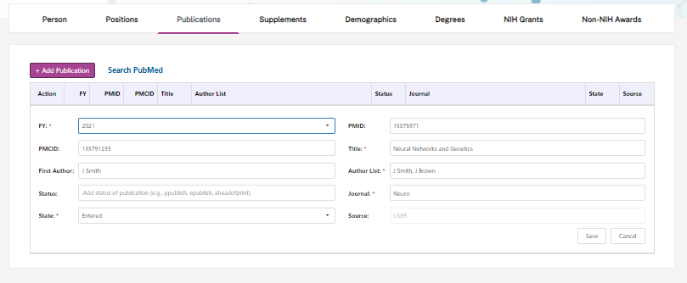
Pull-Down Values
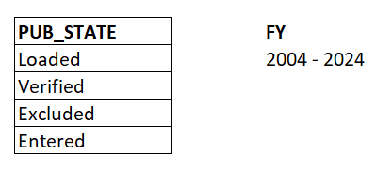
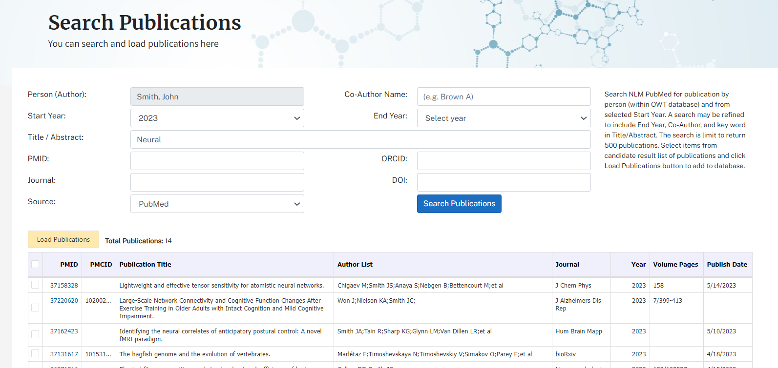

SUPPLEMENTS SCREEN
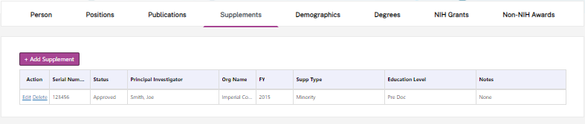
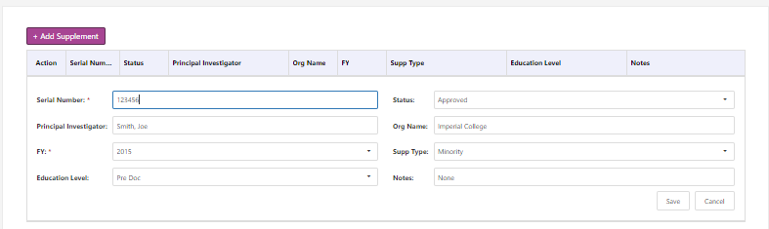
Pull-Down Values
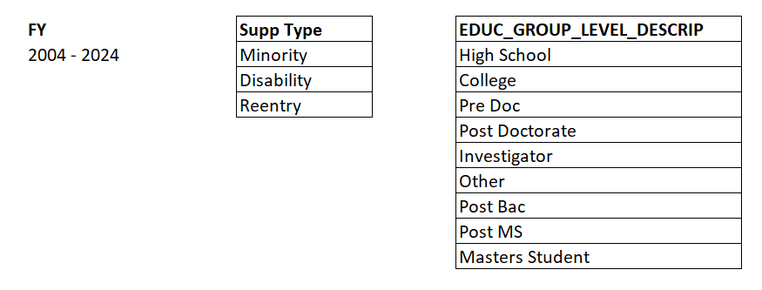

DEMOGRAPHICS SCREEN
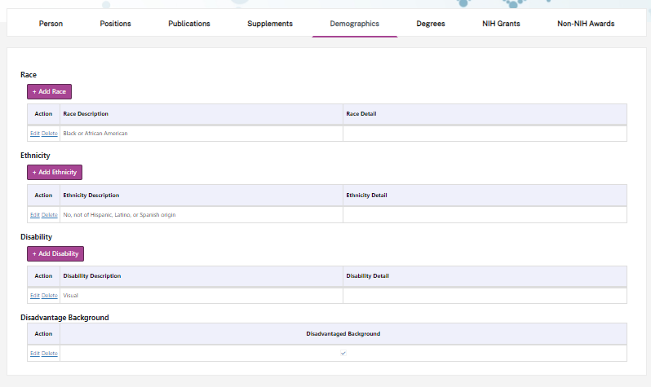
Pull-Down Values 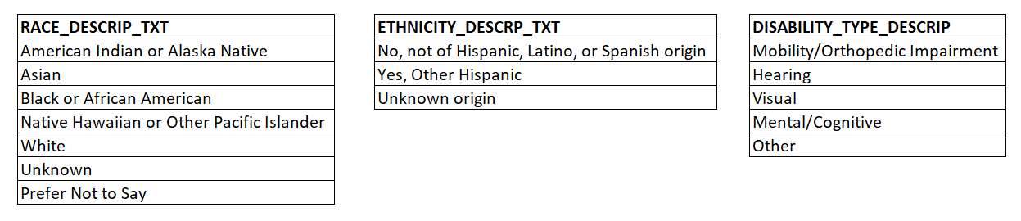

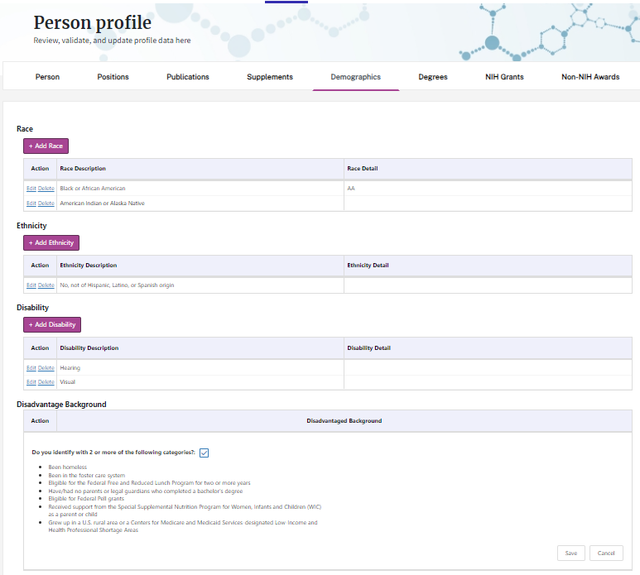
DEGREES SCREEN
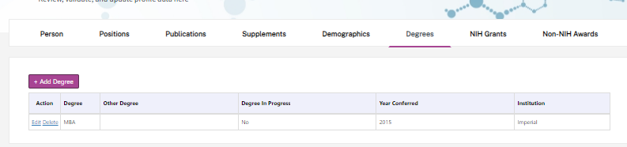
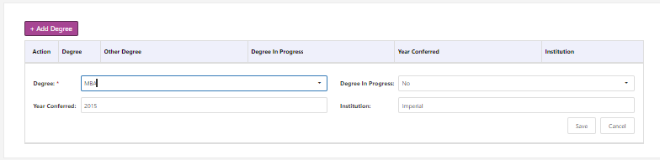
Pull-Down Values
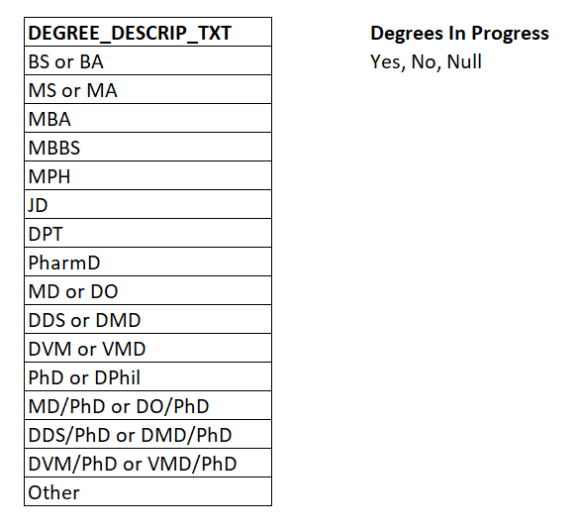

NIH GRANTS SCREEN (Display Only)
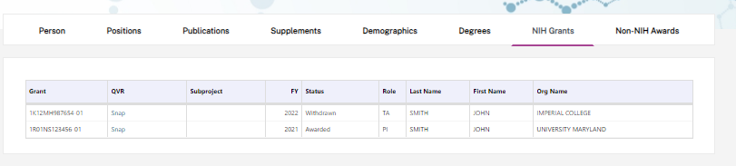
Non-NIH AWARDS
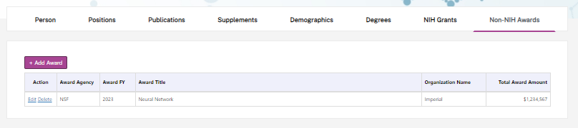
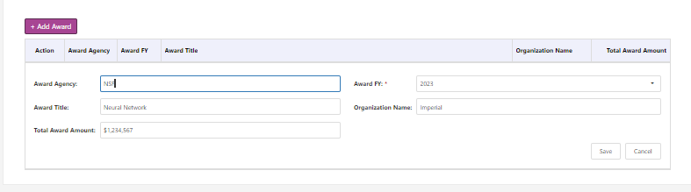
Pull-Down Values
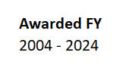

OWT LISTING OF TABLES AND COLUMN NAMES
TableName | ColumnName
BIOMEDICINE | BIOMEDICINE_CODE
BIOMEDICINE | BIOMEDICINE_DESCR_TXT
BIOMEDICINE | BIOMEDICINE_SORT_ORDER
DEGREES | CREATED_BY
DEGREES | CREATED_DATE
DEGREES | DEGREE_DESCRIP_TXT
DEGREES | DEGREE_ID
DEGREES | DEGREE_SORT_ORDER
DEGREES | DEGREE_STATUS_CODE
DEGREES | MODIFIED_BY
DEGREES | MODIFIED_DATE
DISABILITIES | DISABILITY_SORT_ORDER
DISABILITIES | DISABILITY_TYPE_DESCRIP
DISABILITIES | DISABILITY_TYPE_ID
EDUCATIONAL_GROUP_LEVEL | CREATED_BY
EDUCATIONAL_GROUP_LEVEL | CREATED_DATE
EDUCATIONAL_GROUP_LEVEL | EDUC_GROUP_LEVEL_CODE
EDUCATIONAL_GROUP_LEVEL | EDUC_GROUP_LEVEL_DESCRIP
EDUCATIONAL_GROUP_LEVEL | EDUC_GROUP_LEVEL_SORT_ORDER
EDUCATIONAL_GROUP_LEVEL | MODIFIED_BY
EDUCATIONAL_GROUP_LEVEL | MODIFIED_DATE
EDUCATIONAL_GROUP_LEVEL | STATUS_CODE
ERA_USERS_MV | ACCOUNT_TYPE
ERA_USERS_MV | CREATED_DATE
ERA_USERS_MV | EMAIL
ERA_USERS_MV | PERSON_ID
ERA_USERS_MV | PRIMARY_ORG_ID
ERA_USERS_MV | STATUS_CODE
ERA_USERS_MV | USER_ID
ETHNICITY | ETHNICITY_CODE
ETHNICITY | ETHNICITY_DESCRP_TXT
ETHNICITY | ETHNICITY_SORT_ORDER
Genders | Code
Genders | Description
Genders | SortOrder
JOB_FUNCTIONS | CREATED_BY
JOB_FUNCTIONS | CREATED_DATE
JOB_FUNCTIONS | JOB_FUNCTION_DESCRIP
JOB_FUNCTIONS | JOB_FUNCTION_ID
JOB_FUNCTIONS | JOB_FUNCTION_SORT_ORDER
JOB_FUNCTIONS | MODIFIED_BY
JOB_FUNCTIONS | MODIFIED_DATE
JSON_PARSER_PUBMED | AUTHOR_LIST
JSON_PARSER_PUBMED | Element_ID
JSON_PARSER_PUBMED | Name
JSON_PARSER_PUBMED | Object_ID
JSON_PARSER_PUBMED | Parent_ID
JSON_PARSER_PUBMED | PMID
JSON_PARSER_PUBMED | SequenceNo
JSON_PARSER_PUBMED | StringValue
JSON_PARSER_PUBMED | ValueType
JSON_PARSER_PUBMED | VOLUME
LOG_ENTRIES | CHANGED_COLUMNS
LOG_ENTRIES | CREATED_DATE
LOG_ENTRIES | CREATED_USER
LOG_ENTRIES | LOG_ENTRY_ID
LOG_ENTRIES | NEW_VALUES
LOG_ENTRIES | OLD_VALUES
LOG_ENTRIES | OPERATION
LOG_ENTRIES | PRIMARY_KEYS
LOG_ENTRIES | TABLE_NAME
ORCID | EXCEL_ID
ORCID | ORCID
ORCID | PROFILE_PERSON_ID
ORCID | SCOPUS_AUTHOR_ID
ORCID | SOURCE
ORCID | Supp
OWT_USERS | ACTIVE_FLAG
OWT_USERS | CREATED_BY
OWT_USERS | CREATED_DATE
OWT_USERS | EMAIL_ADDR_CURRENT
OWT_USERS | EMAIL_ADDR_PRIOR
OWT_USERS | FIRST_NAME
OWT_USERS | LAST_NAME
OWT_USERS | MODIFIED_BY
OWT_USERS | MODIFIED_DATE
OWT_USERS | PERSON_ID
OWT_USERS | USER_ID
OWT_USERS | USER_NAME
OWT_USERS | USER_ROLE
PERSON_DEGREES | CREATED_BY
PERSON_DEGREES | CREATED_DATE
PERSON_DEGREES | DEGREE_ID
PERSON_DEGREES | DEGREE_IN_PROGRESS_FLAG
PERSON_DEGREES | DEGREE_INSTITUTION_TXT
PERSON_DEGREES | DEGREE_OTHER_TXT
PERSON_DEGREES | DEGREE_SHORT_TXT
PERSON_DEGREES | DEGREE_YEAR_CONFERRED
PERSON_DEGREES | MODIFIED_BY
PERSON_DEGREES | MODIFIED_DATE
PERSON_DEGREES | PERSON_DEGREES_ID
PERSON_DEGREES | PERSON_ID
PERSON_DISABILITIES | CREATED_BY
PERSON_DISABILITIES | CREATED_DATE
PERSON_DISABILITIES | DISABILITY_DETAIL_TXT
PERSON_DISABILITIES | DISABILITY_TYPE_ID
PERSON_DISABILITIES | MODIFIED_BY
PERSON_DISABILITIES | MODIFIED_DATE
PERSON_DISABILITIES | PERSON_DISABILITIES_ID
PERSON_DISABILITIES | PERSON_ID
PERSON_DISADVANTAGES | CREATED_BY
PERSON_DISADVANTAGES | CREATED_DATE
PERSON_DISADVANTAGES | DISADVANTAGED_BACKGROUND
PERSON_DISADVANTAGES | Id
PERSON_DISADVANTAGES | MODIFIED_BY
PERSON_DISADVANTAGES | MODIFIED_DATE
PERSON_DISADVANTAGES | PERSON_ID
PERSON_ETHNICITIES | CREATED_BY
PERSON_ETHNICITIES | CREATED_DATE
PERSON_ETHNICITIES | ETHNICITY_CODE
PERSON_ETHNICITIES | MODIFIED_BY
PERSON_ETHNICITIES | MODIFIED_DATE
PERSON_ETHNICITIES | PERSON_ETHNICITIES_ID
PERSON_ETHNICITIES | PERSON_ETHNICITY_DETAIL_TXT
PERSON_ETHNICITIES | PERSON_ID
PERSON_POSITIONS | BIOMEDICINE_CODE
PERSON_POSITIONS | CLINICAL_POSITION_FLAG
PERSON_POSITIONS | CREATED_BY
PERSON_POSITIONS | CREATED_DATE
PERSON_POSITIONS | CURRENT_FIELD_TXT
PERSON_POSITIONS | CURRENT_POSITION_FLAG
PERSON_POSITIONS | FACULTY_POSITION_FLAG
PERSON_POSITIONS | JOB_FUNCTION_ID
PERSON_POSITIONS | MODIFIED_BY
PERSON_POSITIONS | MODIFIED_DATE
PERSON_POSITIONS | PERSON_ID
PERSON_POSITIONS | PERSON_POSITIONS_ID
PERSON_POSITIONS | POSITION_CODE
PERSON_POSITIONS | POSITION_END_YEAR
PERSON_POSITIONS | POSITION_START_YEAR
PERSON_PUBLICATIONS | CREATED_BY
PERSON_PUBLICATIONS | CREATED_DATE
PERSON_PUBLICATIONS | MODIFIED_BY
PERSON_PUBLICATIONS | MODIFIED_DATE
PERSON_PUBLICATIONS | PERSON_ID
PERSON_PUBLICATIONS | PERSON_PUBLICATION_ID
PERSON_PUBLICATIONS | PUB_STATE
PERSON_PUBLICATIONS | PUBLICATION_ID
PERSON_RACES | CREATED_BY
PERSON_RACES | CREATED_DATE
PERSON_RACES | MODIFIED_BY
PERSON_RACES | MODIFIED_DATE
PERSON_RACES | PERSON_ID
PERSON_RACES | PERSON_RACES_ID
PERSON_RACES | RACE_CODE
PERSON_RACES | RACE_DETAIL_TXT
PersonNONNIHAwards | AwardAgency
PersonNONNIHAwards | AwardFY
PersonNONNIHAwards | AwardOrganization
PersonNONNIHAwards | AwardTitle
PersonNONNIHAwards | CREATED_BY
PersonNONNIHAwards | CREATED_DATE
PersonNONNIHAwards | Id
PersonNONNIHAwards | MODIFIED_BY
PersonNONNIHAwards | MODIFIED_DATE
PersonNONNIHAwards | PersonId
PersonNONNIHAwards | TOTAL_AWARD_AMOUNT
PERSONS | CREATED_DATE
PERSONS | CREATOR_ID
PERSONS | EMAIL_ADDR_CURRENT
PERSONS | EMAIL_ADDR_PRIOR
PERSONS | ERA_COMMONS_ID
PERSONS | EXCEL_ID
PERSONS | FIRST_NAME
PERSONS | FIRST_NAME_FORMER
PERSONS | GENDER_CODE
PERSONS | GENDER_OTHER_TXT
PERSONS | LAST_NAME
PERSONS | LAST_NAME_FORMER
PERSONS | LAST_UPD_DATE
PERSONS | LAST_UPD_ID
PERSONS | LINKEDIN_URL_TXT
PERSONS | MI_NAME
PERSONS | MI_NAME_FORMER
PERSONS | ORCID
PERSONS | PERSON_ID
PERSONS | PERSONAL_URL_TXT
PERSONS | PROFILE_PERSON_ID
PERSONS | SCOPUS_AUTHOR_ID
PERSONS | TWITTER_TXT
POSITIONS | POSITION_CODE
POSITIONS | POSITION_DESCRIP_TXT
PUB_STATE | PUB_STATE
PUB_STATE | PUB_STATE_SORT_ORDER
PUBLICATIONS | CREATED_BY
PUBLICATIONS | CREATED_DATE
PUBLICATIONS | DOI
PUBLICATIONS | ERA_PUB_ID
PUBLICATIONS | JOURNAL_TITLE_TXT
PUBLICATIONS | MODIFIED_BY
PUBLICATIONS | MODIFIED_DATE
PUBLICATIONS | ORCID
PUBLICATIONS | PMCID
PUBLICATIONS | PMID
PUBLICATIONS | PUB_AUTHOR_LIST_TXT
PUBLICATIONS | PUB_BASELINE
PUBLICATIONS | PUB_FIRST_AUTHOR_TXT
PUBLICATIONS | PUB_SOURCE
PUBLICATIONS | PUB_STATUS
PUBLICATIONS | PUB_TITLE_TXT
PUBLICATIONS | PUB_VOLUME_PAGE_TXT
PUBLICATIONS | PUB_YEAR
PUBLICATIONS | PUBLICATION_ID
RACES | RACE_CODE
RACES | RACE_DESCRIP_TXT
RACES | RACE_GROUP_CODE
RACES | RACE_SORT_ORDER
SPIRES_PUBLICATIONS | ACTIVITY_CODE
SPIRES_PUBLICATIONS | ADMIN_PHS_ORG_CODE
SPIRES_PUBLICATIONS | CORE_PROJECT_NUM
SPIRES_PUBLICATIONS | CREATED_BY
SPIRES_PUBLICATIONS | CREATED_DATE
SPIRES_PUBLICATIONS | DOI
SPIRES_PUBLICATIONS | ERA_PUB_ID
SPIRES_PUBLICATIONS | JOURNAL_ISSUE
SPIRES_PUBLICATIONS | JOURNAL_TITLE_TXT
SPIRES_PUBLICATIONS | JOURNAL_VOLUME
SPIRES_PUBLICATIONS | MODIFIED_BY
SPIRES_PUBLICATIONS | MODIFIED_DATE
SPIRES_PUBLICATIONS | PAGE_NUMBER
SPIRES_PUBLICATIONS | PMCID
SPIRES_PUBLICATIONS | PMID
SPIRES_PUBLICATIONS | PROFILE_PERSON_ID
SPIRES_PUBLICATIONS | PUB_AUTHOR_LIST_TXT
SPIRES_PUBLICATIONS | PUB_FIRST_AUTHOR_TXT
SPIRES_PUBLICATIONS | PUB_SOURCE
SPIRES_PUBLICATIONS | PUB_STATUS
SPIRES_PUBLICATIONS | PUB_TITLE_TXT
SPIRES_PUBLICATIONS | PUB_YEAR
SPIRES_PUBLICATIONS | SERIAL_NUM
SPIRES_PUBLICATIONS | SPIRES_PUBLICATION_ID
SUPPLEMENTS | APPL_ID
SUPPLEMENTS | CREATED_BY
SUPPLEMENTS | CREATED_DATE
SUPPLEMENTS | EDUC_GROUP_LEVEL_CODE
SUPPLEMENTS | EXTERNAL_ORG_ID
SUPPLEMENTS | FY
SUPPLEMENTS | MODIFIED_BY
SUPPLEMENTS | MODIFIED_DATE
SUPPLEMENTS | ORG_NAME
SUPPLEMENTS | PERSON_ID
SUPPLEMENTS | PI_GENDER
SUPPLEMENTS | PRINCIPAL_INVESTIGATOR_TXT
SUPPLEMENTS | SERIAL_NUM
SUPPLEMENTS | SUPP_NOTES
SUPPLEMENTS | SUPP_STATUS
SUPPLEMENTS | SUPP_TYPE
SUPPLEMENTS | SUPPLEMENT_ID
SUPPORTEE_APPS | APPL_ID
SUPPORTEE_APPS | APPL_STATUS_GROUP_CODE
SUPPORTEE_APPS | CREATED_BY
SUPPORTEE_APPS | CREATED_DATE
SUPPORTEE_APPS | DESCRIP
SUPPORTEE_APPS | FIRST_NAME
SUPPORTEE_APPS | FULL_GRANT_NUM
SUPPORTEE_APPS | FY
SUPPORTEE_APPS | LAST_NAME
SUPPORTEE_APPS | MODIFIED_BY
SUPPORTEE_APPS | MODIFIED_DATE
SUPPORTEE_APPS | ORG_NAME
SUPPORTEE_APPS | PROFILE_PERSON_ID
SUPPORTEE_APPS | ROLE_TYPE_CODE
SUPPORTEE_APPS | SUBPROJECT_ID
SYSTEM_TRACKING_REGISTRY | APPLICATION_NAME
SYSTEM_TRACKING_REGISTRY | BROWSER_SESSION_ID
SYSTEM_TRACKING_REGISTRY | LOGIN_DATE
SYSTEM_TRACKING_REGISTRY | LOGIN_STATUS
SYSTEM_TRACKING_REGISTRY | LOGOUT_DATE
SYSTEM_TRACKING_REGISTRY | SYS_HOST_NAME
SYSTEM_TRACKING_REGISTRY | SYS_TRACK_ID
SYSTEM_TRACKING_REGISTRY | SYS_USER_NAME
SYSTEM_TRACKING_REGISTRY | SYSTEM_ID
SYSTEM_TRACKING_REGISTRY | USER_ID
SYSTEM_TRACKING_REGISTRY | USER_IP_ADDRESS
SYSTEM_TRACKING_REGISTRY | USER_ROLE
USER_ROLE_CODES | ROLE_DESC
USER_ROLE_CODES | USER_ROLE
USER_ROLE_CODES | USER_ROLE_ORDER

Privacy Statement
On the NIH Login page we have the following Privacy Statement
( https://authtest.nih.gov/CertAuthV3/forms/help/nihloginprivacypolicies.html )
