OMB # 0925-0767
Expiration Date: 01/31/2024

COLLECTION INSTRUCTIONS

The HBCU or small businesses will enter the following information:
- Profile information to set up a user account (account provisioning done through registration)
- Information about a grant they are interested in pursuing
- Information about a contract they are interested in pursuing
- OMB Number and expiration date displayed on the site
- Burden statement that is displayed on the site
- Registration for new users
- User input for monthly, quarterly and annual reporting

User Account Provisioning

Log in screen (OMB Number and Expiration Date)

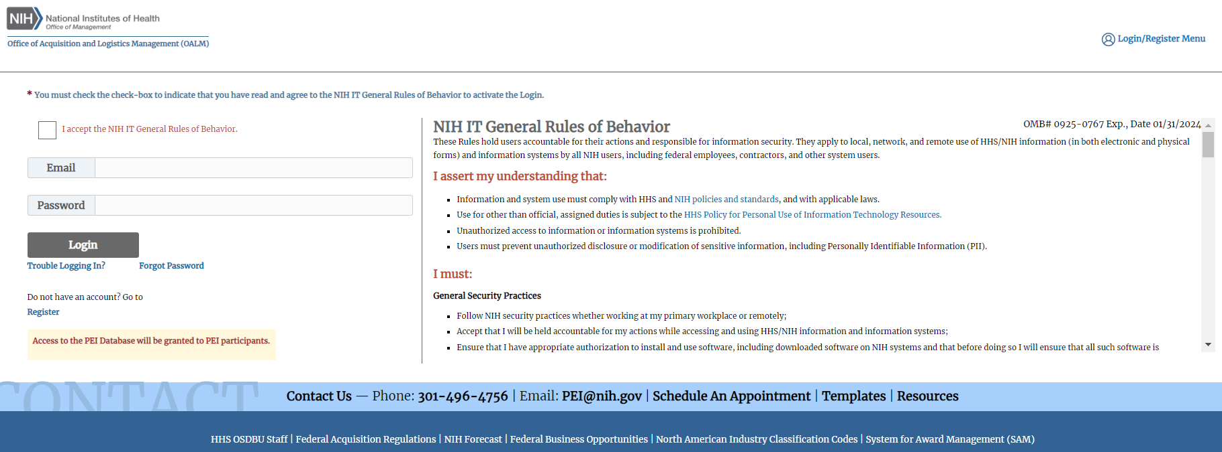
Burden Statement (is at bottom of log in screen, scroll down to the bottom of the log in screen to view the Burden Statement)

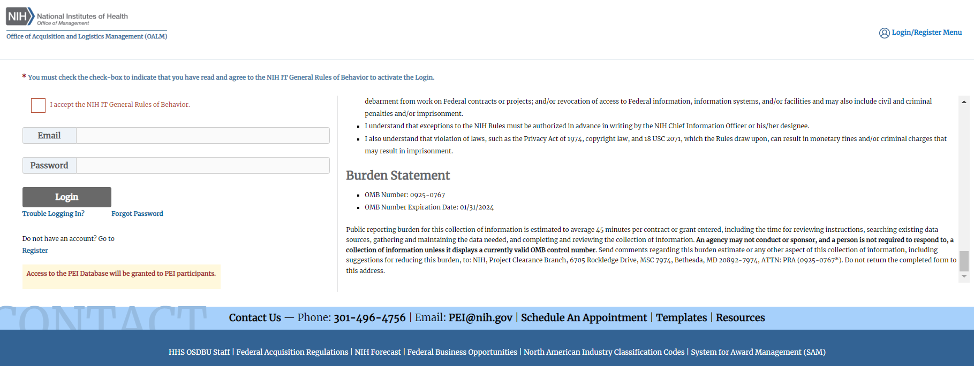

Registration for users

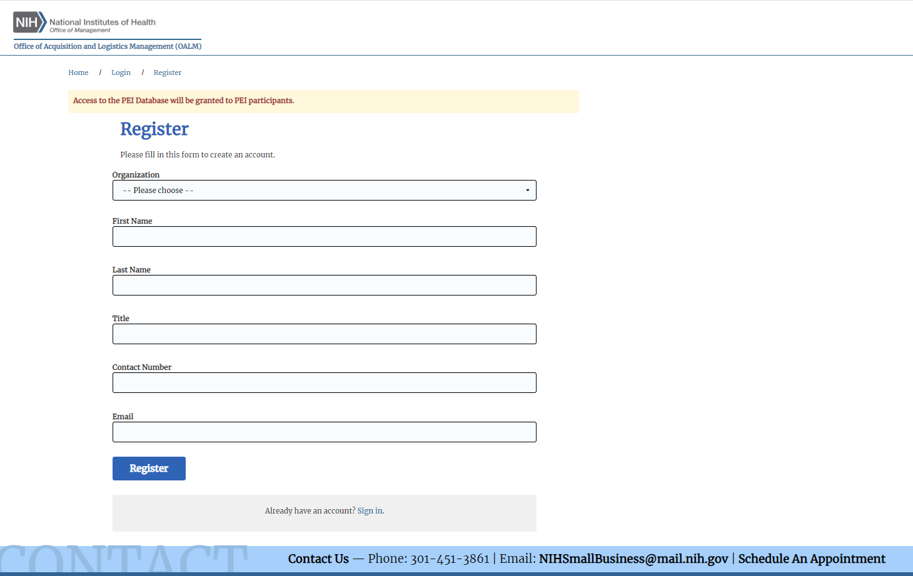
My Org Profile screen
Input organizational data to create a profile accessible to potential teaming partners and NIH staff.

My Grants
Search for and record NIH grant opportunities that you intend to pursue or received notification regarding.

Search for and record NIH grant opportunities that you intend to pursue or received notification regarding. Attributes | Definition
Announcement Number | Funding Opportunity Announcement (FOA) number
Title | Title of the grant opportunity
Activity Category | Category that the activity code belongs to
Activity Code | A 3-character code used to identify a specific category of extramural research activity, applied to financial assistance mechanisms.
Application Type | Type of the grant application, e.g. New, Renewal, Revision.
Teaming | YES/NO question to indicate whether the grant has teaming partners.
Teaming Partner | A partnered HBCU/small business Institute or Center (IC) of the grant.
Grant Status | Current status of the grant, e.g. Interested, Intend to Apply, Not funded.
Start Date | Official date a grant award begins; same as the first day of the first budget period.
End Date | Official date a grant award ends; same as the last day of the last budget period.
IC | Institute or Center
Award Budget | The financial plan for the project or program that the Federal awarding agency or pass-through entity approves during the Federal award process or in subsequent amendments to the Federal award.

My Contracts
Search for and record NIH contract opportunities that you intend to pursue or received notification regarding.
Attributes | Definition
Solicitation Number | Agency assigned notice number to be associated with the solicitation.
Title | Title of the contract opportunity
Notice Type | Type of the contract opportunity notice, such as Award, Combined Synopsis/Solicitation, Pre-solicitation.
Contract Type | Type of the contract, such as Cost No Fee, Cost Plus Award Fee, Cost Plus Fixed Fee.
Contract Vehicle | A contract vehicle is a streamlined method the government uses to buy goods and services.
IC | Institute or Center
Teaming | YES/NO question to indicate whether the grant has teaming partners.
Teaming Partner | A partnered HBCU/small business Institute or Center (IC) of the grant.
Contract Status | Current status of the contract, e.g. Interested, Intend to Apply, Did not win.
Contract Value | Total value of the contract.
Start Date | Official effective date of the contract.
End Date | Official completion date of the contract.

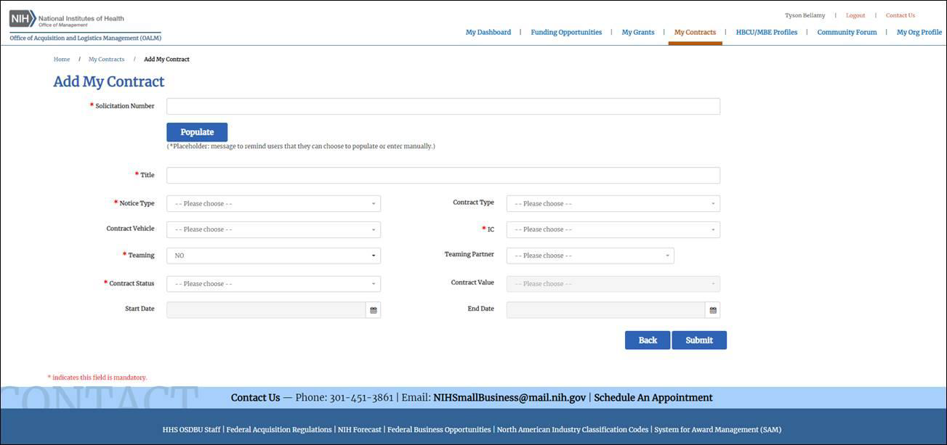

Dashboard

View upcoming events, recent NIH funding opportunities & updates from the NIH Small Business Program Office.

My Reports
Reporting dashboard to edit, submit, and download monthly, quarterly, and annual reports

Monthly Report
Monthly reporting on teaming partners and training

Monthly Report – Teaming Partners
Monthly reporting on teaming partners information

Monthly Report – Training
Monthly reporting on training evaluation

Quarterly Report
Quarterly reporting on teaming partners and PEI Program

Quarterly Report – Teaming Partners
Quarterly reporting on teaming partners information and evaluation

Quarterly Report – PEI Program
Quarterly reporting on PEI Program evaluation

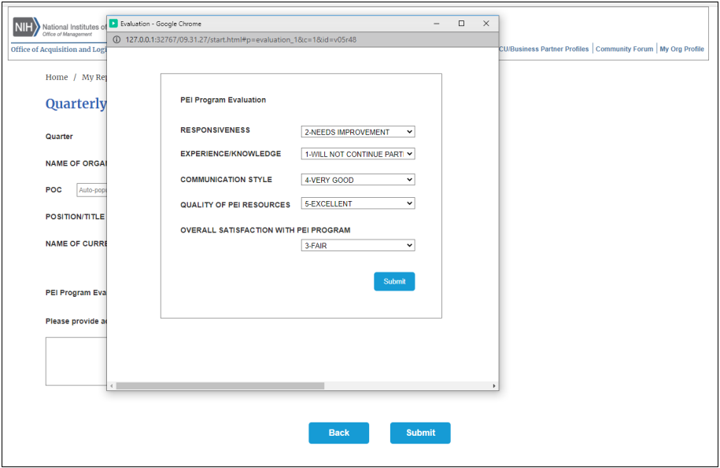

Annual Report
Annual reporting on teaming partners and SBPO

Annual Report
Annual reporting on teaming partners evaluation

Annual Report
Annual reporting on the NIH SBPO evaluation

