**Permits Online (PONL) Signing Authority Section**

After logging on to PONL, users may add, edit, or delate information in the Signing Authority Section of any new or amended permit function of PONL within Step 2: Key personnel and trade names / Step 2a:

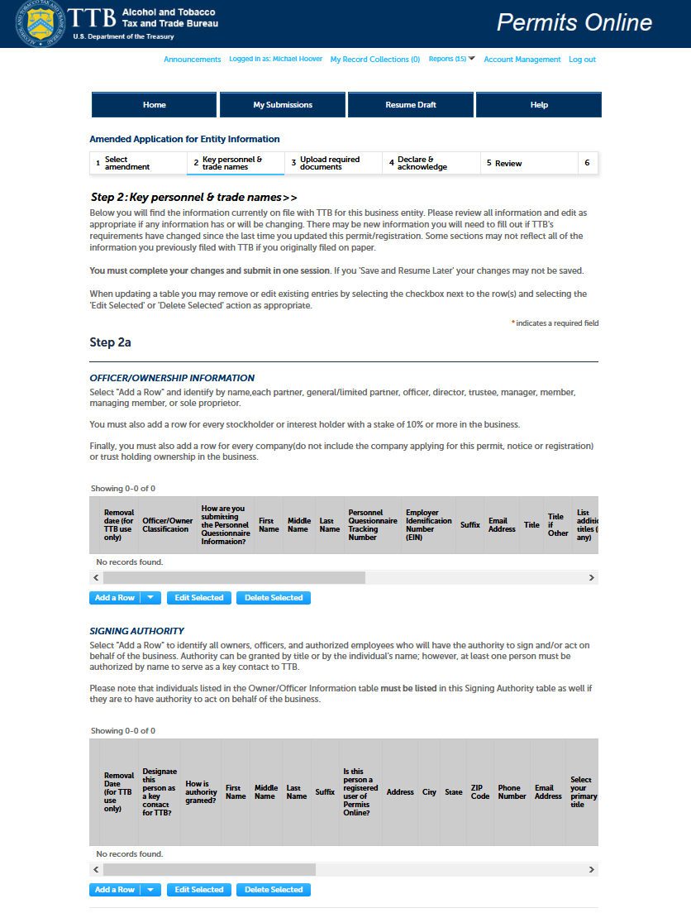

Within the Signing Authority Section, after clicking Add a Row, Edit Selected, or Delete Selected, the PONL system presents the user with the Signing Authority Section data entry screen:

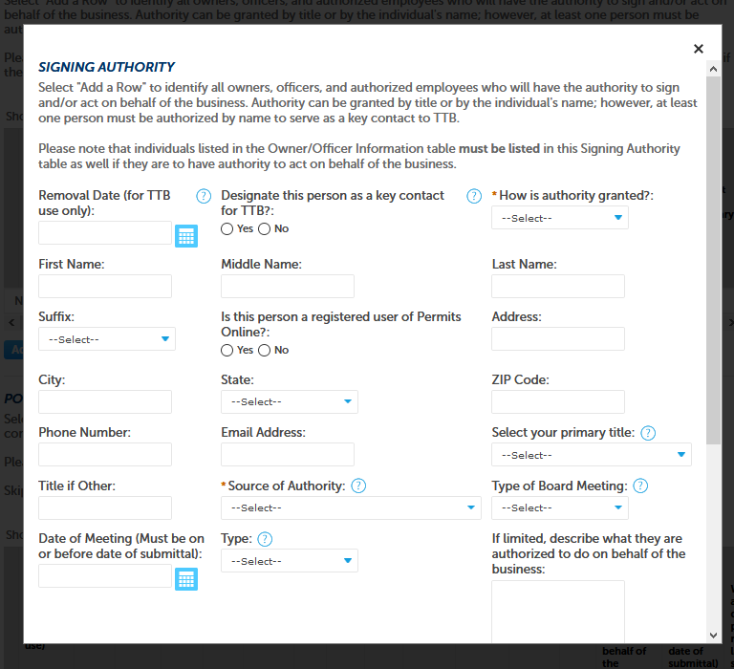

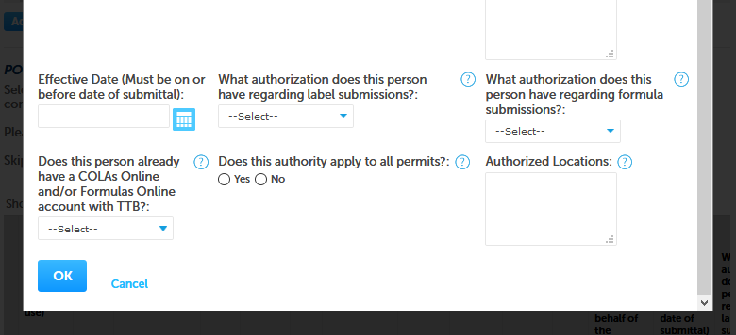

After entering, editing, or deleting data and clicking the OK button, the user returns to the Step 2 / 2a screen and is able to see a summary of the entered or revised data in the Signing Authority Section:

(Close up of the Signing Authority section of the Step 2a Screen shown below.)

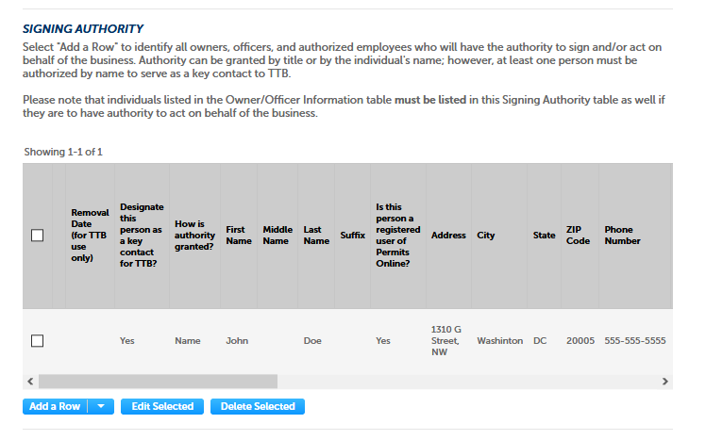

The user then goes onto to complete the new or amended permit, and/or goes thru to the submission function to submit the Signing Authority information to TTB.

[END]