MEMORANDUM NATIONAL CENTER FOR EDUCATION STATISTICS
Institute of Education Sciences
United States Department of Education

Date: January 3, 2023
To: Bev Pratt, OMB
Through: Carrie Clarady, NCES
From: Mary Coleman, NCES
Re: TALIS 2024 Main Survey (OMB# 1850-0888 v.13) - changes from last approved 2024 Main Survey Questionnaires

OMB approved recruitment and pre-survey activities for the TALIS 2024 field test sample, administration of the field test, and school recruitment activities for the 2024 main survey in August 2022 (OMB# 1850-0888 v.8). In December 2022, OMB approved the international versions of the field test instruments (OMB#1850-0888 v.9) and the U.S. adapted field test questionnaires (OMB# 1850-0888 v.10). In May 2023, OMB approved an increase in the school sample size for the TALIS main survey (OMB#1850-0888 v.11). In December 2023, OMB approved the main survey instruments (OMB#1850-0888 v.12).
TALIS 2024 includes the core TALIS teacher and principal questionnaires that are required for each participating country, as well as a new and optional Teacher Knowledge Survey (TKS). The purpose of the TKS is to better understand the teacher pedagogical knowledge base at the national level. The goal is to use results from the TKS to understand the extent to which teachers are prepared with the knowledge and skills for 21st century teaching (e.g., using technology in instruction, teaching in diverse classroom environments, and using modern pedagogical approaches). The U.S. included the TKS in the TALIS 2024 field test and will include TKS as part of the U.S. main study. The TKS is a new and proprietary instrument and will not be published for public comment as part of the Paperwork Reduction Act (PRA) review process.
This request is for approval of five changes made to the previously approved TALIS 2024 main survey instruments (OMB#1850-0888 v.12). Table 1 summarizes the changes to Appendix B, while Table 2 summarizes the changes to the proprietary and unpublished TKS instruments (submitted under separate cover). In addition, small changes were made to Part A and are detailed below.

Part A
We have revised Part A to include the last approved OMB package (OMB#1850-0888 v.12).
To meet the international data collection schedule for the main study, U.S. recruitment activities need to begin by June 2023 and U.S. questionnaires must be finalized by December 2023.
The previous submission (OMB #1850-0888 v.8) requested approval for: (1) recruitment and pre-survey activities for the 2023 field test sample; (2) administration of the field test; and (3) school recruitment and pre-survey activities for the 2024 main study sample. That package was approved in August 2022. OMB approved the international versions of the field test instruments (OMB#1850-0888 v.9) and the final U.S. versions of the field test instruments (OMB#1850-0888 v.10) in December 2022. In May 2023, OMB approved an increase in the school sample size for the TALIS main study (OMB#1850-0888 v.11). In December 2023, OMB approved the final U.S. versions of the main study instruments (OMB#1850 V 12).
Field test recruitment materials, including letters to state and district officials and school principals, the text for a TALIS field test brochure, summary of activities, “frequently asked questions,” and the text for the teacher invitation email are provided in Appendix A-1. A similar set of Main study recruitment materials are provided in Appendix A-2.

Appendix B - Questionnaire Items and Forms
Appendix B contains the revised national versions of the TALIS Main Survey Core Principal and Teacher Surveys. TKS items are not available for public distribution and therefore the questionnaire forms are not included in Appendix B; TKS instruments are provided by email to OMB for review.
Table 1. Summary of changes to OMB-Approved TALIS Main Survey instruments
# | Description of Change |  | Item Image
1. | Item 24 of the teacher questionnaire, form A, was changed from “To predict student performance based on prior achievement” to “To efficiently learn about and summarize a topic”. |  | 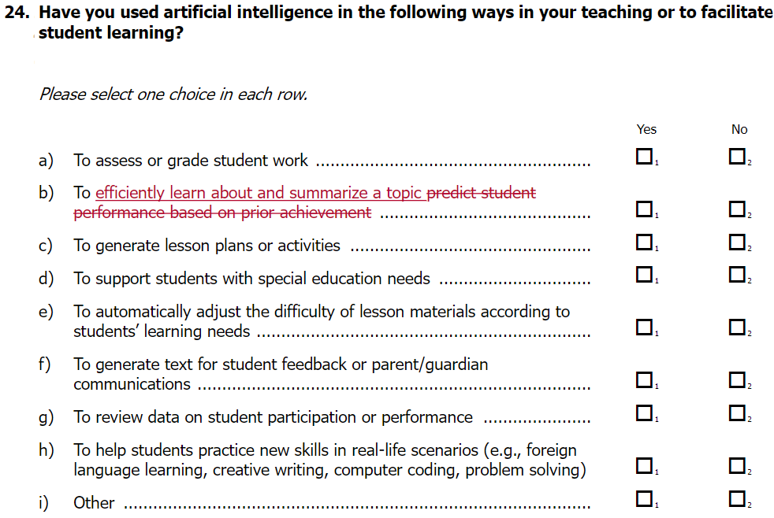
Reason for change: This item was added to the main survey and was not tested in the field trial instruments. After releasing the main survey instruments to countries for preparation, IEA revised this item and updated in the instruments. IEA did not provide a reason for the change.
2. | Item 25 of the teacher questionnaire, form A was corrected from “digital tools and resources” to “digital resources and tools” to ensure consistency of the phrase across instruments. |  | 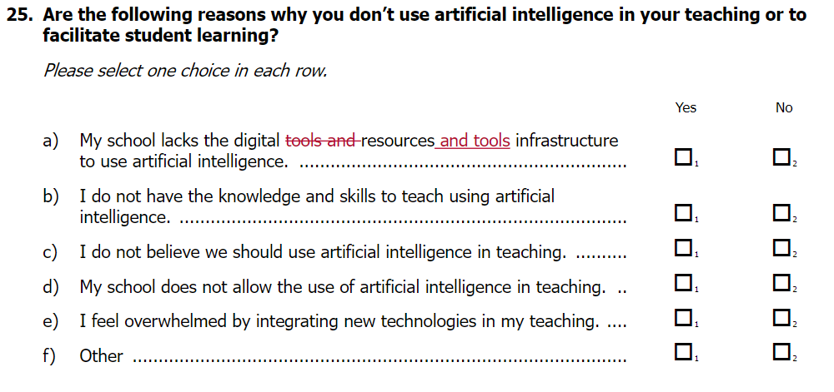
Reason for change: This change was to correct a mistake. The term “digital resources and tools” is throughout the instruments.
3. | Item 60 in teacher questionnaires was removed from form B and C (remains on Form A as number 51). |  | 60. Thinking about education at the 7th, 8th, and 9th grade level as a whole, what is your single most important recommendation to stakeholders or policy makers in this country?
Reason for change: This is an open-ended item that requires additional resources for coding responses. IEA decided to limit fielding to one form.
4. | Item 11 was removed from Principal Questionnaire. |  | 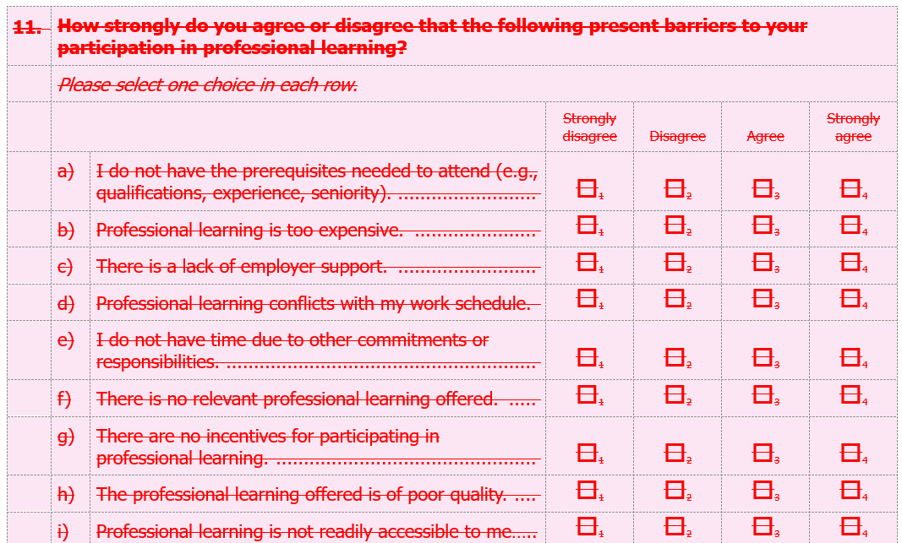
Reason for change: Dropped by the TALIS Governing Board at a special session.
5. | Item 14 was added to Form B (already contained in Form A) | During your most recent complete calendar week, approximately how many 60-minute hours did you spend in total on tasks related to your job at this school?  Please enter a number.  Hours in total
Reason for change: IEA detected a conflict/inconsistency in TQ Form B relative to TQ Form A with respect to item 14. Item14 had been removed from Form B in the main survey instruments. As a side-effect, “Of this total, ” as the lead-in to TQ_15 no longer fit the flow. In consultation with the OECD and QEG Chair, the solution was to re-insert item 14 instead of adapting sematics of item 15 or any other solution.
6. | OMB language on the title page was updated on all instruments to reflect the approved changes in timing from v.12. | Updated from “The time required to complete this information collection is estimated to average 60 minutes...” to “The time required to complete this information collection is estimated to average 45-60 minutes per teacher.”
Reason for change: The timing change was approved in the v.12 submission. This change is to update the language on the title page (B-1, B-32, B-64, B-104) to match the approved timing change.

TKS - Questionnaire Items and Forms
TKS items are not available for public distribution and therefore the questionnaire forms are not included in Appendix B; TKS instruments are provided by email to OMB for review. For completeness, we have detailed the sole change to the TKS instrument in this change memo.
Table 2. Summary of changes to OMB-Approved TALIS TKS instruments
1. | Item 35 from the teacher questionnaire was also added to all four TKS forms. |  | How many students are currently in this target class?  Please enter a number.  
Reason for change: IEA originally removed this item after the field trial. At the request of countries, they added the item back to the instrument on Nov. 21.
2. | OMB language on the title page was updated on all instruments to reflect the approved changes in timing from v.12. | Updated from “The time required to complete this information collection is estimated to average 60 minutes...” to “The time required to complete this information collection is estimated to average 45-60 minutes per teacher.”
Reason for change: The timing change was approved in the v.12 submission. This change is to update the language on the title page (TKS p.1, p.64, p. 126, p. 189) to match the approved timing change.

