National Teacher and Principal Survey
of 2023-2024 (NTPS 2023-24)

OMB# 1850-0598 v.43

Appendix C
2023-24 NTPS Online Respondent Portal Instrument Details

National Center for Education Statistics
U.S. Department of Education

January 2023

The NTPS Respondent Portal is a web-based interface, the purpose of which is to allow schools to:
- Submit their Teacher Listing Form (TLF) electronically, either by verifying a pre-populated list of teachers, uploading an Excel file, or entering teacher information manually;
- Update school contact information, including the principal and survey coordinator’s names and e-mail addresses;
- Check the status of each questionnaire assigned to the school;
- Request replacement paper questionnaires; and
- Access a resource center to learn about the NTPS and/or get ideas for how to encourage participation within the school.
NTPS instrument screenshots are provided as examples throughout this document. These screenshots are based on the specifications provided to programmers for the development of the 2023-24 NTPS Respondent Portal.

NTPS Respondent Portal Instrument Pages

Item: Login
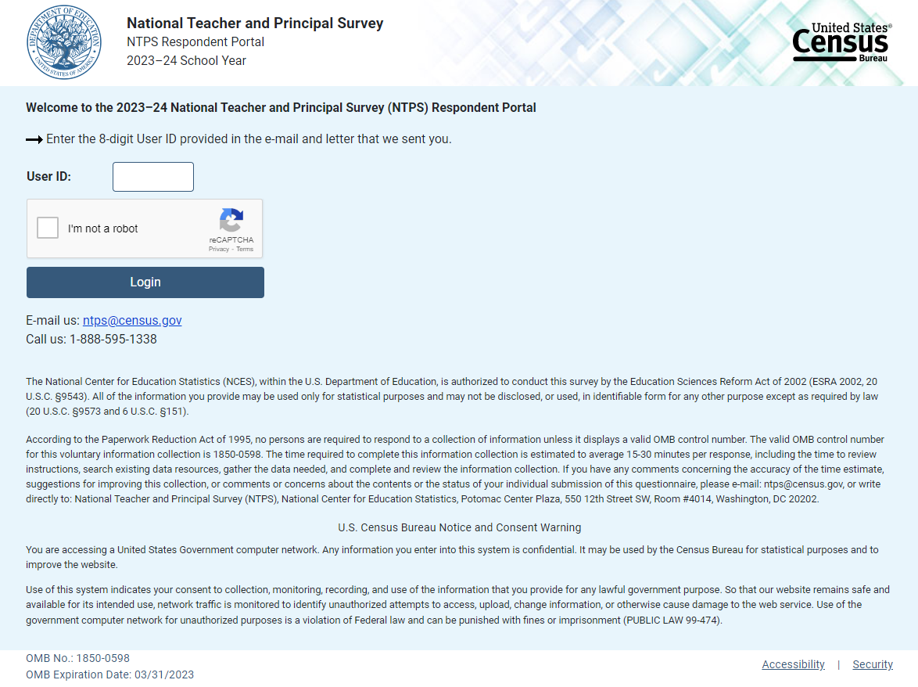

35

Item: PIN
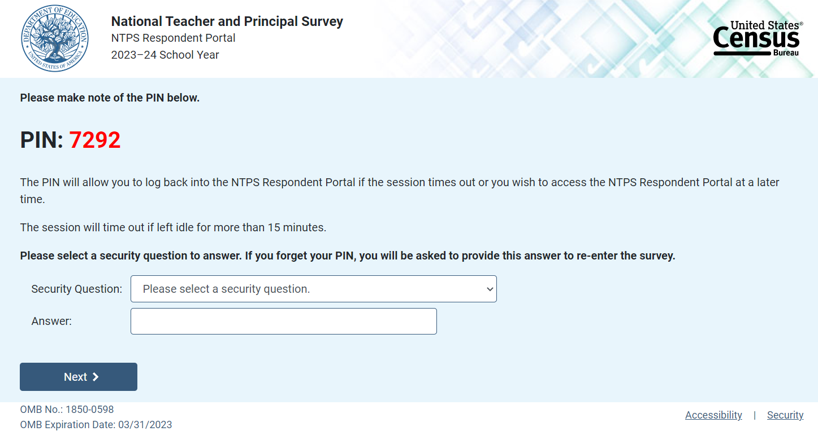

Item: Recovery
If the respondent attempts to re-enter the instrument and does not know their PIN, (s)he may reset the PIN by answering the security question set upon initial login.

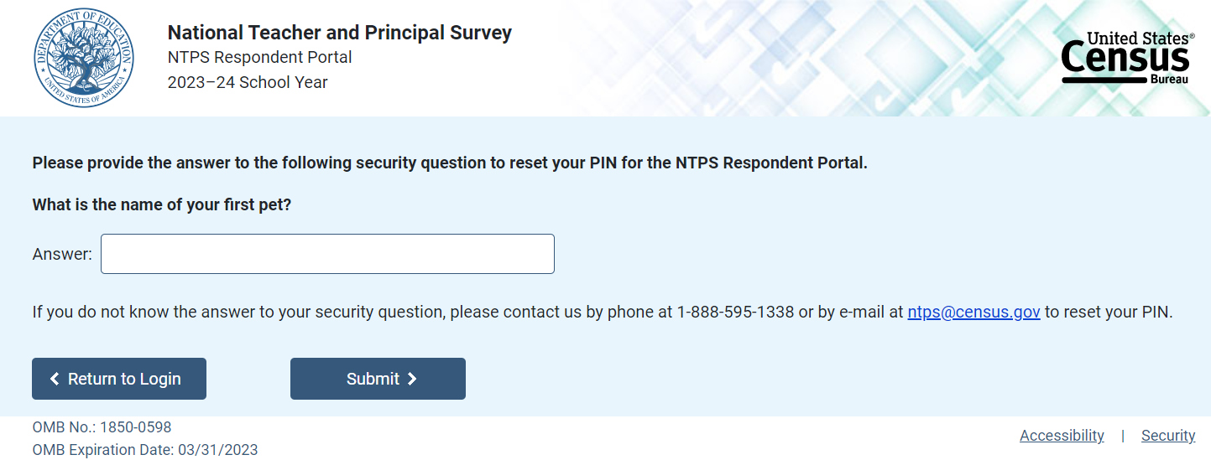

If the respondent answers the security question correctly, (s)he is given a new PIN.
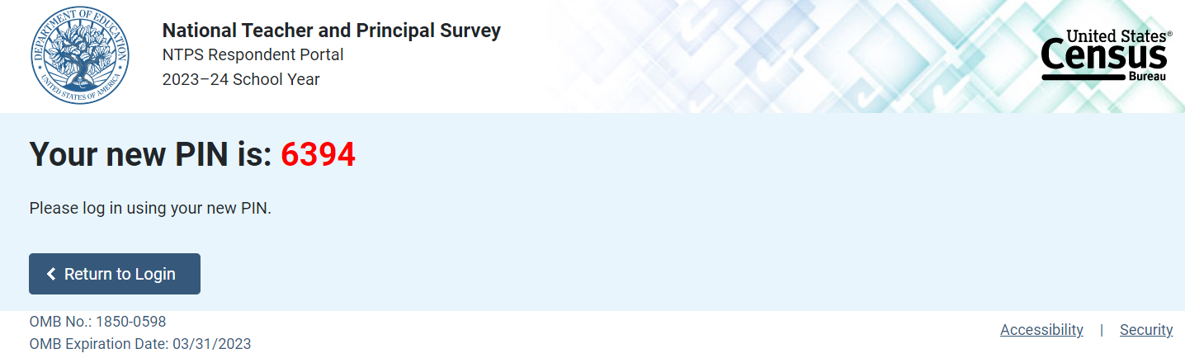

Item: Accessibility
Accessibility is a modal pop-up that will appear over whichever page the respondent was on when (s)he clicked on the “Accessibility” link located on the bottom of the webpage.
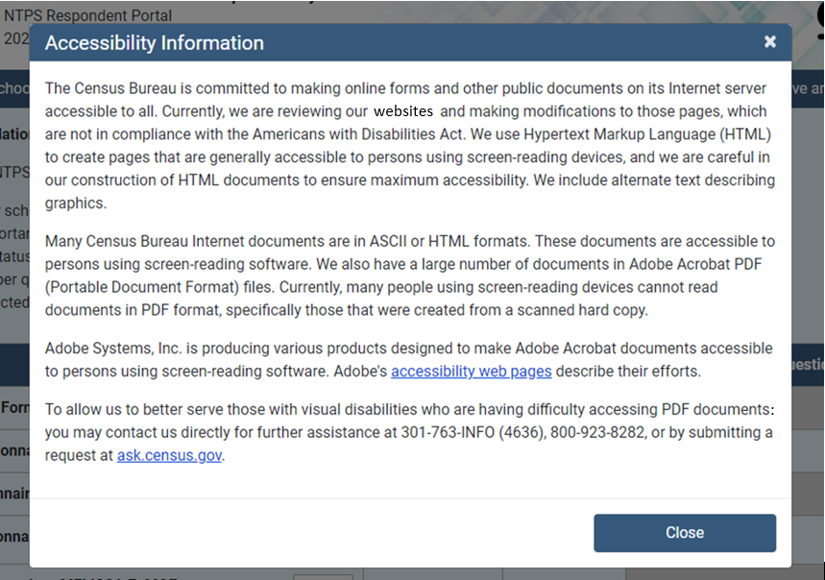

The link (“accessibility web pages”) brings the user to: http://www.adobe.com/accessibility/products/acrobat.html and the user sees this:

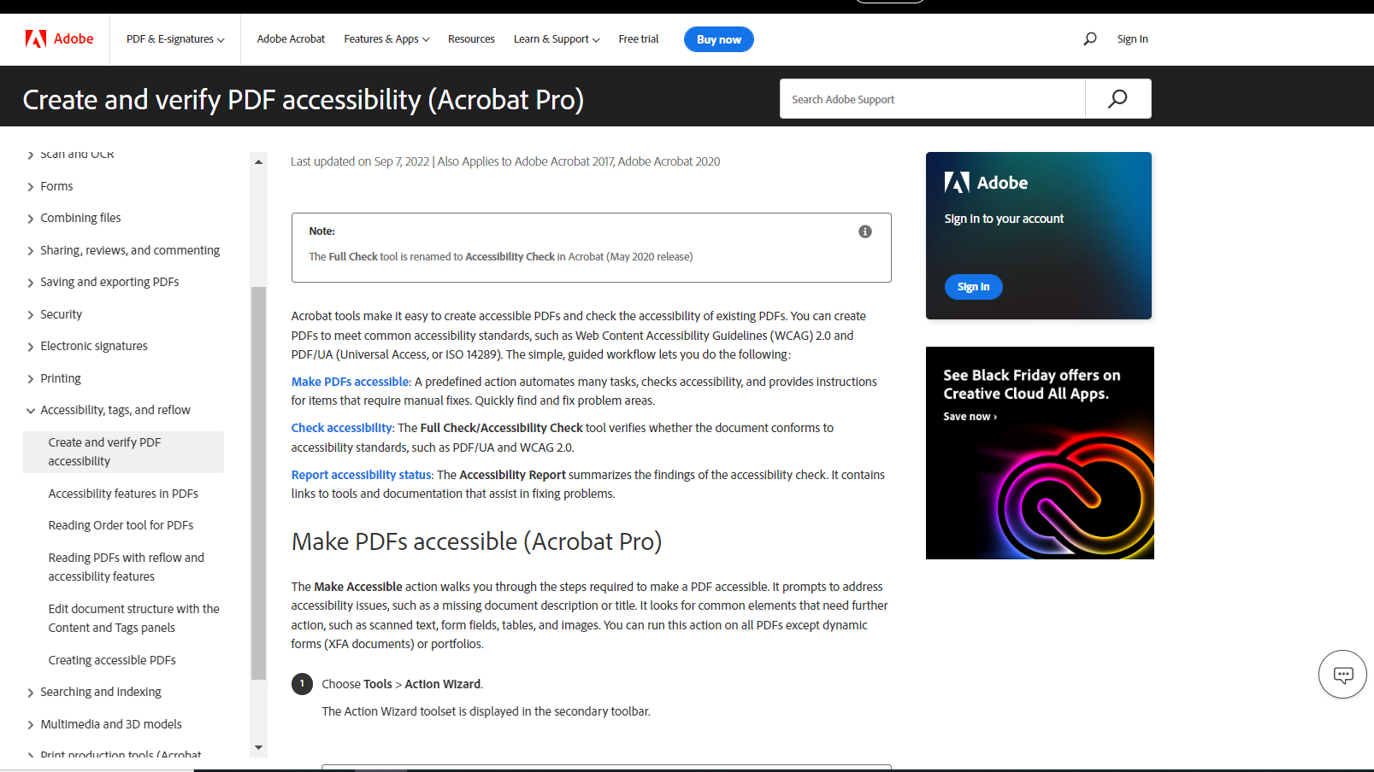

Item: Security
Security is a modal pop-up that will appear over whichever page the respondent was on when (s)he clicked on the “Security” link located on the bottom of the webpage.
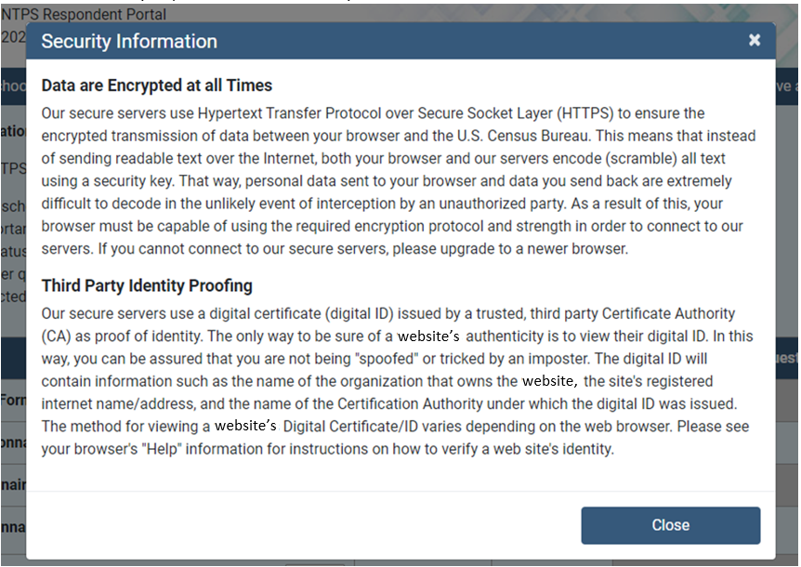

Item: Contact Us
Contact Us is a modal pop-up that will appear over whichever page the respondent was on when (s)he clicked on “Contact Us” in the menu bar.
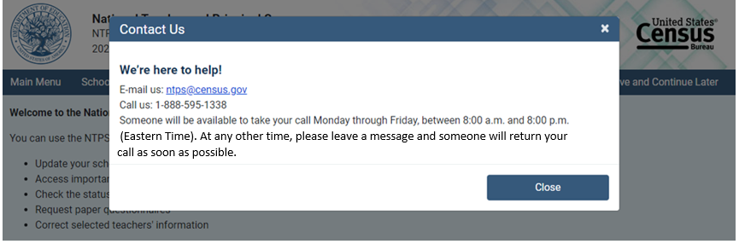

NTPS Respondent Portal

Item: Main Menu
The following image is a mock-up of the Respondent Portal main menu before teachers are sampled for the survey.
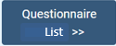
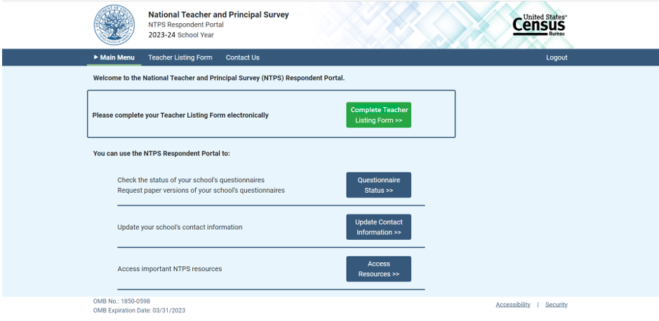
.

The following image is a mock-up of the Respondent Portal main menu after teachers have been sampled for the survey.
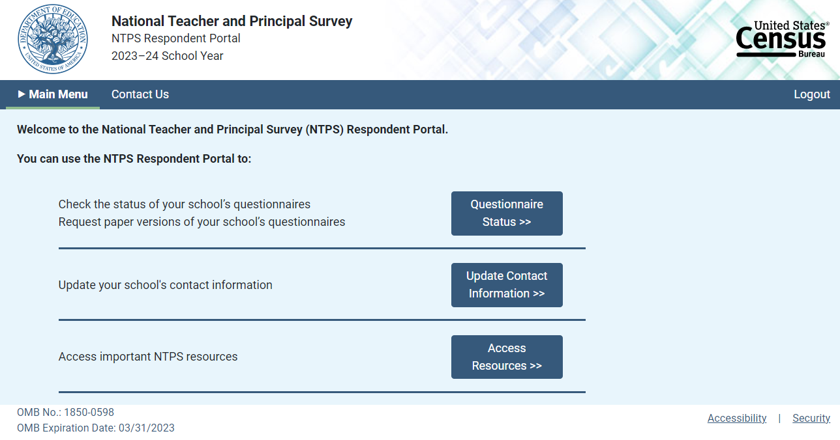

Correct selected teachers’ name or e-mail address

Item: Questionnaire Status
The following image is a mock-up of the questionnaire status page before the Teacher Listing Form has been completed.
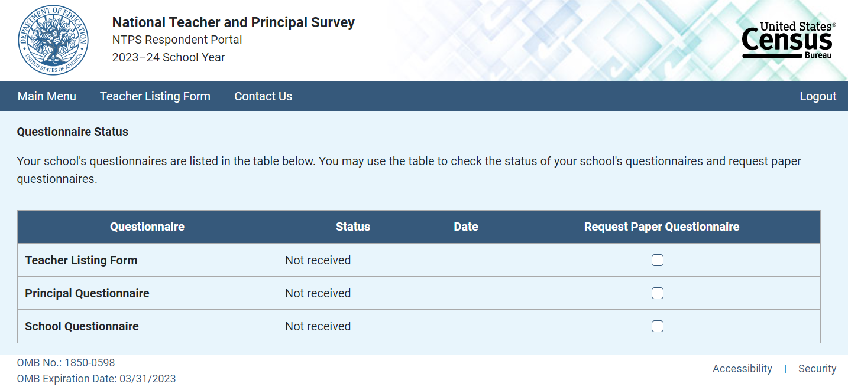

The following image is a mock-up of the questionnaire status page after teachers have been sampled for the survey. The image below is for a school whose teachers are not part of one of the incentive conditions that includes a school-level incentive. Schools whose teachers are part of one of those conditions would also see text here that reminds the school how many teacher responses are needed in order to receive the school-level incentive.

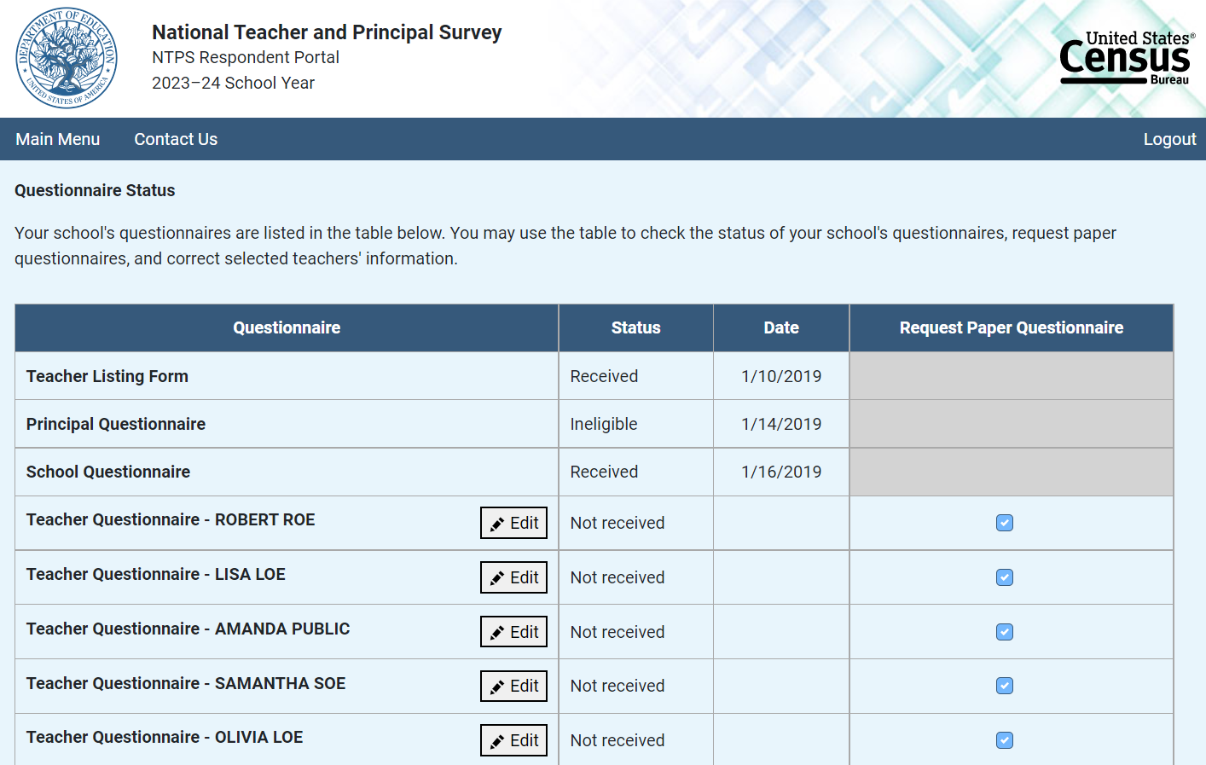
name or e-mail address.

Item: Request Questionnaire
Request Questionnaire is a modal pop-up. The modal text varies based on the questionnaire requested (i.e., the questionnaire name is included in the modal pop-up). The image below is for a Principal Questionnaire request.
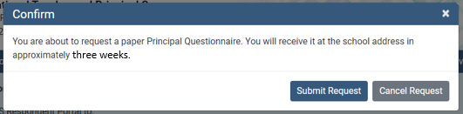

Item: Edit Teacher Information
Edit Teacher Information is a modal pop-up.
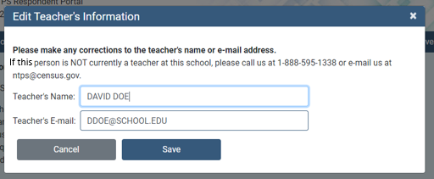

Item: School Contact Information
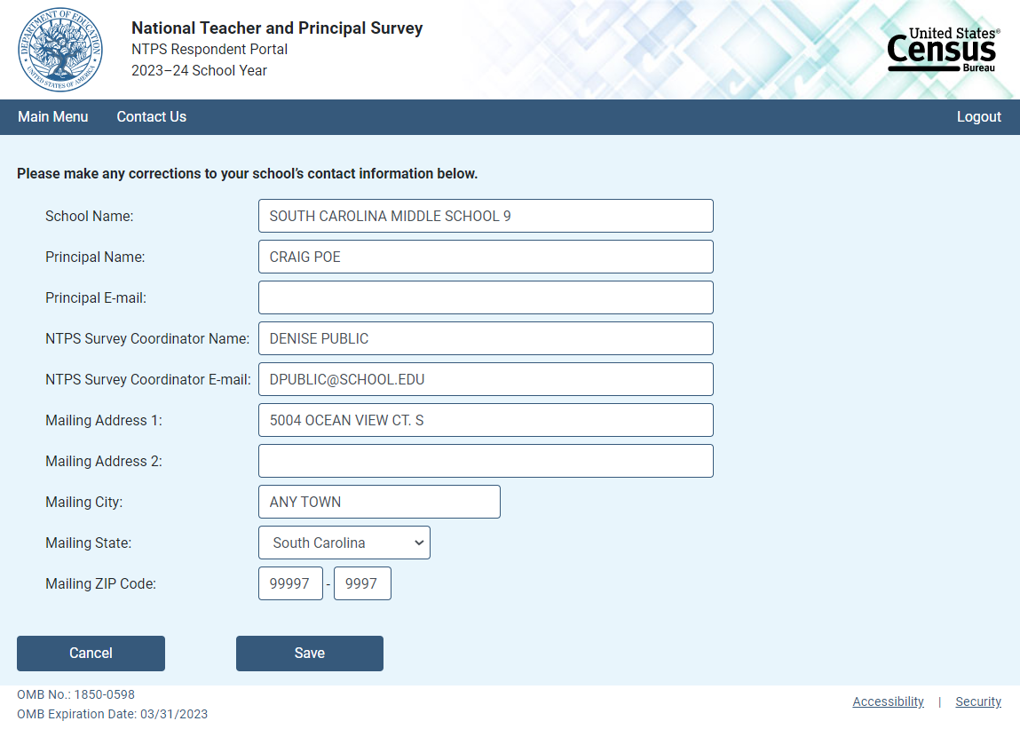

Item: Resources
The following image is a mock-up of the Respondent Portal Resources page.
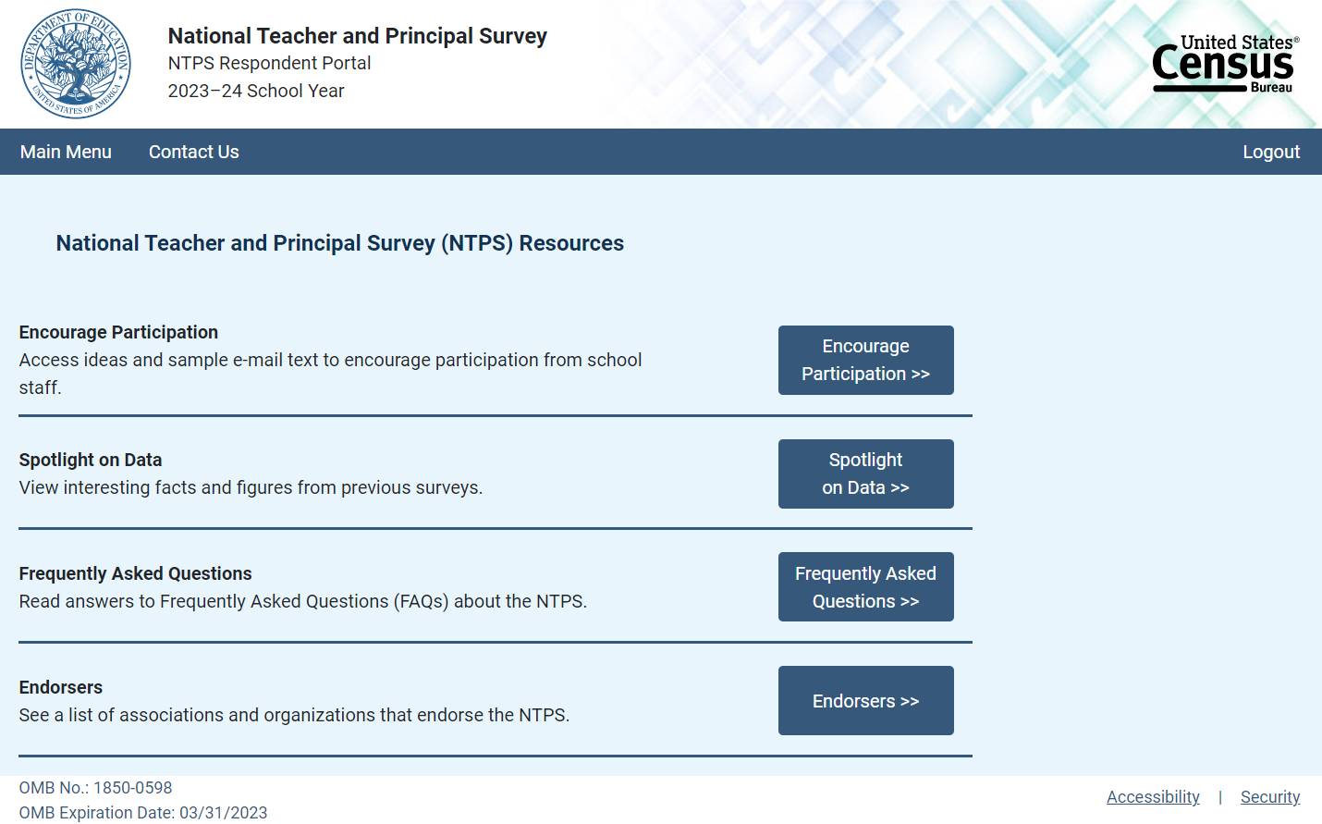

Item: Encourage Participation
Encourage Participation is a modal pop-up that will appear over the Resources page.
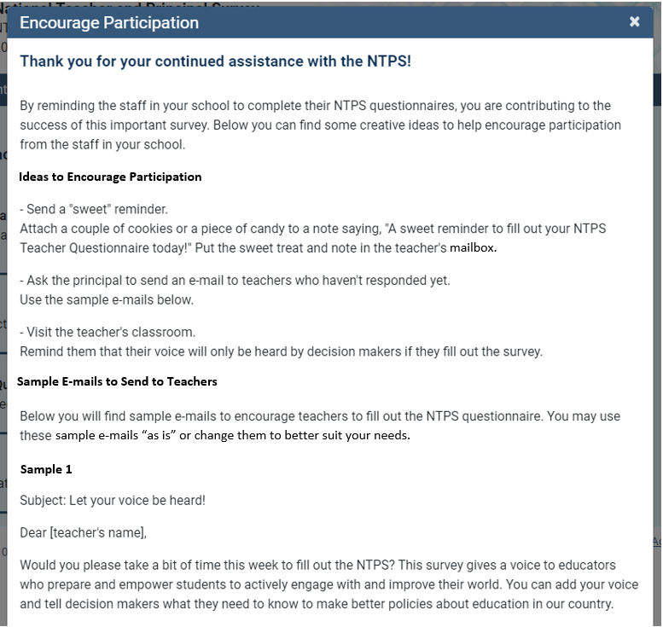

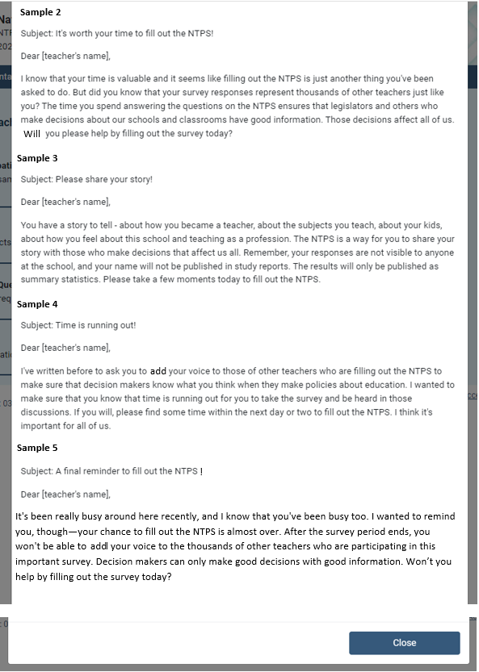
Will you
add

Item: Spotlight on Data
Spotlight on Data is a modal pop-up that will appear over the Resources page.
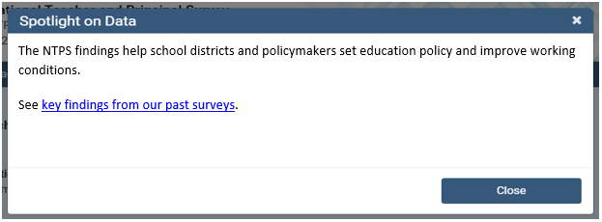

Item: Frequently Asked Questions
Frequently Asked Questions is a modal pop-up that will appear over the Resources page. The complete text for the Frequently Asked Questions modal is provided below the image. A “Go back to FAQ list” link is provided below the response to each question; this link returns the respondent to the top of the modal.
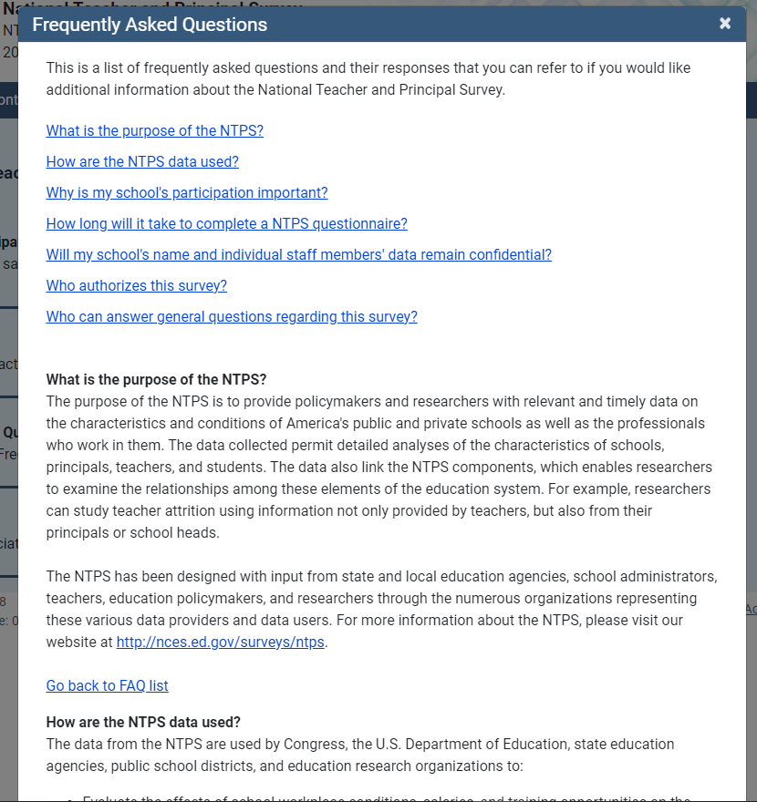
What is the purpose of the National Teacher and Principal Survey (NTPS)?

The purpose of the NTPS is to provide policymakers and researchers with relevant and timely data on the characteristics and conditions of America’s public, charter, and private K–12 schools and the professionals who work in them. The data collected permit detailed analyses of the characteristics of schools, principals, teachers, and students. The data also link NTPS findings across questionnaires, including the follow-up questionnaires, which enable researchers to examine the relationships among multiple elements of the education system. For example, researchers can study the relationship between principal years of experience and teacher job satisfaction or teacher attrition and school climate.

The NTPS has been designed with input from state and local education agencies, school administrators, teachers, education policymakers, and researchers through the numerous organizations representing these various data providers and data users. For more information about the NTPS, please visit our website at http://nces.ed.gov/surveys/ntps.

Text:
This is a list of frequently asked questions and their responses that you can refer to if you would like additional information about the National Teacher and Principal Survey.
What is the purpose of the National Teacher and Principal Survey (NTPS)?
How are the NTPS data used?
Why is my school’s participation important?
How long does it take to complete a NTPS questionnaire?
Will my school’s and individual staff members’ data remain confidential?
Who authorizes this survey?
Who can answer general questions regarding this survey?

What is the purpose of the NTPS?
The purpose of the NTPS is to provide policymakers and researchers with relevant and timely data on the characteristics and conditions of America’s public, charter, and private K–12 schools and the professionals who work in them. The data collected permit detailed analyses of the characteristics of schools, principals, teachers, and students. The data also link NTPS findings across questionnaires, including the follow-up questionnaires, which enable researchers to examine the relationships among multiple elements of the education system. For example, researchers can study the relationship between principal years of experience and teacher job satisfaction or teacher attrition and school climate.

The NTPS has been designed with input from state and local education agencies, school administrators, teachers, education policymakers, and researchers through the numerous organizations representing these various data providers and data users. For more information about the NTPS, please visit our website at http://nces.ed.gov/surveys/ntps.

How are the NTPS data used?
The data from the NTPS are used by Congress, the U.S. Department of Education, state education agencies, public school districts, and education research organizations to:
- Evaluate the effects of school workplace conditions, salaries, and training opportunities on the educational workforce;
- Assess school staffing practices and personnel policies;
- Aid in the Department of Education’s program planning in the areas of teacher shortage, teaching policies, and teacher education;
- Measure teacher and principal attrition and retention through follow-up surveys.

Why is my participation important?
This survey is a primary source of information about what is happening in K–12 schools across the United States from the perspective of administrators and teachers. Only a small percentage of schools are selected to participate; therefore, your school is important for the success of this survey.

How long will it take to complete a NTPS questionnaire?
While the surveys will vary in length, each questionnaire will take approximately 15 to 40 minutes to complete.

Will my school’s and individual staff members’ data remain confidential?
Yes, both the U.S. Department of Education and the U.S. Census Bureau follow strict procedures to protect the confidentiality of study participants. All of the information you provide may be used only for statistical purposes and may not be disclosed, or used, in identifiable form for any other purpose except as required by law (20 U.S.C. §9573 and 6 U.S.C. §151). In addition, your responses to the survey questions will not be shared with any of your school staff or administration. Participation is voluntary, but responses are necessary to make the results of this study accurate and timely.

Who authorizes this survey?
The National Center for Education Statistics (NCES), within the U.S. Department of Education, is authorized to conduct this survey by the Education Sciences Reform Act of 2002 (ESRA 2002, 20 U.S.C. §9543). The U.S. Census Bureau will administer this survey on behalf of the NCES. The Office of Management and Budget (OMB) approved this survey. The OMB control number is 1850-0598 and the approval expiration date is XX/XX/XXXX.

Who can answer general questions regarding this survey?
The U.S. Census Bureau can answer any questions you have about the survey. Staff can be reached by phone at 1-888-595-1338, Monday through Friday, between 8:00 a.m. and 8:00 p.m. (Eastern Time). At any other time, please leave a message and someone will return your call as soon as possible. The U.S. Census Bureau is also available to answer your questions via e-mail at ntps@census.gov.

[Close button]

Item: Endorsers
Endorsers is a modal pop-up that will appear over the Resources page. Endorsements have not yet been solicited; therefore, the text is currently a place-holder.
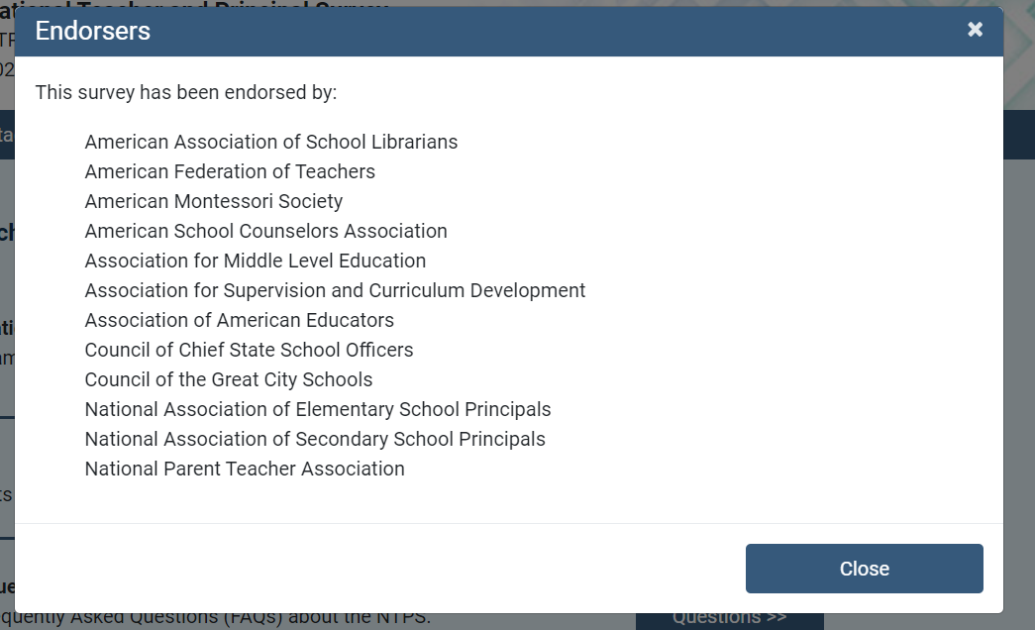

NTPS Respondent Portal – Teacher Listing Form (TLF)

TLF Page: Teacher Listing Form Instructions
The Teacher Listing Form Instructions are accessible by clicking “Click here for detailed instructions” on the Upload page or by clicking “Click here for important information about the other staff that may teach at this school…” on the Summary page.
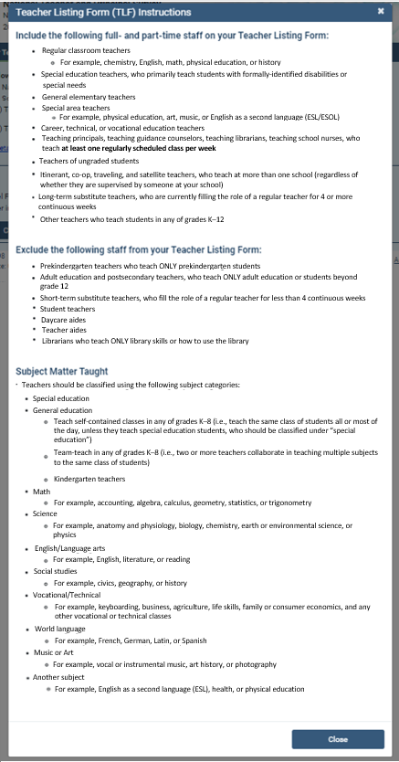

TLF Page: Provide a TLF
Respondents in schools that do not have a pre-populated Teacher Listing Form are given two options to complete their Teacher Listing Form, as shown below.
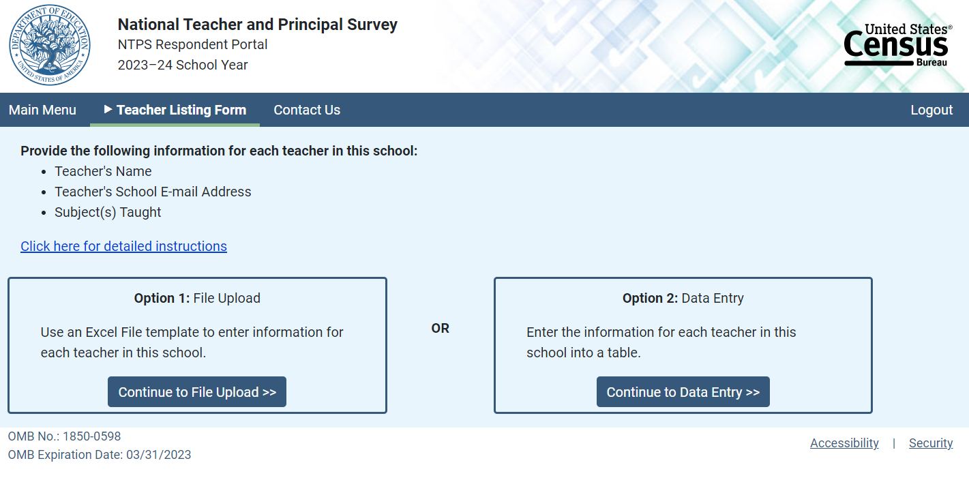

When the respondent clicks “Click here for detailed instructions,” the Teacher Listing Form instructions modal pop-up opens on the screen. When the respondent clicks the button for “Option 1: File Upload”, (s)he is directed to the File Upload page. When the respondent clicks the button for “Option 2: Data Entry”, (s)he is directed to the Summary page.

TLF Page: File Upload
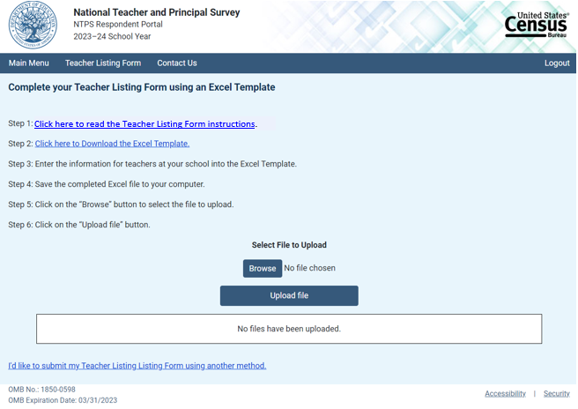

Upload File

When the respondent clicks “Click here to Download the Excel Template,” the Excel template is as follows:
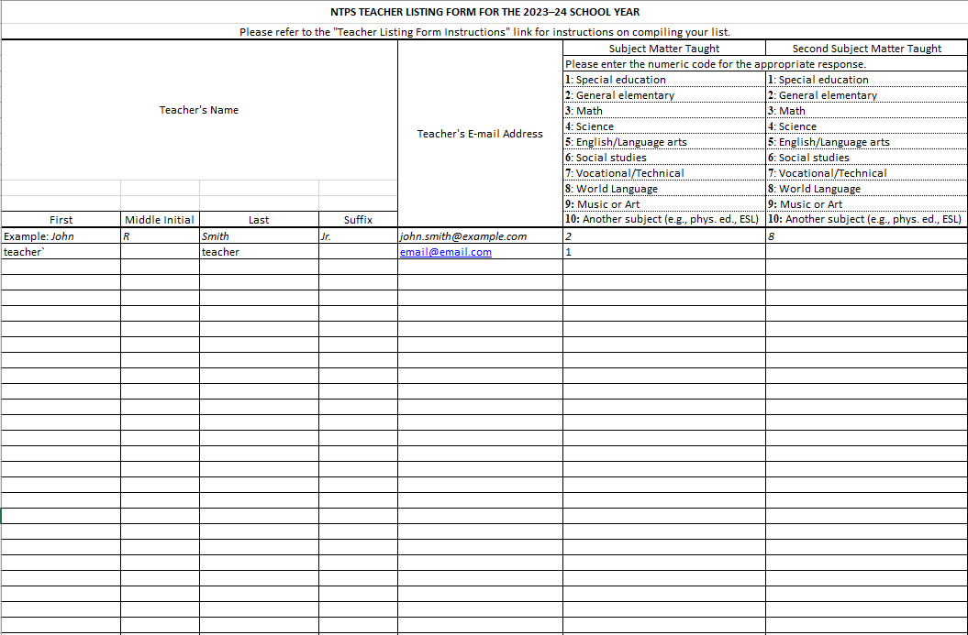

Once the respondent has uploaded a file using the “Browse” and “Upload file” buttons, the file is listed in the box on the page, as shown below. Respondents who use the template may either review or submit their Teacher Listing Form from this page. Respondents who click “Review the Teacher Listing Form” are directed to the Summary page.
Review or Submit
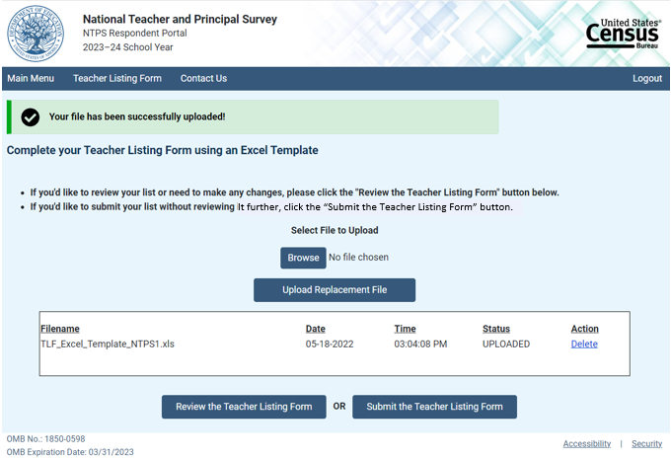

Respondents who do not use the template or whose data in the template were not able to be parsed are able to submit their Teacher Listing Form by clicking on “Submit the Teacher Listing Form”, but cannot review it.

Submit Only
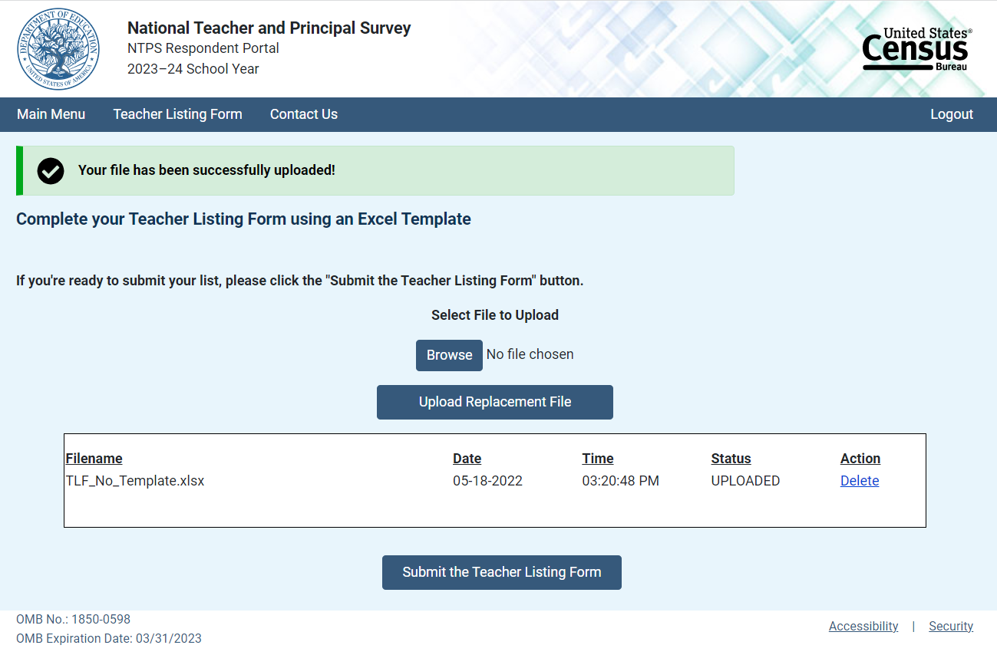

Submit the Teacher Listing Form

Clicking on “I’d like to submit my Teacher Listing Form using another method” directs the respondent to the Summary page.

TLF Page: Summary
Respondents in schools with a pre-populated Teacher Listing Form are asked to review and confirm the pre-populated list. When they enter the Summary page, they receive the following modal pop-up over the Summary page shown below:
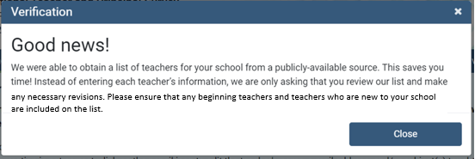

Respondents in schools with a pre-populated Teacher Listing Form or who successfully upload teachers using the Excel template will see a list of their entered teachers on the Summary page:
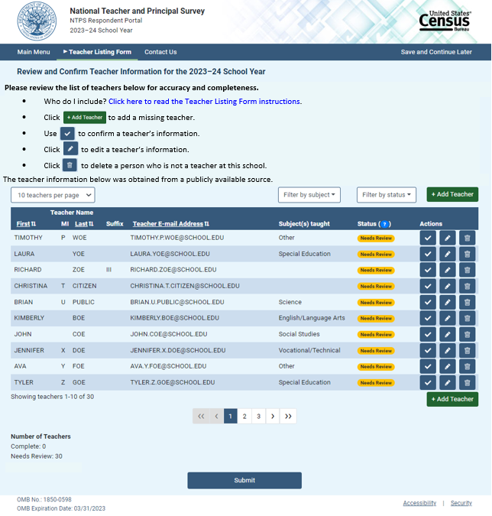

Submit
When the respondent clicks “Click here to read the Teacher Listing Form instructions,” the Teacher Listing Form instructions modal pop-up opens on the screen.

The formatting of the teacher rows changes as the respondent confirms or deletes teachers, as shown below:
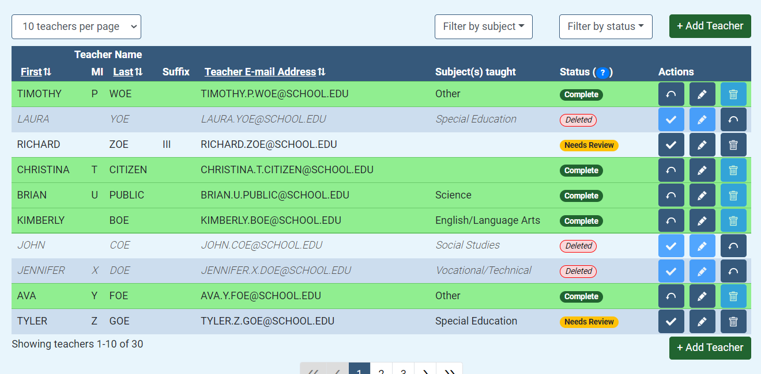

Clicking on the “Add Teacher” button opens the following modal pop-up:
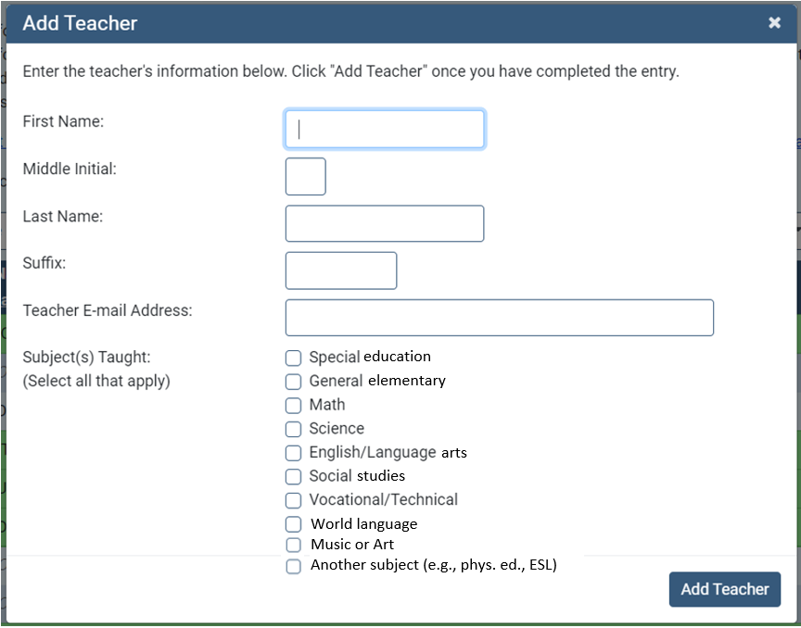
Clicking on the pencil icon (“Edit Teacher”) opens the following modal pop-up:
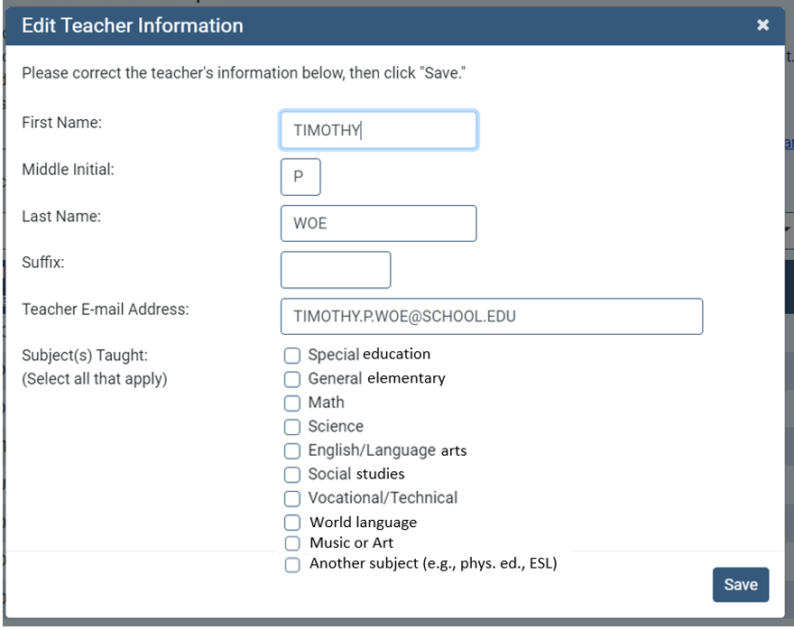
Clicking on the “?” next to Status in the table header opens the following modal pop-up:
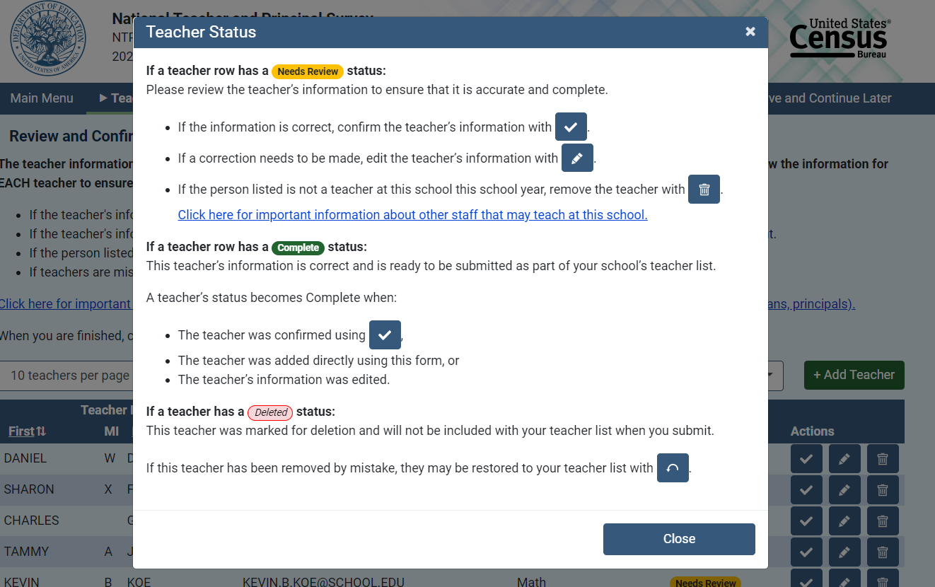
Respondents in schools without a pre-populated list are able to enter their teacher information onto the Summary page:
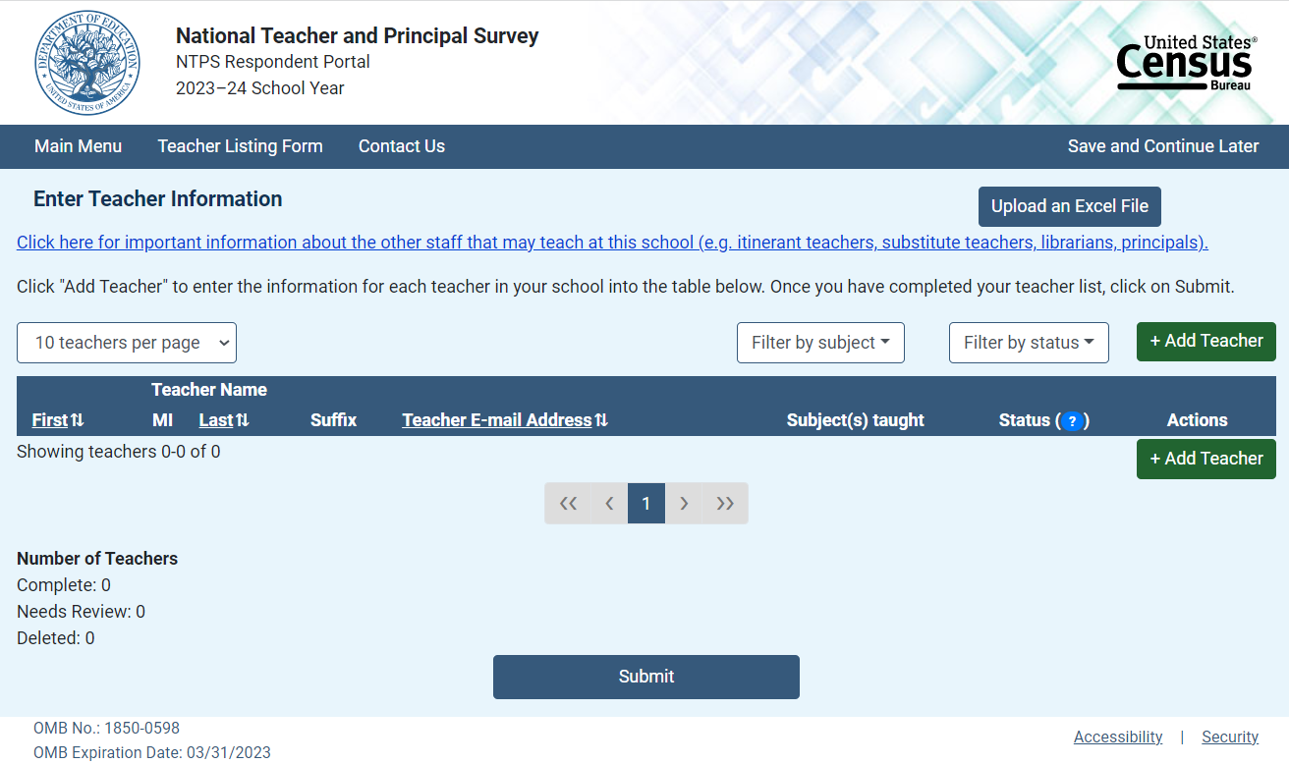
“Submit”.

Clicking on the “Upload an Excel File” directs the respondent to the Upload File page. If they have entered teacher information, they receive the following warning message:
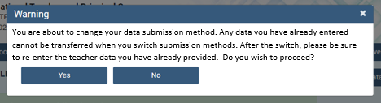

TLF Page: TLF Contact
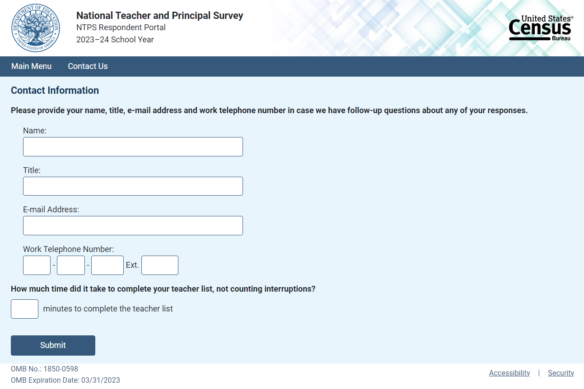

TLF Page: Thank You
