**OMB Instrument Form for Generic Citizen Science ICRs**

**Burden Statement:**

This collection of information is approved by OMB under the Paperwork Reduction Act, 44 U.S.C. 3501 et seq. (OMB Control No. 2080-0083). Responses to this collection of information are voluntary. This research is conducted to support efforts to restore living resources in the Chesapeake Bay ecosystem under the Clean Water Act (CWA) Section 117, 33 USC Section 1267. An agency may not conduct or sponsor, and a person is not required to respond to, a collection of information unless it displays a currently valid OMB control number. The public reporting and record keeping burden for this collection of information is estimated to range from 5-10 minutes per response. Send comments on the Agency’s need for this information, the accuracy of the provided burden estimates and any suggested methods for minimizing respondent burden to the Regulatory Support Division Director, U.S. Environmental Protection Agency (2821T), 1200 Pennsylvania Ave., NW, Washington, D.C. 20460. Include the OMB control number in any correspondence. Do not send the completed form to this address.

**Information and Packet for Meeting Participants**

**How do the People of Crisfield feel about their Natural Spaces and Coastal Environment?**

**Overview:**

The US Environmental Protection Agency’s Office of Research and Development (US EPA ORD) is partnering with Crisfield, Maryland to better understand the community’s challenges and goals, and work together to co-develop research and methods around the potential use of natural infrastructure, or ‘nature-based solutions’, such as marsh restoration, dune restoration, or living shorelines, for protection from coastal flooding and associated natural resource benefits to community health and wellbeing.

We will be discussing the following questions as a group. You can also choose to provide your own written answers here if you prefer, or in addition to any discussion. All responses are voluntary. Both written and verbal responses will be treated anonymously.

**Question 1a**. Which neighborhood in the Crisfield area do you live or work, or do you come from outside of the Crisfield area?

Please mark an X next to the neighborhoods where you live and/or work. Refer to Map #1 for neighborhoods.

|  |  |  |
| --- | --- | --- |
|  | Primary Residence | Primary Work Location |
| Box Iron Area |  |  |
| Byrdtown |  |  |
| Cove Street |  |  |
| Daughertytown |  |  |
| Downtown Condos |  |  |
| Hammock Pointe |  |  |
| Hopewell |  |  |
| Lawsonia |  |  |
| Mariners |  |  |
| Marion Station |  |  |
| Myrtle Street Area |  |  |
| N. Somerset Avenue |  |  |
| S. Somerset Avenue |  |  |
| Outside of the Crisfield Area  Please list the town or city. |  |  |

**Question 1b**. What motivated you to want to be a part of the discussion today?

**Question 2a**. What are the natural habitats or green space that contribute most to the unique character of Crisfield?

Please place an X next to the top (5-10) habitats or greenspaces you consider most important to Crisfield. Please note any more specific information about why you selected each.

|  |  |  |
| --- | --- | --- |
| **Habitat or Greenspace** | **Most Important** | **More specific details or specific location?** |
| Open Water in the Bay |  |  |
| Rivers and Streams |  |  |
| Lakes and Ponds |  |  |
| Beaches and Dunes |  |  |
| Eelgrass, Seagrass, Aquatic Vegetation |  |  |
| Rocky Shoreline |  |  |
| Tidal flats or mudflats |  |  |
| Salt marsh |  |  |
| Freshwater wetlands |  |  |
| Forests |  |  |
| Agricultural Pasturelands |  |  |
| Agricultural Croplands |  |  |
| City greenspaces (Parks, Landscaping) |  |  |
| Other (Please Explain) |  |  |

**Question 2b**. Where are the natural habitats or greenspaces that contribute to the unique character of Crisfield?

Please circle on the map natural areas and greenspace you think are most important to Crisfield. Please write-in any important natural areas or green spaces that you think are missing.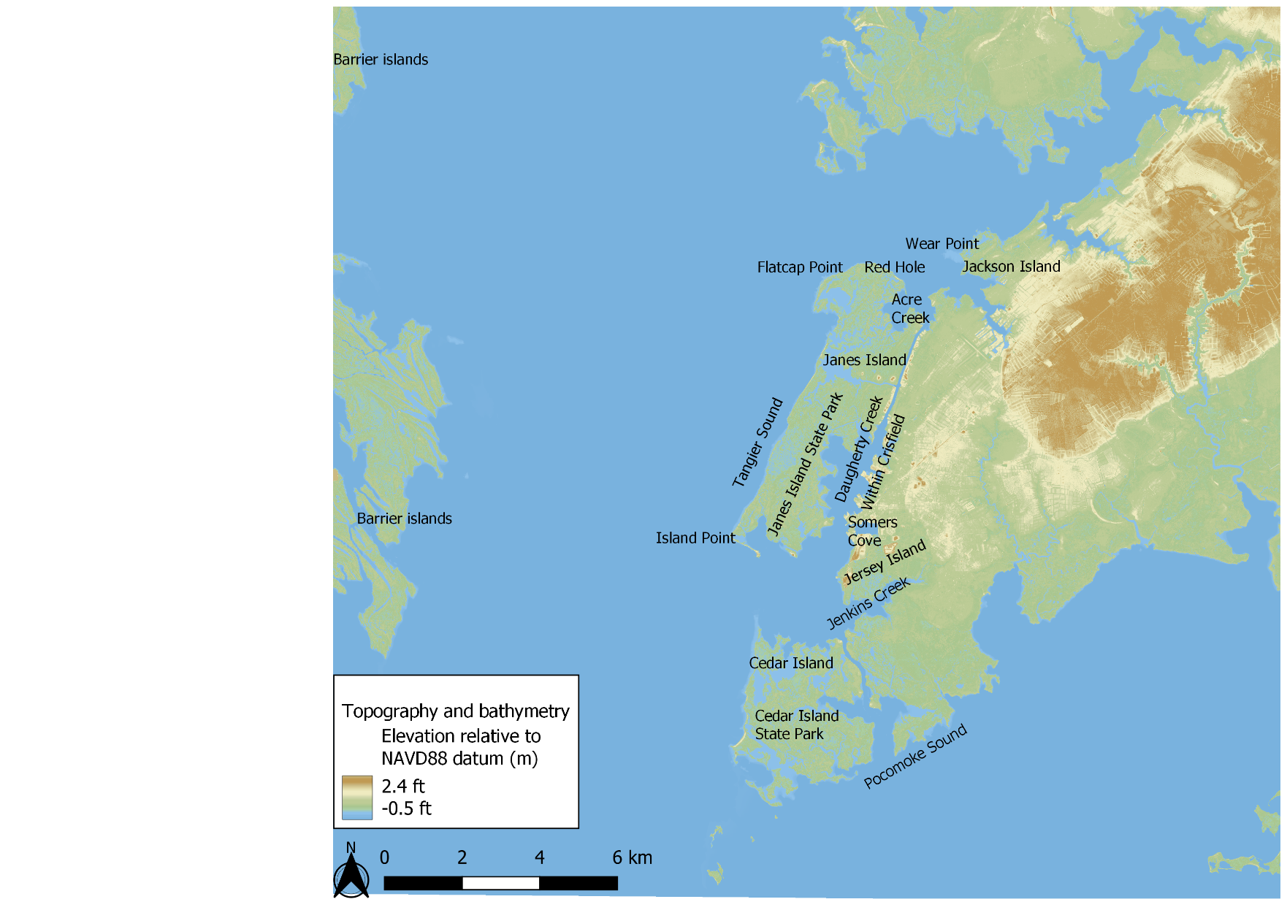

**Question 3a**. How have these natural spaces changed in your lifetime, and what impacts have those changes had on the Crisfield community?

**Question 3b**. What organizations, or business, or neighborhoods have been most impacted by these changes in green spaces in and around Crisfield?

**Question 4**. How do the people of Crisfield use or interact with natural habitats and green spaces? Why do they care about these spaces?

Place an X next to the top (5-10) natural resource users you consider most important to the character of Crisfield. Please note any more specific details about what or why natural spaces matter to them.

| **Type of Natural Resource User** | | **Most Important** | **What natural spaces do they use or care about?** |
| --- | --- | --- | --- |
| **Agricultural** | Livestock Grazers |  |  |
| Agricultural Processors |  |  |
| Aquaculture (farming aquatic fauna) |  |  |
| Farmers (such as crops, orchards) |  |  |
| Forestry; Silviculture |  |  |
| **Commercial / Industrial** | Food Extractors (fishing, hunting, or trapping of edible organisms for commercial purposes) |  |  |
| Timber / Fiber / Ornamental Extractors (such as logging, shell collection for commercial purposes) |  |  |
| Industrial Processors (such as manufacturing, mills, oil and gas) |  |  |
| Private Energy Generators (such as power plants, hydroelectric dams, wind turbines, solar) |  |  |
| Pharmaceutical / Food Supplement Suppliers (use of nature-derived ingredients in medicines, vitamins) |  |  |
| Trappers / Hunters of Fur or Hides for commercial purposes |  |  |
| Commercial Property Owners (private owners of commercial or industrial property) |  |  |
| Private Water Plant Operators (drinking or other uses) |  |  |
| **Governmental / Municipal / Residential** | Municipal Water Plant Operators (drinking or other uses) |  |  |
| Public Energy Generators (such as power plants, hydroelectric dams, wind turbines, solar) |  |  |
| Residential Property Owners (homeowners; landowners) |  |  |
| Military / Coast Guard (infrastructure, training activities) |  |  |
| Public Sector Property Owners (government owned property or land) |  |  |
| **Transportation** | Transporters of Goods (shipping of cargo by planes, trains, ships, trucks) |  |  |
| Transporters of People (cruises, ferries, airports, trains, harbors) |  |  |
| **Subsistence or Traditional / Tribal Uses (‘Living Off the Land’)** | Water Subsistence (such as wells, cisterns, rain gardens, rain barrels) |  |  |
| Food and Medicinal Subsistence (hunting, fishing, or gathering as a major source to fill nutrition or medical needs) |  |  |
| Timber / Fiber / Ornamental Subsistence (such as firewood or clothing materials) |  |  |
| Building Material Subsistence (relies on natural materials for housing needs) |  |  |
| **Recreational** | Experiencers / Viewers (such as bird or wildlife watching, hiking, biking, camping, sightseeing, sunbathing) |  |  |
| Food Pickers / Gatherers (such as berry picking, mushroom gathering, clam digging for recreation) |  |  |
| Hunters (for recreation or sport) |  |  |
| Fishing (for recreation or sport) |  |  |
| Waders / Swimmers / Divers (SCUBA, snorkeling) |  |  |
| Boaters (such as sailboats, jet skis, speed boats, kayaks, surfboards) |  |  |
| **Inspirational** | Spiritual and Ceremonial Participants (such as festivals, tribal or religious ceremonies) |  |  |
| Artists (such as writers, painters, sculptors, cinematography, music) |  |  |
| **Learning** | Students and Educators (such as field trips, outdoor labs) |  |  |
| Researchers (scientific research) |  |  |
| **Non-Use** | People Who Care (preserve for ethical reasons or future generations) |  |  |
| **Others Not Listed Here** |  |  |  |

**Question 5**. Thinking about the top types of natural resource users identified in the previous question, what specific characteristics of natural habitat or greenspace do you think are most important to them, and the people of Crisfield in general?

Which of the following Environmental Attributes are most important to the top natural resource users identified in question 4? What specific characteristics do these user groups care most about?

| **Category** | **Examples** | **Important to Which Types of Users?** | **What specifically (such as type, species, location) is most important?** |
| --- | --- | --- | --- |
| Atmosphere | Air quality, wind, sunlight, temperature, precipitation, humidity |  |  |
| Soil and Substrate | Mud, clay, organic matter, stones, rocks |  |  |
| Water | Surface water, ground water, water quality, water quantity, water movement |  |  |
| Fauna | Fauna diversity, edible fauna, charismatic or rare fauna, pollinators, pest predators, commercially or culturally important fauna |  |  |
| Flora | Flora diversity, edible or medicinal flora, charismatic or rare flora, commercially or culturally important flora |  |  |
| Fungi | Fungal diversity, edible or medicinal fungi, charismatic or rare fungi, commercially or culturally important fungi |  |  |
| Other Natural Materials | Fuel, fiber, minerals, driftwood, shells, acorns, honey |  |  |
| Site Appeal | Sounds, scents, scenic views, natural phenomena, open spaces, ecological condition |  |  |
| Extreme Events | Flood protection, wildfire suppression, storm surge reduction, wave breaking, erosion control |  |  |
| Other Not Listed Here |  |  |  |

**Question 6.** Would you like to see these natural resources and their impacts to the people of Crisfield change in the future in any way? If so, how?

**Question 7.**  Nature-based solutions have been implemented in other communities to help improve resilience to flooding by buffering against storm surge and protecting the coastline from erosion.

How might nature-based solutions such as the ones below benefit the top natural resources and natural resource users you just identified as important to Crisfield? Are there other actions that might do a better job to preserve or protect the natural resources you identified as important to Crisfield?

|  |  |  |
| --- | --- | --- |
| **Natural Infrastructure** | **Explanation** | **Potential impacts to Crisfield’s top natural resources and natural resource users?** |
| Artificial reefs | A manmade structure that promotes habitat for oysters or other species |  |
| Beach nourishment | Placing additional sediment on a beach or nearshore, to mimic or enhance a natural shoreline |  |
| Dune restoration | Build up of dunes via beach restoration and addition of native vegetation |  |
| Living berms | Raised, vegetated barriers along the beach to help prevent flooding |  |
| Living shoreline | A protected or stabilized shoreline made of natural materials such as plants, sand, or rock |  |
| Marsh restoration | Actions to return natural function to a degraded wetland, or establish new acres of wetland habitat |  |
| Oyster reefs | Establishment or enhancement of oyster aggregations |  |
| Restoration of barrier islands | Actions to restore geographic features and vegetation of barrier islands |  |
| Seagrass restoration | Actions to restore or enhance density or acres of submerged aquatic vegetation |  |
| Other actions? |  |  |

**REFERENCE MATERIAL**

**Reference Material #1**  Map of Crisfield community neighborhoods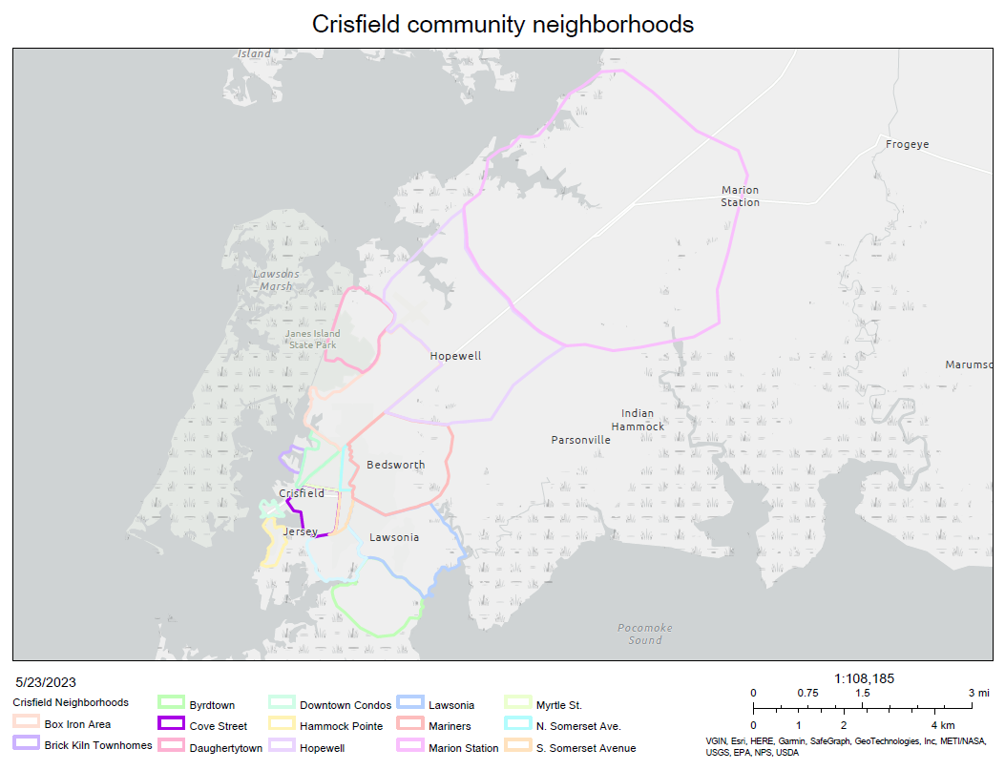

**Reference Material #2**. List of Natural Resource Users

| Category | Subcategory | Definition |
| --- | --- | --- |
| Agricultural | Livestock Grazers | Uses the environment to graze livestock |
| Agricultural Processors | Cleans edible products |
| Aquaculturalists | Farms aquatic fauna (e.g., fish, shrimp, oysters) |
| Farmers | Farms terrestrial or aquatic flora (e.g., crops, orchards) |
| Foresters | Plants and raises trees (i.e., silviculture) |
| Commercial / Industrial | Food Extractors | Uses the natural abundance of edible organisms (e.g., hunting, trapping, or fishing for livelihood, job, commercial, or artisanal purposes) |
| Timber / Fiber / Ornamental Extractors | Extracts or harvests timber, fiber, wood, or ornamental extraction or harvest for commercial or business purposes (e.g., logging, shell collection) |
| Industrial Processors | Uses natural resources in industrial processing such as manufacturing (e.g., textile or steel industries), mills, or oil and gas extraction and processing) |
| Energy Generators | Uses the environment for energy production or placement of power generation structures includes power plants (electric and nuclear), dams, turbines (wind, water, or wave), solar |
| Pharmaceutical / Food Supplement Suppliers | Collects organisms from nature that are used for pharmaceuticals, medicines, food supplements, or vitamins for commercial sale |
| Fur / Hide Trappers / Hunters | Hunts or traps fauna for fur or hides for commercial sale |
| Commercial Property Owners | Owners of private land for commercial or industrial purposes |
| Private Drinking Water Plant Operators | Provides water for private purposes |
| Governmental / Municipal / Residential | Municipal Drinking Water Plant Operators | Provides water for the Community |
| Public Energy Generators | Uses the environment for energy production or placement of power generation structures for the community, includes power plants (electric and nuclear), dams, turbines (wind, water, or wave), solar panels, and geothermal systems |
| Residential Property Owners | Homeowners of private land |
| Military / Coast Guard | Uses the environment for placement of infrastructure or training activities |
| Public Sector Property Owners | Uses or benefits from the environment as an owner of property and in a way not specified in other government, municipal, and residential subclasses. |
| Transportation | Transporters of Goods | Uses the environment to transport goods (e.g., shipping, cargo, commercial navigation, barges, freight, planes, trains) |
| Transporters of People | Uses the environment to transport people (e.g., cruises, ferries, airplanes, airports, trains, harbors) |
| Subsistence | Water Subsisters | Relies on natural sources for water including drinking water and tribal or traditional uses (may use wells, cisterns, rain gardens, rain barrels, etc.) |
| Food and Medicinal Subsisters | Uses natural sources of edible flora, fauna, and fungi as a major source of food; includes hunting, fishing, and gathering as well as other tribal or traditional uses |
| Timber / Fiber / Ornamental Subsisters | Relies on timber, fiber, or fauna for survival, including tribal or cultural traditions (e.g., firewood) |
| Building Material Subsisters | Relies on natural materials for infrastructure and housing |
| Recreational | Experiencers / Viewers | Views and experiences the environment as an activity (e.g., bird, wildlife, or fauna watching; nature appreciation; hiking, biking, camping, climbing, outings, sunbathing, sightseeing, beach combing) |
| Food Pickers / Gatherers | Recreationally collects or gathers edible flora, fungi, or fauna (does not include hunting or trapping) (e.g., berry picking, mushroom gathering; clam digging) |
| Hunters | Hunts for recreation or sport |
| Anglers | Fishes for recreation or sport |
| Waders / Swimmers / Divers | Recreates in or under the water (e.g., snorkeling, SCUBA, swimming, beachgoing, wading, diving, bathing) |
| Boaters | Recreates in motorized or unmotorized watercraft (e.g., sailboats, ski boats, jet skis, kayaks, surfboards) |
| Inspirational | Spiritual and Ceremonial Participants | Uses the environment for spiritual, ceremonial, or celebratory purposes (e.g., harvest festivals, tribal observances, traditional ceremonies, religious rites) |
| Artists | Uses the environment to produce art, includes writers, painters, sculptors, cinematographers, and recording artists |
| Learning | Students and Educators | Includes all educational uses, interests, or opportunities including field trips and outdoor laboratories |
| Researchers | Includes opportunities or interest for significant scientific research and improving scientific knowledge |
| Non-Use | People Who Care | Believes it is important to preserve the environment for moral or ethical reasons, for fear of its loss, or to allow their future selves or future generations to visit or rely upon it |

**Reference Material #3**. List of environmental attributes that could be important to people.

|  |  |  |
| --- | --- | --- |
| Category | Environmental Attribute | Definition |
| Atmosphere | Air Quality | The degree to which air is clean, clear, and pollution-free |
| Wind Strength / Speed | The speed and force of the wind |
| Precipitation | Weather in which something, including rain, snow, sleet, and/or hail, is falling from the sky |
| Sunlight | Light from the sun |
| Temperature | A measure of the warmth or coldness of the weather or climate |
| Soil | Soil Quality | The suitability of soil for use based on physical, chemical, and/or biological characteristics |
| Soil Quantity | The amount of soil present, could be measured in terms of volume, depth, and/or extent |
| Substrate Quality | The suitability of substrate for use based on physical, chemical, and/or biological characteristics |
| Substrate Quantity | The amount of substrate present, could be measured in terms of volume, depth, and/or extent |
| Water | Water Quality | The suitability of water for use based on physical, chemical, and/or biological characteristics |
| Water Quantity | The amount of water present, could be measured in terms of volume, depth, total yield, and/or peak flow |
| Water Movement | The amount of water flowing per unit of time, includes aspects such as surface water movement through watersheds, wave action, etc |
| Fauna | Fauna Community | The interacting animal life present in the area |
| Edible Fauna | Fauna fit to be eaten by humans |
| Medicinal Fauna | Fauna that has healing properties as is or after processing |
| Keystone Fauna | Fauna on which other species depend, its absence would significantly alter the ecosystem |
| Charismatic Fauna | Fauna with symbolic value or widespread popular appeal |
| Rare Fauna | Fauna that are uncommon or infrequently encountered |
| Pollinating Fauna | Fauna that moves pollen from plant to plant |
| Pest Predator / Depredator Fauna | Fauna that prey upon pest species |
| Commercially Important Fauna | Fauna that has importance for commerce |
| Spiritually / Culturally Important Fauna | Fauna that has importance for spiritual or cultural practices or beliefs |
| Flora | Flora Community | The interacting plant life present in the area |
| Edible Flora | Flora fit to be eaten by humans |
| Medicinal Flora | Flora that has healing properties as is or after processing |
| Keystone Flora | Flora on which other species depend, its absence would significantly alter the ecosystem |
| Charismatic Flora | Flora with symbolic value or widespread popular appeal |
| Rare Flora | Flora that are uncommon or infrequently encountered |
| Commercially Important Flora | Flora that has importance for commerce |
| Spiritually / Culturally Important Flora | Flora that has importance for spiritual or cultural practices or beliefs |
| Fungi | Fungal Community | The interacting fungal life present in the area |
| Edible Fungi | Fungi fit to be eaten by humans |
| Medicinal Fungi | Fungi that has healing properties as is or after processing |
| Rare Fungi | Fungi that are uncommon or infrequently encountered |
| Commercially Important Fungi | Fungi that has importance for commerce |
| Spiritually / Culturally Important Fungi | Fungi that has importance for spiritual or cultural practices or beliefs |
| Other Natural Components | Fuel Quality | The suitability of material, based on physical, chemical, and/or biological characteristics, to produce heat or power through burning or other methods |
| Fuel Quantity | The amount of fuel present, could be measured in terms of volume, mass, and/or extent |
| Fiber Material Quality | The suitability of material, based on physical, chemical, and/or biological characteristics, to be used in production of textiles |
| Fiber Material Quantity | The amount of fiber material present, could be measured in terms of volume, mass, and/or extent |
| Mineral / Chemical Quality | The suitability of material for use based on physical, chemical, and/or biological characteristics |
| Mineral / Chemical Quantity | The amount of material present, could be measured in terms of volume, mass, and/or extent |
| Presence of Other Natural Materials for Artistic Use or Consumption (e.g. Shells, Acorns, Honey) | The presence and/or extent of materials suitable for artistic use or consumption |
| Composite (Site Appeal and Extreme Events) | Sounds | The sounds or combination of sounds arising from the area |
| Scents | The scents or combination of scents arising from the area |
| Viewscapes | The views and vistas available in the area |
| Phenomena (e.g. Sunsets, Northern Lights, etc) | Natural phenomena arising from a combination of environmental attributes |
| Ecological Condition | The overall quality of the ecological system based on physical, chemical, and biological characteristics |
| Open Space | Land that is undeveloped, but may be landscaped or otherwise in use, and is available for use |
| Flooding | The likelihood the area will experience flooding and the likely severity of the flooding |
| Wildfire | The likelihood the area will experience wildfire and the likely severity of the fire |
| Extreme Weather Events | The likelihood the area will experience extreme weather events and the likely severity of the events |
| Earthquakes | The likelihood the area will experience earthquakes and the likely severity of the earthquakes |

**Reference #4** Examples of nature-based solutions that may help to reduce storm surge and coastal erosion.

| **Natural Infrastructure** | **Description** |
| --- | --- |
| Artificial reefs | Artificial reefs that are adaptable to promote oyster growth and other benthic habitat have been assessed as part of the nature-based solutions being developed. These structures can be designed to withstand high-energy oceanic conditions and can provide a good first line of defense to dissipate wave energy before reaching the shorelines. Examples of these types of structures include pre-cast concrete units such as concrete reef balls and reef castles as well as conventional rock. Marine mattresses are a good alternative for scour protection of these systems and can provide additional habitat for oysters and crabs. |
| Beach nourishment | The process of placing additional sediment on a beach or in the nearshore. Can involve dredging sand from an offshore area, pumping it onshore, and sculpting beaches that both mimic and enhance the original shoreline. |
| Dune restoration | Sand dunes provide a natural buffer against storm surges, and offset the coastline substantially from the water, thereby protecting native vegetation, and coastal areas. In particular, areas with wide sandy beaches and littoral sediment deposition potential are ideally suited for dune restoration as a first line of defense against coastal erosion due to storm surges. |
| Living berms | Nearly horizontal portion of a beach or backshore having an abrupt fall and formed by wave deposition of material and marking the limit of ordinary high tides. Confine water flow within a specified area to prevent flooding. |
| Living Shorelines | Living shorelines encompass a wide variety of solutions that incorporate substrate alterations, SAV and shoreline vegetation, living sills, and recruitment of aquatic organisms to create a rich food web with enhanced connectivity across the littoral, pelagic, and benthic zones. These solutions not only provide storm surge attenuation potential, but also provide significant ecosystem co-benefits for recreation, blue economy, and blue carbon sequestration. |
| Marsh restoration | Marsh restoration was assessed to complement other nature-based approaches such as dune restoration and living shorelines. One of the benefits of having healthy marshes is that they can reduce wave energy, storm surge, and sometimes even flooding. Some of the alternatives assessed for marsh restoration include installing marshes with offshore edgings and sills such as rock sill, shell bags, reef balls, coir log sill, marine mattresses, and marsh mounds. Others include marsh migration by placing fill and vegetation to promote sediment accretion and variations of this. |
| Oysters Reefs | Dense aggregations of oysters that form large colonial communities. Because oyster larvae need to settle on hard substrates, new oyster reefs may form on stone or other hard marine debris. |
| Restoration of Barrier Islands | Barrier islands form as waves repeatedly deposit sediment parallel to the shoreline. As wind and waves shift according to weather patterns and local geographic features, these islands constantly move, erode, and grow. They can even disappear entirely. They are generally separated from the mainland by tidal creeks, bays, and lagoons. Beaches and sand dune systems form on the side of the island facing the ocean; the side facing the shore often contains marshes, tidal flats, and maritime forests. These areas are important habitat for seabirds, fish and shellfish, and nesting sea turtles. |
| Seagrass Restoration | Small-scale projects in low energy environments to regenerate or enhance the quality or quantity of submerged aquatic vegetation. |