**Survey Instrument for**

**bloomWatch & cyanoScope Cyanobacteria Monitoring Project**

**bloomWatch**

The images below represent the data collection screens of the phone APP (revised Survey123-based APP) that will be utilized to collect important information on the location of potentially harmful cyanobacteria blooms, their size, prevailing weather and waterbody surface conditions, and if these waters are accessible to the public for recreational purposes.

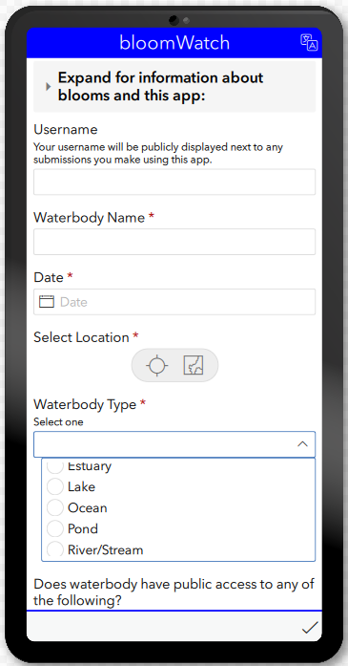

**3**

**2**

**1**

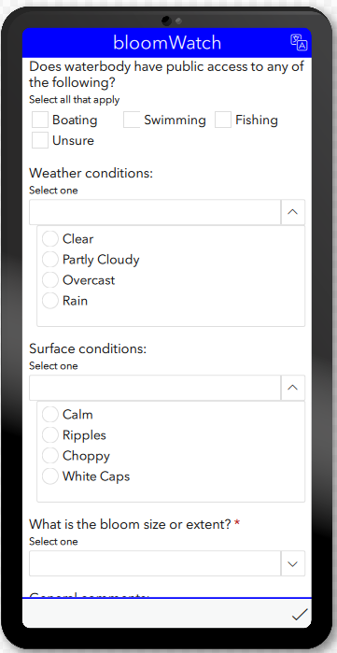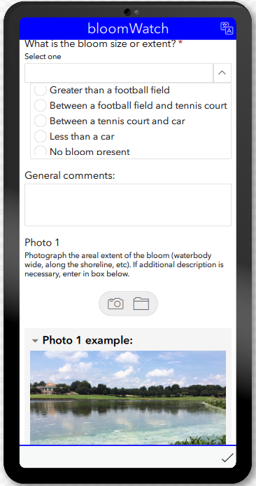

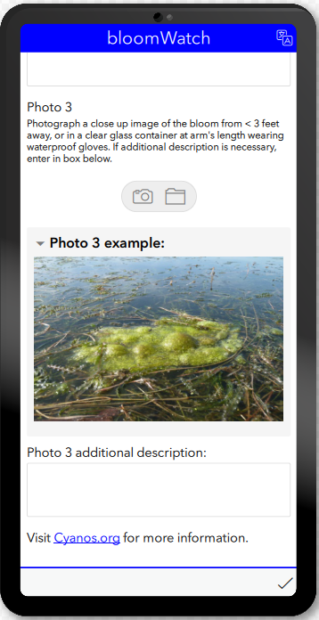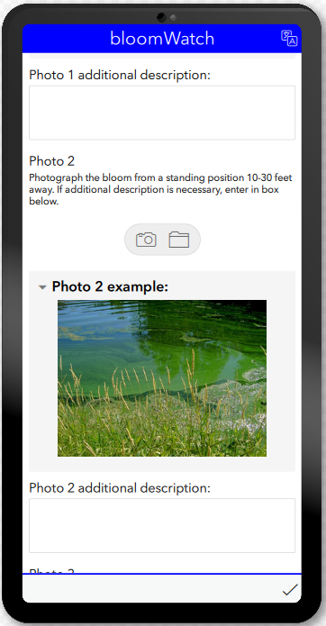

**5**

**4**

**cyanoScope**

These screenshots represent the image upload screens for microscopic images that are collected as a part of this program. Images will help determine if the bloom material are actually cyanobacteria that can be potentially toxic and the relative abundance and type of cyanobacteria present.



**Step 1: cyanoScope images are uploaded by the user to the iNaturalist cyanoScope project page**

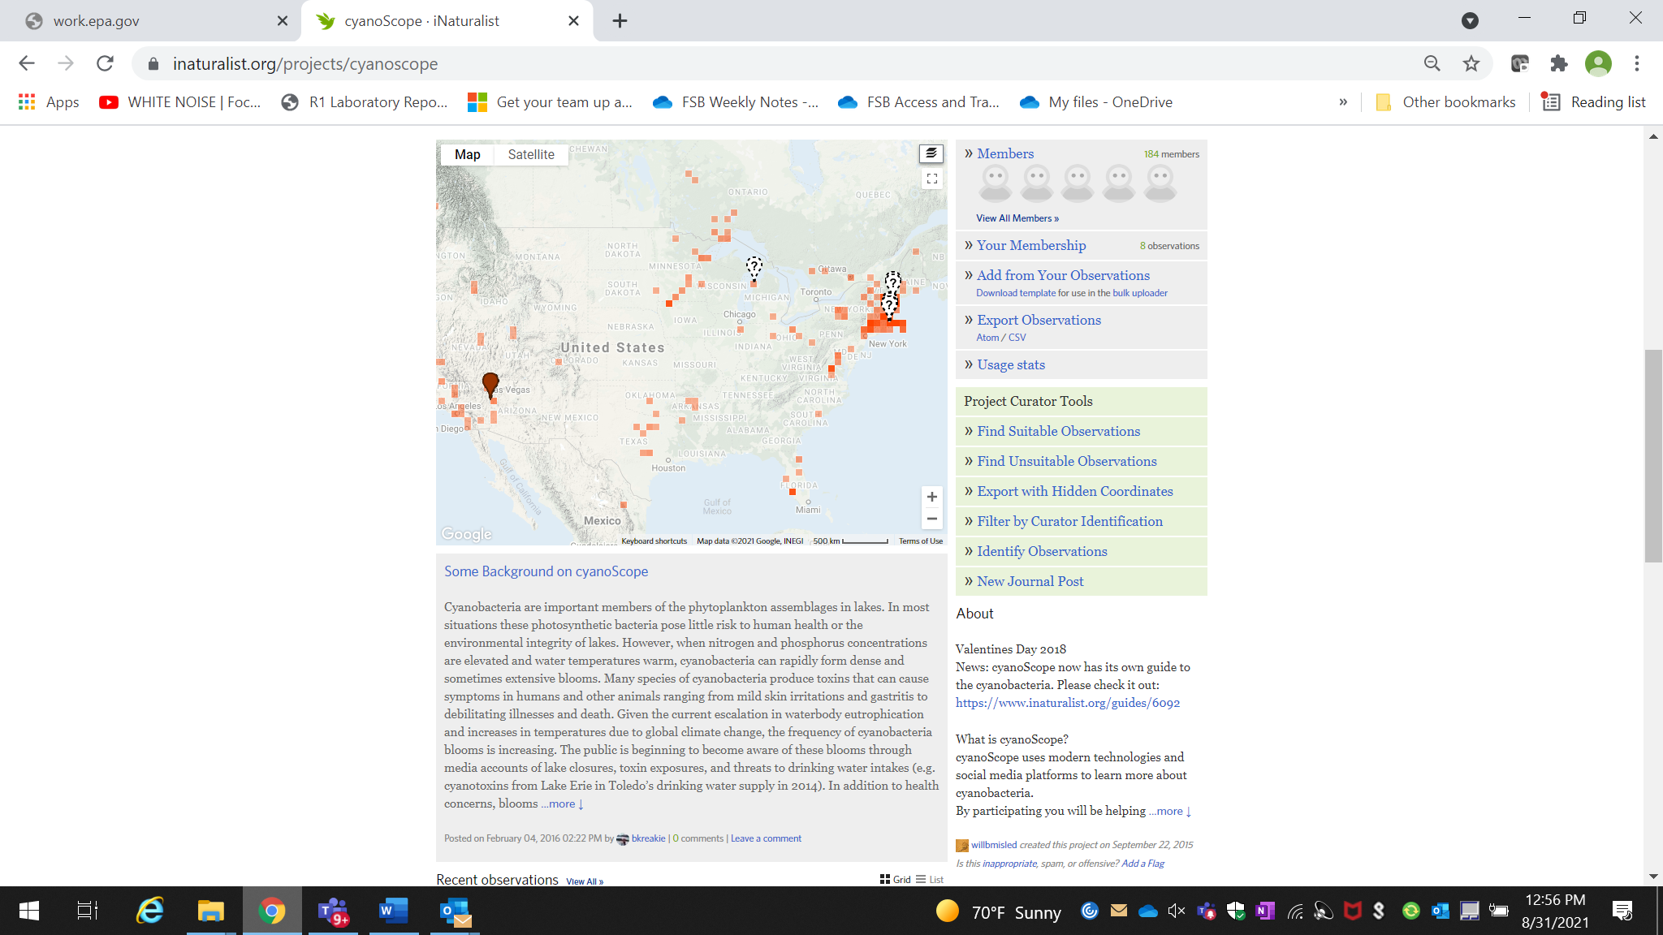

**Step 2: Microscopic images of cyanobacteria are georeferenced and placed on a location map**

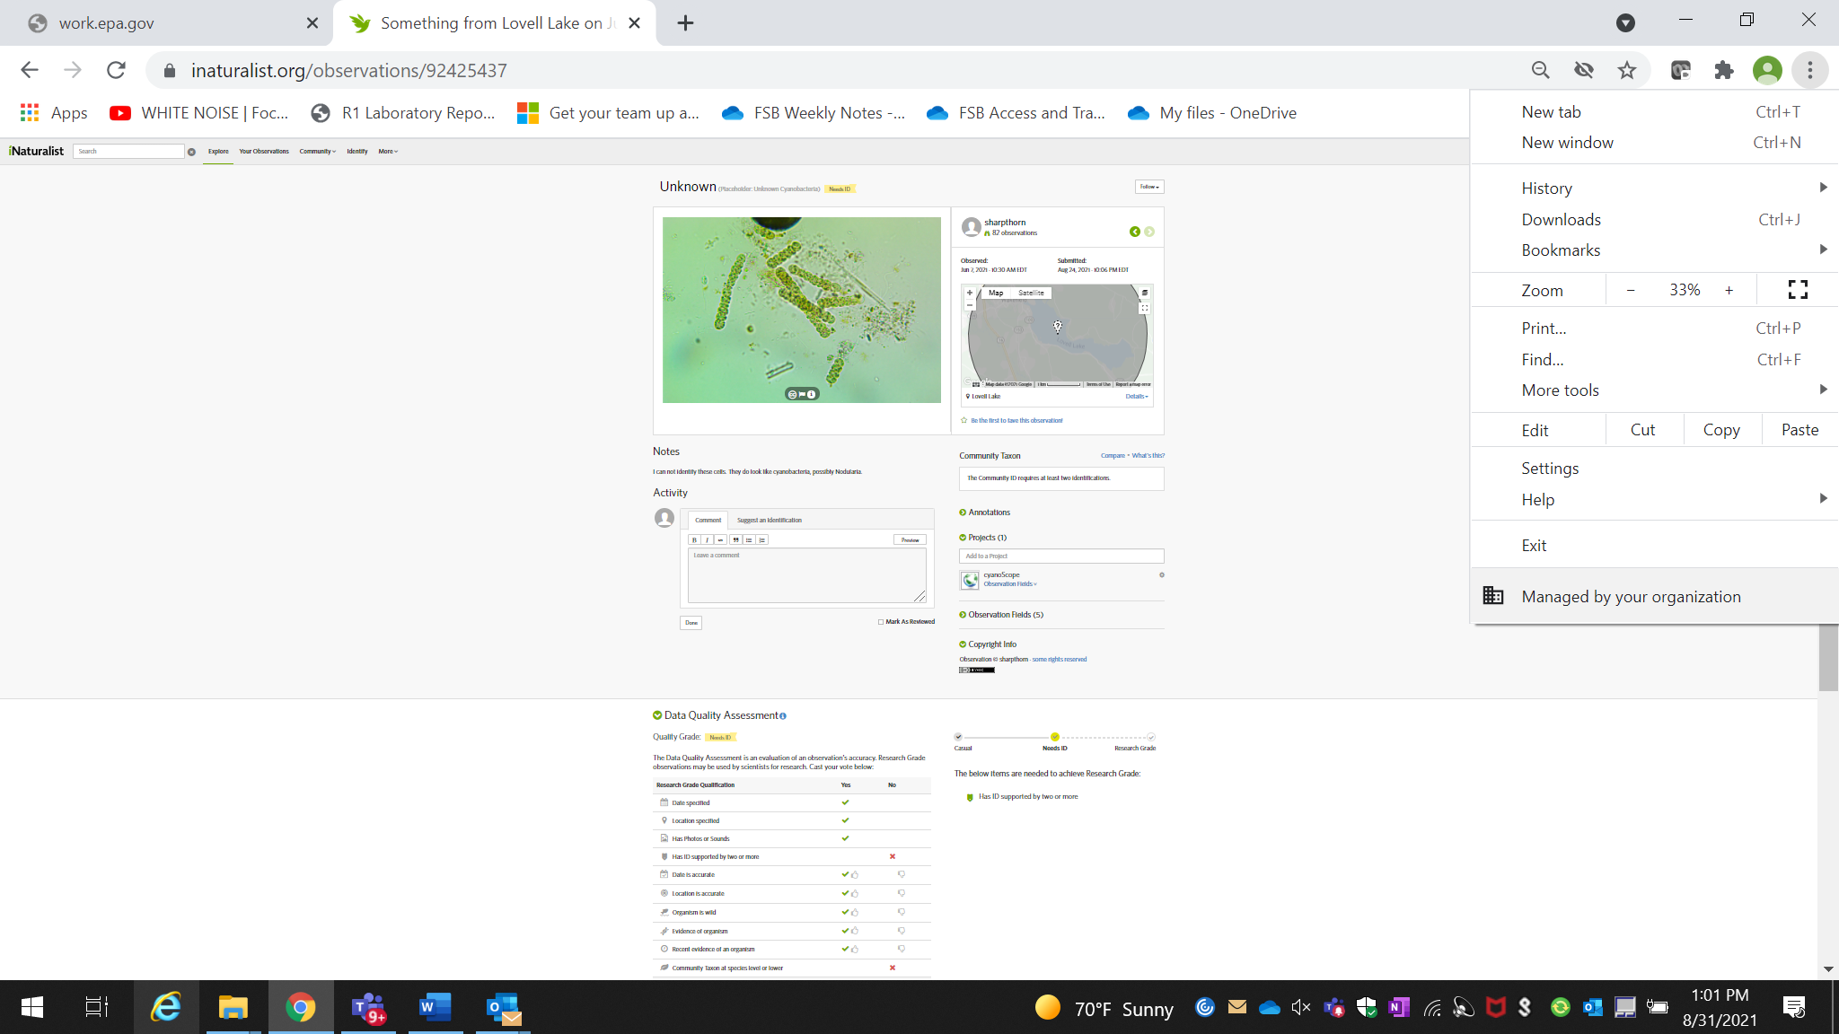

**Step 3: Microscopic images are taxonomically identified**

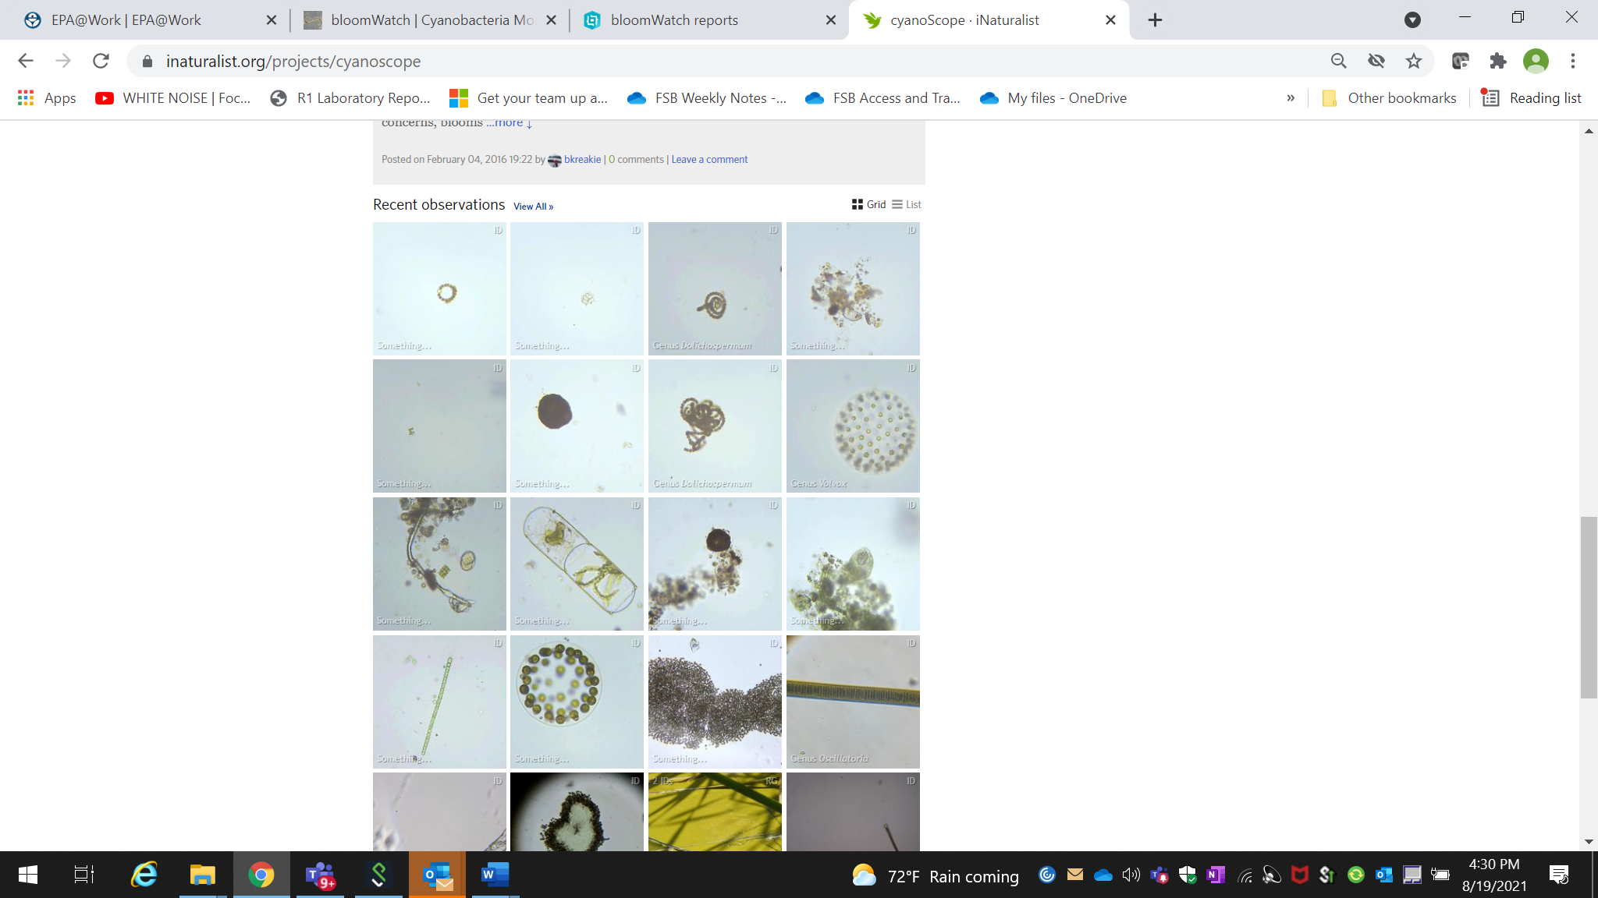

**Step 4: Confirmed images are added to a list of observations**