# OMB Instrument Form for Generic Citizen Science ICRs

## Burden Statement:

This collection of information is approved by OMB under the Paperwork Reduction Act, 44 U.S.C. 3501 et seq. (OMB Control No. 2080-0083). Responses to this collection of information are voluntary (Crowdsourcing and Citizen Science Act of 2017, 15 U.S. Code §3724). An agency may not conduct or sponsor, and a person is not required to respond to, a collection of information unless it displays a currently valid OMB control number. The public reporting and record keeping burden for this collection of information is estimated to be 2 minutes per response. Send comments on the Agency’s need for this information, the accuracy of the provided burden estimates and any suggested methods for minimizing respondent burden to the Regulatory Support Division Director, U.S. Environmental Protection Agency (2821T), 1200 Pennsylvania Ave., NW, Washington, D.C. 20460. Include the OMB control number in any correspondence. Do not send the completed form to this address.

# OMB Instrument Form for Generic Citizen Science ICRs

*\*On this page, you can include your instrument form. The Paperwork Reduction Act uses the term “instrument” for all devices used to carry-out an information collection. An instrument can be anything from a paper form to an online survey to an electronic data interface. In speaking about ICRs, terms like “form” and “survey” are frequently used in place of the term “instrument.” If you have an app, you can paste screenshots of the app here.*

**Intro Screen** **Home Screen**  **About Odor Explore**

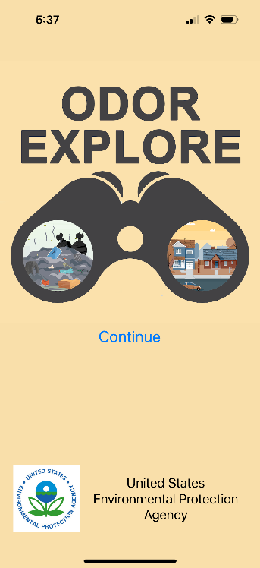 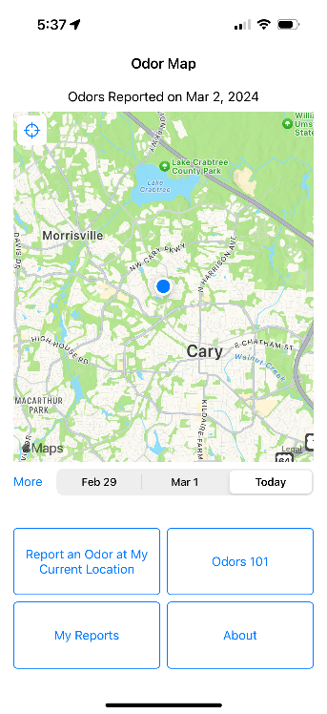 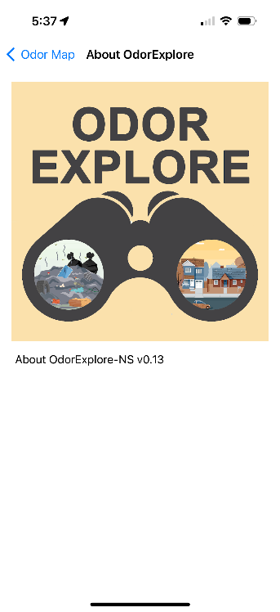

**Information Collection Request – Reporting an Odor at My Current Location:**

**Question 1 of 4 Question 2 of 4 Question 3 of 4 Question 4 of 4**

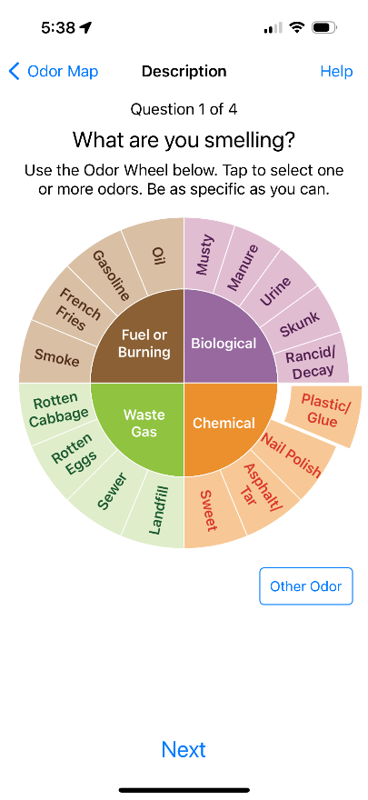 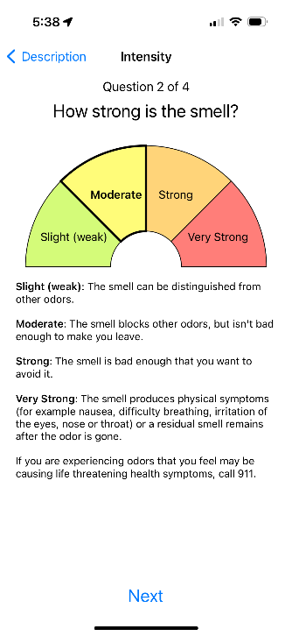 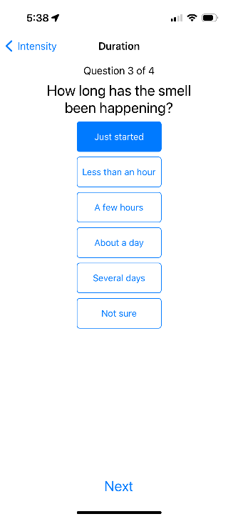 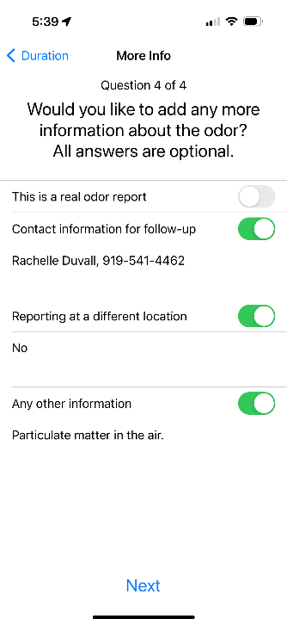

**Summary of Report Confirmation of Report Displayed**

**Submitted Report on Home Screen**

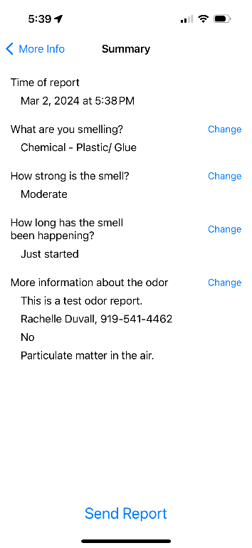 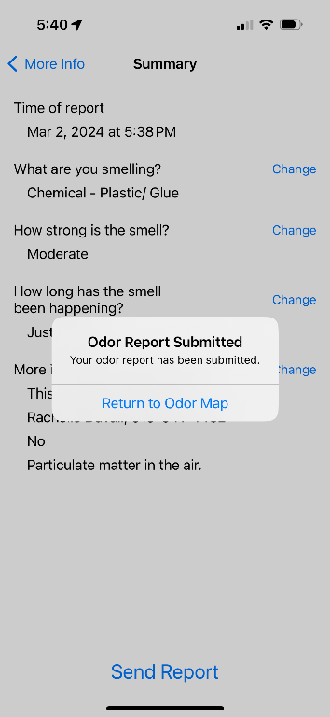 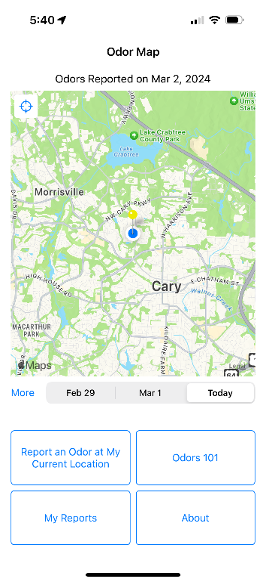

**User View of Information Collection Request – “My Reports”:**

**Summary of User-Detailed Summary of User-**

**Submitted Reports Submitted Report**

