Screenshots of how to Submit ATCO data using Airports External Portal: (<https://aep.airports.faa.gov/Home.aspx>)

Step 1 – go to <https://aep.airports.faa.gov/Home.aspx>

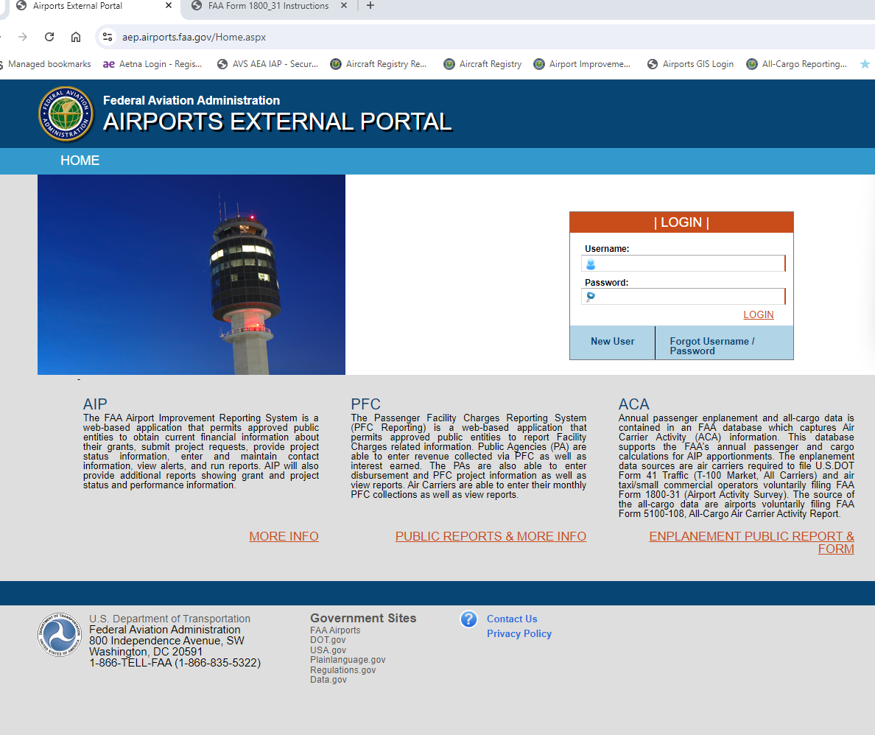

Step 2 – Click on ATCO Form

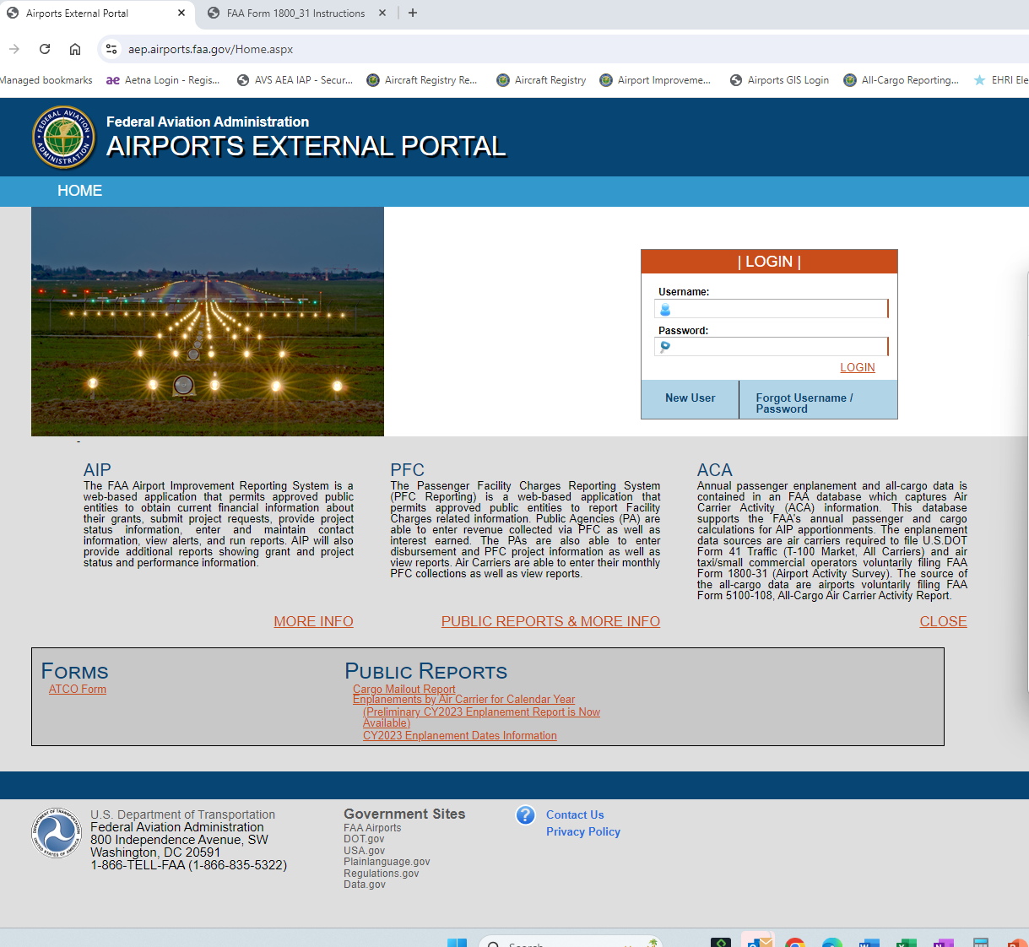

Step 3: The Instructions and submit section appear –

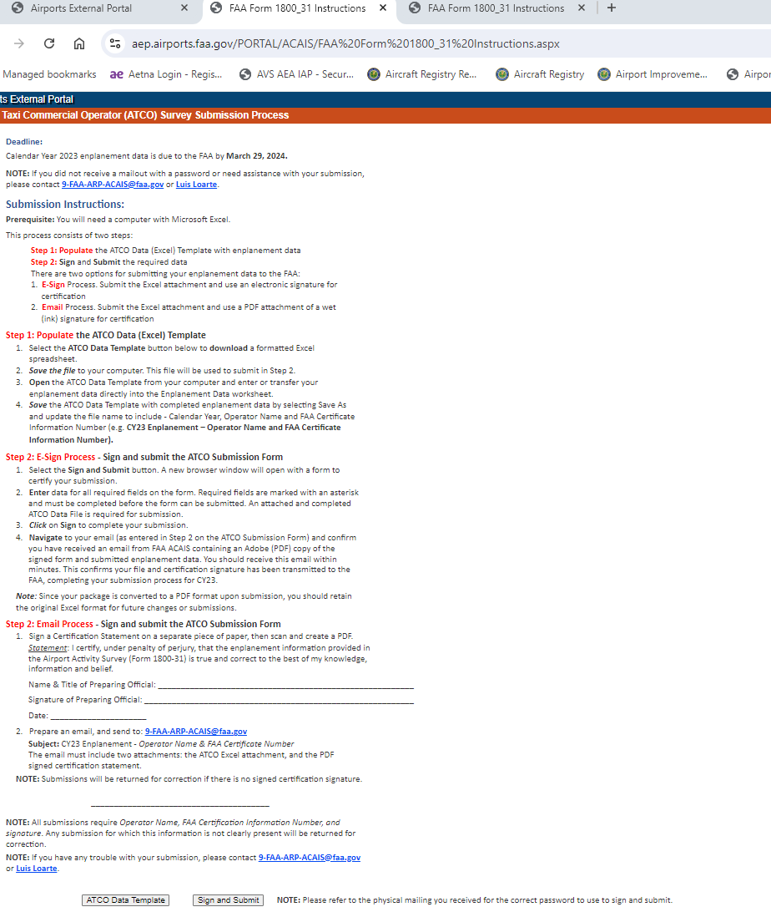

Step 4: Click on Sign ATCO Data template

The ATCO form will be downloaded



Step 5: Fill out form and then Sign - the Air Carrier will need a password to submit – we provide that



Step 6: Sign and submit – all done

