Contents
OMB Control Number in REEport 1
Project Initiation Form Screenshots 2
Progress Report Form Screenshots 14
Final Report Form Screenshots 24
Financial Report Form Screenshots 36

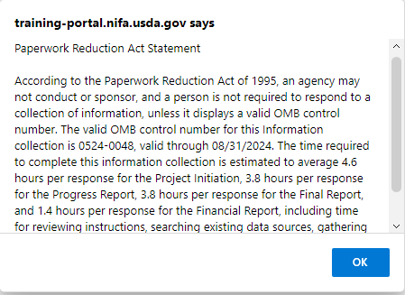
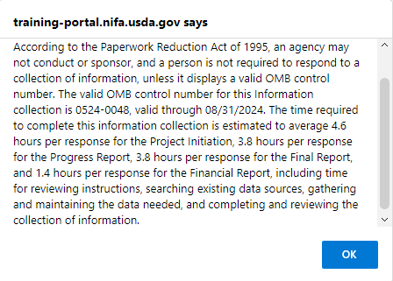

Project Initiation Form Screenshots
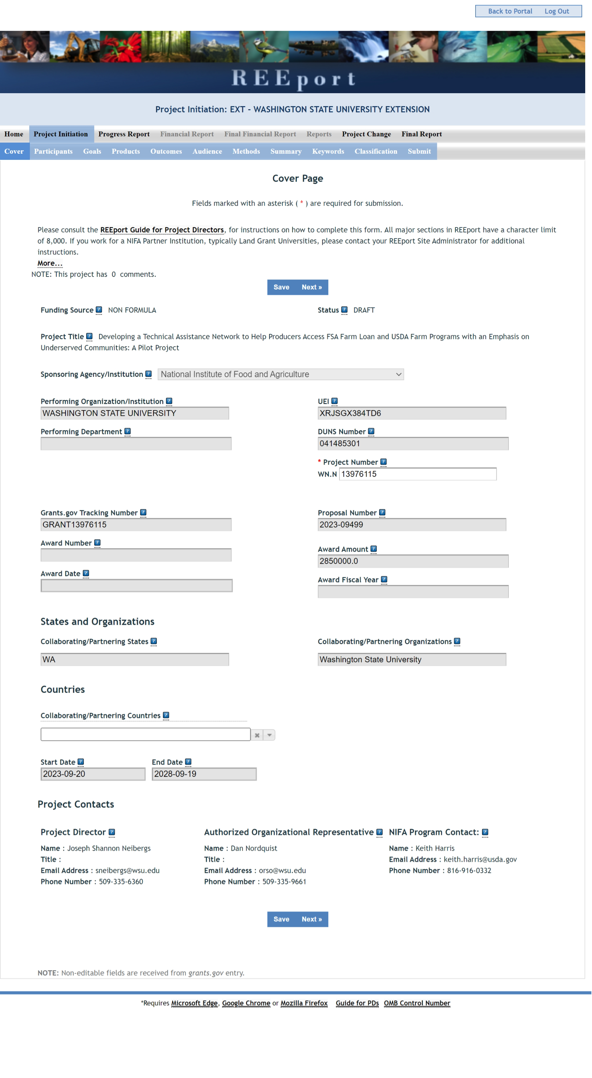
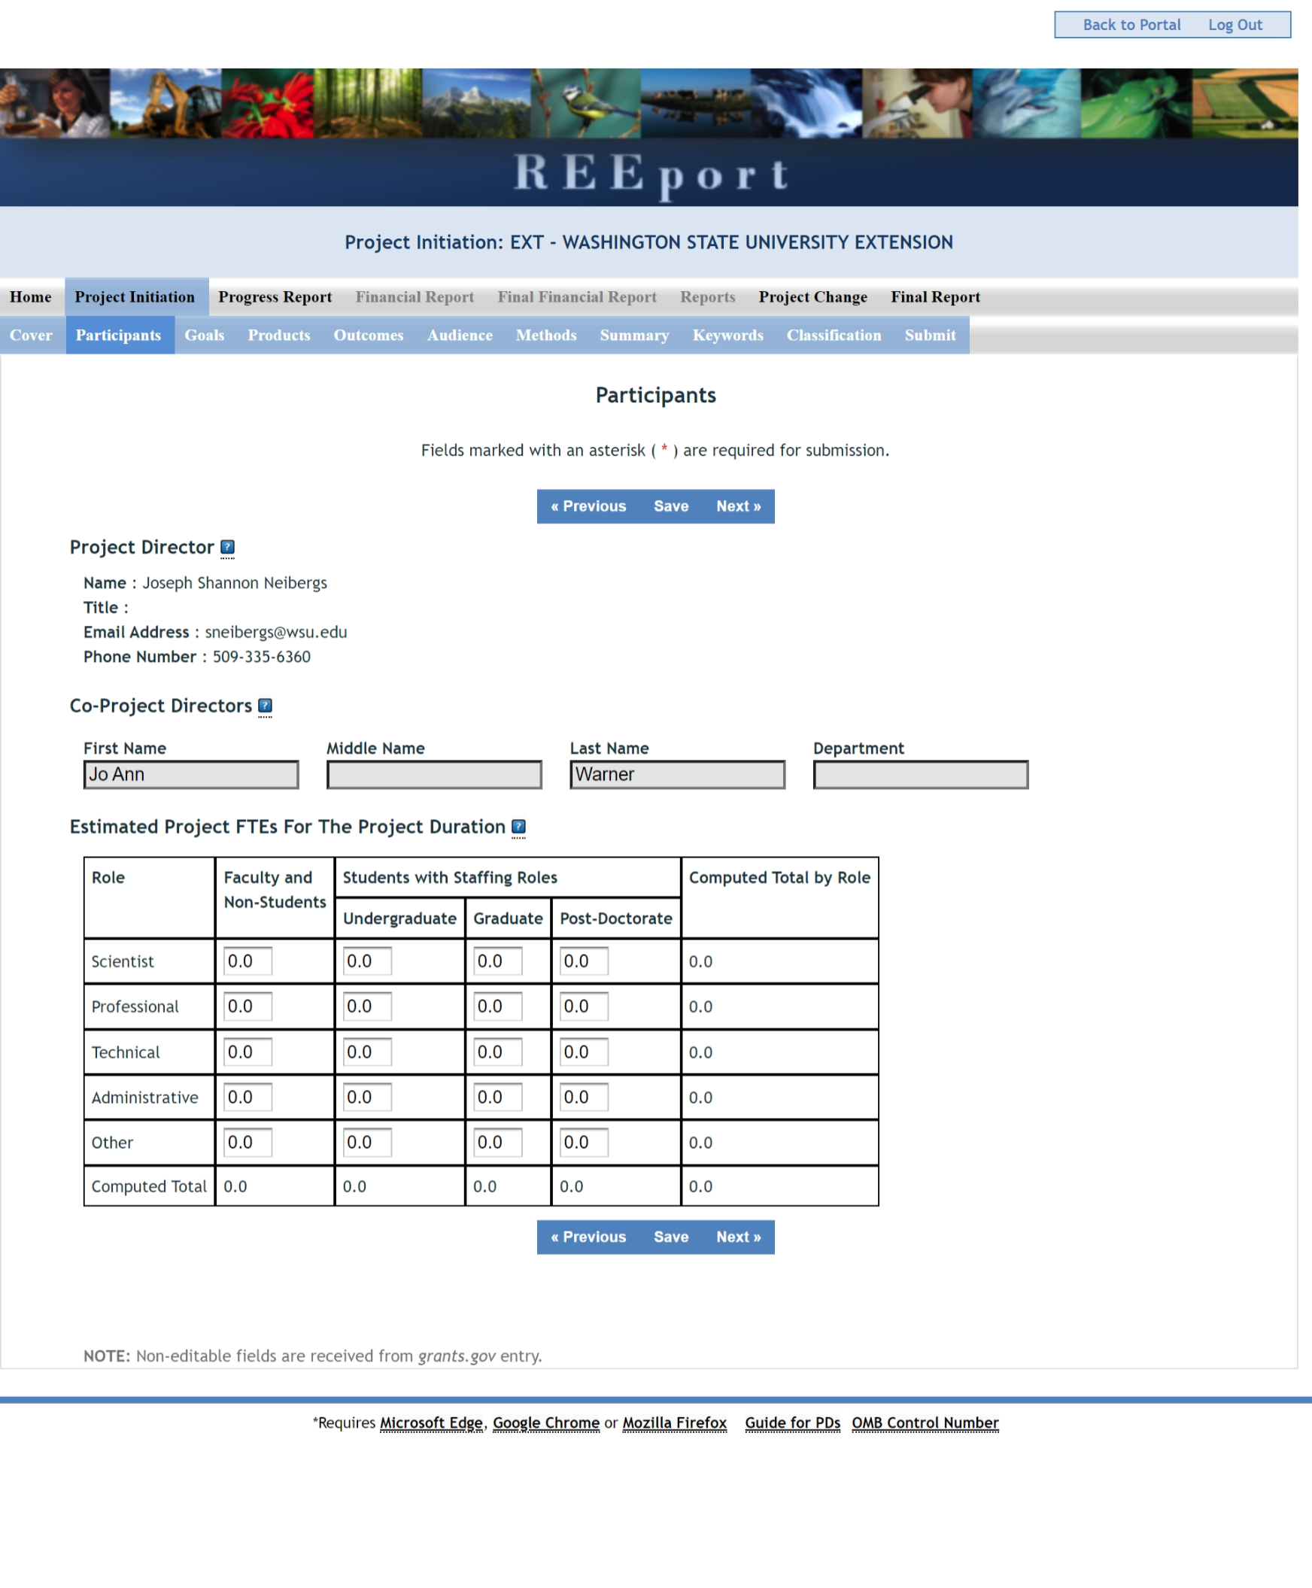
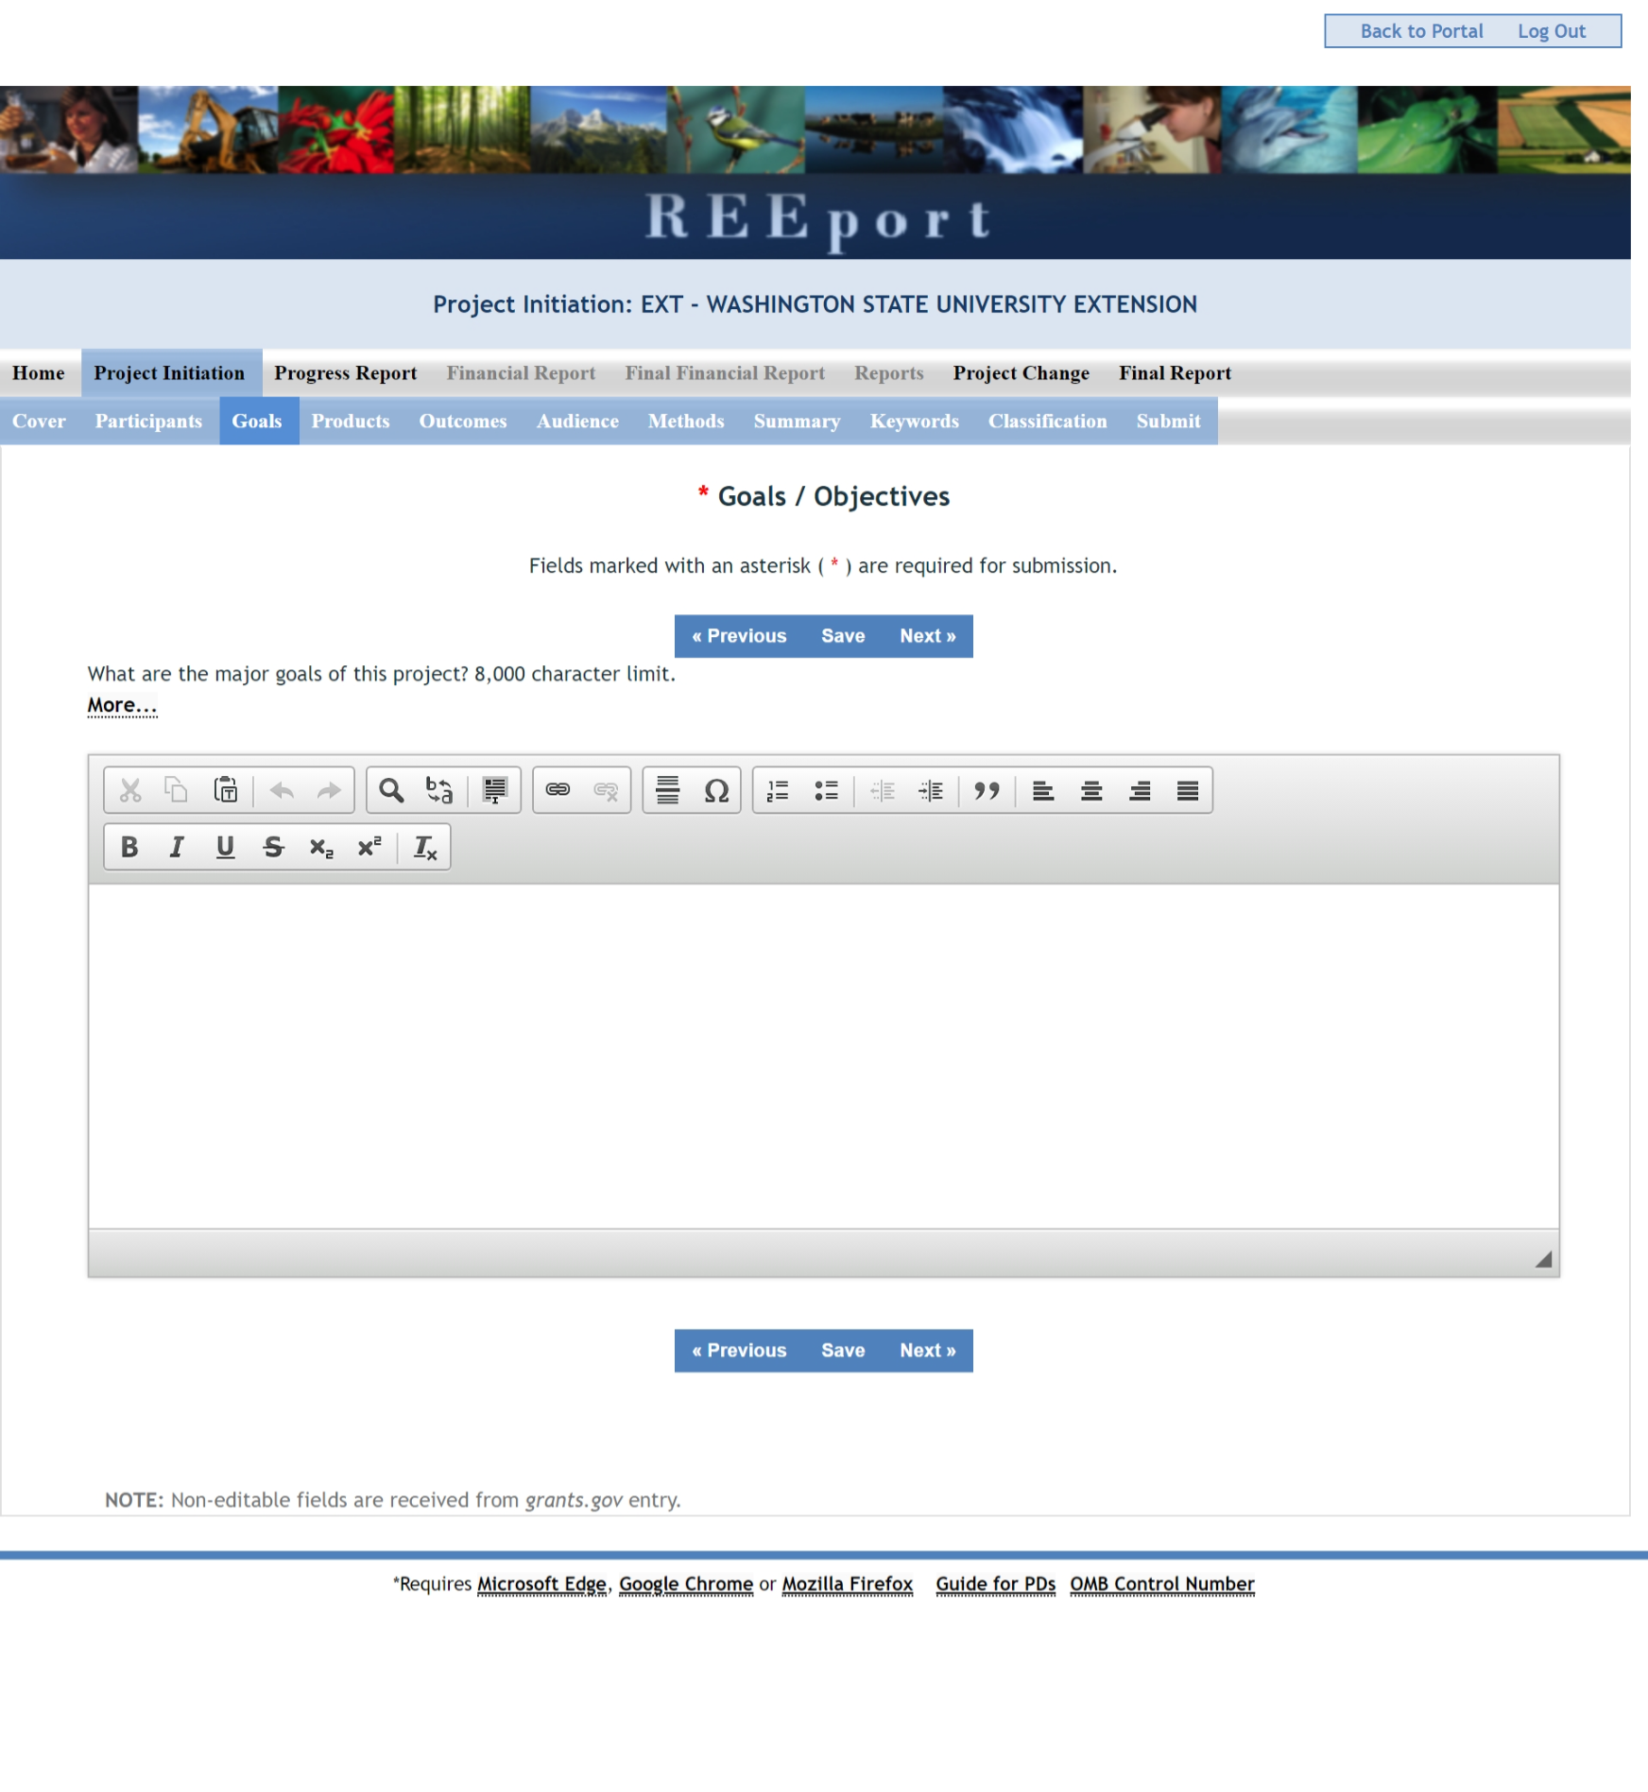
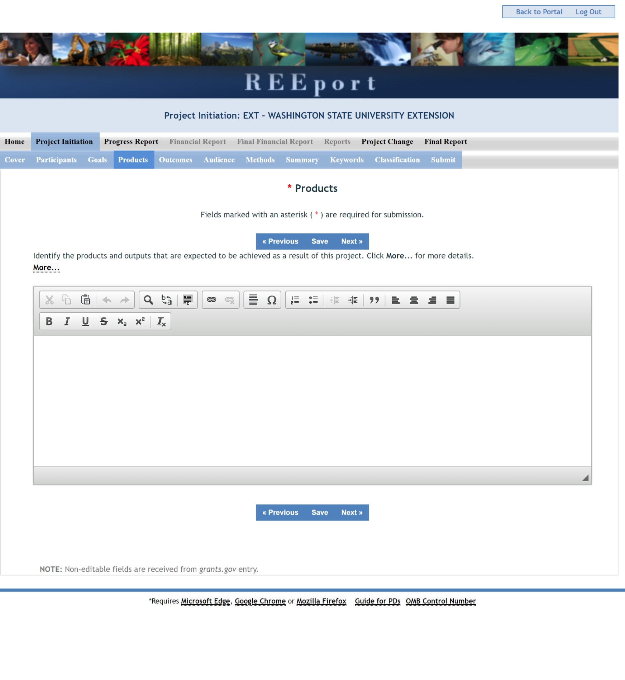
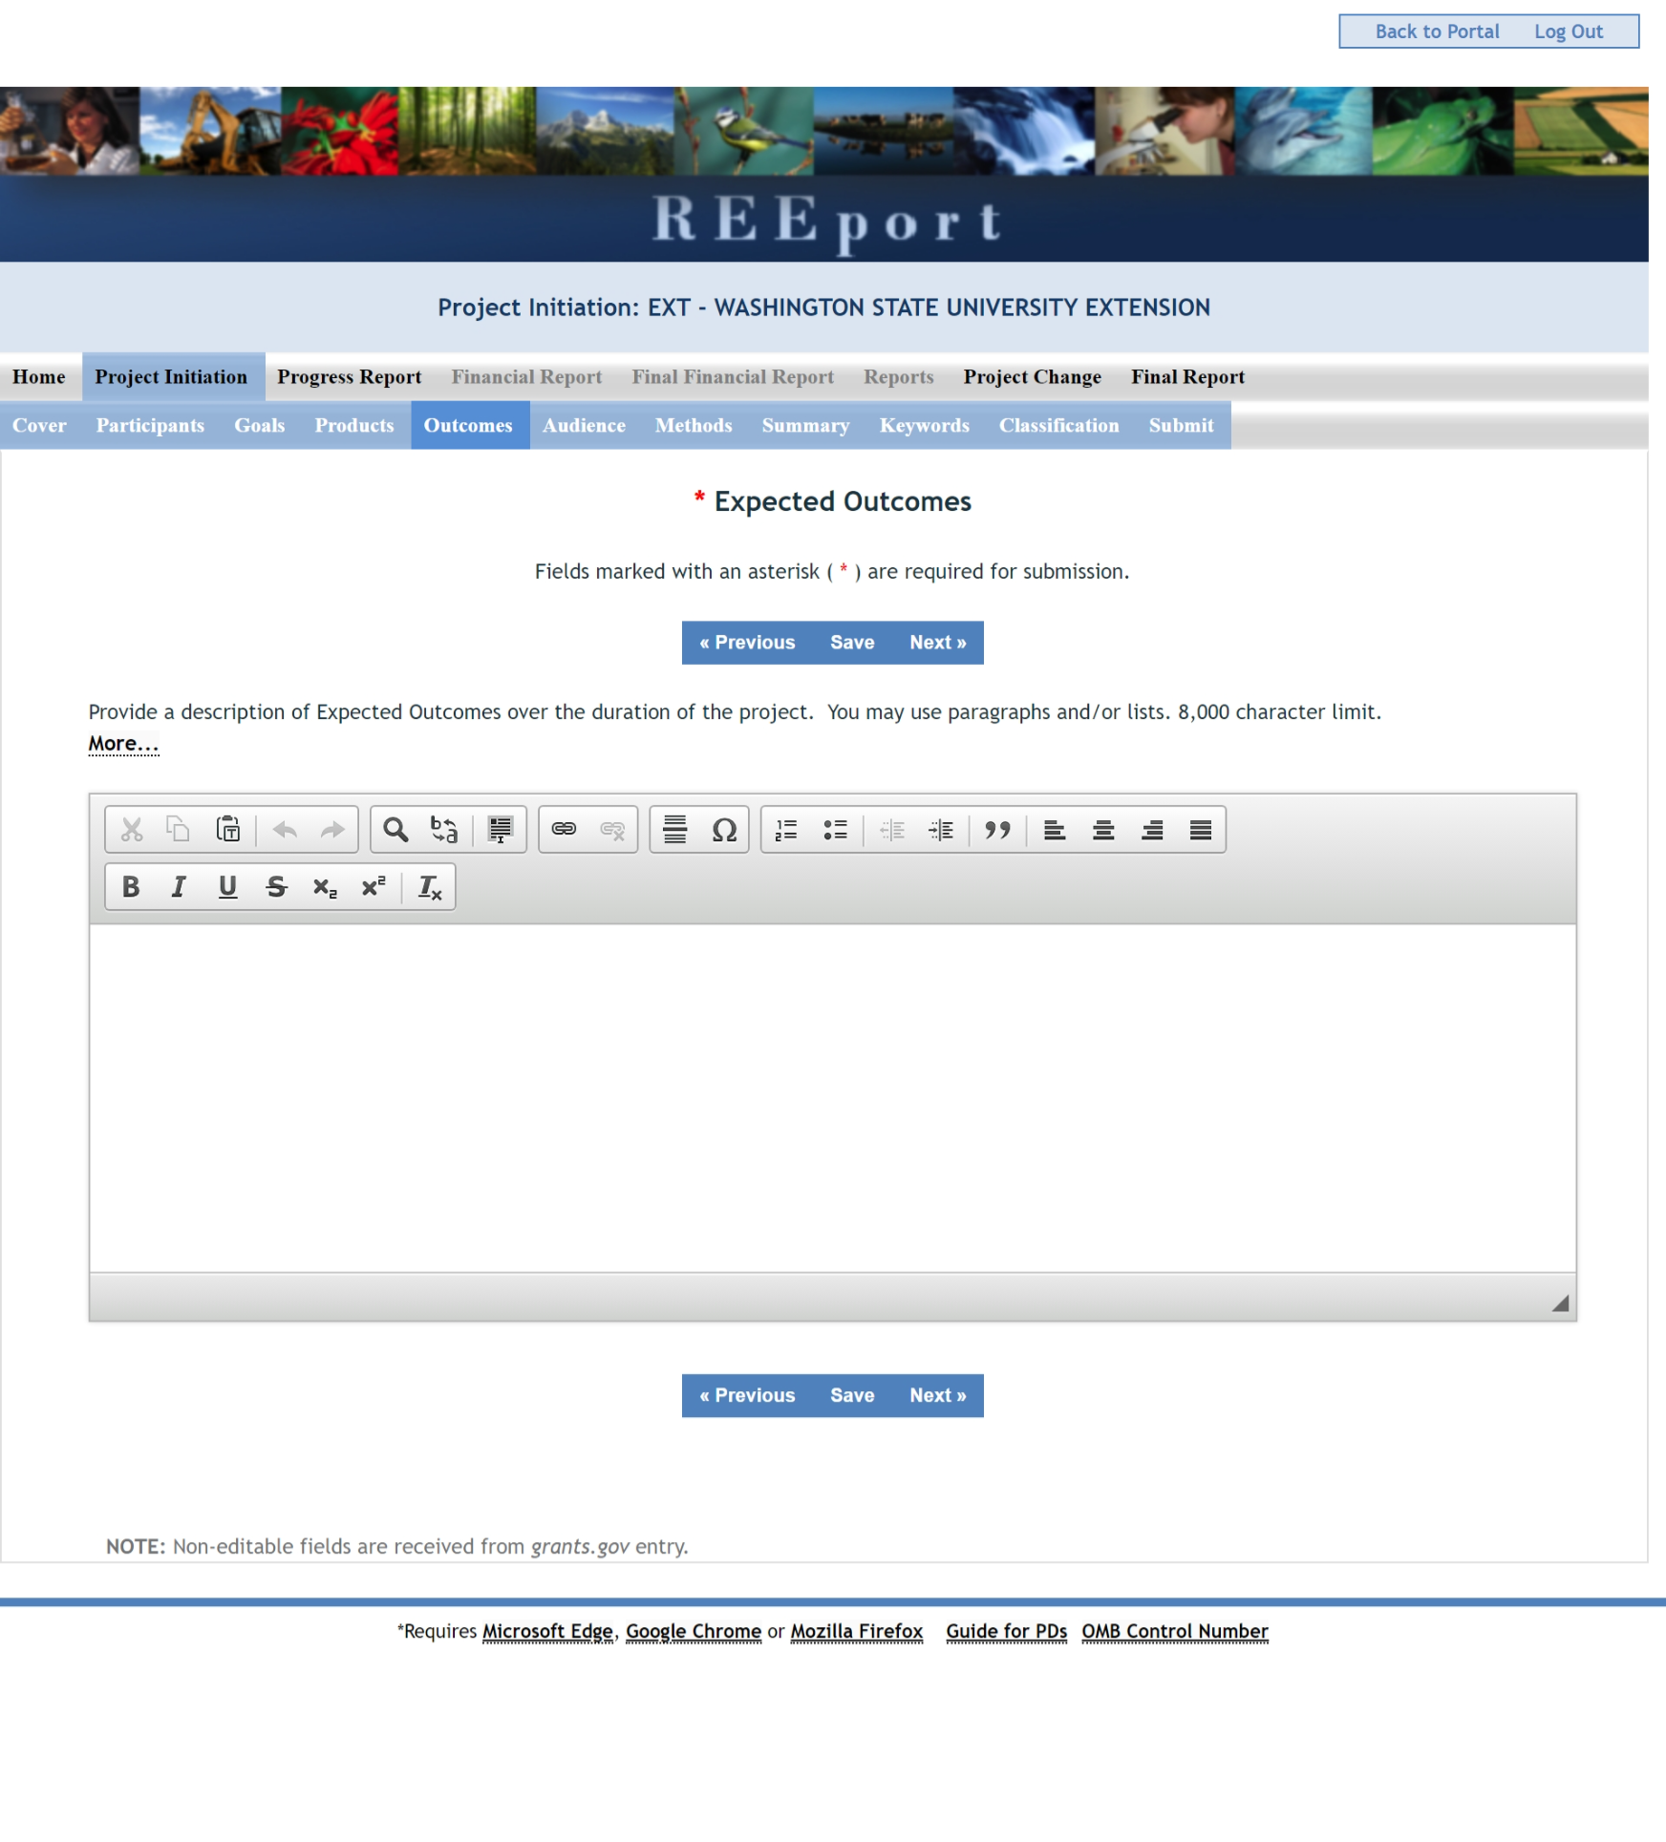
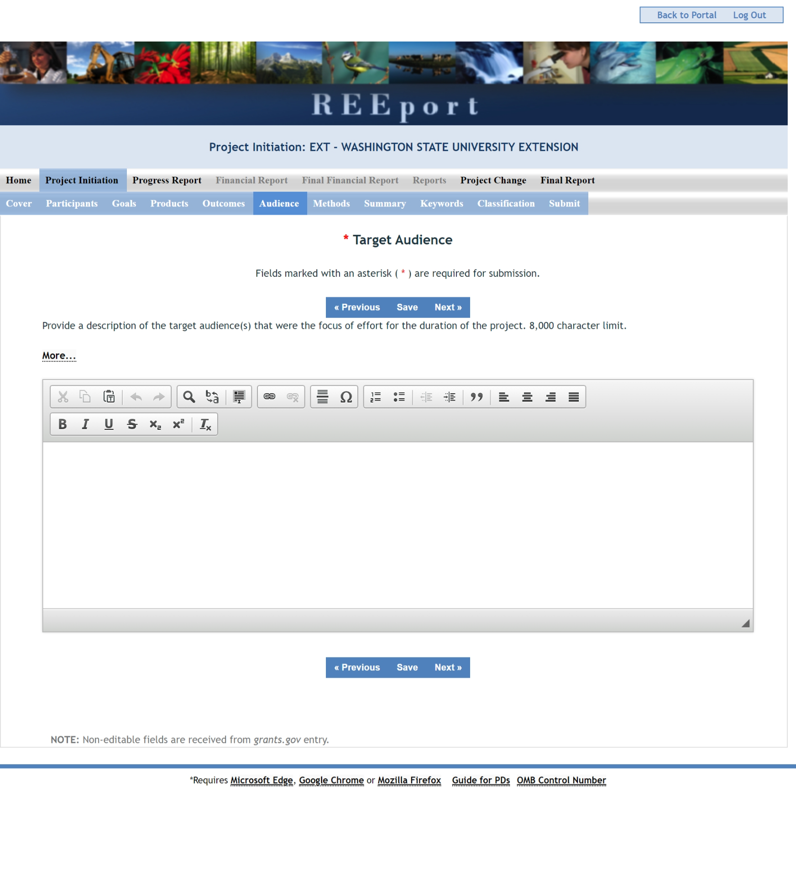
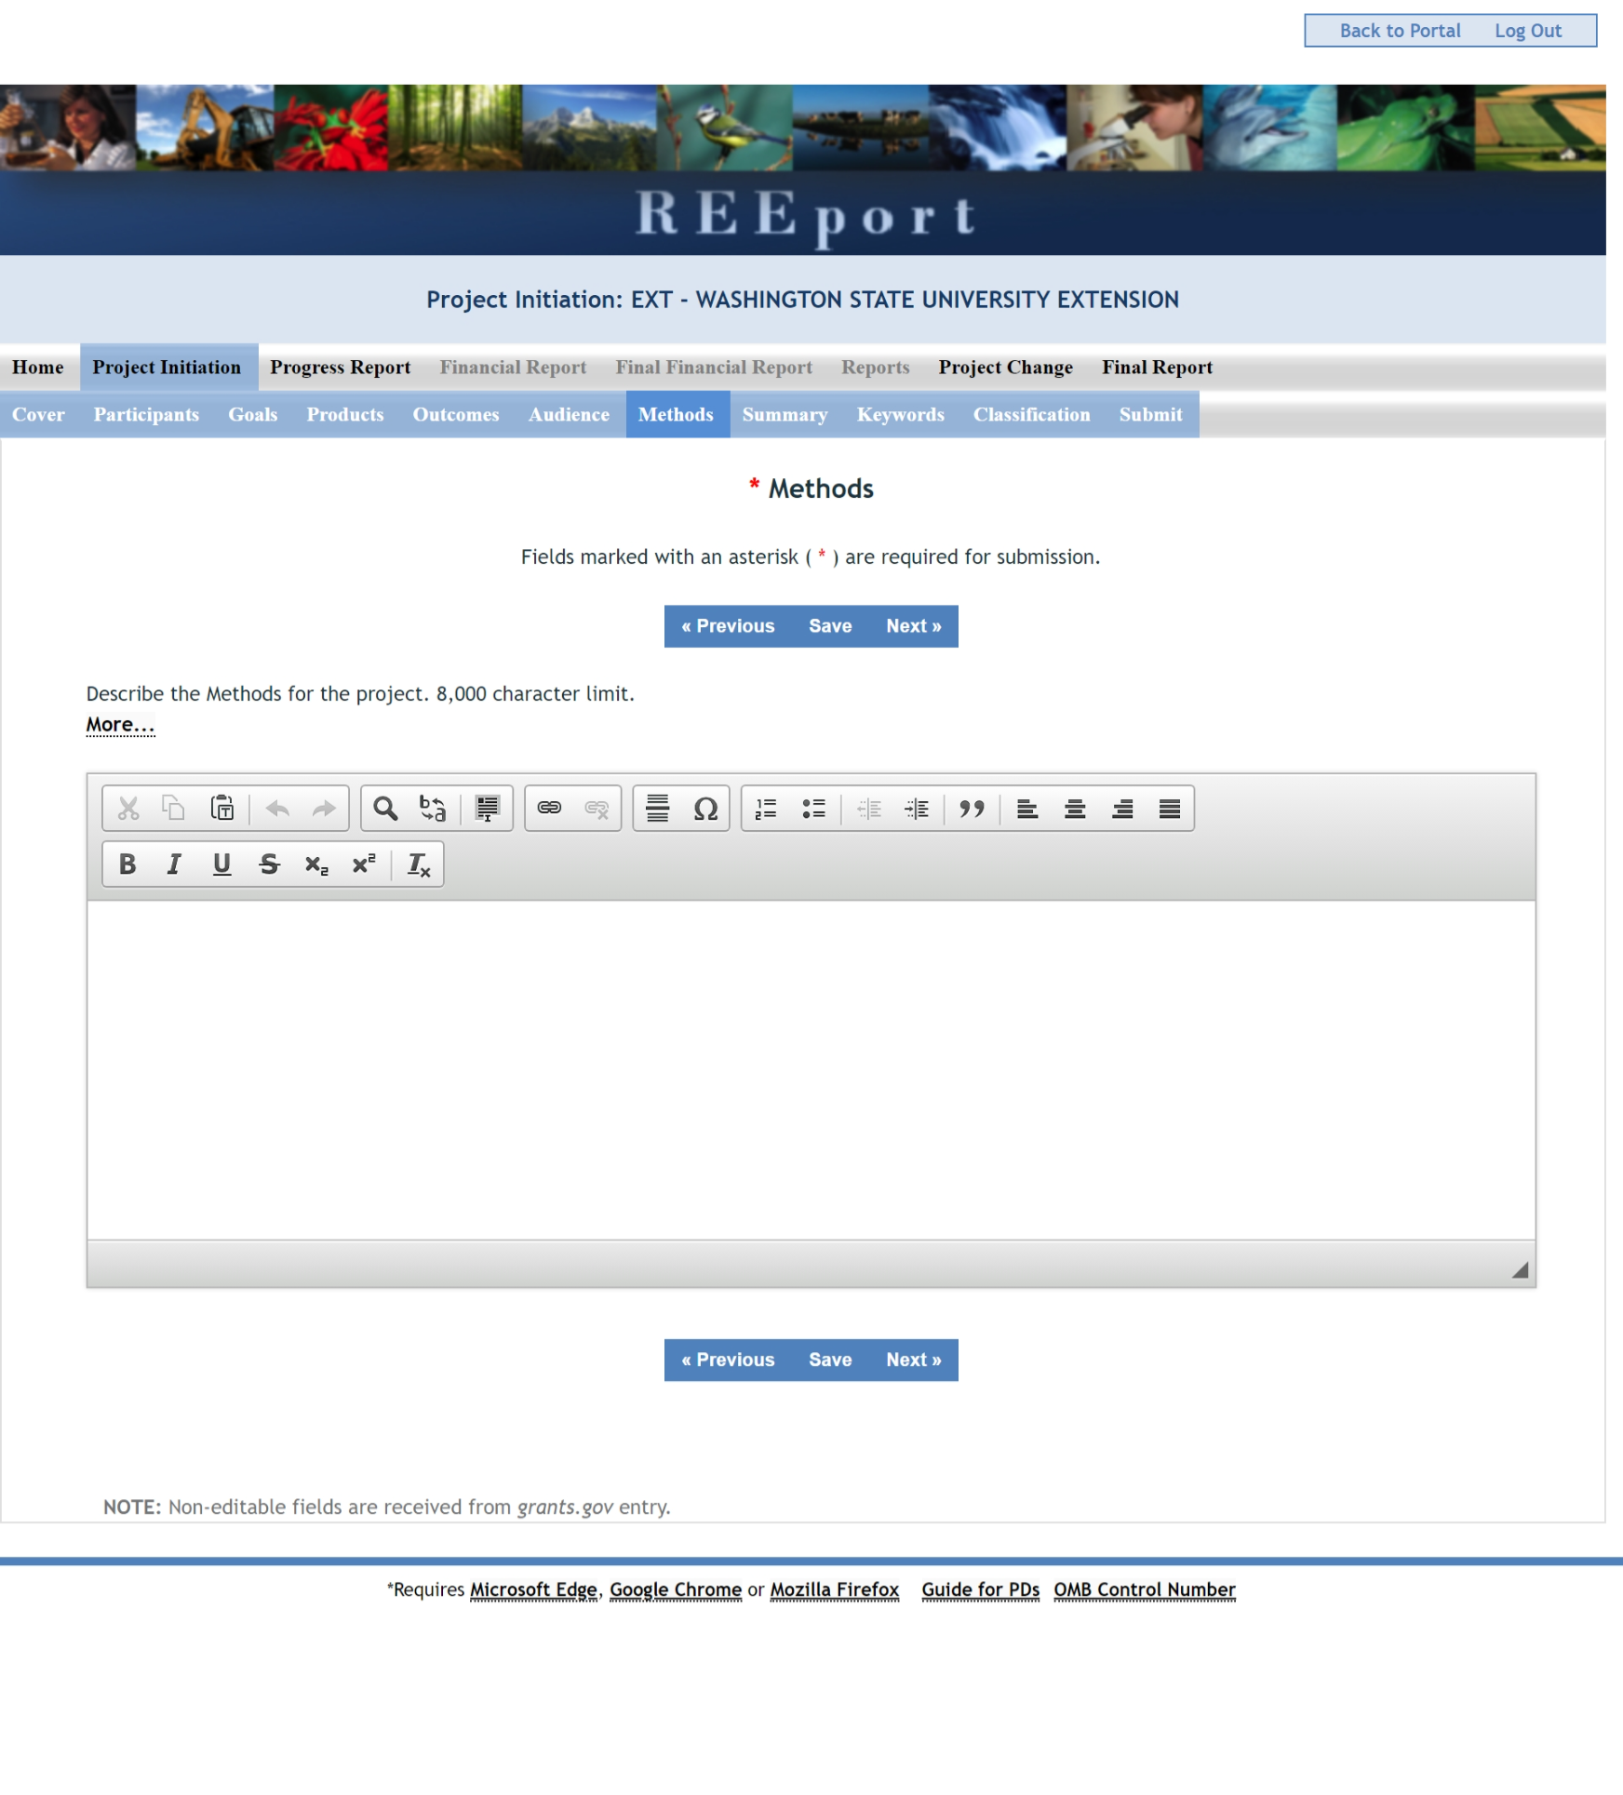
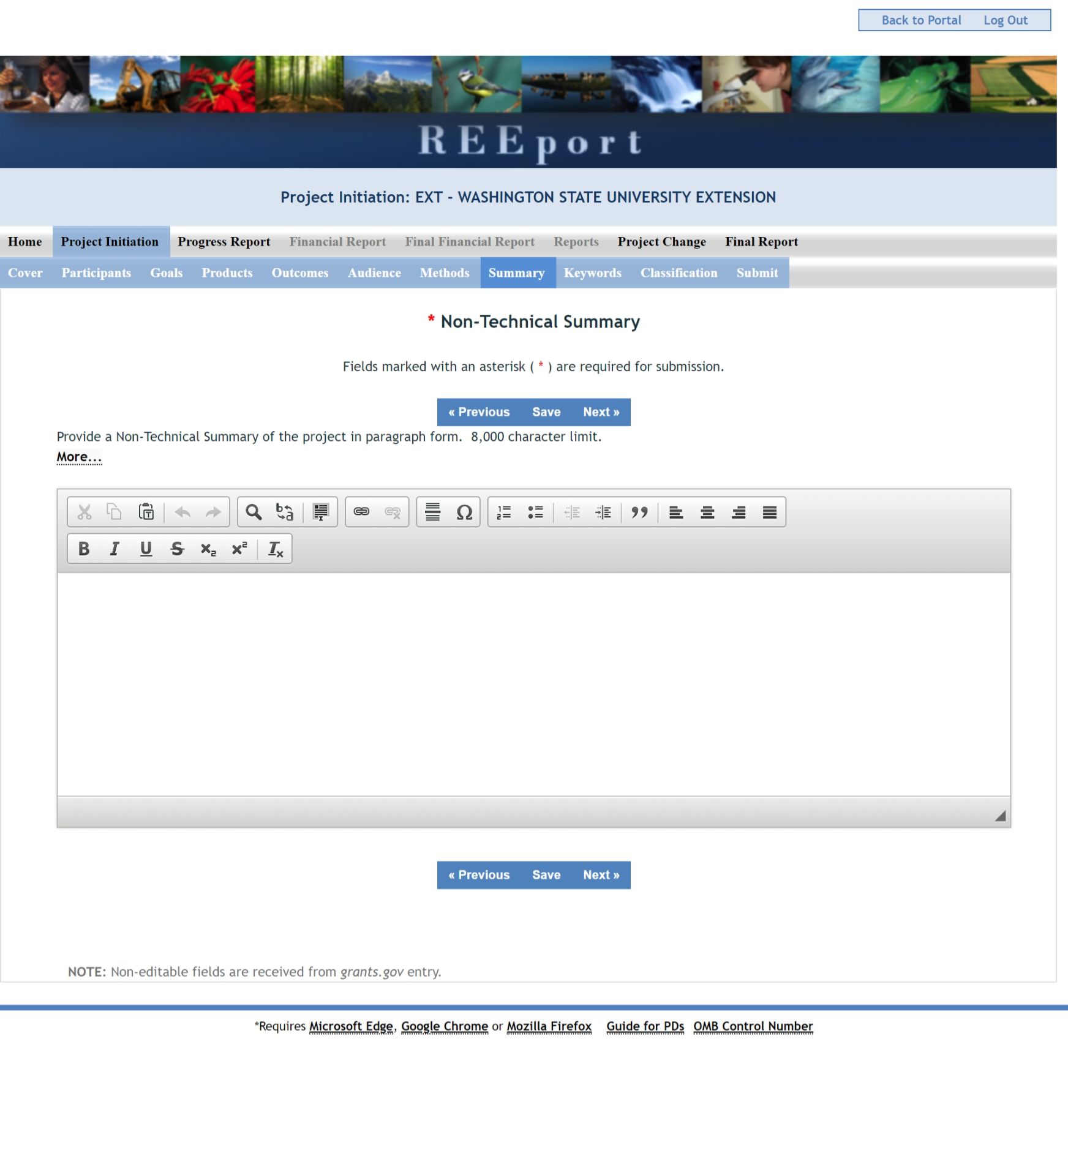
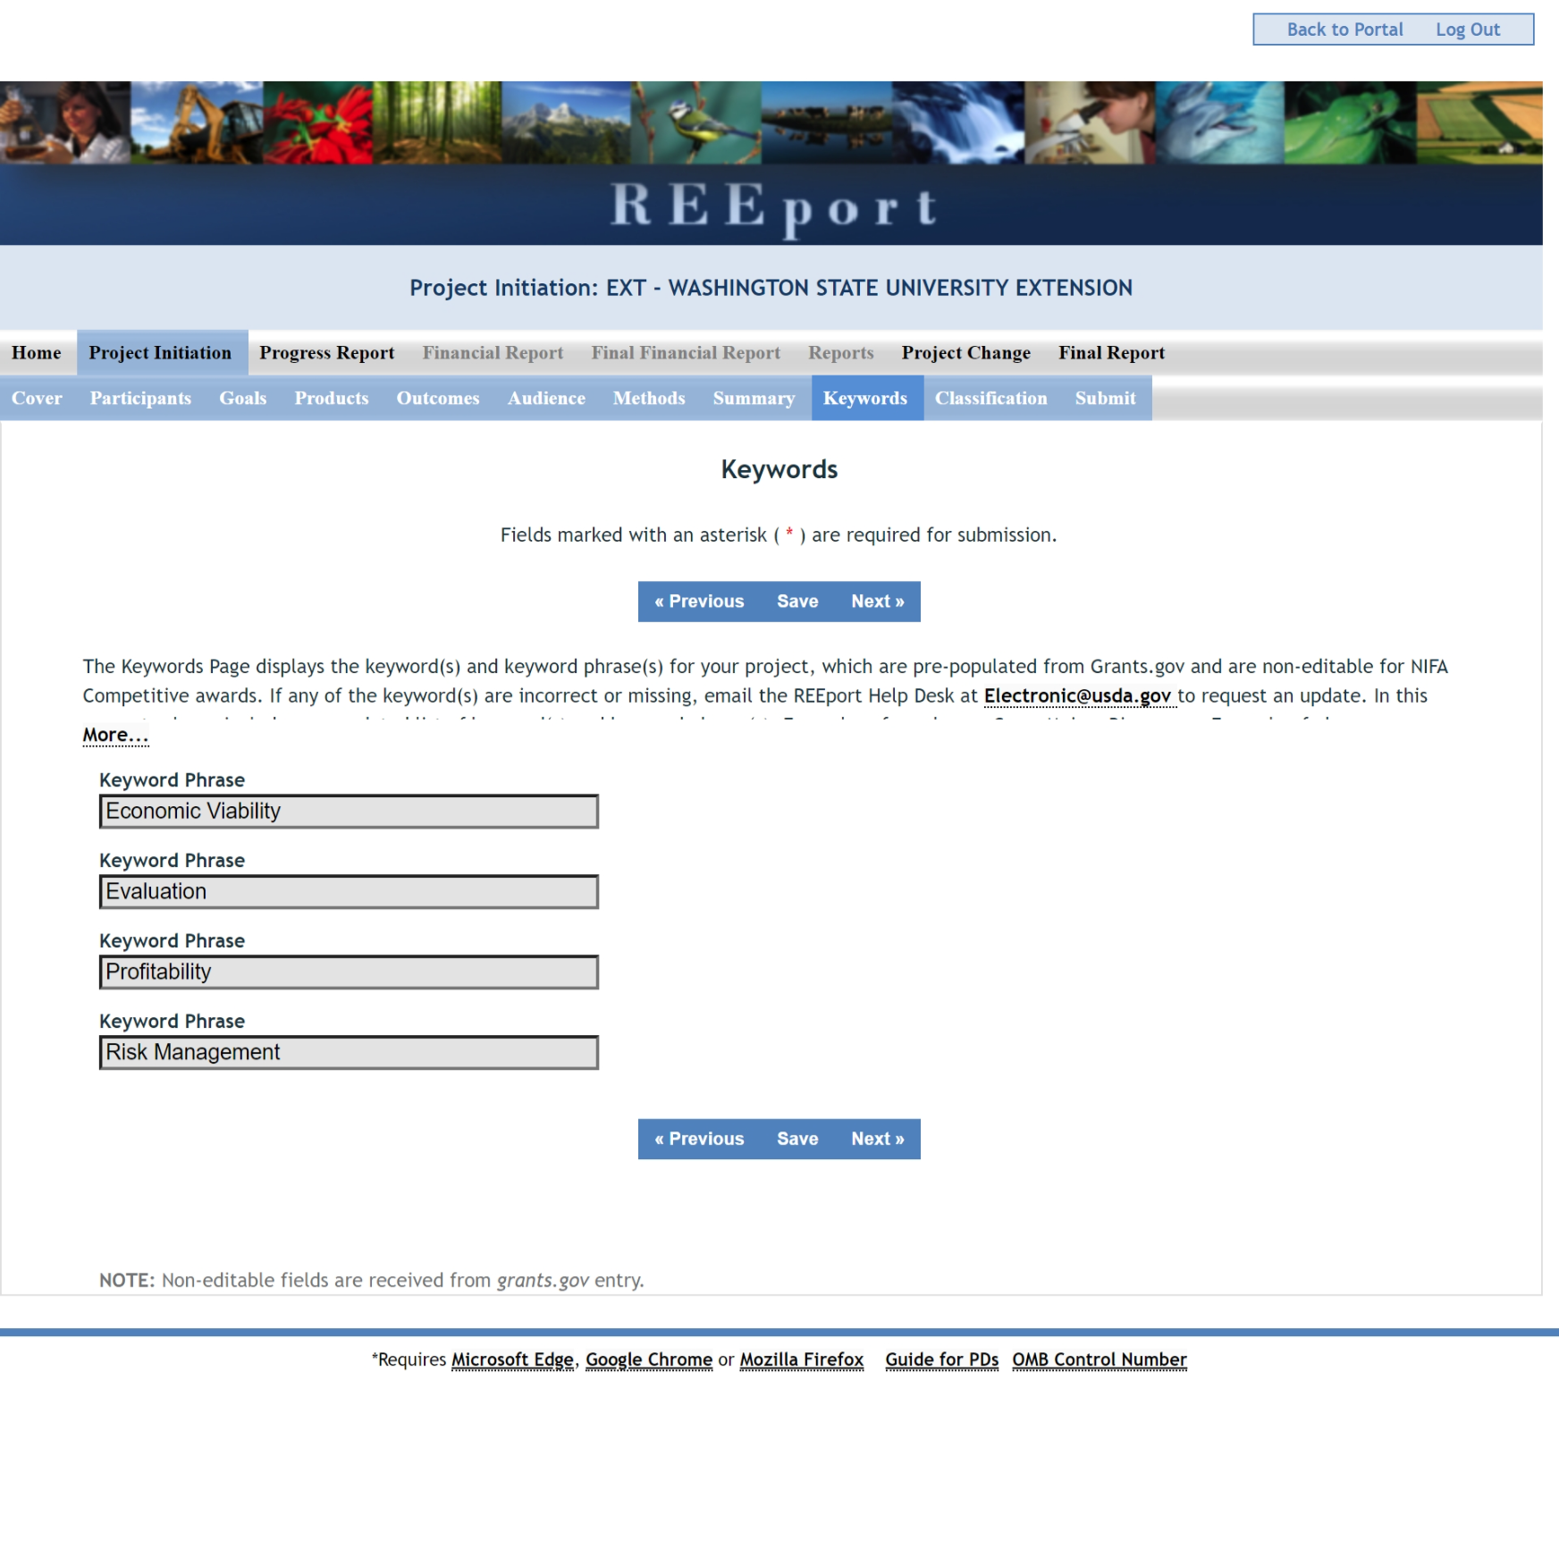
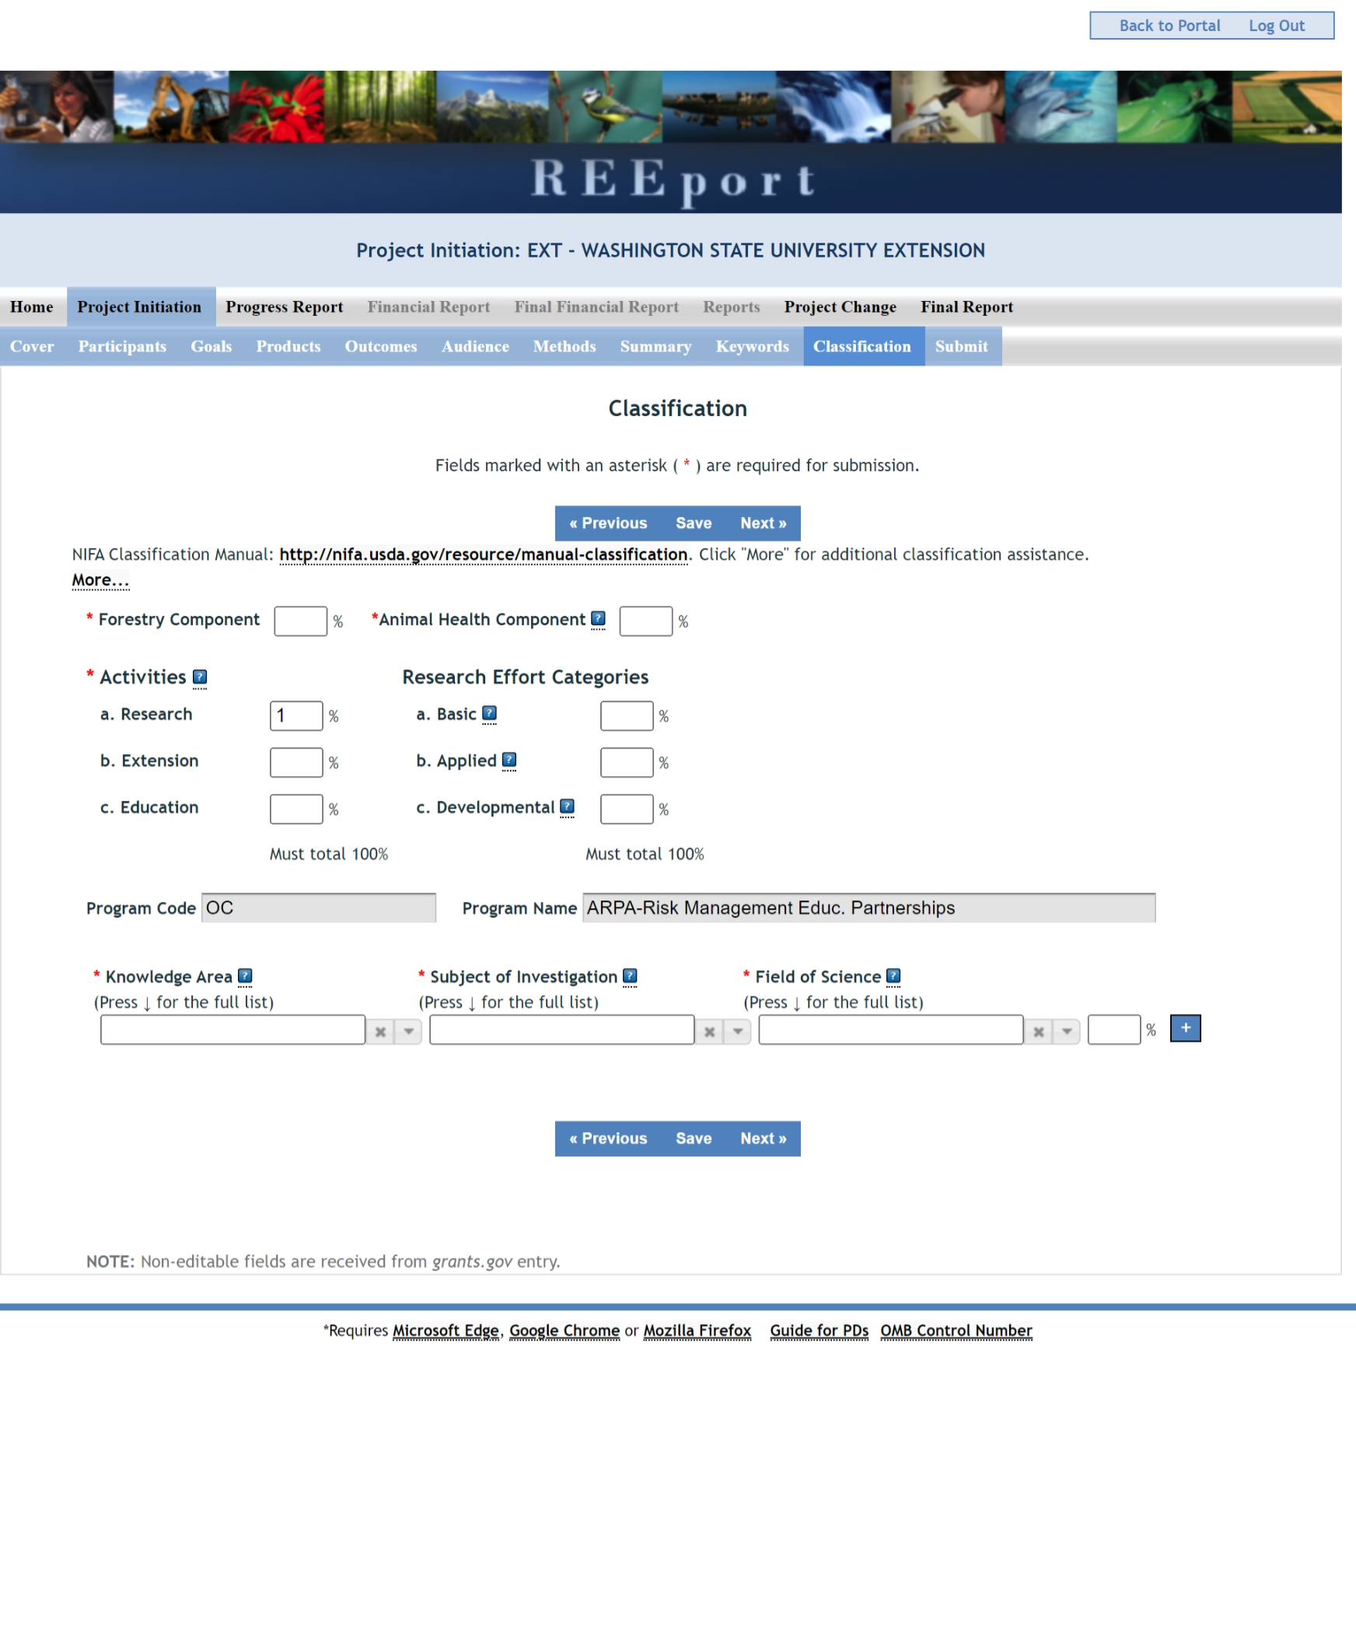
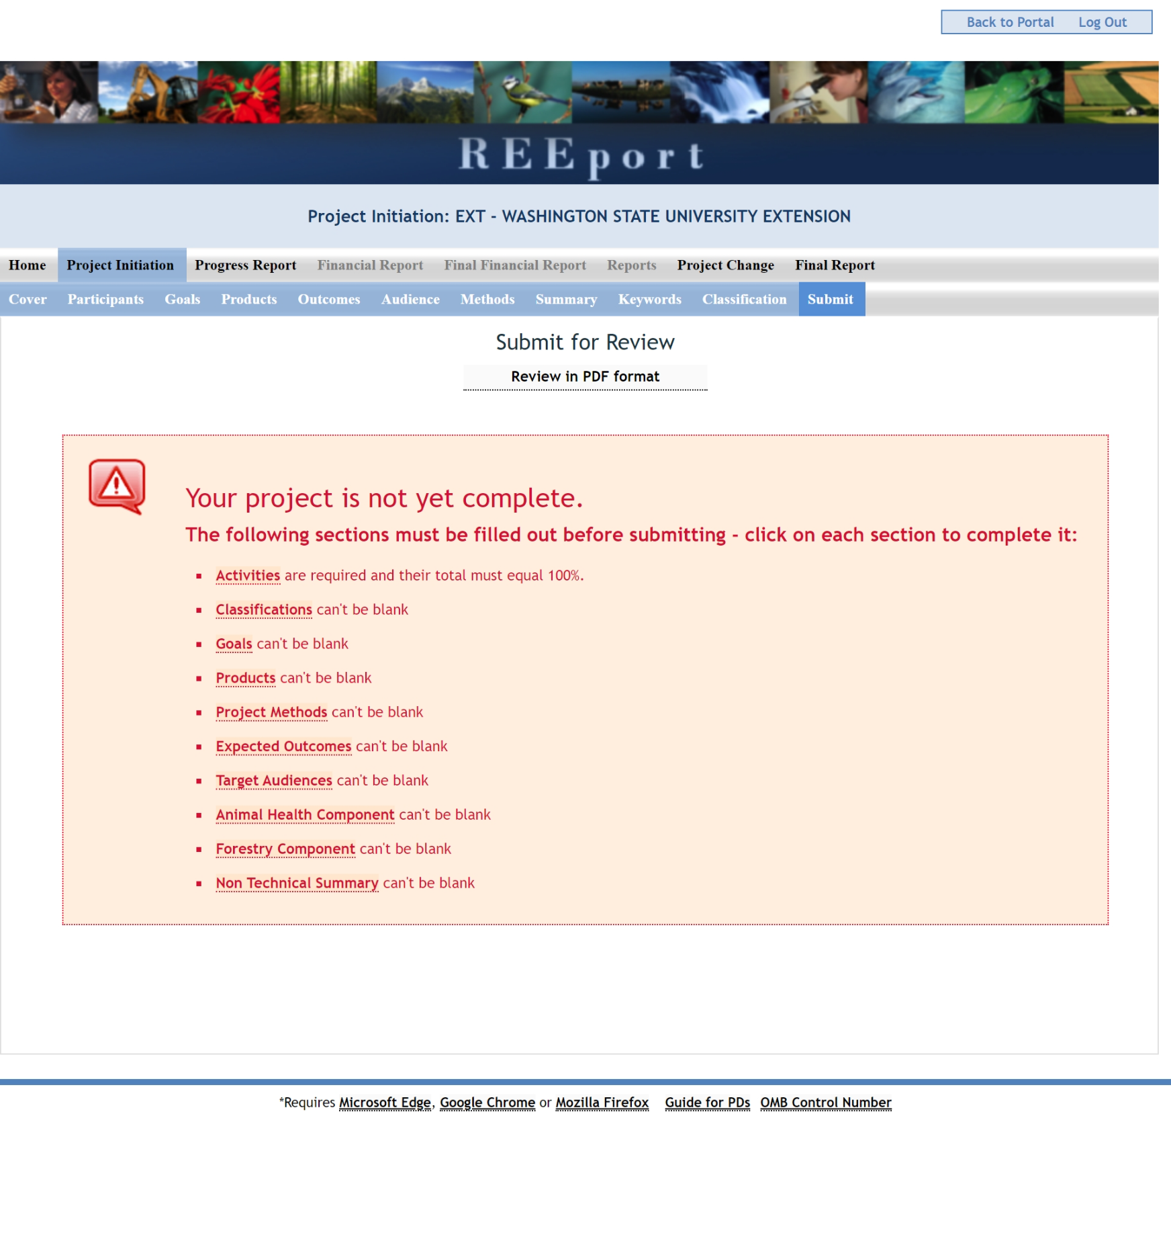
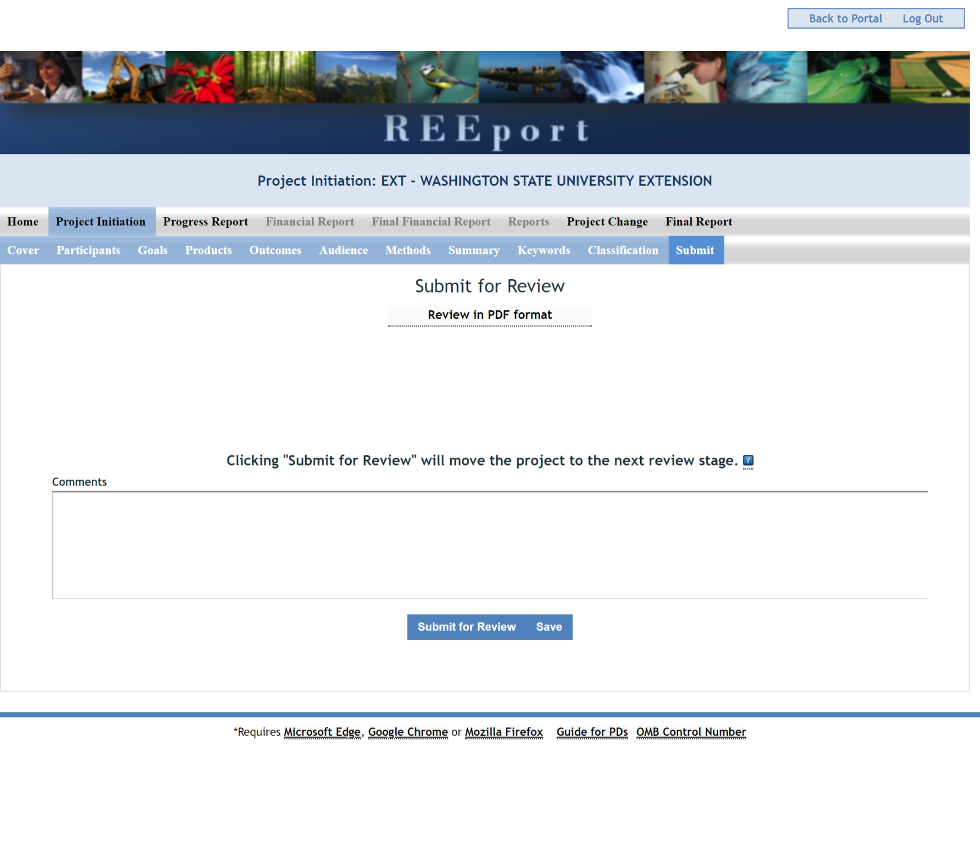

Progress Report Form Screenshots
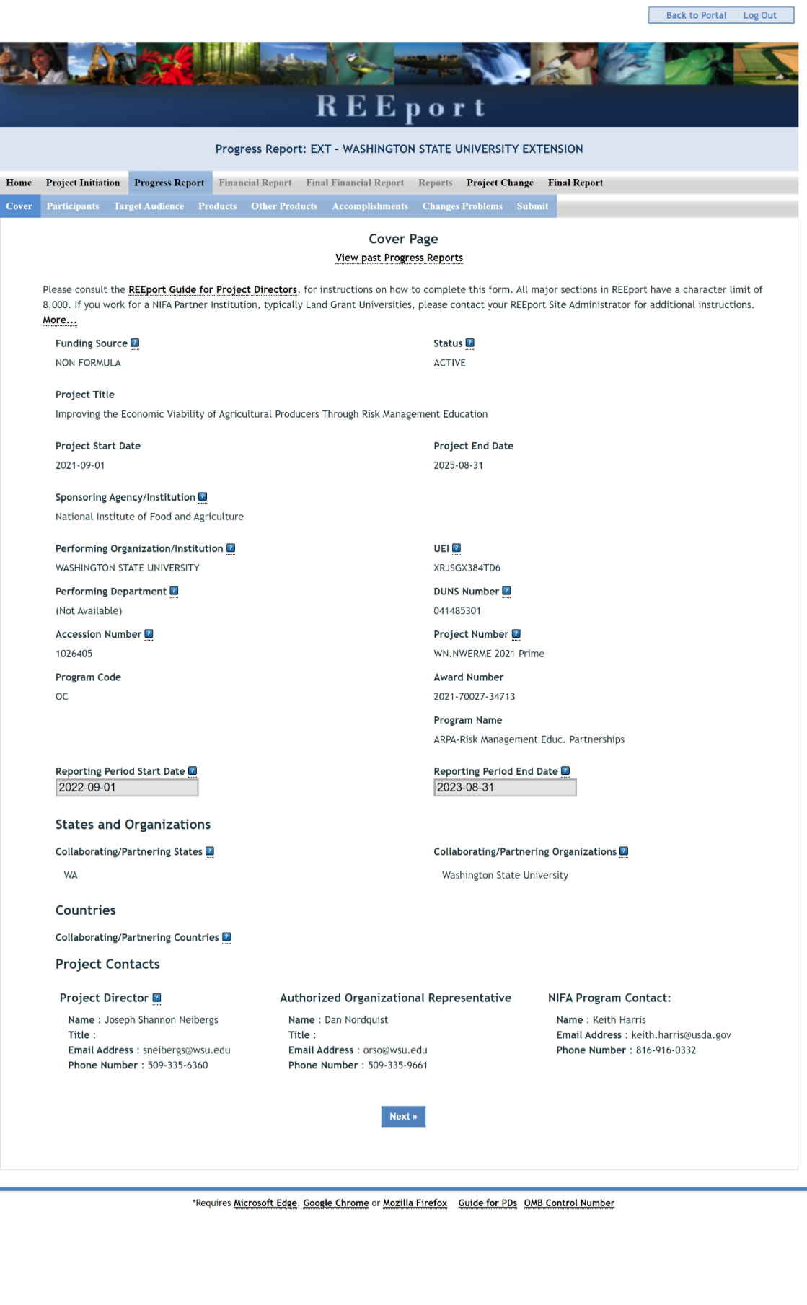
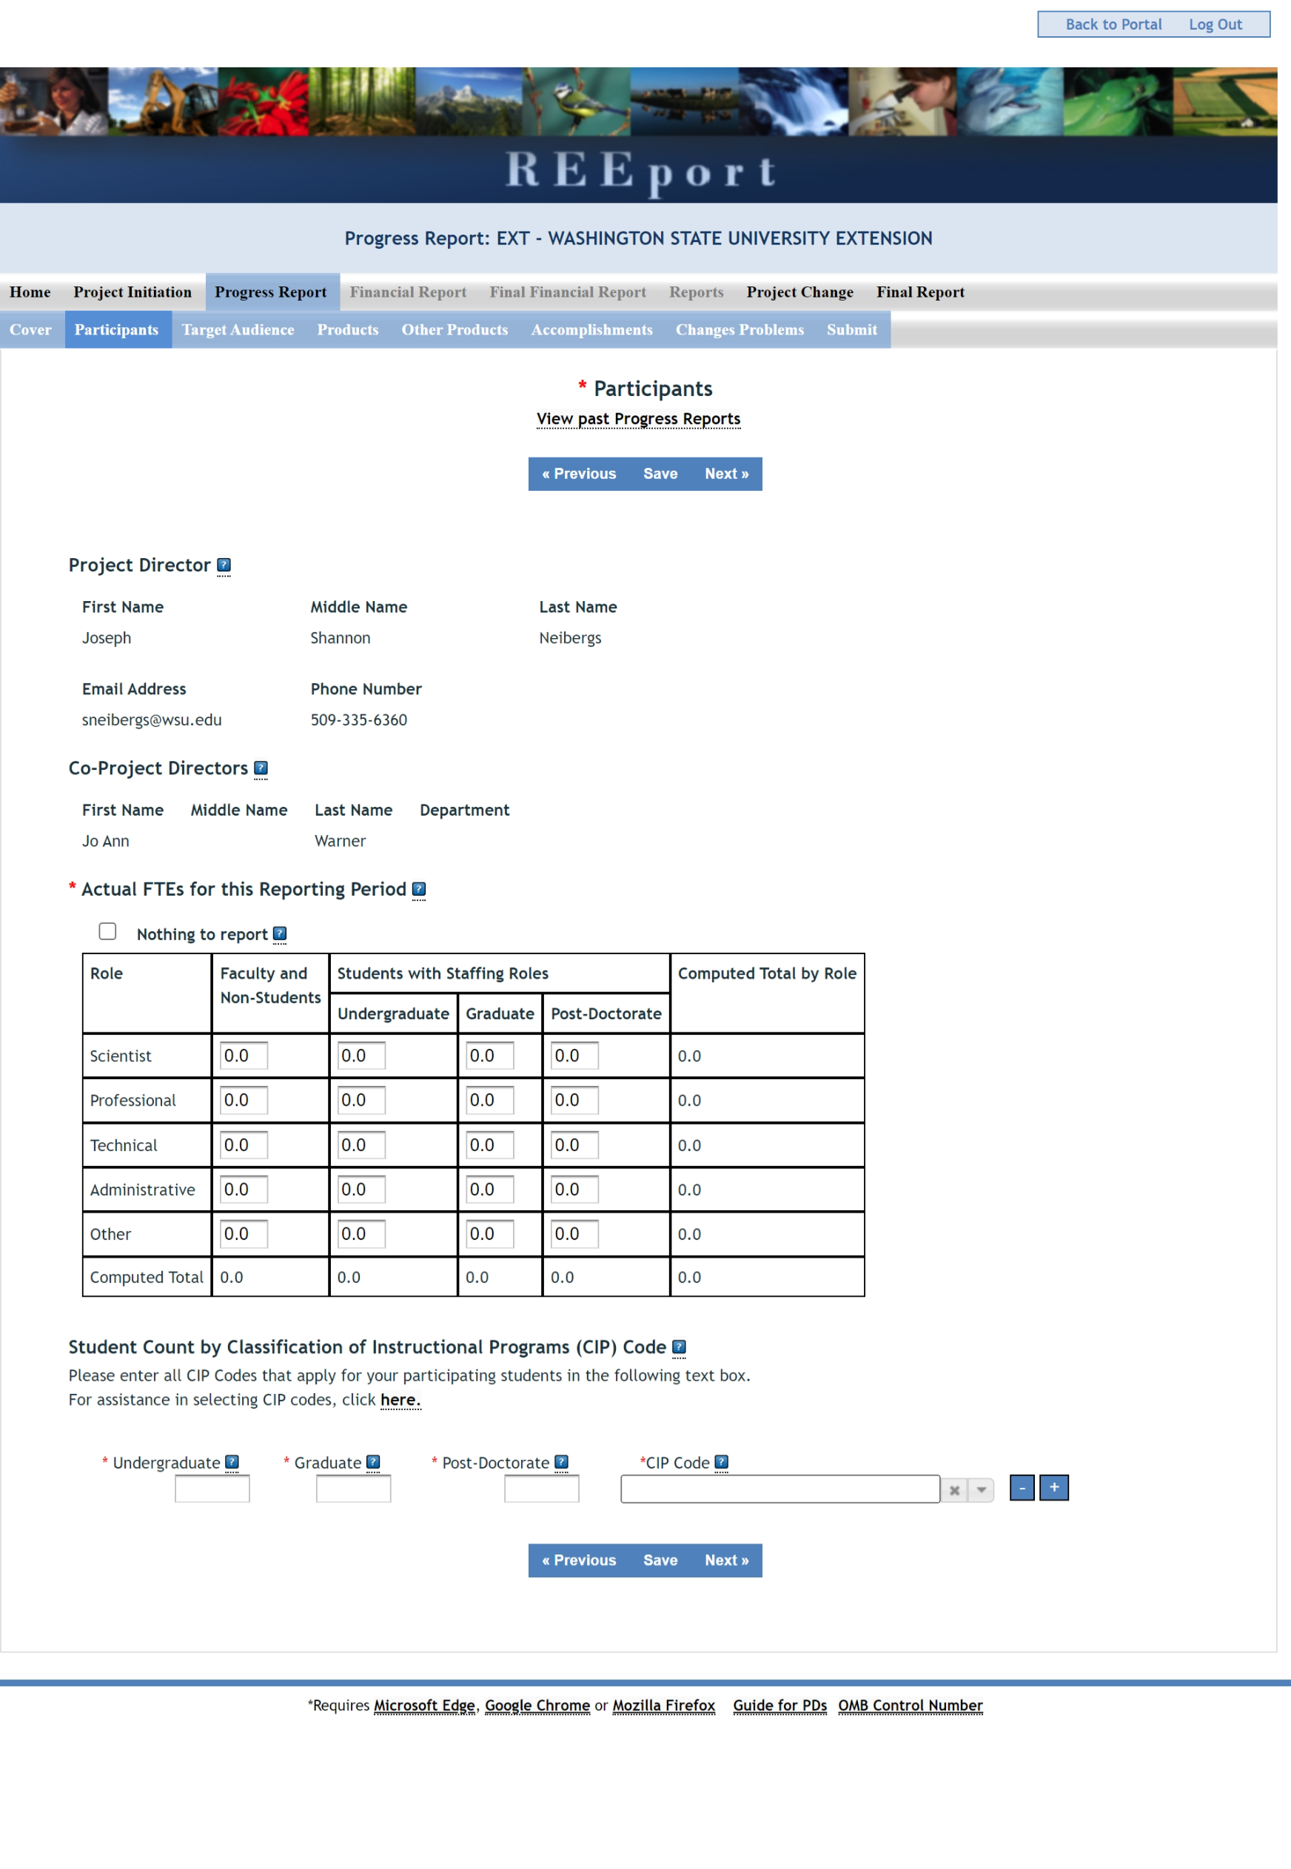
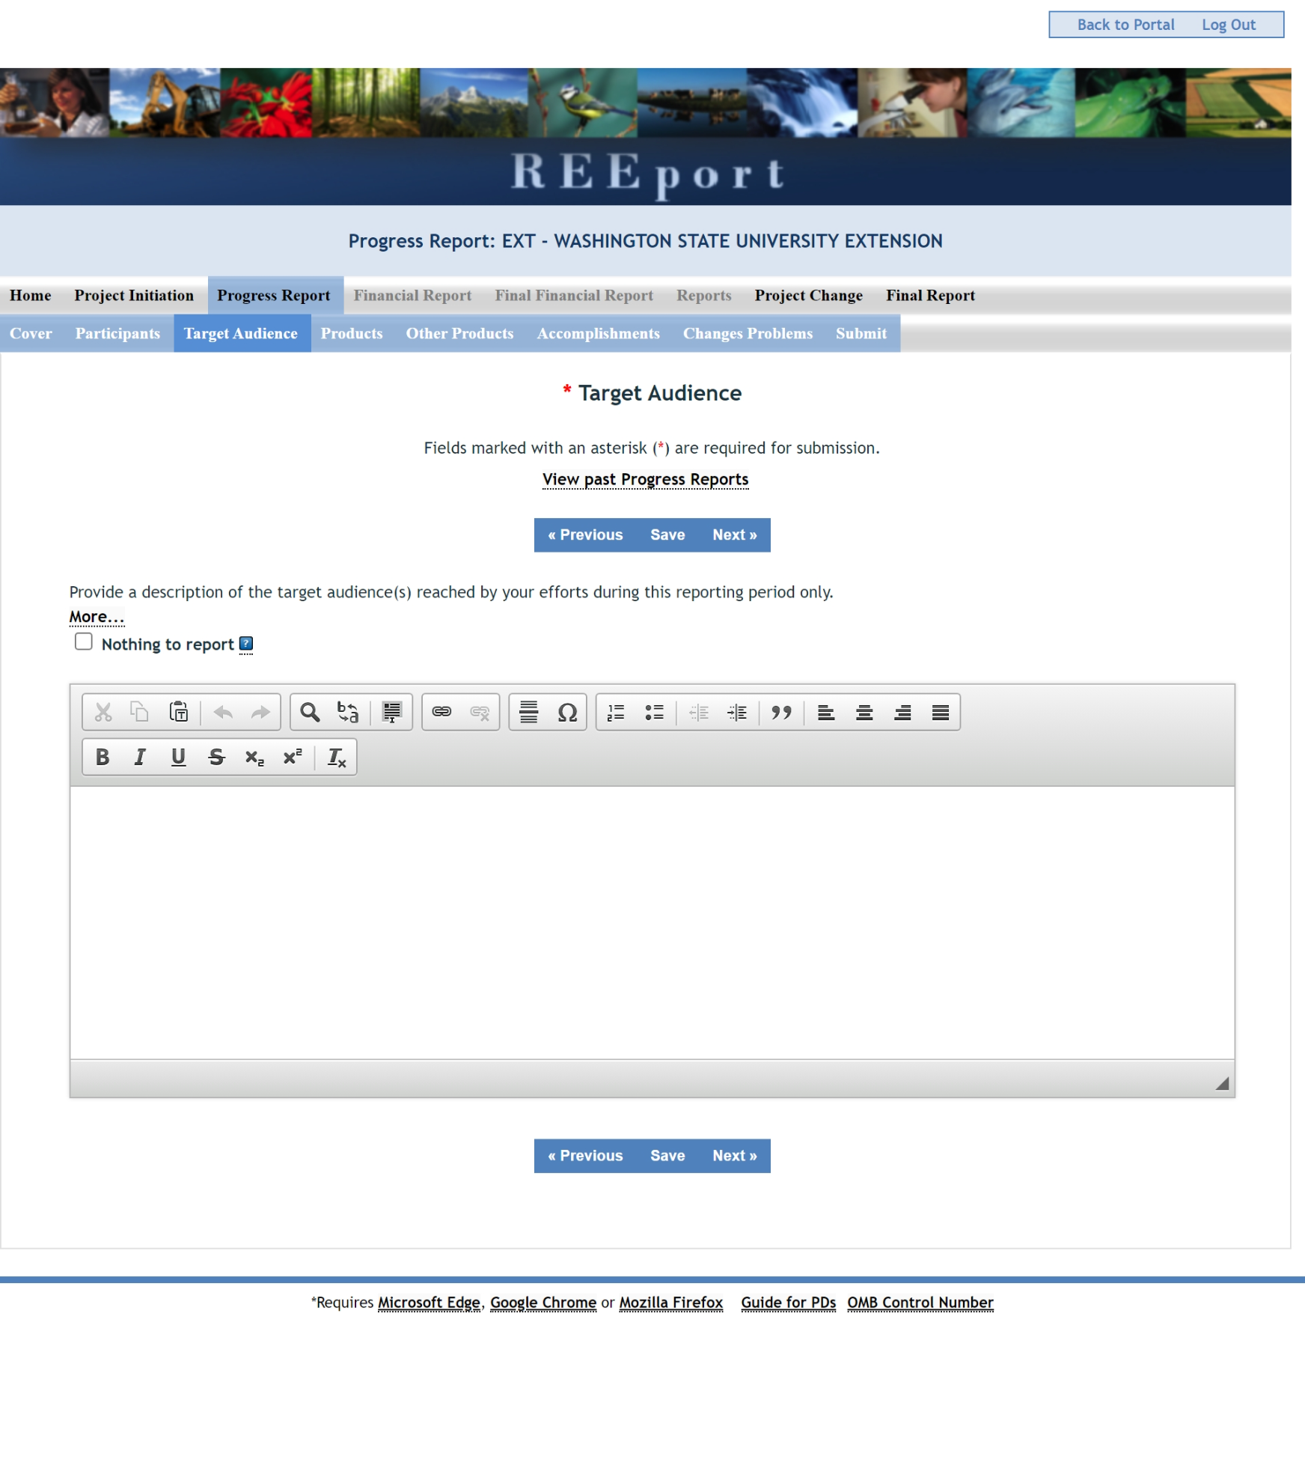

Revision:

On the Products page in the Progress Report tab, above the Publications section on the screen, a certification statement field will be added (see button labeled “Click here to complete the DR 1020-006 Certification Statement”):

I certify reporting for this project/program is in compliance with USDA DR 1020-006 concerning scholarly publications and data assets produced from extramural research supported wholly or in part by NIFA, for the current reporting period.
- Yes, any applicable scholarly publications have been submitted to the National Agricultural Library’s (NAL) PubAg and any applicable data assets have been submitted to NAL’s Ag Data Commons. These submissions included the NIFA grant or accession number and digital persistent identifiers for the publication or data asset (such as DOI) and the authors (such as ORCID).
- Yes, this project/program did not produce any scholarly publications during the reporting period and all data assets produced are exempt from DR 1020-006.
o N/A, this project/program did not produce any scholarly publications and data assets as defined by DR 1020-006 during the reporting period.
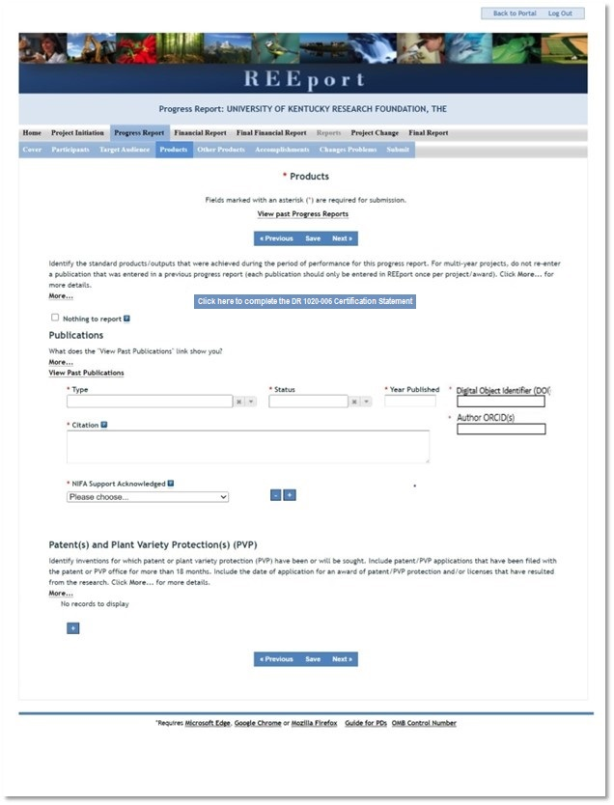
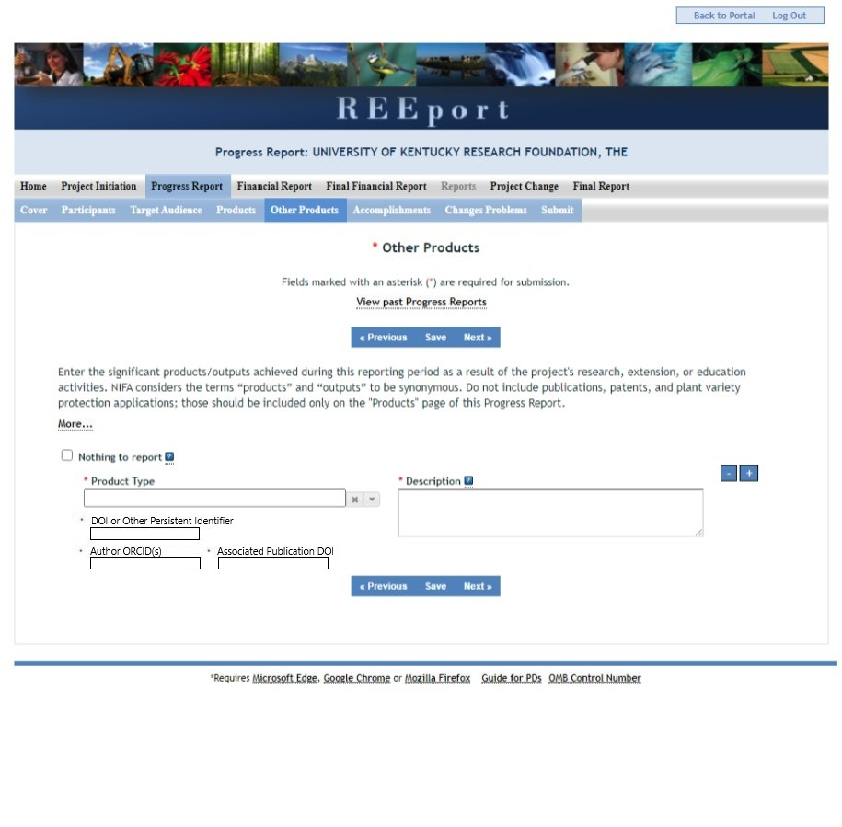

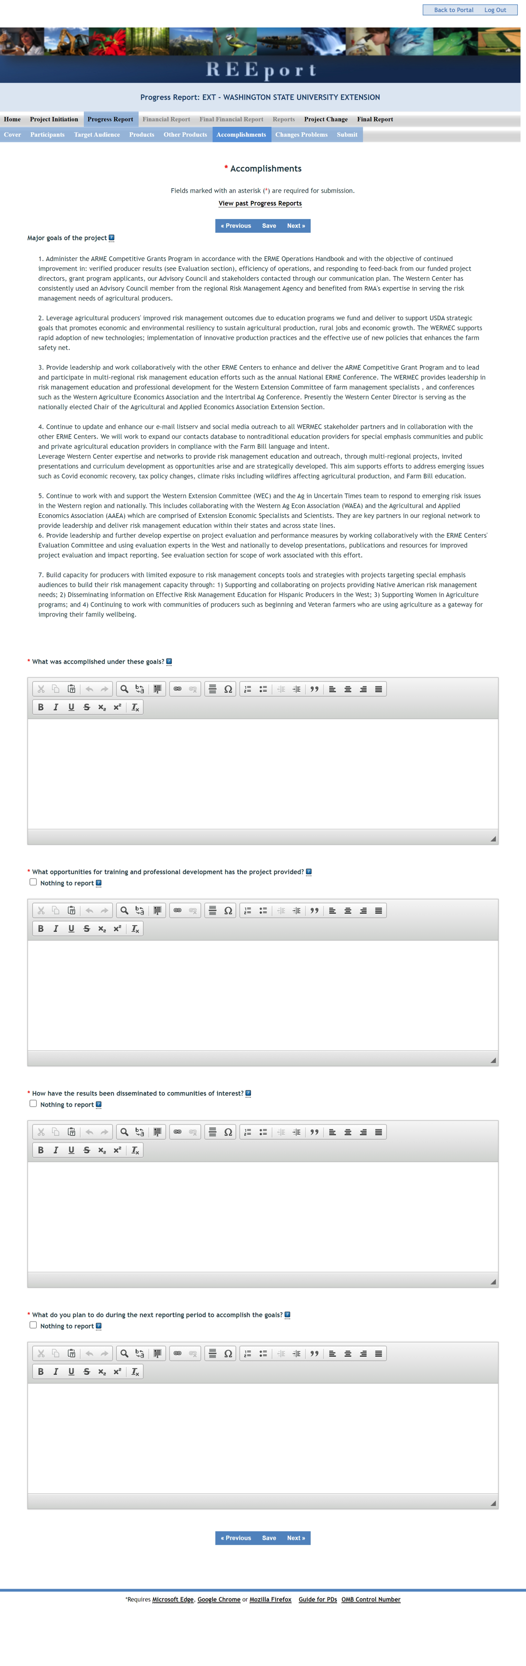
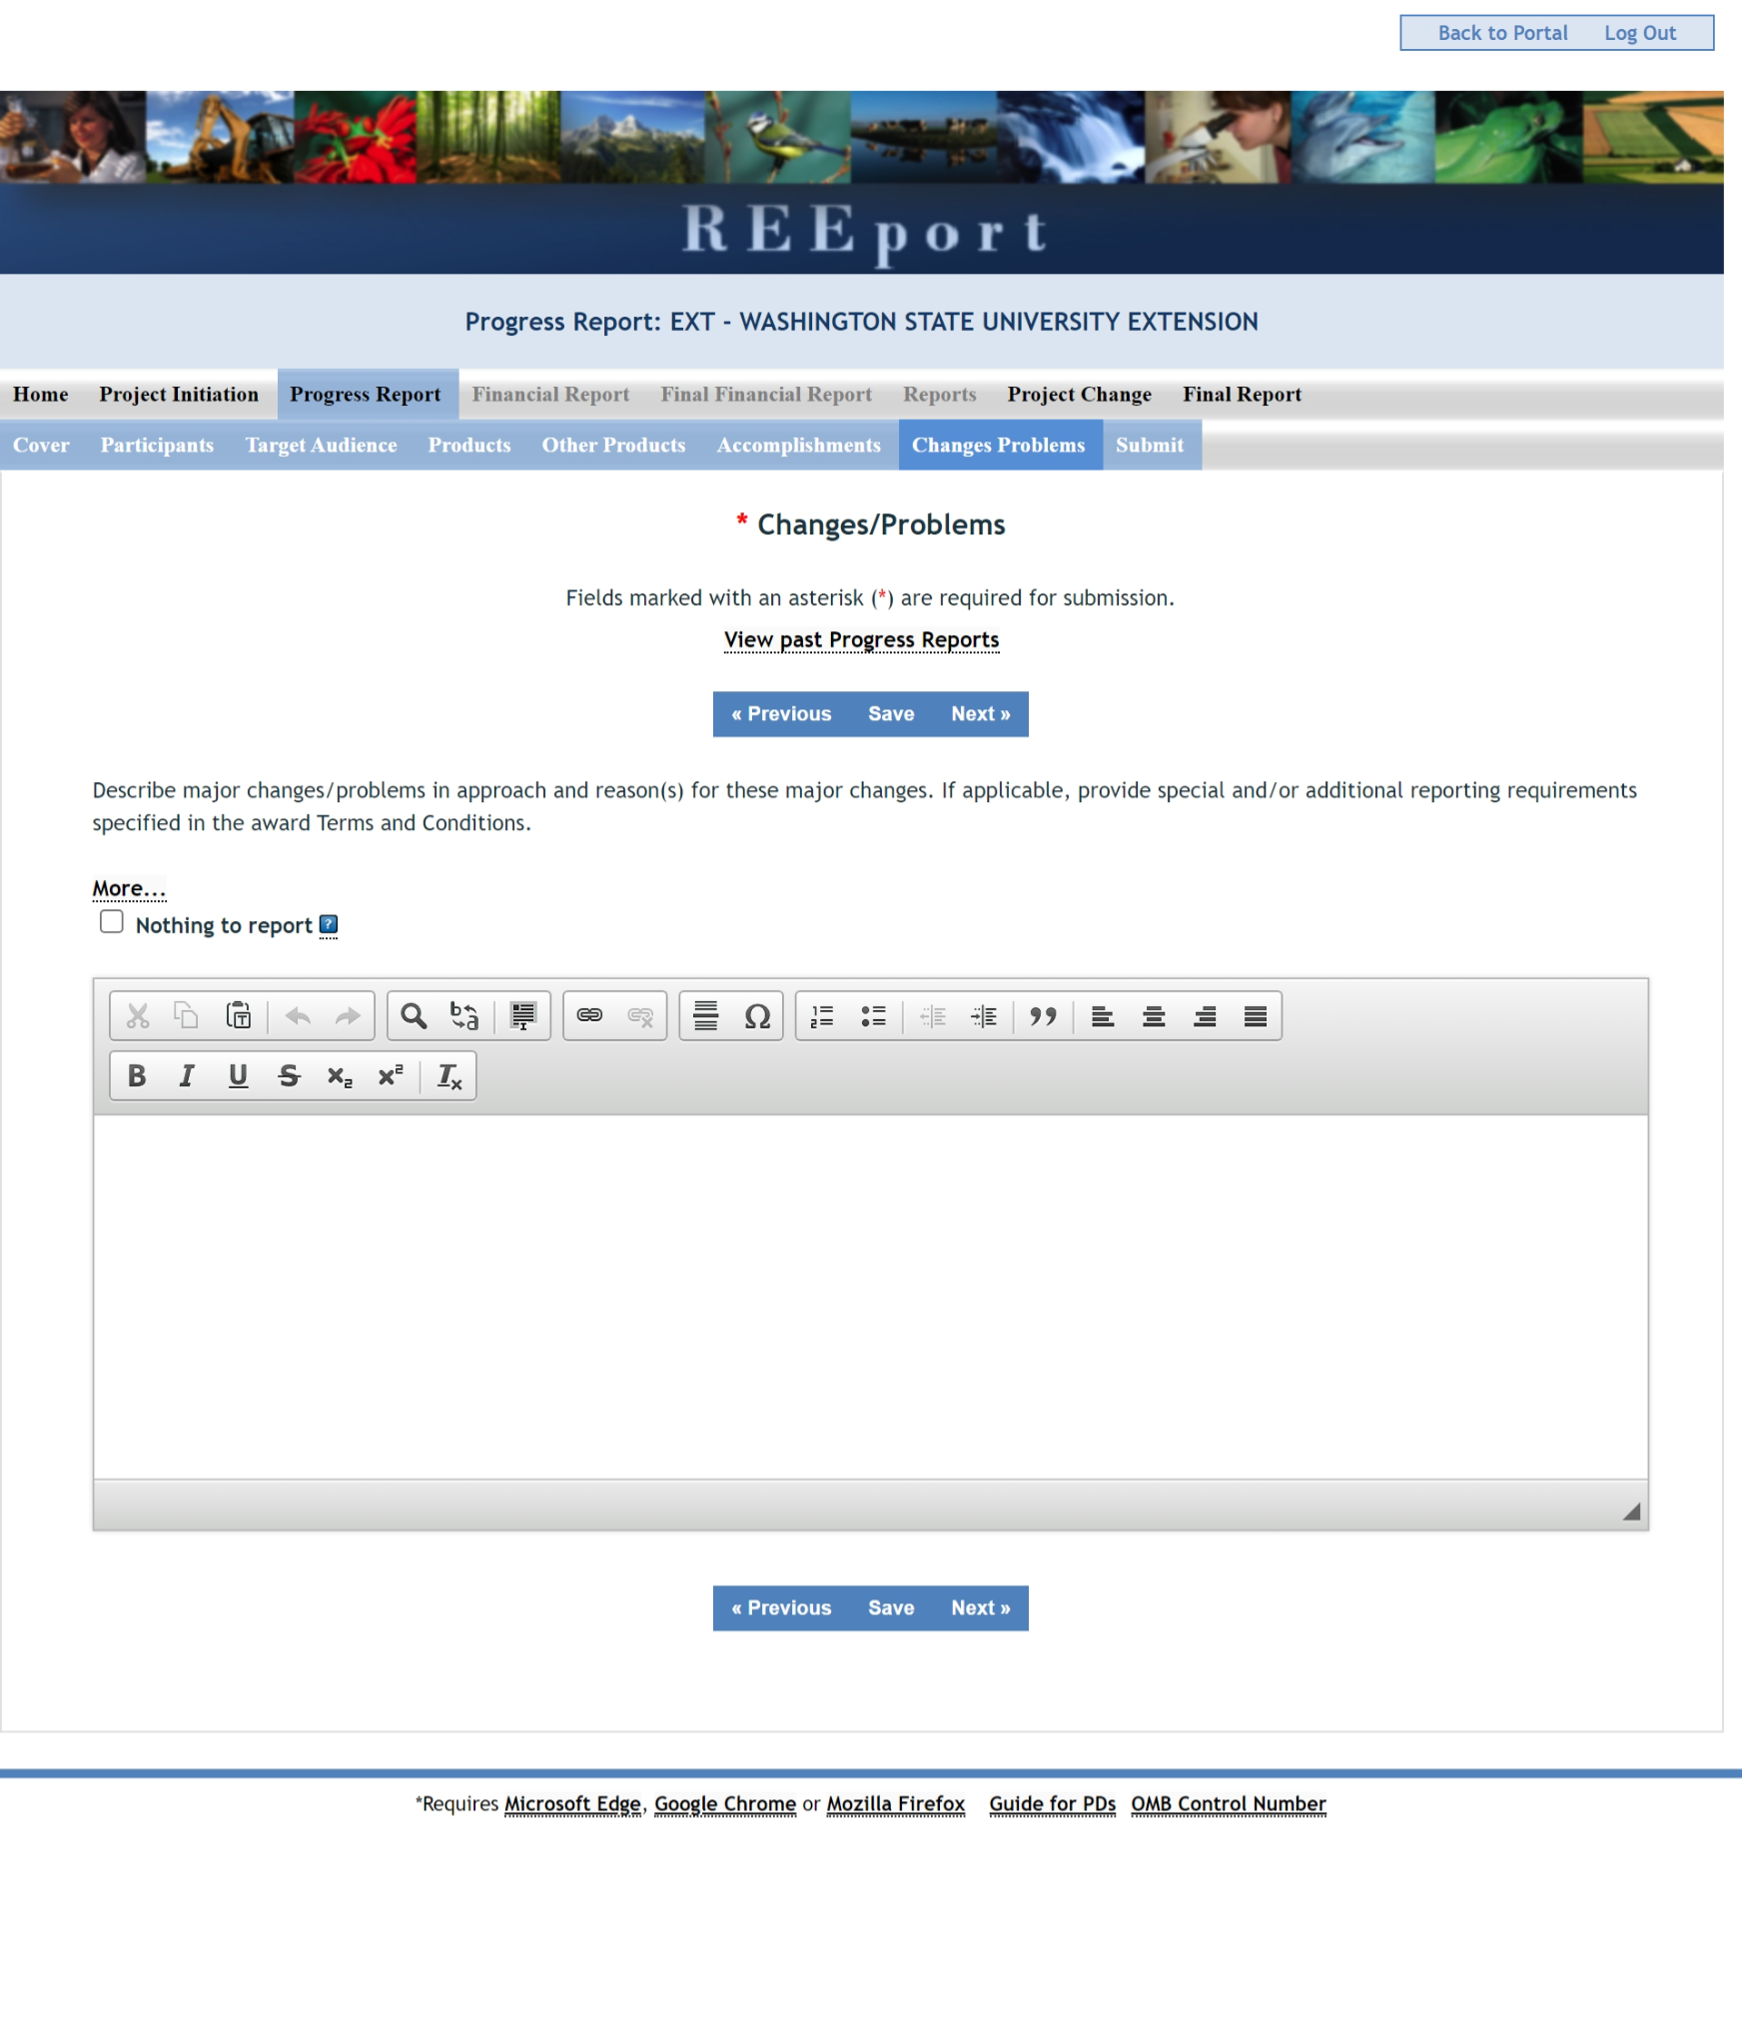
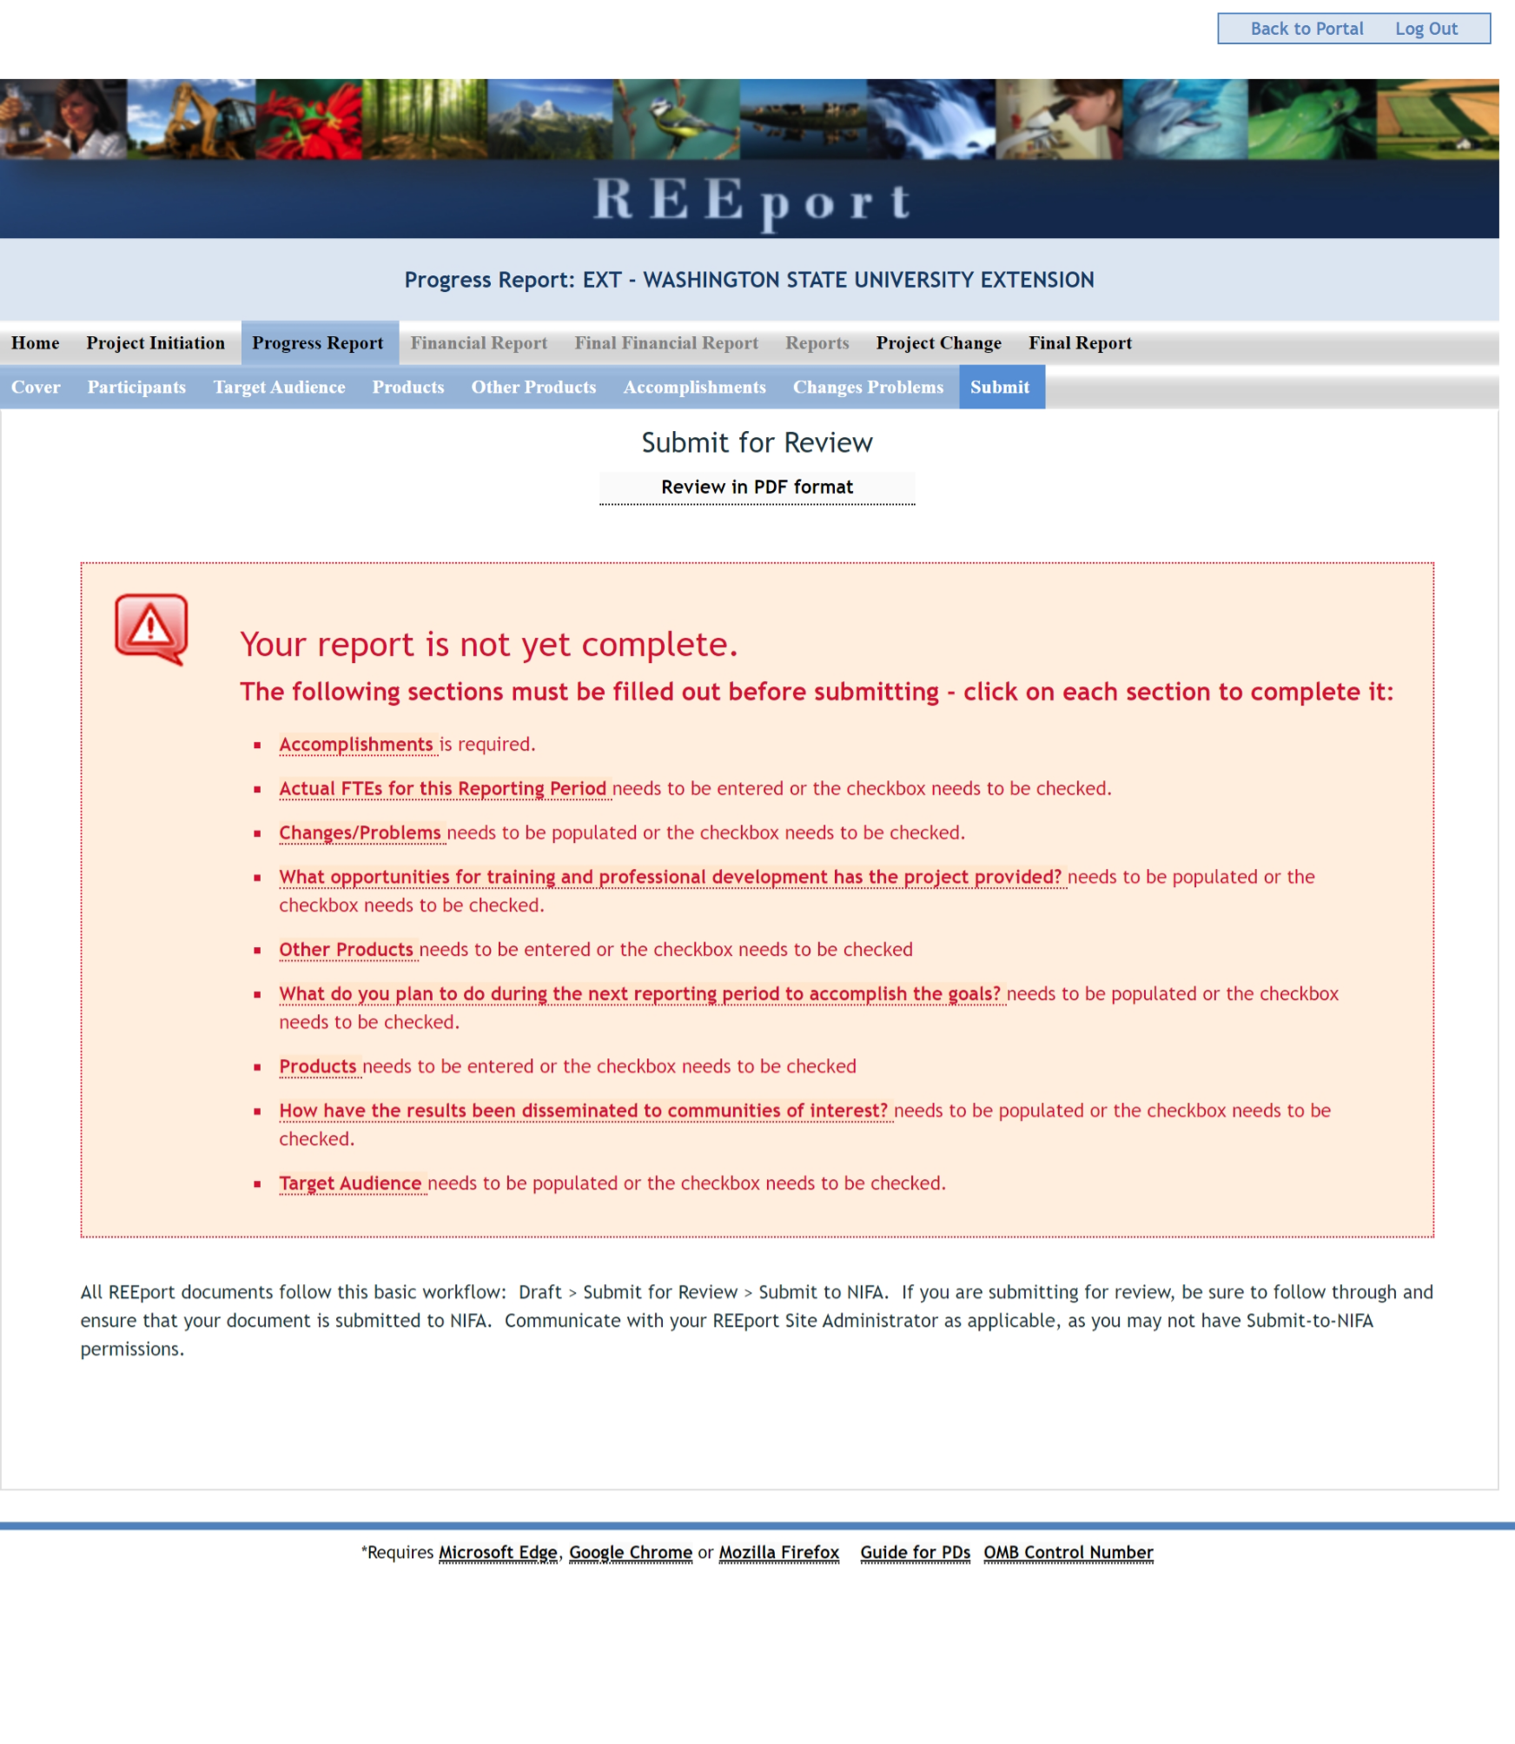
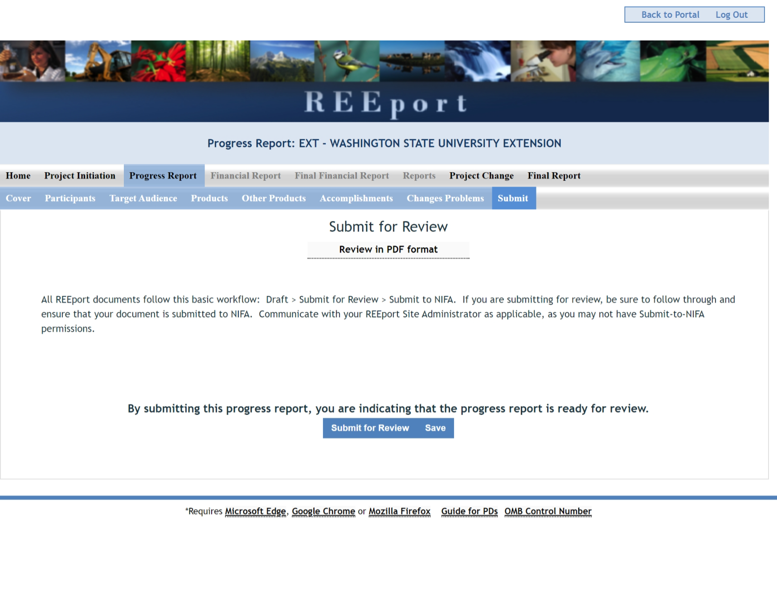

Final Report Form Screenshots
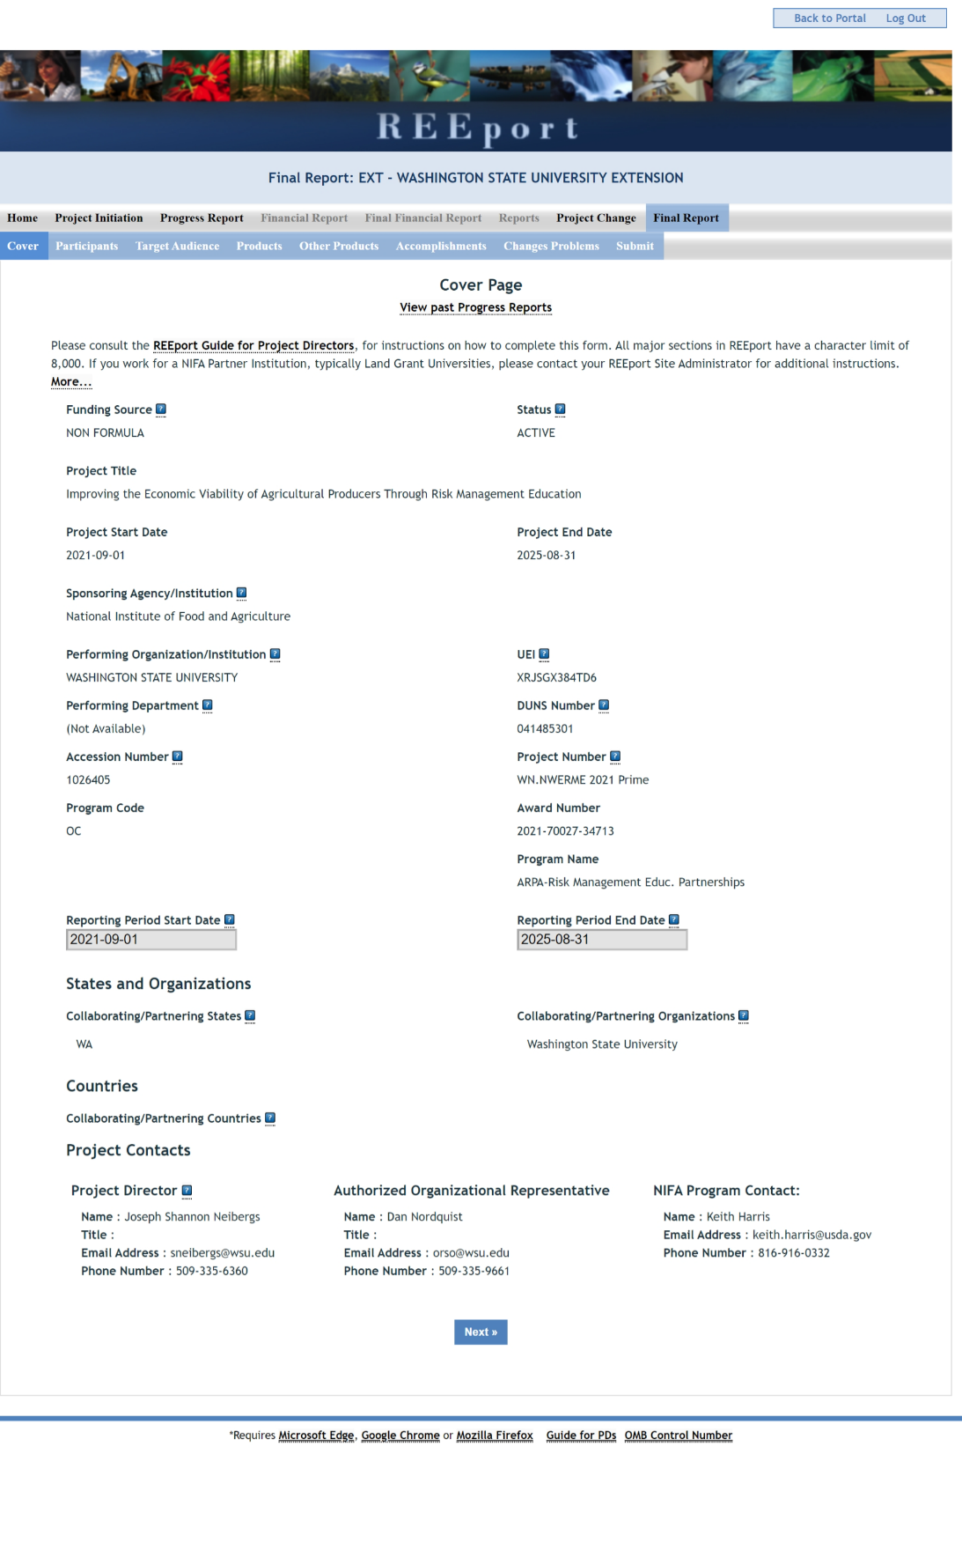
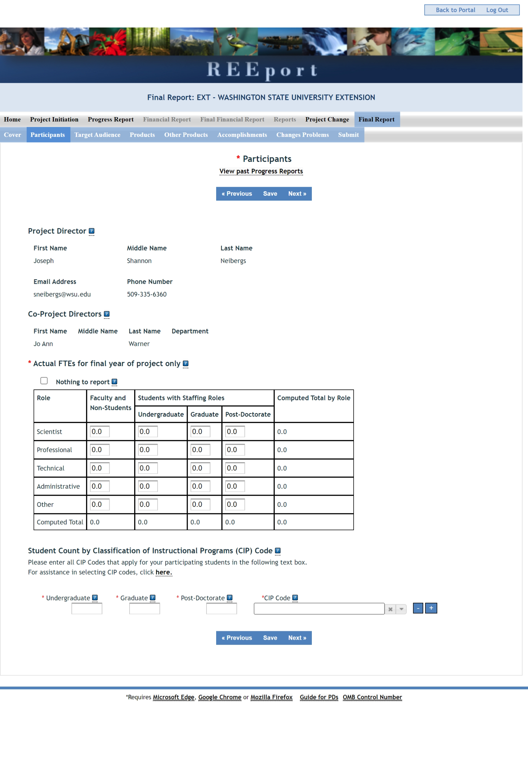
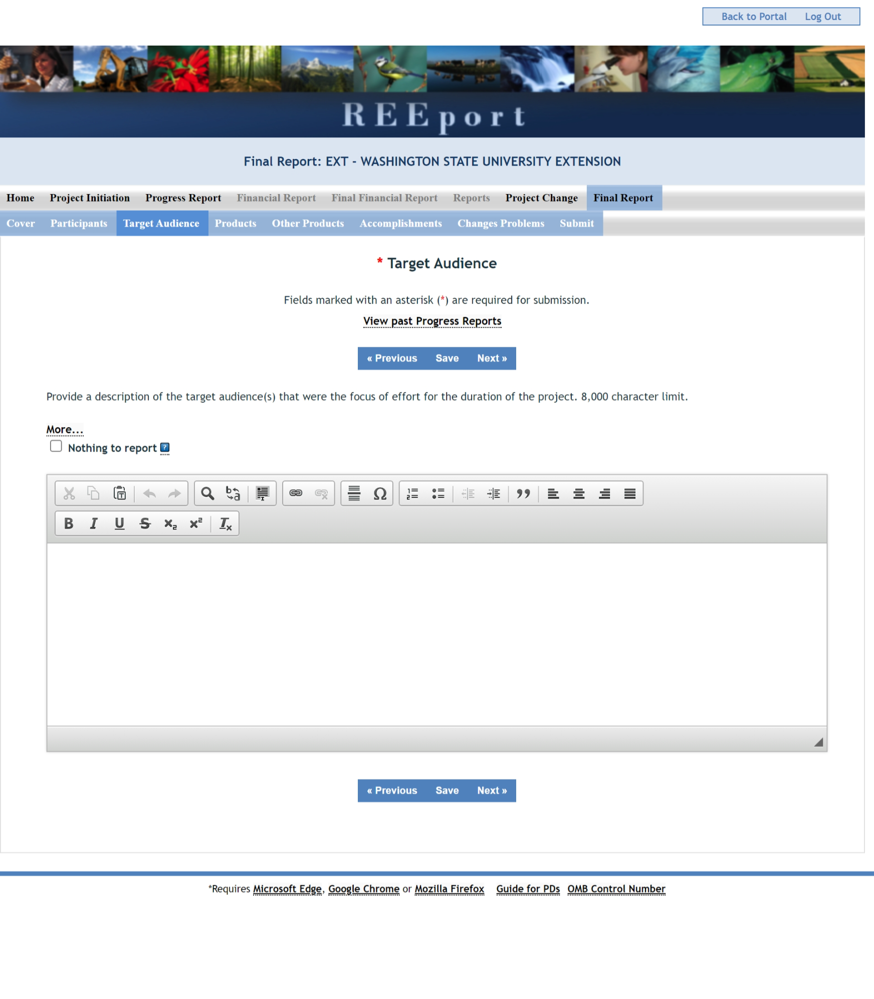

Revision:

On the Products page in the Final Report tab, above the Publications section, a certification statement will be added (see button labeled “Click here to complete the DR 1020-006 Certification Statement”):

I certify reporting for this project/program is in compliance with USDA DR 1020-006 concerning scholarly publications and data assets produced from extramural research supported wholly or in part by NIFA, for the current reporting period.
- Yes, any applicable scholarly publications have been submitted to the National Agricultural Library’s (NAL) PubAg and any applicable data assets have been submitted to NAL’s Ag Data Commons. These submissions included the NIFA grant or accession number and digital persistent identifiers for the publication or data asset (such as DOI) and the authors (such as ORCID).
- Yes, this project/program did not produce any scholarly publications during the reporting period and all data assets produced are exempt from DR 1020-006.
o N/A, this project/program did not produce any scholarly publications and data assets as defined by DR 1020-006 during the reporting period.
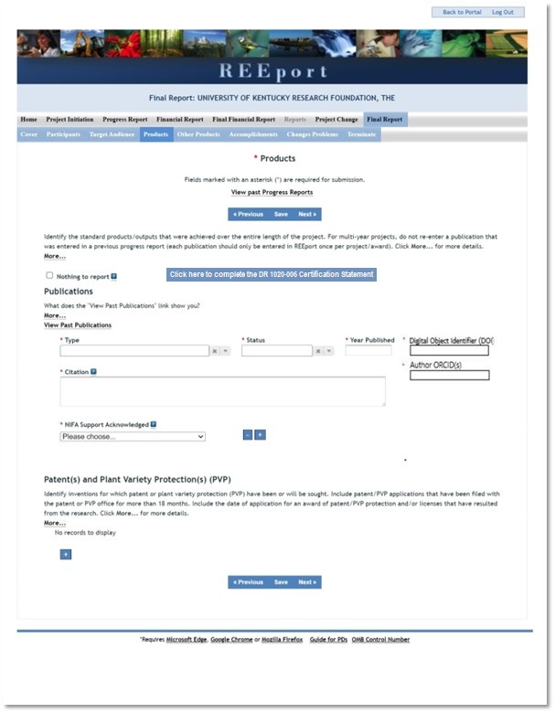

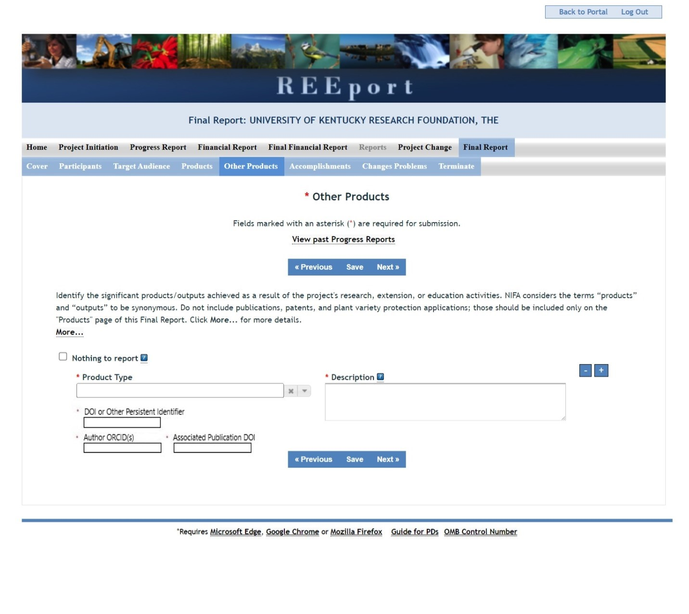

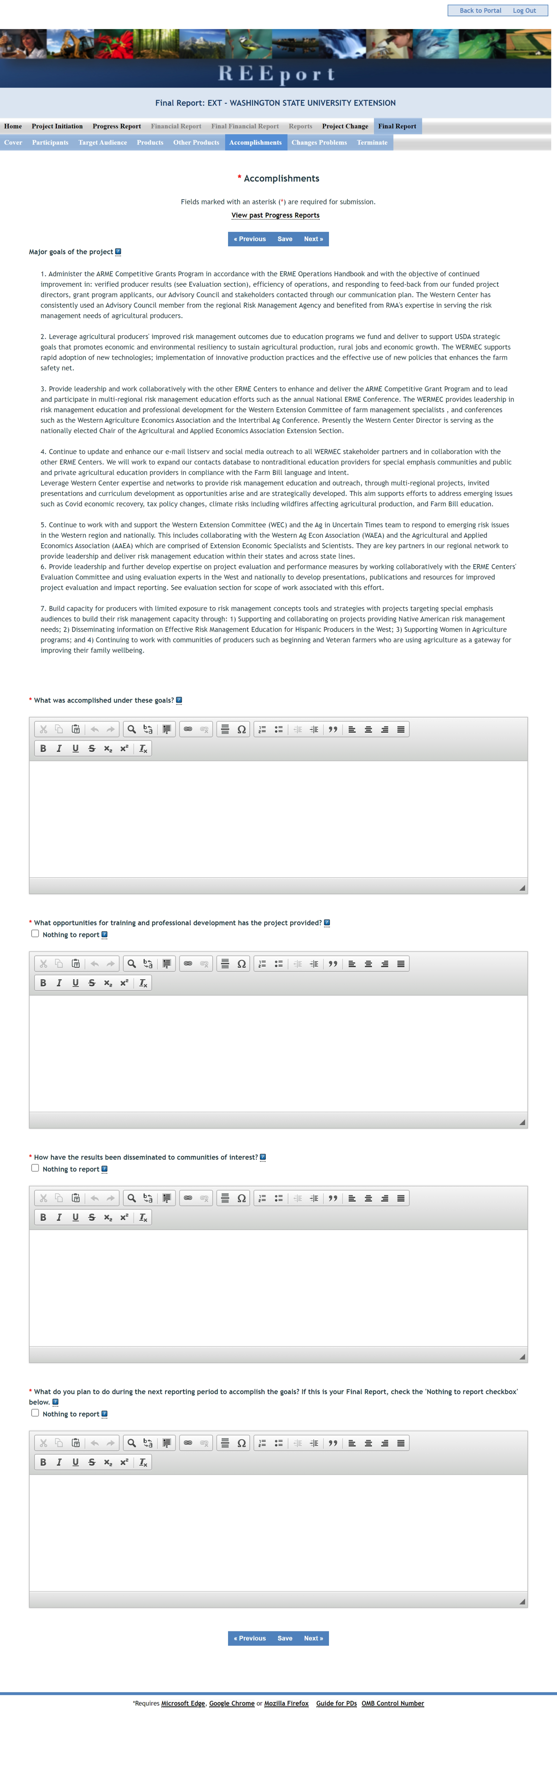

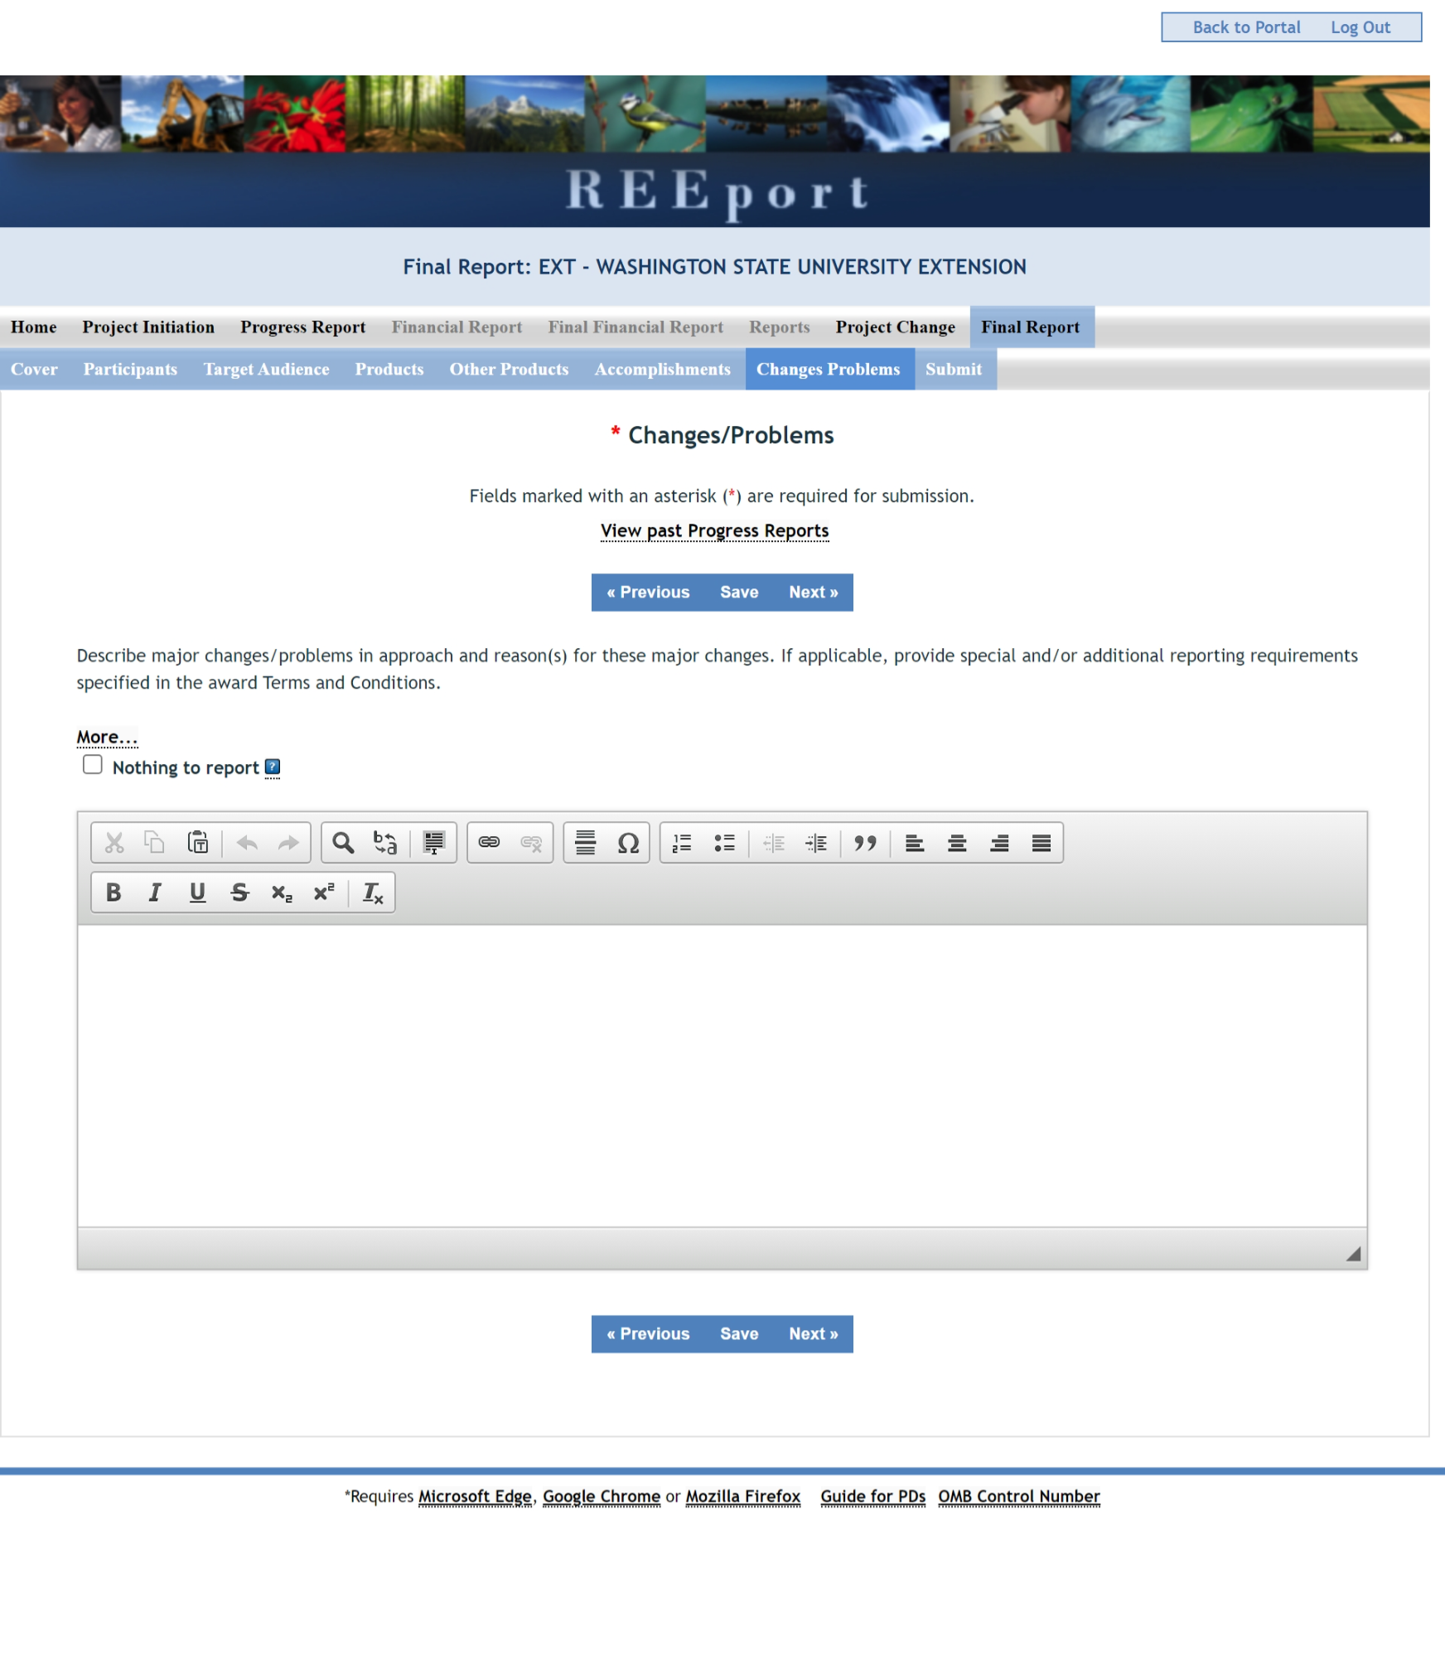
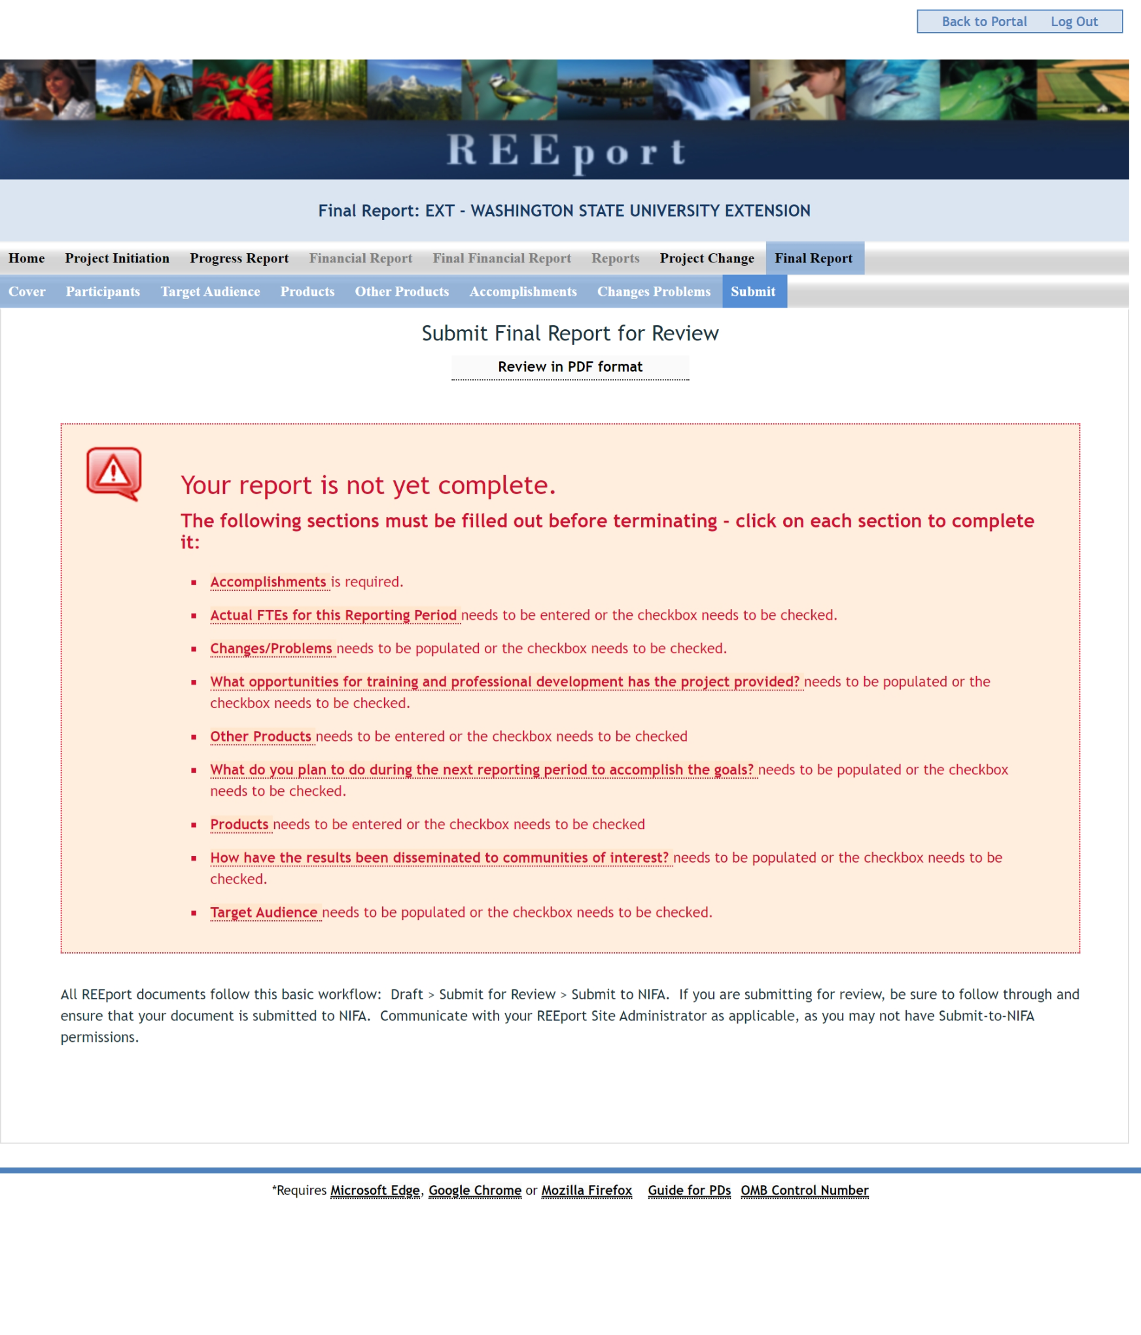
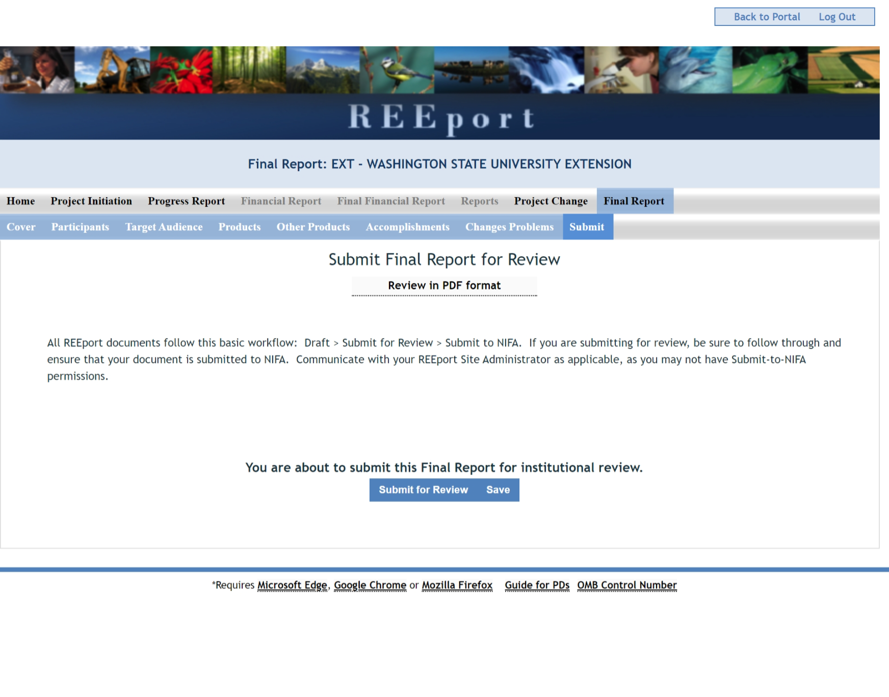

Financial Report Form Screenshots
