Supporting Statement – Part A

**MILK AND MILK PRODUCTS**

OMB No. 0535-0020

**A. JUSTIFICATION**

This is a request for continuing approval of the National Agricultural Statistics Service (NASS) milk and milk products information collection for another 3 years. The data collection procedures, definitions of the target populations, sample designs, and survey methodologies are essentially unchanged from the currently approved docket.

The Dairy Products Report is the only report of its kind that collects data on the utilization of milk. The report collects data on the types of products that milk is processed into (cheese, butter, ice cream, dry products, etc.) this information is used by numerous government agencies, manufacturers, cold storage facilities, importers, and exporters. The information is also used by NASS for our end of the year utilization reports.

The Milk Production Report collects data directly from farmers, most of which are covered by Federal Milk Orders that are administered by AMS. The NASS reports come out monthly and report the number of milk cows, average milk produced per cow and total milk production. This information is vital to predicting future milk production which helps in the stabilization of milk and dairy product prices. These data are also used in setting county estimates at the end of the year. This information is important in determining the total value of production by dairy farmers. This information can be used by RMA in determining insurance coverage for dairy farmers on a local basis.

This renewal will include program changes beginning with the January 2025 surveys. Every five years NASS conducts a program review following the completion of the Census of Agriculture. NASS considered public input requested through a program review announcement [released on Dec. 19, 2023](https://www.nass.usda.gov/Newsroom/Notices/2023/12-19-2023.php) for these changes.

The milk production program changes are summarized in the following Agricultural Statistics Board Notice: April 4, 2024 “NASS announces program changes following five-year review” at this link: <https://www.nass.usda.gov/Newsroom/Notices/2024/04-04-2024.php>

**1. Explain the circumstances that make the collection of information necessary. Identify any legal or administrative requirements that necessitate the collection. Attach a copy of the appropriate section of each statute and regulation mandating or authorizing the collection of information.**

The National Agricultural Statistics Service’s primary function is to prepare and issue official State and national estimates of crop and livestock production, disposition, and prices and to collect information on related environmental and economic factors. Estimates of milk production and manufactured dairy products are an integral part of this program. Milk and dairy statistics are used by the U.S. Department of Agriculture to help administer price support programs and by the dairy industry in planning, pricing, and projecting supplies of milk and milk products.

General authority for these data collection activities is granted under U.S. Code Title 7, Section 2204. The legislative actions which affect these surveys are from November 2000, when Congress enacted the “Dairy Market Enhancement Act of 2000," U.S. Code Title 7, Section 1621, and Public Law 106-532 which changed the program from voluntary to mandatory for reporting the moisture content of cheddar cheese plus the price and quantity of cheddar cheese, butter, non-fat dry milk, and dry whey.

Amendments have been published to the Agricultural Marketing Act of 1946 in conformance with legislated changes enacted by the Dairy Market Enhancement Act of 2000 and the Farm Security and Rural Development Act of 2002. The amendments established a program of mandatory dairy product information reporting. The program requires each manufacturer to report to the USDA information concerning the price, quantity, and moisture content of dairy products sold by the manufacturer. In addition, entities storing dairy products are to report information on the quantity of dairy products stored. Any manufacturer or other entity that processes, markets, or stores less than 1,000,000 pounds of dairy products per year are exempt. The program will provide timely, accurate, and reliable market information; facilitate more informed marketing decisions; and promote competition in the dairy product manufacturing industry.

In April 2012 the authority for collecting Dairy Product Prices was moved from NASS to the Agricultural Marketing Service (AMS). NASS will continue to collect milk production and manufactured dairy product data under this OMB approval. The collection of fluid milk prices by NASS from milk receiving plants is collected under OMB number 0535-0003.

**2. Indicate how, by whom, and for what purpose the information is to be used. Except for a new collection, indicate the actual use the agency has made of the information received from the current collection.**

Statistics on milk production and manufactured dairy products are used by the U.S. Department of Agriculture to carry out the National Dairy Support Program. The Agriculture Act of 1949, as amended (7 U.S.C. 1446) states that "The price of milk shall be supported at such level ... as the Secretary determines necessary in order to assure an adequate supply of pure and wholesome milk to meet current needs … such price support shall be provided through purchases of milk and the products of milk."

Estimates of total milk production, number of milk cows, and milk production per cow are used extensively by the dairy industry in planning, pricing, and projecting supplies of milk and milk products. The Agriculture and Consumer Protection Act of 1973 (PL 93-86) directed the Secretary of Agriculture to conduct cost of production studies for certain commodities including milk. These data are used by the USDA’s Economic Research Service (ERS) to update the Cost of Production estimates. Plant receipts of milk by State of origin and milk tests are also used as benchmarks for cash income from dairy farming. In 2022, U.S. dairy farmers produced 226 billion pounds of milk, worth $57.3 billion. The annual average number of milk cows on farms in 2022 was 9.40 million head. The rate of milk production per cow was 24,087 pounds in 2022. The USDA Foreign Agricultural Service uses NASS production data to develop export incentive programs.

Secretary of Agriculture has the authority to change price support levels based on "trigger" purchases. NASS production data is used to identify trends and predict when the "trigger" purchase point will occur.

Manufactured dairy products statistics are collected monthly and used by USDA to establish monthly estimates of stocks, shipments, and prices received for such products as butter, cheese, dry whey, and nonfat dry milk. Under Public Law 106-532, facilities storing more than 1,000,000 pounds of human grade nonfat dry milk or dry whey are required to complete this report monthly. Response to this survey by all other manufacturing dairy plants is voluntary. These data are used by the USDA to assist in the determination of the fair market value of raw milk. The Economic Research Service (ERS) puts together per capita consumption of all dairy products, including ice cream, using NASS data.

The price of milk is supported by the Agricultural Commodities Act which is administered by USDA’s Agricultural Marketing Service (AMS). This price is supported through the purchase of manufactured dairy products. The principal products that are purchased at support levels are butter, nonfat dry milk, and cheese. NASS publishes statistics on major manufactured dairy products to illustrate how milk produced in the United States is utilized. In 2022, the U.S. dairy manufacturers produced 14.1 billion pounds of total cheese (excluding cottage cheese), 2.06 billion pounds of butter, 2.63 billion pounds of dry milk powder, 915 million pounds of dry whey, and 1.44 billion gallons of frozen products (ice cream, sherbet, and frozen yogurt).

**3. Describe whether, and to what extent, the collection of information involves the use of automated, electronic, mechanical, or other technological collection techniques or other forms of information technology, e.g., permitting electronic submission of responses, and the basis for the decision for adopting this means of collection. Also describe any consideration of using information technology to reduce burden.**

Nearly all of NASS information collections include a web-based data collection mode, which NASS calls “electronic data reporting” or EDR. The remaining surveys that do not make use of EDR are too infrequent or impractical to use that mode of data collection.

The Quarterly Milk Production Survey is mailed out to the respondents. Farmers can reply by either the internet or by mailing the paper questionnaire back to one of our Regional Field Offices. After the first week of data collection, if the respondent does not reply, NASS will attempt to collect the data by either a Computer Assisted Telephone Interview (CATI) or a Computer Assisted Personal Interview (CAPI).

Respondents to the monthly Manufactured Dairy Products survey now have the option of completing the survey either by internet, a computer assisted telephone interview or by paper; whichever method they choose. The annual Manufactured Dairy Products survey is not available on the internet.

The main portal for our on-line surveys is <https://portal.agcounts.usda.gov/portal/s/>.

Respondents are mailed an instruction sheet on how to reach this site along with the survey questionnaire. Once there, the respondents must enter the valid survey code and their own personalized user ID, which is printed on the label of the questionnaire that was mailed to them.

Approximately 5.1% of the dairy farmers responded by internet to the quarterly Milk Production survey. Approximately 52% of the dairy plants who are required to report monthly to the Manufactured Dairy survey do it by internet. Approximately 19% of the voluntary respondents to the Manufactured Dairy survey responded by internet. Overall, there was an 11.0% response rate by internet.

**4. Describe efforts to identify duplication. Show specifically why any similar information already available cannot be used or modified for use for the purposes described in Item 2 above.**

NASS cooperates with State Departments of Agriculture and land grant universities to conduct agricultural surveys. Published data reports for milk receipts and manufactured dairy products complement and subsidize dairy related data collected by the Agricultural Marketing Service. This cooperation eliminates duplication of data gathering by two agencies.

**5. If the collection of information impacts small businesses or other small entities (Item 5 of OMB Form 83-I), describe any methods used to minimize burden.**

Information requested on the quarterly milk production inquiries can be provided with a minimum amount of difficulty by the respondent and generally without having to consult their record books. During the spring classify period, NASS reviews the population, stratification, and sampling for all surveys. During this process NASS reviews sample sizes to make sure that samples are kept at a minimum while still allowing for statistically sound estimates representing the US farm population.

Respondents can complete the manufactured dairy products questionnaires from their normal day-to-day operating records. Operations that produce small quantities or produce only on a seasonal basis may request the annual survey that they can complete at the end of the year rather than having to reply monthly.

Approximately 78% of the total sample is estimated to be classified as small operations.

**6. Describe the consequence to Federal program or policy activities if the collection is not conducted or is conducted less frequently, as well as any technical or legal obstacles to reducing burden.**

Less frequent data collection would eliminate data needed to keep the

Government and agricultural industry and other data users abreast of changes at the State and National levels. Timing and frequency of the various reports dependent on these surveys have evolved to meet the needs of government and the industry while minimizing the burden on the reporting public.

**7. Explain any special circumstances that would cause an information collection to be conducted in a manner inconsistent with the general information guidelines in 5 CFR 1320.5.**

There are no special circumstances associated with this information collection.

**8. Provide a copy and identify the date and page number of publication in the Federal Register of the agency's notice, required by 5 CFR 1320.8 (d), soliciting comments on the information collection prior to submission to OMB. Summarize public comments received in response to that notice and describe actions taken by the agency in response to these comments.**

The Federal Register Notice soliciting comments was published on December 5, 2023, on pages 84301-84302. No public comment was received.

**Describe efforts to consult with persons outside the agency to obtain their views on the availability of data, frequency of collection, the clarity of instructions and record-keeping, disclosure, or reporting format (if any), and on the data elements to be recorded, disclosed, or reported.**

NASS consults with other government agencies such as the Agricultural Marketing Service (AMS), Economic Research Service (ERS), and Animal and Plant Health Inspection Service (APHIS) on a regular basis. Other groups consulted are the Dairy Herd Improvement Association (DHIA) and Marketing Associations. There are extensive meetings with representatives from the dairy industry to accurately assess requirements. NASS invites comments from respondents on all data collection instruments.

The following individuals have provided input on many of the NASS renewals.

Katelyn McCullock, Director

Livestock Marketing Information Center

303-716-9936 - [www.lmic.info](http://www.lmic.info)

Bill Lapp

Advanced Economic Solutions

[Bill@aesresearch.com](mailto:Bill@aesresearch.com)

402-980-1164

Roger Cryan, Chief Economist

American Farm Bureau Federation

202-406-3729 w

[www.fb.org](http://www.fb.org)

[rogerc@fb.org](mailto:rogerc@fb.org)

**9. Explain any decision to provide any payment or gift to respondents.**

There are no payments or gifts to respondents.

**10. Describe any assurance of confidentiality provided to respondents and the basis for the assurance in statute, regulation, or agency policy.**

Questionnaires include a statement that individual reports are confidential. U.S. Code Title 18, Section 1905; U.S. Code Title 7, Section 2276; and Title III of Pub. L. No. 115-435 (CIPSEA) provide for confidentiality of reported information. All employees of NASS and all enumerators hired and supervised under a cooperative agreement with the National Association of State Departments of Agriculture (NASDA) must read the regulations and sign a statement of compliance.

Additionally, NASS employees and NASS contractors comply with the OMB implementation guidance document, “Implementation Guidance for Confidential Information Protection and Statistical Efficiency Act of 2018, Title III of Pub. L. No. 115-435, codified in 44 U.S.C. Ch. 35” CIPSEA supports NASS’s pledge of confidentiality to all respondents and facilitates the agency’s efforts to reduce burden by supporting statistical activities of collaborative agencies through designation of NASS agents, subject to the limitations and penalties described in CIPSEA.

The following confidentiality pledge statement will appear on all NASS questionnaires.

The information you provide will be used for statistical purposes only. Your responses will be kept confidential and any person who willfully discloses ANY identifiable information about you or your operation is subject to a jail term, a fine, or both. This survey is conducted in accordance with the Confidential Information Protection and Statistical Efficiency Act of 2018, Title III of Pub. L. No. 115-435, codified in 44 U.S.C. Ch. 35 and other applicable Federal laws. For more information on how we protect your information please visit: <https://www.nass.usda.gov/confidentiality>. Response is [**voluntary/mandatory]**.

Minor changes were made to the wording of the pledge so that it would be consistent with NASS procedures.

For those facilities which store human-grade nonfat dry milk or dry whey, response to the Monthly Dairy Products Report is **mandatory** and subject to verification by the Agricultural Marketing Service (AMS) under **Public Law No. 106-532**. This law specifically protects the confidentiality of the operator’s data from public disclosure, except as directed by the US Secretary of Agriculture or the US Attorney General for enforcement purposes to ensure compliance with the Dairy Product Mandatory Reporting program. (Copy of the law is included as an attachment in the supporting documents)

The CIPSEA protection does not apply to mandatory data that is protected by Public Law No. 106-532.

**11. Provide additional justification for any questions of a sensitive nature.**

There are no questions of a sensitive nature.

**12. Provide estimates of the hour burden of the collection of information. The statement should indicate the number of respondents, frequency of response, annual hour burden, and an explanation of how the burden was estimated. If this request for approval covers more than one form, provide separate hour burden estimates for each form, and aggregate the hour burdens in Item 13 of OMB Form 83-I. Provide estimates of annualized cost to respondents for the hour burdens for collections of information, identifying and using appropriate wage rate categories.**

Burden hours based on the average completion time per questionnaire are summarized below.

Cost to the public of completing a questionnaire is assumed to be comparable to the hourly rate of those requesting the data. Reporting time of 11,596 hours is multiplied by $40.51 per hour for a total cost to the public of $469,753.96.

NASS uses the Bureau of Labor Statistics’ [Occupational Employment Statistics](https://gcc02.safelinks.protection.outlook.com/?url=https%3A%2F%2Fwww.bls.gov%2Foes%2Ftables.htm&data=05%7C01%7C%7C0dfa853ce58b450e4c6d08db4bf22e86%7Ced5b36e701ee4ebc867ee03cfa0d4697%7C0%7C0%7C638187275750778372%7CUnknown%7CTWFpbGZsb3d8eyJWIjoiMC4wLjAwMDAiLCJQIjoiV2luMzIiLCJBTiI6Ik1haWwiLCJXVCI6Mn0%3D%7C3000%7C%7C%7C&sdata=iyYh41NlowLuNPjL%2Fj1A320Wkyw3j46t1yzKMTWBPgY%3D&reserved=0) (most recently published on April 25, 2023 for the previous May) to estimate an hourly wage for the burden cost. The May 2022 mean wage for bookkeepers was $22.81. The mean wage for farm managers was $40.29. The mean wage for farm supervisors was $28.28. The mean wage of the three is $30.46. To calculate the fully loaded wage rate (includes allowances for Social Security, insurance, etc.) NASS will add 33% for a total of $40.51 per hour.

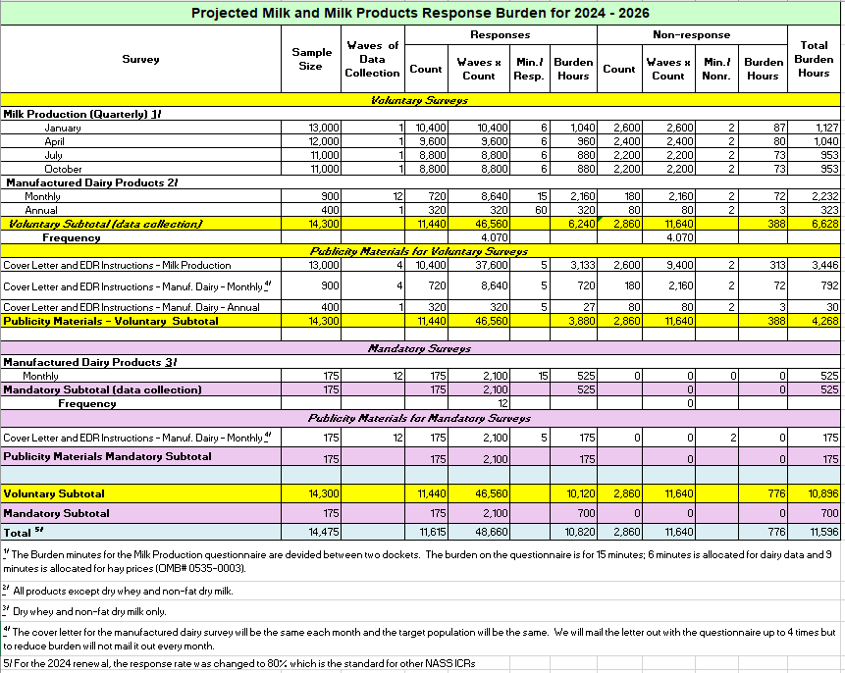

**13. Provide an estimate of the total annual cost burden to respondents or record-keepers resulting from the collection of information.**

There are no capital/start-up or ongoing operation/maintenance costs associated with this information collection.

**14. Provide estimates of annualized cost to the Federal government; provide a description of the method used to estimate cost which should include quantification of hours, operational expenses, and any other expense that would not have been incurred without this collection of information.**

The total cost to the federal government for the Milk and Milk Products Surveys is estimated at $2.8 million annually. The majority of this is for staff costs. The calculated costs include the fully loaded wage rates (includes allowances for Social Security, insurance, etc.).

**15. Explain the reasons for any program changes or adjustments (reasons for changes in burden).**

The increase in the number of responses and respondent burden is due primarily to a program change. In the previous approvals, NASS used a response rate of 70% for estimating respondent burden.  For this renewal, NASS increased the response rate used for estimating burden to 80% which is the standard factor used for estimating burden in most NASS ICRs.  
  
There is a minor increase to the sample size and respondent burden for the manufactured dairy mandatory surveys.

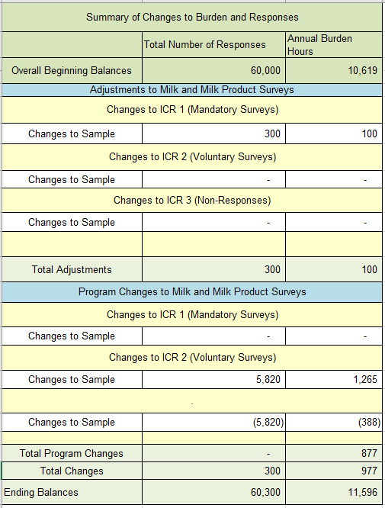

**16. For collections of information whose results will be published, outline plans for tabulation and publication. Address any complex analytical techniques that will be used. Provide the time schedule for the entire project, including beginning and ending dates of the collection of information, completion of report, publication dates, and other actions.**

The quarterly milk production questionnaires are mailed to a sample of dairy producers about one week prior to the target dates (Jan. 1, Apr. 1, July 1, and Oct.1).

Questionnaires are edited and summarized in time for estimates to be received in Washington, D.C., NASS headquarters on the 12th or 13th of the next month. Milk production estimates are released from Washington, D.C. 4 to 5 days later. There is the regular monthly publication, *Milk Production*, a special January issue, and an annual summary. These publications and those mentioned below are available on-line immediately after release at:

<https://usda.library.cornell.edu/concern/publications/h989r321c>

In the months that a survey is not conducted NASS will use historic data, combined with administrative data, which will be scaled using seasonal trends to estimate milk production for the non-survey months.

The monthly manufactured dairy products questionnaires are mailed to dairy plants the last business day of the month. Respondents have approximately 14 -21 days to return their report. For non-respondents the estimating procedure for the monthly manufactured dairy products involves matching survey reports with reports from the same respondent the previous month and previous year. After these identical reports are summarized, product by product, the percentage change is calculated. The indicated change in production, multiplied by the previous month's estimate, is the estimate for the current month. Field Offices prepare a listing of data by month for all plants in the universe.

Summarized State data are due in Washington, D.C. about the 24th of the month. This data is reviewed and published about the 5th of the following month. In addition to the monthly publication, *Dairy Products*, there is an annual survey questionnaire and annual summary publication.

Annual Dairy Products Summary

<https://usda.library.cornell.edu/concern/publications/jm214p131>

Monthly Dairy Products Summary

<https://usda.library.cornell.edu/concern/publications/m326m1757?locale=en&page=2>

Annual Agricultural Prices

<https://usda.library.cornell.edu/concern/publications/c821gj76b?locale=en>

Monthly Milk Production

<https://usda.library.cornell.edu/concern/publications/h989r321c?locale=en>

Milk Production, Disposition and Income Annual Summary

<https://usda.library.cornell.edu/concern/publications/4b29b5974>

Changes will be made on state level data that will be published in NASS livestock reports (including milk production) beginning in January 2025 are summarized at this link: <https://www.nass.usda.gov/Newsroom/Notices/2024/04-04-2024.php>

**17. If seeking approval to not display the expiration date for OMB approval of the information collection, explain the reasons that display would be inappropriate.**

No approval is requested for non-display of the expiration date.

**18. Explain each exception to the certification statement identified in Item 19, “Certification for Paperwork Reduction Act Submissions” of OMB Form 83-I.**

There are no exceptions to the certification statement.

April 2024