Non-substantive Change Request
0535-0007 – Stocks Reports
Grain Stocks Report Profile – 2024

This non-substantive change request affects the Grain Stocks Report Profile. The changes resulted from consultation with a few members of industry as well as a few cognitive interviews. The specific changes are itemized below and highlighted in the draft questionnaire.
- Item 1b and 1d: Added a skip instruction for the “no response”
- Item 2 - Clarified what types of storage facilities are included in storage capacity.
- Item 2 – Added the following yes/no questions to determine temporary or emergency storage.
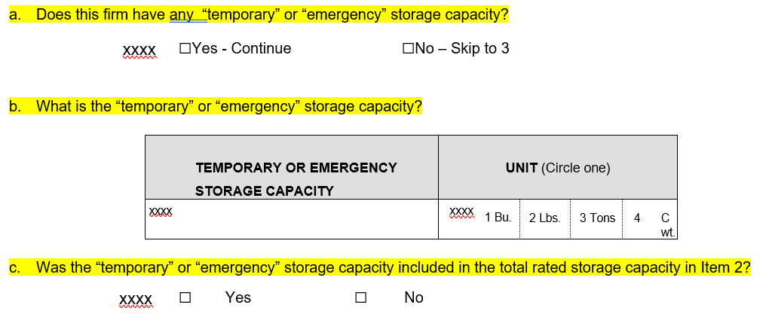
- Item 3 – Instead of a table of commodities and one Yes/No on whether the operation expects to store any of the listed commodities, the operator is asked Yes/No for each commodity individually.
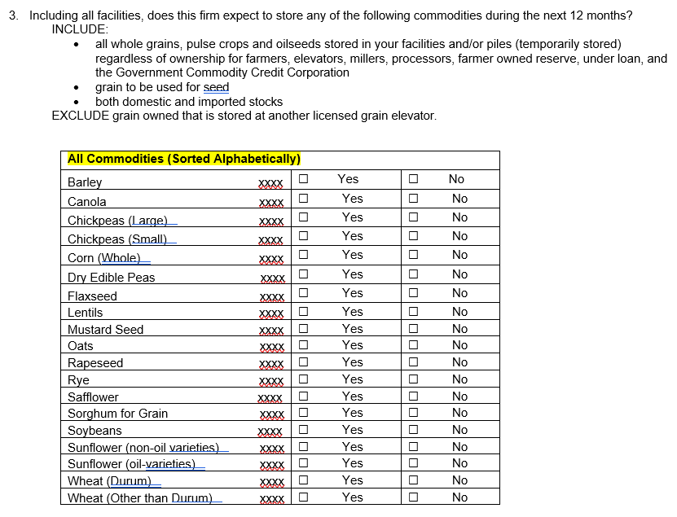

The survey team has added a respondent location sheet to help the respondent fill out the profile questionnaire.

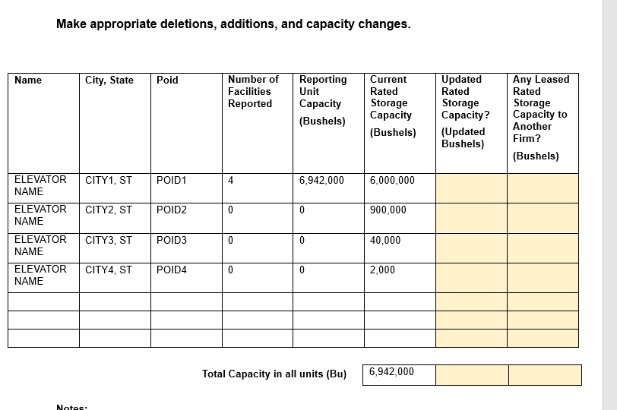

These changes will not impact the current sample size or respondent burden.
The revised questionnaire is loaded to ROCIS.

