OMB Control Number: 0560-XXXX, OMB Expiration Date: XX/XX/XXXX

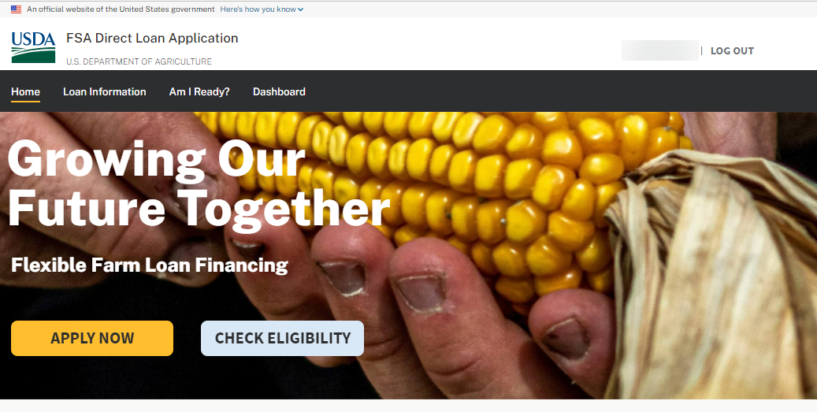
ONLINE LOAN APPLICATION PROCESS FLOW
Paperwork Reduction Act Review Package
Prepared: September 21, 2023

Note: Label on all screenshots shown as “FSA Direct Loan Application”. However, this has been changed to “FSA Online Loan Application”.

DASHBOARD
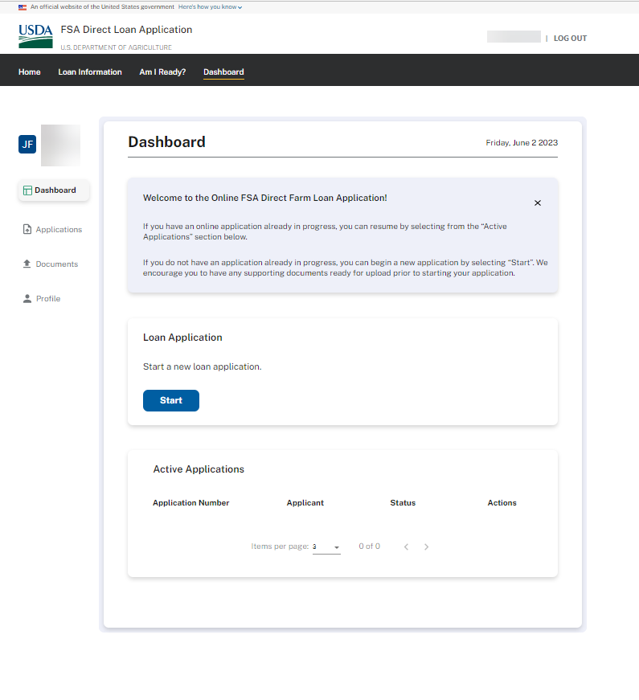

OPERATOR CERTIFICATION
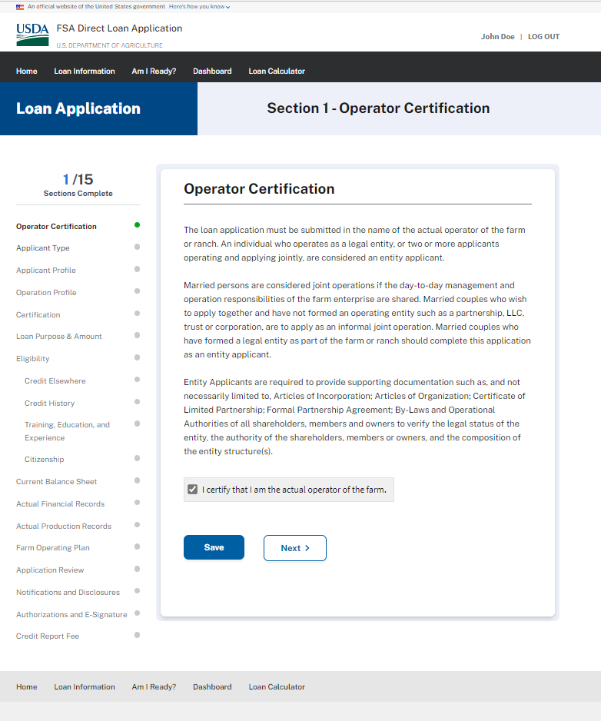
APPLICANT IDENTIFICATION
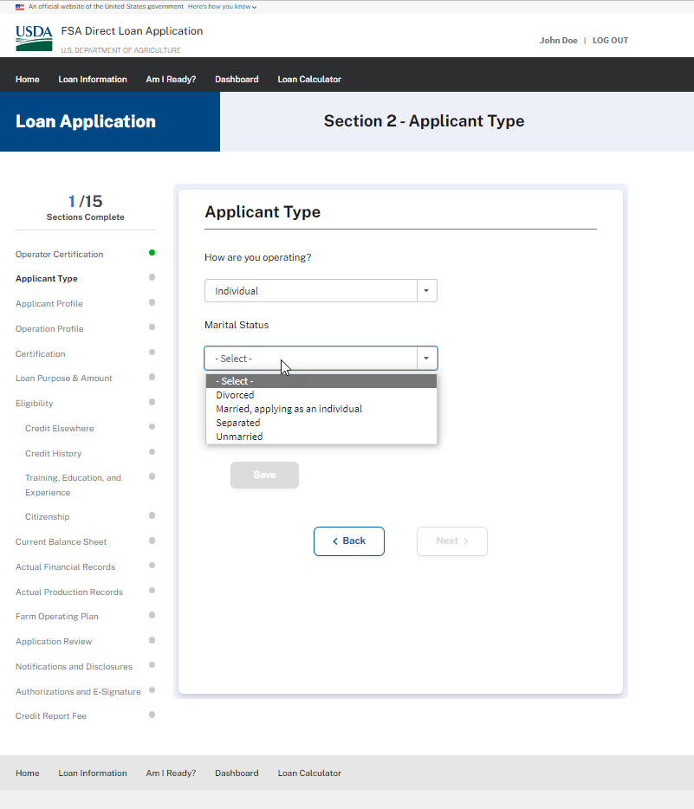

APPLICANT PROFILE
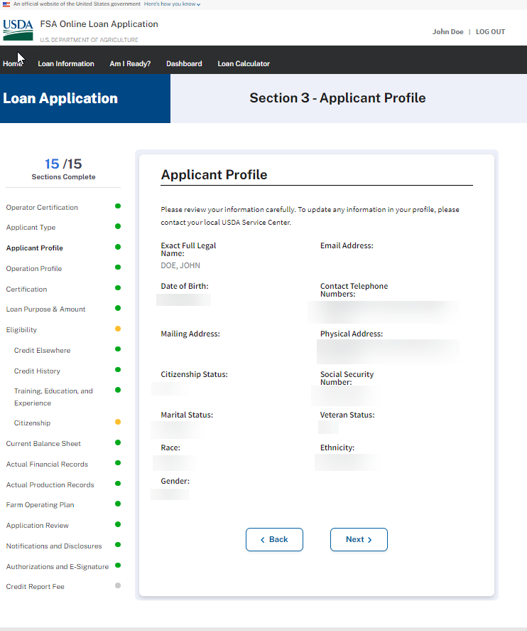
OPERATION PROFILE
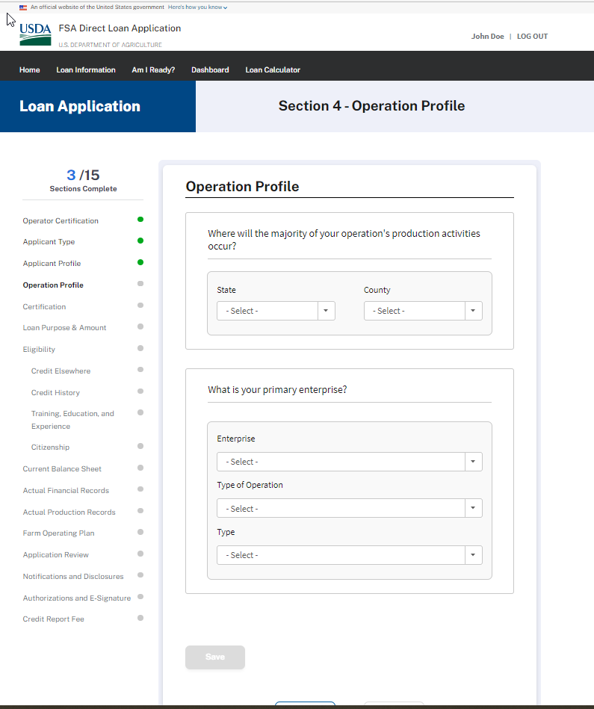
CERTIFICATION (Minimized)
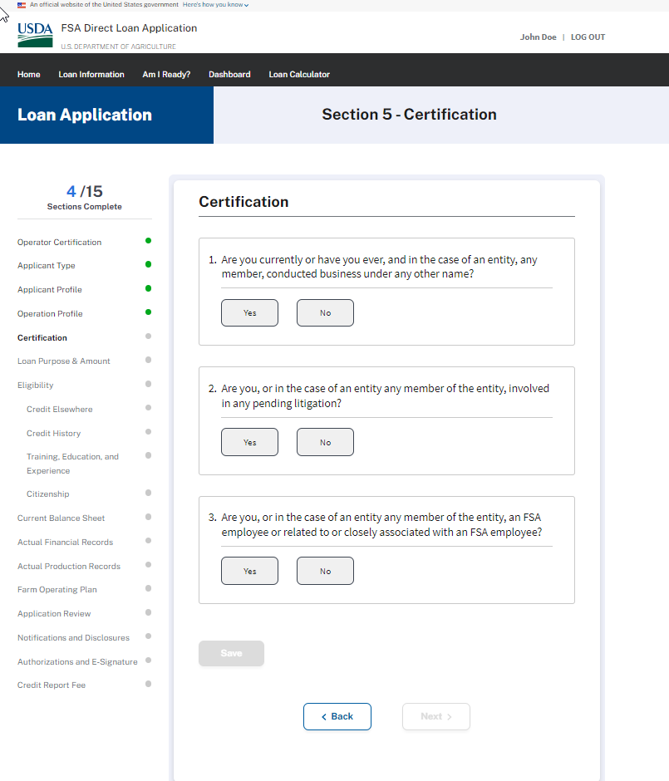

CERTIFICATION (Expanded)
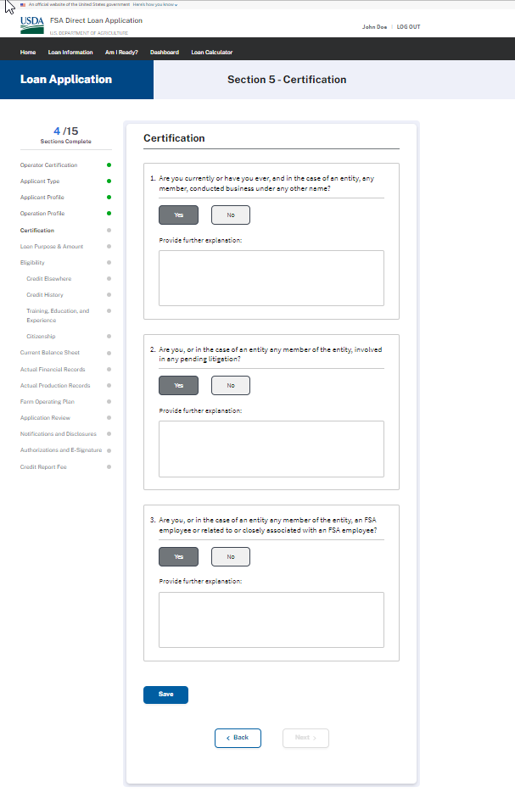
LOAN PURPOSE & AMOUNT
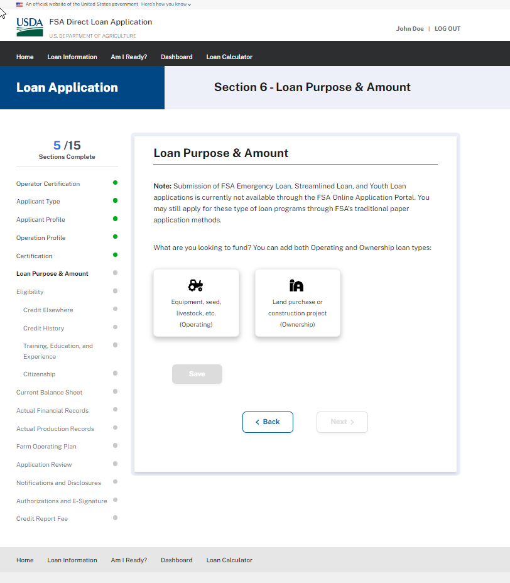
LOAN PURPOSE & AMOUNT (Operating Type Loans)
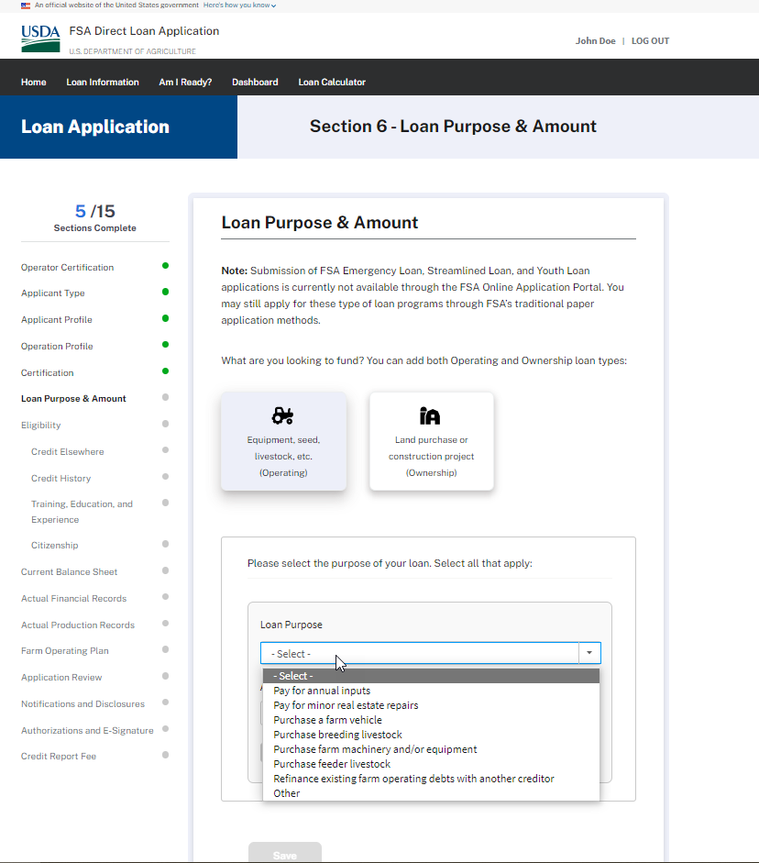

LOAN PURPOSE & AMOUNT (Operating Type Loans – Annual Inputs)
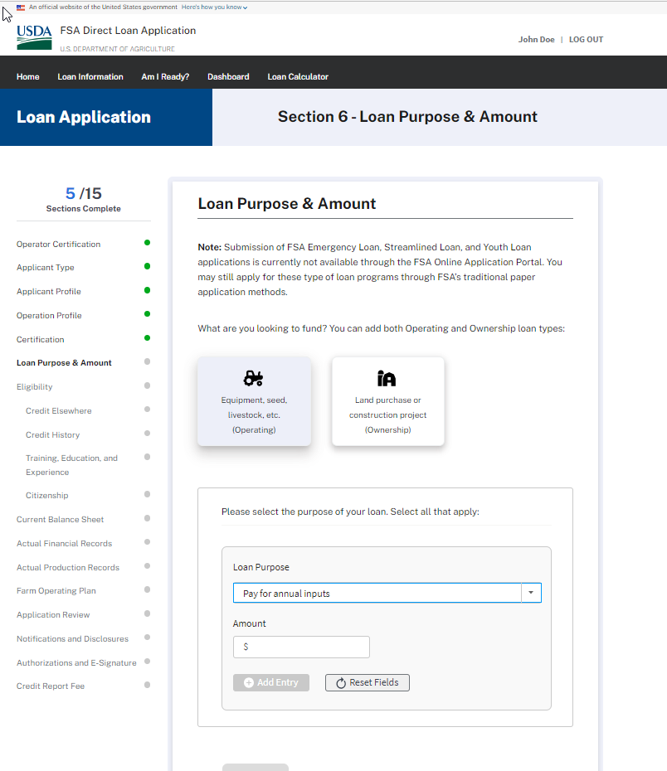

LOAN PURPOSE & AMOUNT (Operating Type Loans – Minor real estate repairs or “Other”)
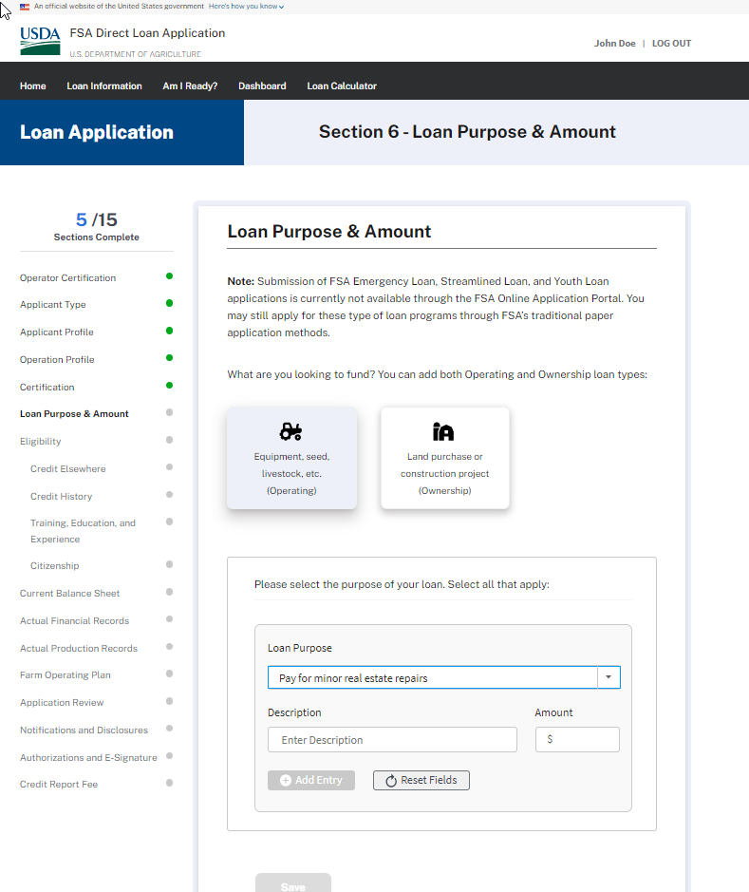
LOAN PURPOSE & AMOUNT (Operating Type Loans – Purchase a farm vehicle, Purchase farm machinery and/or equipment)
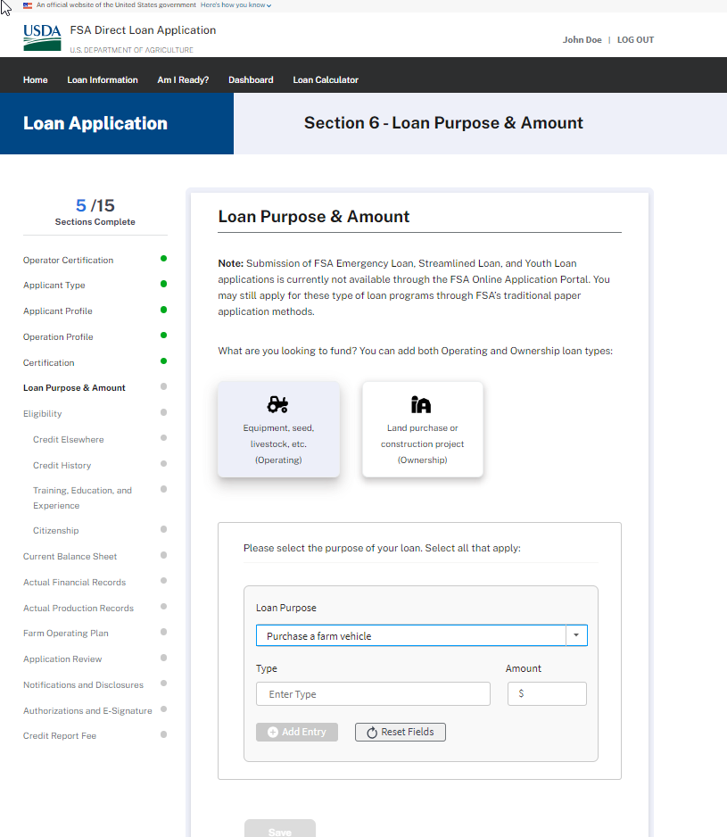

LOAN PURPOSE & AMOUNT (Operating Type Loans – Purchase breeding livestock, Purchase feeder livestock)
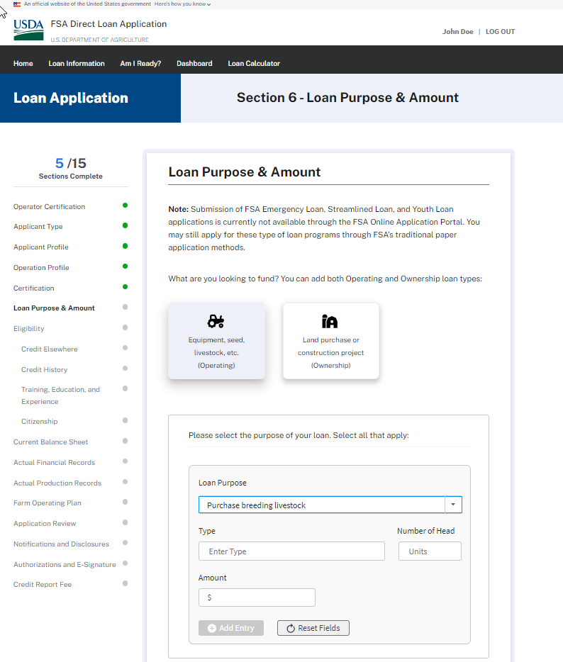
LOAN PURPOSE & AMOUNT (Operating Type Loans – Refinance existing farm operating debts with another creditor)
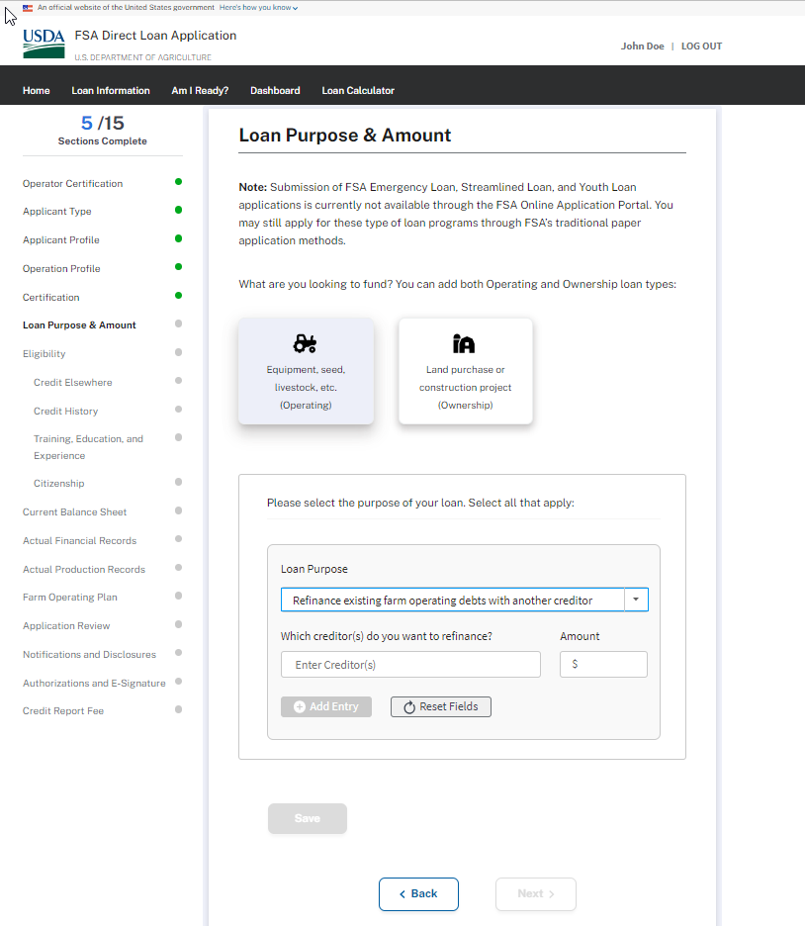

LOAN PURPOSE & AMOUNT (Ownership Loans)
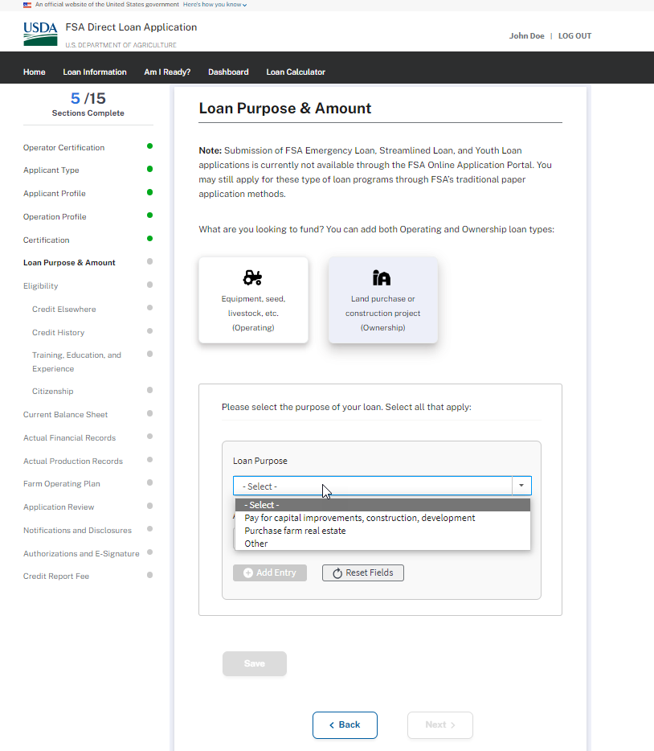

LOAN PURPOSE & AMOUNT (Ownership Loans – Pay for capital improvements, construction, development & Other)
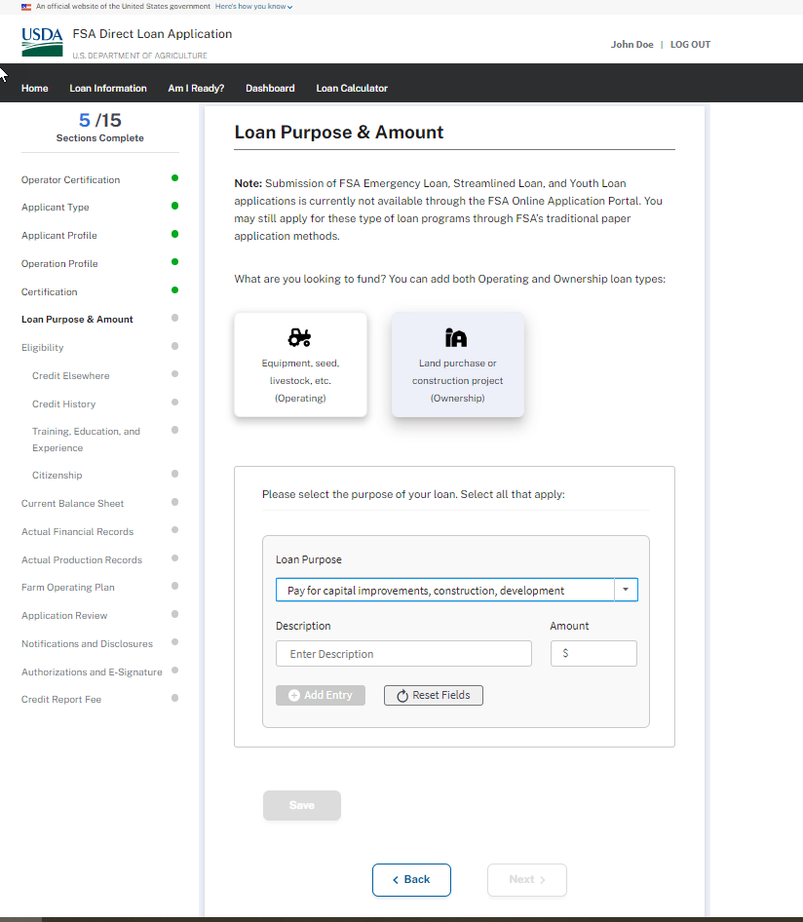

LOAN PURPOSE & AMOUNT (Ownership Loans – Purchase farm real estate)
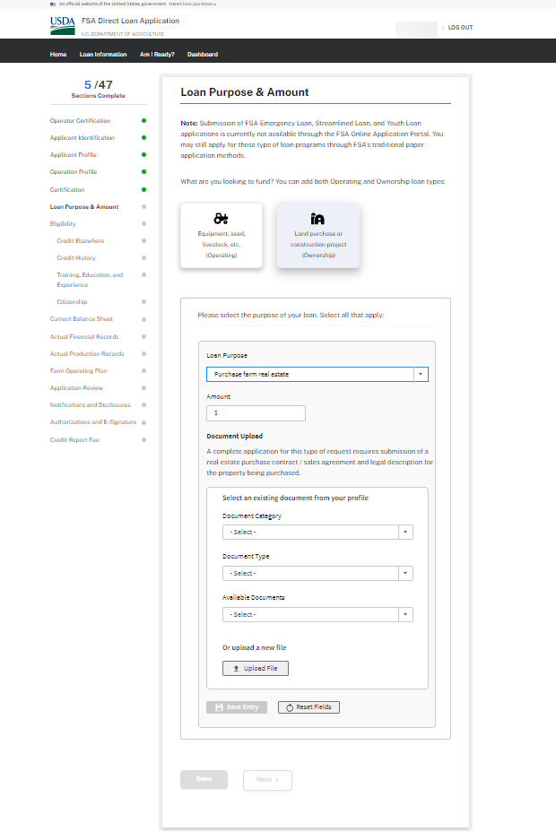
Eligibility (Credit Elsewhere)
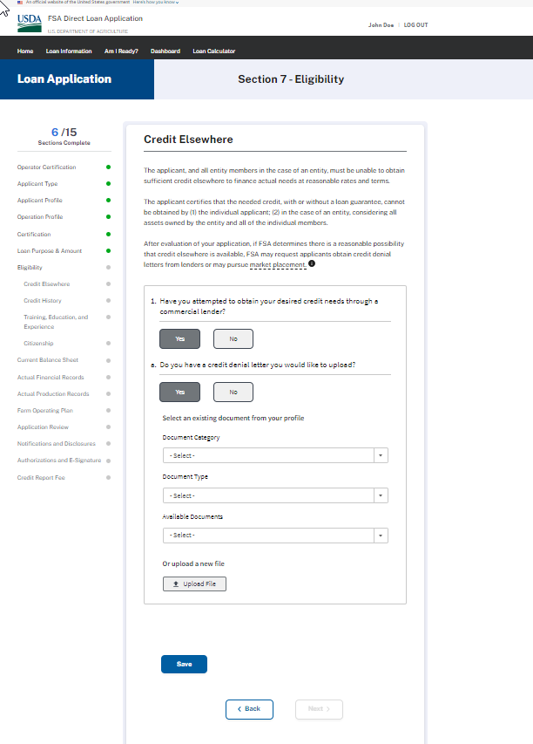

ELIGIBILITY – CREDIT HISTORY
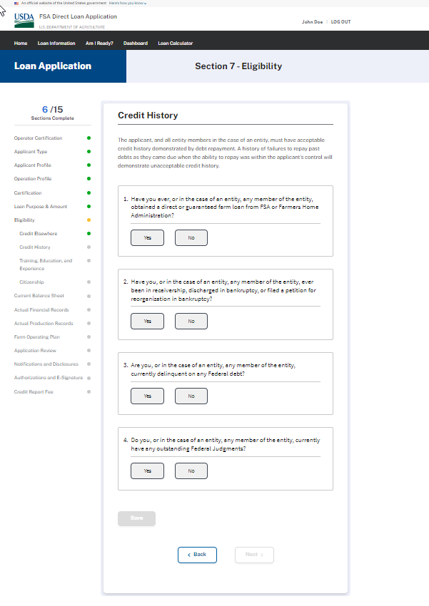

ELIGIBILITY – CREDIT HISTORY – Question 1 & 1a - Expanded
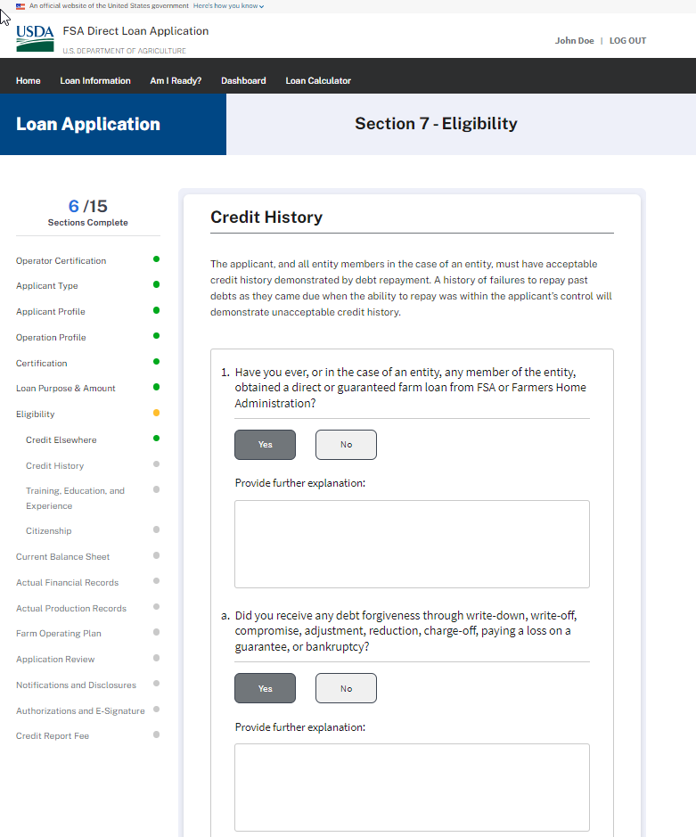

ELIGIBILITY – CREDIT HISTORY – Question 2 - Expanded
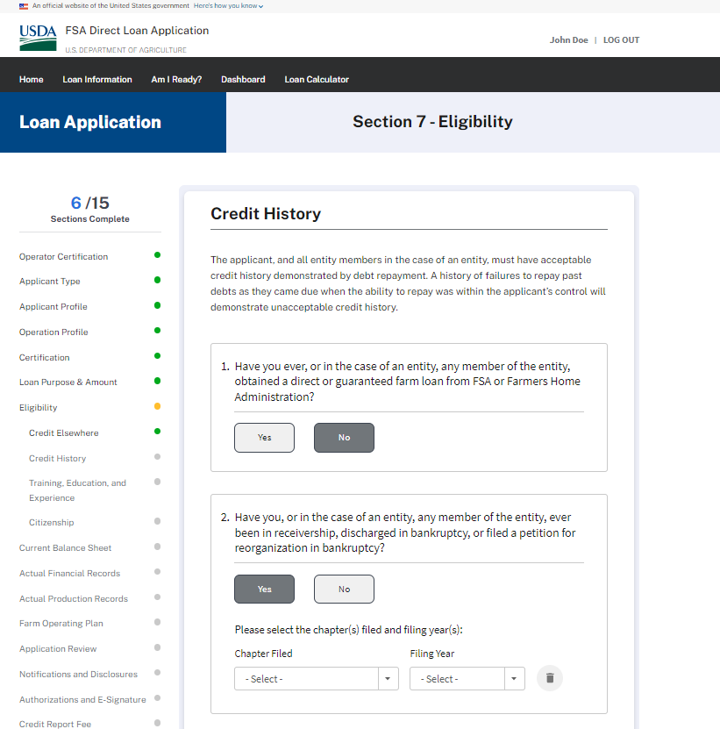

ELIGIBILITY – CREDIT HISTORY – Question 3 & 4 - Expanded
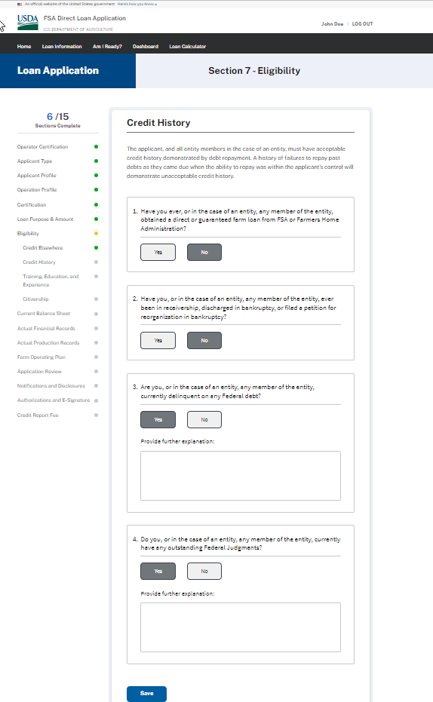
ELIGIBILITY – TRAINING, EDUCATION, & EXPERIENCE (Wireframe - Expanded)
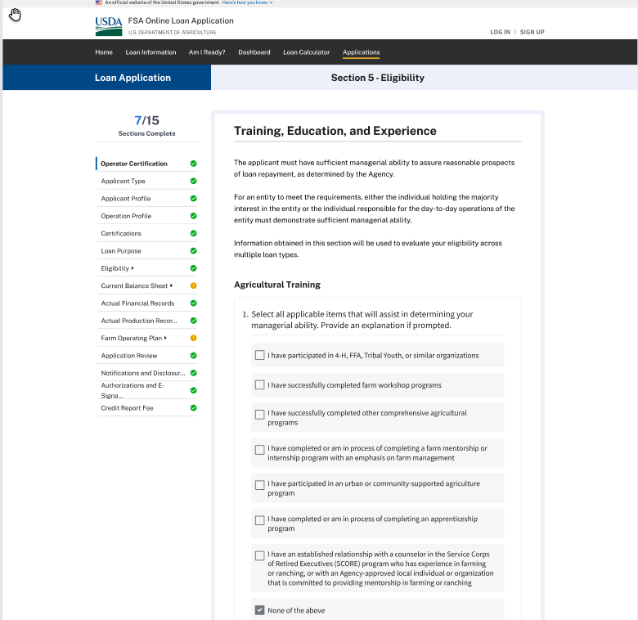

ELIGIBILITY – TRAINING, EDUCATION, & EXPERIENCE (Wireframe - Expanded)

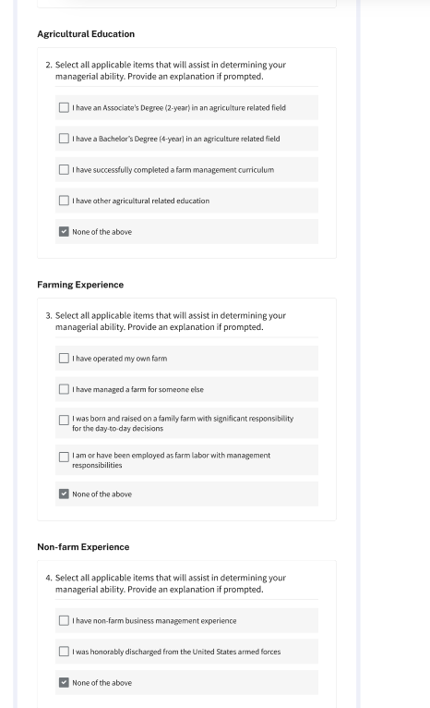

ELIGIBILITY – TRAINING, EDUCATION, & EXPERIENCE (Expanded – “I have operating my own farm” subsequent question)
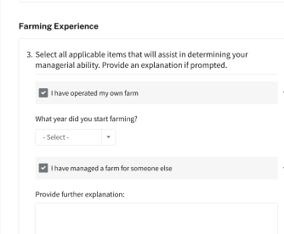

ELIGIBILITY – TRAINING, EDUCATION, & EXPERIENCE (Expanded – All other selections except for “I have operating my own farm” provide same explanation box)

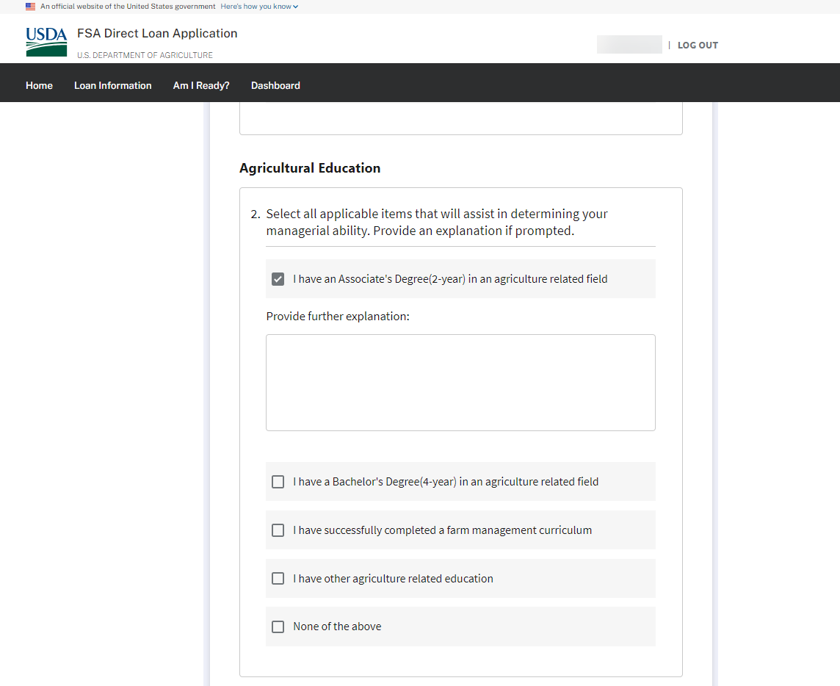

ELIGIBILITY – TRAINING, EDUCATION, & EXPERIENCE (Supporting Documents upload)

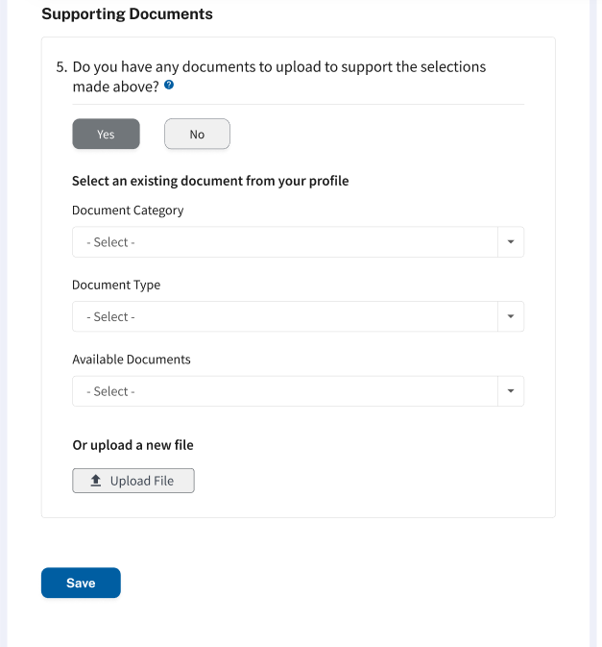

ELIGIBILITY – CITIZENSHIP
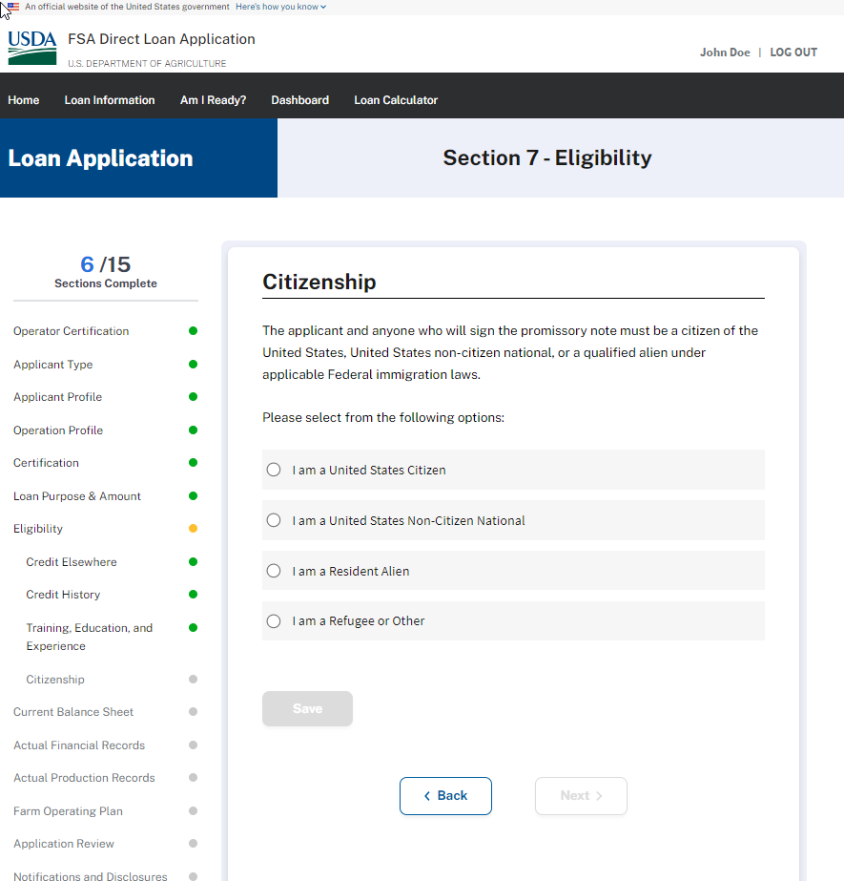

ELIGIBILITY – CITIZENSHIP
If anything besides United States Citizen is selected, the applicant wil be provided ability to upload supporting documents:
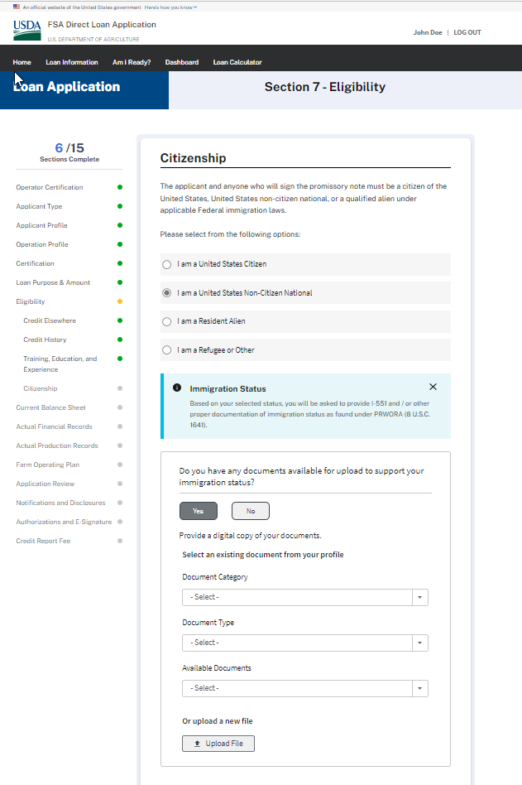
CURRENT BALANCE SHEET – Question 1 – Answered “Yes” – Fully Expanded
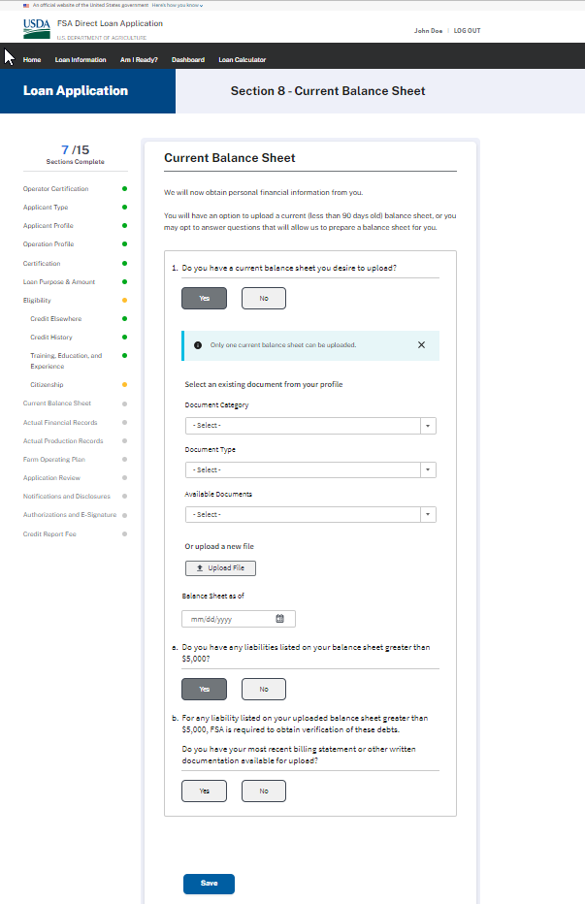

CURRENT BALANCE SHEET – Question 1 – Answered “No”
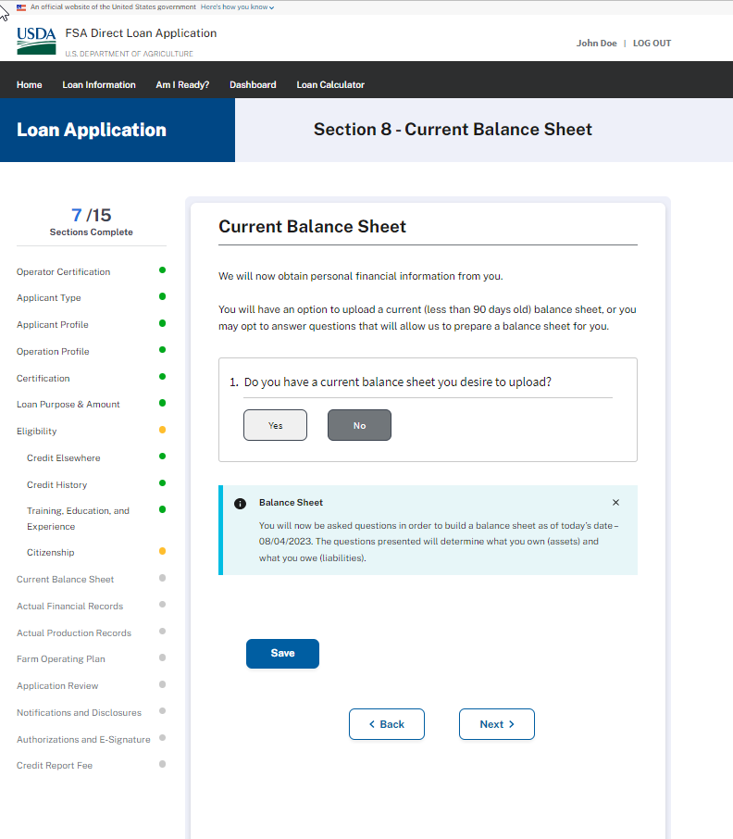

CURRENT BALANCE SHEET – Wireframe - Assets - Question 1
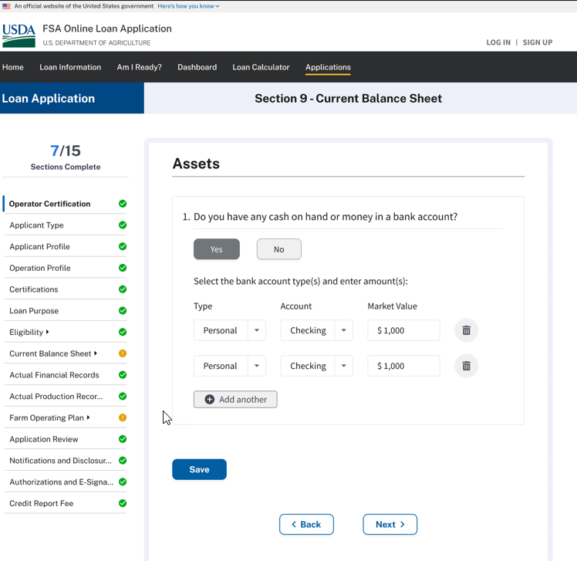
CURRENT BALANCE SHEET – Assets - Question 2
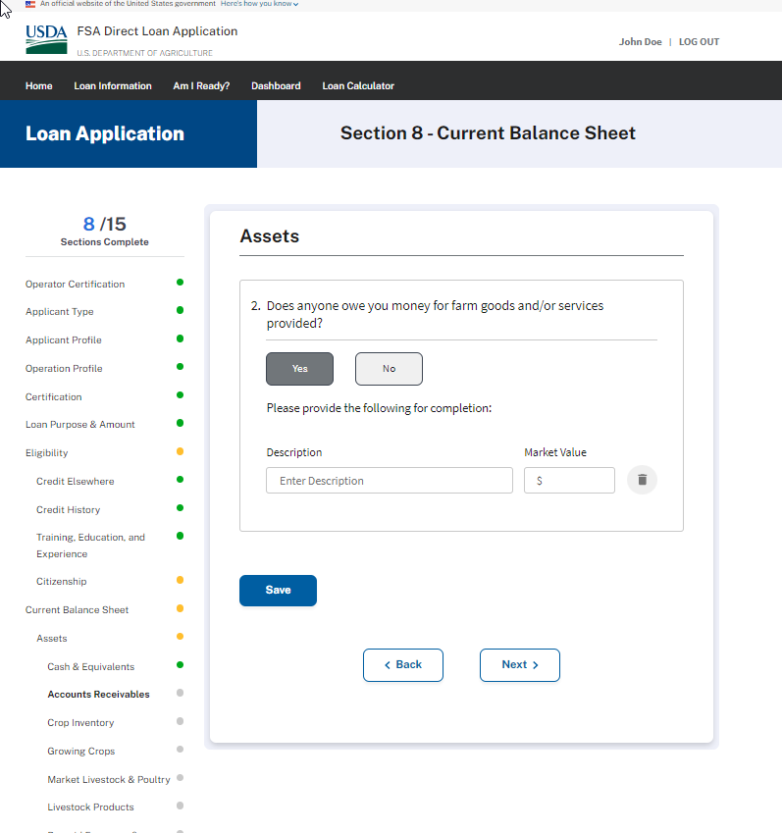

CURRENT BALANCE SHEET – Assets - Question 3
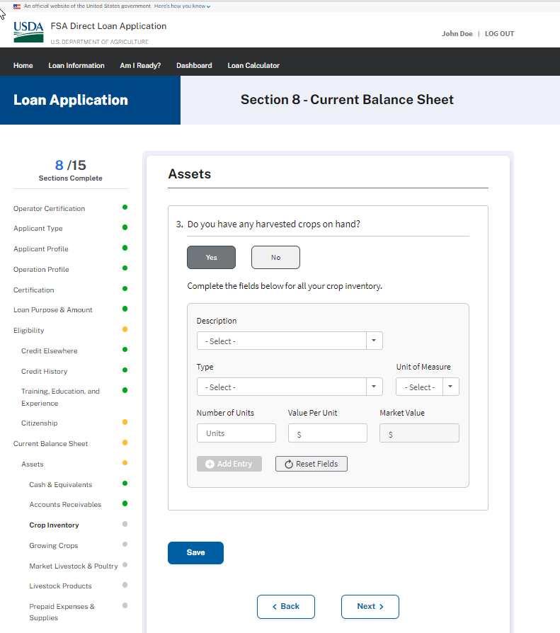

CURRENT BALANCE SHEET – Assets - Question 4
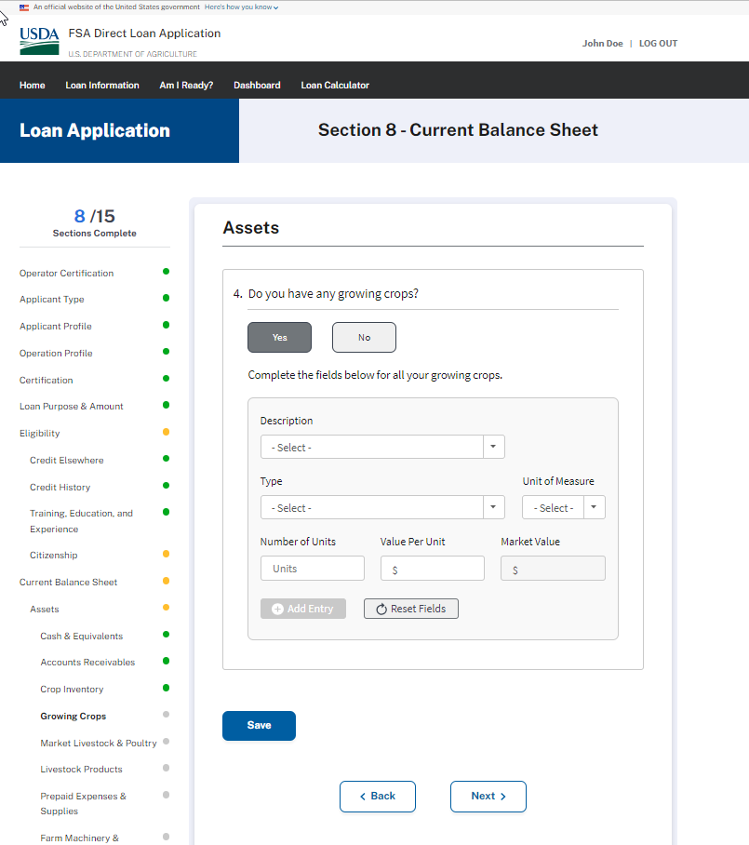

CURRENT BALANCE SHEET – Assets - Question 5
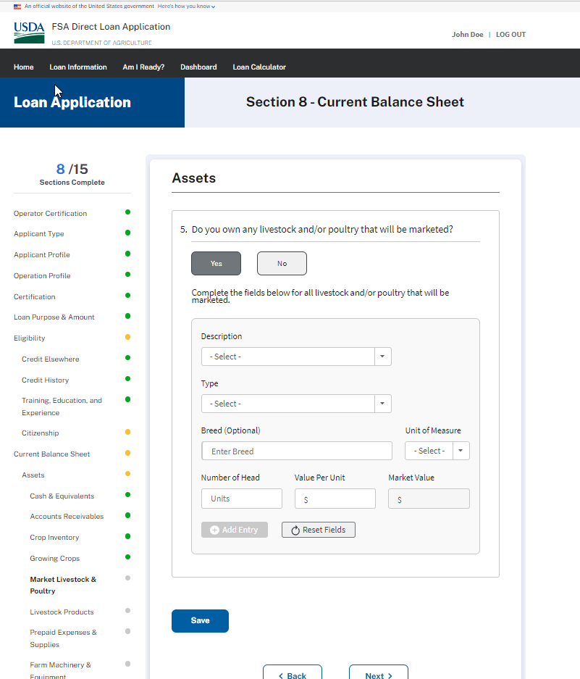

CURRENT BALANCE SHEET – Assets - Question 6
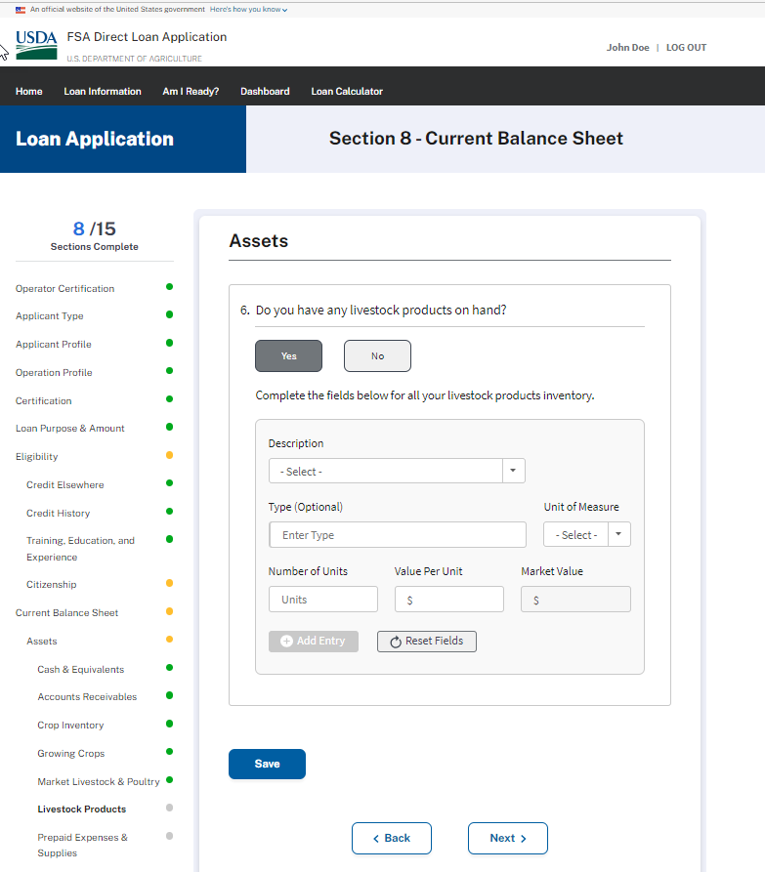

CURRENT BALANCE SHEET – Assets - Question 7
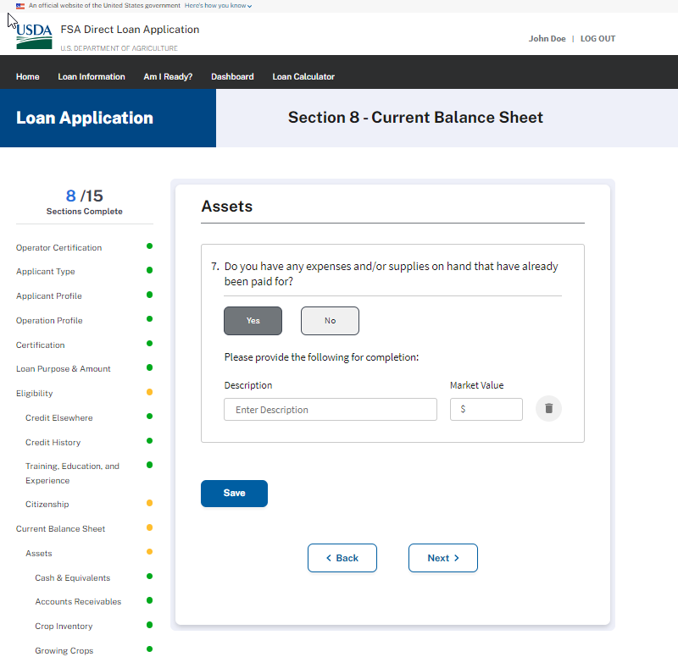

CURRENT BALANCE SHEET – Assets - Question 8
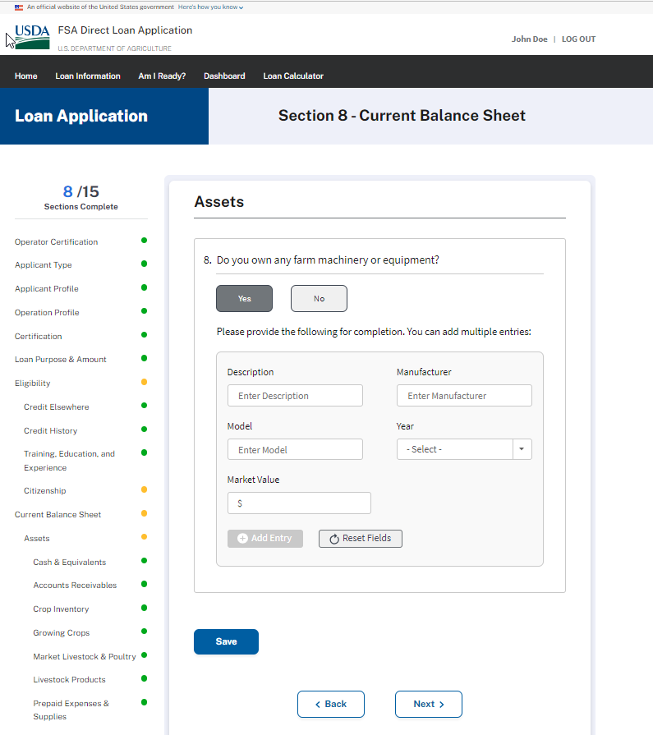

CURRENT BALANCE SHEET – Assets - Question 9
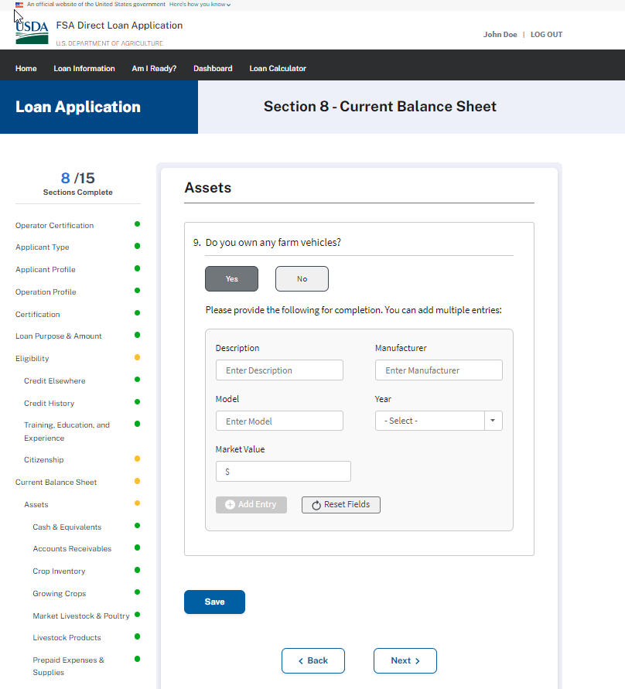

CURRENT BALANCE SHEET – Assets - Question 10
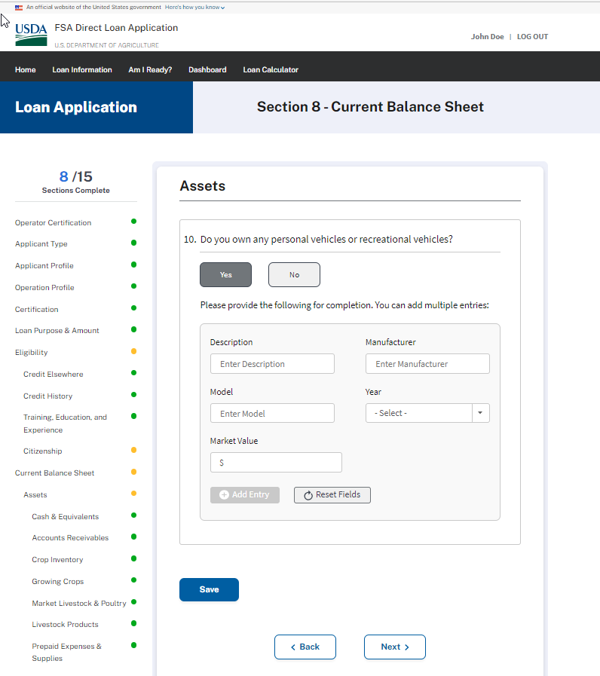

CURRENT BALANCE SHEET – Assets - Question 11
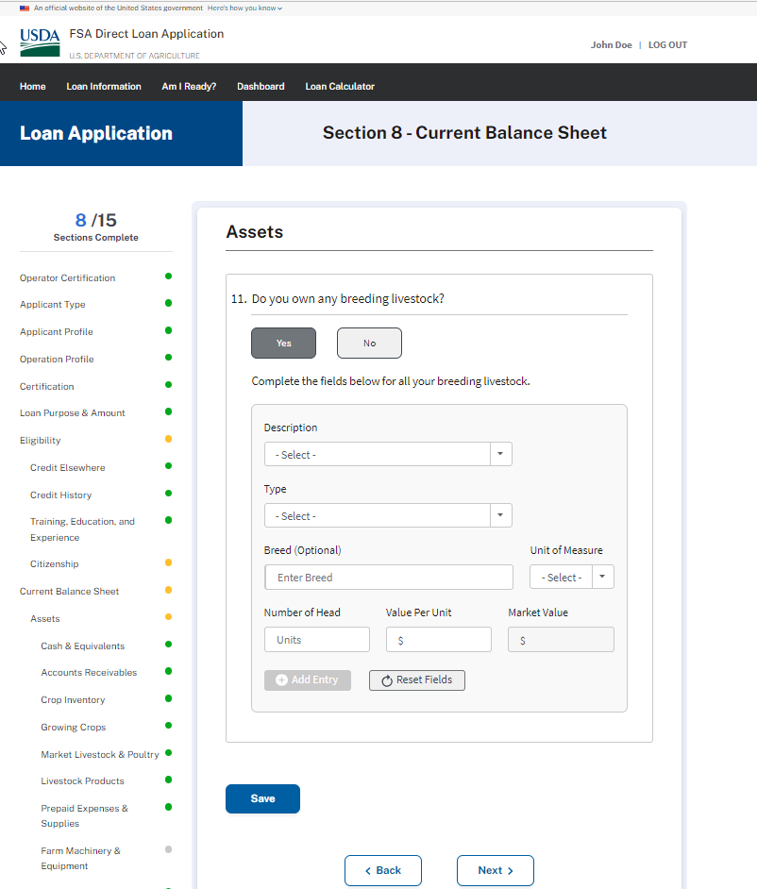

CURRENT BALANCE SHEET – Assets - Question 12
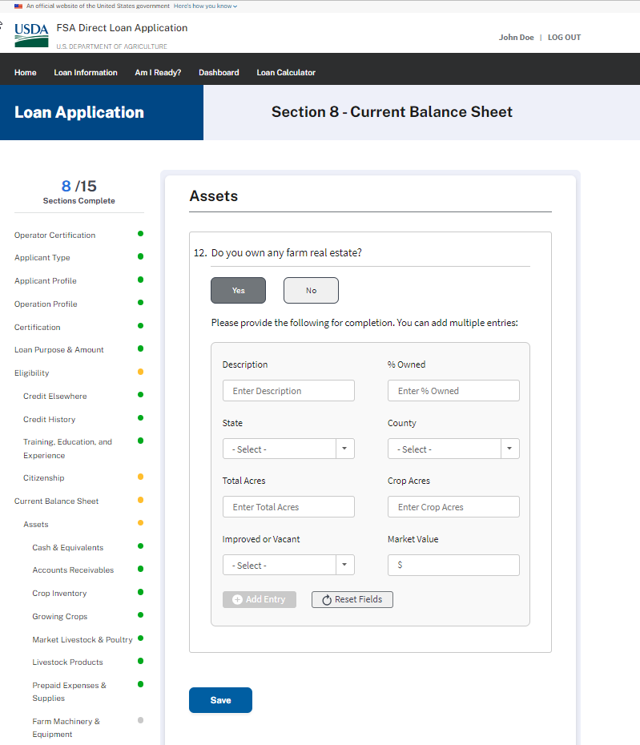

CURRENT BALANCE SHEET – Assets - Question 13
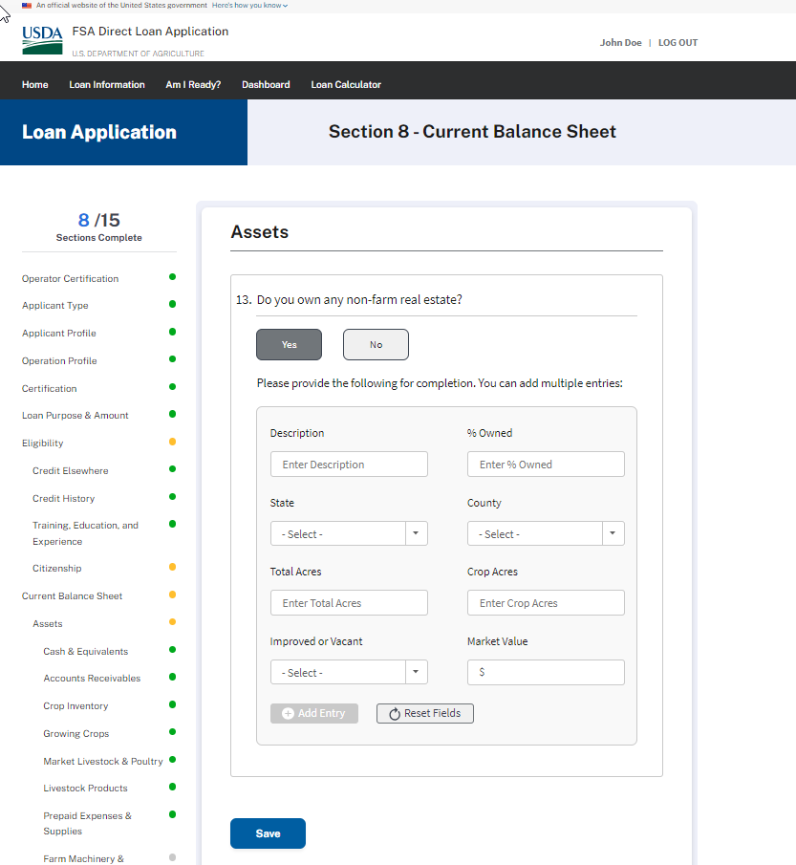

CURRENT BALANCE SHEET – Assets - Question 14
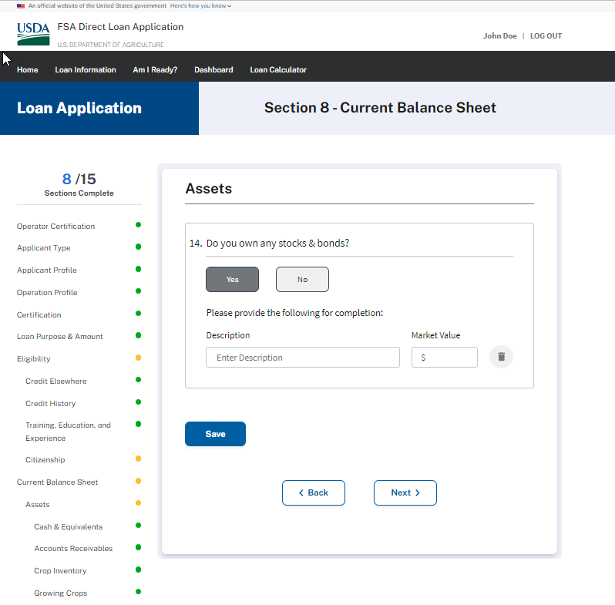

CURRENT BALANCE SHEET – Assets - Question 15
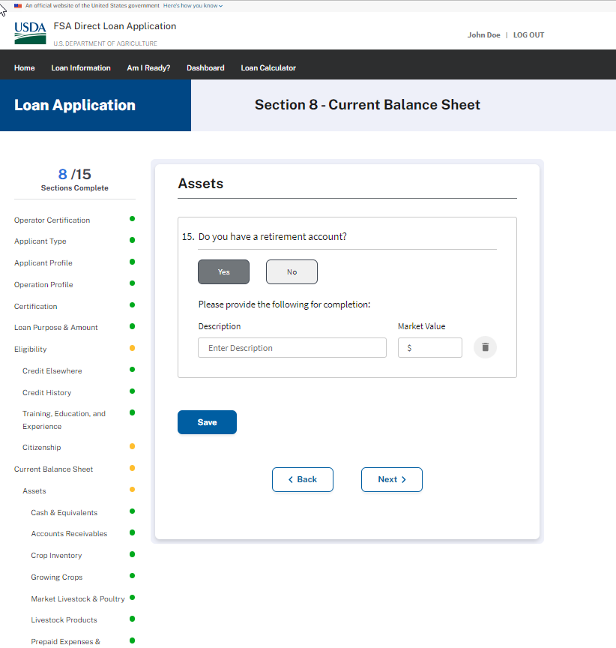

CURRENT BALANCE SHEET – Assets - Question 16
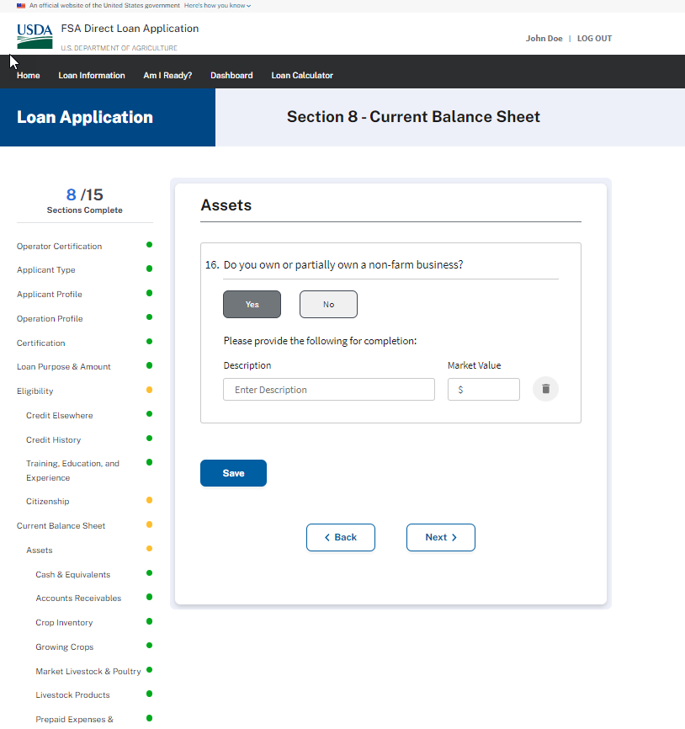

CURRENT BALANCE SHEET – Assets - Question 17
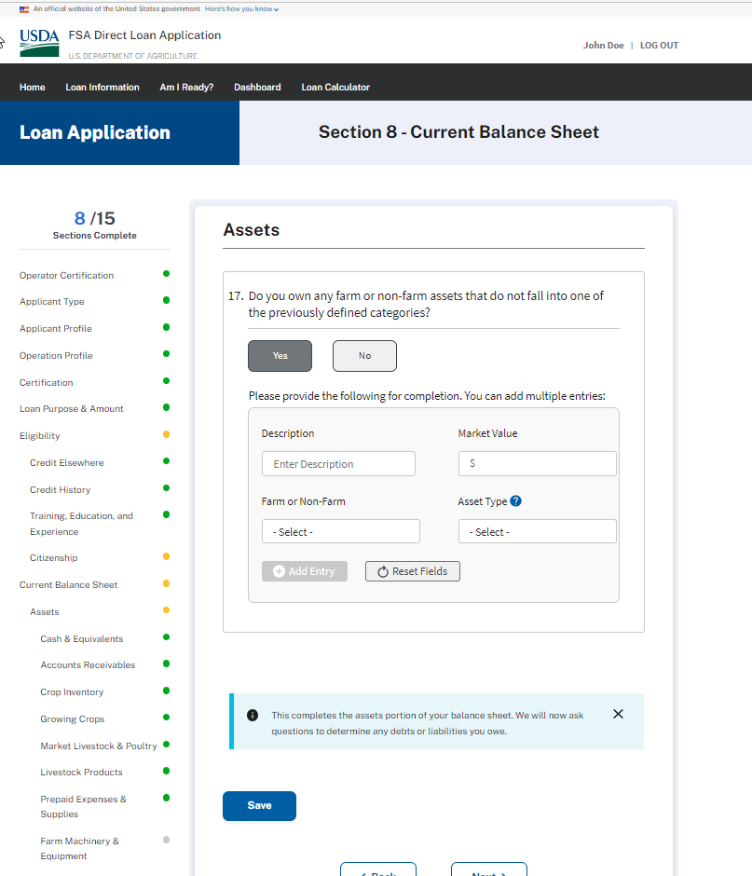
CURRENT BALANCE SHEET – Liabilities - Question 18
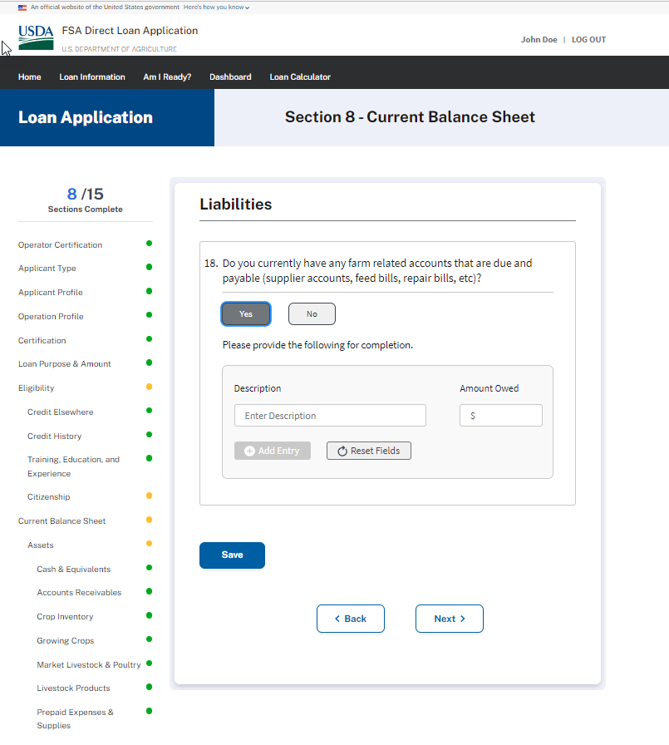

CURRENT BALANCE SHEET – Liabilities - Question 19
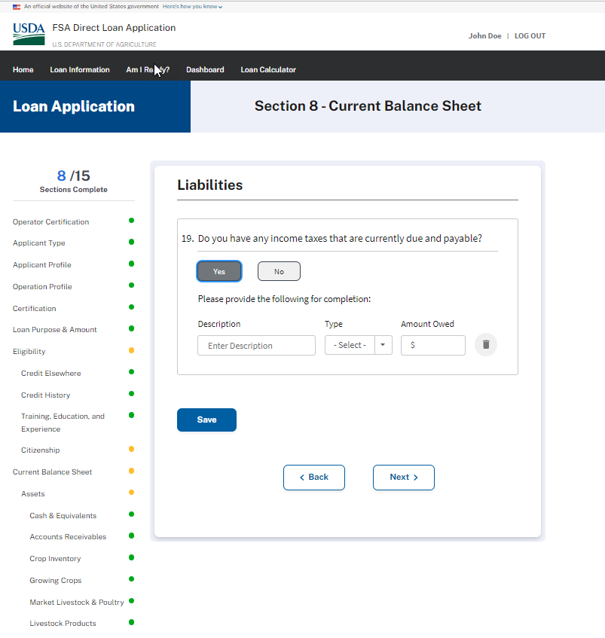

CURRENT BALANCE SHEET – Liabilities - Question 20
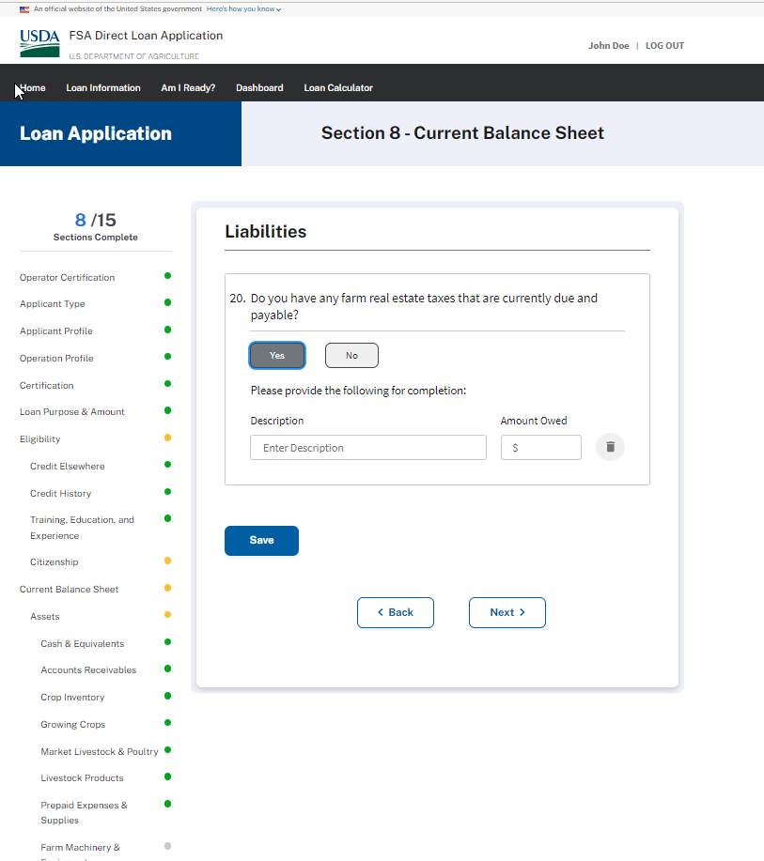

CURRENT BALANCE SHEET – Liabilities - Question 21
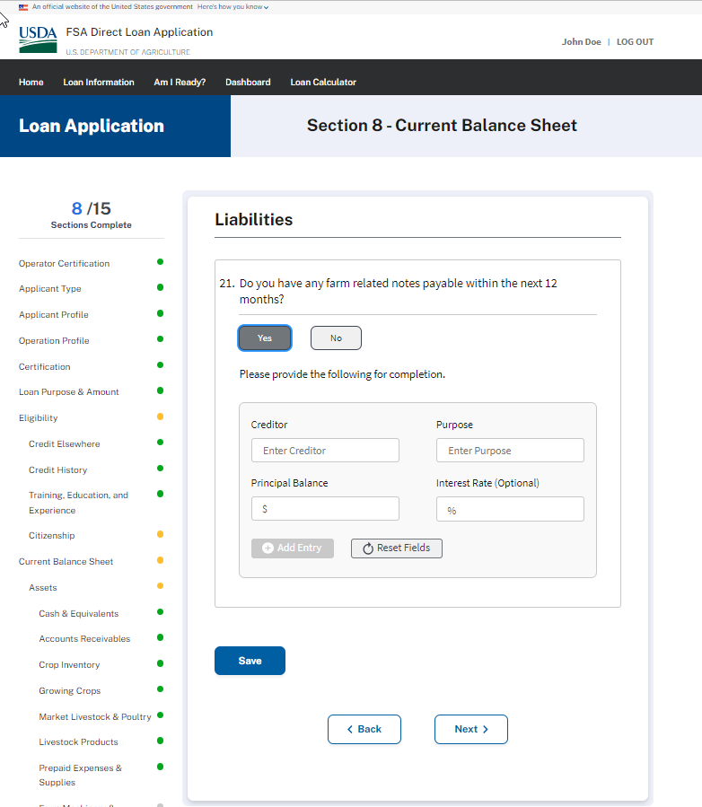

CURRENT BALANCE SHEET – Liabilities - Question 22
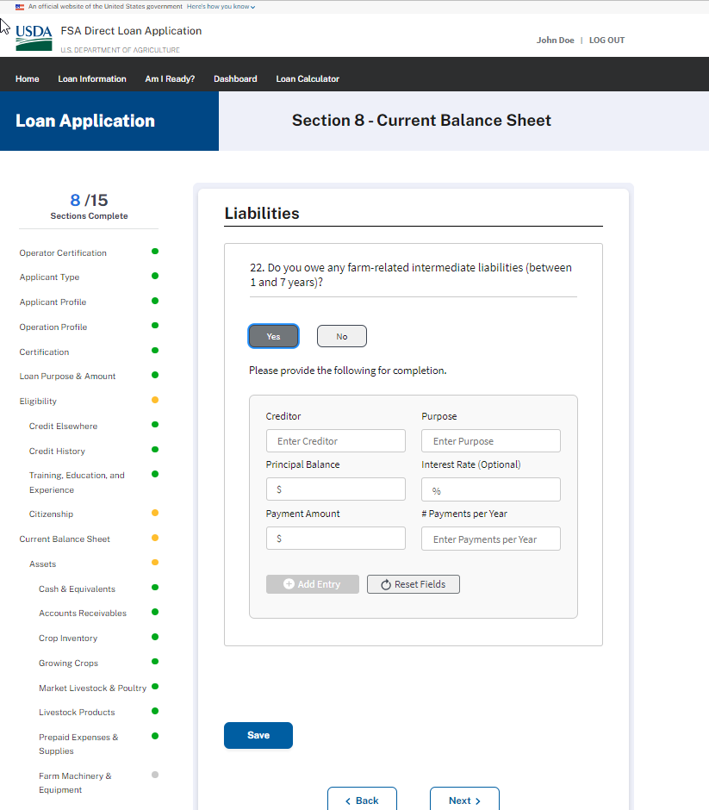

CURRENT BALANCE SHEET – Liabilities - Question 23
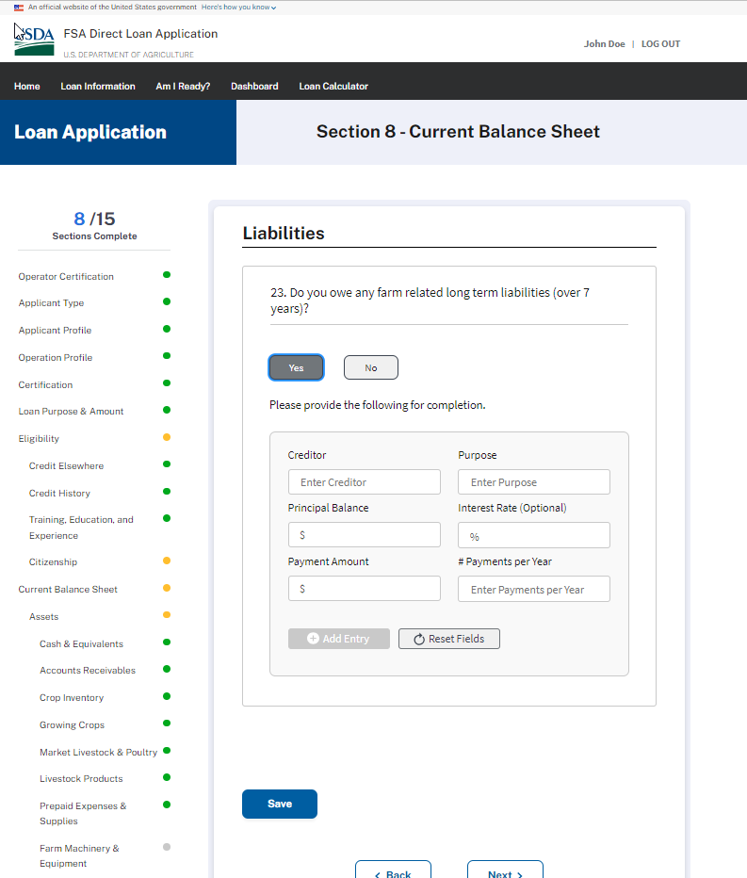

CURRENT BALANCE SHEET – Liabilities - Question 24
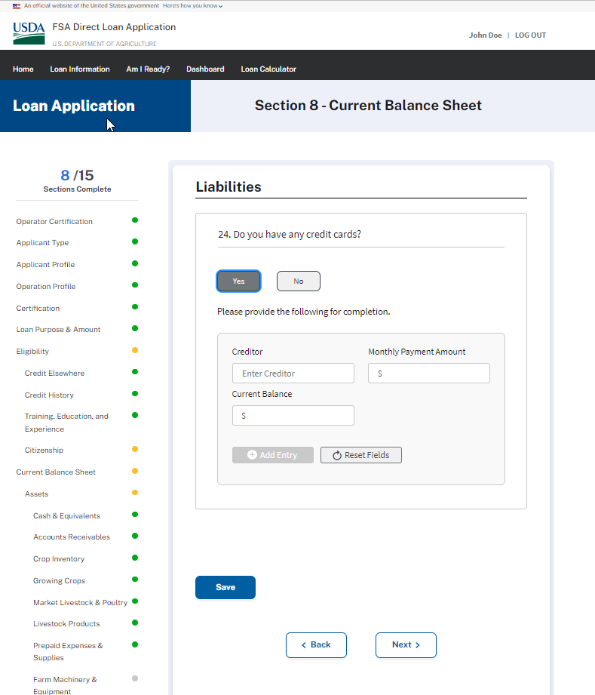

CURRENT BALANCE SHEET – Liabilities - Question 25
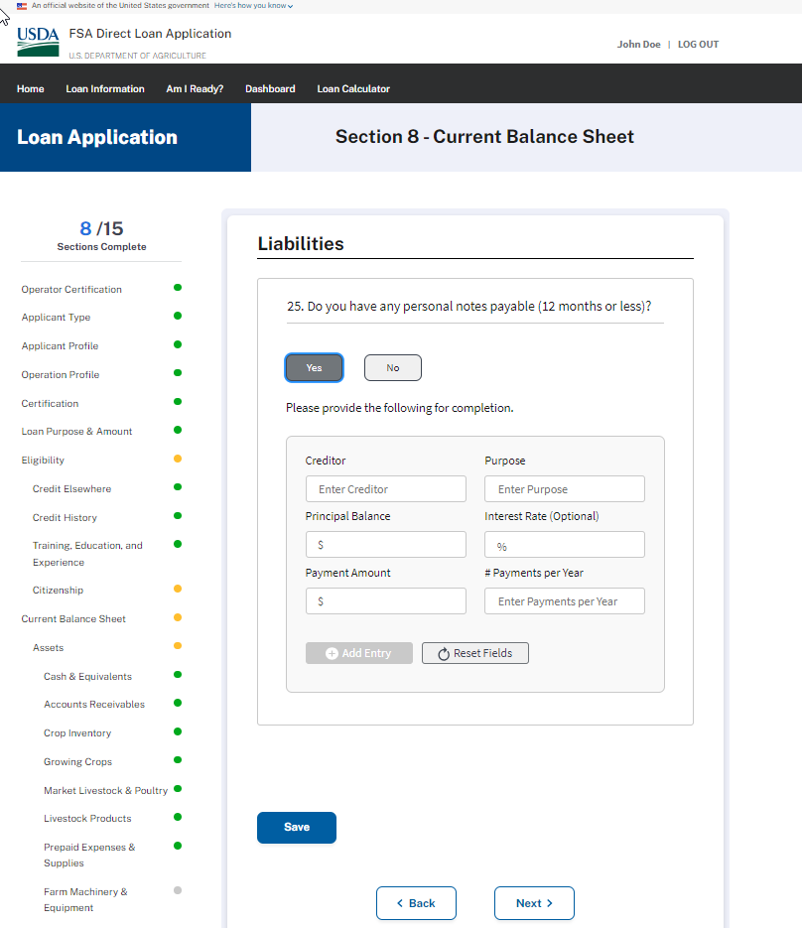

CURRENT BALANCE SHEET – Liabilities - Question 26
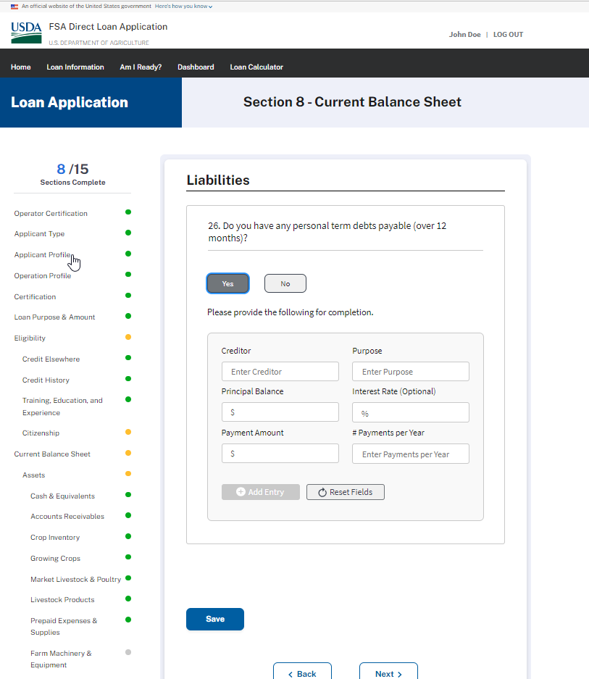

ACTUAL FINANCIAL RECORDS
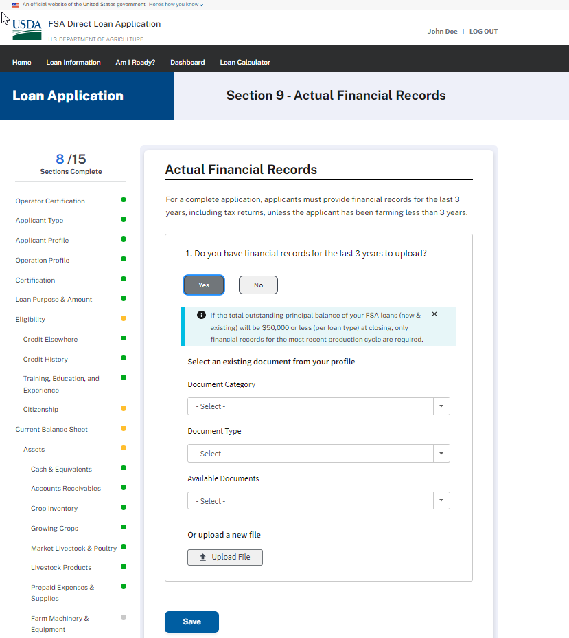
ACTUAL PRODUCTION RECORDS
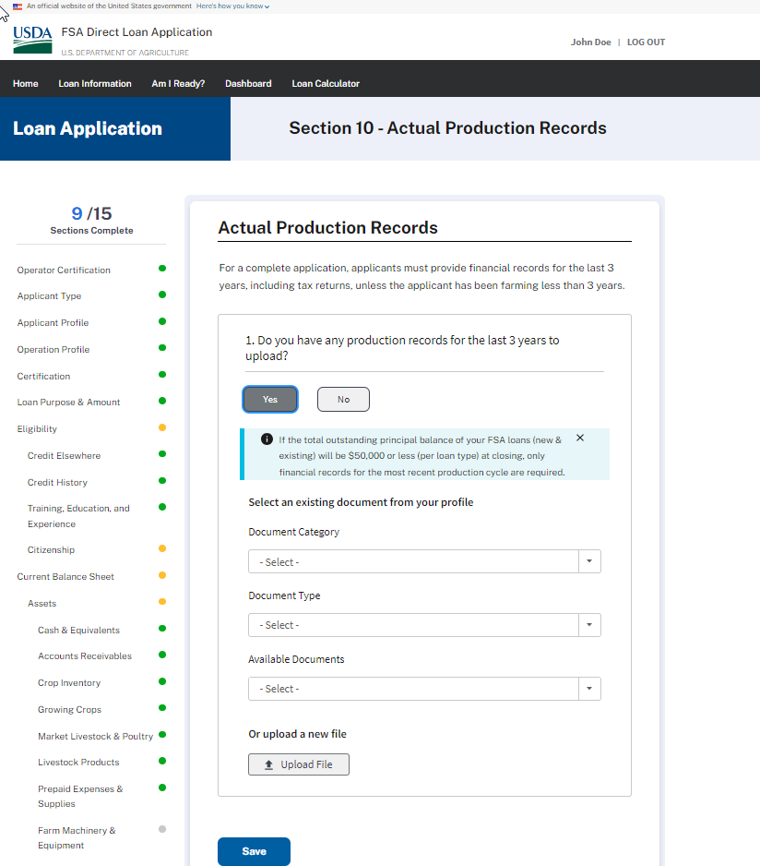
FARM OPERATING PLAN – Wireframe

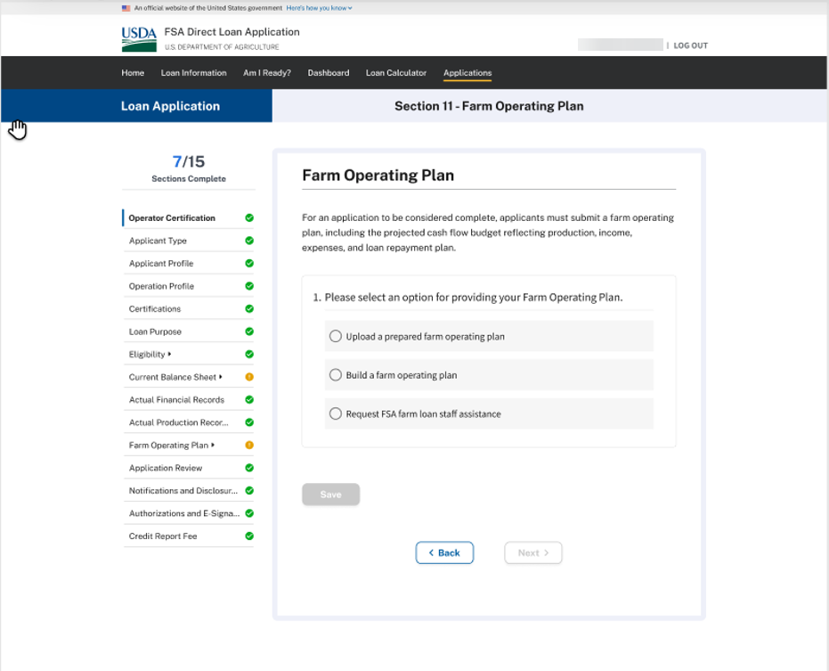
FARM OPERATING PLAN (1a) – Wireframe - When applicant chooses to upload a prepared farm operating plan
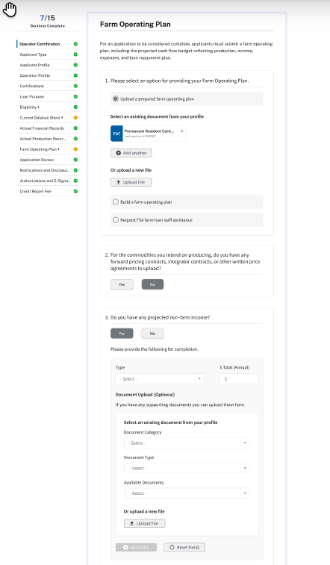

FARM OPERATING PLAN – Wireframe – When the applicant chooses to build a farm operating plan
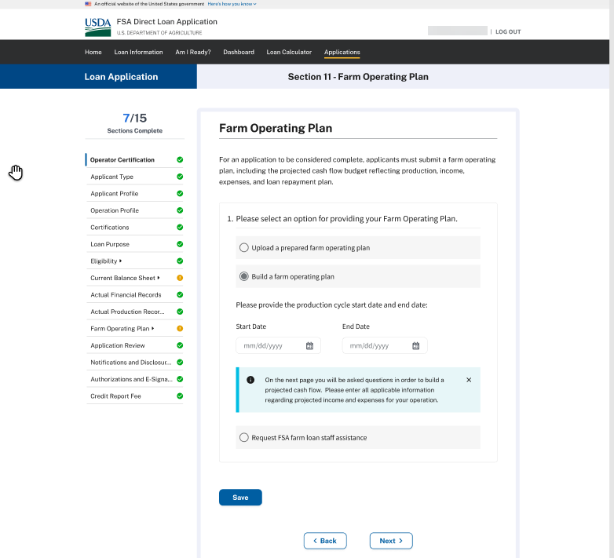

FARM OPERATING PLAN – Wireframe – When the applicant chooses to build a farm operating plan – Farm Income Question #1
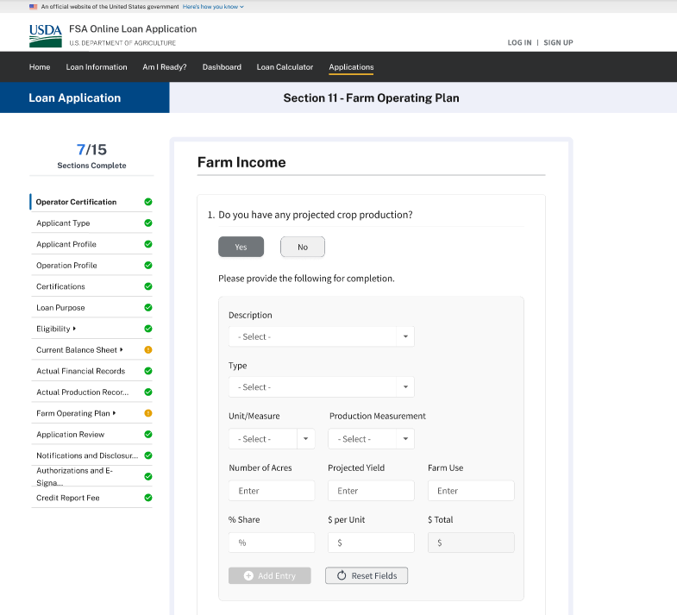

FARM OPERATING PLAN – Wireframe – When the applicant chooses to build a farm operating plan Farm Income Question #2
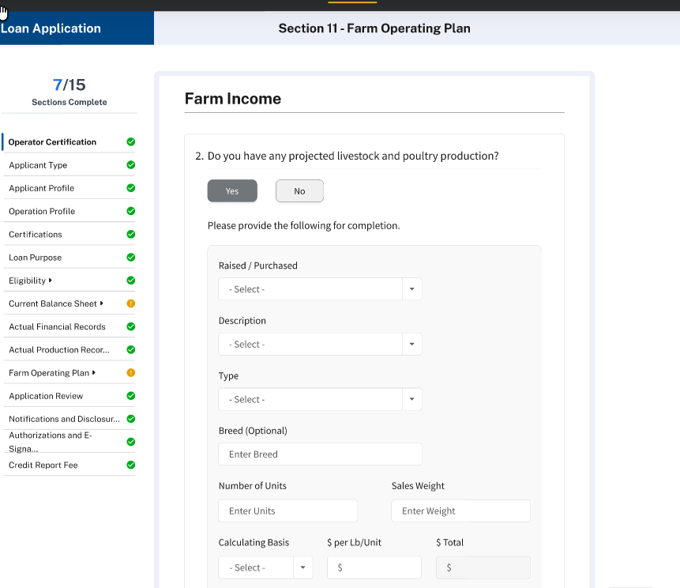

FARM OPERATING PLAN – Wireframe – When the applicant chooses to build a farm operating plan Farm Income Question #3
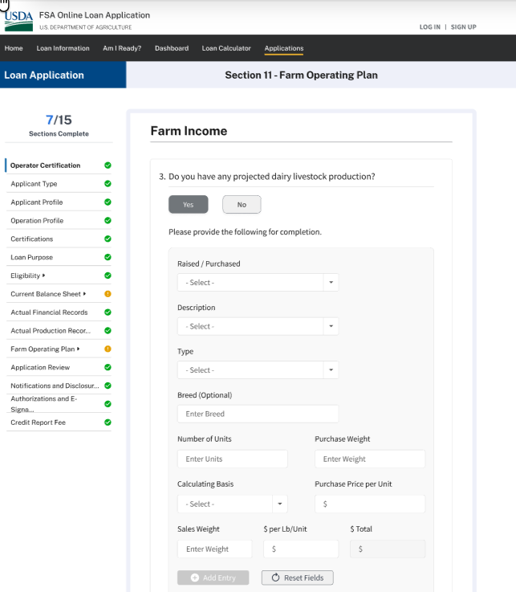

FARM OPERATING PLAN – Wireframe – When the applicant chooses to build a farm operating plan Farm Income Question #4
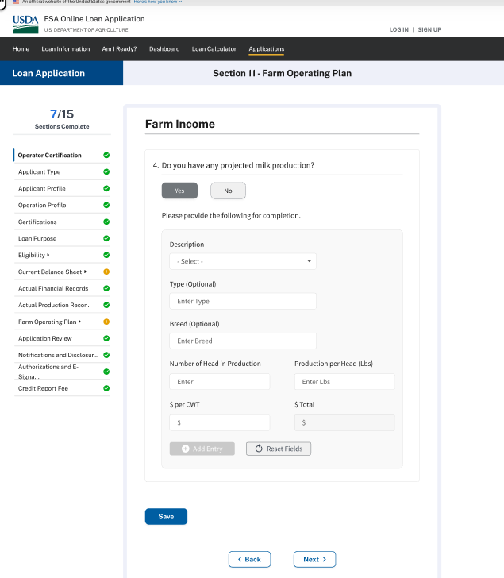

FARM OPERATING PLAN – Wireframe – When the applicant chooses to build a farm operating plan Farm Income Question #5
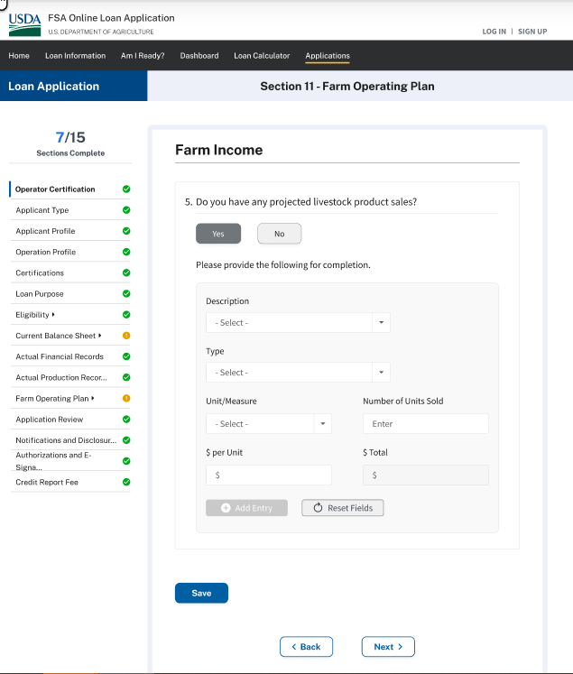

FARM OPERATING PLAN – Wireframe – When the applicant chooses to build a farm operating plan Farm Income Question #6
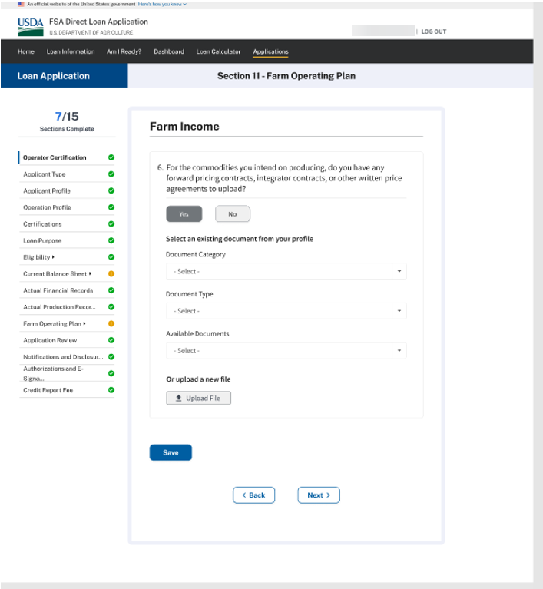

FARM OPERATING PLAN – Wireframe – When the applicant chooses to build a farm operating plan Farm Income Question #7
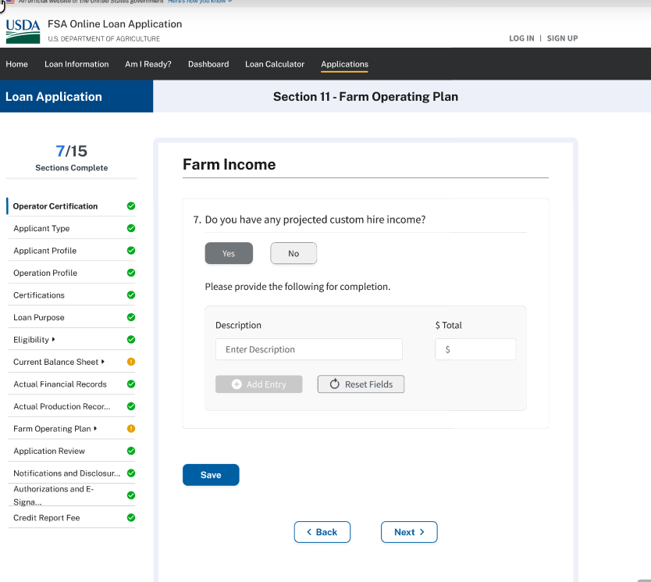

FARM OPERATING PLAN – Wireframe – When the applicant chooses to build a farm operating plan Farm Income Question #8
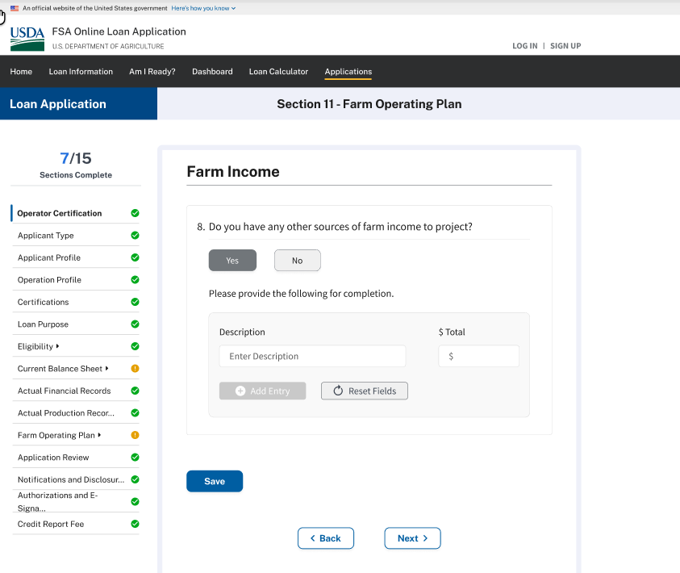

FARM OPERATING PLAN – Wireframe – When the applicant chooses to build a farm operating plan
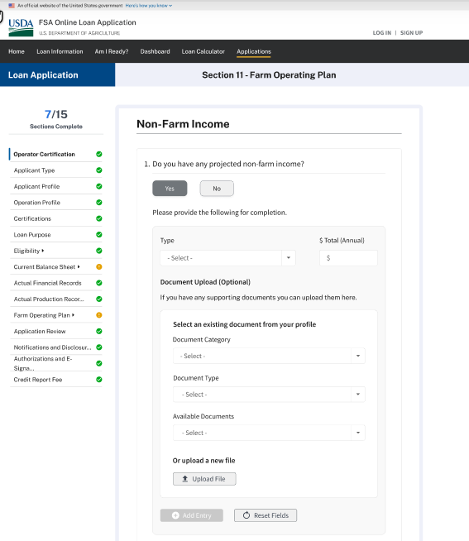

FARM OPERATING PLAN – Wireframe – When the applicant chooses to build a farm operating plan
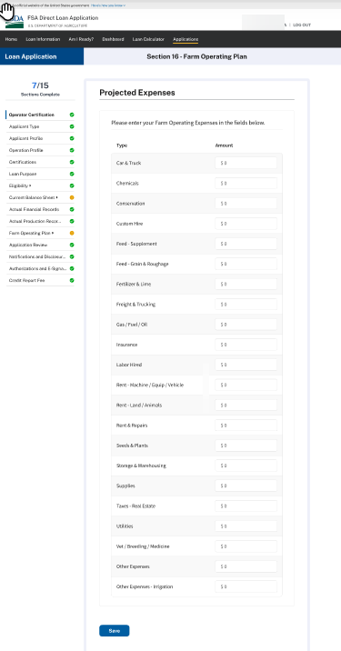

FARM OPERATING PLAN – Wireframe – When the applicant chooses to build a farm operating plan
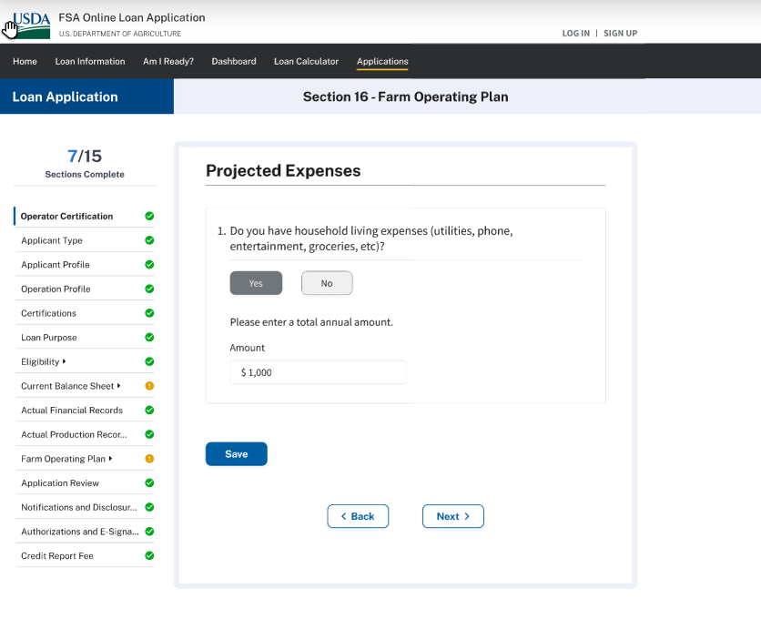

FARM OPERATING PLAN – Wireframe – When the applicant chooses to build a farm operating plan
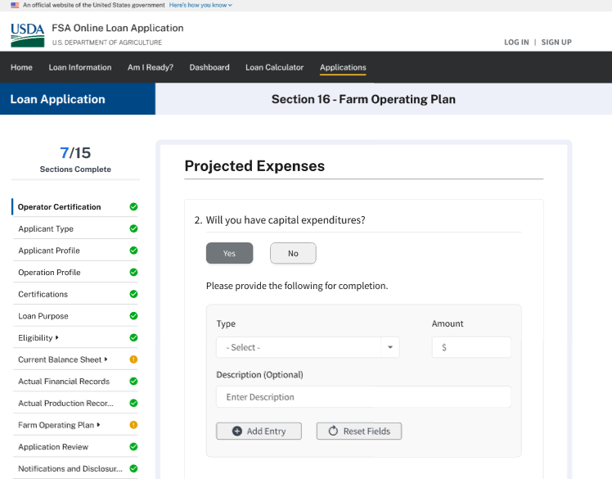

FARM OPERATING PLAN – Wireframe – When the applicant requests FSA farm loan staff assistance
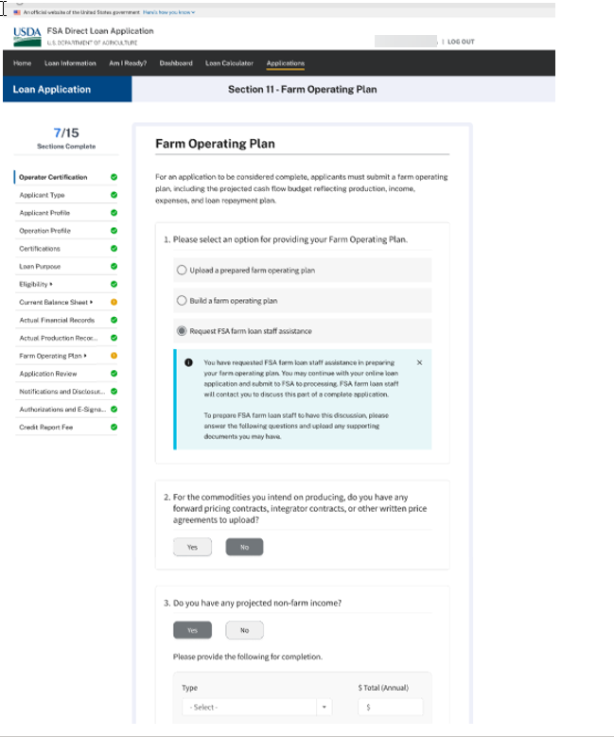

APPLICATION REVIEW
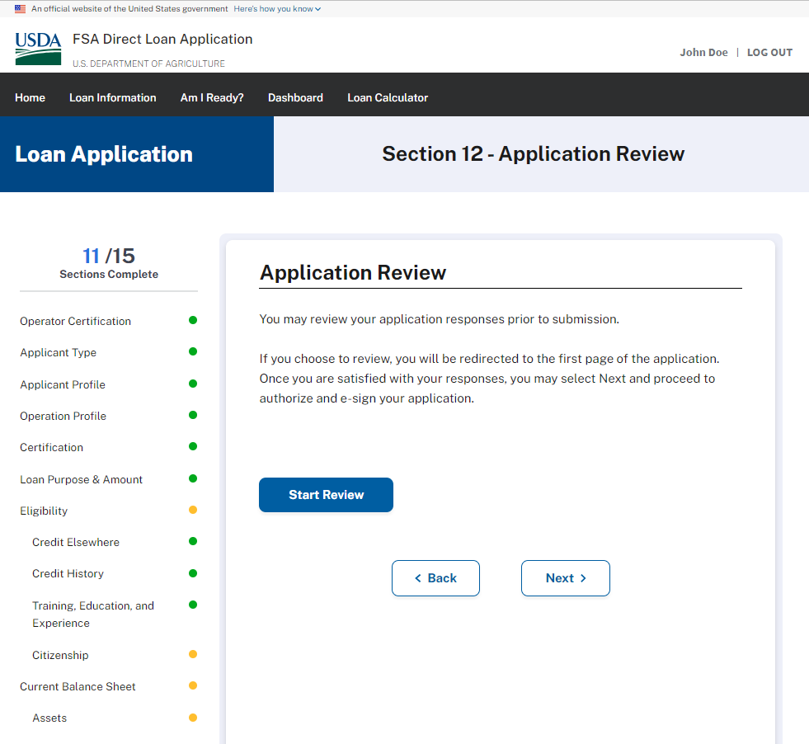
NOTIFICATION & DISCLOSURES - Minimized
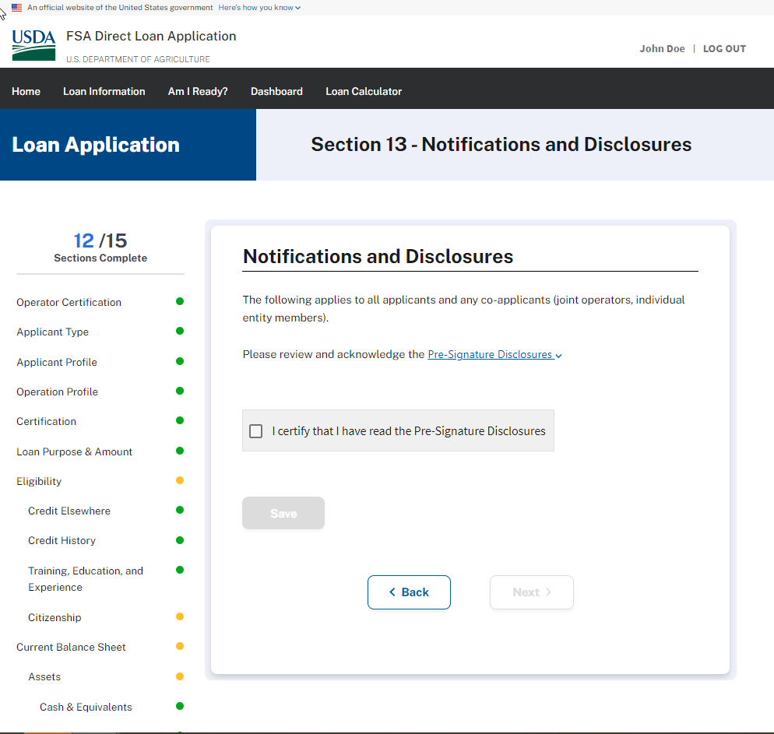

NOTIFICATION & DISCLOSURES - Maximized
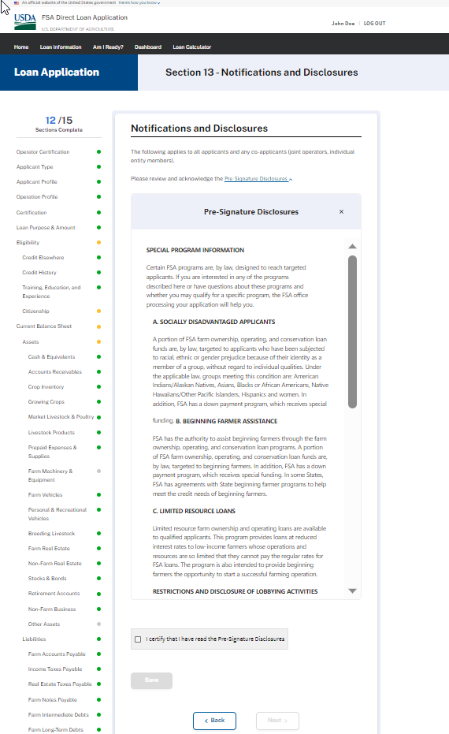

AUTHORIZATIONS AND E-SIGNATURE
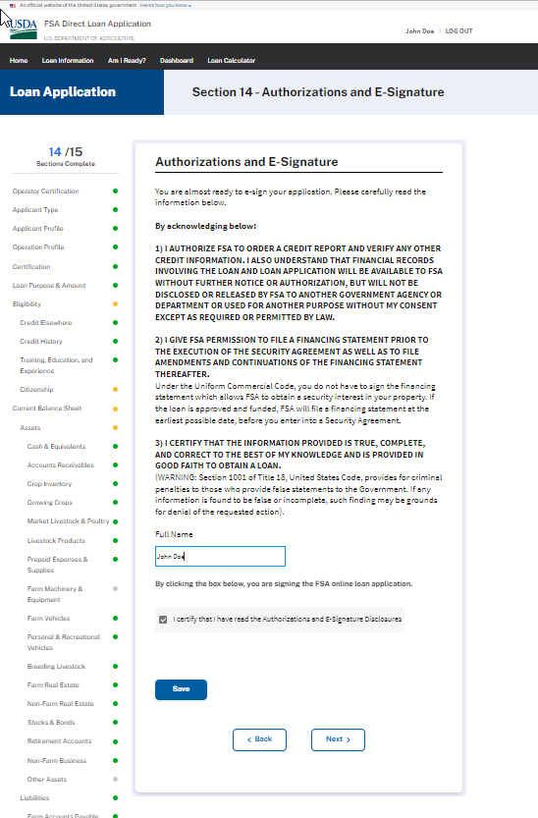

CREDIT REPORT FEE & SUBMISSION
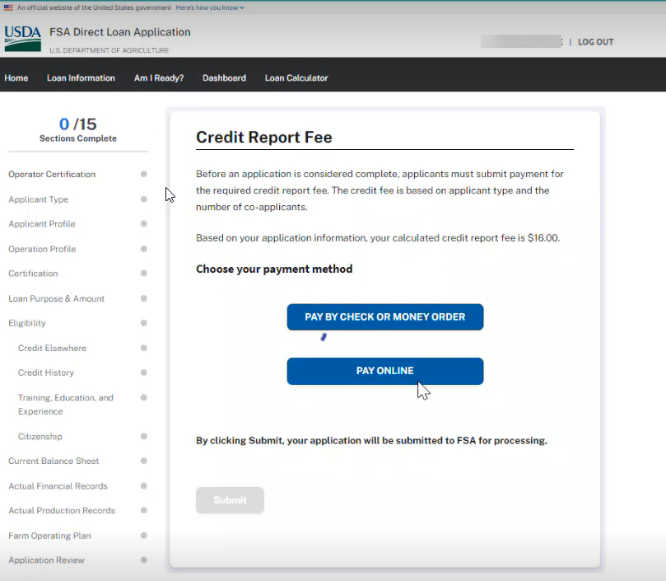

Payment of Credit Report Fee Online
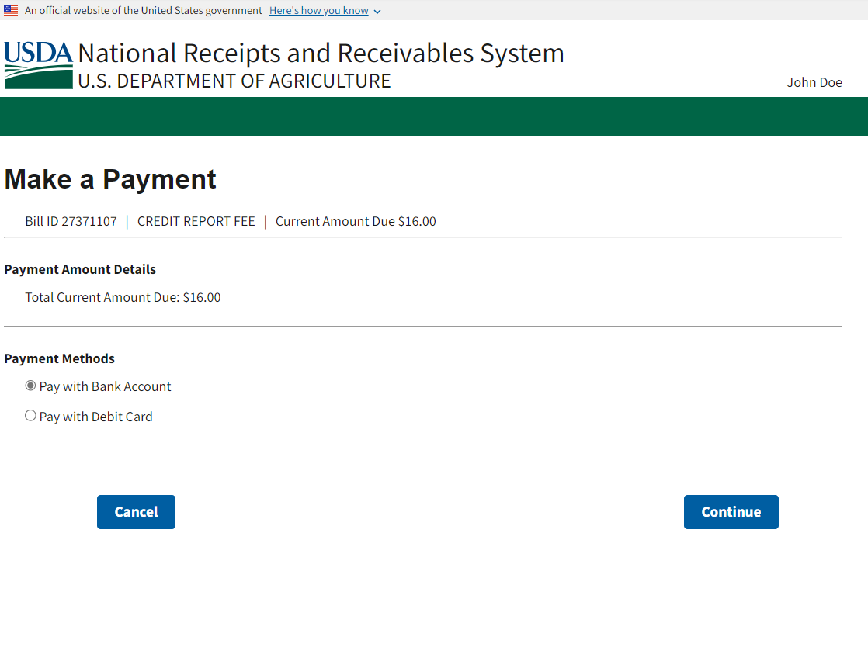

Payment of Credit Report Fee Online (continued - ACH Bank Account option)
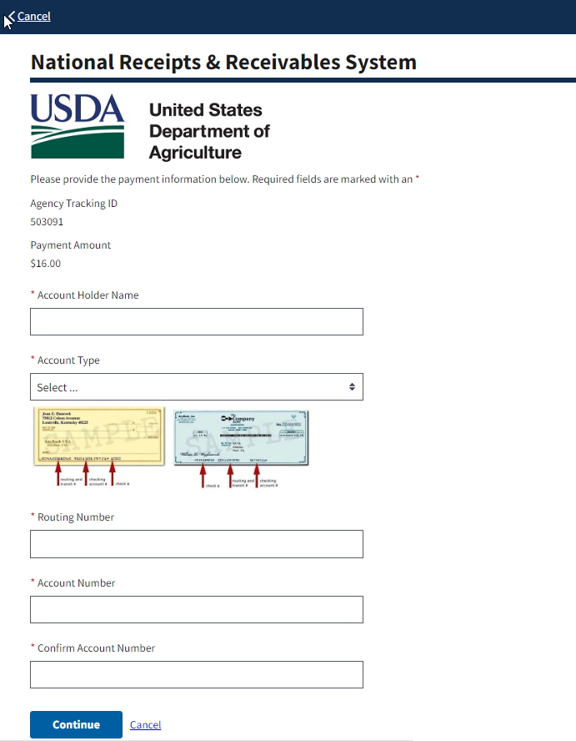

Payment of Credit Report Fee Online (continued – Debt Card option)
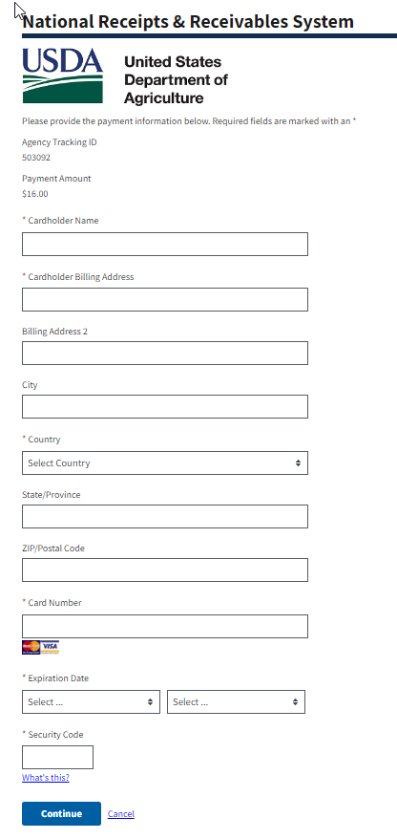
Public Burden Statement (Paperwork Reduction Act): Public reporting burden for this collection is estimated to average 1.51 hours per response, including reviewing instructions, gathering and maintaining the data needed, completing (providing the information), and reviewing the collection of information. You are not required to respond to the collection or FSA may not conduct or sponsor a collection of information unless it displays a valid OMB control number of 0560-XXXX.

