nFORM 2.0 Screens to Collect Information

on Services Provided to Participants

Note: Screen shots include fictional names for illustrative purposes. OMB Control Number and Expiration Date appear on entry to nFORM system and individual surveys.

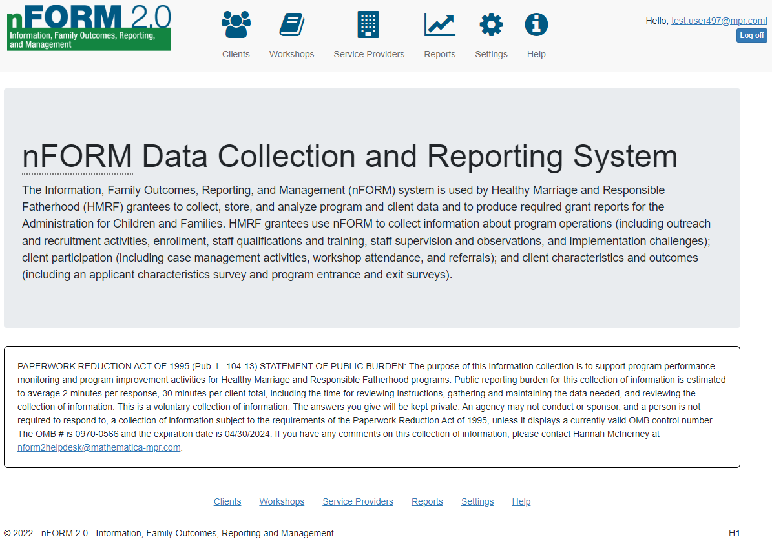
PAPERWORK REDUCTION ACT OF 1995 (Pub. L. 104-13) STATEMENT OF PUBLIC BURDEN: The purpose of this information collection is to support program performance monitoring and program improvement activities for Healthy Marriage and Responsible Fatherhood programs. Public reporting burden for this collection of information is estimated to average 2 minutes per response, 30 minutes per client total, including the time for reviewing instructions, gathering and maintaining the data needed, and reviewing the collection of information. This is a voluntary collection of information. The answers you give will be kept private. An agency may not conduct or sponsor, and a person is not required to respond to, a collection of information subject to the requirements of the Paperwork Reduction Act of 1995, unless it displays a currently valid OMB control number. The OMB # is 0970-0566 and the expiration date is XX/XX/XXXX. If you have any comments on this collection of information, please contact Hannah McInerney at nform2helpdesk@mathematica-mpr.com.

C1-C6. Client Level Data on Service Contacts, Referrals, Incentives, and Workshops
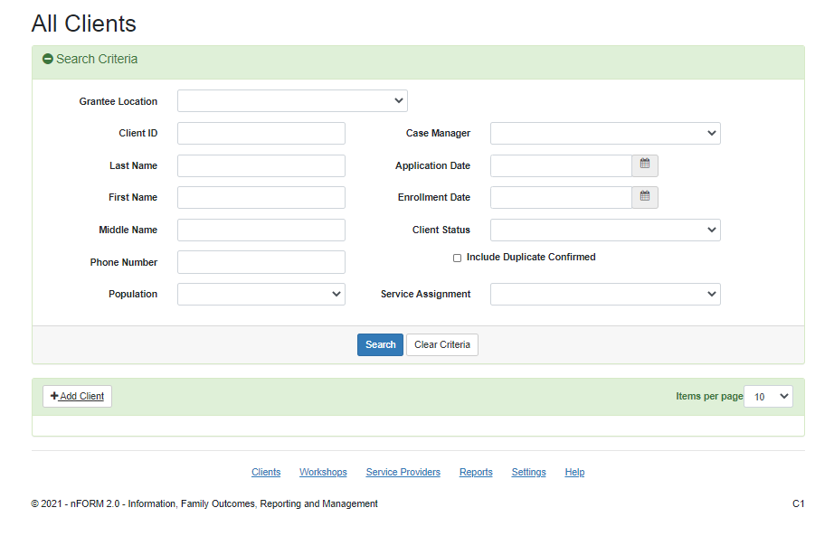

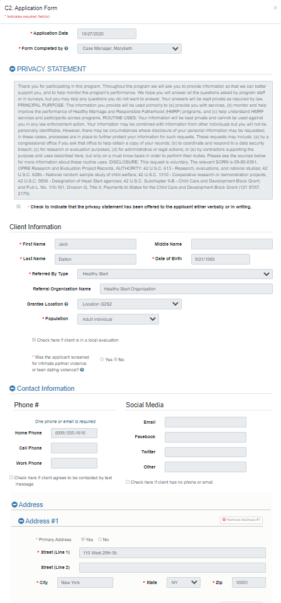
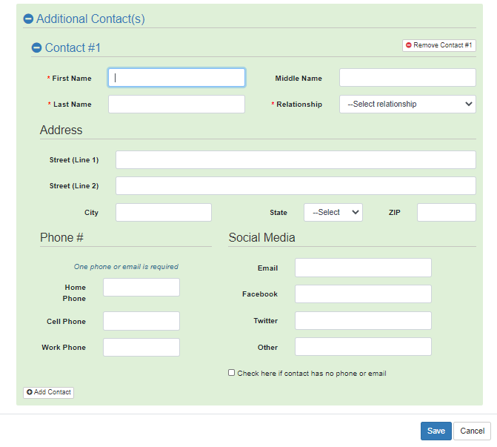

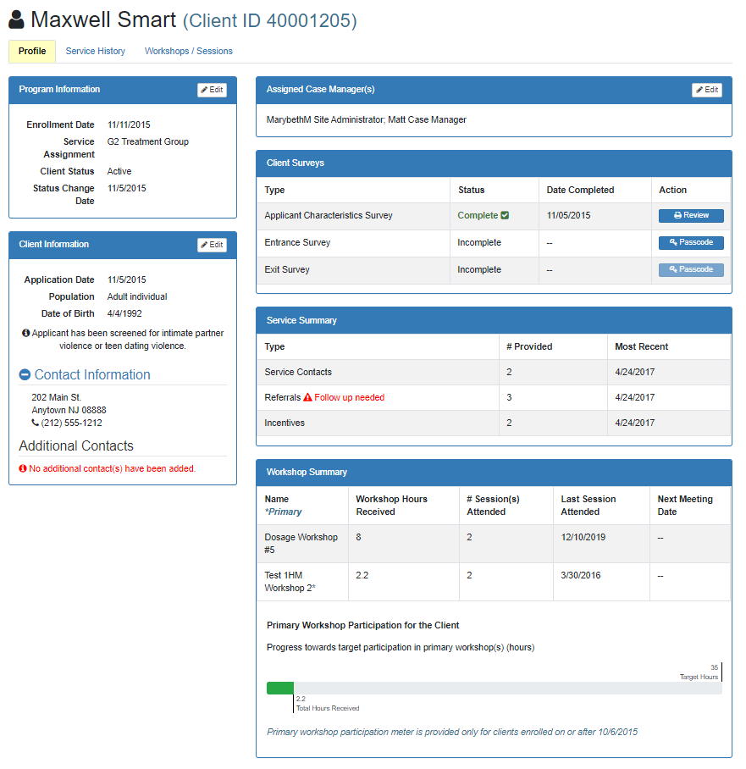

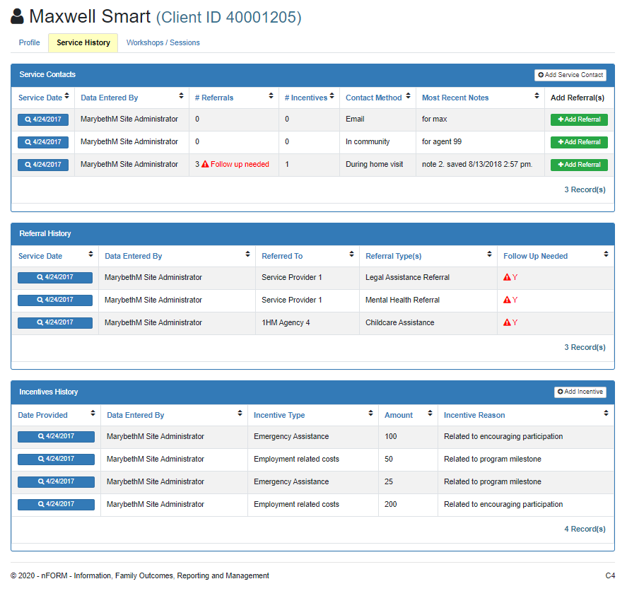

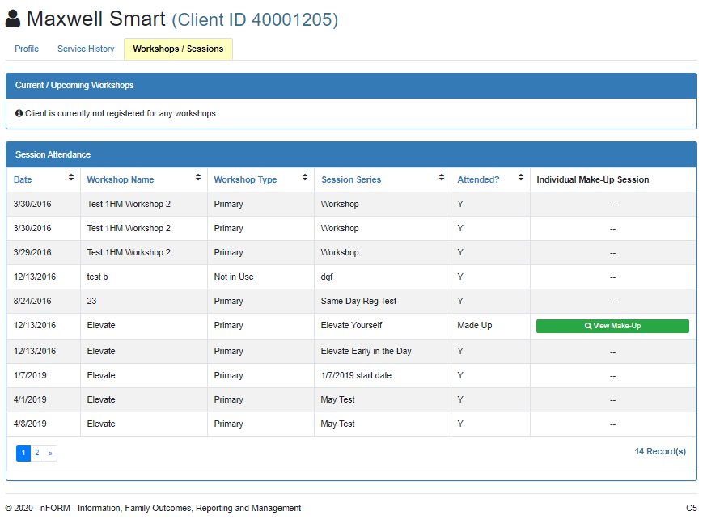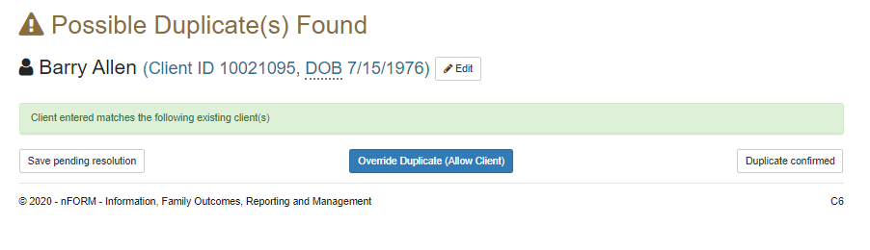

C7/C12/C13. Add/Edit Client Service Contacts, Referrals, and Incentives
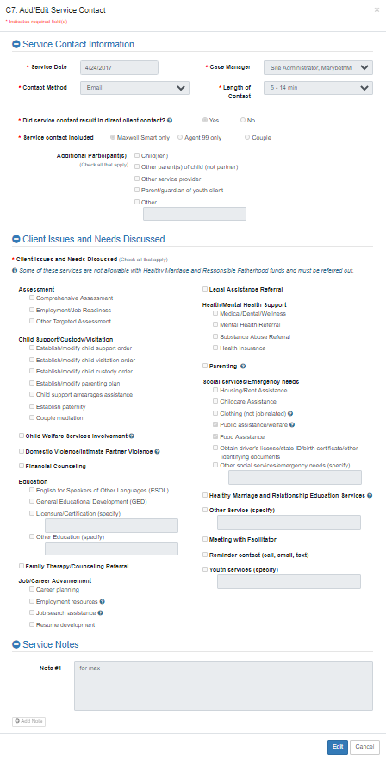
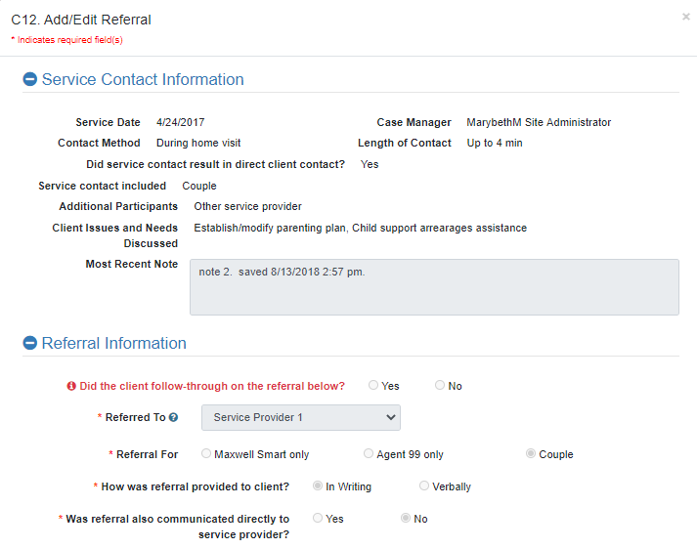
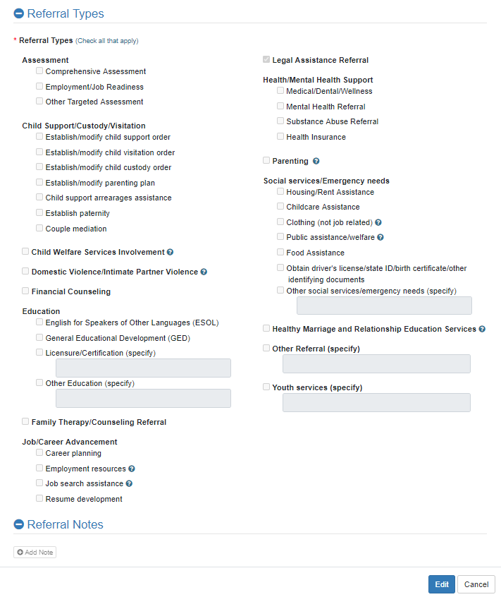

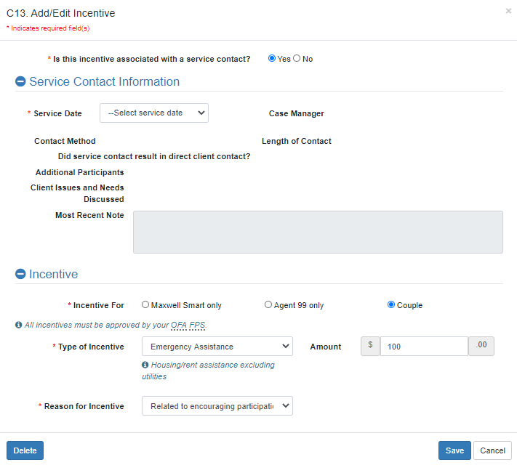

W1. Workshop List
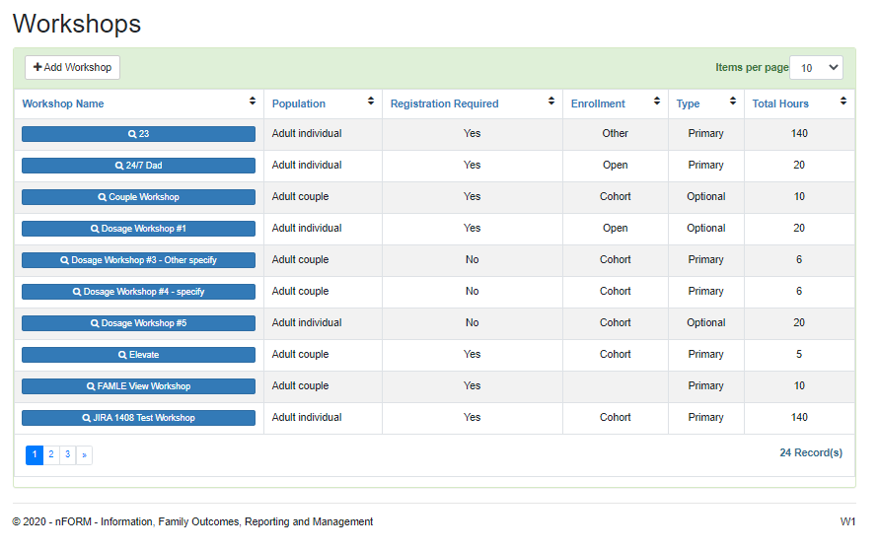

W2. Add/Edit Workshop
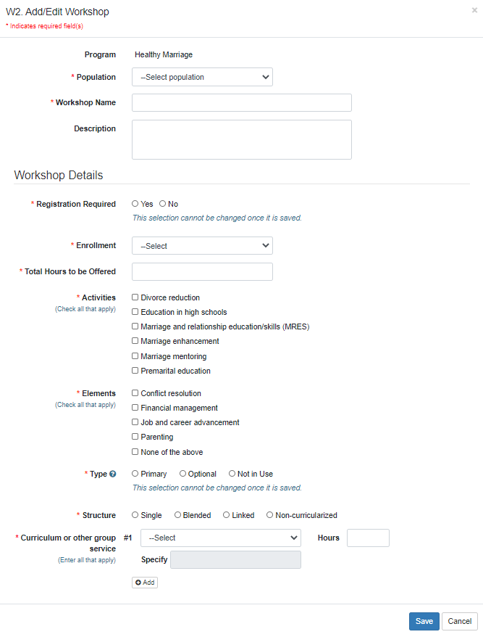
W5. Add/Edit Workshop Session Series
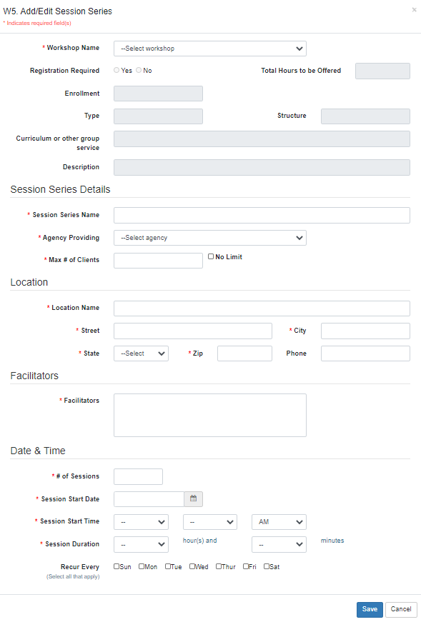
W4/W8. Manage Session Series and Client Registration
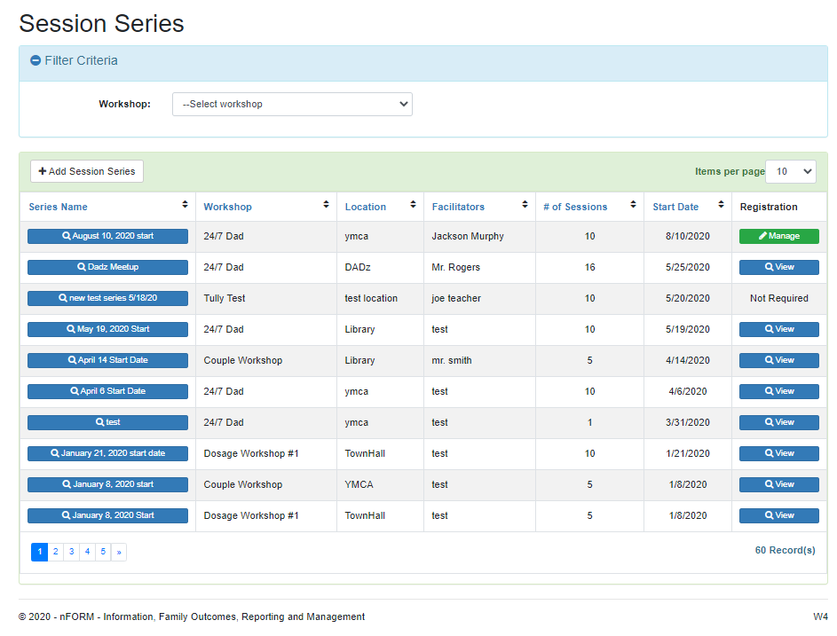

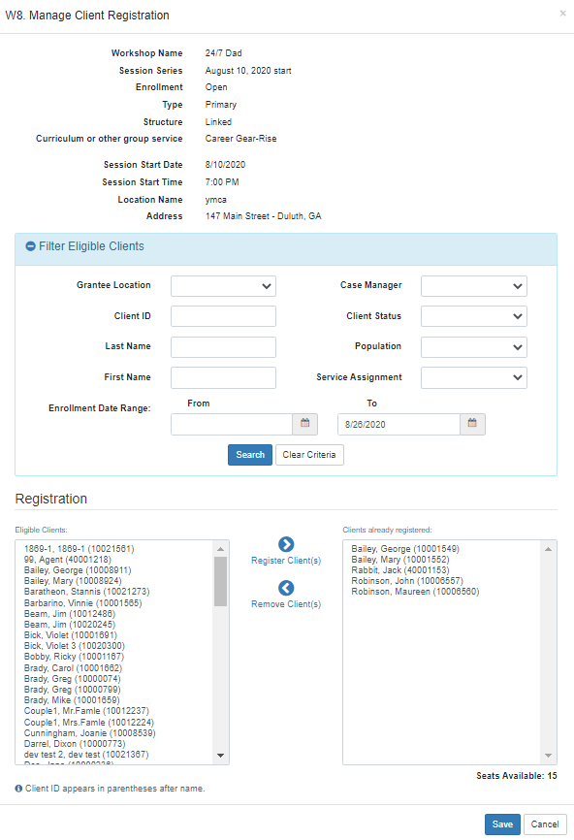
W7/W9/C11. Manage Session Occurrences and Attendance
