Current Location of Child
Located on UC Portal Discharge Tab
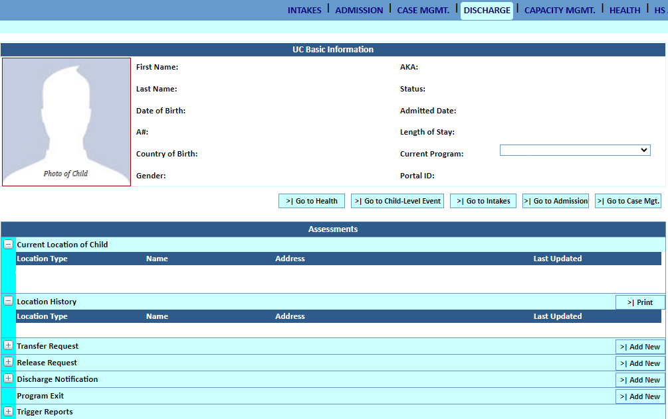
Auto-populated each time the location is updated
Auto-populated when Location Type = Program
Auto-populated when Location Type = Program
Dropdown (see below for available options)
Section will auto-populate, adding a new entry each time Current Location of Child is updated

Location Type Dropdown Options
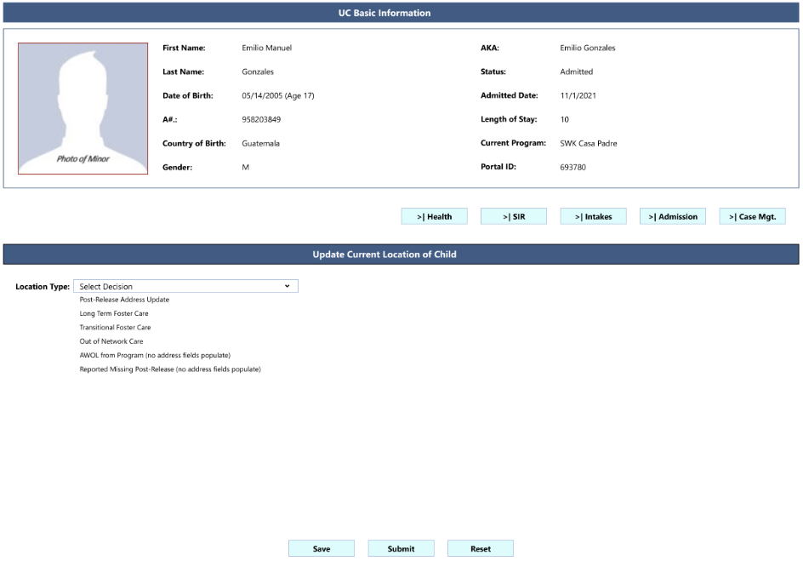
Additional fields populate (see below)
Address will auto-populate (see above)
No address fields populate
Post-Release Address Update
Program
Reported Missing Post-Release
Program

Additional Fields for Post-Release Address Update
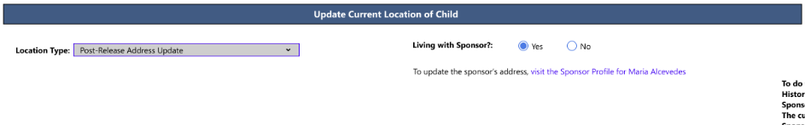
The user will enter changes of address in the Sponsor Assessment (Form S-5). To keep data integrity, the address originally entered in Form S-5 may not be overwritten. Rather, changes of address will be maintained in an address history table.

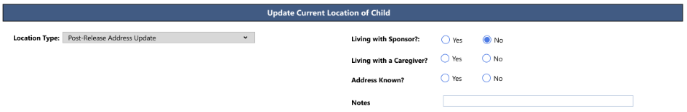
Fields display if “no” is selected for “Living with Sponsor?”

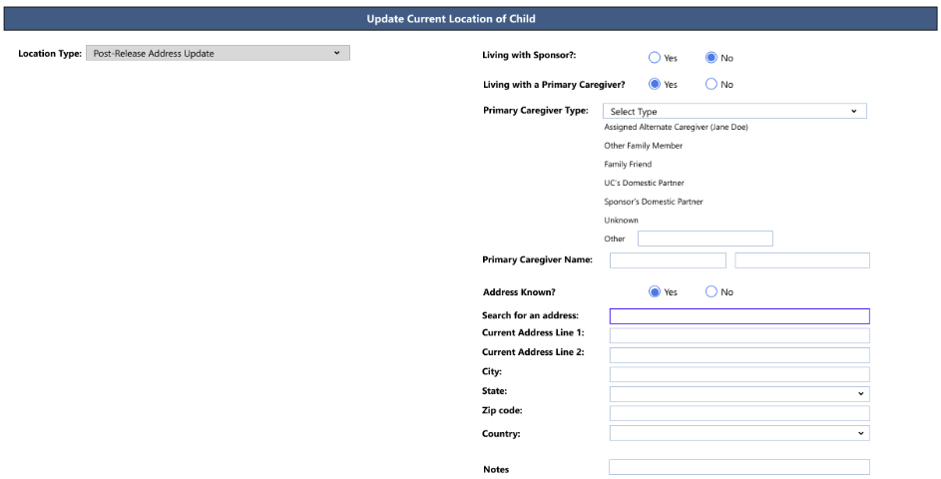
“Primary Caregiver Name” and all address fields will auto-populate if “Assigned Alternate Caregiver” is selected for “Primary Caregiver Type.” Address fields will be editable in case updates are needed.
Name of Assigned Alternate Caregiver documented in the Sponsor Assessment (Form S-5) will populate in the dropdown option
Fields will display here if “yes” is selected for “Address Known?”
Fields display if “yes” is selected for “Living with Primary Caregiver?”

