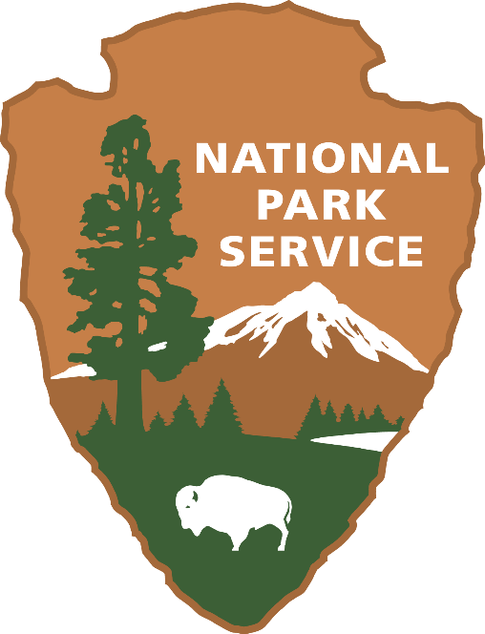

NPS SURVEY OF EDUCATORS

**NON-RESPONSE SURVEY**

**Paperwork Reduction Act Statement:** The National Park Service is authorized by 54 U.S.C. 100070 to collect this information. This survey is designed to provide information to NPS Education Program staff about teachers’ experiences and preferences surrounding NPS education program offerings to improve existing and future educational programs. Your responses to this collection are completely voluntary and will remain anonymous. You can end the process at any time and will not be penalized in any way for choosing to do so. Data collected will only be reported in aggregates and no individually identifiable responses will be reported. A Federal agency may not conduct or sponsor, and you are not required to respond to, a collection of information unless it displays a currently valid OMB Control Number. OMB has assigned control number XXXX-XXXX current expiration date is XX/XX/XXXX. Your response is not required to obtain or retain a benefit.

**Estimated Burden Statement:** Public reporting for this collection of information is estimated to be about 2 minutes per respondent. Send comments regarding this burden estimate or any other aspect of this collection of information, including suggestions for reducing this burden, to the NPS Information Collection Clearance Officer, National Park Service, 13461 Sunrise Valley Dr. (MS-244), Herndon, VA 20171.  **Please do not send the completed survey to this address.**

|  |
| --- |
| Note to Reviewers: If respondents click ‘no’ on the email invitation, they will be taken to a webpage that will contain the following text and non-response survey. |

This study seeks to understand educators’ attitudes toward National Park Service (NPS) Education Programs. During the initial email invitation, you indicated that you refused to complete the full survey. Would you be willing to answer three questions instead? It should take you no more than one minute.

Q 1. Do you teach or have you taught 3rd, 4th, or 5th grade in the past five years? (check all that apply)

* 3rd grade
* 4th grade
* 5th grade
* Have not taught 3rd to 5th grade in the past five years

Q2. At what type of school do you teach?? (Choose one)

* Public
* Private
* Home School

Q3. Is your school considered Title 1?

* Yes
* No

If you have any questions or concerns, please contact: Jenn Thomsen, University of Montana; [Jennifer.thomsen@umontana.edu](mailto:Jennifer.thomsen@umontana.edu) (email).

END OF SURVEY