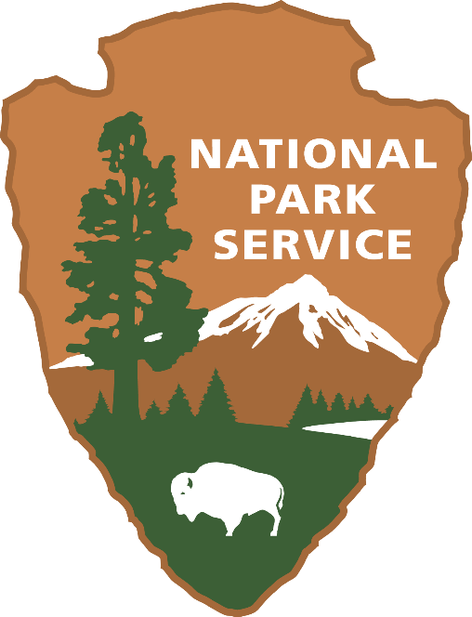

NPS SURVEY OF EDUCATORS

**Introductory Letter from NPS sites to teachers:**

Hello…,

The National Park Service (NPS) Department of Interpretation, Education, and Volunteers is working with the University of Montana on a study to better understand the role of the NPS in the greater education system.

We are seeking input from educators teaching 3rd-5th grade who have participated in NPS Education Programs. The goal of the study is to inform and improve future programming and expand the participation of teachers in a variety of NPS Education Programs.

This week you will receive an email either from Dr. Jennifer Thomsen or Dr. Elena Bigart from the University of Montana with a link to the online survey. It is deployed using Qualtrics program, and the questions may vary depending on your involvement with NPS Education Programs. Since it is an external email, please check your junk/spam folder. We kindly ask you to fill out the survey, as your input is very important and will help us improve the programs.

Thank you,

XXXX

**Initial Email:**

Hello…,   
   
This is Elena Bigart reaching out from the Institute for Tourism and Recreation Research (ITRR) at the University of Montana.  
   
The National Park Service (NPS) Department of Interpretation, Education, and Volunteers provided us with a list of teachers to receive an online survey that was developed to better understand the role of the NPS in the greater education system.  
  
We are seeking input from educators teaching 3rd-5th grade who have participated in NPS Education Programs. The goal of the study is to inform and improve future programming and expand the participation of teachers in a variety of NPS Education Programs.  
   
We kindly ask you to fill it out, as your input is very valuable and will help improve future programs. The survey should take no longer than 10 minutes. Your participation is voluntary, your responses will be anonymous, and you can choose to stop taking the survey at any point.   
  
If you have any questions or concerns, please contact Kerry Olsen (NPS,  [Kerry_Olson@nps.gov](mailto:Kerry_Olson@nps.gov)), Jennifer Thomsen (University of Montana, [Jennifer.thomsen@umontana.edu](mailto:Jennifer.thomsen@umontana.edu)), or myself.   
  
Thank you,  
Elena  
   
   
********************  
Elena A. Bigart, Ph.D.  
Social Scientist and Research Associate  
Institute for Tourism and Recreation Research  
W.A. Franke College of Forestry and Conservation  
University of Montana, Missoula, MT 59812  
(406) 243-6210  
[elena.bigart@umontana.edu](mailto:elena.bigart@umontana.edu)  
*********************

**First reminder email:**

Hello…,

Two weeks ago, we contacted you to participate in a survey for the National Park Service.

We are seeking input from educators teaching 3rd-5th grade who have participated in NPS Education Programs. The goal of the study is to inform and improve future programming and expand the participation of teachers in a variety of NPS Education Programs.

If you have not had the opportunity to complete the survey, please do so. It should take no longer than 10 minutes, and your input is very valuable. This online survey is available at the link below. Your participation is voluntary, your responses will be anonymous, and you can choose to stop taking the survey at any point. Another reminder to complete the survey will be sent in a couple of weeks.

If you have any questions or concerns, please contact Kerry Olsen (NPS, [Kerry_Olson@nps.gov](mailto:Kerry_Olson@nps.gov)), Jennifer Thomsen (University of Montana, [Jennifer.thomsen@umontana.edu](mailto:Jennifer.thomsen@umontana.edu)), or myself.

Thank you,

Elena

********************

Elena A. Bigart, Ph.D.

Social Scientist and Research Associate

Institute for Tourism and Recreation Research

W.A. Franke College of Forestry and Conservation

University of Montana, Missoula, MT 59812

(406) 243-6210

[elena.bigart@umontana.edu](mailto:elena.bigart@umontana.edu)

*********************

**Second reminder email**

Hello…,

A few weeks ago, we contacted you to participate in a survey for the National Park Service.

We are seeking input from educators teaching 3rd-5th grade who have participated in NPS Education Programs. The goal of the study is to inform and improve future programming and expand the participation of teachers in a variety of NPS Education Programs.

If you have not had the opportunity to complete the survey, please do so. It should take no longer than 10 minutes, and your input is very valuable. This online survey is available [at](https://nam04.safelinks.protection.outlook.com/?url=https%3A%2F%2Frrcassociates.az1.qualtrics.com%2Fjfe%2Fpreview%2FpreviewId%2F8cb5c517-fb7c-4bef-8026-e30908e09801%2FSV_2bHGQgoZHilIY9E%3FQ_CHL%3Dpreview%26Q_SurveyVersionID%3Dcurrent&data=05%7C01%7Celena.bigart%40mso.umt.edu%7C07f1ceb5db48474be2cf08db404cddcc%7C68407ce503da49ffaf0a724be0d37c9d%7C0%7C0%7C638174471287278356%7CUnknown%7CTWFpbGZsb3d8eyJWIjoiMC4wLjAwMDAiLCJQIjoiV2luMzIiLCJBTiI6Ik1haWwiLCJXVCI6Mn0%3D%7C3000%7C%7C%7C&sdata=swHeQQGulba7uHbOPbFq7GAiMjU%2B4TwvWGgn%2F%2BpcnTE%3D&reserved=0) the link below. Your participation is voluntary, your responses will be anonymous, and you can choose to stop taking the survey at any point. This is the final reminder to complete the survey.

If you have any questions or concerns, please contact Kerry Olsen (NPS, [Kerry_Olson@nps.gov](mailto:Kerry_Olson@nps.gov)), Jennifer Thomsen (University of Montana, [Jennifer.thomsen@umontana.edu](mailto:Jennifer.thomsen@umontana.edu)), or myself.

Thank you,

Elena

********************

Elena A. Bigart, Ph.D.

Social Scientist and Research Associate

Institute for Tourism and Recreation Research

W.A. Franke College of Forestry and Conservation

University of Montana, Missoula, MT 59812

(406) 243-6210

[elena.bigart@umontana.edu](mailto:elena.bigart@umontana.edu)