

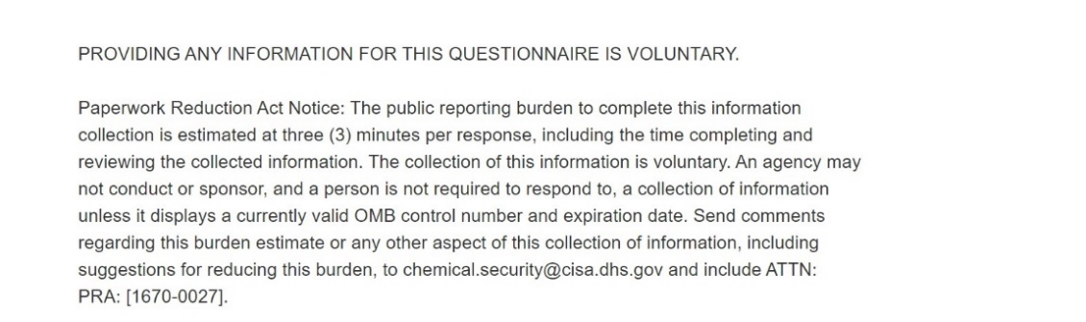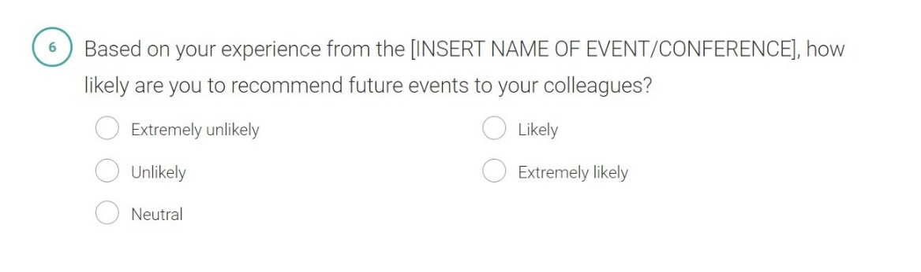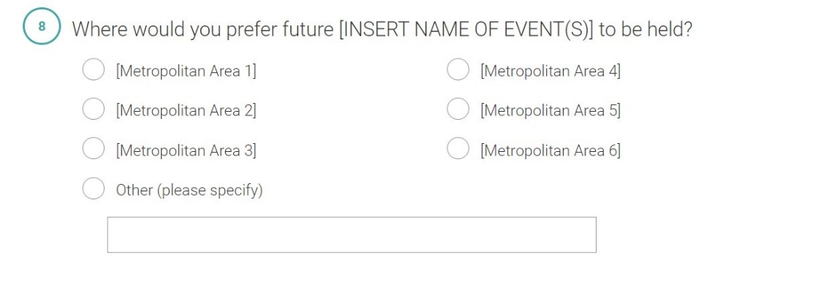

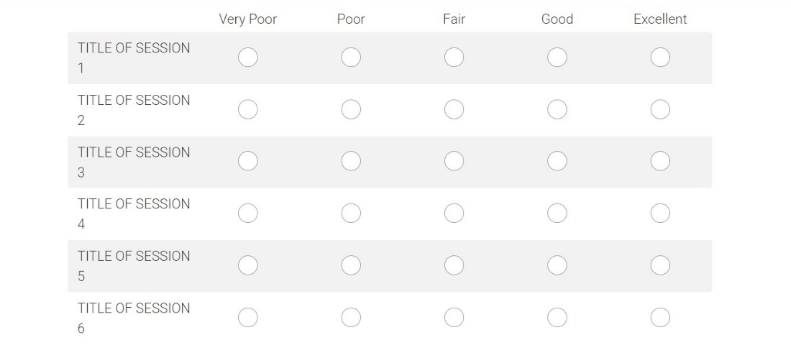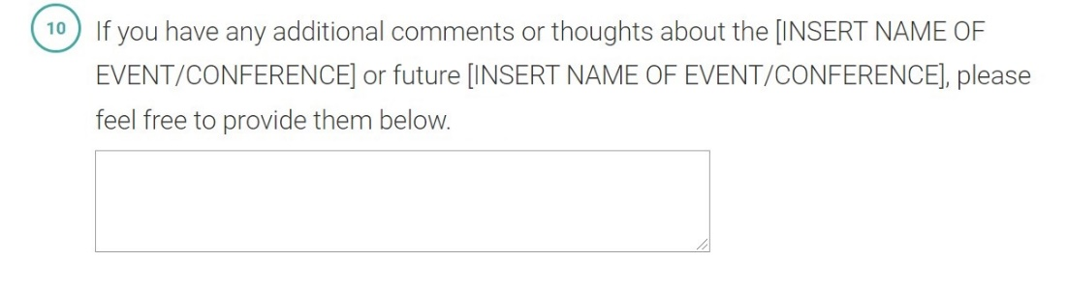

**Privacy Settings within Survey Monkey for this Instrument**

