# CISA Central’s Customer Feedback Survey

**PRA Burden Statement:** The public reporting burden to complete this information collection is estimated at 3 minutes per response, including the time completing and reviewing the collected information. The collection of this information is voluntary. An agency may not conduct or sponsor, and a person is not required to respond to a collection of information unless it displays a currently valid OMB control number and expiration date. Send comments regarding this burden estimate or any other aspect of this collection of information, including suggestions for reducing this burden to DHS/CISA. Mail Stop 0608, 245 Murray Lane SW, Arlington, VA 20598. ATTN: PRA [1670-0027].

The CISA Central Operations Center is a 24/7 information sharing hub on emerging threats and incidents involving Communication, Cyber and Physical Critical Infrastructure. Central Operations provides reports to DHS and CISA Senior Leaders, internal partners, and external stakeholders and are required to solicit feedback to improve reporting products. Information collected will be used internally to improve reporting products. Making a feedback survey available to stakeholders was recently identified as a requirement in a GAO Audit. A link will be provided at the bottom of each report sent to the various distribution lists. Stakeholders who wish to provide feedback on a report will select the embedded link in the report, complete a brief survey using Microsoft Forms, and submit. No personally identifiable information will be collected or maintained.

Disclaimer

Please **Do Not**add any Personally Identifiable Information (PII).  PII is any information that permits the identity of an individual to be directly or indirectly inferred, including any other information which is linked or linkable to that individual regardless of whether the individual is a U.S. citizen, lawful permanent resident, visitor to the U.S., or employee or contractor to the Department.

1. **Title of Report:**

Enter your Answer

1. **Date of Report**

Please input Date (M/d/yyyy)

1. **Please select partner type:**
   * County
   * Federal
   * Industry Partner
   * Interagency Partner
   * International Partner
   * Local
   * Local Level
   * Other
   * Regional
   * State
   * Territorial
   * Tribal

1. **Please rate your satisfaction with each of the following by selecting an option below**

1. **How do you plan to use this product in support of your mission? (Check all that apply.)**

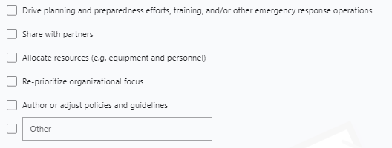

1. **To further understand your response to question 5, please provide specific details in which you would use this product.**

Enter your Answer

1. **What did the product not address that you anticipated it would?**

Enter your Answer

1. **Please list any other comments, questions, or concerns you may have regarding this product below.**

Enter your Answer

1. **To what extent do you agree with the following two statements?**

1. **Was this product useful to your Agency’s Leadership?**

Enter your Answer

1. **How did you obtain this product?**
   * Email
   * Partner Agency
   * HSIN
   * Other