National Student Loan Data System

NSLDS
Financial Value Transparency and Gainful Employment (FVT/GE) User Guide
Volume 2: FVT/GE Program Submittal Reporting

June 2024

Table of Contents
Change Log Table 4
Chapter 1: Overview 5
1.1 Introduction 5
1.2 Reporting Requirements 5
Chapter 2: FVT/GE Program Submittal File 6
2.1 FVT/GE Batch Processing 7
2.1.1 FVT/GE Program Submittal File Information 8
2.1.2 Qualifying Graduate Program Information 10
2.2 FVT/GE Program File-Level Error File 11
2.3 FVT/GE Program Error/Acknowledgement File 12
2.4 Batch File Formats 12
2.4.1 FVT/GE Program Submittal File 12
2.4.2 FVT/GE Program File-Level Error File 13
2.4.3 FVT/GE Program Error/Acknowledgement File 13
2.5 Timing 14
Chapter 3: Program Submittal via NSLDSFAP 15
3.1 FVT/GE Programs Page 16
3.2 Add FVT/GE Program Data 18
3.3 Edit FVT/GE Program Data 22
3.4 Deactivate Program 24
Chapter 4: FVT/GE Spreadsheet Submittal Process 26
4.1 Creating a Spreadsheet 27
4.1.1 Rename Worksheet 28
4.1.2 Spreadsheet with Field Names 29
4.2 Uploading a FVT/GE Spreadsheet Submittal File 29
4.2.1 FVT/GE Spreadsheet Submittal Page Results 30
4.3 Working Errors 31
Appendix A: FVT/GE Program Submittal File Record Layouts 32
FVT/GE Program Submittal and Error/Acknowledgement File Layout 34
Fixed Width 34
Comma Separated Values 39
FVT/GE Program File-Level Error File 44
Fixed Width 44
Comma Separate Values 46
File Level Errors 49
Reporting Instructions/Edits 50
FVT/GE Program Submittal File Header Record- Edits 50
FVT/GE Program Submittal File Detail Record 01- Edits 52
FVT/GE Program Submittal File Trailer Record- Edits 64
Appendix B: State Codes 65
Contact Information 66

List of Tables

Table 1: Neither GE nor Eligible Non-GE Programs 6
Table 2: FVT/GE Program Submittal File Detail Record (01) 8
Table 3: FVT/GE Program Submittal Source, Target, and Timing 14
Table 4: NSLDS FVT/GE files- Sending to NSLDS 15
Table 5: NSLDS FVT/GE files - Receiving from NSLDS 15
Table 6: File-Level Errors 49

List of Figures
Figure 1: Reporting Periods and Deadlines 7
Figure 2: FVT/GE Program Submittal File Positions (1-84) 10
Figure 3: FVT/GE Program Submittal File Positions (113-255) 10
Figure 4: FVT/GE Program File-Level Error File 11
Figure 5: FVT/GE Program File-Level Error File 12
Figure 6: FVT/GE Program Error/Acknowledgement File- No Errors 12
Figure 7: NSLDS Homepage – FVT/GE Programs Link 16
Figure 8: FVT/GE Programs Page - Search 16
Figure 9: FVT/GE Programs Page – Search Results 18
Figure 10: FVT/GE Programs Page – Add Program 19
Figure 11: Add Program Page 21
Figure 12: FVT/GE Programs Page – Edit 23
Figure 13: Edit Program Popup 24
Figure 14: FVT/GE Programs Page – Deactivate 25
Figure 15: Deactivate? Popup 26
Figure 16: Spreadsheet Submittal Page 27
Figure 17: Program Spreadsheet Submittal Template 28
Figure 18: Rename Worksheet 28
Figure 19: Rename Worksheet 28
Figure 20: Spreadsheet Submittal Page – Upload Submittal Files 30
Figure 21: Spreadsheet Submittal Page – Download Errors 31

Change Log Table

The change log table below is updated each time Volume 2 of the NSLDS Financial Value Transparency and Gainful Employment (FVT/GE) User Guide is updated, providing you with a cumulative list of revisions made to the document.

Date | Section | Page(s) | Changes/Note
6/2024 | 1.1 | 5 | Updated Introduction
6/2024 | Chapter 3 | 15 – 26 | Added Program Submittal via NSLDSFAP section
6/2024 | Chapter 4 | 26 – 31 | Added FVT/GE Program Spreadsheet Submittal Process section
6/2024 | Appendix A | 36, 41 | Updated Qualifying Graduate Program Field description in fixed-width and CSV file layouts
6/2024 | Appendix B | 65 – 66 | Included State Code Values

Chapter 1: Overview

1.1 Introduction
Volume 2 of the NSLDS Financial Value Transparency and Gainful Employment (FVT/GE) User Guide focuses on the reporting of program information to the National Student Loan Data System (NSLDS®).
Schools can choose to report program-specific information through batch reporting via the Student Aid Internet Gateway (SAIG), through online reporting, or the spreadsheet submittal process via the NSLDS Professional Access website. Depending on your school’s preferred method, managing the reporting process may require a combination of batch and online access. Please refer to the Introduction for instructions on how sign up for FVT/GE Batch Services or online access.
NSLDS batch reporting supports both the fixed-width and comma-separated values (CSV) formats, providing versatility to meet your school's technical requirements and preferences.
This program submittal reporting volume provides schools with details on the descriptions for the FVT/GE Program Batch Submittal File, along with information on the header and trailer details, file formats, data elements, and definitions. This volume also provides the error codes used for the FVT/GE Program Batch Submittal File and their descriptions, as well as detail about the FVT/GE Program File-Level Error File and the FVT/GE Program Error Acknowledgment File. Further information within this volume explains how schools can report FVT/GE program data using both online reporting and the spreadsheet submittal process via the NSLDS Professional Access website.

1.2 Reporting Requirements
The FVT/GE regulations require that schools annually report data to NSLDS by Oct. 1st, after the most recently completed award year. There are two types of data schools will report to NSLDS for programs at the institution (six-digit OPEID) level: student-specific information and program-specific information. This volume will detail the procedures for schools to submit program-specific information to NSLDS. Reporting includes information about each GE or Eligible Non-GE Program at your institution on an annual basis for the most recently completed award year. Schools must report specific information for each GE or Eligible Non-GE Program.
GE Programs and Eligible Non-GE Programs are identified by a combination of an institution's six-digit OPEID number, the program's six-digit Classification of Instructional Programs (CIP) code as assigned by the institution or determined by the Secretary, and the program's credential level (e.g., associate’s degree or bachelor’s degree). A GE Program or an Eligible Non-GE Program could include multiple Title IV-eligible programs, as defined under 34 CFR 668.8, if the institution offers multiple distinct programs that have the same six-digit CIP code and credential level. There are also some Title IV-eligible programs that are neither GE nor Eligible Non-GE Programs. They are not subject to reporting or any other requirements in the FVT/GE regulations.
Table 1: Neither GE nor Eligible Non-GE Programs
These programs do not need to be reported as they are neither GE nor Eligible Non-GE Programs
Approved Comprehensive Transition and Postsecondary (CTP) Programs
Approved Prison Education Programs
Postbaccalaureate Teacher Certification Programs where the institution does not award a credential
Programs at least two academic years in length that are acceptable for full credit toward a bachelor’s degree
Preparatory coursework for which eligible students may receive Direct Loan funds

Refer to GEN-24-04 Regulatory Requirements for Financial Value Transparency and Gainful Employment for more information.

Accuracy in reporting is crucial for schools, as some information provided will be verified against information already stored in NSLDS. This process ensures the Department can generate an accurate Completers List for schools and calculate accurate debt-to-earnings (D/E) rates and earnings premium (EP) measures for the program. The Completers List process and the calculation process will be detailed in future volumes of the NSLDS FVT/GE User Guide.

Chapter 2: FVT/GE Program Submittal File
Schools will have various options to submit FVT/GE program-specific data to NSLDS, including the FVT/GE Batch Program Submittal File via SAIG and online reporting functions through the NSLDS Professional Access website. This section will detail how schools can submit their program-specific data through the FVT/GE Batch Program Submittal File via SAIG.

Figure 1 provides the reporting periods and deadlines to report program data to NSLDS for current and future years. The Reporting Period is the period of time for which the school is reporting data.

Figure 1: Reporting Periods and Deadlines

Schools should report FVT/GE program-specific information to the Department on an annual basis. Institutions must provide program information for each eligible program if the program has a total of at least 30 completers over the four most recently completed award years within any group of substantially similar programs. A group of substantially similar programs is defined as all programs in the same four-digit CIP code at an institution.

The Program Submittal file allows schools to submit program data such as the accrediting agency name, whether the program is a qualifying graduate program or a Liberal Arts Program at a proprietary school, the total number of enrolled students in that program, and so forth. The FVT/GE Program Submittal File should only contain program-level data at the 6-digit OPEID level.

2.1 FVT/GE Batch Processing
Schools may submit an FVT/GE Program Submittal file to NSLDS via SAIG using one of the batch file layouts described in Appendix A. After receiving the FVT/GE Program Submittal File, NSLDS will perform validation checks for any file-level errors. If any errors are found, NSLDS will not process the submittal file and return a File-Level Error File to the school. An FVT/GE Program File-Level Error File would typically be returned if there are format issues or issues in the Header or Trailer record. If no File-Level errors are found, the FVT/GE Program Error/Acknowledgment File will be sent to schools for each processed FVT/GE Program Submittal File. This file will only list the first error on a record submitted that triggered the issue. If there are no errors, the FVT/GE Program Error/Acknowledgment file will contain only a Header and Trailer record.
After a school corrects any errors in their FVT/GE Program Submittal File as indicated by either the FVT/GE Program File-Level Error File or the FVT/GE Program Error/Acknowledgment File, the school is then able to resubmit the corrected file to NSLDS.

2.1.1 FVT/GE Program Submittal File Information
The FVT/GE Program Submittal File is the file schools are required to submit to report FVT/GE program data to NSLDS. Institutions must provide program information for each eligible Title IV program that has a total of at least 30 completers over the four most recently completed award years within any group of substantially similar programs. Substantially similar is defined as all programs in the same four-digit CIP code at an institution.

The program submittal file contains one Header record, one or more Detail Records, and one Trailer Record.

Table 2 displays the data that must be included when submitting the FVT/GE Program Submittal file Detail Record (‘01’) to NSLDS. Schools should report this information annually but can report it more frequently.

Table 2: FVT/GE Program Submittal File Detail Record (01)
Program Detail Record Fields
Award Year
Program Identifiers (CIP Code, Credential Level, Length of Program, Length of Program Measurement, Weeks in Title IV Academic Year)
Count of Enrolled Students in the Program (Includes both Title IV and non-Title IV students)
State of Main Campus
Program Prepares Students for Licensure in State of Main Campus
Program Name
CIP Year
Qualifying Graduate Program Indicator
Programmatically Accredited Indicator
Accrediting Agency Name
Liberal Arts Bachelor’s Degree Program at Proprietary Institution
Count of Program Graduates who Attempted Licensure Exam
Count of Program Graduates who Passed Licensure Exam
Count of Enrolled Students in the Program
State Two/Three/Four/Five in MSA of Main Campus
Program Prepares Students for Licensure in MSA State Two/Three/Four/Five
Invalid Flag

Additional details on the definitions of these fields can be found in Appendix A below.
Schools can also utilize the Program Submittal File to either update or invalidate a previously submitted FVT/GE record. Schools need to make sure that the values they are reporting (to update or invalidate the existing FVT/GE record) match the information stored with the current record on NSLDS. The following are the fields that must match between the current and existing records:

- Award Year
- CIP Code
- Credential Level
- Published Length of Program
- Published Length of Program Measurement
- Weeks in Title IV Academic Award Year

If a match is found and the Invalid Flag field is a ‘Y’, NSLDS will invalidate the existing record that it was matched to. If the Invalid flag field is ‘N’ or space, NSLDS will process and update the existing record.

Figures 2 and 3 provide an example of the FVT/GE Program Submittal File. Please note that the images below illustrate different portions of the FVT/GE Program Submittal File: Figure 2 displays positions 1-84, while Figure 3 displays positions 113-255.

Figure 2: FVT/GE Program Submittal File Positions (1-84)
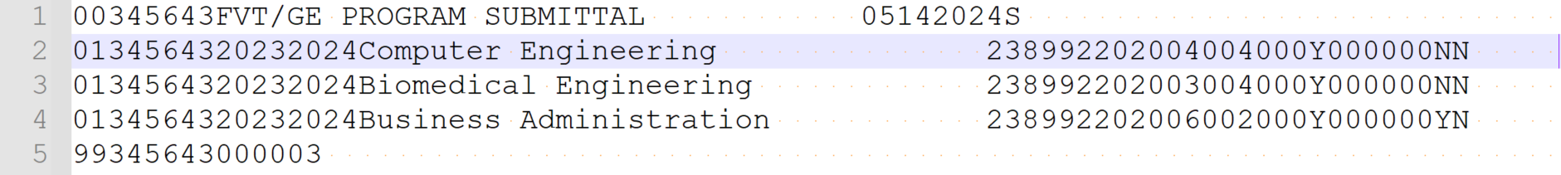

Figure 3: FVT/GE Program Submittal File Positions (113-255)
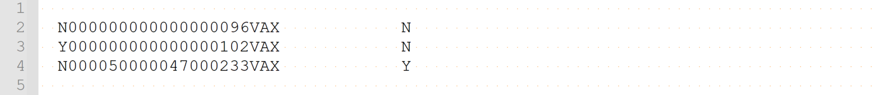

Enrollment data from NSLDS and the information provided by schools in the submittal file will be utilized to draft the Completers List and calculate the program’s debt-to-earnings (D/E) and earnings premium (EP) measure. The Completers List process and the calculation process will be detailed in future volumes of the NSLDS FVT/GE User Guide.

2.1.2 Qualifying Graduate Program Information
The Qualifying Graduate Program Indicator field will help NSLDS to determine whether the program is considered a qualifying graduate program or a program other than a qualifying graduate program. A qualifying graduate program is a program whose students must complete required postgraduation training programs to obtain licensure to practice in the field. Such programs must be accredited by an agency that meets State requirements if a State has such requirements for licensure. In order to be considered a qualifying graduate program, at least half of a program’s graduates must obtain licensure in a State where the postgraduation training requirements apply. Refer to GEN-24-04 Regulatory Requirements for Financial Value Transparency and Gainful Employment for more information.
NSLDS identifies if a program is defined as a qualifying graduate program through the following two methods:
- The program’s credential level is at the graduate level and the program’s CIP code is included in the list created by the Department of Education.
- The school indicated a ‘Y’ in the Qualifying Graduate Program Indicator field of the FVT/GE Program Submittal File.
When a school indicates a ‘Y’ in the Qualifying Graduate Program Indicator field to inform NSLDS that the program is eligible, NSLDS verifies its CIP code against the list supplied by the Department to confirm if the program meets the qualifications.

2.2 FVT/GE Program File-Level Error File
After receiving the FVT/GE Program Submittal File, NSLDS will perform validation checks for any file-level errors. If any errors are found, NSLDS will return a File-Level Error File to the school. File-level errors typically relate to file format, header/trailer errors, or an incorrect TG mailbox.

Figure 4 illustrates a portion of the FVT/GE Program Submittal File in CSV format that triggered a file-level error.

Figure 4: FVT/GE Program File-Level Error File

In this example, the FVT/GE Program Submittal File triggered file-level error 13: Value does not equal Institution Code in Header Record. Error code 13 was triggered because the header record was submitted with the six-digit OPEID of ‘345643’, while the trailer record was submitted with a six-digit OPEID ‘345642’ which does not match the six-digit OPEID submitted in the header record.

Figure 5 illustrates a portion of the FVT/GE Program File-Level Error File that would be returned in CSV format and displays file-level error 13.

Figure 5: FVT/GE Program File-Level Error File

If the FVT/GE Program Submittal File triggers a file-level error, only one detail record will be returned in the FVT/GE File-Level Error File, as shown in Figure 5. The returned record will be made up of zeros and spaces, with only the Error Code field populated with the file-level error that was triggered. Refer to Table 6 for all file-level error codes and definitions.

2.3 FVT/GE Program Error/Acknowledgement File
The FVT/GE Program Error/Acknowledgement File is returned to schools by NSLDS after the FVT/GE Program Submittal File is submitted and it passes all validation checks for any file-level errors. This file will only list the first error on a record submitted that triggered the issue. If there are no errors, the FVT/GE Program Error/Acknowledgment file will contain only a Header and Trailer record.
Note: As of this publication, the FVT/GE Program Error/Acknowledgement file will only display one error. However, in the future, the file will display up to five errors.

Figure 6 is an example of an FVT/GE Program Error/Acknowledgement File (fixed-width format) if there are no record-level errors present in the FVT/GE Program Submittal File.

Figure 6: FVT/GE Program Error/Acknowledgement File- No Errors

2.4 Batch File Formats
Multiple file formats are available for the purpose of FVT/GE reporting. NSLDS will support the use of the fixed-width format and the comma separated values (CSV) format. These formats utilize the same data, but the format varies slightly.

2.4.1 FVT/GE Program Submittal File
The following description outlines the basics of the fixed-width or comma separated values (CSV) FVT/GE Program Submittal File.
The following outlines the basics of the fixed-width or comma separated values (CSV) Submittal file.
- Header Record – Each FVT/GE Program file contains a single Header record. The Header record identifies the source of the file and the file’s preparation/creation date, as well as other identifying information.
- Detail Records – Each FVT/GE file may contain one or more Detail Records. Each program should be submitted in its own Detail Record (01).
- Trailer Record – Each FVT/GE Program File contains a single Trailer Record to correspond to the Header Record included in the file. The Trailer Record shows the total number of Detail Records contained in the file.
Format Data – All records must be formatted according to the record layout and field definitions in Appendix A. Verify data and check for formatting errors before submitting a file to NSLDS.

2.4.2 FVT/GE Program File-Level Error File
The following outlines the basics of the fixed-width or comma separated values (CSV) FVT/GE Program File-Level Error File.

- Header, Detail, and Trailer Record – Each FVT/GE Program File-Level Error File contains one Header record, one Detail Record ‘01’ with one error code at the end of the record, and one Trailer record. The Header record identifies the source of the file and the date the file-level error was generated, as well as other identifying information. Detail Record ‘01’ contains all spaces and zeros, except for the Error Code 1 field which will identify the file level error present in the FVT/GE Program Submittal File. The Trailer record will show the Detail Record count of one.

Descriptions of the File-Level Error Codes are provided in Appendix A.

2.4.3 FVT/GE Program Error/Acknowledgement File
The following outlines the basics of the fixed-width or comma separated values (CSV) FVT/GE Program Error/Acknowledgement File.

- Header, Detail, and Trailer Records – Each FVT/GE Program Error/Acknowledgement File contains a single Header record, one Detail Record with one error code at the end of the applicable record, and a single Trailer record. If there are no errors found in the FVT/GE Program Submittal File, then there will only be a single Header record and a single Trailer record returned to acknowledge NSLDS received the Submittal File. The Header record identifies the source of the file and the date the record-level error was generated, as well as other identifying information. The Detail record identifies the record that has received an error. As noted above, only one record-level error will be returned. In the future, the Detail Record will display up to five errors. Records without errors that were accepted by NSLDS will not be included in the file. The Trailer record shows the number of Detail records contained in the file.

Descriptions of all record level edits are provided in Appendix A.

2.5 Timing
Each file type has a timing component associated with its processing. See
Table 3 for the timing of each file.

Table 3: FVT/GE Program Submittal Source, Target, and Timing
File Type | Source/From | Target/To | Frequency/Timing
FVT/GE Program Submittal File | Institutions | NSLDS | Schools are required to submit program data on an annual basis, with the option to report more frequently if desired.  All reporting must be completed by Oct. 1st, after the most recently completed award year.
FVT/GE Program File-Level Error File | NSLDS | Institutions | Within 36 hours of NSLDS successfully processing the FVT/GE Program Submittal File
FVT/GE Program Error/Acknowledgement File | NSLDS | Institutions | Within 36 hours of NSLDS successfully processing the FVT/GE Program Submittal File with no file-level errors.

If a school submits an FVT/GE Program Submittal file and does not receive an FVT/GE File-Level Error File or an FVT/GE Program Error/Acknowledgement within 36-38 hours of submitting, please call the NSLDS Customer Support Center for assistance.

Batch files are submitted using the school’s SAIG TG Mailbox associated with the FVT/GE Batch services as designated by the school. Schools will submit the FVT/GE Program Submittal File to the NSLDS TG Mailbox TG50012 and NSLDS will return the File-Level Error File, or the Error/Acknowledgement File form the same TG Mailbox, TG50012.

Table 4 and 5 displays the message classes for the FVT/GE Program Batch Submittal File, FVT/GE Program File-Level Error File, and the FVT/GE Program Error/Acknowledgement File for both the fixed-width format and CSV format.

Table 4: NSLDS FVT/GE files- Sending to NSLDS
Message Class | Description
GEFVPFIN | FVT/GE Program Submittal File – fixed-width
GEFVPCIN | FVT/GE Submittal File – CSV

Table 5: NSLDS FVT/GE files - Receiving from NSLDS
Message Class | Description
GEFVPFOP | - FVT/GE File-Level Error File – fixed-width  - FVT/GE Error/Acknowledgement File – fixed-width
GEFVPCOP | - FVT/GE File-Level Error File – CSV  - FVT/GE Error/Acknowledgement File – CSV

Chapter 3: Program Submittal via NSLDSFAP
Starting in late summer 2024, schools may choose to submit FVT/GE program data to NSLDS via the NSLDS Professional Access website. In order to report program data via the web, a user associated with your school must have an active NSLDS User ID with Enrollment Update access.

3.1 FVT/GE Programs Page
The FVT/GE Program page can be found by clicking the FVT/GE Programs link under the FVT/GE tab on the NSLDS Professional Access website. This page displays detailed information regarding programs associated with the six-digit OPEID and allows schools to view program data they submitted through either the FVT/GE Program Batch Submittal File or the FVT/GE Spreadsheet Submittal process. Schools will, in the future, be able to add new program data, edit current data, or deactivate previously submitted FVT/GE program records.
Figure 7: NSLDS Homepage – FVT/GE Programs Link
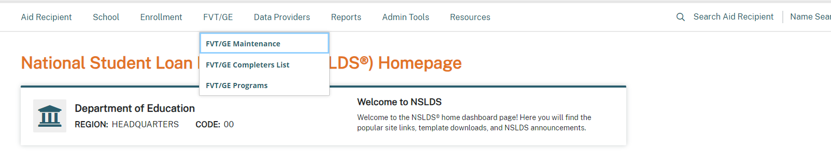

Figure 8: FVT/GE Programs Page - Search
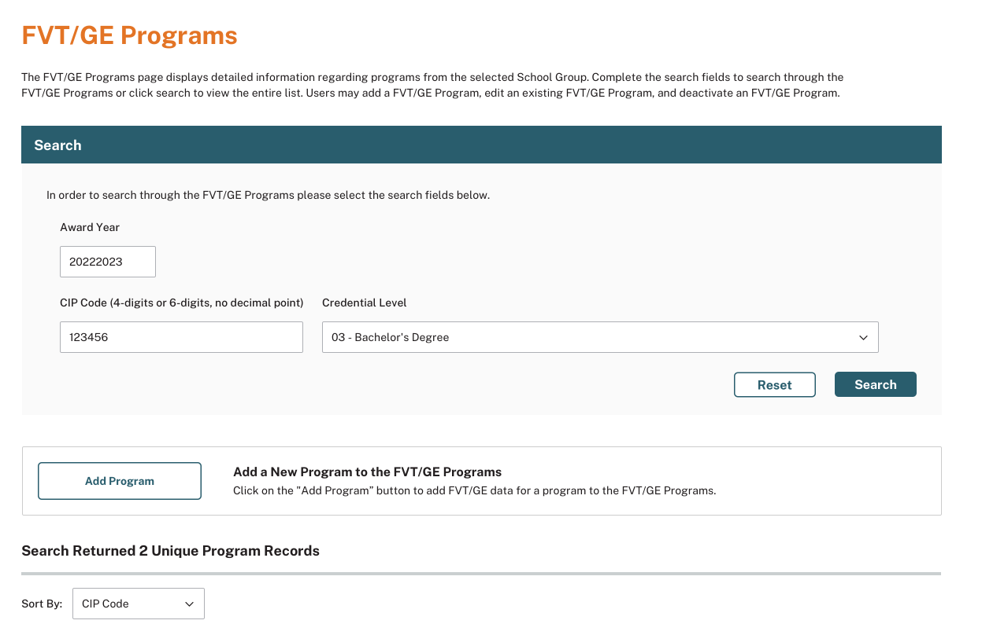

The FVT/GE Programs page allows users to search for specific programs by the following fields:
- Award Year – Award year the student was enrolled in the program.
- CIP Code – The four or six-digit Classification of Instructional Programs code (without period) identifying a program's academic content.
- Credential Level – Credential Level of the program the student was enrolled in during the award year.
  - 01 – Undergraduate Certificate or Diploma Program
  - 02 – Associate degree
  - 03 - Bachelor's Degree
  - 04 - Post Baccalaureate Certificate
  - 05 - Master's Degree
  - 06 - Doctoral Degree
  - 07 - First Professional Degree
  - 08 - Graduate/Professional Certificate

Once the user clicks the ‘Search’ button the FVT/GE Programs Page either displays the entire list of records or a list of records based on the selected criteria. This page will display programs submitted by the school via the web, the FVT/GE Program Batch Submittal File, or the Program Spreadsheet Submittal process. Additionally, the count of records returned will be displayed.

Figure 9: FVT/GE Programs Page – Search Results
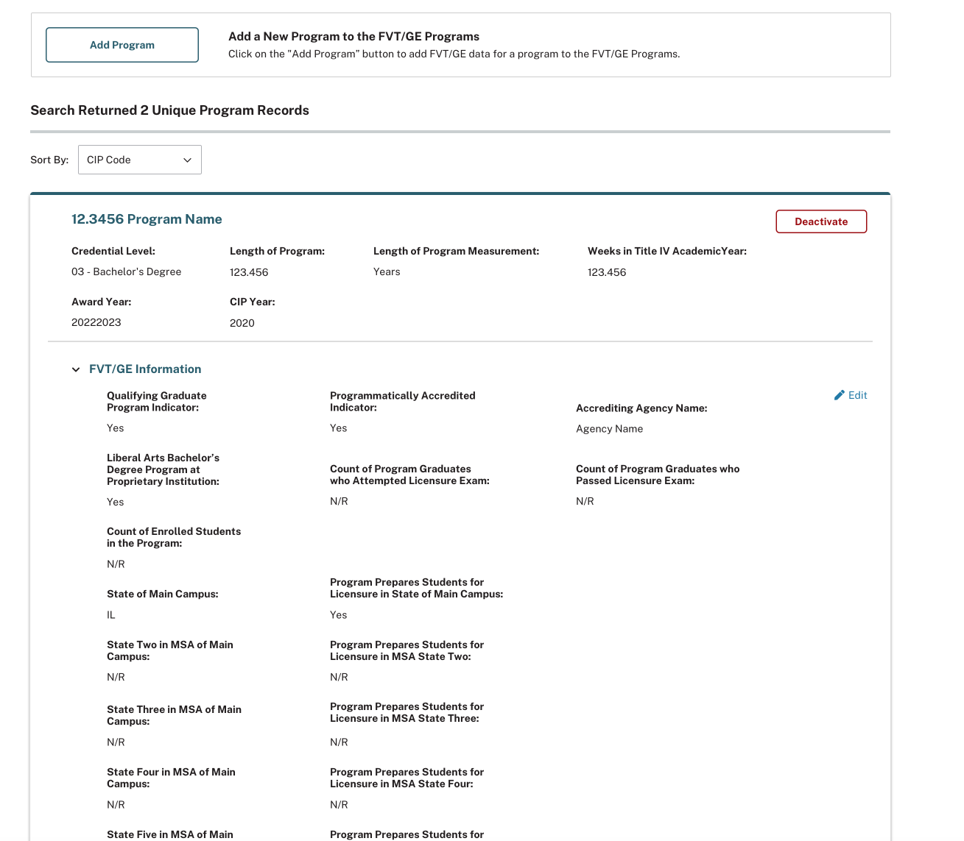

The FVT/GE Programs page will display current and active FVT/GE records. Records that have been deactivated through the web or invalidated via batch will not display on the FVT/GE Programs page. Only 20 records will display per page and users must click ‘Next’ or ‘Previous’ to navigate between pages.

3.2 Add FVT/GE Program Data
Starting in late summer 2024, schools may submit FVT/GE Program data through the FVT/GE Programs page. To add data for a program, users must click the ‘Add Program’ button located below the search section.

Figure 10: FVT/GE Programs Page – Add Program
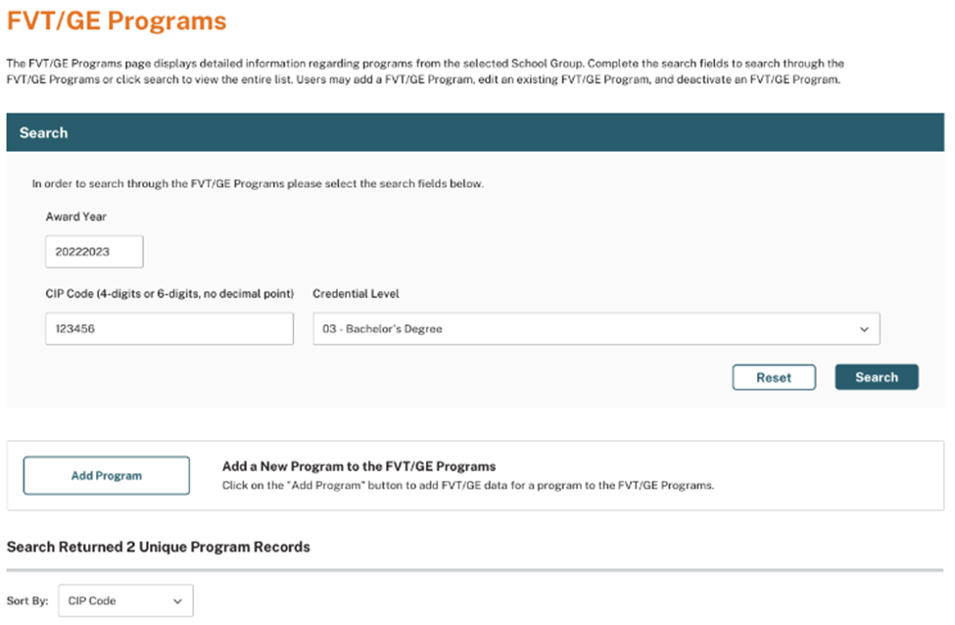
Once the user clicks the ‘Add Program’ button, they will be directed to the Add Program Page. Schools may add one unique program at a time via the web.
The following fields are required in order to add a program:
- Award Year – Award year the student was enrolled in the program.
- CIP Code – The four or six-digit Classification of Instructional Programs code (without period) identifying a program's academic content.
- Credential Level – Credential Level of the program the student was enrolled in during the award year.
  - 01 – Undergraduate Certificate or Diploma Program
  - 02 – Associate degree
  - 03 - Bachelor's Degree
  - 04 - Post Baccalaureate Certificate
  - 05 - Master's Degree
  - 06 - Doctoral Degree
  - 07 - First Professional Degree
  - 08 - Graduate/Professional Certificate
- Length of Program – The length of the instructional program in weeks, months, or years as published by the school.
- Length of Program Measurement – The unit of measure for the length of the instructional program as published by the school.
  - Weeks
  - Months
  - Years
- Weeks in Title IV Academic Year – The total number of weeks of instruction in the program’s academic year.

Figure 11: Add Program Page
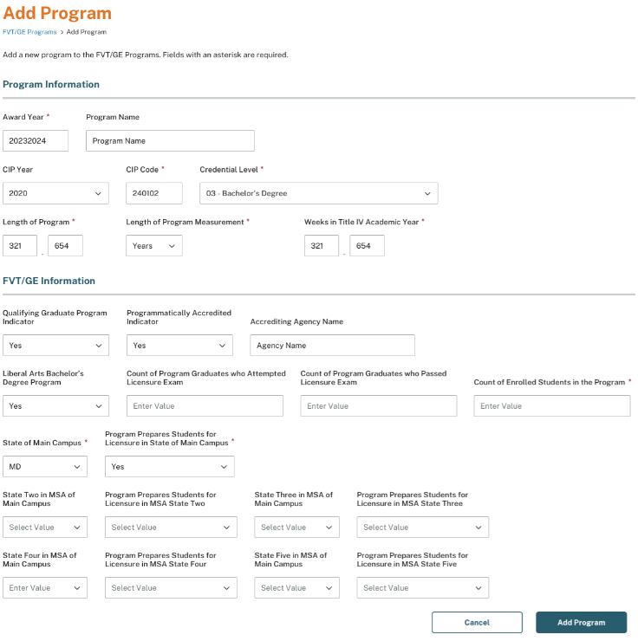

The following fields are not mandatory and should only be submitted if they are applicable:

- Program Name
- CIP Year
- Qualifying Graduate Program
- Programmatically Accredited
- Accrediting Agency Name
- Liberal Arts Bachelor’s Degree Program at Proprietary Institution
- Count of Program Graduates who Attempted Licensure Exam
- Count of Program Graduates who Passed Licensure Exam
- Count of Enrolled Students in the Program (Title IV and non-Title IV students)
- State of Main Campus
- Program Prepares Students for Licensure in State of Main Campus
- State Two/Three/Four/Five in MSA of Main Campus
- Program Prepares Students for Licensure in MSA State Two/Three/Four/Five

Additional details on the definitions of these fields can be found in Appendix A.
When all applicable fields have been populated with no errors, the user will click the ‘Add Program’ button to submit the program to NSLDS. Upon successfully adding a program, users will be automatically brought back to the FVT/GE Program page and a message will display stating: ‘The FVT/GE Program record was successfully added’.

3.3 Edit FVT/GE Program Data
Starting in late summer 2024, users will have the ability to edit existing FVT/GE Program data via the web, regardless of whether the program data was initially submitted by batch, web, or spreadsheet submittal. However, users are only able to update FVT/GE program information and may not edit program identifiers or the award year. In order to update program identifiers or the award year, you must invalidate the entire program record through batch or deactivate the program record via the web.
To edit Program information, click the ‘Edit’ link within the respective program record you wish to update

Figure 12: FVT/GE Programs Page – Edit
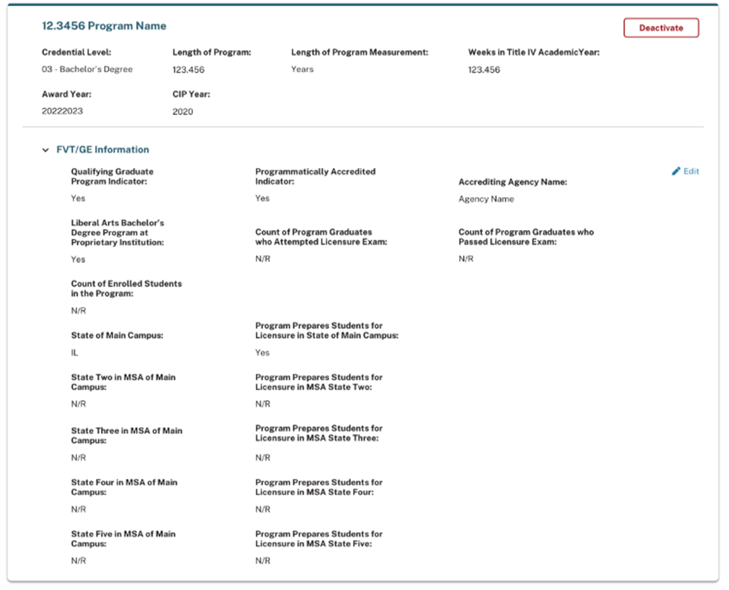

Once the user clicks the ‘Edit’ link, the ‘Edit Program’ popup will display, allowing the users to make updates. Once all applicable information has been successfully updated, the user will click ‘Save’.

Figure 13: Edit Program Popup
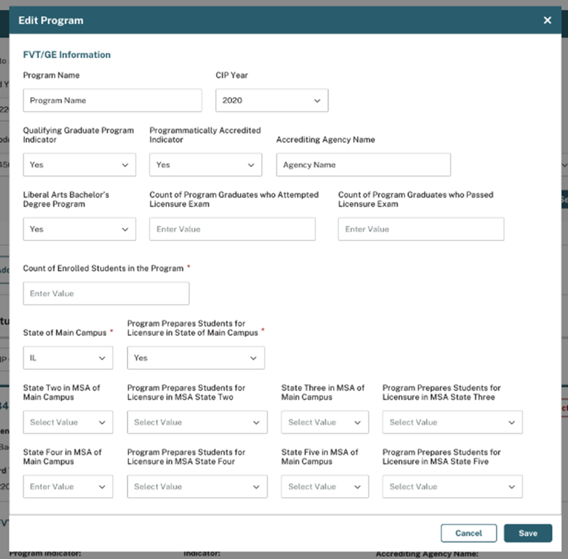

Once the record has been successfully updated, a message will appear at the top of the page stating: ‘The program record was successfully edited’.

3.4 Deactivate Program
Starting in late summer 2024, if a user needs to remove an existing program record, click the ‘Deactivate’ button located within the program’s card. Once the user clicks the ‘Deactivate’ button, the ‘Deactivate?’ popup will display, enabling the user to remove a program record.
Figure 14: FVT/GE Programs Page – Deactivate
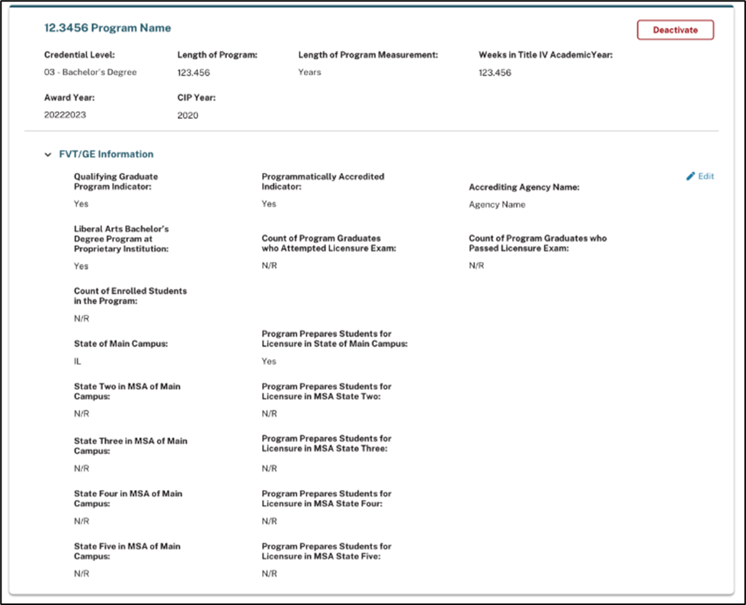

Figure 15: Deactivate? Popup
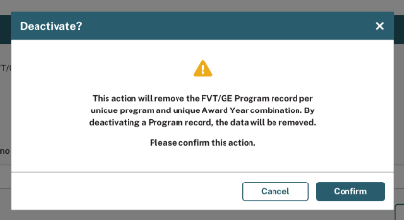

Upon clicking the ‘Confirm’ button, a message will display on the FVT/GE Programs page stating, ‘The record was successfully deactivated’. As a result, the applicable program record will be removed from the school’s Program list for both web and batch processing. Should the user decide to add a program that has been deactivated back, they will need to manually add the program record again via batch, web, or spreadsheet submittal.

Chapter 4: FVT/GE Spreadsheet Submittal Process
The FVT/GE Spreadsheet Submittal process allows schools to report FVT/GE program data to NSLDS via spreadsheet upload on the NSLDS Professional Access website. The FVT/GE Program Spreadsheet Submittal is located on the Spreadsheet Submittal page under the School tab on NSLDSFAP.
This spreadsheet contains the same fields as detailed in Appendix A and will be processed in real-time. Any errors will be presented to the school. Upon successful upload of a file and processing of the data, the information will be used to update the NSLDS database.

Figure 16: Spreadsheet Submittal Page
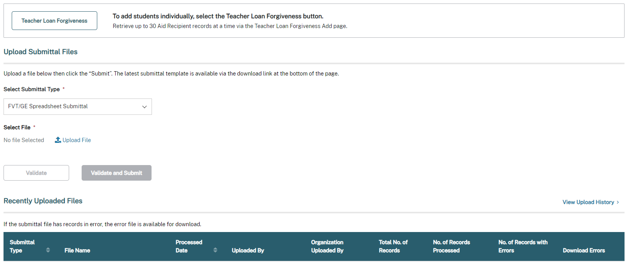

4.1 Creating a Spreadsheet
The FVT/GE Spreadsheet Submittal is another tool that can be used by schools to submit program specific FVT/GE data. Users can create their own spreadsheets or use the template provided. The spreadsheet can be created with the first row containing the field names, found in Appendix A, or by utilizing the template that is available for download on the Spreadsheet Submittal page. In order for NSLDS to accept the spreadsheet template the first row must contain the field names. If the school chooses to create their own spreadsheet template, the fields found in Appendix A must be used as a reference.
It is crucial that the user created spreadsheet is saved securely. It is also recommended that the spreadsheet have a unique name so that it can be easily identified during the upload process. Please ensure that when saving the file, it is saved as a spreadsheet file in a format with an extension of .xls or .xlsx (Excel™ format). Any other extensions will cause the entire file to be rejected.
The spreadsheet has a file size limit of 5,000 KB (5 MB). Any file size over this limit will cause the spreadsheet to be rejected. File size varies depending on amount of data in the spreadsheet.

Figure 17: Program Spreadsheet Submittal Template
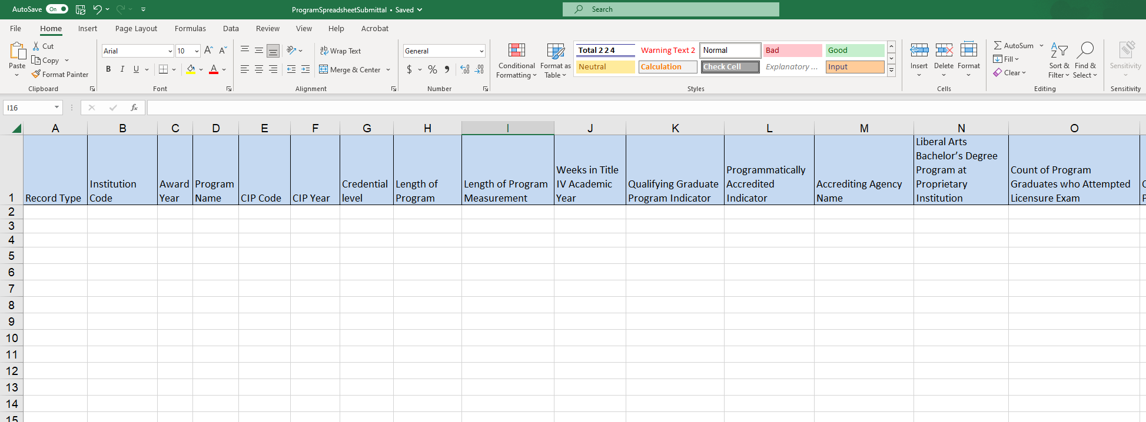

4.1.1 Rename Worksheet
If the user is not using the available template for download, the first step in creating the spreadsheet is to rename the worksheet that will be utilized for data entry, and subsequent data upload. To rename the worksheet:
- Right click on the worksheet tab name.
- Select Rename.
- When the current name of the tab is highlighted, type “upload file”.
- Click out of the tab and the name will be stored.

Figure 18: Rename Worksheet
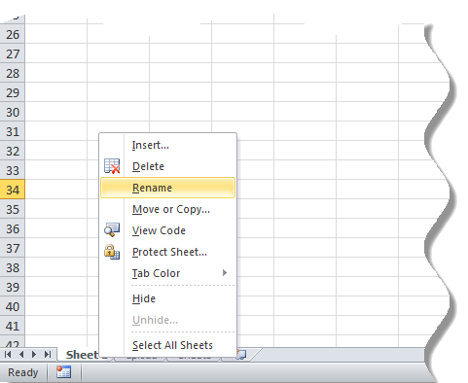

Figure 19: Rename Worksheet
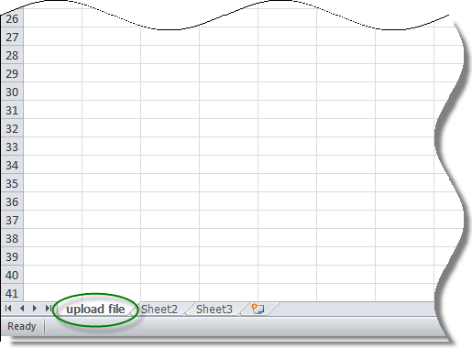

NSLDS will look for a worksheet with the name “upload file”. If the worksheet has any other name, NSLDS will attempt to load the data found in the first tab, or Sheet 1, of the spreadsheet. If Sheet 1 is empty, the user will receive the message “Spreadsheet has no data”. It is suggested that the worksheet be correctly labeled for upload.
Also, NSLDS will only process one worksheet per spreadsheet, per upload. Any other worksheets will be ignored if they are present in the file, as will any records they may contain. If there are additional sheets that need to be submitted, after the first worksheet is uploaded, the school can rename the initial uploaded file to a different name and name the next sheet to “upload file”. Submit the file to NSLDS again, and the new page will be uploaded.

4.1.2 Spreadsheet with Field Names
When creating the spreadsheet, the field names are to be created by the user. The names of the fields must match to those presented in Appendix A and each name must be contained within an individual column. The names of the fields will appear in Row One, beginning in column A with “Record Type” and ending in column AB with “Invalid Flag”. Schools are permitted to enter data within columns A through AB. The user created spreadsheet submittal does not require Header and Trailer Records as the batch file does. Fields identified as optional do not require data to be provided. However, the column for the field names must still appear in the spreadsheet, even if the data is not being supplied.

4.2 Uploading a FVT/GE Spreadsheet Submittal File
The Spreadsheet Submittal page is found under the School tab on the NSLDS Professional Access website and allows users the ability to report FVT/GE data via spreadsheet submittal.
The page allows the user to search for the spreadsheet submittal file they would like to submit and upload it from the location where it is securely stored. Because of the sensitivity of the information included in the file, it must be saved in a secure manner on the local hard drive of the user’s computer or stored in a secure manner on an external medium such as a flash drive or network. Once the file is located, the user will then need to select the manner for which errors, if any, will be returned.
Figure 20: Spreadsheet Submittal Page – Upload Submittal Files

4.2.1 FVT/GE Spreadsheet Submittal Page Results
After the FVT/GE spreadsheet has been uploaded, validation is done to identify if there are any errors in the file. Users must ensure they click the ‘Validate and Submit’ button to confirm the spreadsheet was submitted. When the user selects ‘Validate and Submit’ the system will review and validate all data in the spreadsheet. Any records that were submitted and successfully passed validation with no errors will be processed.
If any record that was submitted triggers an error, a message will display along with the number of records with errors. Additionally, a link will be provided under the ‘Download Errors’ section on the Spreadsheet Submittal page, enabling the user to identify records that need corrected.

Figure 21: Spreadsheet Submittal Page – Download Errors
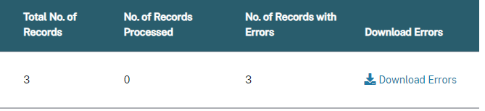
Once the user clicks the Download Errors link, the submitted FVT/GE Spreadsheet Submittal File displays all submitted records and highlights all cells in error for each applicable record. These errors will be highlighted for the user to easily access once they download the Error File. NSLDS will display the errors and their descriptions in the Error (AC) Column.

4.3 Working Errors
All records are validated against the edits described in Appendix A, and any errors will be identified in the Errors (AC) Column of the Errors File. Users have the option to correct data in the Errors File directly or make corrections in the original file that was submitted. If opting to correct errors in the Error File, users should rename the file before resubmitting to maintain a record of prior submittals. Regardless of the chosen method, any records in error must be corrected and resubmitted to NSLDS for processing. If there is a need to remove rows from the spreadsheet, the ‘Delete Row’ function in Excel should be utilized to ensure complete removal of the applicable data.

Appendix A: FVT/GE Program Submittal File Record Layouts
This appendix outlines the file layout for the FVT/GE Program Submittal File, the file layout for the FVT/GE Program File-Level Error File including the file-level error definitions, and the file layout for the FVT/GE Program Error/Acknowledgment File including the record-level error definitions.
Institutions will submit an FVT/GE Program Submittal file to NSLDS. NSLDS will return an FVT/GE Program File-Level Error File if the submittal file fails file-level validations, or an FVT/GE Program Error/Acknowledgement File if the submittal file passes all file-level validations but contains records-level errors or for NSLDS to confirm receipt of the submittal file.

When an institution receives an FVT/GE File-Level Error File, it indicates that NSLDS could not process the submittal file because it contained file-level errors. File level errors are generally caused by invalid values in the header and/or trailer records, an incorrect TG mailbox or incorrect detail record counts in the trailer record. When an institution receives an FVT/GE Error/Acknowledgement File containing one header record and one trailer record, it indicates that NSLDS received the submittal file with no errors and it was successfully submitted to NSLDS. If the FVT/GE Program Error/Acknowledgement File contains one header, one or more detail records, and one trailer record, NSLDS found record-level errors in the FVT/GE Program Submittal File. Institutions may correct the errors received in the FVT/GE Program File-Level Error File or FVT/GE Program Error/Acknowledgement File and submit the FVT/GE Program Submittal file again to NSLDS.

Appendix A includes information on the following layouts:
- Fixed-Width
- Comma Separated Values (CSV)

The Fixed-Width (FW) layout includes the following information for each field:
- Pos FR- (Position From) – Starting position of the field (Please note that Pos FR (Position From) only applies to Fixed-Width).
- Pos TO- (Position To) – Ending position of the field (Please note that Pos TO (Position To) only applies to Fixed-Width).
- Attribute/Name- Brief, descriptive title of the field.
- Description- Short narrative definition of the field.
- Field Format- Indicator of the kind of value that must be in the field, as follows:
- Char. (Character) denotes a field that may contain spaces, letters, or numbers in any combination—for example, 17 Magnolia Street. Character fields not specifically reported must be filled with spaces. If a field is said to require a value ‘greater than spaces’, the field must contain at least one letter or number.
- Num. (Numeric) denotes a field that must contain only numbers- for example, 12345 as a Detail Record Count in a trailer record. Letters, special characters, or spaces in a numeric field are invalid. An entry of T491_24, for example, would not be accepted. Unless otherwise specified in the record layout, numeric fields not specifically reported must be filled with zeroes.
- Date fields must contain only numeric data, 8 digits, and appear in the format CCYYMMDD, where:
- CC = 2-digit century
- YY = 2-digit year
- MM = 2-digit month designation (01–12)
- DD = 2-digit day designation (01–31, depending on month and year)
- Under this convention, an entry of 20140430 would be accepted, but 043014 would not. Unless otherwise specified in the record layout, date fields not specifically reported must be filled with zeroes.
- Lth (Length)/Size- Number of bytes the field occupies (Please note that Lth (Length) only applies to Fixed-Width).

The field composition of the layout description includes all of the information listed above in addition to the following:
- Comments- Additional information about the field.
- Edit(s)- Description of the error checking that NSLDS applies to the file that is returned.
- Reporting- Instructions indicating whether the field must contain data other than spaces or zeros are described below:
- Mandatory- Fill in this field for every Detail record.
- Optional- Fill in this field if the information is applicable.

FVT/GE Program Submittal and Error/Acknowledgement File Layout

Fixed Width

Header Record Length= 255
Pos. Start | Pos. End | Attribute | Description | Field Format | Lth
1 | 2 | Record Type | '00' indicates header record | Num. | 2
3 | 8 | Institution Code (OPEID) | The institution's 6-digit ED Office of Postsecondary Education (OPE) code used to identify the institution. | Num. | 6
9 | 43 | Header Text | File Name  - Must equal 'FVT/GE PROGRAM SUBMITTAL' for Program Submittal file.  - Will be 'FVT/GE PROGRAM ERROR/ACKNOWLEDGMENT' for Error/Acknowledgement File | Char. | 35
44 | 51 | Submittal Date | Date the file was created.  - Date the FVT/GE Program Submittal File was created (CCYYMMDD)  - Date the FVT/GE Error/Acknowledgment File was generated (CCYYMMDD) | Date | 8
52 | 52 | File Type | Value to indicate the specific type of FVT/GE file.  'S'= Submittal File  'E' = Error/Acknowledgement File | Char. | 1
53 | 255 | Filler | Spaces | Char. | 203

Detail Record 01 (Length= 255)
Pos. Start | Pos. End | Attribute | Description | Field Format | Lth
1 | 2 | Record Type | '01' indicates detail record | Num. | 2
3 | 8 | Institution Code (OPEID) | The institution's 6-digit ED Office of Postsecondary Education (OPE) code used to identify the institution. | Num. | 6
9 | 16 | Award Year | Award year the student was enrolled in the program. Must be consecutive years. (CCYYCCYY) | Char. | 8
17 | 51 | Program Name | The institutional name given to each program. | Char. | 35
52 | 57 | CIP Code | The six-digit Classification of Instructional Programs code (without period) identifying a program's academic content. | Num. | 6
58 | 61 | CIP Year | The year in which the certified CIP Code used by NSLDS were published.  Values are:  - 2010  - 2020  Format: CCYY | Char. | 4
62 | 63 | Credential Level | Credential Level of the program the student was enrolled in during this award year.  Values are:  - '01' (Undergraduate certificate or Diploma program)  - '02' (Associate's degree)  - '03' (Bachelors degree)  - '04' (Post baccalaureate certificate)  - '05' (Master's degree)  - '06' (Doctoral degree)  - '07' (First professional degree)  - '08' (Graduate / Professional certificate) | Num. | 2
64 | 69 | Published Length of Program | The length of the instructional program in weeks, months, or years as published by the school.  Format “nnnnnnn", with an implied decimal point between the third and fourth digit. Thus, schools should report:  - "000100" to represent a value of one tenth.  - "001000" to represent a value of one.  - "010000" to represent a value of ten.  - "100000" to represent a value of one hundred.  Value must be numeric and greater than zero. | Num. | 6
70 | 70 | Published Length of Program Measurement | The unit of measure for the length of the instructional program as published by the school.  Values are:  - 'W' (Weeks)  - 'M' (Months)  - 'Y' (Years) | Char. | 1
71 | 76 | Weeks in Title IV Academic Year | The total number of weeks of instruction in the program’s academic year. Only report when Published Length of Program Measurement is W or M. Format “nnnnnn”, with an implied decimal point between the third and fourth digits. For example, schools would report:  - 26 weeks: 026000  - 30 weeks: 030000 | Num. | 6
77 | 77 | Qualifying Graduate Program Indicator | The indicator to show whether the reported program is a qualifying graduate program whose students are required to complete postgraduate training programs.  Valid values are:  - 'Y’ (Yes)  - 'N' (No)  - Space (N/A - Program will not be considered a Qualifying Graduate Program) | Char. | 1
78 | 78 | Programmatically Accredited Indicator | Indicates whether the program is programmatically accredited.  Valid values are:  - ‘Y’ (Yes)  - ‘N’ (No)  - Space (N/A) | Char. | 1
79 | 113 | Accrediting Agency Name | The name of the agency that accredits the program. | Char. | 35
114 | 114 | Liberal Arts Bachelor’s Degree Program at Proprietary Institution | Indicates if the program is a bachelor’s degree program in liberal arts and 1) the institution has been regionally accredited since October 2007; 2) the program has been offered by the institution since January 2009; and 3) the institution offering the program is a proprietary institution.  Valid values are:  - ‘Y’ (Yes)  - ‘N’ (No)  - Space (N/A)  Note: If this field is reported with a ‘Y’, the Credential Level for the program must equal ‘03’ (Bachelor’s degree). | Char. | 1
115 | 120 | Count of Program Graduates who Attempted Licensure Exam | The total number of program graduates who took a licensure exam in most recently completed award year. | Num. | 6
121 | 126 | Count of Program Graduates who Passed Licensure Exam | The total number of program graduates who passed a licensure exam in most recently completed award year. | Num. | 6
127 | 132 | Count of Enrolled Students in the Program | The total number of students enrolled in the program for the most recently completed award year. | Num. | 6
133 | 134 | State of Main Campus | The State where the main campus is located. | Char. | 2
135 | 135 | Program Prepares Students for Licensure in State of Main Campus | Indicates if the program does or does not prepare students for licensure in the state where the main campus is located.  Valid values are:  - 'Y' (Yes)  - 'N' (No)  - 'X' (Not Applicable) | Char. | 1
136 | 137 | State Two in MSA of Main Campus | The second State in the metropolitan statistical area (MSA) in which the main campus is located, if applicable. | Char. | 2
138 | 138 | Program Prepares Students for Licensure in MSA State Two | Indicates if the program does or does not prepare students for licensure in the second State in the MSA of the main campus.  Valid values are:  - ‘Y’ (Yes)  - ‘N’ (No)  - ‘X’ (Not Applicable)  - ‘Space’ (No State Two in MSA) | Char. | 1
139 | 140 | State Three in MSA of Main Campus | The third State in the metropolitan statistical area (MSA) in which the main campus is located, if applicable. | Char. | 2
141 | 141 | Program Prepares Students for Licensure in MSA State Three | Indicates if the program does or does not prepare students for licensure in the third State in the MSA of the main campus.  Valid values are:  - 'Y' (Yes)  - 'N' (No)  - 'X' (Not Applicable)  - 'Space' (No State Three in MSA) | Char. | 1
142 | 143 | State Four in MSA of Main Campus | The fourth State in the metropolitan statistical area (MSA) in which the main campus is located, if applicable. | Char. | 2
144 | 144 | Program Prepares Students for Licensure in MSA State Four | Indicates if the program does or does not prepare students for licensure in the fourth State in the MSA of the main campus.  Valid values are:  - ‘Y’ (Yes)  - ‘N’ (No)  - ‘X’ (Not Applicable)  - ‘Space’ (No State Four in MSA) | Char. | 1
145 | 146 | State Five in MSA of Main Campus | The fifth State in the metropolitan statistical area (MSA) in which the main campus is located, if applicable. | Char. | 2
147 | 147 | Program Prepares Students for Licensure in MSA State Five | Indicates if the program does or does not prepare students for licensure in the fifth State in the MSA of the main campus.  Valid values are:  - 'Y' (Yes)  - 'N' (No)  - 'X' (Not Applicable)  - 'Space' (No State Five in the MSA) | Char. | 1
148 | 148 | Invalid Flag | Flag that indicates if the school is submitting the file to invalidate an existing FVT/GE Record. Valid values are:  - 'Y' (Yes)  - 'N' (No)  - Space (No) | Char. | 1
149 | 150 | Error Code 1 | Code of error returned to school by NSLDS.  - Submit spaces in FVT/GE Program Submittal File | Char. | 2
151 | 152 | Error Code 2 | Code of error returned to school by NSLDS.  - Submit spaces in FVT/GE Program Submittal File  Note: This field is a placeholder for use in the future. | Char. | 2
153 | 154 | Error Code 3 | Code of error returned to school by NSLDS.  - Submit spaces in FVT/GE Program Submittal File  Note: This field is a placeholder for use in the future. | Char. | 2
155 | 156 | Error Code 4 | Code of error returned to school by NSLDS.  - Submit spaces in FVT/GE Program Submittal File  Note: This field is a placeholder for use in the future. | Char. | 2
157 | 158 | Error Code 5 | Code of error returned to school by NSLDS.  - Submit spaces in FVT/GE Program Submittal File  Note: This field is a placeholder for use in the future. | Char. | 2
159 | 255 | Filler | Spaces | Char. | 97

Trailer Record (Length= 255)
Pos. Start | Pos. End | Attribute | Description | Field Format | Lth
1 | 2 | Record Type | '99' indicates trailer record | Num. | 2
3 | 8 | Institution Code (OPEID) | The institution's 6-digit ED Office of Postsecondary Education (OPE) code used to identify the institution. | Num. | 6
9 | 14 | Detail Record Count | Number of detail records  - Number of detail records in the submittal file.  - Number of detail records in the Error/Acknowledgement file. | Num. | 6
15 | 255 | Filler | Spaces | Char. | 241

Comma Separated Values
Header Record- CSV
Attribute | Description | Field Format
Record Type | '00' indicates header record | Num.
Comma | Comma | Char.
Institution Code (OPEID) | The institution's 6-digit ED Office of Postsecondary Education (OPE) code used to identify the institution. | Num.
Comma | Comma | Char.
Header Text | File Name:  - Must equal 'FVT/GE PROGRAM SUBMITTAL' for Program Submittal file.  - Will be 'FVT/GE PROGRAM ERROR/ACKNOWLEDGMENT' for Error/Acknowledgement File. | Char.
Comma | Comma | Char.
Submittal Date | Date the file was created.  - Date the FVT/GE Program Submittal File was created (CCYYMMDD)  - Date the FVT/GE Error/Acknowledgment File was generated (CCYYMMDD) | Date
Comma | Comma | Char.
File Type | Value to indicate the specific type of FVT/GE file  'S'= Submittal File  'E'= FVT/GE Error/Acknowledgment File | Char.

Detail Record 01 - CSV
Attribute | Description | Field Format
Record Type | '01' indicates detail record | Num.
Comma | Comma | Char.
Institution Code (OPEID) | The institution's 6-digit ED Office of Postsecondary Education (OPE) code used to identify the institution. | Num.
Comma | Comma | Char.
Award Year | Award year the student was enrolled in the program. Must be consecutive years. (CCYYCCYY) | Char.
Comma | Comma | Char.
Program Name | The institutional name given to each program. | Char.
Comma | Comma | Char.
CIP Code | Six-digit Classification of Instructional Programs code (without period) identifying a program's academic content | Num.
Comma | Comma | Char.
CIP Year | The year in which the certified CIP Code used by NSLDS were published.  Values are:  - 2010  - 2020  Format: CCYY | Char.
Comma | Comma | Char.
Credential Level | Credential Level of the program the student was enrolled in during this award year.  Values are:  - ‘01’ (Undergraduate certificate or Diploma program)  - ‘02’ (Associate’s degree)  - ‘03’ (Bachelor’s degree)  - ‘04’ (Post baccalaureate certificate)  - ‘05’ (Master’s degree)  - ‘06’ (Doctoral degree)  - ‘07’ (First professional degree)  - ‘08’ (Graduate / Professional certificate) | Num.
Comma | Comma | Char.
Published Length of Program | The length of the instructional program in weeks, months, or years as published by the school.  Format “nnnnnnn", with an implied decimal point between the third and fourth digit. Thus, schools should report:  - "000100" to represent a value of one tenth.  - "001000" to represent a value of one.  - "010000" to represent a value of ten.  - "100000" to represent a value of one hundred.  Value must be numeric and greater than zero. | Num.
Comma | Comma | Char.
Published Length of Program Measurement | The unit of measure for the length of the instructional program as published by the school.  Values are:  - ‘W’ (Weeks)  - ‘M’ (Months)  - ‘Y’ (Years) | Char.
Comma | Comma | Char.
Weeks in Title IV Academic Year | The total number of weeks of instruction in the program’s academic year. Only report when Published Length of Program Measurement is W or M. Format “nnnnnn”, with an implied decimal point between the third and fourth digits. For example, schools would report:  - 26 weeks: 026000  - 30 weeks: 030000 | Num.
Comma | Comma | Char.
Qualifying Graduate Program Indicator | The indicator to show whether the reported program is a qualifying graduate program whose students are required to complete postgraduate training programs.  Valid values are:  - 'Y' (Yes)  - 'N' (No)  - Space (N/A - Program will not be considered a Qualifying Graduate Program) | Char.
Comma | Comma | Char.
Programmatically Accredited Indicator | Indicates whether the program is programmatically accredited.  Valid values are:  - ‘Y’ (Yes)  - ‘N’ (No)  - Space (N/A) | Char.
Comma | Comma | Char.
Accrediting Agency Name | The name of the agency that accredits the program. | Char.
Comma | Comma | Char.
Liberal Arts Bachelor’s Degree Program at Proprietary Institution | Indicates if the program is a bachelor’s degree program in liberal arts and 1) the institution has been regionally accredited since October 2007; 2) the program has been offered by the institution since January 2009; and 3) the institution offering the program is a proprietary institution.  Valid values are:  - ‘Y’ (Yes)  - ‘N’ (No)  - Space (N/A)  Note: If this field is reported with a ‘Y’, the Credential Level for the program must equal ‘03’ (Bachelor’s degree). | Char.
Comma | Comma | Char.
Count of Program Graduates who Attempted Licensure Exam | The total number of program graduates who took a licensure exam in most recently completed award year. | Num.
Comma | Comma | Char.
Count of Program Graduates who Passed Licensure Exam | Total number of program graduates who passed a licensure exam in most recently completed award year. | Num.
Comma | Comma | Char.
Count of Enrolled Students in the Program | The total number of students enrolled in the reported program for the most recently completed award year. | Num.
Comma | Comma | Char.
State of Main Campus | The State where the main campus is located. | Char.
Comma | Comma | Char.
Program Prepares Students for Licensure in State of Main Campus | Indicates if the program does or does not prepare students for licensure in the state where the main campus is located.  Valid values are:  - 'Y' (Yes)  - 'N' (No)  - 'X' (Not Applicable) | Char.
Comma | Comma | Char.
State Two in MSA of Main Campus | The second State in the metropolitan statistical area (MSA) in which the main campus is located. | Char.
Comma | Comma | Char.
Program Prepares Students for Licensure in MSA State Two | Indicates if the program does or does not prepare students for licensure in the second State in the MSA of the main campus.  Valid values are:  - ‘Y’ (Yes)  - ‘N’ (No)  - ‘X’ (Not Applicable)  - ‘Space’ (No State Two in MSA) | Char.
Comma | Comma | Char.
State Three in MSA of Main Campus | The third State in the metropolitan statistical area (MSA) in which the main campus is located. | Char.
Comma | Comma | Char.
Program Prepares Students for Licensure in MSA State Three | Indicates if the program does or does not prepare students for licensure in the third State in the MSA of the main campus.  Valid values are:  - 'Y' (Yes)  - 'N' (No)  - 'X' (Not Applicable)  - 'Space' (No State Three in MSA) | Char.
Comma | Comma | Char.
State Four in MSA of Main Campus | The fourth State in the metropolitan statistical area (MSA) in which the main campus is located. | Char.
Comma | Comma | Char.
Program Prepares Students for Licensure in MSA State Four | Indicates if the program does or does not prepare students for licensure in the fourth State in the MSA of the main campus.  Valid values are:  - 'Y' (Yes)  - 'N' (No)  - 'X' (Not Applicable)  - 'Space' (No State Four in MSA) | Char.
Comma | Comma | Char.
State Five in MSA of Main Campus | The fifth State in the metropolitan statistical area (MSA) in which the main campus is located. | Char.
Comma | Comma | Char.
Program Prepares Students for Licensure in MSA State Five | Indicates if the program does or does not prepare students for licensure in the fifth State in the MSA of the main campus.  Valid values are:  - 'Y' (Yes)  - 'N' (No)  - 'X' (Not Applicable)  - 'Space' (No State Five in the MSA) | Char.
Comma | Comma | Char.
Invalid Flag | Flag that indicates if the school is submitting the file to invalidate an existing FVT/GE Record.  Valid values are:  - ‘Y’ (Yes)  - ‘N’ (No)  - ‘Space’ (No) | Char.
Comma | Comma | Char.
Error Code 1 | Code of error returned to school by NSLDS.  - Submit spaces in FVT/GE Program Submittal File | Char.
Comma | Comma | Char.
Error Code 2 | Code of error returned to school by NSLDS.  - Submit spaces in FVT/GE Program Submittal File  Note: This field is a placeholder for use in the future. | Char.
Comma | Comma | Char.
Error Code 3 | Code of error returned to school by NSLDS.  - Submit spaces in FVT/GE Program Submittal File  Note: This field is a placeholder for use in the future. | Char.
Comma | Comma | Char.
Error Code 4 | Code of error returned to school by NSLDS.  - Submit spaces in FVT/GE Program Submittal File  Note: This field is a placeholder for use in the future. | Char.
Comma | Comma | Char.
Error Code 5 | Code of error returned to school by NSLDS.  - Submit spaces in FVT/GE Program Submittal File  Note: This field is a placeholder for use in the future.. | Char.

Trailer Record-CSV
Attribute | Description | Field Format
Record Type | '99' indicates trailer record | Num.
Comma | Comma | Char.
Institution Code (OPEID) | The institution's 6-digit ED Office of Postsecondary Education (OPE) code used to identify the institution. | Num.
Comma | Comma | Char.
Detail Record Count | Number of detail records  - Number of detail records in the submittal file.  - Number of detail records in the Error/Acknowledgement file. | Num.

FVT/GE Program File-Level Error File

Fixed Width
FVT/GE Program File-Level Error File Layout Header Record (Length= 255)
Pos. Start | Pos. End | Attribute | Description | Field Format | Lth
1 | 2 | Record Type | Record Type will be '00'. | Num. | 2
3 | 8 | Institution Code (OPEID) | Institution Cod (OPEID) will be the value reported in the FVT/GE Program Submittal File’s first, or only, Header Record. | Num. | 6
9 | 43 | Header Text | File Name will be ‘FVT/GE PROGRAM FILE-LEVEL ERROR’ | Char. | 35
44 | 51 | Submittal Date | Date will be the date the FVT/GE Program File-Level Error File was generated | Date | 8
52 | 52 | File Type | Value to indicate the specific type of FVT/GE file.  'F' = FVT/GE Program File-Level Error File | Char. | 1
53 | 255 | Filler | Spaces | Char. | 203

FVT/GE Program File-Level Error File Layout Detail Record (Length= 255)
Pos. Start | Pos. End | Attribute | Description | Field Format | Lth
1 | 2 | Record Type | Record Type will be '01'. | Num. | 2
3 | 8 | Institution Code (OPEID) | Institution Code will be zeros | Num. | 6
9 | 16 | Award Year | Award Year will be zeros. | Char. | 8
17 | 51 | Program Name | Program Name will be spaces | Char. | 35
52 | 57 | CIP Code | CIP Code will be zeros | Num. | 6
58 | 61 | CIP Year | CIP Year will be zeros | Char. | 4
62 | 63 | Credential Level | Credential Level will be spaces | Num. | 2
64 | 69 | Published Length of Program | Published Length of Program will be spaces. | Num. | 6
70 | 70 | Published Length of Program Measurement | Published Length of Program Measurement will be zeros. | Char. | 1
71 | 76 | Weeks in Title IV Academic Year | Weeks in Title IV Academic Year will be spaces | Num. | 6
77 | 77 | Qualifying Graduate Program Indicator | Qualifying Graduate Program Indicator will be a space | Char. | 1
78 | 78 | Programmatically Accredited Indicator | Programmatically Accredited Indicator will be a space | Char. | 1
79 | 113 | Accrediting Agency Name | Accrediting Agency Name will be spaces. | Char. | 35
114 | 114 | Liberal Arts Bachelor’s Degree Program at Proprietary Institution | Liberal Arts Bachelors Degree Program at Proprietary Institution will be a space. | Char. | 1
115 | 120 | Count of Program Graduates who Attempted Licensure Exam | Count of Program Graduates who Attempted Licensure Exam will be zeros | Num. | 6
121 | 126 | Count of Program Graduates who Passed Licensure Exam | Count of Program Graduates who Passed Licensure Exam will be zeros. | Num. | 6
127 | 132 | Count of Enrolled Students in the Program | Count of Enrolled Students in the Program will be zeros. | Num. | 6
133 | 134 | State of Main Campus | State of Main Campus will be spaces | Char. | 2
135 | 135 | Program Prepares Students for Licensure in State of Main Campus | Program Prepares Students for Licensure in State of Main Campus will be a space | Char. | 1
136 | 137 | State Two in MSA of Main Campus | State Two in MSA of Main Campus will be spaces | Char. | 2
138 | 138 | Program Prepares Students for Licensure in MSA State Two | Program Prepares Students for licensure in MSA State Two will be a space | Char. | 1
139 | 140 | State Three in MSA of Main Campus | State Three in MSA of Main Campus will be spaces | Char. | 2
141 | 141 | Program Prepares Students for Licensure in MSA State Three | Program Prepares Students for licensure in MSA State Three will be a space | Char. | 1
142 | 143 | State Four in MSA of Main Campus | State Four in MSA of Main Campus will be spaces | Char. | 2
144 | 144 | Program Prepares Students for Licensure in MSA State Four | Program Prepares Students for licensure in MSA State Four will be a space | Char. | 1
145 | 146 | State Five in MSA of Main Campus | State Five in MSA of Main Campus will spaces | Char. | 2
147 | 147 | Program Prepares Students for Licensure in MSA State Five | Program Prepares Students for licensure in MSA State Five will be a space | Char. | 1
148 | 148 | Invalid Flag | Invalid Flag will be a space. | Char. | 1
149 | 150 | Error Code 1 | Error Code 1 will be the file-level error code triggered by NSLDS (Refer to Table 6 for the File-Level Error Codes and their descriptions). | Char. | 2
151 | 152 | Error Code 2 | Error Code 2 will be spaces. | Char. | 2
153 | 154 | Error Code 3 | Error Code 3 will be spaces. | Char. | 2
155 | 156 | Error Code 4 | Error Code 4 will be spaces. | Char. | 2
157 | 158 | Error Code 5 | Error Code 5 will be spaces. | Char. | 2
159 | 255 | Filler | Spaces | Char. | 97

FVT/GE Program File-Level Error File Layout Trailer Record (Length= 255)
Pos. Start | Pos. End | Attribute | Description | Field Format | Lth
1 | 2 | Record Type | Record Type will be the value '99'. | Num. | 2
3 | 8 | Institution Code (OPEID) | Institution Code will be the value reported in the FVT/GE Program Submittal file. | Num. | 6
9 | 14 | Detail Record Count | Detail Record Count will be one. | Num. | 6
15 | 255 | Filler | Spaces | Num. | 241

Comma Separate Values
FVT/GE Program File-Level Error File Layout Header Record
Attribute | Description | Field Format
Record Type | Record Type will be ‘00’ | Num.
Comma | Comma | Char.
Institution Code (OPEID) | Institution Cod (OPEID) will be the value reported in the FVT/GE Program Submittal File’s first, or only, Header Record. | Num.
Comma | Comma | Char.
Header Text | File Name will be ‘FVT/GE PROGRAM FILE-LEVEL ERROR’ | Char.
Comma | Comma | Char.
Submittal Date | Date will be the date the FVT/GE Program File-Level Error File was generated | Date
Comma | Comma | Char.
File Type | Value to indicate the specific type of FVT/GE file.  'F' = FVT/GE Program File-Level Error File | Char.

FVT/GE Program File-Level Error File Layout Detail Record
Attribute | Description | Field Format
Record Type | Record Type will be '01'. | Num.
Comma | Comma | Char.
Institution Code (OPEID) | Institution Code will be zeros | Num.
Comma | Comma | Char.
Award Year | Award Year will be zeros. | Char.
Comma | Comma | Char.
Program Name | Program Name will be spaces | Char.
Comma | Comma | Char.
CIP Code | CIP Code will be zeros | Num.
Comma | Comma | Char.
CIP Year | CIP Year will be zeros | Char.
Comma | Comma | Char.
Credential Level | Credential Level will be spaces | Num.
Comma | Comma | Char.
Published Length of Program | Published Length of Program will be spaces. | Num.
Comma | Comma | Char.
Published Length of Program Measurement | Published Length of Program Measurement will be zeros. | Char.
Comma | Comma | Char.
Weeks in Title IV Academic Year | Weeks in Title IV Academic Year will be spaces | Num.
Comma | Comma | Char.
Qualifying Graduate Program Indicator | Qualifying Graduate Program Indicator will be a space | Char.
Comma | Comma | Char.
Programmatically Accredited Indicator | Programmatically Accredited Indicator will be a space | Char.
Comma | Comma | Char.
Accrediting Agency Name | Accrediting Agency Name will be spaces. | Char.
Comma | Comma | Char.
Liberal Arts Bachelor’s Degree Program at Proprietary Institution | Liberal Arts Bachelors Degree Program at Proprietary Institution will be a space. | Char.
Comma | Comma | Char.
Count of Program Graduates who Attempted Licensure Exam | Count of Program Graduates who Attempted Licensure Exam will be zeros | Num.
Comma | Comma | Char.
Count of Program Graduates who Passed Licensure Exam | Count of Program Graduates who Passed Licensure Exam will be zeros. | Num.
Comma | Comma | Char.
Count of Enrolled Students in the Program | Count of Enrolled Students in the Program will be zeros. | Num.
Comma | Comma | Char.
State of Main Campus | State of Main Campus will be spaces | Char.
Comma | Comma | Char.
Program Prepares Students for Licensure in State of Main Campus | Program Prepares Students for Licensure in State of Main Campus will be a space | Char.
Comma | Comma | Char.
State Two in MSA of Main Campus | State Two in MSA of Main Campus will be spaces | Char.
Comma | Comma | Char.
Program Prepares Students for Licensure in MSA State Two | Program Prepares Students for licensure in MSA State Two will be a space | Char.
Comma | Comma | Char.
State Three in MSA of Main Campus | State Three in MSA of Main Campus will be spaces | Char.
Comma | Comma | Char.
Program Prepares Students for Licensure in MSA State Three | Program Prepares Students for licensure in MSA State Three will be a space | Char.
Comma | Comma | Char.
State Four in MSA of Main Campus | State Four in MSA of Main Campus will be spaces | Char.
Comma | Comma | Char.
Program Prepares Students for Licensure in MSA State Four | Program Prepares Students for licensure in MSA State Four will be a space | Char.
Comma | Comma | Char.
State Five in MSA of Main Campus | State Five in MSA of Main Campus will spaces | Char.
Comma | Comma | Char.
Program Prepares Students for Licensure in MSA State Five | Program Prepares Students for licensure in MSA State Five will be a space | Char.
Comma | Comma | Char.
Invalid Flag | Invalid Flag will be a space. | Char.
Comma | Comma | Char.
Error Code 1 | Error Code 1 will be the file-level error code triggered by NSLDS (Refer to Table 6 for the File-Level Error Codes and their descriptions). | Char.
Comma | Comma | Char.
Error Code 2 | Error Code 2 will be spaces. | Char.
Comma | Comma | Char.
Error Code 3 | Error Code 3 will be spaces. | Char.
Comma | Comma | Char.
Error Code 4 | Error Code 4 will be spaces. | Char.
Comma | Comma | Char.
Error Code 5 | Error Code 5 will be spaces. | Char.

FVT/GE Program File-Level Error File Layout Trailer Record
Attribute | Description | Field Format
Record Type | Record Type will be the value '99'. | Num.
Comma | Comma | Char.
Institution Code (OPEID) | Institution Code will be the value reported in the FVT/GE Program Submittal file. | Num.
Comma | Comma | Char.
Detail Record Count | Detail Record Count will be one. | Num.

File Level Errors
Users may experience file level errors not listed in the FVT/GE Program Submittal File Header Record, FVT/GE Program Submittal File Detail Record 01, and FVT/GE Program Submittal File Trailer Record sections below. There are also file level errors not caused by a particular field but caused by the format of the file or issues regarding the TG Mailbox. File level errors are detailed below:

Table 6: File-Level Errors
Edit Level | Error Code | Error
File Level | 01 | First record is not a Header Record
File Level | 02 | Header Record count in the file is less than one.
File Level | 47 | Header Record count does not equal Trailer Record count.
File Level | 03 | Header Record, Detail Record(s), and Trailer Record are not in correct sequence.
File Level | 04 | TG Mailbox is not authorized to report on school group
File Level | 05 | Invalid File Format
File Level | 06 | Header Record Type not equal to '00'
File Level | 07 | Institution Code not valid.
File Level | 08 | Header Text not valid.
File Level | 09 | Submittal Date not valid.
File Level | 10 | File Type not valid.
File Level | 11 | There are no Detail Records in the file
File Level | 12 | Record Type not equal to '99'
File Level | 13 | Value does not equal Institution Code in Header Record
File Level | 14 | Detail Record Count not valid
File Level | 15 | Detail Record Type not equal to ‘01’

Reporting Instructions/Edits

FVT/GE Program Submittal File Header Record- Edits
The following section provides the reporting specifications of the Header Record at the beginning of the FVT/GE Program Submittal File.

FVT/GE Program Submittal File Header Record |  | Record Type
Mandatory/Optional  M | Type  Num. | Size  2 | Position  1-2
Description | A 2-digit number that indicates header record.
Comments | Must be populated with '00'.
Edit Level | Error Code | Error
File Level | 06 | Record Type not equal to '00'

FVT/GE Program Submittal File Header Record |  | Institution Code (OPEID)
Mandatory/Optional  M | Type  Num. | Size  6 | Position  3-8
Description | The institution's 6-digit Office of Postsecondary Education Identifier (OPEID).
Comments | - Must be all numbers and a valid 6-digit OPE institution group code from the NSLDS.  - The 6-digit code which identifies the specific institution group being reported on.
Edit Level | Error Code | Error
File Level | 07 | Institution Code not valid.

FVT/GE Program Submittal File Header Record |  | Header Text
Mandatory/Optional  M | Type  Char. | Size  35 | Position  9-43
Description | Indicates the type of file.
Comments | - FVT/GE Program Submittal must equal 'FVT/GE PROGRAM SUBMITTAL'.  - File name of the FVT/GE Error/Acknowledgment File. Must equal ''FVT/GE PROGRAM ERROR/ACKNOWLEDGMENT'
Edit Level | Error Code | Error
File Level | 08 | Header Text not valid.

FVT/GE Program Submittal File Header Record |  | Submittal Date
Mandatory/Optional  M | Type  Date | Size  8 | Position  44-51
Description | The date the file was created.
Comments | Must be valid date in the correct format, and the date cannot be in the future.  - The date the FVT/GE Program Submittal File was created.  - The date the FVT/GE Program Error/Acknowledgment File was generated.  - Format CCYYMMDD.
Edit Level | Error Code | Error
File Level | 09 | Submittal Date not valid.

FVT/GE Program Submittal File Header Record |  | File Type
Mandatory/Optional  M | Type  Char. | Size  1 | Position  52
Description | Value to indicate the specific type of FVT/GE file.
Comments | 'S'= FVT/GE Program Submittal File  ‘E’ = Error/Acknowledgement File
Edit Level | Error Code | Error
File Level | 10 | File Type not valid.

FVT/GE Program Submittal File Detail Record 01- Edits
The following section provides the reporting specifications of the Detail Record 01 in the FVT/GE Program Submittal File.

FVT/GE Program Submittal File Detail Record |  | Record Type
Mandatory/Optional  M | Type  Num. | Size  2 | Position  1-2
Description | Two characters that indicates detail record.
Comments | Must be populated with '01'.
Edit Level | Error Code | Error
File Level | 15 | Record Type not equal to ‘01’

FVT/GE Program Submittal File Detail Record |  | Institution Code (OPEID)
Mandatory/Optional  M | Type  Num. | Size  6 | Position  3-8
Description | The institution's 6-digit ED Office of Postsecondary Education (OPE) code used to identify the institution.
Comments | OPEID must be 6-digits.
Edit Level | Error Code | Error
Record Level | 16 | Invalid Institution Code

FVT/GE Program Submittal File Detail Record |  | Award Year
Mandatory/Optional  M | Type  Char. | Size  8 | Position  9-16
Description | Award year the student was enrolled in the program. Must be consecutive years.
Comments | - Format: CCYYCCYY  - Example: the award year of July 1, 2023 - June 30, 2024 would be identified as 20232024.
Edit Level | Error Code | Error
Record Level | 17 | Required Field
Record Level | 18 | Permitted Value Violation
Record Level | 19 | Award Years not consecutive.

FVT/GE Program Submittal File Detail Record |  | Program Name
Mandatory/Optional  M | Type  Char. | Size  35 | Position  17-51
Description | Institutional name of the program the student was enrolled in during the award year.
Comments | N/A
Edit Level | Error Code | Error
N/A | N/A | N/A

FVT/GE Program Submittal File Detail Record |  | CIP Code
Mandatory/Optional  M | Type  Num. | Size  6 | Position  52-57
Description | Six-digit Classification of Instructional Programs code (without period) identifying a program's academic content.
Comments | - Do not include the '-' or '.' between the first 2 characters and the last 4 characters of the code.  - Must be a valid CIP Code from the CIP Year 2010 and 2020 list of available codes.
Edit Level | Error Code | Error
Record Level | 28 | CIP Code must be a valid code

FVT/GE Program Submittal File Detail Record |  | CIP Year
Mandatory/Optional  O | Type  Char. | Size  4 | Position  58-61
Description | The year in which the certified CIP Code used by NSLDS were published.
Comments | - CIP Year reported must equal to one of the following:  - '2010'  - '2020'  - Format: CCYY
Edit Level | Error Code | Error
Record Level | 21 | CIP Code must be a valid code

FVT/GE Program Submittal File Detail Record |  | Credential Level
Mandatory/Optional  M | Type  Num. | Size  2 | Position  62-63
Description | Credential Level of the program the student was enrolled in during this award year.
Comments | Valid values are:  - '01' (Undergraduate certificate or Diploma program)  - '02' (Associate's degree)  - '03' (Bachelor’s degree)  - '04' (Post baccalaureate certificate)  - '05' (Master’s degree)  - '06' (Doctoral degree)  - '07' (First professional degree)  - '08' (Graduate / Professional certificate)
Edit Level | Error Code | Error
Record Level | 29 | Invalid Credential Level

FVT/GE Program Submittal File Detail Record |  | Published Length of Program
Mandatory/Optional  M | Type  Num. | Size  6 | Position  64-69
Description | The length of the instructional program in weeks, months, or years as published by the school.
Comments | Format “nnnnnn", with an implied decimal point between the third and fourth digit. Thus, schools should report:  - "000100" to represent a value of one tenth.  - "001000" to represent a value of one.  - "010000" to represent a value of ten.  - "100000" to represent a value of one hundred.  Value must be numeric and greater than zero.
Edit Level | Error Code | Error
Record Level | 23 | Invalid Length of FVT/GE Program value

FVT/GE Program Submittal File Detail Record |  | Published Length of Program Measurement
Mandatory/Optional  M | Type  Char. | Size  1 | Position  70
Description | The unit of measure for the length of the instructional program as published by the school.
Comments | - 'W' (Weeks)  - ‘M’ (Months)  - 'Y' (Years)
Edit Level | Error Code | Error
Record Level | 24 | Invalid Length of Program Measurement value

FVT/GE Program Submittal File Detail Record |  | Weeks in Title IV Academic Year
Mandatory/Optional  M | Type  Num. | Size  6 | Position  71-76
Description | The total number of weeks of instruction in the program’s academic year.
Comments | - Only report when Published Program Length Measurement is W or M. Format “nnnnnn”, with an implied decimal point between the third and fourth digits. For example, schools would report:  - 26 weeks: 026000  - 30 weeks: 030000
Edit Level | Error Code | Error
Record Level | 25 | Weeks in Title IV Academic Year is not numeric

FVT/GE Program Submittal File Detail Record |  | Qualifying Graduate Program Indicator
Mandatory/Optional  O | Type  Char. | Size  1 | Position  77
Description | The indicator to show whether the reported program is a qualifying graduate program whose students are required to complete postgraduate training programs.
Comments | Valid values are:  - 'Y' (Yes)  - 'N' (No)  - Space (N/A)
Edit Level | Error Code | Error
Record Level | 26 | Value other than 'Y', 'N', or Space is submitted.
Record Level | 27 | Value of 'Y' is reported AND the reported Credential Level is NOT equal to '05', '06', '07', or '08'

FVT/GE Program Submittal File Detail Record |  | Programmatically Accredited Indicator
Mandatory/Optional  M | Type  Char. | Size  1 | Position  78
Description | Indicates whether the program is programmatically accredited.
Comments | Valid values are:  - 'Y' (Yes)  - 'N' (No)  - Space (N/A)
Edit Level | Error Code | Error
Record Level | 28 | Value other than ‘Y’, ‘N’, or space is submitted

FVT/GE Program Submittal File Detail Record |  | Accrediting Agency Name
Mandatory/Optional  M | Type  Char. | Size  35 | Position  79-113
Description | The name of the agency that accredits the program.
Comments | Report the name of the agency which evaluated and/or awarded programmatic accreditation for the program.
Edit Level | Error Code | Error
Record Level | 29 | Value is blank AND the Programmatically Accredited Indicator is equal to 'Y'.

FVT/GE Program Submittal File Detail Record |  | Liberal Arts Bachelor’s Degree Program at Proprietary Institution
Mandatory/Optional  M | Type  Char. | Size  1 | Position  114
Description | Indicates if the program is a bachelor’s degree program in liberal arts and 1) the institution has been regionally accredited since October 2007; 2) the program has been offered by the institution since January 2009; and 3) the institution offering the program is a proprietary institution.
Comments | - Valid values are:  - ‘Y’ (Yes)  - ‘N’ (No)  - Space (N/A)  - If this field is reported with a ‘Y’, the Credential Level for the program must equal ‘03’ (Bachelor’s degree).
Edit Level | Error Code | Error
Record Level | 30 | Invalid Value
Record Level | 31 | Reported Value does not align with reported credential level

FVT/GE Program Submittal File Detail Record |  | Count of Program Graduates who Attempted Licensure Exam
Mandatory/Optional  O | Type  Num. | Size  6 | Position  115-120
Description | The total number of program graduates who took a licensure exam in most recently completed award year.
Comments | - Report number of graduates who sat for a Licensure Exam in the reported award year as reported to the institution’s accrediting agency.  - If the institution’s accrediting agency does not require the school to provide count of students who take a licensure exam, report space in this field.
Edit Level | Error Code | Error
Record Level | 32 | Invalid Value

FVT/GE Program Submittal File Detail Record |  | Count of Program Graduates who Passed Licensure Exam
Mandatory/Optional  O | Type  Num. | Size  6 | Position  121-126
Description | The total number of program graduates who passed a licensure exam in most recently completed award year.
Comments | - Report number of graduates who passed a Licensure Exam in the reported award year as reported to the institution’s accrediting agency.  - If the institution’s accrediting agency does not require the school to provide count of students who pass a licensure exam, report space in this field.
Edit Level | Error Code | Error
Record Level | 33 | Invalid Value

FVT/GE Program Submittal File Detail Record |  | Count of Enrolled Students in the Program
Mandatory/Optional  M | Type  Num. | Size  6 | Position  127-132
Description | The total number of students enrolled in the program for the most recently completed award year.
Comments | - Number of total students enrolled in the reported program for the reported award year.  - Includes both Title IV and non-Title IV students
Edit Level | Error Code | Error
Record Level | 34 | Required Value

FVT/GE Program Submittal File Detail Record |  | State of Main Campus
Mandatory/Optional  M | Type  Char. | Size  2 | Position  133-134
Description | The State where the main campus is located.
Comments | State Code must be a valid State Code.
Edit Level | Error Code | Error
Record Level | 35 | Required Value

FVT/GE Program Submittal File Detail Record |  | Program Prepares Students for Licensure in State of Main Campus
Mandatory/Optional  M | Type  Char. | Size  1 | Position  135
Description | Indicates if the program does or does not prepare students for licensure in the state where the main campus is located.
Comments | Valid values are:  - 'Y' (Yes)  - 'N' (No)  - 'X' (Not Applicable)
Edit Level | Error Code | Error
Record Level | 36 | Required Value

FVT/GE Program Submittal File Detail Record |  | State Two in MSA of Main Campus
Mandatory/Optional  O | Type  Char. | Size  2 | Position  136-137
Description | The second State in the metropolitan statistical area (MSA) in which the main campus is located.
Comments | State Code must be a valid State Code.
Edit Level | Error Code | Error
Record Level | 37 | Invalid Value

FVT/GE Program Submittal File Detail Record |  | Program Prepares Students for Licensure in MSA State Two
Mandatory/Optional  O | Type  Char. | Size  1 | Position  138
Description | Indicates if the program does or does not prepare students for licensure in the second State in the MSA of the main campus.
Comments | Valid values are:  - 'Y' (Yes)  - 'N' (No)  - 'X' (Not Applicable)  - Space (No State Two in MSA)
Edit Level | Error Code | Error
Record Level | 38 | Invalid Value

FVT/GE Program Submittal File Detail Record |  | State Three in MSA of Main Campus
Mandatory/Optional  O | Type  Char. | Size  2 | Position  139-140
Description | The third State in the metropolitan statistical area (MSA) in which the main campus is located.
Comments | State Code must be a valid State Code.
Edit Level | Error Code | Error
Record Level | 39 | Invalid Value

FVT/GE Program Submittal File Detail Record |  | Program Prepares Students for Licensure in MSA State Three
Mandatory/Optional  O | Type  Char. | Size  1 | Position  141
Description | Indicates if the program does or does not prepare students for licensure in the third State in the MSA of the main campus.
Comments | Valid values are:  - 'Y' (Yes)  - 'N' (No)  - 'X' (Not Applicable)  - Space (No State Three in MSA)
Edit Level | Error Code | Error
Record Level | 40 | Invalid Value

FVT/GE Program Submittal File Detail Record |  | State Four in MSA of Main Campus
Mandatory/Optional  O | Type  Char. | Size  2 | Position  142-143
Description | The fourth State in the metropolitan statistical area (MSA) in which the main campus is located.
Comments | State Code must be a valid State Code.
Edit Level | Error Code | Error
Record Level | 41 | Invalid Value

FVT/GE Program Submittal File Detail Record |  | Program Prepares Students for Licensure in MSA State Four
Mandatory/Optional  O | Type  Char. | Size  1 | Position  144
Description | Indicates if the program does or does not prepare students for licensure in the fourth State in the MSA of the main campus.
Comments | Valid values are:  - 'Y' (Yes)  - 'N' (No)  - 'X' (Not Applicable)  - Space (No State Four in MSA)
Edit Level | Error Code | Error
Record Level | 42 | Invalid Value

FVT/GE Program Submittal File Detail Record |  | State Five in MSA of Main Campus
Mandatory/Optional  O | Type  Char. | Size  2 | Position  145-146
Description | The fifth State in the metropolitan statistical area (MSA) in which the main campus is located.
Comments | State Code must be a valid State Code.
Edit Level | Error Code | Error
Record Level | 43 | Invalid Value

FVT/GE Program Submittal File Detail Record |  | Program Prepares Students for Licensure in MSA State Five
Mandatory/Optional  O | Type  Char. | Size  1 | Position  147
Description | Indicates if the program does or does not prepare students for licensure in the fifth State in the MSA of the main campus.
Comments | Valid values are:  - 'Y' (Yes)  - 'N' (No)  - 'X' (Not Applicable)  - Space (No State Five in MSA)
Edit Level | Error Code | Error
Record Level | 44 | Invalid Value

FVT/GE Program Submittal File Detail Record |  | Invalid Flag
Mandatory/Optional  O | Type  Char. | Size  1 | Position  148
Description | Flag that indicates if the school is submitting the file to invalidate an existing FVT/GE Record.
Comments | Valid values are:  - ''Y' (Yes)  - ''N' (No)  - Space (No)
Edit Level | Error Code | Error
Record Level | 45 | Invalid Value
Record Level | 46 | No existing FVT/GE Record exists for program reported when Invalid Flag is set to 'Y'

FVT/GE Program Submittal File Detail Record |  | Error Code 1
Mandatory/Optional  N/A | Type  Char. | Size  2 | Position  149-150
Description | Code of error returned to school by NSLDS.
Comments | - Submit spaces for FVT/GE Program Submittal File.  - Error Code 1 will be returned for each record with error(s) in the FVT/GE Error/Acknowledgment File.
Edit Level | Error Code | Error
N/A | N/A | N/A

FVT/GE Program Submittal File Detail Record |  | Error Code 2
Mandatory/Optional  N/A | Type  Char. | Size  2 | Position  151-152
Description | Code of error returned to school by NSLDS.
Comments | - Submit spaces for FVT/GE Program Submittal File.  Note: This field is a placeholder for use in the future
Edit Level | Error Code | Error
N/A | N/A | N/A

FVT/GE Program Submittal File Detail Record |  | Error Code 3
Mandatory/Optional  N/A | Type  Char. | Size  2 | Position  153-154
Description | Code of error returned to school by NSLDS.
Comments | - Submit spaces for FVT/GE Program Submittal File.  Note: This field is a placeholder for use in the future.
Edit Level | Error Code | Error
N/A | N/A | N/A

FVT/GE Program Submittal File Detail Record |  | Error Code 4
Mandatory/Optional  N/A | Type  Char. | Size  2 | Position  155-156
Description | Code of error returned to school by NSLDS.
Comments | - Submit spaces for FVT/GE Program Submittal File.  Note: This field is a placeholder for use in the future.
Edit Level | Error Code | Error
N/A | N/A | N/A

FVT/GE Program Submittal File Detail Record |  | Error Code 5
Mandatory/Optional  N/A | Type  Char. | Size  2 | Position  157-158
Description | Code of error returned to school by NSLDS.
Comments | - Submit spaces for FVT/GE Program Submittal File.  Note: This field is a placeholder for use in the future.
Edit Level | Error Code | Error
N/A | N/A | N/A

FVT/GE Program Submittal File Trailer Record- Edits
The following section provides the reporting specifications of the Trailer Record at the end of the FVT/GE Program Submittal File.

FVT/GE Program Submittal File Trailer Record |  | Record Type
Mandatory/Optional  M | Type  Num. | Size  2 | Position  1-2
Description | A 2-digit number that indicates header record.
Comments | Must be populated with '99'.
Edit Level | Error Code | Error
File Level | 12 | Record Type not equal to '99'

FVT/GE Program Submittal File Trailer Record |  | Institution Code (OPEID)
Mandatory/Optional  M | Type  Num. | Size  6 | Position  3-8
Description | The institution's 6-digit Office of Postsecondary Education Identifier (OPEID).
Comments | OPEID must be 6-digits.
Edit Level | Error Code | Error
File Level | 13 | Value does not equal Institution Code in Header Record

FVT/GE Program Submittal File Trailer Record |  | Detail Record Count
Mandatory/Optional  M | Type  Num. | Size  6 | Position  9-14
Description | Number of detail records
Comments | - Number of detail records in the FVT/GE Program Submittal File.  - Number of detail records in the FVT/GE Program Error/Acknowledgment File.
Edit Level | Error Code | Error
File Level | 16 | Detail Record Count not valid.

Appendix B: State Codes
State Codes – this appendix provides the valid State Codes to be used in a Submittal File or on the NSLDS website.
Code | State | Code | State
AK | Alaska | NC | North Carolina
AL | Alabama | ND | North Dakota
AR | Arkansas | NE | Nebraska
AZ | Arizona | NH | New Hampshire
CA | California | NJ | New Jersey
CO | Colorado | NM | New Mexico
CT | Connecticut | NR | Not Available
DC | District of Columbia | NV | Nevada
DE | Delaware | NY | New York
FL | Florida | OH | Ohio
GA | Georgia | OK | Oklahoma
GU | Guam | OR | Oregon
HI | Hawaii | PA | Pennsylvania
IA | Iowa | PR | Puerto Rico
ID | Idaho | RI | Rhode Island
IL | Illinois | SC | South Carolina
IN | Indiana | SD | South Dakota
KS | Kansas | TN | Tennessee
KY | Kentucky | TX | Texas
LA | Louisiana | UK | Unknown
MA | Massachusetts | UT | Utah
MD | Maryland | VA | Virginia
ME | Maine | VI | Virgin Islands
MI | Michigan | VT | Vermont
MN | Minnesota | WA | Washington
MO | Missouri | WI | Wisconsin
MS | Mississippi | WV | West Virginia
MT | Montana | WY | Wyoming

Contact Information
If you have questions about the information in this user guide, please contact the NSLDS Customer Support Center at 1-800-999-8219. You can also contact Customer Support by email at nslds@ed.gov.

If you have policy questions about the FVT/GE regulations, please direct them to GE24@ed.gov.

