APHIS 71 CAHPS MICO App Activity Descriptions
General Participant Information | Below
Aquatic Animal Health Team (CAHPS Pillar 1) | Below
Risk Evaluation (CAHPS Pillar 2) | Below
Early Detection System (CAHPS Pillar 3) | Below
Official Surveillance (CAHPS Pillar 3) | Below
Disease Investigation (CAHPS Pillar 4) | Below
Pathogen Reporting (CAHPS Pillar 4) | Below
Response and Recovery (CAHPS Pillar 5) | Below
Biosecurity Plan | Output from app using inputted data from pillar 2
Official annual Surveillance Plan | Output from app using inputted data from pillar 3
Disease investigation and Reporting Plan | Output from app using inputted data from pillar 4
Response and Recovery Plan | Output from app using inputted data from pillar 5
Communication Plan | Under EDS
CAHPS Workbook (CAHPS pillars and MIR) | Separate attachment
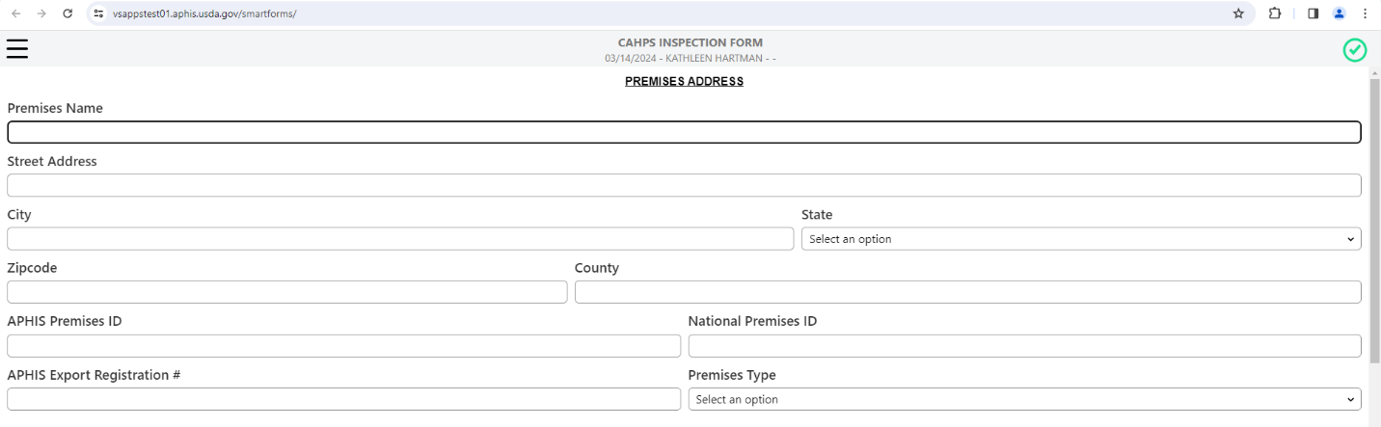
Activity Description: General Participant Info
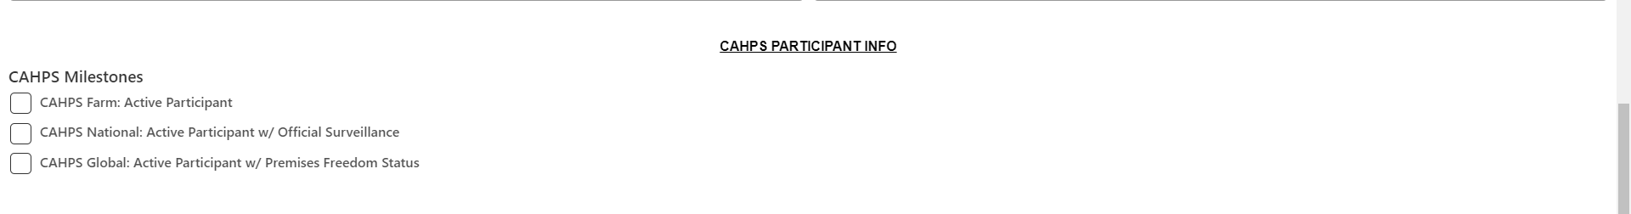

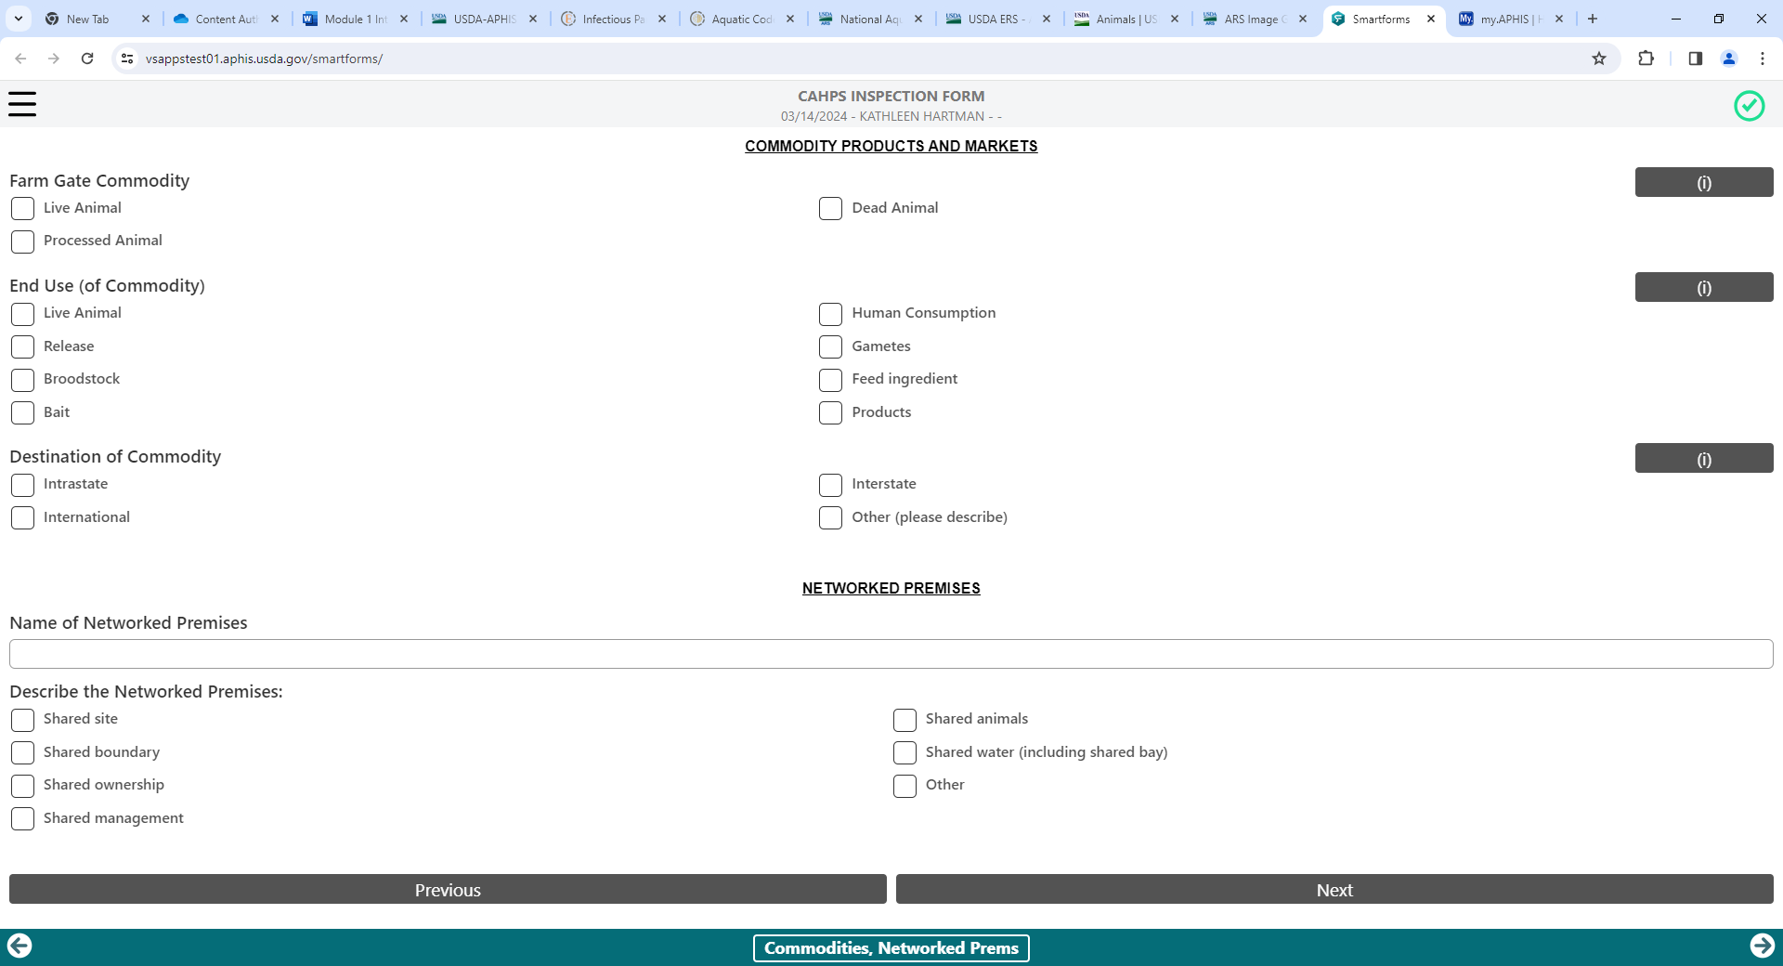
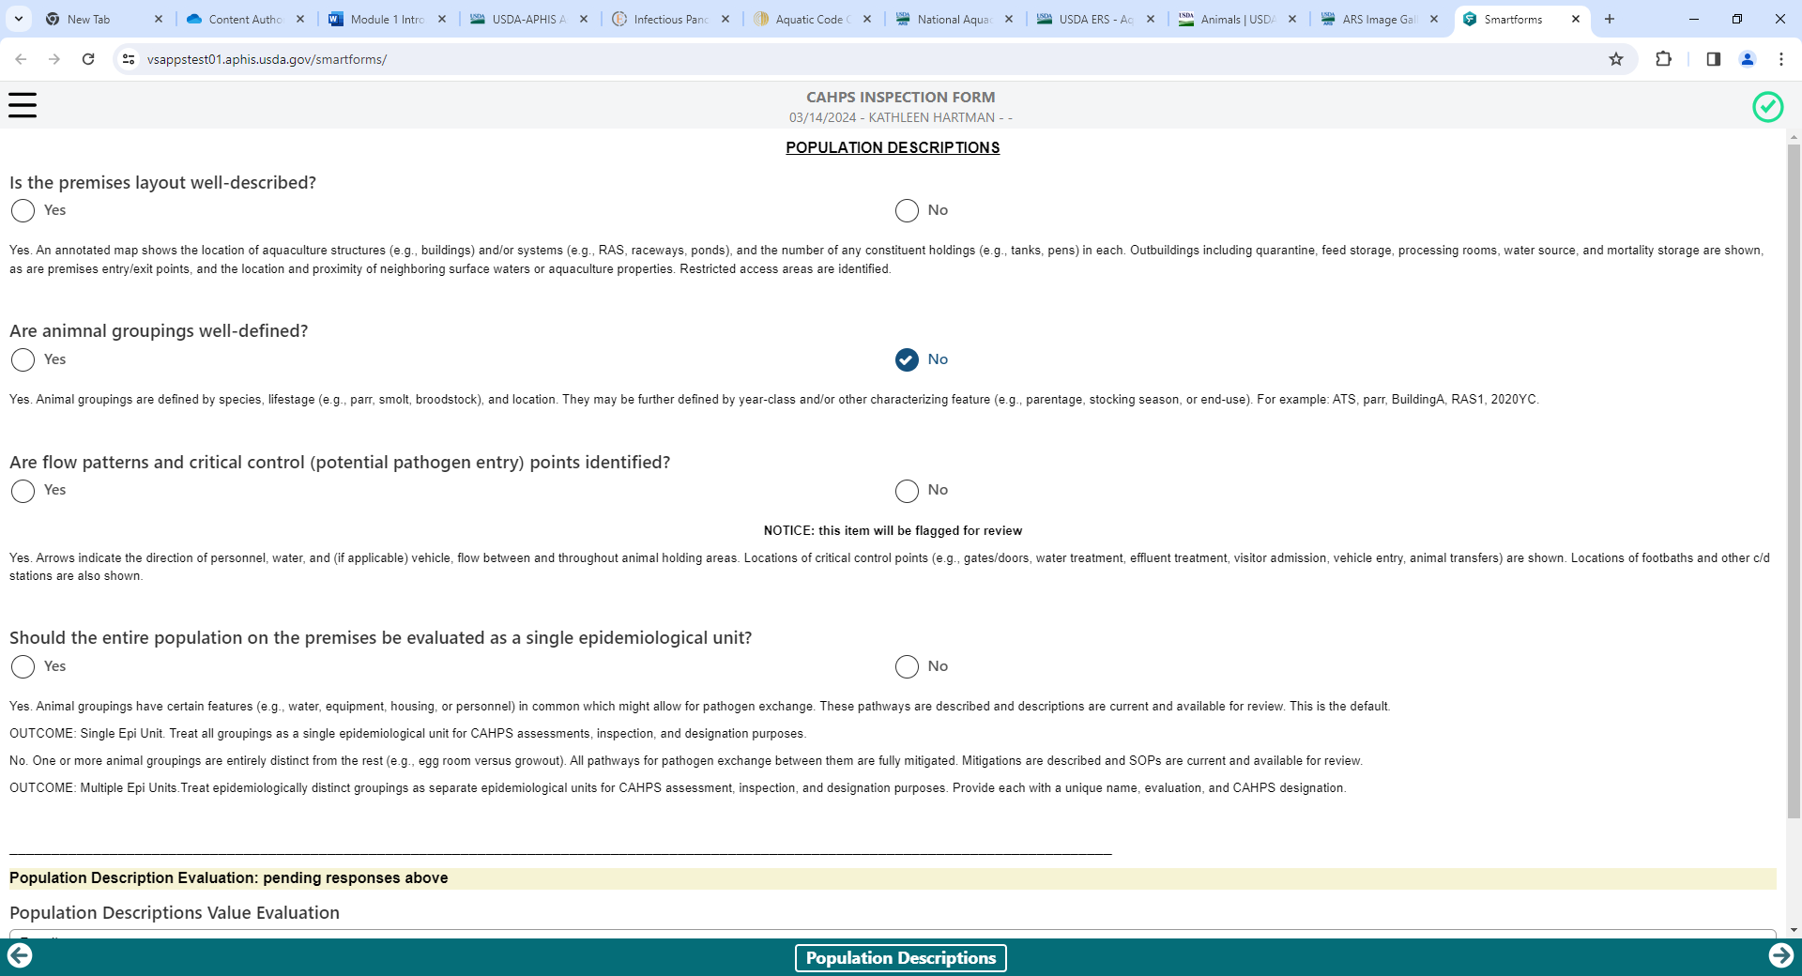
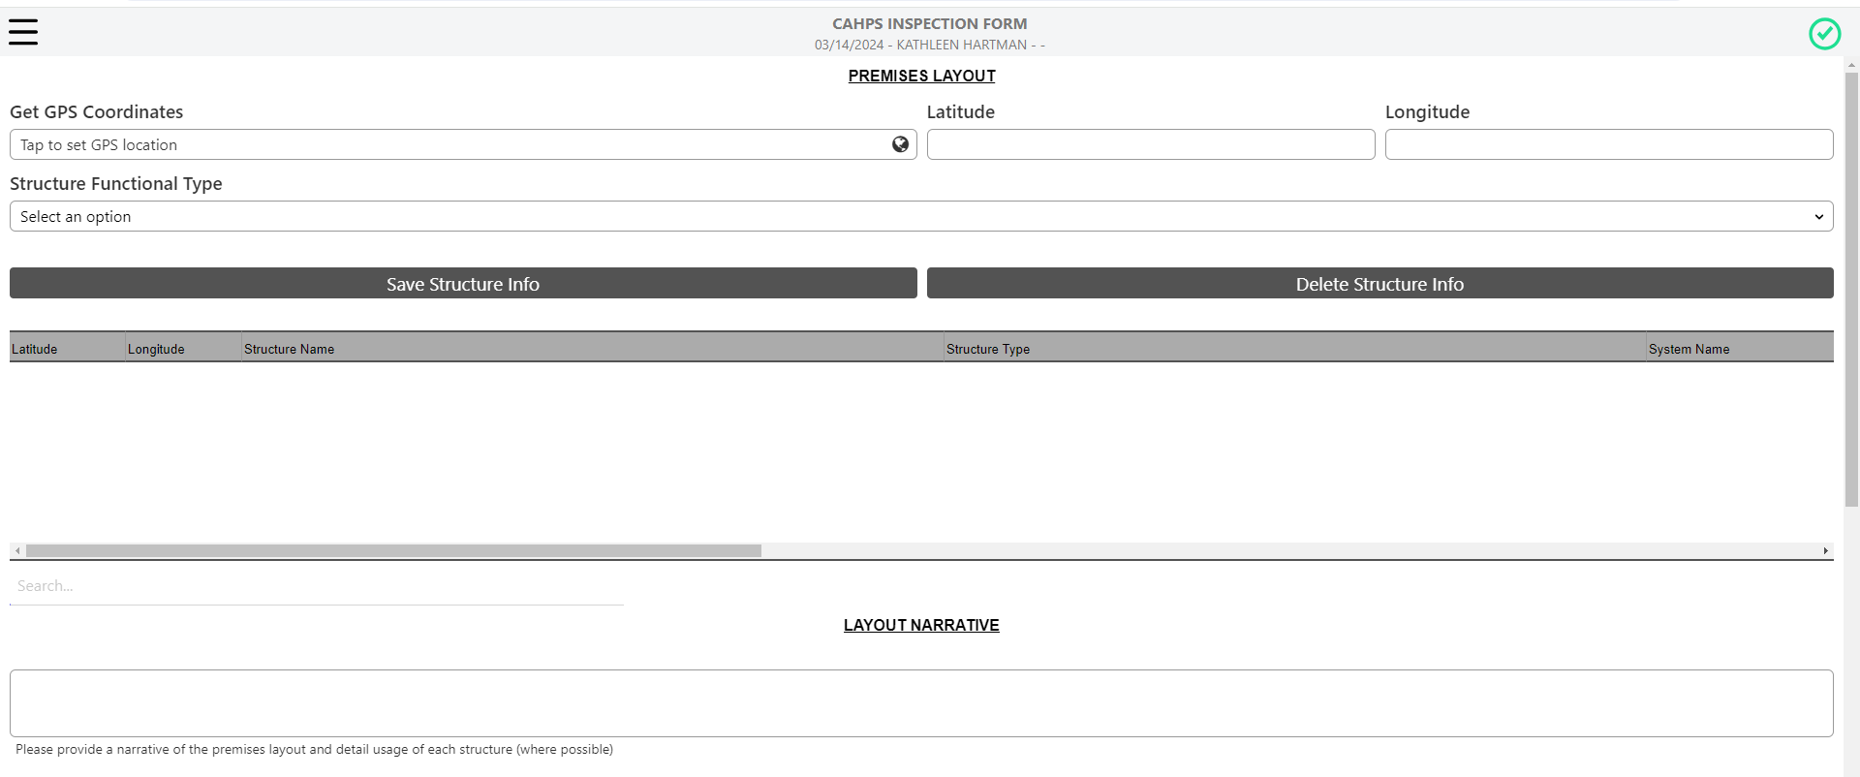

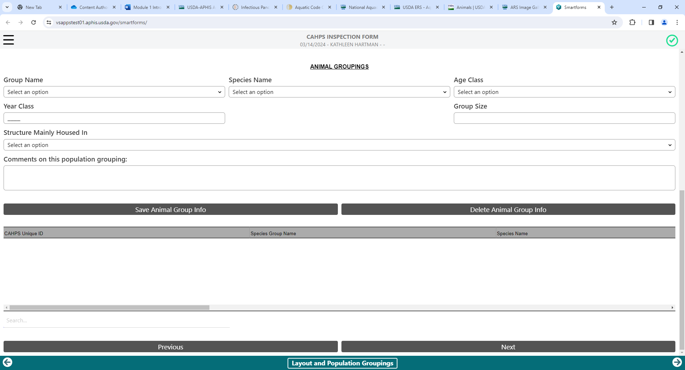
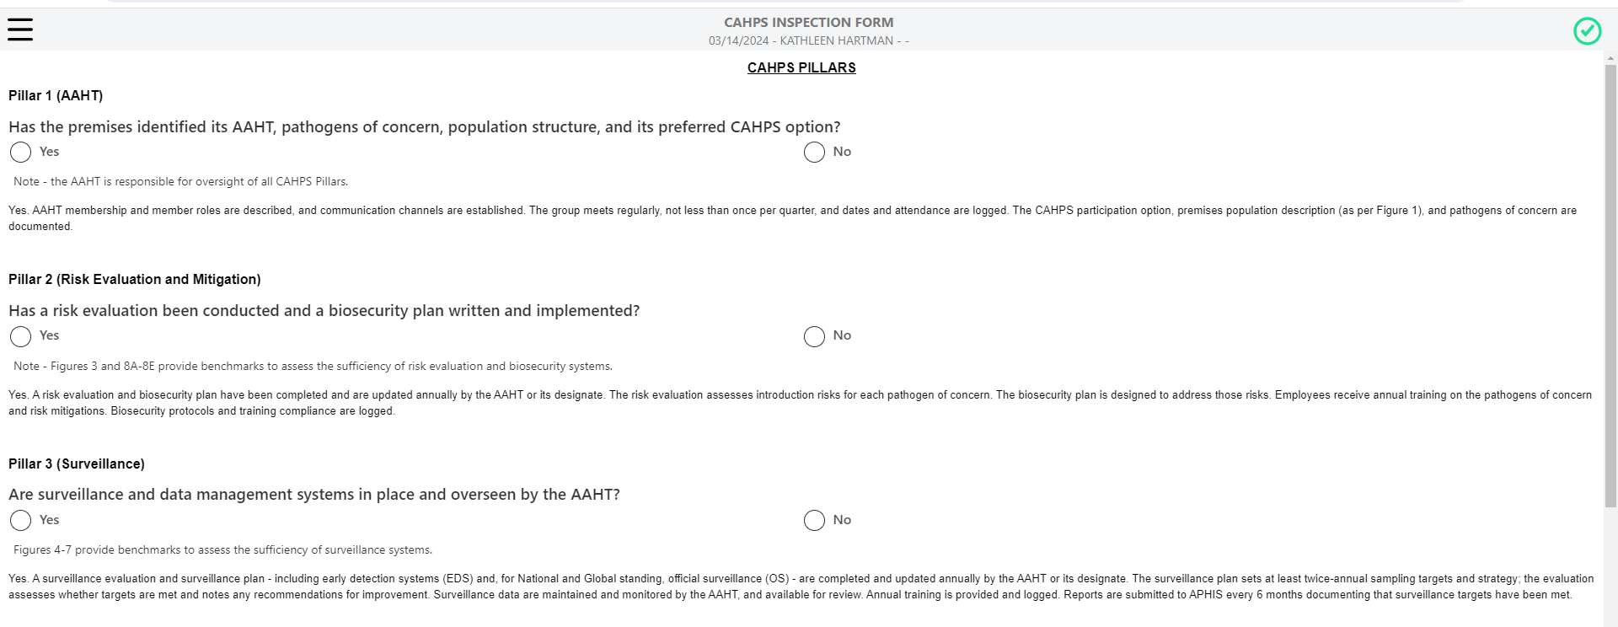
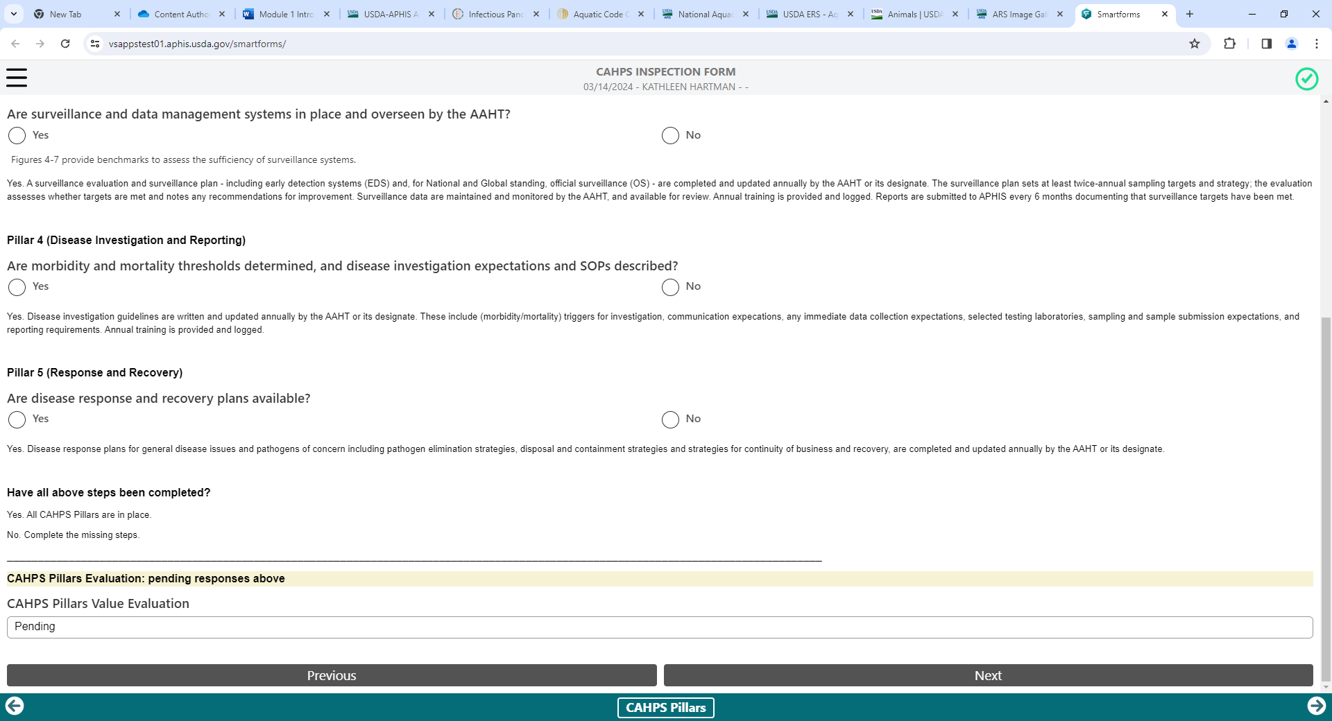
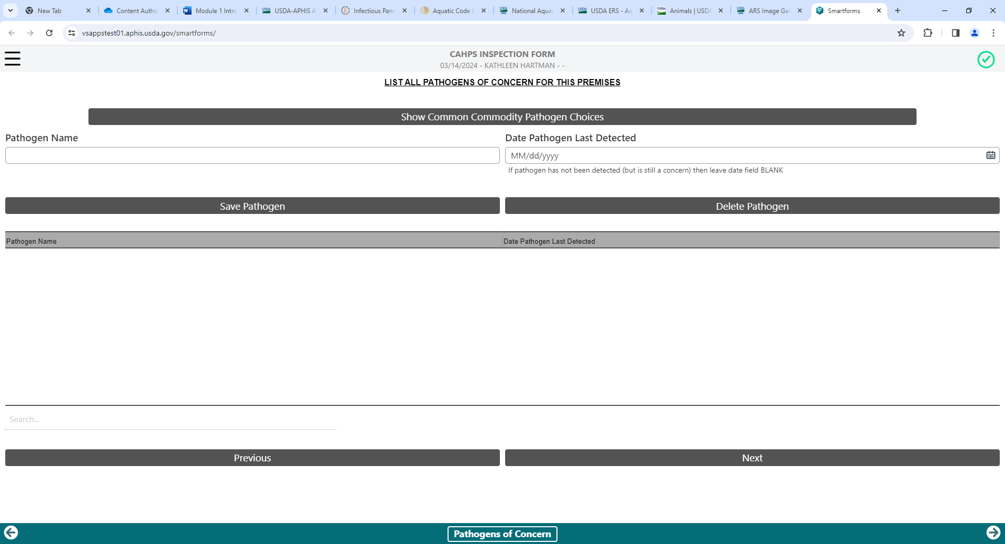
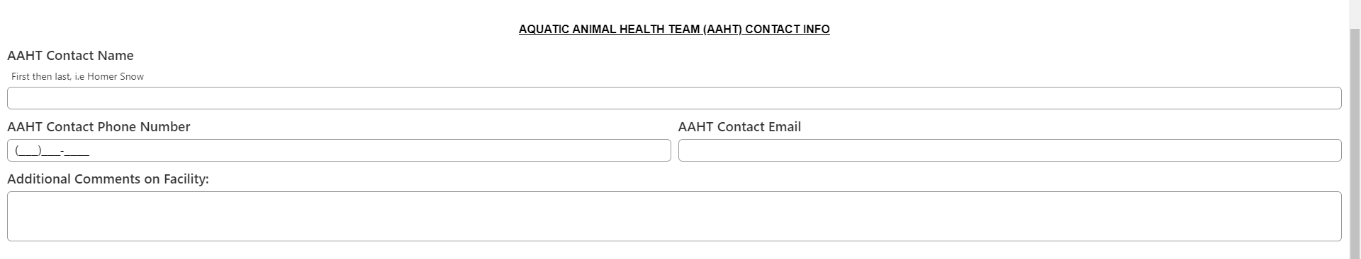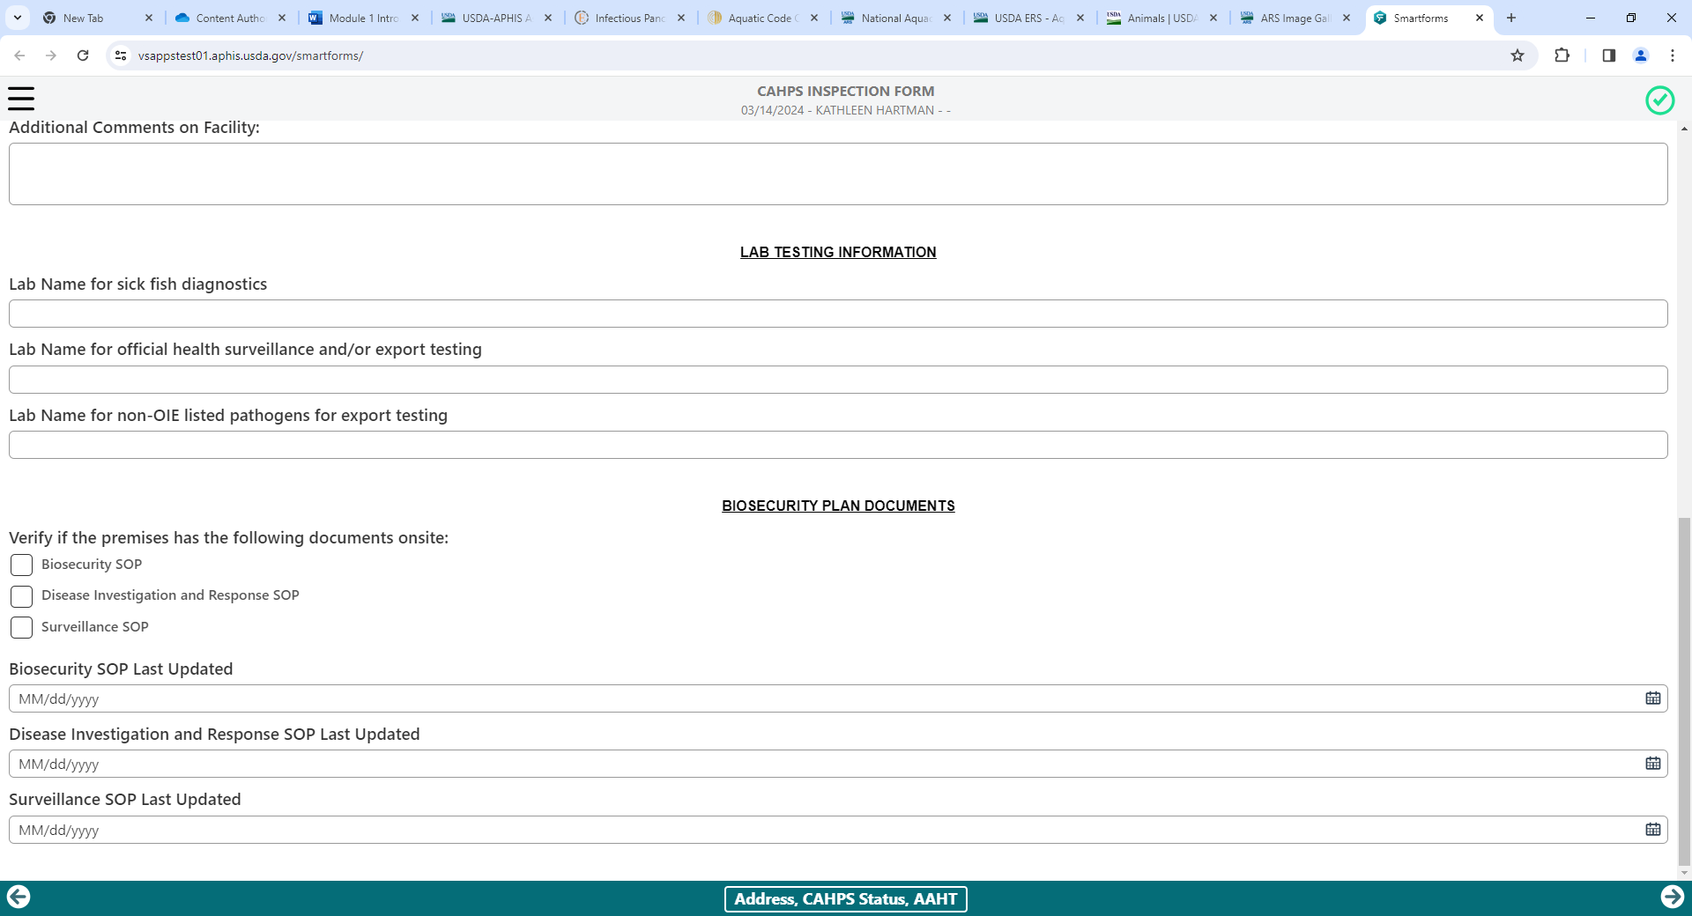
Activity Description: Aquatic Animal Health Team (CAHPS Pillar 1)

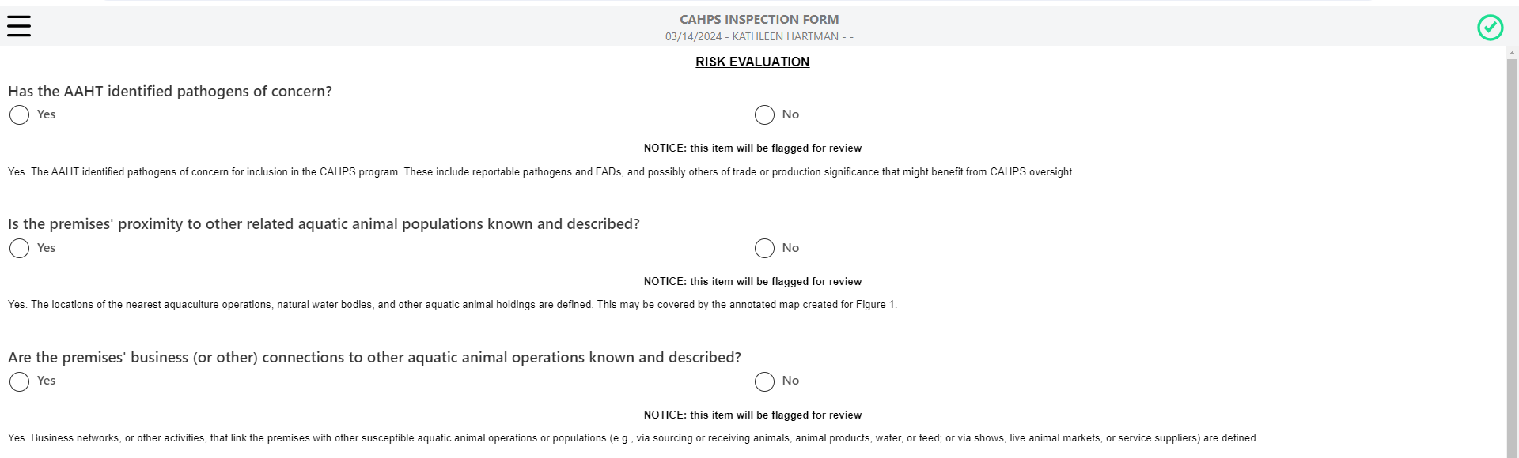
Activity Description: Risk Evaluation (CAHPS Pillar 2)

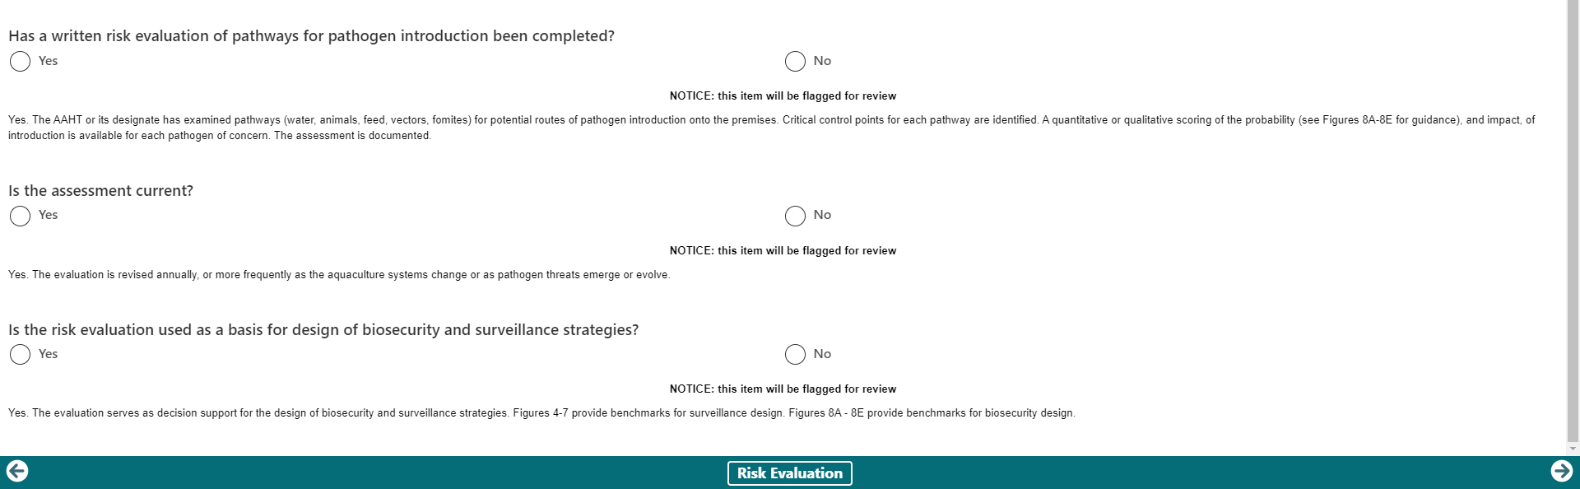
Activity Description: Early Detection Systems (CAHPS Pillar 3)
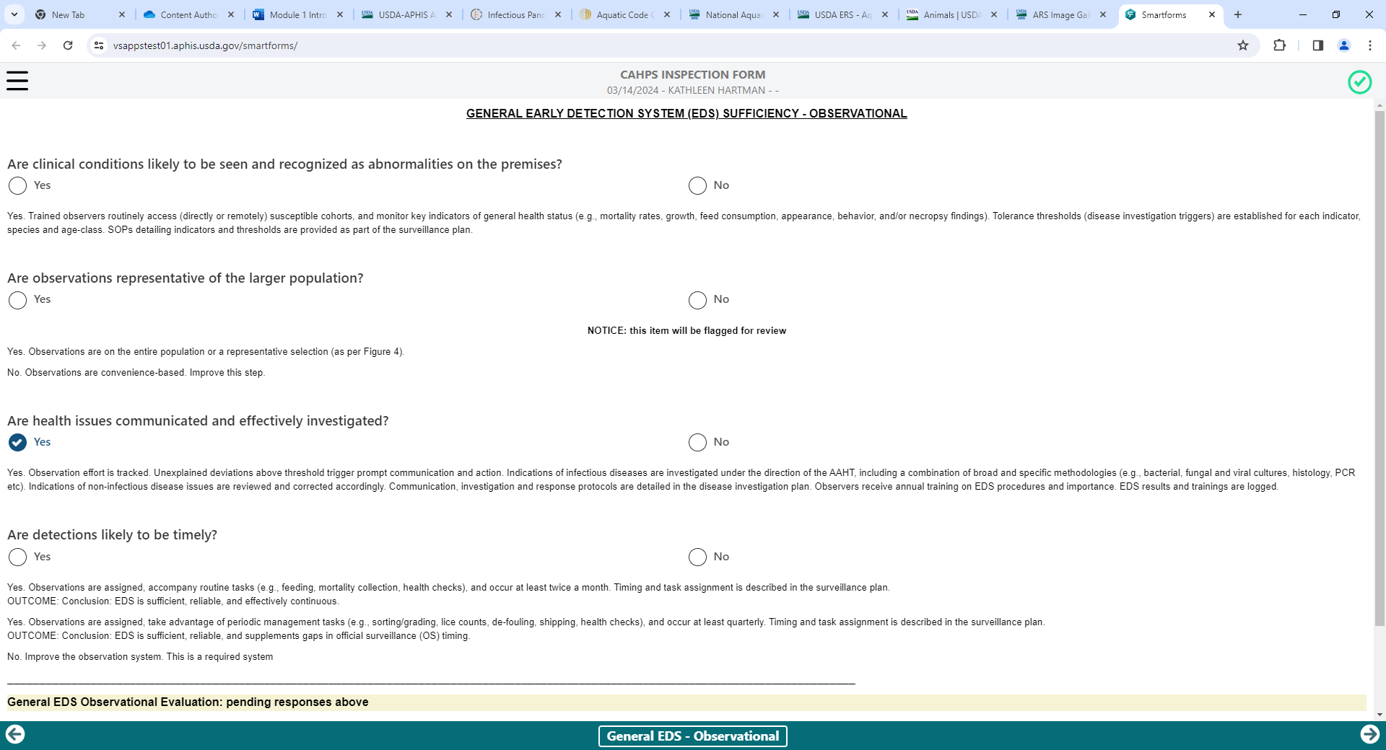

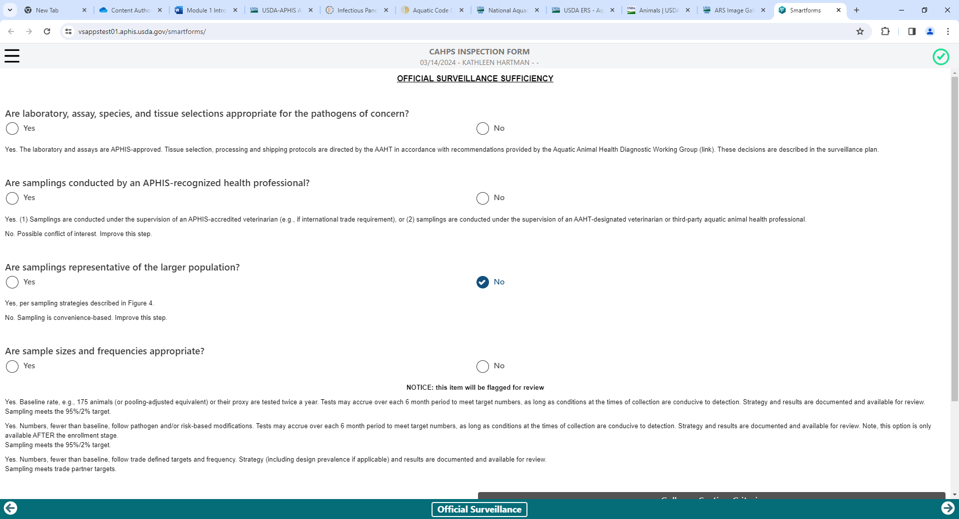
Activity Description: Official Surveillance (CAHPS Pillar 3)
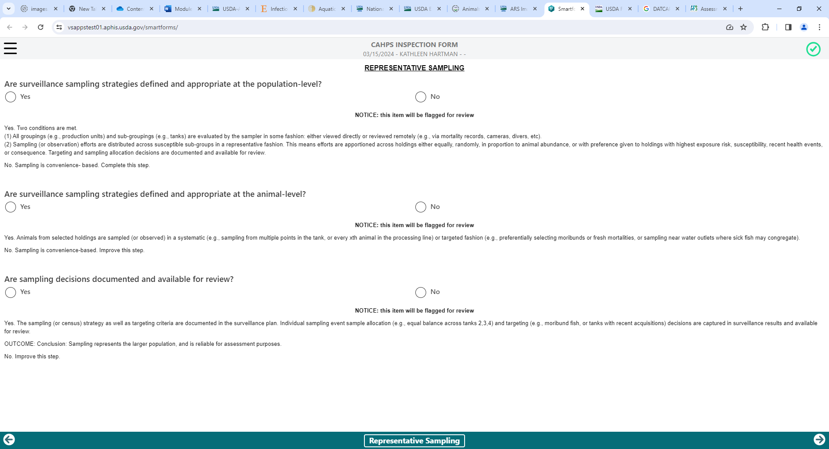

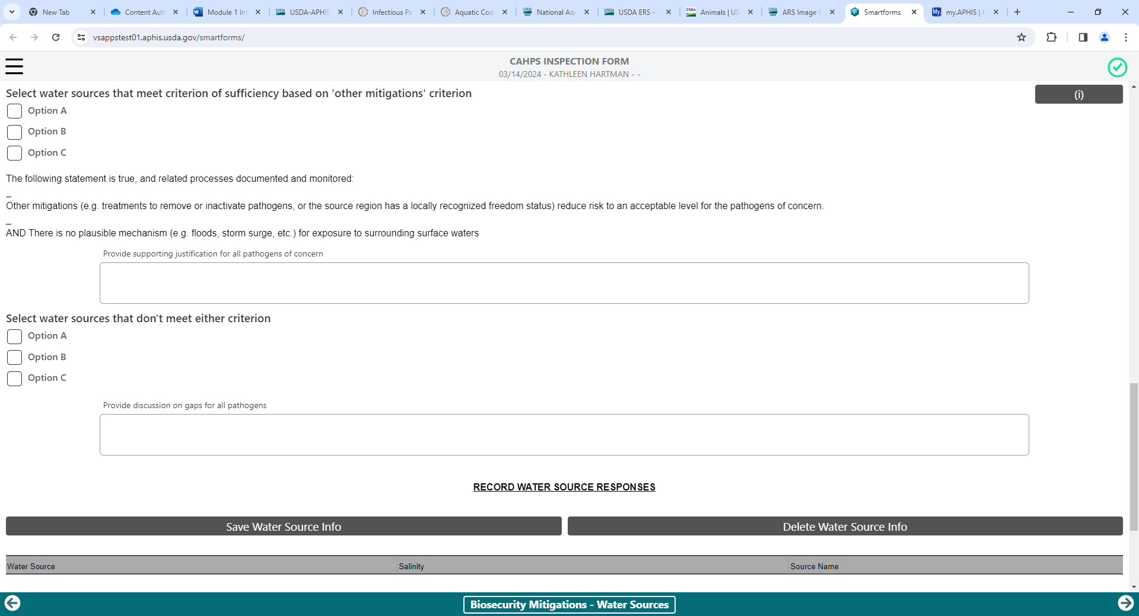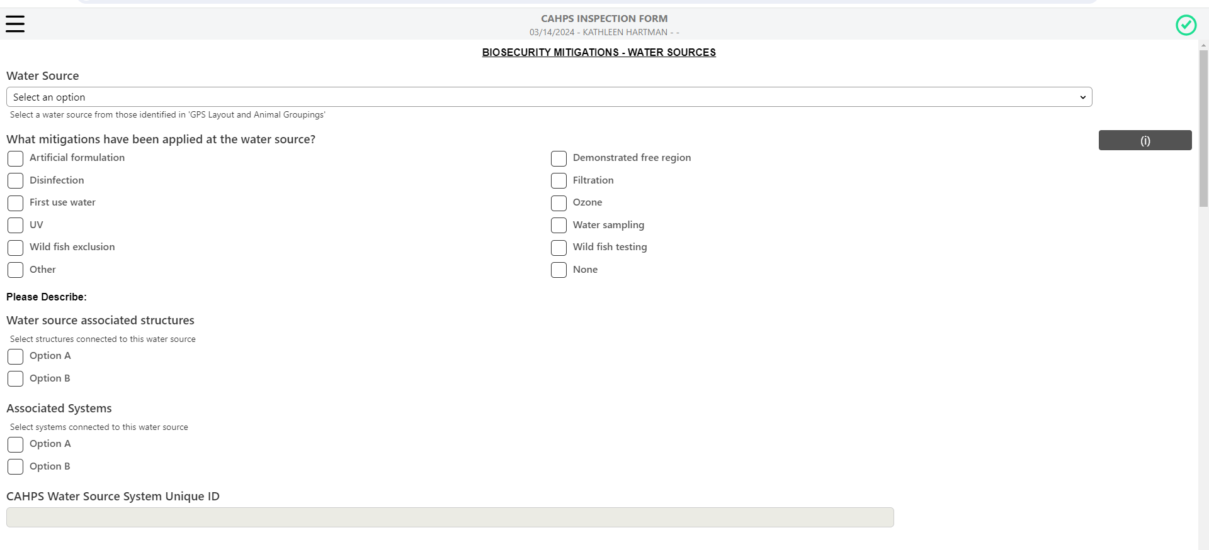
Activity Description: Biosecurity Plan (CAHPS Pillar 3)
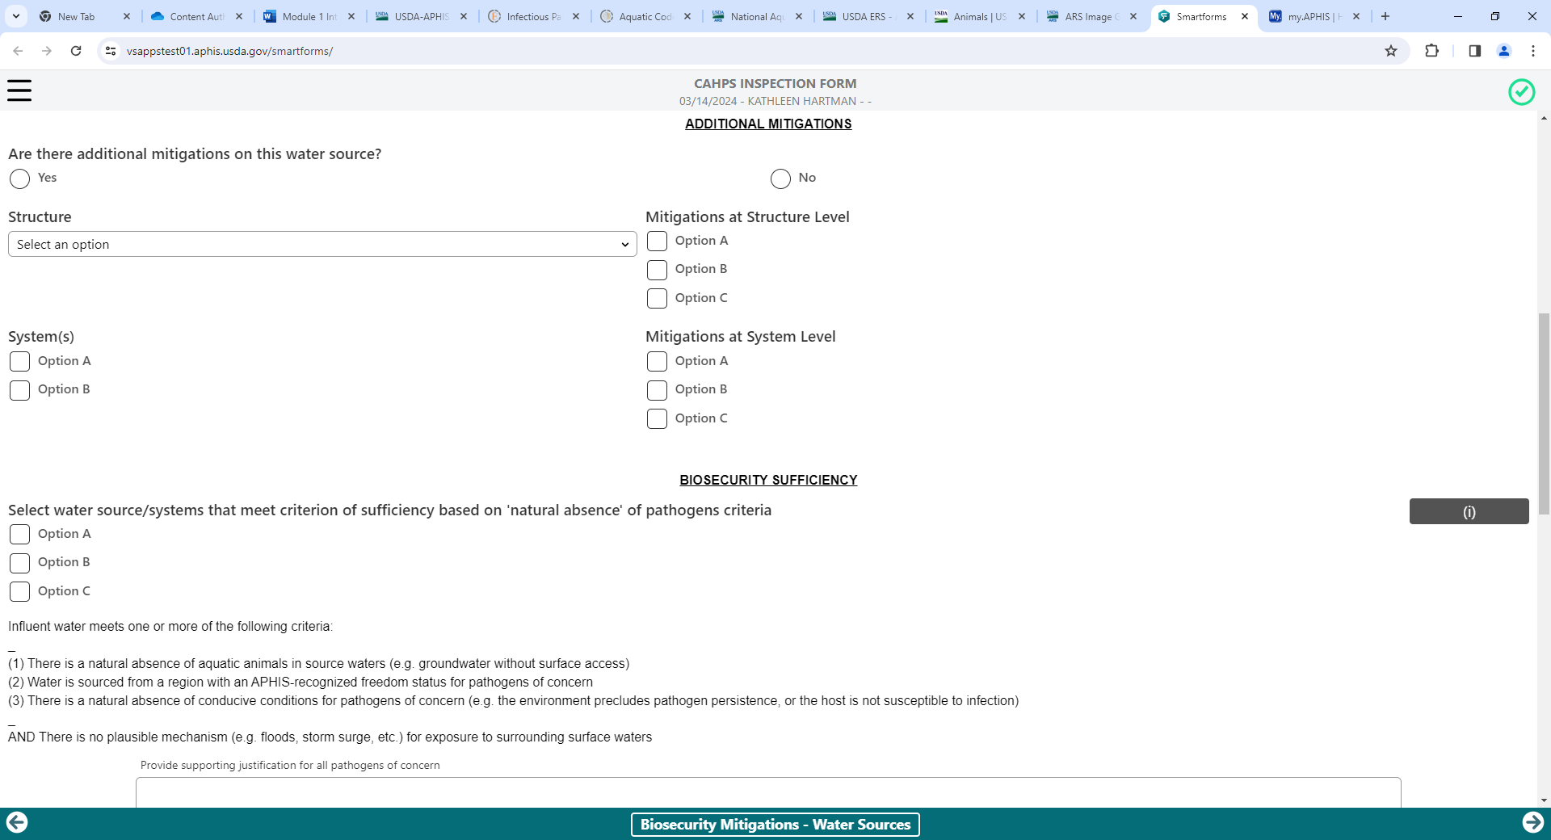
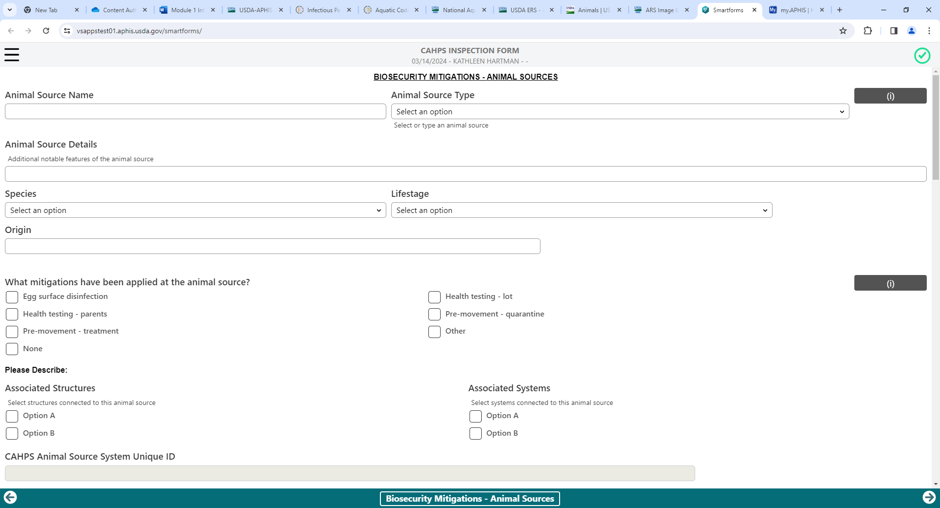
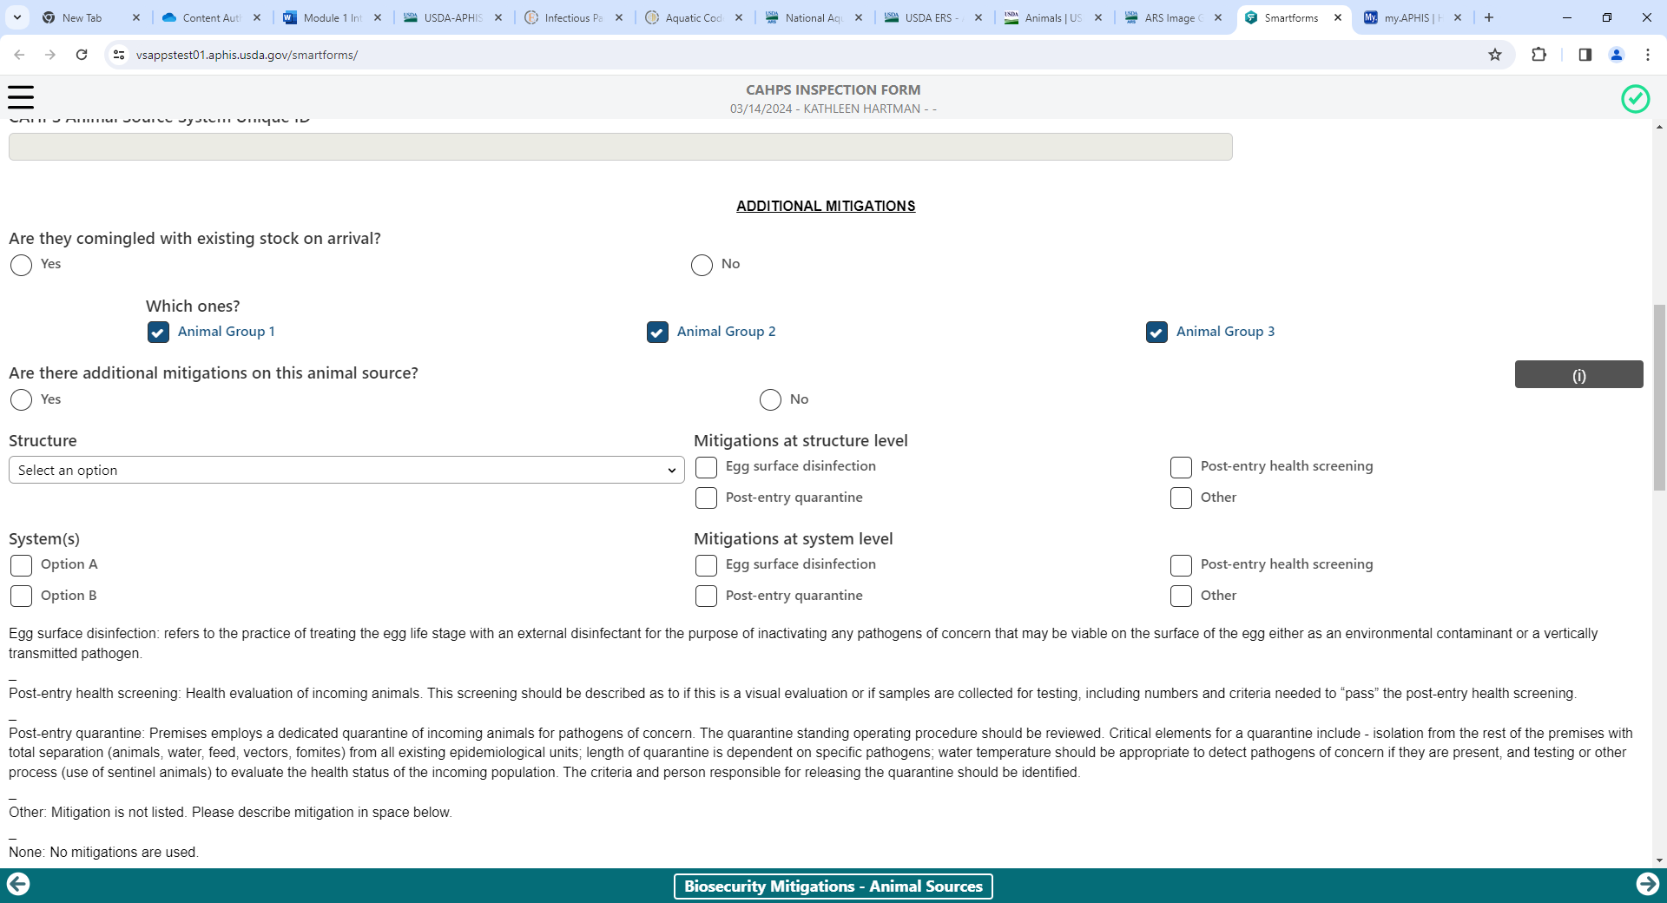

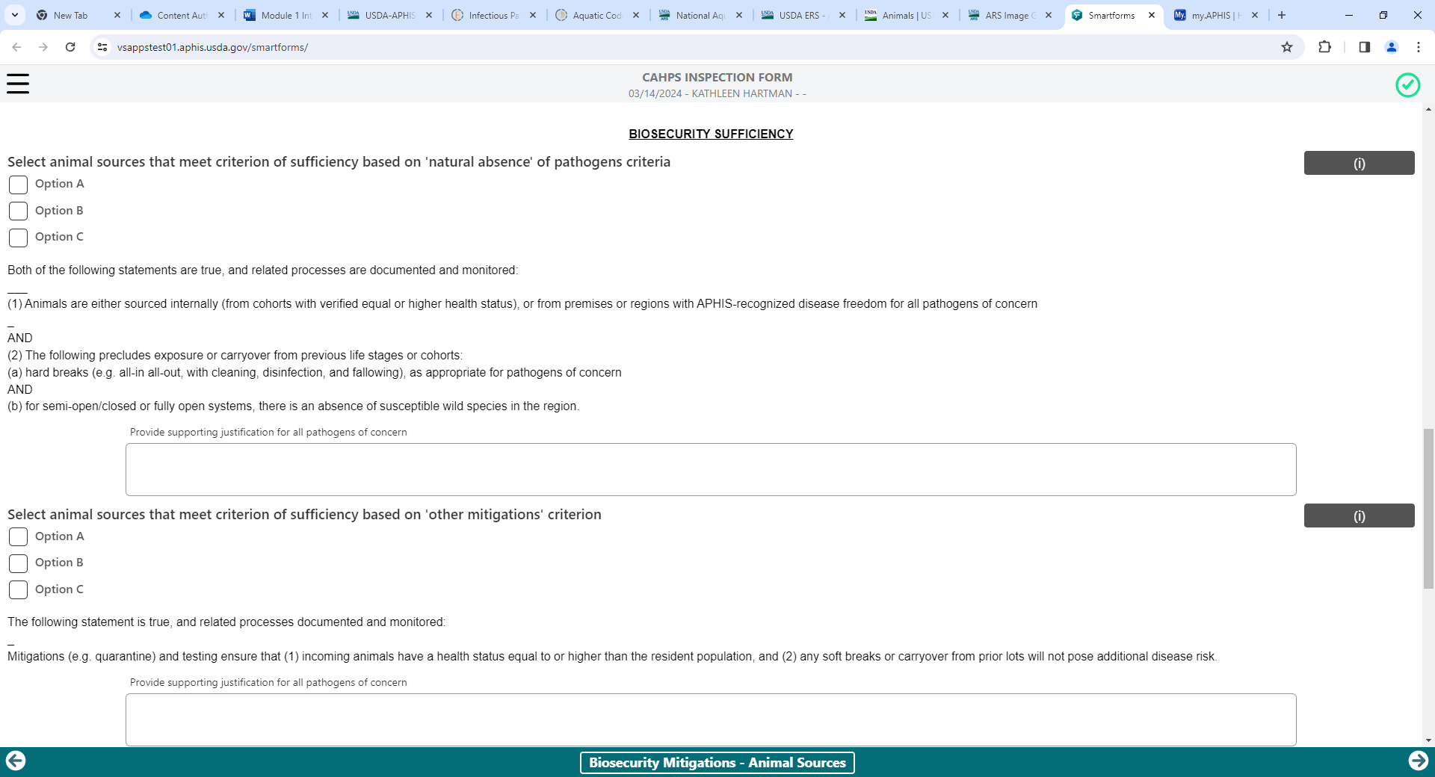
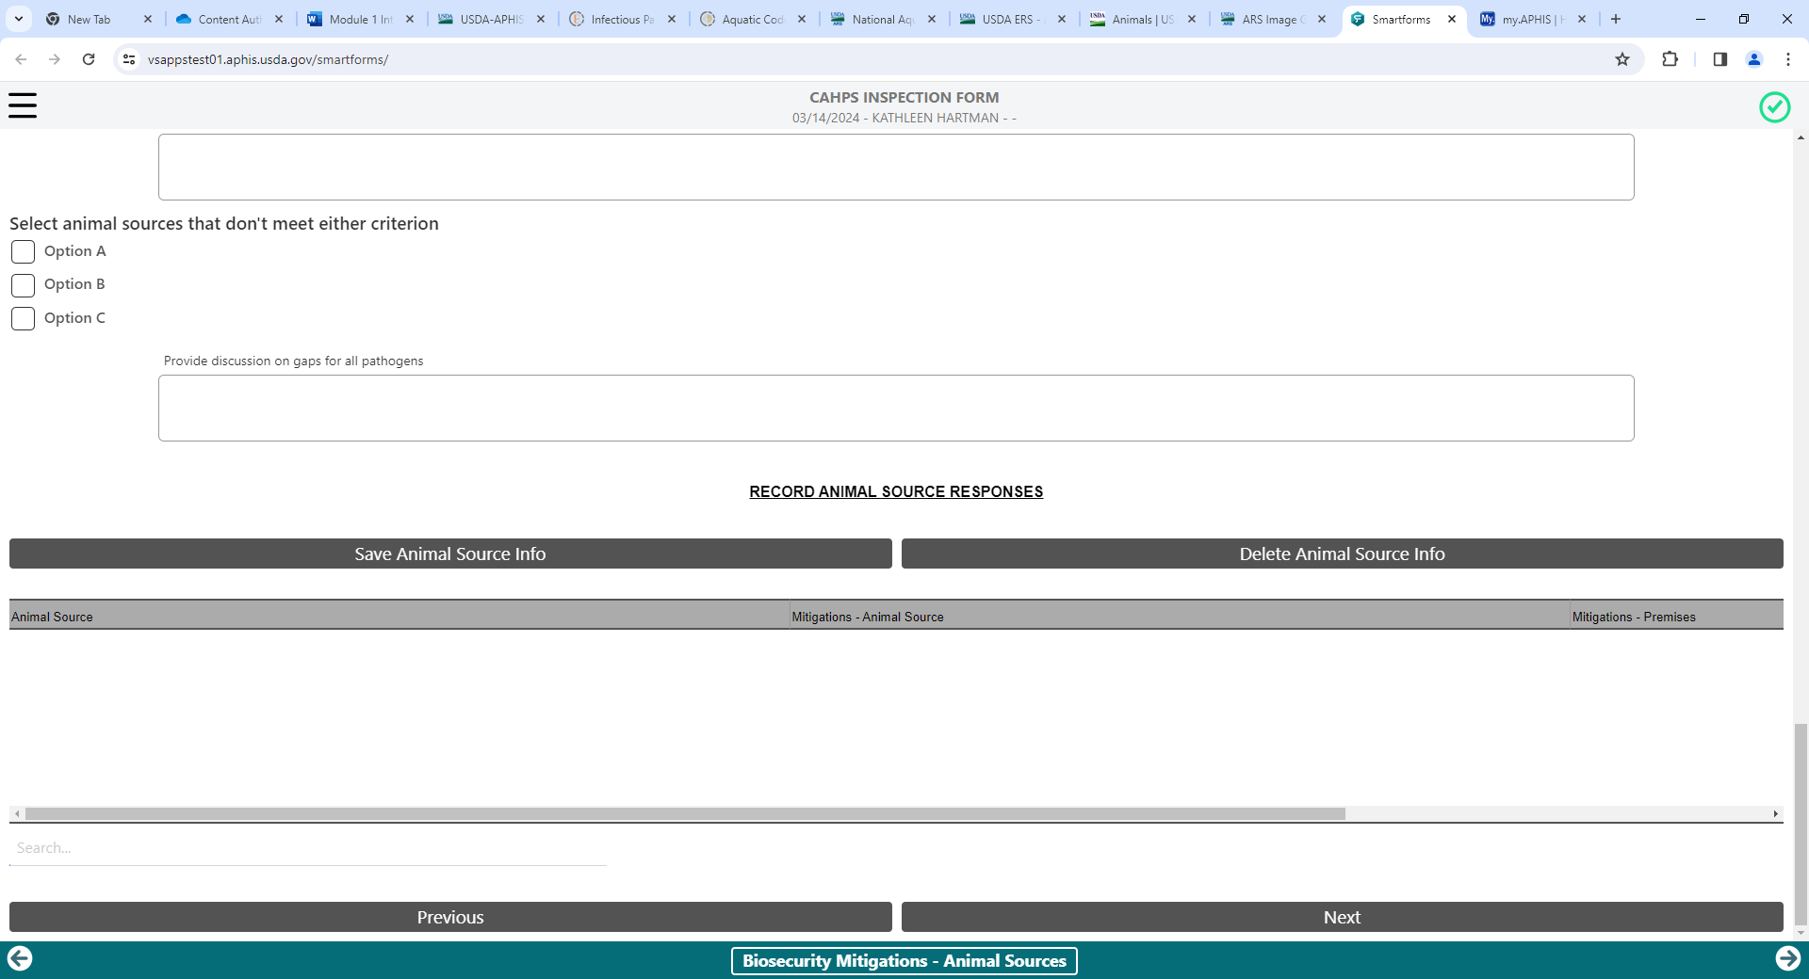
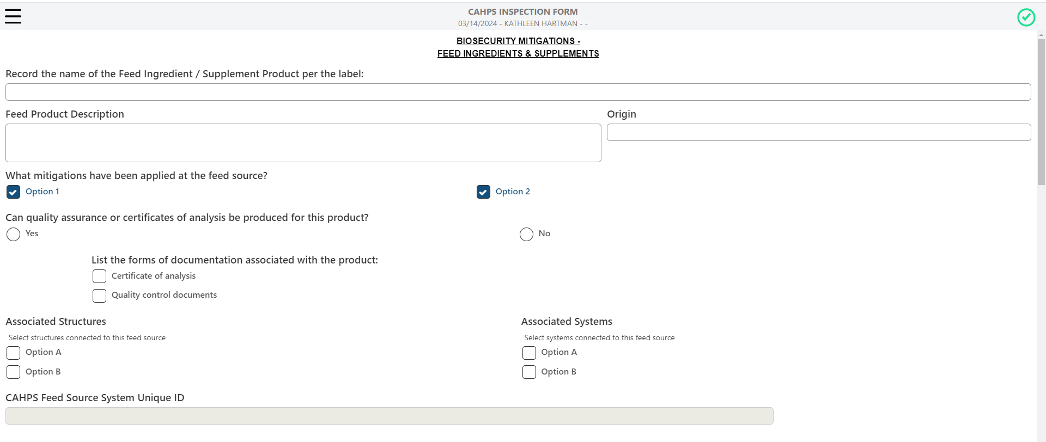
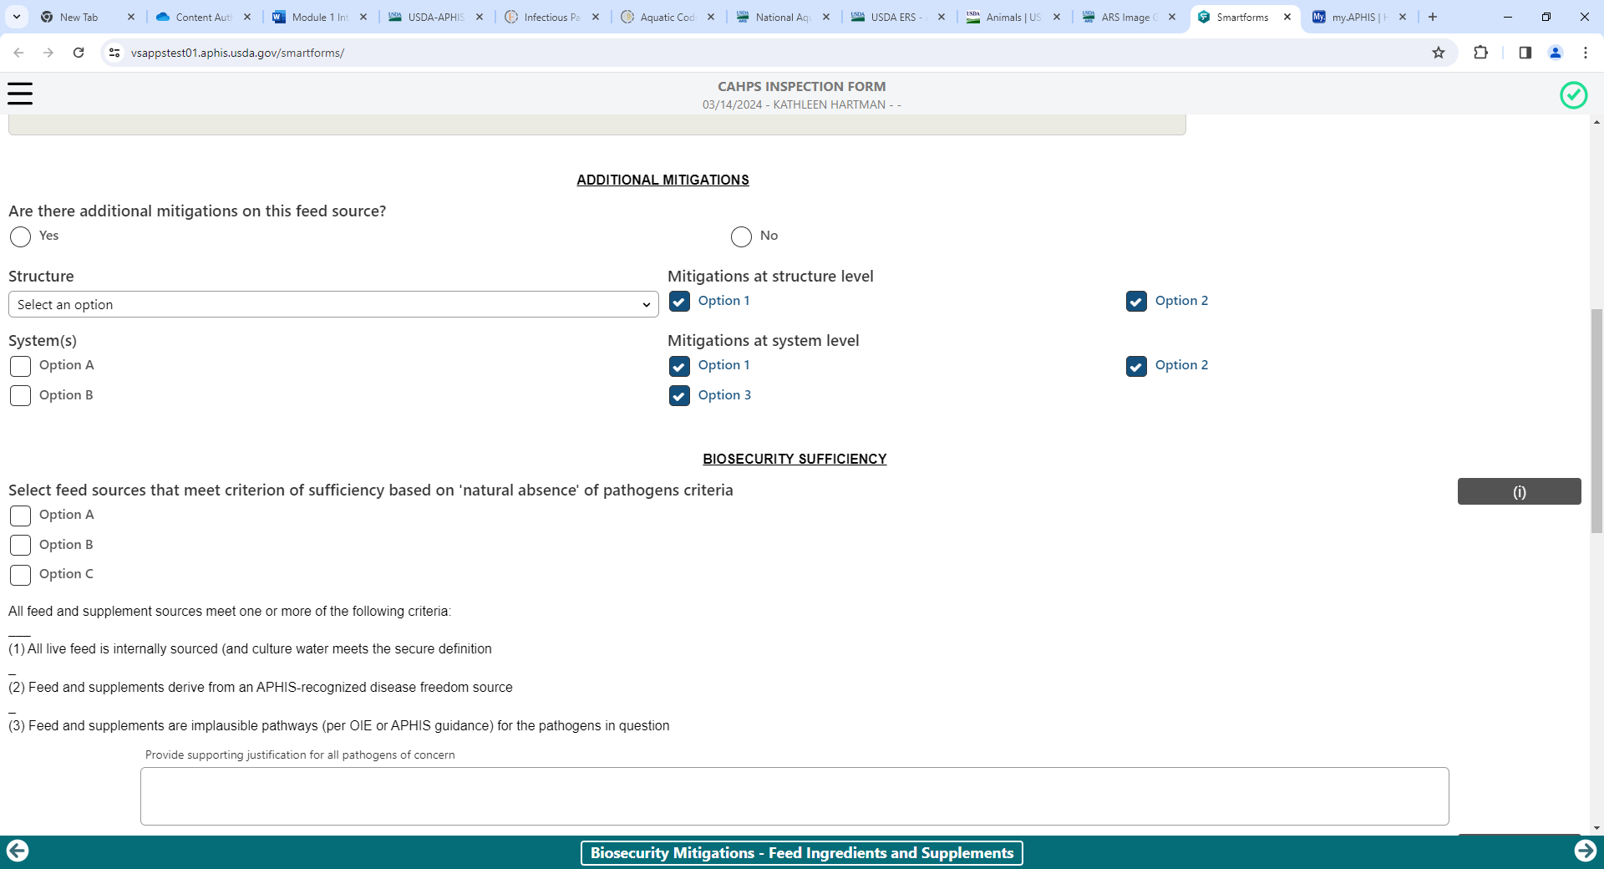
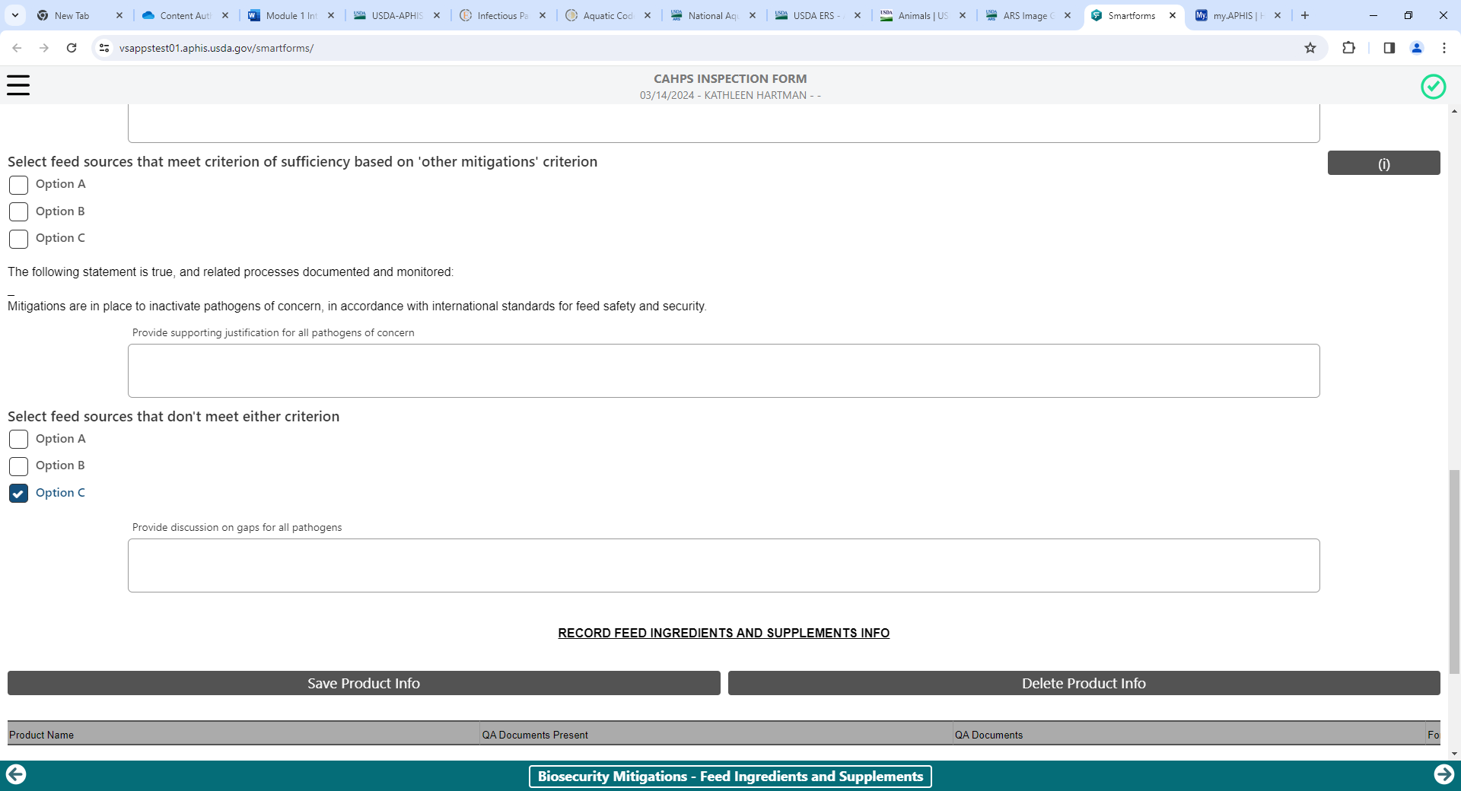

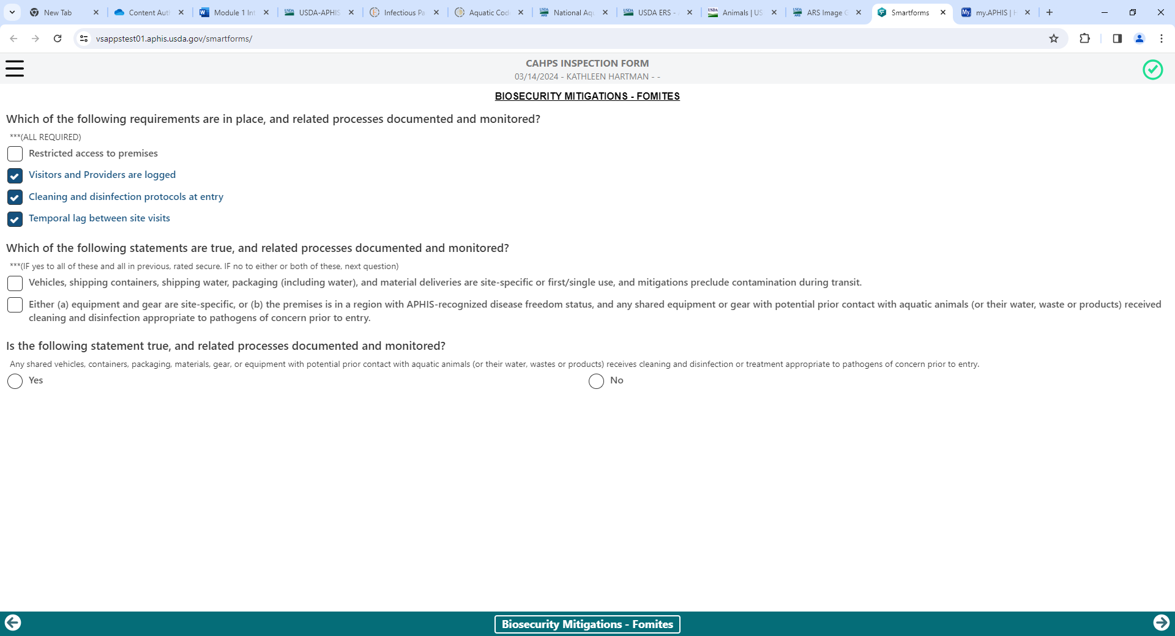
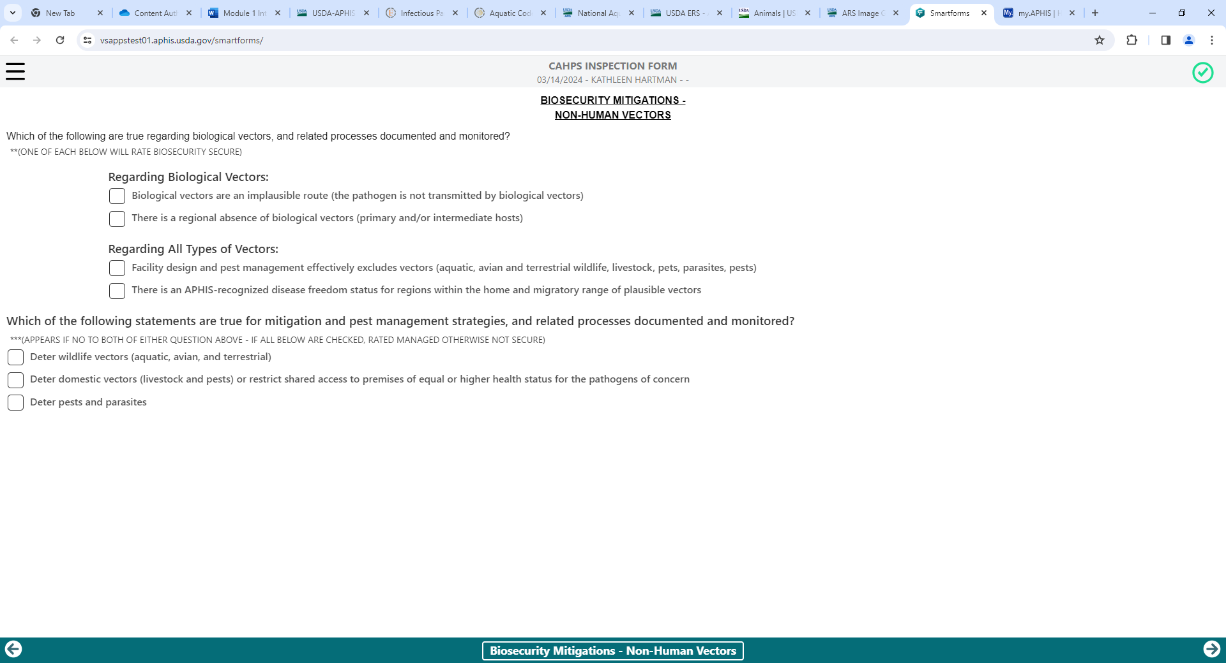
Activity Description: Disease Investigation and Reporting (CAHPS Pillar 4)
Activity Description: Response and Recovery (CAHPS Pillar 5)

