|  |  |
| --- | --- |
| According to the Paperwork Reduction Act of 1995, an agency may not conduct or sponsor, and a person is not required to respond to, a collection of information unless it displays a valid OMB control number. The valid OMB control number for this information collection is 0579-XXXX. The time required to complete this information collection is estimated to average 1 hour per activity, including the time for reviewing instructions, searching existing data sources, gathering and maintaining the data needed, and completing and reviewing the collection of information. | OMB APPROVED  0579-XXXX  EXP DATE XX/XXXX |

|  |  |
| --- | --- |
| *APHIS 71 CAHPS MICO App Activity Descriptions* |  |
| General Participant Information | Below |
| Aquatic Animal Health Team (CAHPS Pillar 1) | Below |
| Risk Evaluation (CAHPS Pillar 2) | Below |
| Early Detection System (CAHPS Pillar 3) | Below |
| Official Surveillance (CAHPS Pillar 3) | Below |
| Disease Investigation (CAHPS Pillar 4) | Below |
| Pathogen Reporting (CAHPS Pillar 4) | Below |
| Response and Recovery (CAHPS Pillar 5) | Below |
| Biosecurity Plan | Output from app using inputted data from pillar 2 |
| Official annual Surveillance Plan | Output from app using inputted data from pillar 3 |
| Disease investigation and Reporting Plan | Output from app using inputted data from pillar 4 |
| Response and Recovery Plan | Output from app using inputted data from pillar 5 |
| Communication Plan | Under EDS |
| CAHPS Workbook (CAHPS pillars and MIR) | Separate attachment |

*Activity Description: General Participant Info*

*Activity Description: Aquatic Animal Health Team (CAHPS Pillar 1)*

*Activity Description: Risk Evaluation (CAHPS Pillar 2)*

*Activity Description: Early Detection Systems (CAHPS Pillar 3)*

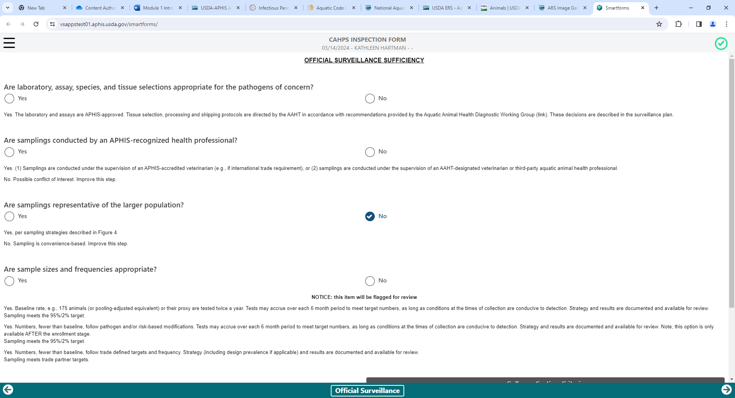

*Activity Description: Official Surveillance (CAHPS Pillar 3)*

*Activity Description: Biosecurity Plan (CAHPS Pillar 3)*

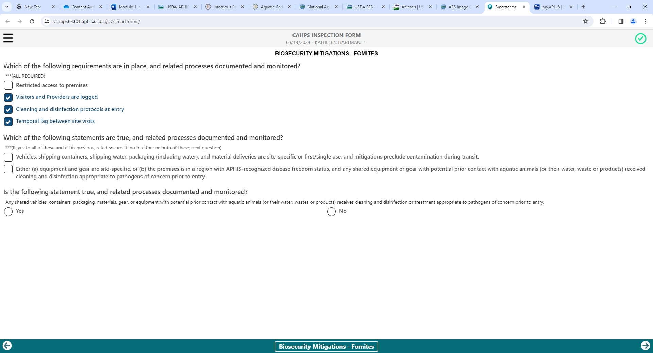

*Activity Description: Disease Investigation and Reporting (CAHPS Pillar 4)*

*Activity Description: Response and Recovery (CAHPS Pillar 5)*