**Appendix I. Police Station Letter**

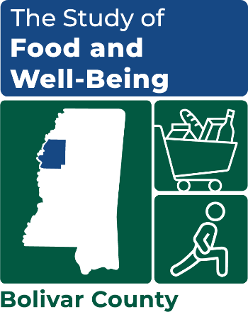

OMB Number: 0584-XXXX

Expiration Date: XX/XX/20XX

[DATE]

[NAME]

[ADDRESS]

[ADDRESS 2]

[CITY], [STATE] [ZIP]

Dear [COUNTY/LOCAL Police Department]:

The U.S. Department of Agriculture’s (USDA) Food and Nutrition Service is conducting a new survey called the ***Study of Food and Well-Being.*** The USDA has contracted with Mathematica to design and conduct this study. This study aims to learn about how to help families access healthy and affordable food, and design programs and policies that aim to reduce hunger.

[COUNTY] County has been selected to be part of the Study of Food and Well-Being. From [insert date] through [insert date] we will have several professional interviewers in the county. Interviewers will carry a Mathematica ID and a letter that indicates they are authorized to visit homes in the area to request participation in the study. They will visit selected addresses and screen households to determine their eligibility for the study. We expect to interview about [insert number] households during this time period. If a member of the household decides to participate, they will be asked to complete a 35-minute survey.

We have enclosed a study flyer for you to review and post in a public area so other officers and staff working in your department will know about the study. To learn more about the study, see the enclosed brochure, visit our website at [www.XXXX.com](http://www.XXXX.com), or call our toll-free number at XXX-XXX-XXXX.

Thanks in advance for your cooperation and support of the Study of Food and Well-Being!

Sincerely,

|  |  |  |
| --- | --- | --- |
| Kim McDonald | Michael Burke | |
| *---insert signature image here---* | *---insert signature image here---* | |
| Survey Director | Project Officer | |
| [PHONE] | (703) 305-4369 | |
| [EMAIL] | michael.burke@usda.gov |

This information is being collected to assist the Food and Nutrition Service (FNS) in understanding the interrelated factors that affect food insecurity and poverty. This is a voluntary collection and FNS will use the information to aid in the administration of the Supplemental Nutrition Assistance Program. This collection does request personally identifiable information under the Privacy Act of 1974. According to the Paperwork Reduction Act of 1995, an agency may not conduct or sponsor, and a person is not required to respond to, a collection of information unless it displays a valid OMB control number. The valid OMB control number for this information collection is 0584-[xxxx]. The time required to complete this information collection is estimated to average 1 minute (0.0167 hours) per response, including the time for reviewing instructions, searching existing data sources, gathering and maintaining the data needed, and completing and reviewing the collection of information. Send comments regarding this burden estimate or any other aspect of this collection of information, including suggestions for reducing this burden, to: U.S. Department of Agriculture, Food and Nutrition Service, Office of Policy Support, 1320 Braddock Place, 5th Floor, Alexandria, VA 22306 ATTN: PRA (0584-xxxx). Do not return the completed form to this address.