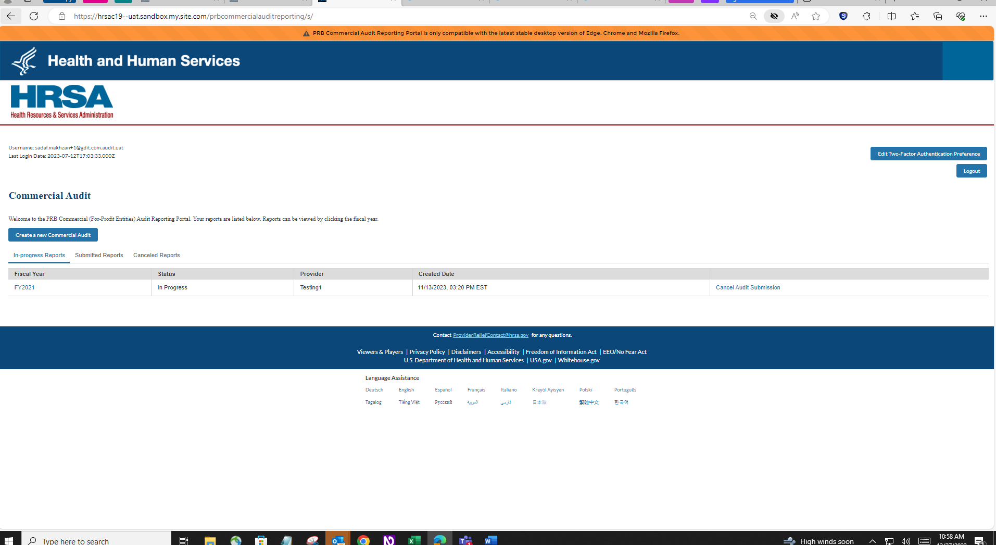

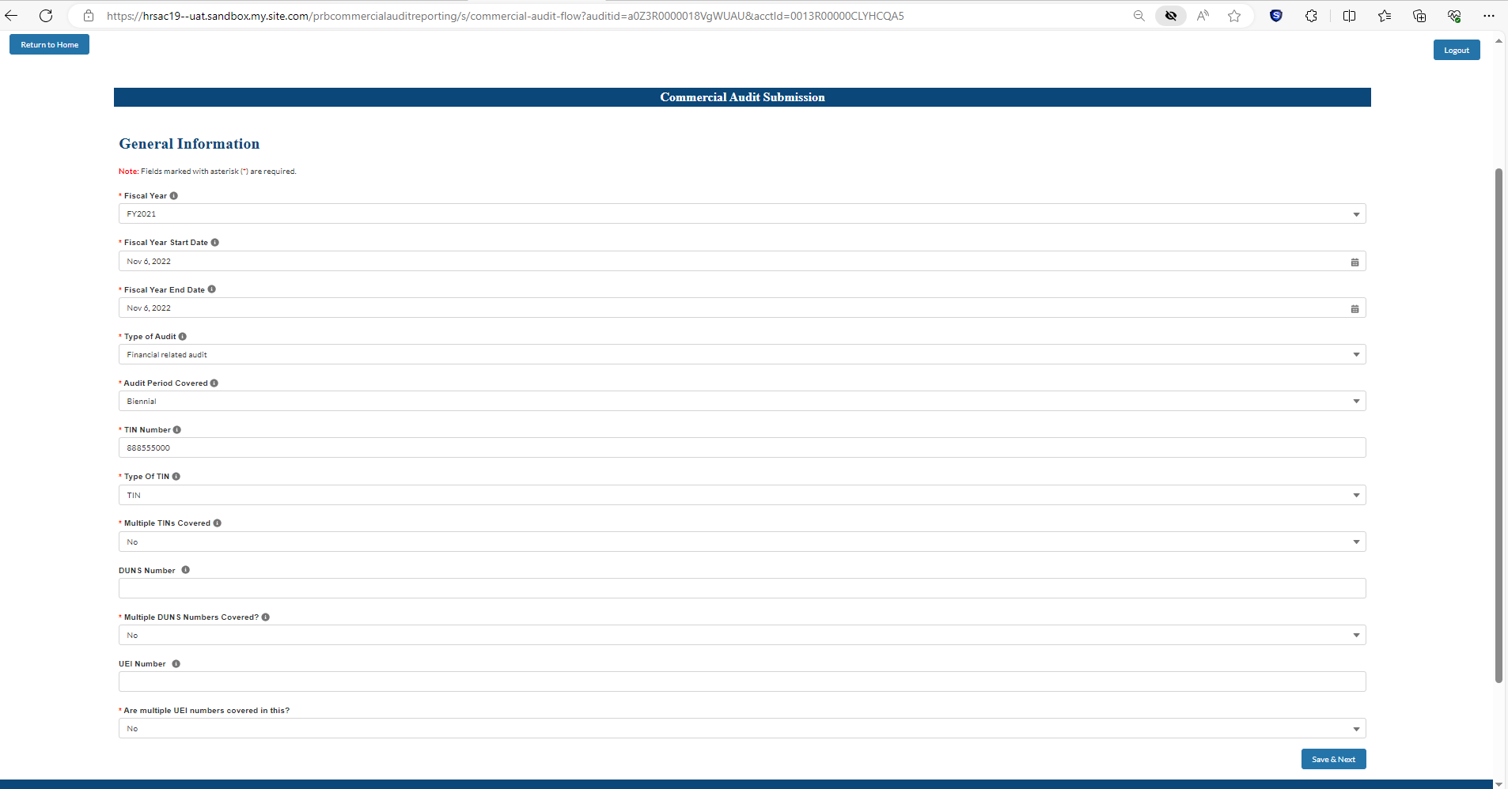

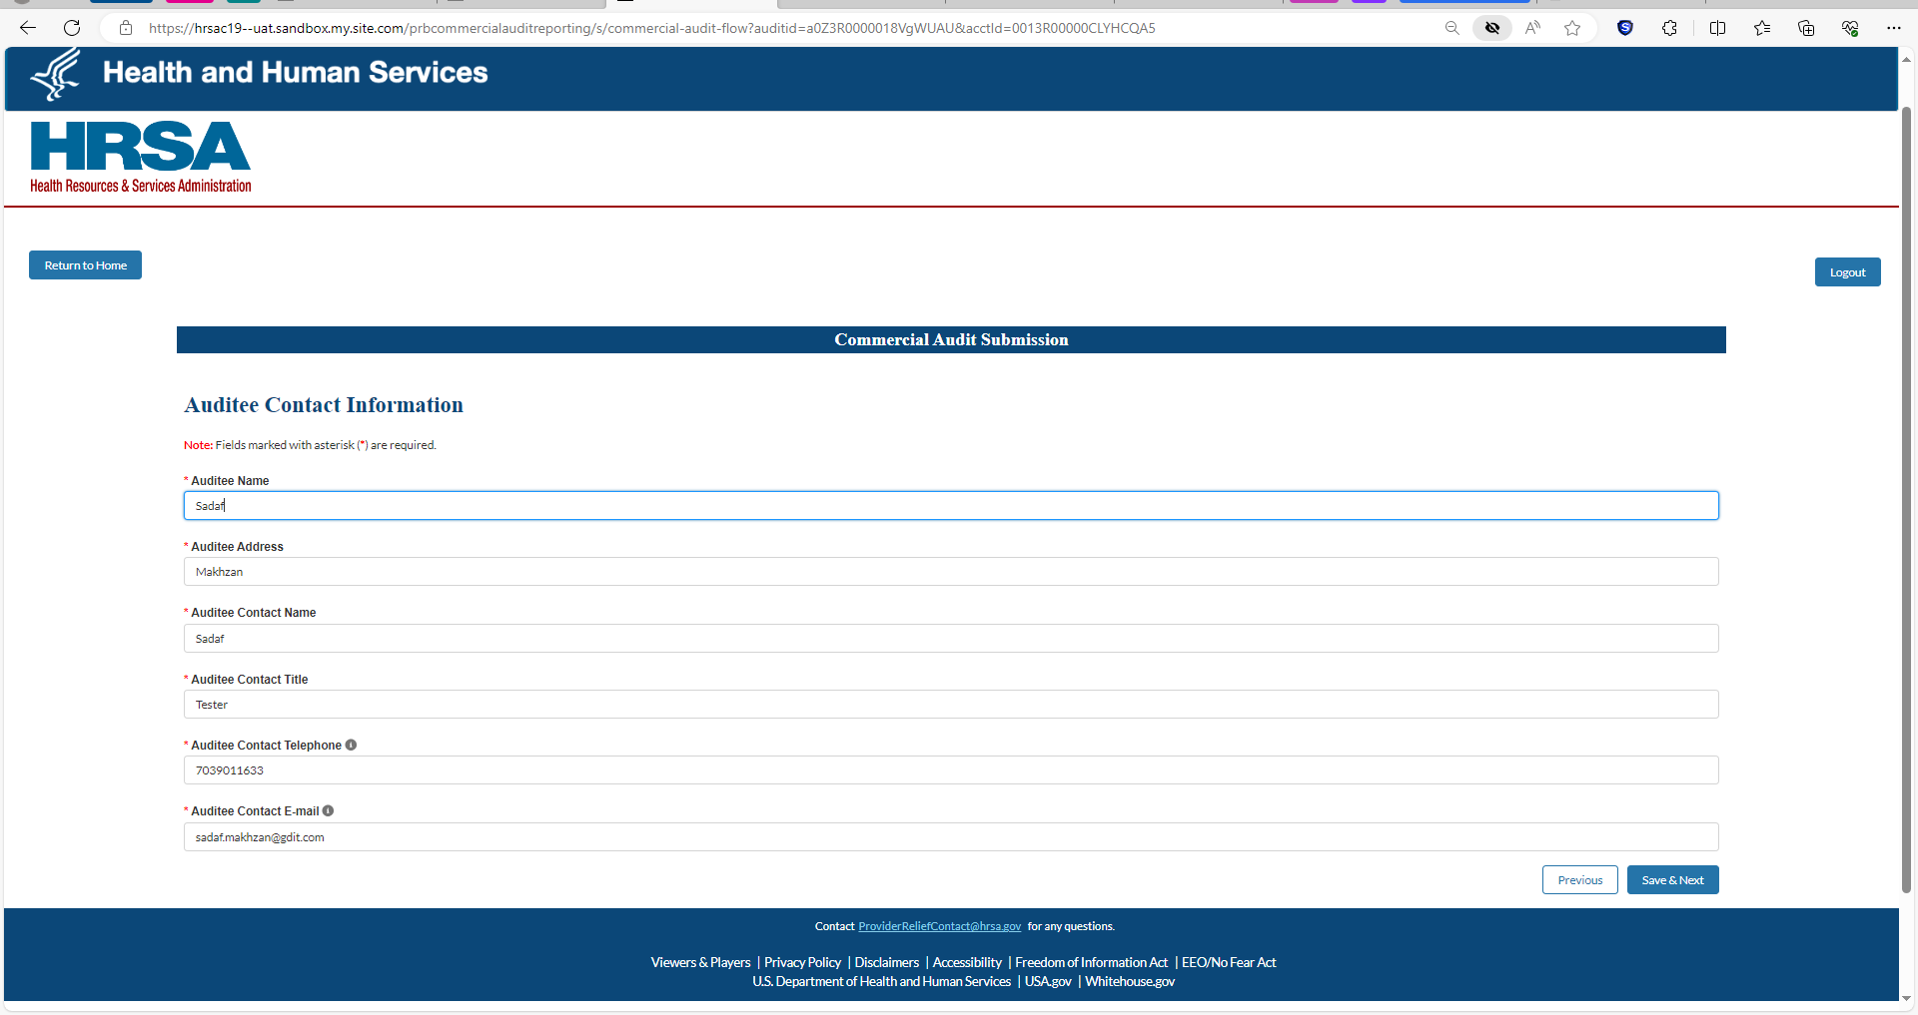

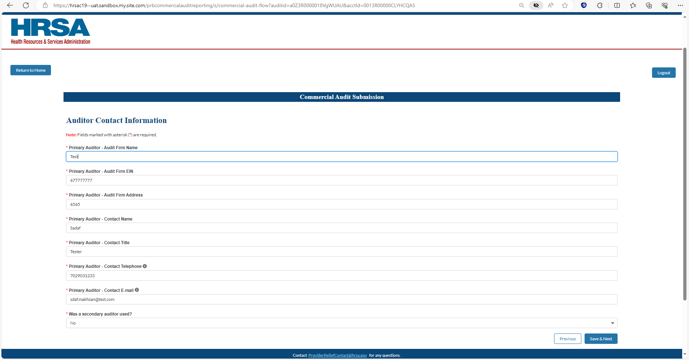

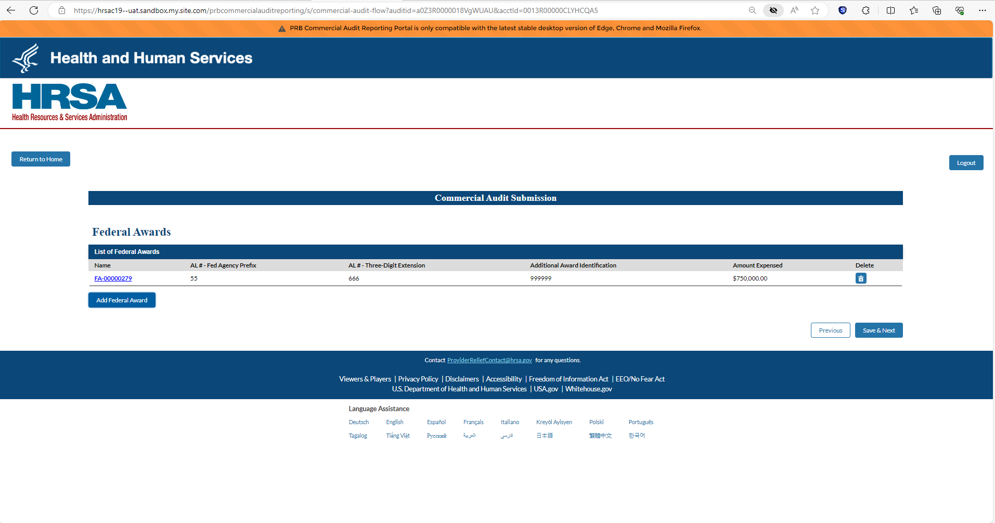

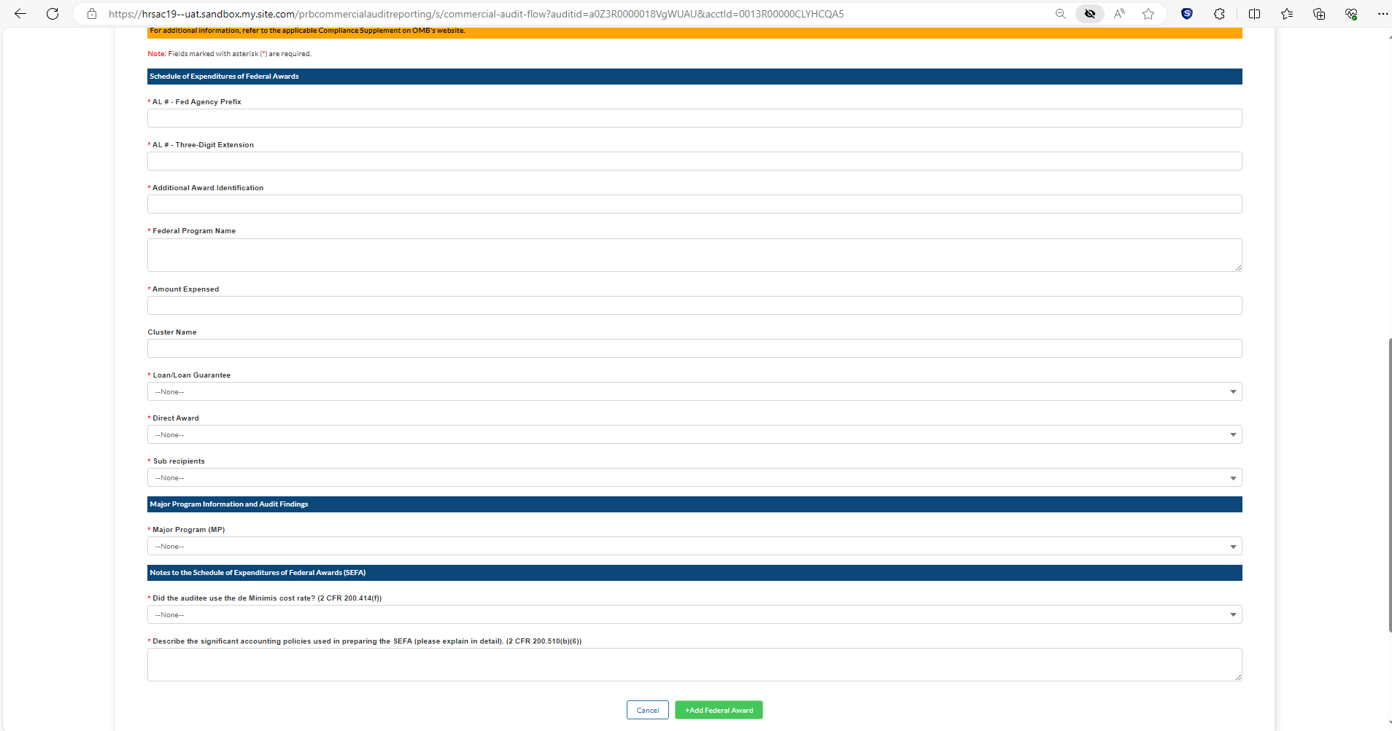

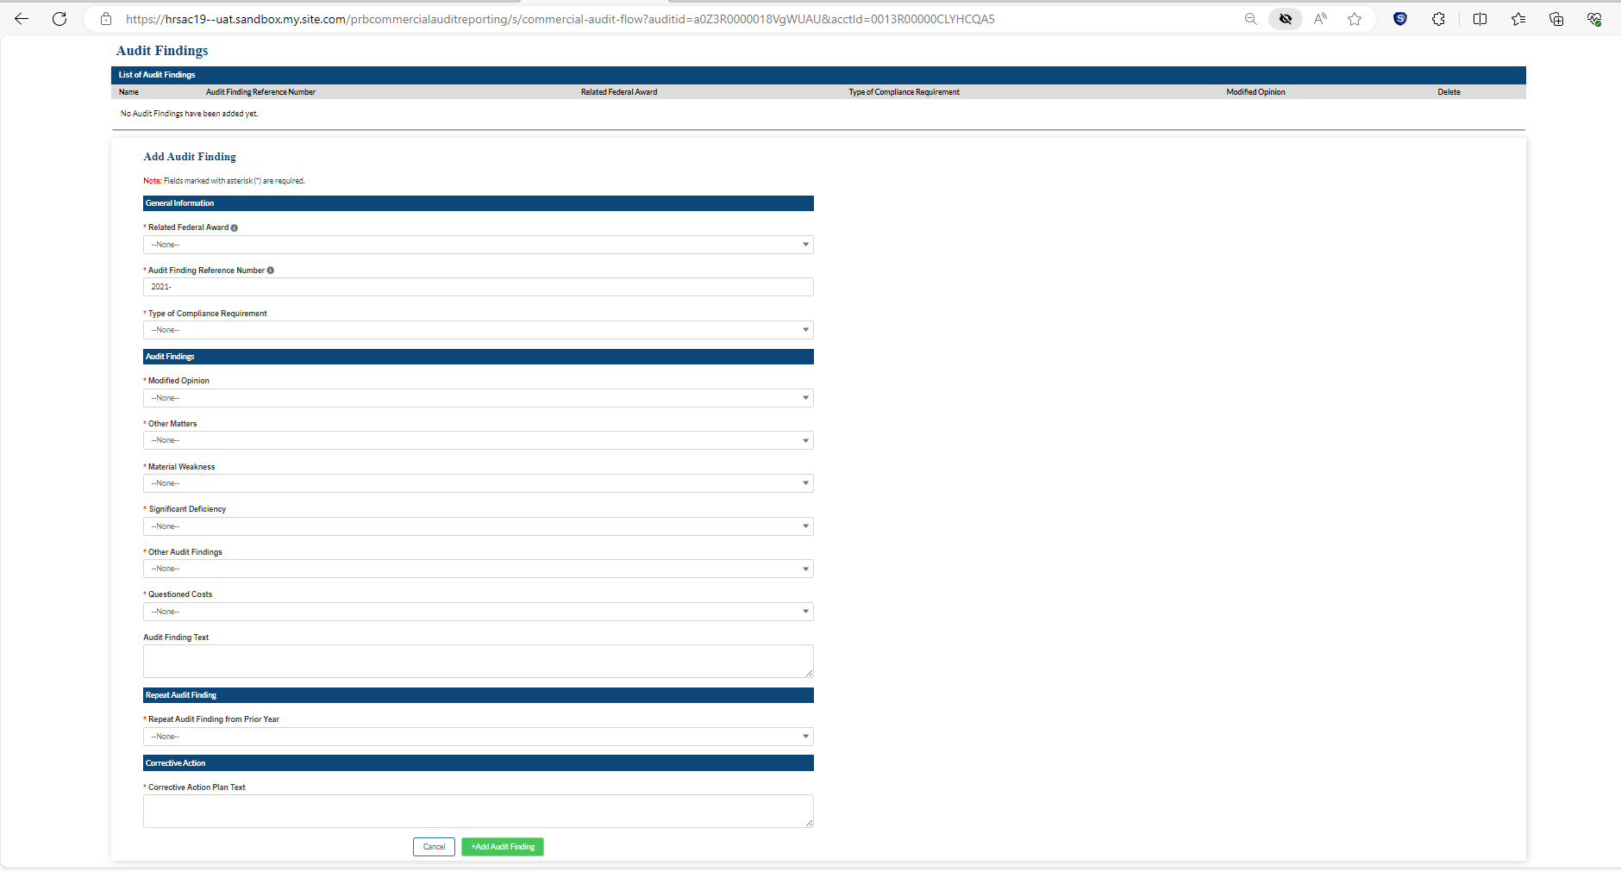

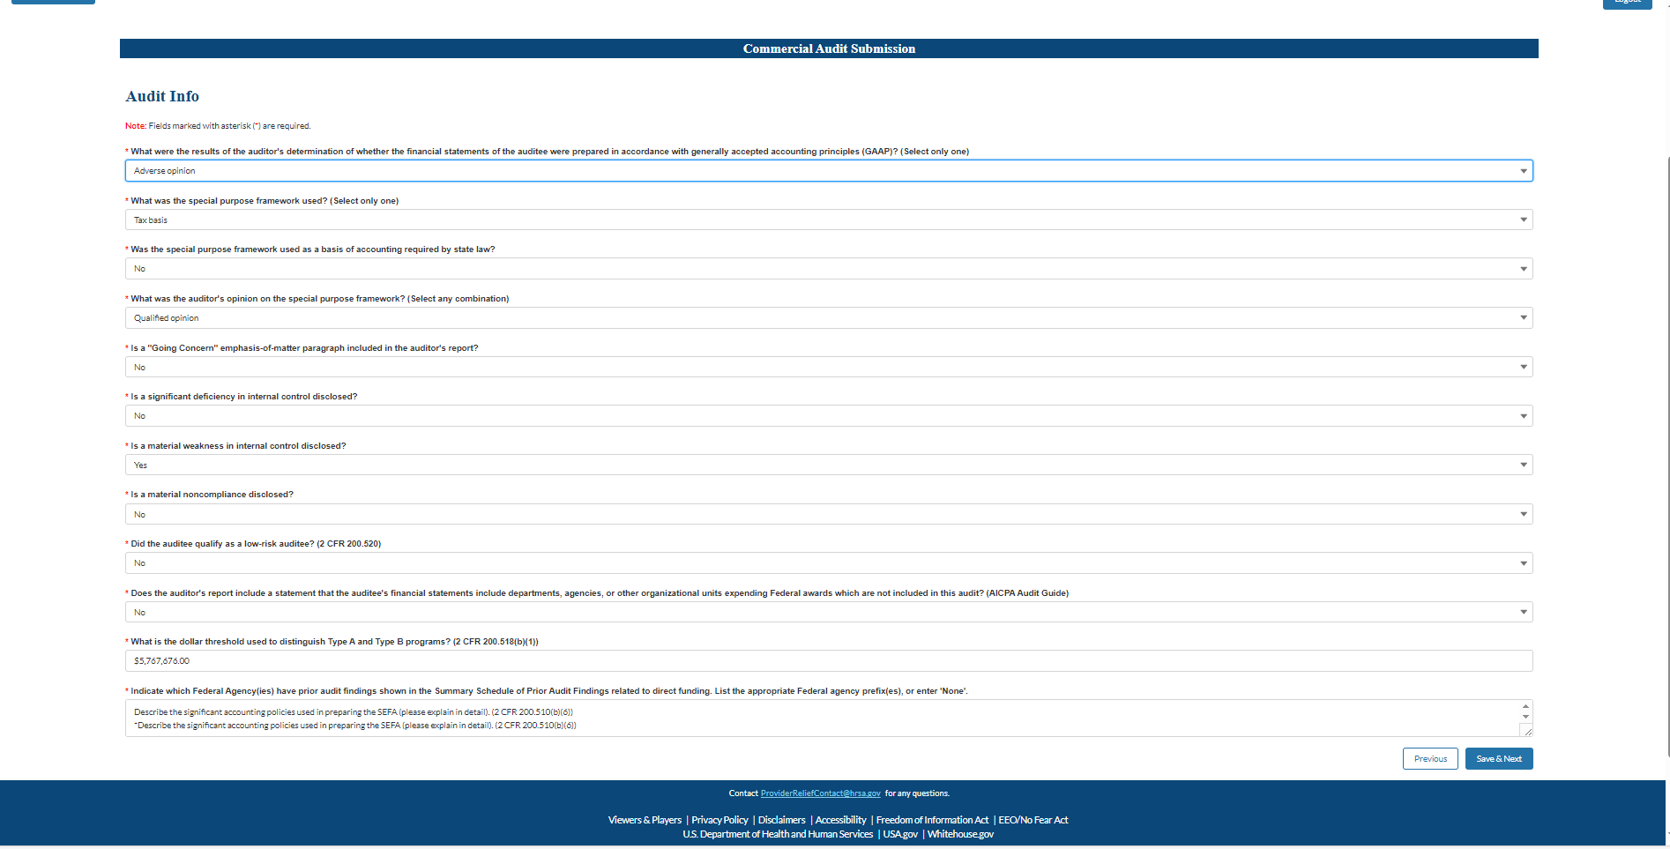

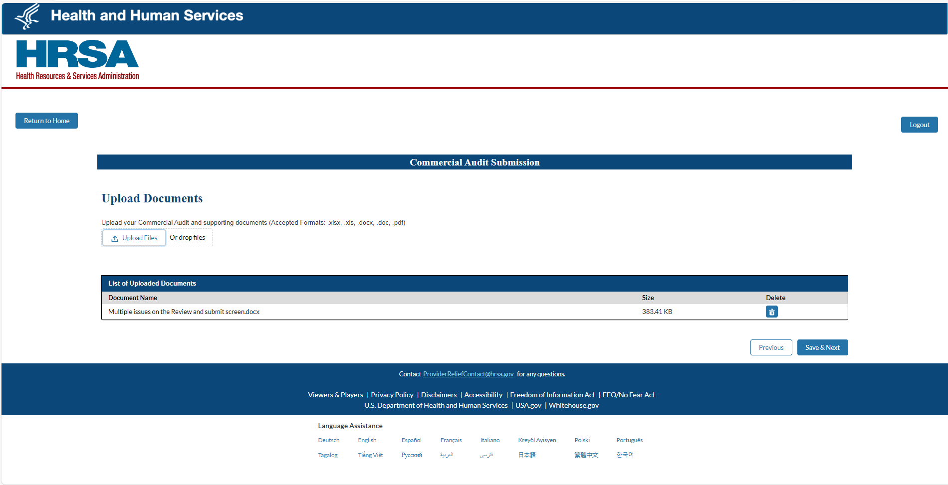

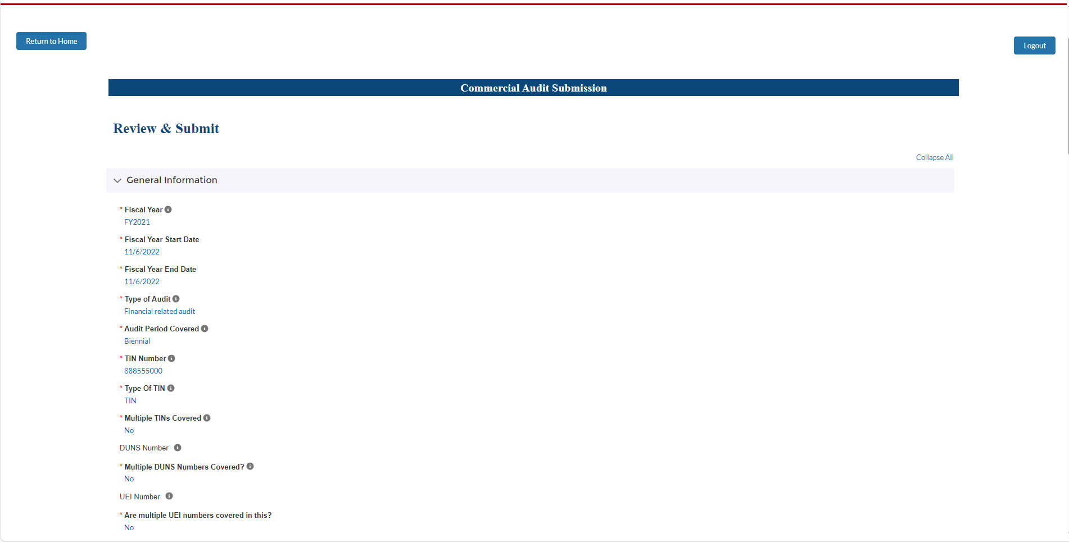

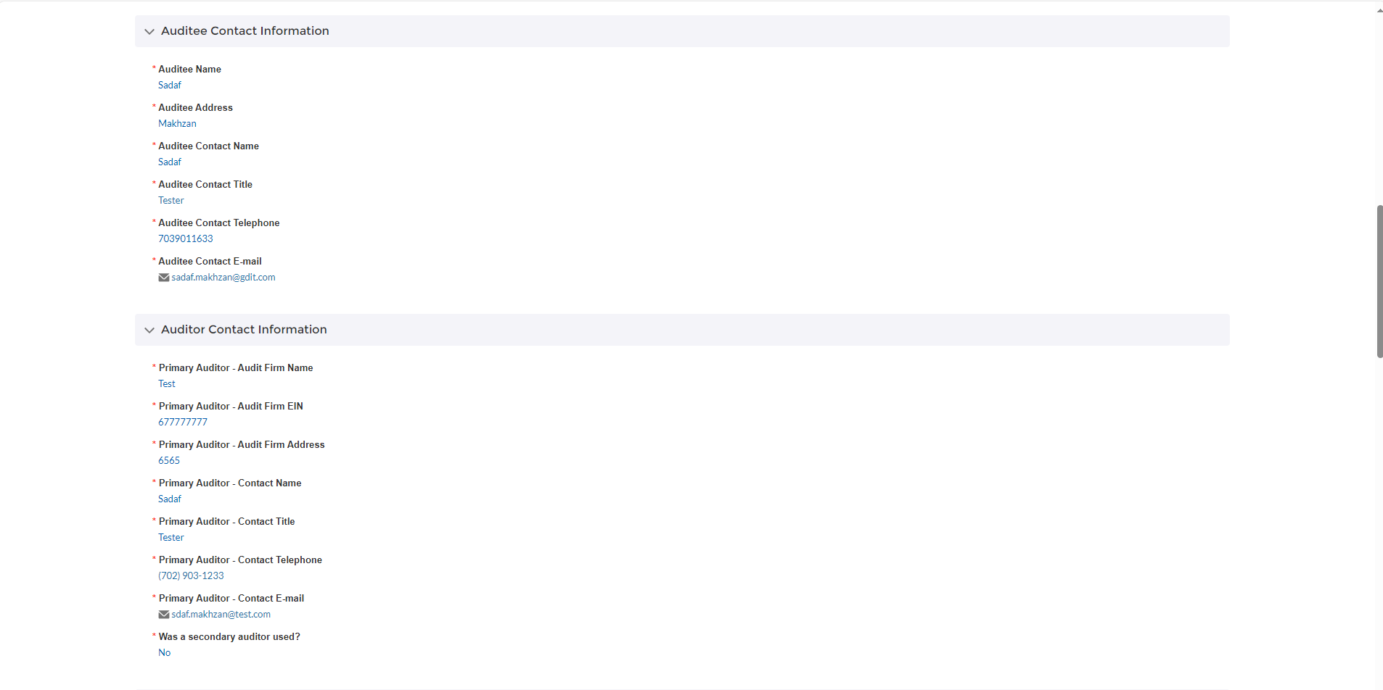

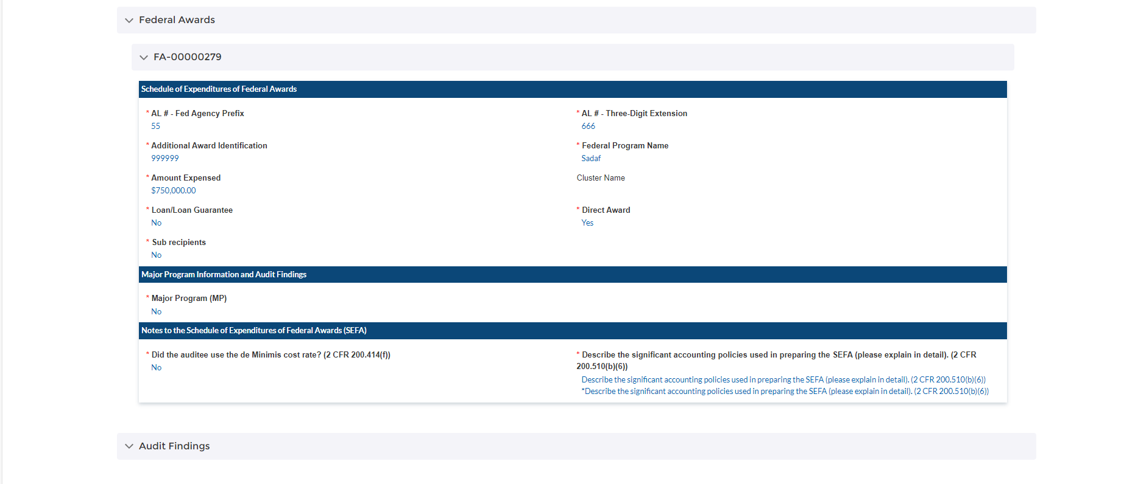

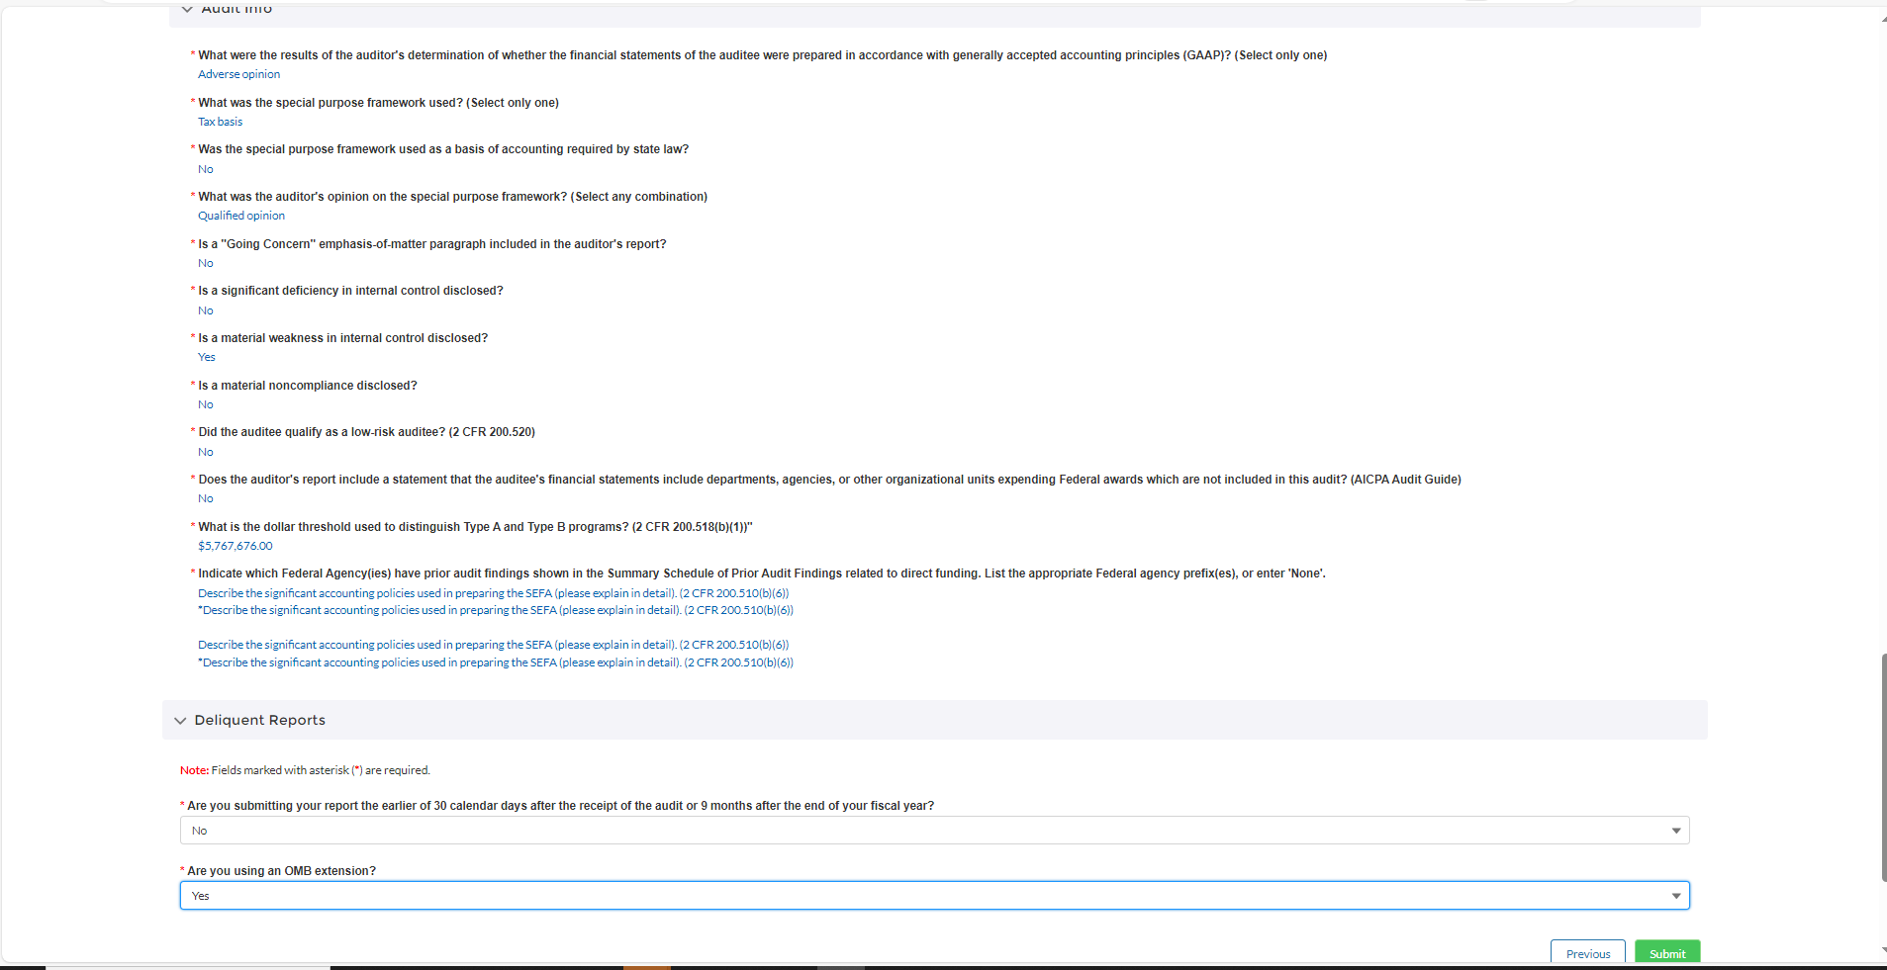

**Public Burden Statement:** The purpose of this information collection is to follow 45 CFR 75 Subpart F for Provider Relief Program funding. An agency may not conduct or sponsor, and a person is not required to respond to, a collection of information unless it displays a currently valid OMB control number. The OMB Control Number for this information collection is 0906-XXXX and is valid until MM/DD/20XX. Public reporting burden for this collection of information is estimated to average xx hours per response, including the time for reviewing instructions, searching existing data sources, and completing and reviewing the collection of information. Send comments regarding this burden estimate or any other aspect of this collection of information, including suggestions for reducing this burden, to HRSA Reports Clearance Officer, 5600 Fishers Lane, Room 14N136B, Rockville, Maryland, 20857 or [paperwork@hrsa.gov](mailto:paperwork@hrsa.gov).