Form Approved
OMB No. 0920-1402
Expiration Date: XX/XX/XXXX

Surveillance of HIV-related service barriers among Individuals with Early or Late HIV Diagnoses (SHIELD)

  - Attachment 4a

Model Quantitative Recruitment Script (English)

Public reporting burden of this collection of information is estimated to average 15 minutes per response, including the time for reviewing instructions, searching existing data sources, gathering and maintaining the data needed, and completing and reviewing the collection of information. An agency may not conduct or sponsor, and a person is not required to respond to a collection of information unless it displays a currently valid OMB control number. Send comments regarding this burden estimate or any other aspect of this collection of information, including suggestions for reducing this burden to CDC/ATSDR Reports Clearance Officer; 1600 Clifton Road NE, MS D-74, Atlanta, Georgia 30333; Attn: OMB-PRA (0920-1402)

Model Quantitative Recruitment Script and Guidance

Project Area Staff Make Initial Contact

This document provides model scripts and guidance for staff making initial contact with a potential participant over the phone for quantitative surveys. To minimize the chance of an adverse event, you must confirm the potential participant’s identity before mentioning HIV or this project. A potential participant may not know their HIV status; therefore, you should know national and local procedures on how to address this before starting recruitment.

After confirmation of identity, if the person meets eligibility requirements and agrees to participate, you should schedule an interview or provide a personalized link to the web survey if the person requests it.

Information Needed Before the Cold Call: To confirm a potential participant’s identity over the phone, you should obtain their information before calling them. When you contact the potential participant, you will ask them to provide matching information. Use two or more methods to confirm their identity. Examples include:
- Full first, middle, and last name (including suffix, if available)
- Date of birth (month, day, and year)
- Phone number
- Current or past address
- Social Security Number
In addition, you should check whether the potential participant is aware of their HIV status by looking into eHARS or other supplementary sources of information. For example, a single report in eHARS with no subsequent visits to an HIV provider and no additional CD4 or viral load tests may indicate that the person may not be aware of their status.

Sample Script

Recruiter: Hi, may I speak to [first name of person]?

- If the person is not available and someone else answers:

Recruiter: My name is [recruiter’s name]. [Potential participant’s first name] was chosen to take part in a health survey. Please have them call me back at [phone number].

- If you reach their voicemail:

Recruiter: Hi, I’m trying to reach [potential participant’s first name]. This is [recruiter’s name] from the [health department name]. You are one of a small group of people in [project area] chosen to take part in our confidential health survey. If you decide to take part, you’ll get [amount and type of token of appreciation]. Please give me a call at [your phone number]. Thank you.

(Note: You can also use the voicemail script when texting the potential participant)

- If you reach the person:

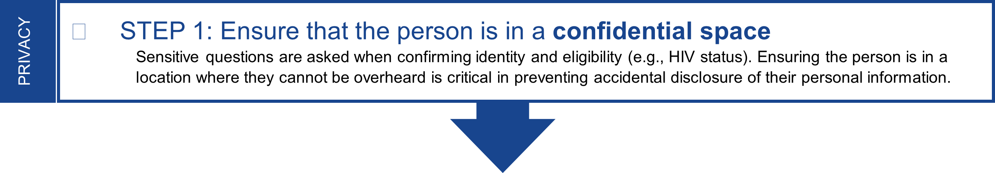

Recruiter: My name is [recruiter’s name]. I’m calling from the [health department name] to let you know that you were selected to take part in our health survey. If you take part, you’ll get [amount and type of token of appreciation]. You can schedule an appointment to take the survey with an interviewer over the phone or you can take the survey online at a time that is convenient for you.

Since only people chosen for this survey can take part, I do need to ask you a few questions to make sure that I am talking to the correct person. To keep your information private, you need to be in a space where no one can hear your answers. Are you in a private space?

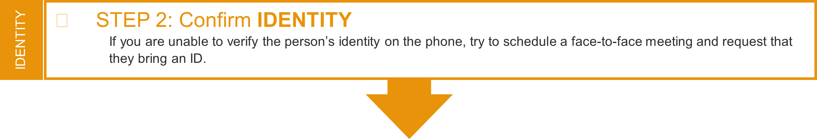

If the person states that they are in a private space, then move forward with confirming their identity:

To confirm the potentially eligible person’s identity, you can ask:
- What is your full name (including middle name and/or suffix)?
- What is your date of birth?
- I see you were born in July. Can you tell me the year?
- In my records, I have another phone number for John Doe that begins with (404) 639. Can you tell me the last four digits of that phone number?
- In my records, I have an old address for John Doe with the street number 1437. Can you tell me what street goes with that number?
- I have the first 3 digits of your SS# as 123, can you tell me the last 4 digits?
- Would you please show me an ID card or a driver’s license so that I can make sure I am speaking with the right person (in person or video recruitment)?

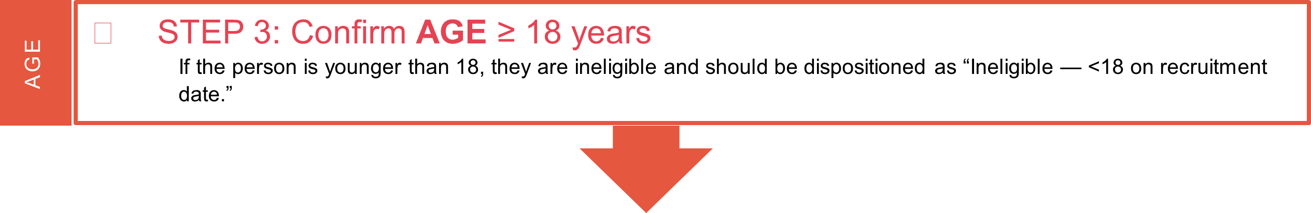

Once the person’s identity is confirmed, move to the eligibility questions:

Recruiter: Thank you for confirming your identity. Next, I’ll ask you a few questions to see if you are eligible for the survey. How old are you?

RESIDENCE
- STEP 4: Confirm CURRENT RESIDENCE
If current residence is Florida, Houston, Louisiana, or Michigan, continue recruitment.
sTOP REcruitment if current residence is [states without ORP approval to collect data].
If current residence is any other jurisdiction, check ORP permission and continue or stop recruitment as appropriate.
If recruitment is stopped because state’s ORP does not allow data collection, disposition as “Ineligible –
current residence in jurisdiction without ORP permission.”

Recruiter: What city and state are you currently living in?
RESIDENCE ON SAMPLING DATE

- If living in a jurisdiction that does not allow data collection:

Recruiter: Thank you for this information. Based on where you live, we cannot move forward with the survey, but thank you for your time.

HIV DIAGNOSIS
- STEP 5: Confirm FIRST HIV diagnosis WITHIN PAST 18 MONTHS
If the person tested HIV-positive for the first time within the past 18 months but is not aware of their status, they may be eligible and should be provided counseling and linkage referrals per your health department’s protocol. They should not be recruited until they have been informed of their status. See Section 2.2.2 of the Protocol for more guidance.
If the person did not receive their first diagnosis within the past 18 months, they are ineligible and should be dispositioned as “Ineligible - No HIV diagnosis in past 18 months” or “Ineligible – previously diagnosed” as appropriate. Ineligible persons should still be informed of their HIV status if they are unaware and should be offered counseling and linkage referrals per your health department’s protocol.

Recruiter: Thank you for confirming that information. The reason you were selected for this project is because you were diagnosed with a health condition that is reported to the state health department. Can you tell me the condition(s) you have been diagnosed with?

  - If HIV is mentioned, ask: Our records show that you were first diagnosed with HIV in [month] [year]. Is this correct?

(Note: Let the participant know that this month and year of diagnosis will be used throughout the survey. If the participant says this month and year is incorrect, confirm and record the correct date or month/year. If they were NOT first diagnosed within the past 18 months, probe to find out if they received a previous diagnosis. If participant says this is their first diagnosis and the eHARS date of diagnosis is within the past 18 months, ask the participant to confirm the date of diagnosis.)

    - If no, move to the closing step below*. Otherwise, proceed to Step 6.

  - If HIV is not mentioned, proceed to the next question below

- If no, ask: Would it be all right if I listed some health conditions that are reported to the health department? You can tell me whether you have been diagnosed with any of these conditions. (e.g., meningitis, tuberculosis, HIV, measles)

  - If the person still does not identify HIV, do not proceed with recruitment and move to the closing step below*. Then complete the following:
- Follow local procedures for delivering positive HIV test results, post-test counseling, and linking persons to confirmatory testing and HIV care. If the investigation concludes that the person is HIV positive, the focus should be linkage to HIV care.
- Report to your CDC project officer the fact that you have contacted a person unaware of their HIV status and consider whether the event meets the criteria for adverse event reporting.
- Provide contact information so that the person can contact project staff if they want to participate later.
- If the person identifies HIV, ask: Our records show that you were first diagnosed with HIV in [month] [year]. Is this correct?

Note: let the participant know that this month and year of diagnosis will be used throughout the interview. If the participant says this month and year is incorrect, confirm and record the correct date or month/year. If they were NOT first diagnosed within the past 18 months, probe to find out if they received a previous diagnosis. If participant says this is their first diagnosis and the eHARS date of diagnosis is within the past 18 months, ask the participant to confirm the date of diagnosis.)

  - If no, move to the closing step below*.

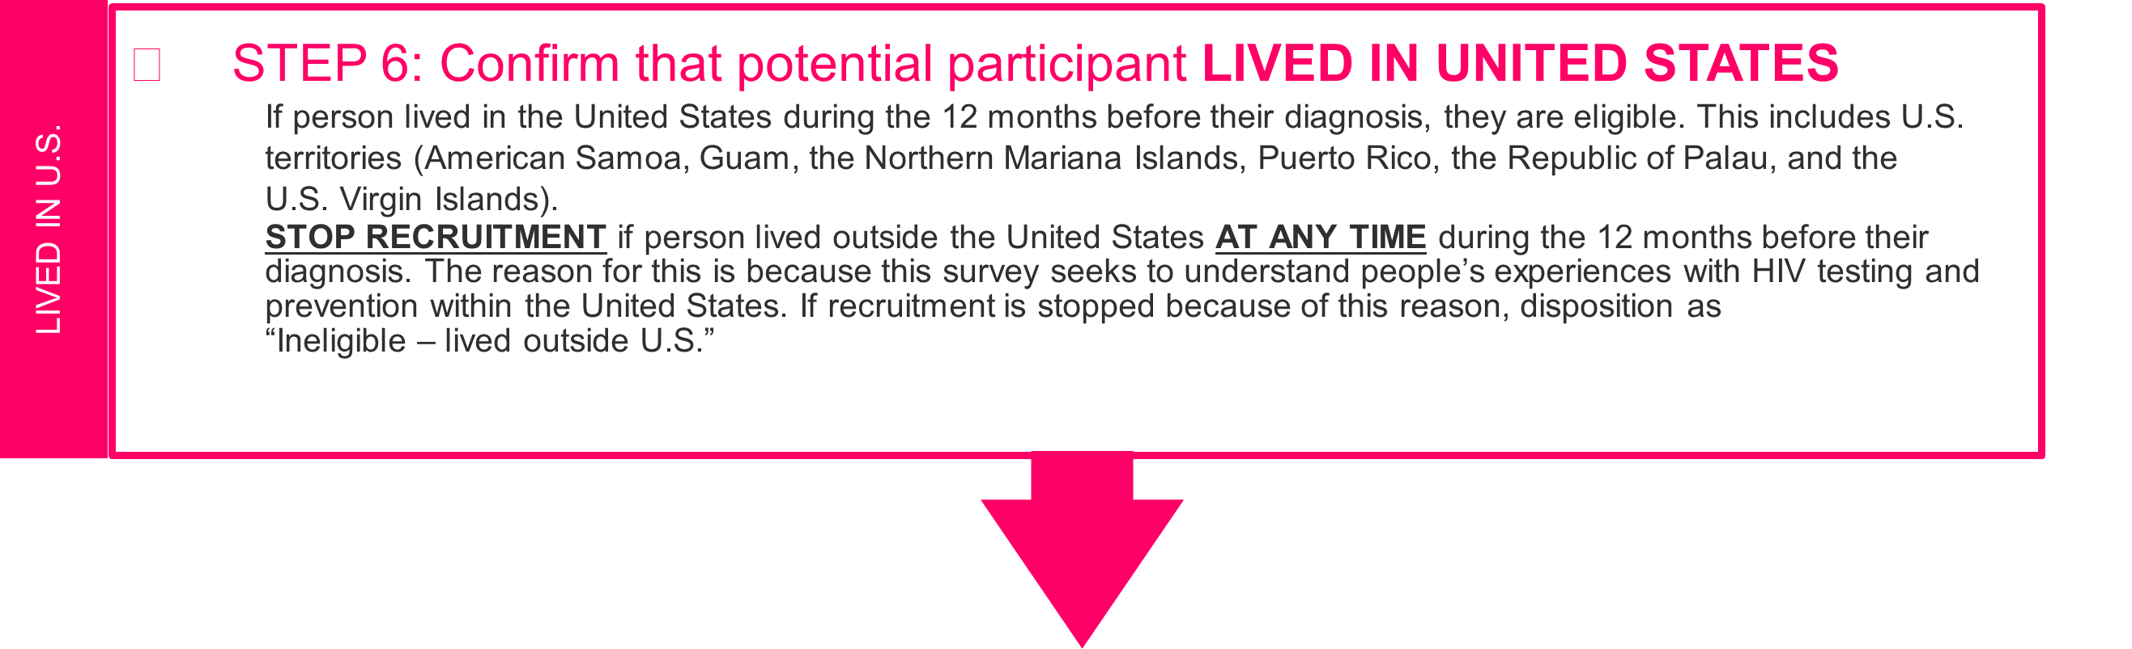
Recruiter: Thank you for that information. The last thing we need to know to find out if you are eligible is where you lived in the year before you were diagnosed with HIV. In the 12 months before you received your HIV diagnosis, were you living in the United States?

If steps 2 to 6 are NOT met, the person is NOT eligible for participation.
STOP AT THIS POINT and proceed to the closing step below.

*CLOSING STEP:

*Recruiter: Unfortunately, based on your answers, we cannot move forward with the survey. But thank you for your time and I hope you have a great day.

If steps 2 to 6 are MET, then the potential participant is eligible for participation.
Proceed with recruitment.

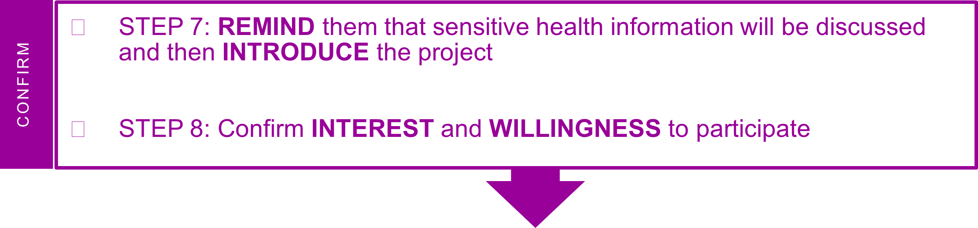

Recruiter: Thank you for allowing me to check that you are the right person.

Let me tell you more about this health survey. Here at the [name of HD] we are interested in speaking with people who received a recent HIV diagnosis to better understand their experiences with medical care in [project area] and how we can improve programs and services.

The health survey is called [local project name]. If you take part in this survey you will be asked questions about your health and medical care. This survey is confidential and will cover some sensitive health information. Your answers to these questions will be kept private and separate from identifying information such as your name or phone number.
You will receive a token of appreciation worth $50 for taking part in this survey. Does this sound like something you would be interested in doing?”

- If interested in participating in the project:

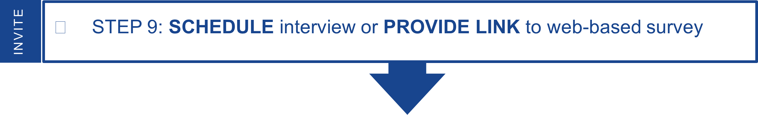

Recruiter: Great! The survey will take about 50 minutes. Would you like to schedule an interview over the phone or take the survey online?

  - If the participant chooses a phone interview:

Recruiter: Ok, would you like to take the survey now or schedule a time to take the survey later?

  - If participant chooses to take the survey now (live transfer):

Recruiter: Ok, please stay on the line while I connect you to an interviewer.

The recruiter will need to input in the scheduling tool:
- A unique identifier for the participant
- Month and year of HIV diagnosis as indicated in eHARS or updated after confirming with the participant during this conversation.
- Stage of infection at diagnosis: Stage 0 or Stage 3
- Preferred language of interview (English or Spanish)

Once the participant is registered, inform the participant that you will connect them to an interviewer. Ask them to remain on the call and be prepared to provide their ID number to the interviewer at the start of the interview. Give the participant their ID number. Explain that the ID number is used instead of their name to protect their identity. This way the responses they provide to the interviewer will not be linked to their names or contact information. Remind the participant that to keep their information and responses to the survey questions private, the participant should move to a location where no one can overhear. Let the participant know that they will need to have a pen and paper handy when they call for their interview so they can write down their Amazon gift code at the end of the interview.
Let the participant know that the interviewer does not have their name or contact information. Provide your contact information and instruct the participant to call you back if the call is disconnected for any reason. Inform the participant that you will remain on the line until they are connected to an interviewer and that if an interviewer is not available, you will help them reschedule to take the survey for a later date.

If the participant has internet access, help them locate the online response cards at
https://www.cdc.gov/hiv/statistics/systems/shield/index.html. If they do not have access to the internet, ask them for a mailing address where they can receive the response cards. Let the participant know that they can contact you should they need to reschedule the interview or would like to complete the web-based survey. Follow procedures for using the scheduling portal – refer to Protocol Appendix E.2.

  - If participant chooses to schedule the phone interview for later:

Recruiter: Ok, let’s find a day and time that works for you.

The recruiter will need to input in the scheduling tool:
- A unique identifier for the participant
- Month and year of HIV diagnosis as indicated in eHARS or updated after confirming with the participant during this conversation.
- Stage of infection: Stage 0 or Stage 3
- Preferred language of interview (English or Spanish)

Once the interview is scheduled, inform the participant that they will need to call the interviewer’s phone number at the designated time and provide an ID number to the interviewer at the start of the interview. Give the participant the interview phone number and the ID number. Explain that the ID number is used instead of their name to protect their identity. This way the responses they provide to the interviewer will not be linked to their names or contact information. Remind the participant that to keep their information and responses to the survey questions private, the participant should plan to call from a location where no one can overhear.
Let the participant know that the interviewer does not have their name or contact information, and you will be the one sending them a reminder about the interview. Ask them if they want to be contacted by text or phone with a reminder about the interview. Ask them if they want to receive a reminder 1 hour, 30 mins, or 15 mins before the call. Let the participant know that they will need to have a pen and paper handy when they call for their interview so they can write down their Amazon gift code at the end of the interview.

If the participant has internet access, help them locate the online response cards at https://www.cdc.gov/hiv/statistics/systems/shield/index.html. If they do not have access to the internet, ask them for a mailing address where they can receive the response cards. Provide your contact information to the participant and let them know that they can contact you should they need to reschedule the interview or would like to complete the web-based survey. Follow procedures for using the scheduling portal – refer to Protocol Appendix E.2.

  - If the participant chooses a web-based survey:

Recruiter: Great! You can start the survey at any time using the personalized link I will give you. We are asking that you complete this survey within a week from today. You do not have to complete it in one sitting. If you need to stop mid-way and come back, you can save your responses and finish the survey later.

The recruiter will need to input in the scheduling tool:
- A unique identifier for the participant
- Month and year of HIV diagnosis as indicated in eHARS or updated after confirming with the participant during this conversation.
- Stage of infection at diagnosis: Stage 0 or Stage 3
- Preferred language of online survey (English or Spanish)

Ask the participant how they would prefer to receive the link – via text message, email, or over the phone. Provide the link and unique ID. Let them know that if one week has gone by and they have not completed the survey, you will contact them to remind them to complete the survey. Provide your contact information to the participant and let them know that they can contact you if they need the link again or would prefer to schedule an interview. Let the participant know that they will need to have a pen and paper handy when they complete the online survey so they can write down their Amazon gift code at the end of the survey.
Follow procedures for using the scheduling portal – refer to Protocol Appendix E.2.

  - If not interested in participating in the project:

Recruiter: May I ask why you are not interested? Knowing why will help us improve the survey in the future.

Capture this information. Attempt to address concerns using refusal aversion techniques. If they still refuse, thank the person for their time and end recruitment.

