Form Approved
OMB No. 0920-1402
Expiration Date: XX/XX/XXXX

Surveillance of HIV-related service barriers among Individuals with Early or Late HIV Diagnoses (SHIELD)

  - Attachment 4b

Model Quantitative Recruitment Script (Spanish)

Public reporting burden of this collection of information is estimated to average 15 minutes per response, including the time for reviewing instructions, searching existing data sources, gathering and maintaining the data needed, and completing and reviewing the collection of information. An agency may not conduct or sponsor, and a person is not required to respond to a collection of information unless it displays a currently valid OMB control number. Send comments regarding this burden estimate or any other aspect of this collection of information, including suggestions for reducing this burden to CDC/ATSDR Reports Clearance Officer; 1600 Clifton Road NE, MS D-74, Atlanta, Georgia 30333; Attn: OMB-PRA (0920-1402)

Model Quantitative Recruitment Script and Guidance

Project Area Staff Make Initial Contact

This document provides model scripts in Spanish and guidance for staff making initial contact with a potential participant over the phone for quantitative surveys. To minimize the chance of an adverse event, you must confirm the potential participant’s identity before mentioning HIV or this project. A potential participant may not know their HIV status; therefore, you should know national and local procedures on how to address this before starting recruitment.

After confirmation of identity, if the person meets eligibility requirements and agrees to participate, you should schedule an interview or provide a personalized link to the web survey if the person requests it.

Information Needed Before the Cold Call: To confirm a potential participant’s identity over the phone, you should obtain their information before calling them. When you contact the potential participant, you will ask them to provide matching information. Use two or more methods to confirm their identity. Examples include:
- Full first, middle, and last name (including suffix, if available)
- Date of birth (month, day, and year)
- Phone number
- Current or past address
- Social Security Number
In addition, you should check whether the potential participant is aware of their HIV status by looking into eHARS or other supplementary sources of information. For example, a single report in eHARS with no subsequent visits to an HIV provider and no additional CD4 or viral load tests may indicate that the person may not be aware of their status.

Sample Script

Recruiter: Hola, ¿podría hablar con [nombre de la persona]?

- If the person is not available and someone else answers:

Recruiter: Me llamo [nombre del reclutador]. [Nombre del posible participante] fue elegido(a) para participar en una encuesta de salud. Por favor, pídale que me llame al [número de teléfono].

- If you reach their voicemail:

Recruiter: Hola, estoy tratando de comunicarme con [nombre del posible participante]. Me llamo [nombre del reclutador] y estoy llamando de [nombre del departamento de salud]. Usted es una de tan solo un grupo pequeño de personas en [área del proyecto] escogidas para participar en nuestra encuesta confidencial de salud. Si decide participar, recibirá [cantidad y tipo de regalo de agradecimiento]. Por favor, llámeme al [su número de teléfono]. Gracias..

(Note: You can also use the voicemail script when texting the potential participant)

- If you reach the person:

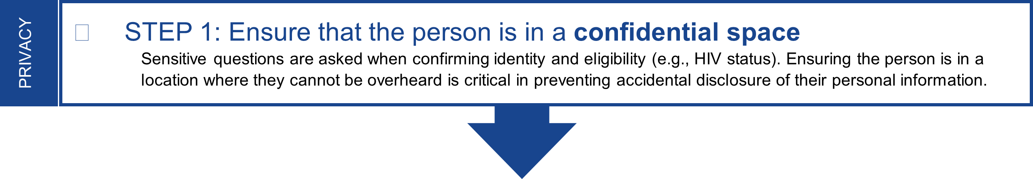

Recruiter: Me llamo [nombre del reclutador]. Llamo del [nombre del departamento de salud] para avisarle que usted fue seleccionado para participar en nuestra encuesta de salud. Si participa, recibirá [cantidad y el tipo de regalo de agradecimiento]. Puede programar una cita para hacer la encuesta telefónicamente con un entrevistador o puede hacerla en línea en un momento que sea conveniente para usted.

Como solo pueden participar las personas que hayan sido escogidas para esta encuesta, necesito hacerle unas preguntas para asegurarme de estar hablando con la persona indicada. Para mantener privada su información, debe estar en un lugar donde nadie pueda escuchar sus respuestas. ¿Está en un lugar privado?

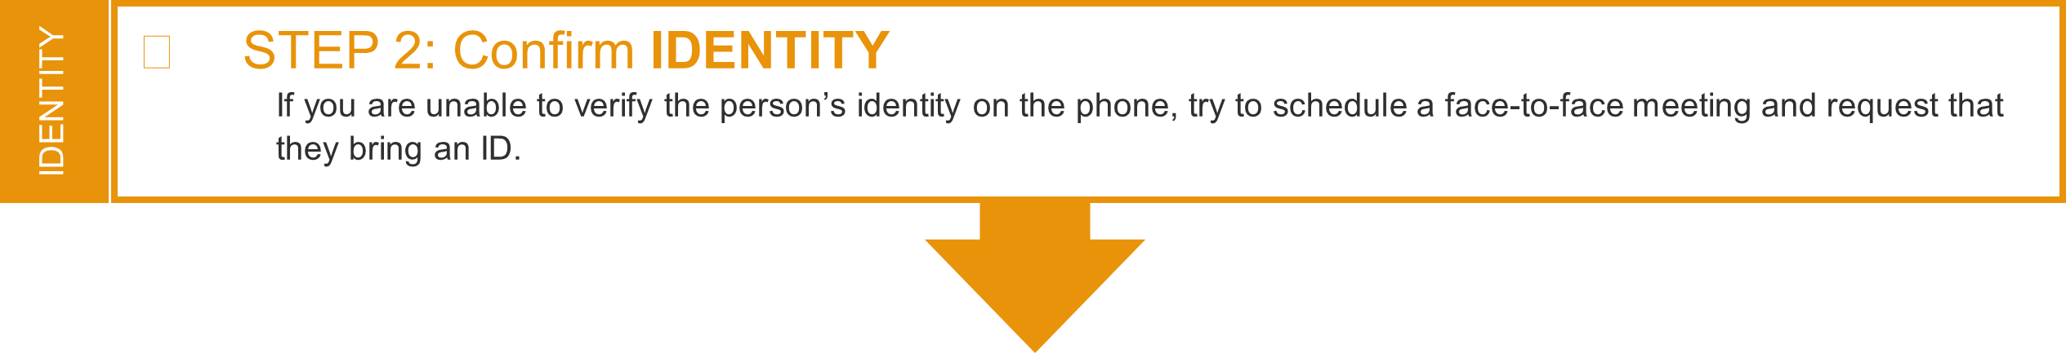

If the person states that they are in a private space, then move forward with confirming their identity:

To confirm the potentially eligible person’s identity, you can ask:
- ¿Cuál es su nombre completo (incluidos su segundo nombre o sufijo)?
- ¿Cuál es su fecha de nacimiento?
- Veo que nació en julio. ¿Puede decirme el año?
- En mis registros tengo otro número de teléfono para John Doe que comienza con (404) 639. ¿Me puede decir los últimos cuatro dígitos de ese número de teléfono?
- En mis registros tengo una dirección vieja para John Doe con el número de la calle 1437. ¿Puede decirme el nombre de la calle que va con ese número?
- Tengo los primeros 3 dígitos de su número de Seguro Social como 123, ¿puede decirme los últimos 4?
- ¿Podría mostrarme una tarjeta de identificación o licencia de conducir para que pueda asegurarme de estar hablando con la persona indicada (reclutamiento en persona o por video conferencia)?

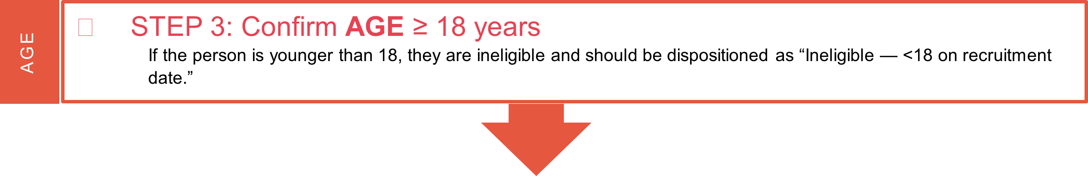

Once the person’s identity is confirmed, move to the eligibility questions:

Recruiter: Gracias por confirmar su identidad. Ahora le haré algunas preguntas para ver si es elegible para participar en la encuesta. ¿Cuántos años tiene?

RESIDENCE
- STEP 4: Confirm CURRENT RESIDENCE
If current residence is Florida, Houston, Louisiana, or Michigan, continue recruitment.
sTOP REcruitment if current residence is [states without ORP approval to collect data].
If current residence is any other jurisdiction, check ORP permission and continue or stop recruitment as appropriate.
If recruitment is stopped because state’s ORP does not allow data collection, disposition as “Ineligible –
current residence in jurisdiction without ORP permission.”

Recruiter: ¿En qué ciudad y estado vive actualmente?
RESIDENCE ON SAMPLING DATE

- If living in a jurisdiction that does not allow data collection:

Recruiter:
Gracias por darnos esta información. Segun el lugar donde vive, no podemos proseguir con la encuesta, pero gracias por su tiempo.

HIV DIAGNOSIS
- STEP 5: Confirm FIRST HIV diagnosis WITHIN PAST 18 MONTHS
If the person tested HIV-positive for the first time within the past 18 months but is not aware of their status, they may be eligible and should be provided counseling and linkage referrals per your health department’s protocol. They should not be recruited until they have been informed of their status. See Section 2.2.2 of the Protocol for more guidance.
If the person did not receive their first diagnosis within the past 18 months, they are ineligible and should be dispositioned as “Ineligible - No HIV diagnosis in past 18 months” or “Ineligible – previously diagnosed” as appropriate. Ineligible persons should still be informed of their HIV status if they are unaware and should be offered counseling and linkage referrals per your health department’s protocol.

Recruiter: Gracias por confirmar esa información. El motivo por el que fue escogido para este proyecto es que a usted le diagnosticaron una afección medica que se notifica al departamento de salud estatal. ¿Puede decirme qué afección o afecciones le diagnosticaron?

  - If HIV is mentioned, ask: ¿ Nuestros registros muestran que le diagnosticaron VIH por primera vez en [mes] [año]. Es correcto?

(Note: Let the participant know that this month and year of diagnosis will be used throughout the survey. If the participant says this month and year is incorrect, confirm and record the correct date or month/year. If they were NOT first diagnosed within the past 18 months, probe to find out if they received a previous diagnosis. If participant says this is their first diagnosis and the eHARS date of diagnosis is within the past 18 months, ask the participant to confirm the date of diagnosis.)

    - If no, move to the closing step below*. Otherwise, proceed to Step 6.

  - If HIV is not mentioned, proceed to the next question below

- If no, ask:¿Estaria bien si enumero algunas de las afecciones médicas que se notifican al departamento de salud? Usted puede decirme si le han diagnosticado alguna de estas afecciones. (P. ej., meningitis, tuberculosis, infección por el VIH, sarampión).

  - If the person still does not identify HIV, do not proceed with recruitment and move to the closing step below*. Then complete the following:
- Follow local procedures for delivering positive HIV test results, post-test counseling, and linking persons to confirmatory testing and HIV care. If the investigation concludes that the person is HIV positive, the focus should be linkage to HIV care.
- Report to your CDC project officer the fact that you have contacted a person unaware of their HIV status and consider whether the event meets the criteria for adverse event reporting.
- Provide contact information so that the person can contact project staff if they want to participate later.
- If the person identifies HIV, ask:¿Nuestros registros muestran que le diagnosticaron VIH por primera vez en [mes] [año]. Es correcto?

Note: let the participant know that this month and year of diagnosis will be used throughout the interview. If the participant says this month and year is incorrect, confirm and record the correct date or month/year. If they were NOT first diagnosed within the past 18 months, probe to find out if they received a previous diagnosis. If participant says this is their first diagnosis and the eHARS date of diagnosis is within the past 18 months, ask the participant to confirm the date of diagnosis.)

  - If no, move to the closing step below*.

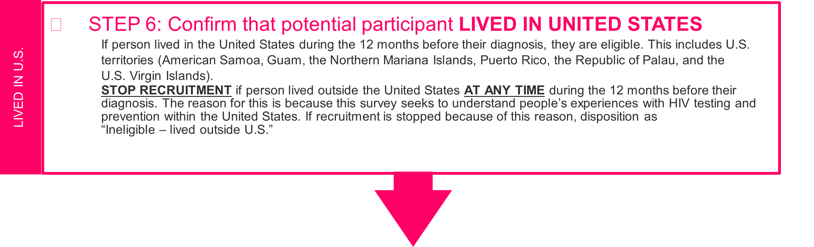
Recruiter: Gracias por darnos esta información. Lo último que necesitamos para saber si es elegible es dónde vivió el año antes de recibir el diagnóstico de infección por el VIH. En los 12 meses anteriores a recibir el diagnóstico de infección por el VIH, ¿estaba viviendo en los Estados Unidos?

If steps 2 to 6 are NOT met, the person is NOT eligible for participation.
STOP AT THIS POINT and proceed to the closing step below.

*CLOSING STEP:

*Recruiter: Lamentablemente, debido a sus respuestas, no podemos proseguir con la encuesta. Pero gracias por su tiempo. Que tenga un buen día.

If steps 2 to 6 are MET, then the potential participant is eligible for participation.
Proceed with recruitment.

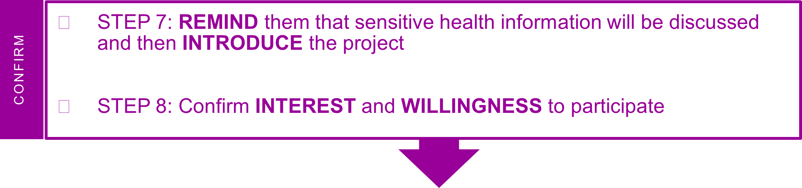

Recruiter: Gracias por permitirme verificar que usted es la persona indicada.

Permítame contarle más sobre esta encuesta de salud. Aquí, en [nombre del departamento de salud], nos interesa hablar con personas que han recibido recientemente el diagnóstico de infección por el VIH para entender mejor sus experiencias con la atención médica que haya recibido en [área del proyecto] y cómo podemos mejorar los programas y servicios.

El nombre de la encuesta de salud es [nombre del proyecto local]. Si participa en esta encuesta, se le harán preguntas sobre su salud y la atención médica recibida. Esta encuesta es confidencial e incluye algunas preguntas de naturaleza delicada sobre su salud. Sus respuestas a estas preguntas se mantendrán privadas y separadas de la información de identificación, como su nombre o número de teléfono.
Recibirá una muestra de agradecimiento por un valor de $50 por participar en esta encuesta. ¿Suena esto como algo que le interesaría hacer?

- If interested in participating in the project:

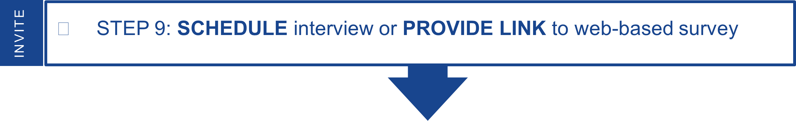

Recruiter: Excelente! Esta encuesta tomará unos 50 minutos. ¿Desea programar una entrevista telefónica o tomar la encuesta en línea?

  - If participant chooses phone interview:

Recruiter: Bien. ¿Le gustaría realizar la encuesta ahora o programar un tiempo para realizarla más tarde?

  - If participant chooses to take the survey now (live transfer):

Recruiter: Bien, por favor quédese en línea mientras lo/la conecto con un entrevistador.

The recruiter will need to input in the scheduling tool:
- A unique identifier for the participant
- Month and year of HIV diagnosis as indicated in eHARS or updated after confirming with the participant during this conversation.
- Stage of infection at diagnosis: Stage 0 or Stage 3
- Preferred language of interview (English or Spanish)

Once the participant is registered, inform the participant that you will connect them to an interviewer. Ask them to remain on the call and be prepared to provide their ID number to the interviewer at the start of the interview. Give the participant their ID number. Explain that the ID number is used instead of their name to protect their identity. This way the responses they provide to the interviewer will not be linked to their names or contact information. Remind the participant that to keep their information and responses to the survey questions private, the participant should move to a location where no one can overhear. Let the participant know that they will need to have a pen and paper handy when they call for their interview so they can write down their Amazon gift code at the end of the interview.
Let the participant know that the interviewer does not have their name or contact information. Provide your contact information and instruct the participant to call you back if the call is disconnected for any reason. Inform the participant that you will remain on the line until they are connected to an interviewer and that if an interviewer is not available you will help them reschedule to take the survey for a later date.

If the participant has internet access, help them locate the online response cards at
https://www.cdc.gov/hiv/statistics/systems/shield/index.html. If they do not have access to the internet, ask them for a mailing address where they can receive the response cards. Let the participant know that they can contact you should they need to reschedule the interview or would like to complete the web-based survey. Follow procedures for using the scheduling portal – refer to Protocol Appendix E.2.

  - If participant chooses to schedule the phone interview for later:

Recruiter: Bien, encontremos una fecha y hora que sea conveniente para usted.

The recruiter will need to input in the scheduling tool:
- A unique identifier for the participant
- Month and year of HIV diagnosis as indicated in eHARS or updated after confirming with the participant during this conversation.
- Stage of infection: Stage 0 or Stage 3
- Preferred language of interview (English or Spanish)

Once the interview is scheduled, inform the participant that they will need to call the interviewer’s phone number at the designated time and provide an ID number to the interviewer at the start of the interview. Give the participant the interview phone number and the ID number. Explain that the ID number is used instead of their name to protect their identity. This way the responses they provide to the interviewer will not be linked to their names or contact information. Remind the participant that to keep their information and responses to the survey questions private, the participant should plan to call from a location where no one can overhear.
Let the participant know that the interviewer does not have their name or contact information, and you will be the one sending them a reminder about the interview. Ask them if they want to be contacted by text or phone with a reminder about the interview. Ask them if they want to receive a reminder 1 hour, 30 mins, or 15 mins before the call. Let the participant know that they will need to have a pen and paper handy when they call for their interview so they can write down their Amazon gift code at the end of the interview.

If the participant has internet access, help them locate the online response cards at https://www.cdc.gov/hiv/statistics/systems/shield/index.html. If they do not have access to the internet, ask them for a mailing address where they can receive the response cards. Provide your contact information to the participant and let them know that they can contact you should they need to reschedule the interview or would like to complete the web-based survey. Follow procedures for using the scheduling portal – refer to Protocol Appendix E.2.

  - If participant chooses web-based survey:

Recruiter: ¡Excelente! Puede comenzar la encuesta en cualquier momento usando el enlace personalizado que le futu. Solicitamos que complete la encuesta dentro de una semana a partir de hoy. No es necesario que la complete de una sola vez. Si necesita futureXXXn el medio y retomar la encuesta después, puede guardar sus respuestas y terminarla después.

The recruiter will need to input in the scheduling tool:
- A unique identifier for the participant
- Month and year of HIV diagnosis as indicated in eHARS or updated after confirming with the participant during this conversation.
- Stage of infection at diagnosis: Stage 0 or Stage 3
- Preferred language of online survey (English or Spanish)

Ask the participant how they would prefer to receive the link – via text message, email, or over the phone. Provide the link and unique ID. Let them know that if one week has gone by and they have not completed the survey, you will contact them to remind them to complete the survey. Provide your contact information to the participant and let them know that they can contact you if they need the link again or would prefer to schedule an interview. Let the participant know that they will need to have a pen and paper handy when they complete the online survey so they can write down their Amazon gift code at the end of the survey.
Follow procedures for using the scheduling portal – refer to Protocol Appendix E.2.

  - If not interested in participating in the project:

Recruiter:¿Puedo preguntarle por qué no está interesado(a)? Saber por qué nos ayudará a mejorar la encuesta en el futuro.

Capture this information. Attempt to address concerns using refusal aversion techniques. If they still refuse, thank the person for their time and end recruitment.

