Appendix L  
  
Provider and family thank you letters

Contents

Appendix L.1 Home-Based Child Care Toolkit for Nurturing School-Age Children Pilot Study provider thank you letter 2

Appendix L.2 Home-Based Child Care Toolkit for Nurturing School-Age Children Pilot Study family thank you letter 4

Appendix L.1  
  
Home-Based Child Care Toolkit for Nurturing School-Age Children Pilot Study provider thank you letter

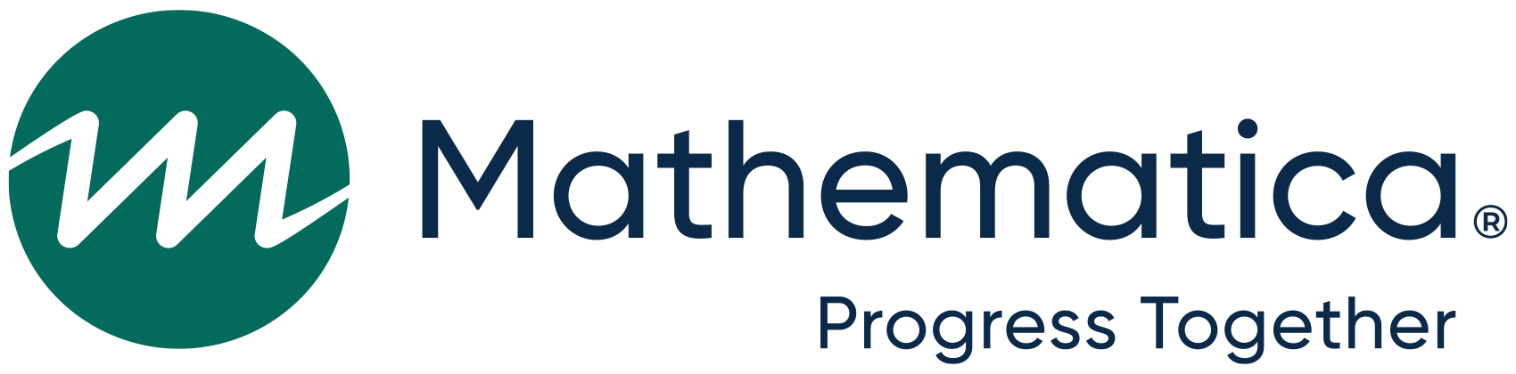

Home-Based Child Care Toolkit for Nurturing School-Age Children Pilot Study provider thank you letter

[DATE]

Dear [FIRST NAME] [LAST NAME],

On behalf of the study team and the Administration for Children and Families, we want to thank you for participating in the Home-Based Child Care Toolkit for Nurturing School-Age Children (HBCC-NSAC Toolkit) Pilot Study! Your input was extremely helpful and will be used to improve the HBCC-NSAC Toolkit.

Included you will find a [(IF PHASE ONE: IF COMPLETED INSTRUMENT 7: $85/ IF DID NOT COMPLETE INSTRUMENT 7: $75) (IF PHASE TWO: IF COMPLETED INSTRUMENT 7: $60/ IF DID NOT COMPLETE INSTRUMENT 7: $50)] gift card as a token of our appreciation for your participation in the HBCC-NSAC Toolkit Pilot Study.

If you have questions or concerns, please contact me at [PHONE NUMBER]. This call is toll-free. You can also email us at [EMAIL]@mathematica-mpr.com.

Sincerely,

Myah Scott

*Deputy Survey Director*

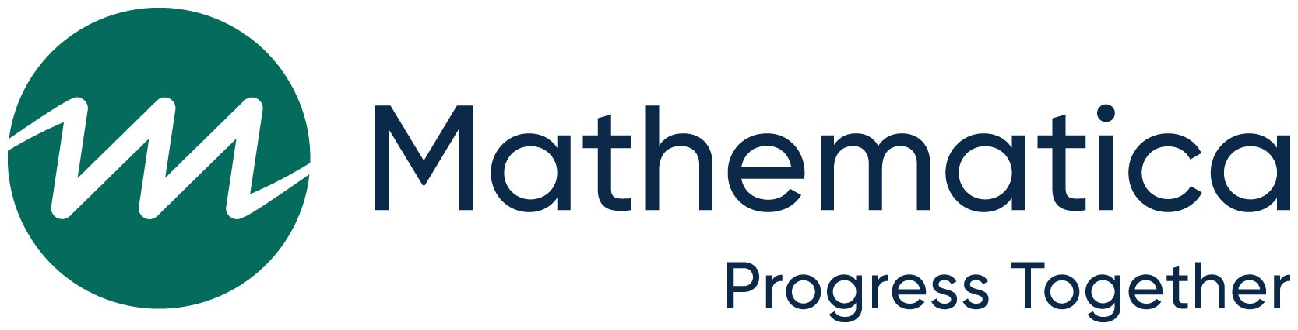

The referenced collection of information is voluntary. Information will be kept private. An agency may not conduct or sponsor, and a person is not required to respond to, a collection of information unless it displays a currently valid OMB control number. The OMB control number for this collection is 0970-0355 and the expiration date is 8/31/2024.

Appendix L.2  
  
Home-Based Child Care Toolkit for Nurturing School-Age Children Pilot Study family thank you letter



The Home-Based Child Care Toolkit for Nurturing School-Age Children Pilot Study family thank-you letter

[DATE]

Dear [FIRST NAME] [LAST NAME],

On behalf of the study team and the Administration for Children and Families, we want to thank you for participating in the Home-Based Child Care Toolkit for Nurturing School-Age Children (HBCC-NSAC Toolkit) Pilot Study! Your input was extremely helpful and will be used to improve the HBCC-NSAC Toolkit.

Included you will find a [(IF PHASE ONE: $35) (IF PHASE TWO: $10) gift card as a token of our appreciation for your participation in the HBCC-NSAC Toolkit Pilot Study.

If you have questions or concerns, please contact me at [PHONE NUMBER]. This call is toll-free. You can also email us at [EMAIL]@mathematica-mpr.com.

Sincerely,

Myah Scott

*Deputy Survey Director*



The referenced collection of information is voluntary. Information will be kept private. An agency may not conduct or sponsor, and a person is not required to respond to, a collection of information unless it displays a currently valid OMB control number. The OMB control number for this collection is 0970-0355 and the expiration date is 8/31/2024.