MIHOPE-K Pilot

Caregiver Contact Materials

*May 2021*

The materials included in this document are organized as follows:

**Fact sheet2**

**INVITATION EMAIL4**

**PRE-ASSESSMENT EMAIL5**

**PRE-ASSESSMENT TEXT7**

**CONSENT8**

**fAMILY EQUIPMENT INSTRUCTIONS10**

**eQUIPMENT RETURN INSTRUCTIONS15**

**MISSED APPOINTMENT EMAILS16**

**MISSED APPOINTMENT TEXTS18**

**FaQ19**

**EQUIPMENT PICK-UP TEXT21**

**THANK YOU LETTER22**

**FaILURE TO RETURN EQUIPMENT LETTER23**

YOUR PARTICIPATION IS NEEDED!

Get a $75 gift card for participating in a virtual visit!

We are looking for mothers ofchildren who will be **entering** kindergarten or first grade in the fall to help us practice our virtual visits! We will be doing them with hundreds of parents and children early next year and want to learn what works best. As a thank you for your time, we will give you a $75 gift card.

To see if you can participate, call [SCHEDULER PHONE] or email MIHOPEStudy@mathematica-mpr.com and tell them that you're interested in the MIHOPE virtual visit.

Frequently Asked Questions

**/** **Why is this virtual visit being done?**

The Mother and Infant Home Visiting Program Evaluation (MIHOPE) is looking to learn about how home visiting programs help children and families. We will be trying out ‘virtual’ visits for our study and need your help! We want to test the forms and procedures before we do the virtual visits with hundreds of families early next year.

**/** **What kind of activities will we do during the virtual visit?**

A local staff member will drop off all the materials you will need for the activities, including a laptop computer. They will wear a mask and follow appropriate social distancing guidelines. A staff member will pick up the materials after you complete the activities. Everything we drop off will be sanitized before we give it to you.

At your scheduled appointment time, we will call you to help you set up the equipment. The first part of the virtual visit will be a quick interview with you. After that, we will do some fun language, math, and memory games with your child. We will also do a memory activity with you and videotape you and your child playing with some toys. At the end of the virtual visit, we will ask you some questions about your experience with the visit to help us understand what works and what we can do better. These questions should take no more than 15 minutes total.

**/** **How long will the virtual visit take?**

The virtual visit will take about 2 hours. As a ‘thank-you’ for your participation, we will give you a **$75 gift card**. We will give you the gift card after the visit is completed, when the materials are picked up by our local staff member.

**/** **Who can I contact with more questions?**

For more information about the virtual visit, you can call [SCHEDULER PHONE] or email [MIHOPEStudy@mathematica-mpr.com](mailto:MIHOPEStudy@mathematica-mpr.com).

From: MIHOPE study inbox

Subject: A virtual visit with MIHOPE

Dear [PARENT FIRST NAME],

[IF CONTACT INFO PROVIDED: [REFERRED NAME] told us you would be a good person to help us out. We are looking for families with children who will be entering kindergarten or first grade in the fall 2021 who would be willing to participate in a virtual visit as part of the Mother and Infant Home Visiting Program Evaluation (MIHOPE). We are trying out a new way of meeting and talking with families.]

[IF EMAIL IS SENT AS PHONE CALL FOLLOW UP: Thank you again for contacting us! We appreciate your interest in our virtual visit with families for the Mother and Infant Home Visiting Program Evaluation (MIHOPE). Here are some additional details about this opportunity.]

MIHOPE seeks to learn about how home visiting programs help children and families. In the past, we visited families in their homes to see how they were doing and did some fun activities with their children. We may not be able to do home visits anymore given health concerns. Because of this, we have created a way to virtually visit families using a computer. We would like your help to see how well it works.

* The virtual visit will take about 2 hours.
* A local staff member will drop off everything you will need. This includes a laptop computer and wireless internet. They will wear a mask and follow social distancing guidelines.
* Everything we drop off will be sanitized before we give it to you.
* At the end of the virtual visit, we will ask you some questions about how it went to help us understand what works and what we can improve.
* After the visit, a local staff member will pick up all the materials.
* As a ‘thank-you,’ we will give you a $75 gift card after the visit is completed, when we pick up the materials.

We would like to visit a wide variety of families. To make sure you are eligible, we have a few questions to ask you over the phone. **Please feel free to reply to this email with a date, time and the best phone number to reach you at between now and [DATE].**

Thanks again!

[SCHEDULER NAME], on behalf of the MIHOPE study team

Mathematica

From: MIHOPE study inbox

Subject: Important reminders for your MIHOPE virtual visit appointment!

Dear [PARENT FIRST NAME],

Thank you for agreeing to participate in a virtual visit as part of the Mother and Infant Home Visiting Program Evaluation (MIHOPE) study! This study is sponsored by the Administration for Children and Families in the U.S. Department of Health and Human Services. The goal of the virtual visit is to learn about how home visiting programs help children and families. **The purpose of this pilot is to learn about how to improve procedures for the virtual visit.**

We have some important reminders for your upcoming appointment:

* **Before your appointment**
* Your appointment is scheduled for **XX:XX AM/PM** on **XX/XX**. If this time doesn’t work for you, please reply to this email or call us back at [SCHEDULER HOTLINE].
* A local staff member will call you to schedule a time to drop off the materials you will need for the virtual visit. Please make sure to have someone home at that time; these materials cannot be left unattended. The local staff member will wear a mask and follow appropriate social distancing guidelines. Everything will be sanitized before we give it to you.
* You will receive a call after the equipment drop-off and before your virtual visit to make sure everything arrived and answer any questions you may have before your visit. Equipment set-up and review of all other materials will happen during the virtual visit.
* **During your appointment**
* The virtual activities will take about 2 hours. We ask that you find a place in your home that will be free of distractions where you and your child may complete the activities.
* You will need to stay in the room with your child during the virtual visit. If you take care of other children or adults in your home, please make sure someone else is available to care for them during the virtual visit.
* We will ask your child to complete the virtual visit in an upright chair. It is best if your child is sitting at a table.
* **After your appointment**
* A local staff member will contact you to schedule a time to pick-up your equipment as soon as possible after the virtual visit.
* You will be given your $75 gift card after you complete the virtual visit, when the local staff member picks up your equipment.

Please let us know if you have any questions by replying to this email or calling [SCHEDULER HOTLINE].

Thanks again!

Alicia Harrington, on behalf of the MIHOPE study team

Mathematica

**Text sent just after scheduled call before virtual visit (sent by interviewer):**

Hi [PARENT NAME]! Excited to connect at [XX:XX AM/PM] on [XX/XX/21] for the MIHOPE visit. Questions? Reschedule? Just call or reply to this text.-[INT NAME] Txt stop 2 end

# 

# PARENT/GUARDIAN PERMISSION FOR PARTICIPATION IN MIHOPE VIRTUAL VISIT PILOT

Thank you for agreeing to take part in the pilot of a virtual visit as part of the Mother and Infant Home Visiting Program Evaluation (MIHOPE). A nonprofit organization called MDRC is running the study. The study team also includes Mathematica, who is conducting the pilot of a virtual visit. This study is funded by the U.S. Department of Health and Human Services. The study aims to improve services for parents with young children.

The goal of this virtual visit is to learn about how home visiting programs help children and families. The information collected will not be used in any study reports; the information collected will only be used to improve the data collection tools.

**What does it mean to participate in these activities?**

If you agree to these activities, we will ask you to do the following. This should take about 2 hours:

* **Set up the electronic equipment.**
* During the virtual visit, set up the equipment needed for you and your child to do the activities. Your interviewer will explain how to do this step-by-step.
* **Agree to do a quick interview and a memory activity.** We will ask you to do a quick interview and a memory activity. You may refuse or stop the interview or activity at any time.
* **Allow your child to participate in activities.**
* We will ask your child to do several activities. You may refuse to allow your child to do any of these activities or you may stop the activities at any time.
* We will ask that you remain present to help your child with technology issues and encourage attention.
* **Allow us to video record you and your child interacting.**
* We will virtually record you and your child interacting and playing with different toys. The videos will be stored in a secure location. The videos will be used to help us learn about the quality of videos collected virtually, how we can improve our procedures, and for training purposes only. You may refuse to be video recorded. You may stop the recording at any time.
* **Answer a few questions about your experience participating in the virtual visit.**
* Right after the virtual visit, we will ask you a few questions about your experience. These questions should take no more than 15 minutes total.

You will receive $75 for completing these activities A local staff member will give you your gift card when they pick up your equipment.

**What are the benefits and risks to me in completing these activities?**

This information will help the study team learn about doing these activities virtually. There is also a small risk that your information or your video will be seen outside the study team. However, the study team follows strict rules to protect your privacy. We will keep your information private unless there is concern that you or someone else may be harmed. For example, if someone from the study team sees or learns about evidence of child abuse or neglect, they would tell someone. In this case, we may report this to Child Protective Services.

**How will my information be kept safe?**

The research team follows strict rules to keep your information private. Any information collected from the virtual visit will be used only for training and to help us improve our procedures. We use secure computers and data storage systems to protect data from being seen by anyone other than the study team. All study staff are trained to protect your privacy. All study staff sign a confidentiality pledge.

**Taking part of these activities is your choice.**

Taking part in these activities is your choice. If you decide not to take part, nothing will happen to you. You may change your mind and decide not to allow us to conduct any of the activities.

**Who can I call with questions?**

If you have questions at any time, please call Alicia Harrington at 609-945-3350.

**Participant’s Statement:**

“I understand the information in this document: I agree to participate in the virtual visit. I will get a copy of this form to keep. The research procedures, risks and benefits have been explained to me. I am free to ask any questions. Doing any of these activities or allowing my child to do any of these activities is my choice. You will collect information about my child. Me or my child can refuse to do any activity. Any information that can identify me will be kept private, unless there is concern that I or someone else may be harmed. As part of the virtual visit, I will be provided with electronic equipment (laptop, MiFi internet device, headphones). I will return these materials immediately after the virtual visit.”

According to the Paperwork Reduction Act of 1995, no persons are required to respond to a collection of information unless it displays a valid OMB control number. The valid OMB control number for this information collection is 0970-0402. The time required to complete the described information collection is estimated to average 2 hours per response, including the time to review instructions, search existing data resources, gather the data needed, and complete and review the information collection

**MIHOPE Virtual Visit: Family Guide**

**Please do not take equipment out of the bag until you are speaking with your interviewer during your virtual visit.**

Thank you for agreeing to participate in a virtual visit as part of the Mother and Infant Home Visiting Program Evaluation (MIHOPE)! Everything you need is included in this bag. Please do not remove anything yet. We will explain how to set everything up during your scheduled appointment.

**What can you expect next?**

1. **A telephone call:** Before your appointment, you will receive a call from the interviewer to confirm your appointment time and walk you through what to expect during the virtual visit. Please do not remove any items from the bag until told to do so by the interviewer.
2. **The virtual visit:** At your scheduled appointment time, the interviewer will give you a call to walk you through the equipment set-up and connection process. At that time, you can remove the items from the bag. Use the pictures in this guide to help identify the different pieces of equipment as you follow along.
3. **Equipment pick-up:** Shortly after the visit is over, a local staff member will return to your home to pick up the equipment. They will also give you a $75 gift card as a thank-you.

**Questions?** Email us at MIHOPEStudy@mathematica-mpr.com or call the local staff member at the number on the Equipment Return Instructions card.

**What’s in the bag?**

The bag you received contains everything you’ll need for the virtual visit:

1. Instructions
   1. MIHOPE Virtual Visit: Family Guide (This handout)
   2. Equipment Return Instructions card
2. Electronics (contained in the smaller, laptop bag)
   1. 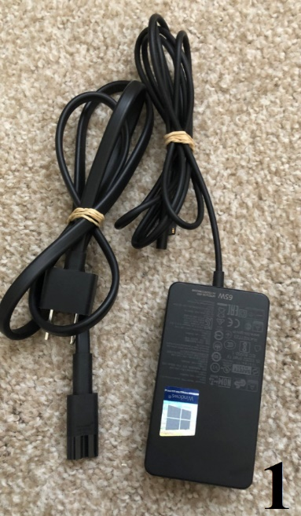Microsoft Surface Pro tablet computer and power cord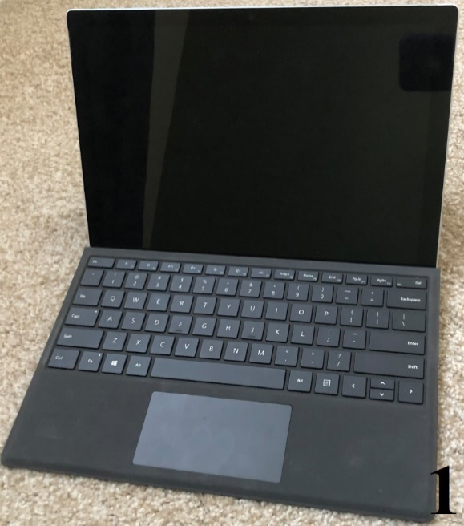
   2. Computer stand 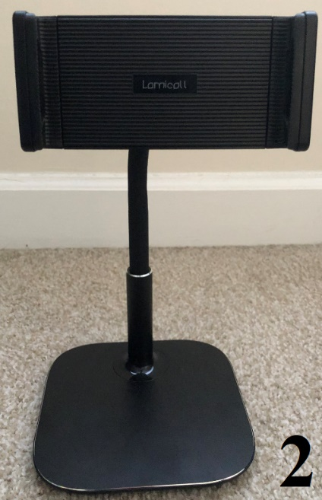
   3. Verizon MiFi (wireless internet device) and power cord 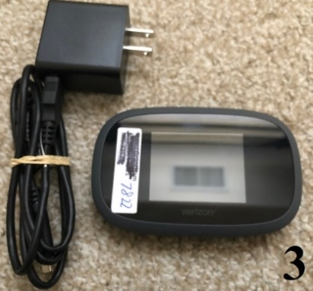
   4. Headset (with microphone)

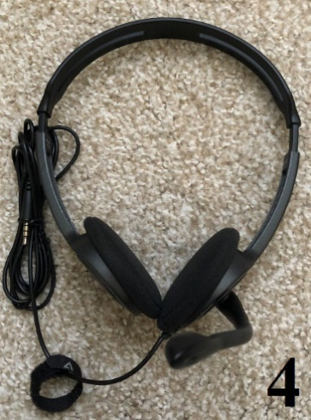

1. Other materials
   1. Three numbered tote bags
   2. [Yoga mat]
   3. Labeled, sealed envelopes (do not open until interviewer says to)
   4. Ruler
   5. Children’s book

**Charging the tablet computer**

The tablet computer should be fully charged when you get it. If you see a “low battery” warning during the visit, let your interviewer know. Plug in the laptop charger on the right-hand side, toward the bottom.

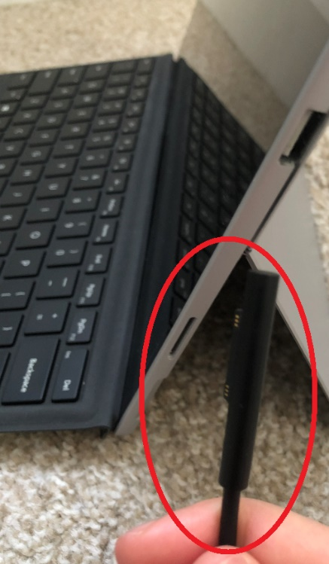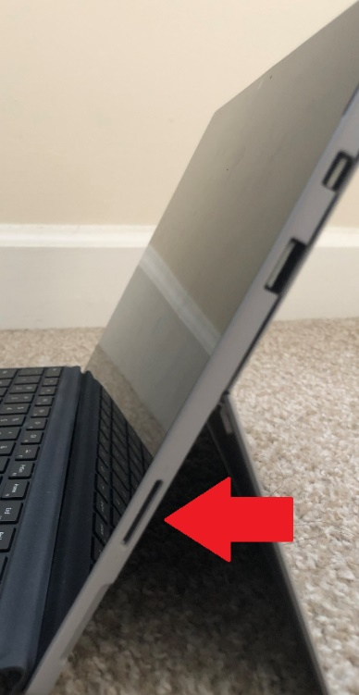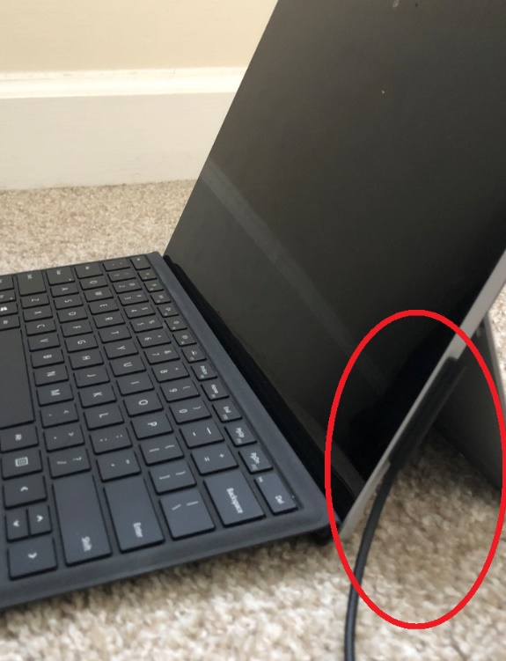

**Charging the MiFi**

The MiFi wireless internet device should be fully charged when you get it. If you see a “low battery” warning during the visit, let your interviewer know. Plug the charger into the bottom of the MiFi.

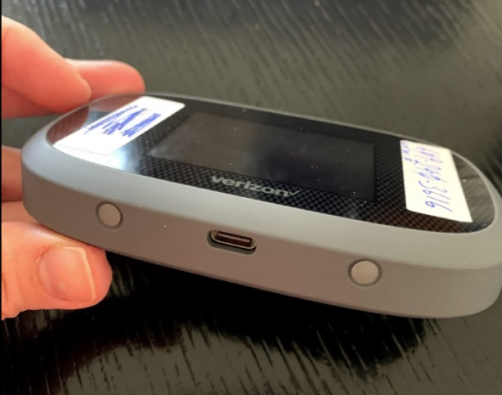 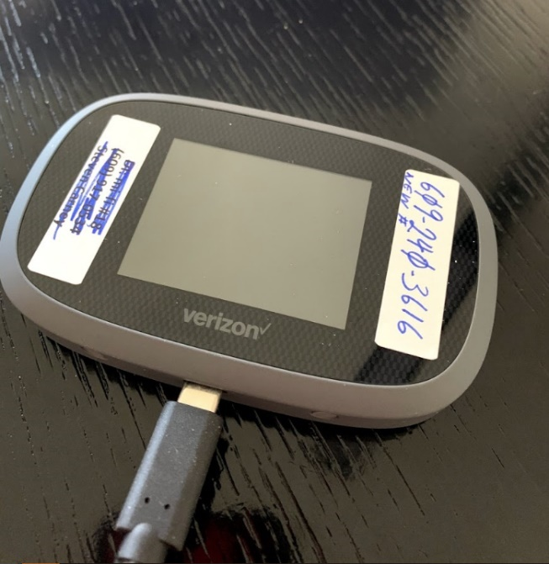

|  |
| --- |
| **Mother and Infant Home Visiting Program Evaluation** Virtual VisitEquipment Return Instructions  * All equipment will be collected ASAP following your virtual visit. You will receive your $75 gift card when we pick up the equipment. * I will return to pick-up your equipment at:   ________AM/PM on ________________   * I will call/text to confirm this pick-up time after your virtual visit is completed. * Please do not leave equipment that is ready for pick-up unattended. * Please make sure all equipment is returned in the bags they came in. * Please call/text me at the number below if you have any questions or issues.  Local Staff Member Name:____________________________ First Name Last Name Local Staff Member Phone:(____)_________-______________ *Thanks for your help!* |

From: MIHOPE study inbox

Subject: Need to schedule equipment drop-off for MIHOPE appointment –

Dear [PARENT FIRST NAME],

Unfortunately, we have been unable to connect with you to drop off the needed equipment for the MIHOPE virtual visit. This step is critical. We are providing all the equipment you will need.

[IF THERE IS STILL WINDOW TO PARTICPATE: We are still excited to include you in our pilot of a virtual visit. We would like to reschedule the drop off and virtual visit. **Please reply to this email with a date and time that would work best for you between now and [DATE] or give us a call at [TOLL FREE LINE].** We look forward to hearing from you!]

[IF PILOT WINDOW IS CLOSED: Unfortunately, we are wrapping up our pilot of a virtual visit and are unable to reschedule for a later date. We appreciate your interest in this effort.]

Please let us know if you have any questions.

Alicia Harrington, on behalf of the MIHOPE study team

Mathematica

From: MIHOPE study inbox

Subject: Need to reschedule equipment pick up – MIHOPE virtual visit [IF PILOT WINDOW IS CLOSED]/Missed MIHOPE appointment – Need to reschedule [IF THERE IS STILL WINDOW TO PARTICIPATE]

Dear [PARENT FIRST NAME],

[IF THERE IS STILL WINDOW TO PARTICIPATE: We are still excited to have you in our study. We are happy to reschedule your virtual visit to better fit your schedule. Unfortunately, we were unable to reach you at your scheduled appointment time for the MIHOPE virtual visit at XX:XX AM on XX/XX. **Please reply to this email with a date and time that would work better for you between now and [DATE] or give us a call at [TOLL FREE LINE].** We look forward to hearing from you!]

[IF PILOT WINDOW IS CLOSED: Unfortunately, we were unable to reach you at your scheduled appointment time for the MIHOPE virtual visit at XX:XX AM on XX/XX. We are wrapping up our pilot and cannot reschedule for a later date.

Please let us know if you have any questions.

Alicia Harrington, on behalf of the MIHOPE study team

Mathematica

From: Local team member email

Subject: Rescheduling MIHOPE equipment pick-up appointment

Dear [PARENT FIRST NAME],

We have been unable to connect with you to pick-up your equipment for the MIHOPE virtual visit. We are eager to provide you with your $75 gift card as a thank you for your participation in the study. We will give it to you when we pick up the equipment. [FOR SECOND REMINDER: On [DROP OFF DATE], you were **loaned** a laptop, wireless router, and other equipment for the MIHOPE virtual visit.  The equipment is **not** yours to keep. It must be returned..]

**Please reply to this email with a date and time within the next two days when we can return to collect this equipment and give you a gift card.**

Please let us know if you have any questions.

Alicia Harrington, on behalf of the MIHOPE study team

Mathematica

**Missed equipment drop-off appointment (sent by local staff member)**

Hi [PARENT NAME]! Sorry we missed you! Trying to drop off equipment for the MIHOPE visit. Call or reply to this text with times that work-[LOCAL STAFF MEMBER NAME] Txt stop 2 end

**Missed virtual visit appointment (sent by SOC/scheduler)**

Hi [PARENT NAME]! You missed your virtual visit at XX:XX AM/PM on XX/XX. Call or reply to this text to reschedule-[ SCHEDULER] Txt stop 2 end

Hi PARENT NAME! Sorry to have missed you for our visit at XX:XX AM/PM on XX/XX. Call or reply to this text with to reschedule-SCHEDULER Txt stop 2 end

**Missed equipment pick-up appointment (sent by local staff member)**

Text 1 (first missed appointment): Hi [PARENT NAME]! We missed you for the MIHOPE equipment pick-up. Please call or reply to this text to arrange for pick-up-[LOCAL STAFF MEMBER NAME] Txt stop 2 end

ALTERNATIVE:

Hi PARENT NAME! Sorry to have missed you for the MIHOPE equipment pick-up. Please call or reply to this text to arrange for pick-up- STAFF NAME Txt stop 2 end

Text 2 (nonresponse 48 hours after Text 1):[PARENT NAME]–We’re still missing the MIHOPE equipment, **loaned** to you for the MIHOPE virtual visit. Call or reply ASAP to reschedule-[LOCAL STAFF MEMBER NAME] Txt stop 2 end

ALTERNATIVE:

PARENT NAME–The MIHOPE equipment is **not** yours to keep. It must be returned. Call or reply to arrange pickup ASAP-STAFF NAME Txt stop 2 end

**Frequently Asked Questions – MIHOPE Pilot**

**What activities will you be doing with me and my child?**

1. We will do a quick interview and memory activity with you.
2. We will play a few games with your child (language, math, and memory games).
3. We will record you and your child playing with toys.
4. We will ask you some questions at the end of the visit about your experience with the visit to help us understand what works and what we can do better.

All these activities are voluntary. For example, you can take breaks between activities, refuse to do any of them, and/or stop an activity at any time. Information from these activities will be kept private. These activities are expected to take about 2 hours.

**I have small children at home that I care for; I’m worried I won’t be able to participate.**

It’s important that we conduct these virtual visits with all types of families, including those with young children at home. This will help us make sure that our processes are flexible enough to work for all families. We will work with your availability and can offer breaks if necessary.

**What happens if I have to stop in the middle and can’t finish it?**

Since the virtual visit should take about two hours, we understand that there may be times when families need to pause and pick-up again at a later time. We can schedule a time to finish the activities later (though we are only conducting these visits in a short window).

**I’m not very good with technology. Will I still be able to participate?**

Yes! We understand that families have different comfort levels with technology. We will work closely with you to set up the equipment and to ensure that everything is working properly.

**What kind of equipment do I need to participate?**

We will provide you with all equipment that you will need, which includes: a laptop computer, headphones and a wireless internet device. We only ask that you identify a location in your home that is free of distraction for your child where they can sit in an upright chair, ideally at a table. If you do not have a table available, we will work with you to figure something out.

**How do I set up my equipment?**

At the start of your visit, we will walk you through how to set up the equipment. Please do not remove the equipment from the bag before this time.

**What if my equipment stops working during the virtual visit?**

As we walk you through the set-up of the equipment, tell us if something does not seem to be working. We will provide you with the help you need. If you have concerns about your equipment before your scheduled appointment time, please call the local staff member using the contact information from the Equipment Return instruction card left with the equipment.

**What happens if I’m disconnected from the virtual visit while it’s being conducted?**

If you get disconnected while the virtual visit is being conducted, we will call you back on the telephone number used to reach you at the start of the visit.

**How do I return my equipment?**

A local staff member will pick up the equipment. Please look at the enclosed Equipment Return instruction card for packing instructions and contact information for the local staff member.

**When will I receive my $75 gift card?**

The local staff member will give you your $75 gift card when they pick up the equipment.

**Text sent just after assessment is completed and pick-up time is confirmed (sent by local staff member) in cases where we have explicit permission to text to this telephone number:**

Thanks for your help, [FIRST NAME]! I’ll pick up the MIHOPE equipment at XX:XX AM/PM on XX/XX. Questions? Reschedule? Text or call-[LOCAL STAFF MEMBER NAME] Txt stop 2 end

[DATE]



**Mother and Infant Home Visiting Program Evaluation**

RE: Thank you!

Thank you for taking part in a MIHOPE virtual visit! We also appreciate the quick return of all equipment used during the visit. Your $75 gift card for completing the visit is included with this letter. Your comments will help us improve our plans before we visit hundreds of families across several states next year. We appreciate your help and enjoyed talking with you.

Thank you again!

Sincerely,

[DATE]

RE: Return of MIHOPE virtual visit equipment

Dear [FIRST NAME] [LAST NAME],

On [DROP OFF DATE], you were **loaned** a laptop, wireless router, and other equipment for the MIHOPE virtual visit.

As of [DATE], we have no record of the return of the MIHOPE virtual visit equipment provided to you.

The equipment is **not** yours to keep. It must be returned.

Please contact [NAME] at [PHONE] as soon as possible to arrange for the return of all equipment.

Regards,