Appendix C1.
Introductory Letter

(English)

OMB Number: xxxx-xxxx
Expiration Date: xx/xx/2026
 | Department of Health and Human Services |  | Office of the Secretary
Office of Medicare Hearings and Appeals
Office of the Chief Judge
2550 S. Clark Street, Suite 2001
Arlington, VA 22202

May 1, 2024

Dear OMHA Hearing Participant:
You recently attended a hearing conducted by the Office of Medicare Hearings and Appeals (OMHA), which administers nationwide hearings for Medicare claims appeals. OMHA is committed to resolving cases efficiently and fairly. To measure the satisfaction of the appellant experience, OMHA has received authority to collect data from a randomly selected set of appellants about their experience with the OMHA appeals process.
You have been randomly selected to complete this survey. If you prefer to complete the survey online, you may access it by going to the following internet address: www.OMHAsurvey.com. Please go to the website and input the computer-generated username and password provided below.
Internet address: www.OMHAsurvey.com
Username: 1400
Password: B5637
If you prefer to speak to a representative who can conduct the survey with you by phone, you may call 844-295-2605 Monday through Friday between 9:00 a.m. and 6:00 p.m. central time. If you choose neither of these options, you will be contacted by a 2M Research survey administrator and given an opportunity to complete the survey by phone. The survey should take about 15 minutes to complete, and all your responses will be anonymous.
OMHA has taken several steps to ensure your privacy is protected. Your survey responses will be separated from your name and specific appeal information to keep your responses anonymous. In addition, 2M Research will not share individual responses with OMHA, but rather will only provide statistical summaries of results. I assure you that your communication with 2M Research, as well as your participation in this survey project, will not be shared with anyone on the administrative law judge teams or anyone outside of OMHA.
Your feedback is valuable to us. Past survey results have been used to improve the quality of our services. OMHA promotes continuous improvement efforts and, based on feedback received from prior hearing participants, has taken steps to improve interactions during scheduling and hearing appeals. Additionally, OMHA received recommendations to standardize the exhibiting process, and subsequently, initiated steps to review and enhance the process.
If you have any questions about this survey or our efforts to maintain your privacy, please contact the OMHA Survey Team at 1-844-295-2605. We value your input. We appreciate your interest in this public service effort, and we look forward to your input in the upcoming weeks.
Sincerely,
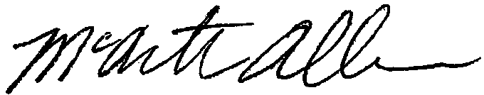
McArthur Allen
Chief Administrative Law Judge

