NATIONAL CENTER FOR EDUCATION STATISTICS NATIONAL ASSESSMENT OF EDUCATIONAL PROGRESS

National Assessment of Educational Progress (NAEP)
2025 Long-Term Trend (LTT) Clearance Package

Appendix G-S

Long-Term Trend (LTT) 2025 Bilingual Spanish Survey Questionnaires

OMB# 1850-0928 v.32



October 2023
revised February 2024

LTT Age 9 and Age 13 Core Math and Reading Survey Questionnaires were previously approved by OMB (OMB# 1850-0928 v.26). Spanish versions of the questionnaires are used when a bilingual accommodation is offered to qualified English Learned (EL) students. The translated questionnaires included in this appendix correspond to their English language counterparts which can be found in Appendix G. The Spanish versions are coded to correspond to the English equivalent with an “s” added to indicate Spanish (e.g. G-S-3). Note that not all LTT 2025 questionnaires are translated, only those that are used when a bilingual accommodation is offered, namely the LTT 2025 student mathematics questionnaires for ages 9 and 13.

This appendix includes all final translated LTT 2025 questionnaires.

Table of Contents
Sample NAEP Questionnaire Cover Page (Age 9) 3
Appendix G-S-1: Summary of Changes Operational LTT Age 9 Mathematics – Spanish Bilingual Student Items 5
Appendix G-S-2: Operational LTT Age 9 Mathematics – Spanish Bilingual Student Items 6
Sample NAEP Questionnaire Cover Page (Age 13) 9
Appendix G-S-3: Summary of Changes Operational LTT Age 13 Mathematics – Spanish Bilingual Student Items 11
Appendix G-S-4: Operational LTT Age 13 Mathematics – Spanish Bilingual Student Items 12

Sample NAEP Questionnaire Cover Page (Age 9)
Note: Sample cover pages will be updated in an upcoming Amendment.
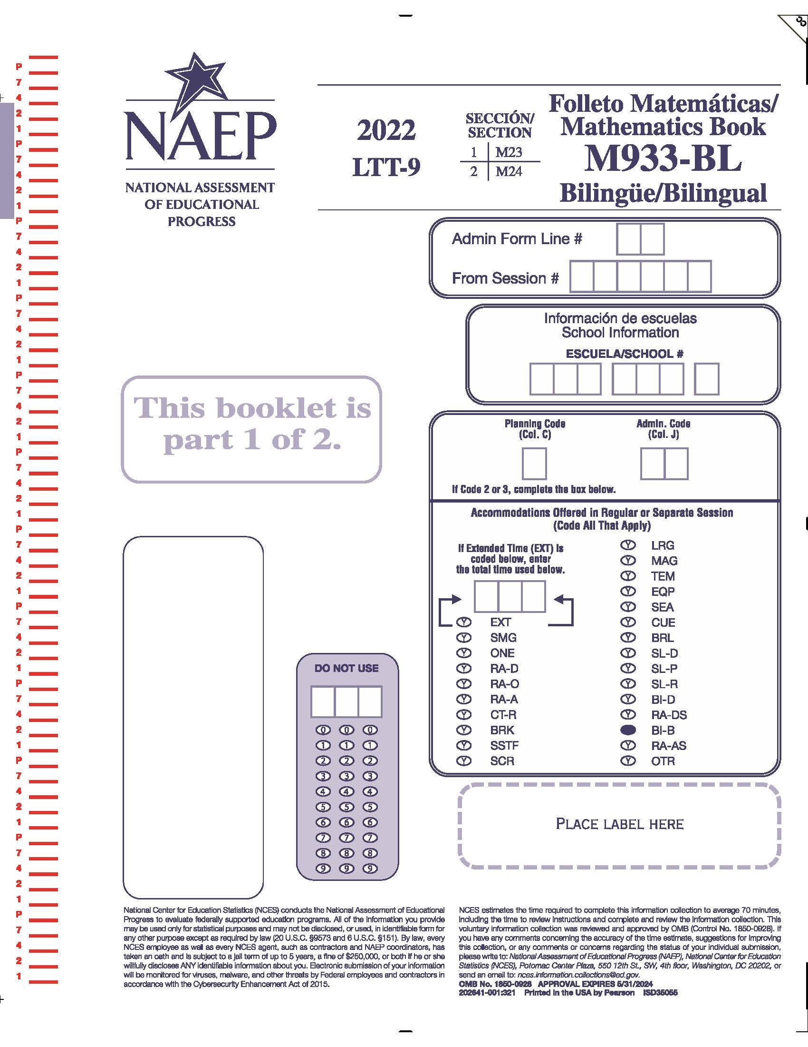
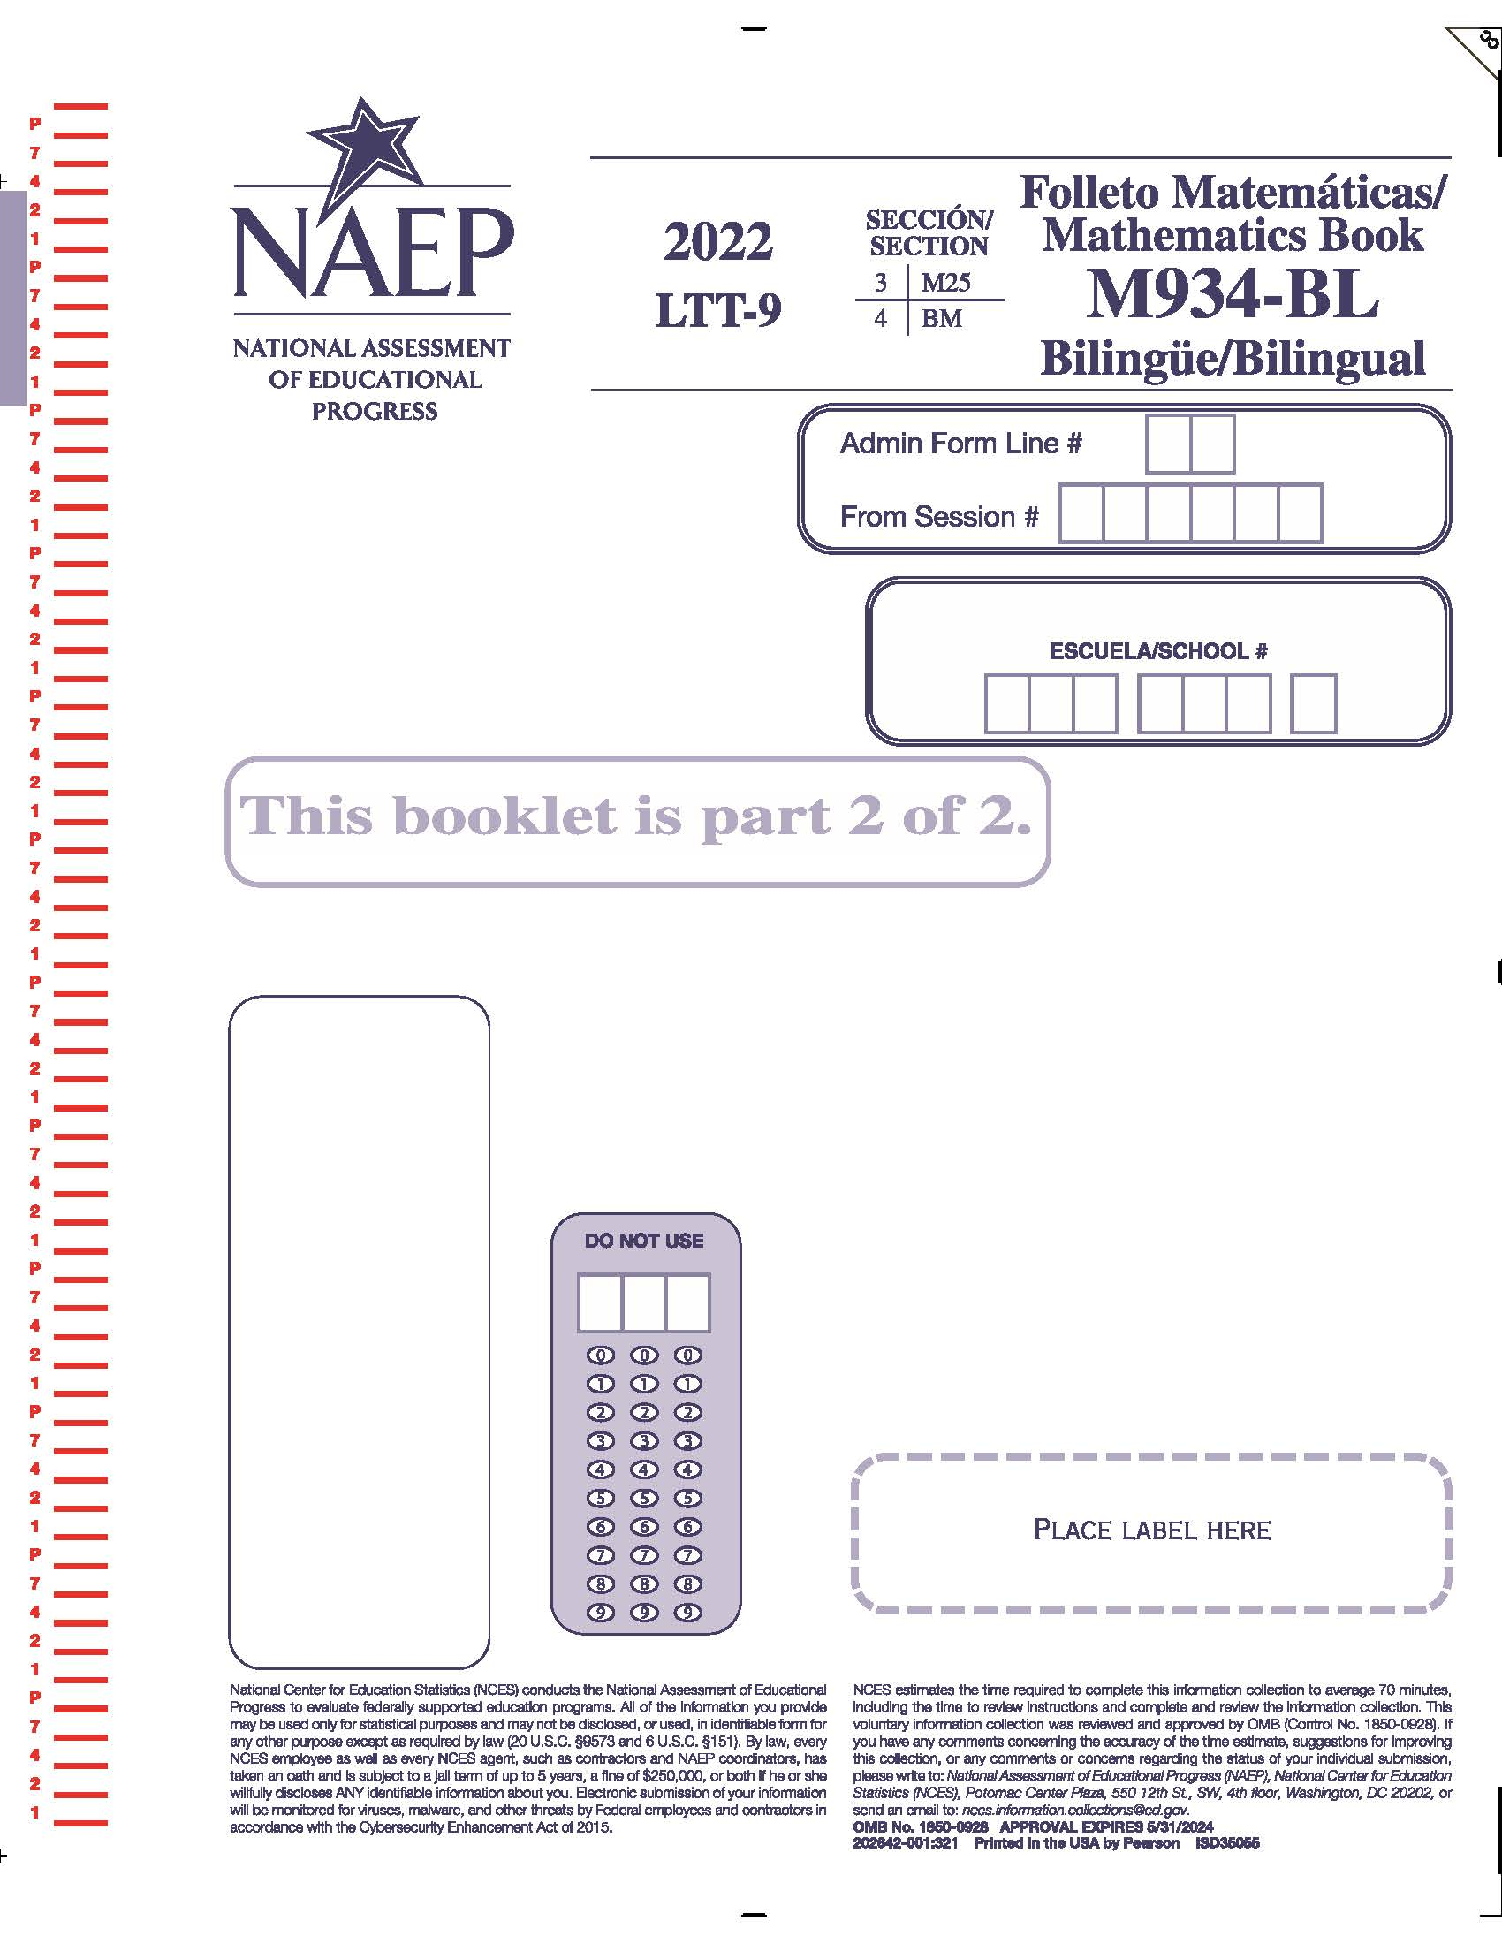

Appendix G-S-1: Summary of Changes Operational LTT Age 9 Mathematics – Spanish Bilingual Student Items

2024/2025 Operational Age 9 Long-Term Trend Mathematics Bilingual Student Items
Previous item | 2025 item | D/A/R/NC+ | Rationale
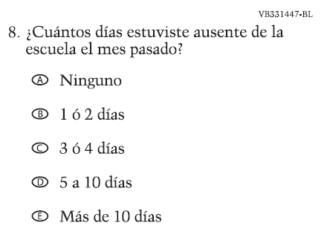  (2022 Operational Age 9 Long-Term Trend Mathematics Bilingual Student Items) | 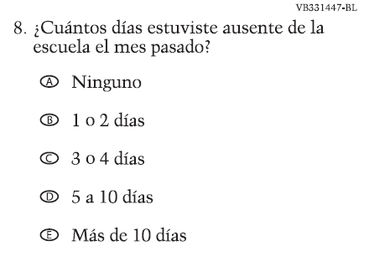  Issue: School Climate | R | To adhere to updated grammar rules, accent mark from the conjunction "ó" in options B and C has been removed.

Appendix G-S-2: Operational LTT Age 9 Mathematics – Spanish Bilingual Student Items
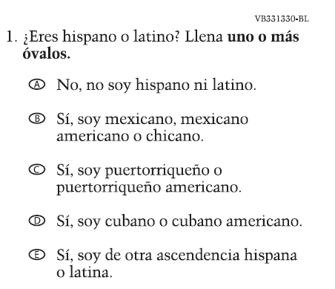

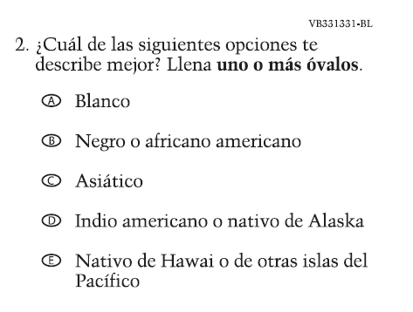

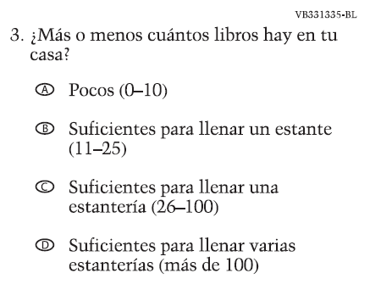

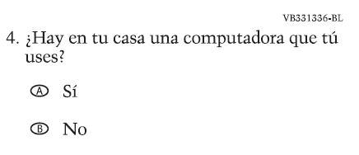

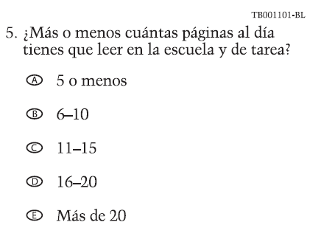

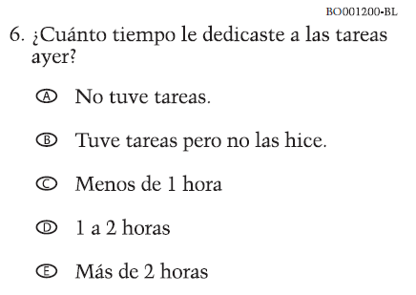

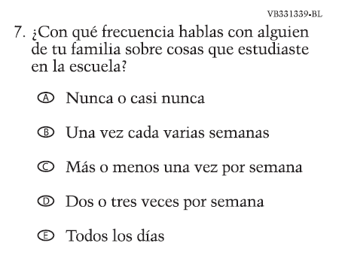

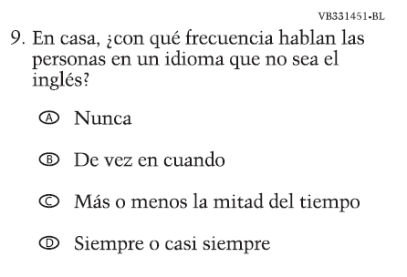

Sample NAEP Questionnaire Cover Page (Age 13)
Note: Sample cover pages will be updated in an upcoming Amendment.
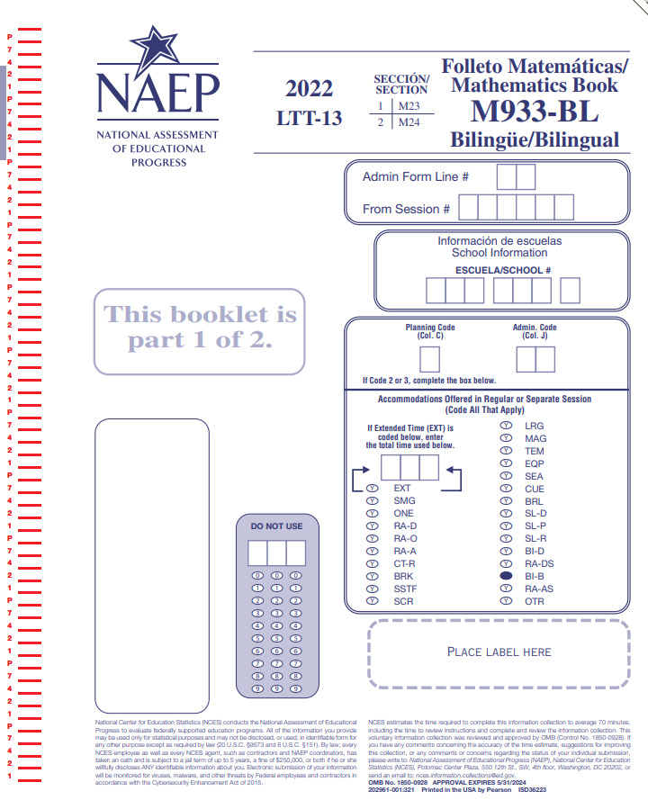
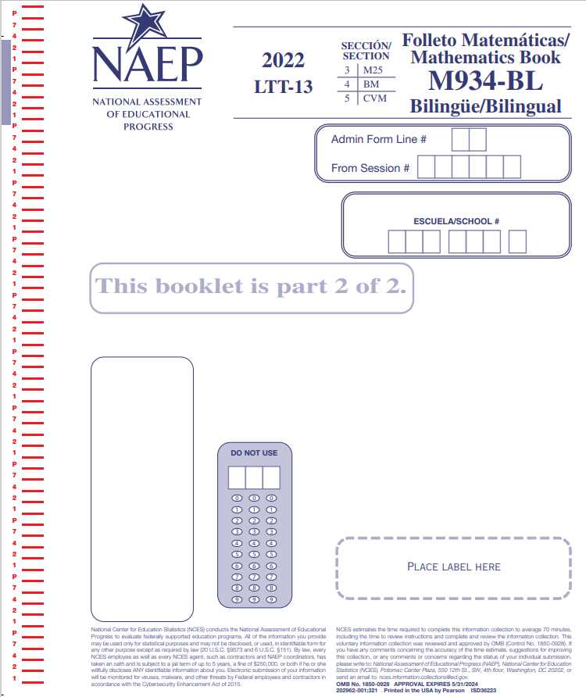

Appendix G-S-3: Summary of Changes Operational LTT Age 13 Mathematics – Spanish Bilingual Student Items

2024/2025 Operational Age 13 Long-Term Trend Mathematics Bilingual Student Items
Previous item | 2025 item | D/A/R/NC+ | Rationale
(2022 Operational Age 13 Long-Term Trend Mathematics Bilingual Student Items) | Issue: School Climate | R | To adhere to updated grammar rules, accent mark from the conjunction "ó" in options B and C has been removed.

Appendix G-S-4: Operational LTT Age 13 Mathematics – Spanish Bilingual Student Items

