**Attachment T: The Obesity & Type II Diabetes Risk Assessment Blood Pressure Readings (Adult)**

*If you require information to be presented in an accessible format or reasonable accommodations to participate in this study, please contact us with any specific requests by calling XXX-XXX-XXXXX or emailing XXXX@XXXX.XXX. If you require language assistance to participate in this study, please contact us with any specific language assistance requests or needs.*

**Paperwork Reduction Act Burden Statement**

This collection of information is voluntary and will be used to evaluate the US Department of Housing and Urban Development’s Community Choice Demonstration. Public reporting burden for this collection of information is estimated to average 15 minutes per response, including the time for reviewing instructions, gathering, and maintaining the data needed, and reviewing the collection of information. An agency may not conduct or sponsor, and a person is not required to respond to, a collection of information unless it displays a currently valid OMB control number. The OMB number for this collection is OMB 2528-0337 which expires on XX/XX/XXXX. Send comments regarding this burden estimate or any other aspect of this collection of information, including suggestions for reducing this burden to NAME at [XXXX@XXXXX.XXX](mailto:XXXX@XXXXX.XXX) or call XXX-XXX-XXXX.

**Privacy Act Statement**

**Authority:**  Section 502 of the Housing and Urban Development Act of 1970 (Public Law 91-609) (12 U.S.C. §§ 1701z-1; 1701z-2(d) and (g)).

**Purpose:**  Evaluation of the Community Choice Demonstration (CCD).

**Routine Use:**  The information will be used for the purpose set forth above and may be provided to Congress or other Federal, state, and local agencies, when determined necessary.

**Disclosure:**  Records will be used for research and statistical analysis and will not be used to make decisions that affect the rights, benefits, or privileges of specific individuals.

**SORN ID:** Community Choice Demonstration Evaluation Data Files, HUD/PDR-09

Note: Some study activities are being funded by the National Institute of Diabetes and Digestive and Kidney Diseases.

[To be given to participants during visit]

**Results Report**

Understanding the test

A blood pressure test measures the pressure in the arteries as the heart pumps. A blood pressure test may be done as a part of a routine health checkup or as a screening for high blood pressure (hypertension). Some people use home monitors to check their blood pressure at home.

Why it’s done

A blood pressure test is a routine part of most health care checkups. Blood pressure screening is an important part of general health care. It allows doctors to monitor risk for hypertension.

What is hypertension?

Hypertension is when the force of the blood pushing against the artery walls is consistently too high. High blood pressure can increase the risk of heart attack, stroke, and other serious health problems.

Summary of Results (Example)

Test 1: 119/71mm Hg

Test 2: 119/70mm Hg

Test 3: 119/70mm Hg

**Averaged, your blood pressure: 119/70mm Hg, NORMAL**

These test results do NOT make or confirm a diagnosis of NORMAL/HIGH blood pressure which can only be determined by a qualified health professional.

Understanding your results

Blood pressure is measured in millimeters of mercury (mm Hg). A blood pressure measurement has two numbers:

* The top number (systolic) is the pressure of the blood flow when the heart muscle squeezes (contracts), pumping blood.
* The bottom number (diastolic) is the pressure measured between heartbeats.

**For VERY HIGH >180/120, we recommend that you follow-up with your health care provider URGENTLY. If you need contact information for a local health clinic, we have provided options below:**

**For ELEVATED -or- HIGH, we recommend that you follow-up with your health care provider as soon as possible. If you need contact information for a local health clinic, we have provided options below:**

[INSERT OPTIONS DEPENDING ON LOCATIONS]

This shows how the American Heart Association groups blood pressures so you can see how your numbers compare.

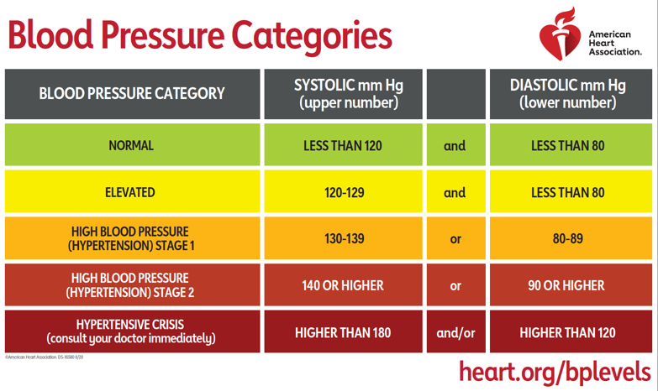

Image Description:

Table entitled “Blood Pressure Categories” showing which levels of Systolic and Diastolic blood pressure in mm Hg units correspond to which blood pressure category. Normal blood pressure is categorized as a systolic level of less than 120 and a diastolic level of less than 80. Elevated blood pressure corresponds to a systolic level of 120 to 129 and a diastolic level of less than 80. High blood pressure (hypertension) stage 1 corresponds to a systolic level of 130-139 or a diastolic level of 80-89. High blood pressure (hypertension) stage 2 corresponds to a systolic level of 140 or higher or a diastolic level of 90 or higher. A hypertensive crisis, for which you should consult your doctor immediately, corresponds to a systolic level higher than 180 and/or a diastolic level higher than 120.

# ID # ________________________ BP Date / /

Period: Baseline: □ Follow-up: □

**Generic Blood Pressure Form**

* 1. PREPARATION FOR BLOOD PRESSURE MEASUREMENTS
     1. Time of Blood Pressure measurements: ____ : ____ AM or PM (noon = 12:00 pm)
     2. Cuff size/type: Small (17-22 cm) ___ (1)   
        Medium (>22-32 cm) ___ (2)   
        Large(>32-42cm) ___ (3)   
        Extra large (>42-50 cm) ___ (4)

Circle Initial SV1 Cuff Size: 1 2 3 4

* + 1. Blood Pressure device # _______________

Wait five minutes seated.

* 1. FIRST BLOOD PRESSURE

SBP / DBP

* + 1. BP value ____ / ____ mm Hg
    2. b. Pulse rate ____ / ____ mm Hg

Wait 30 seconds.

* 1. SECOND BLOOD PRESSURE
     1. BP value ____ / ____ mm Hg
     2. b. Pulse rate . ____ / ____ mm Hg

Wait 30 seconds.

* 1. THIRD BLOOD PRESSURE
     1. BP value ____ / ____mm Hg
     2. b. Pulse rate ____ / ____ mm Hg
  2. Average of the SBP’s and DBP’s, Items 2a, 3a, and 4a ____ / ____ mm Hg

Escape Level #1 - If SBP >180 mmHG or DBP >110 mmHg, at any one visit, refer for medical care.

Escape Level #2 – SBP > 170 mmHg or DBP >105 mmHg, refer to medical care if repeat BP obtained within 7 days also exceeds this level.

BP verification by calculator Overall visit average (see #5 above) ____ / ____

Collected by (staff ID): _____________

Entered by (staff ID): _____________