**Attachment N: The Obesity & Type II Diabetes Risk Assessment Anthropometric Assessments (Adult)**

*If you require information to be presented in an accessible format or reasonable accommodations to participate in this study, please contact us with any specific requests by calling XXX-XXX-XXXX or emailing XXXX@XXXX.XXX. If you require language assistance to participate in this study, please contact us with any specific language assistance requests or needs.*

**Paperwork Reduction Act Burden Statement**

This collection of information is voluntary and will be used to evaluate the US Department of Housing and Urban Development’s Community Choice Demonstration. Public reporting burden for this collection of information is estimated to average 10 minutes per response, including the time for reviewing instructions, gathering, and maintaining the data needed, and reviewing the collection of information. An agency may not conduct or sponsor, and a person is not required to respond to, a collection of information unless it displays a currently valid OMB control number. The OMB number for this collection is OMB 2528-0337 which expires on XX/XX/XXXX. Send comments regarding this burden estimate or any other aspect of this collection of information, including suggestions for reducing this burden to NAME at [XXXX@XXXXX.XXX](mailto:XXXX@XXXXX.XXX) or call XXX-XXX-XXXX.

**Privacy Act Statement**

**Authority:**  Section 502 of the Housing and Urban Development Act of 1970 (Public Law 91-609) (12 U.S.C. §§ 1701z-1; 1701z-2(d) and (g)).

**Purpose:**  Evaluation of the Community Choice Demonstration (CCD).

**Routine Use:**  The information will be used for the purpose set forth above and may be provided to Congress or other Federal, state, and local agencies, when determined necessary.

**Disclosure:**  Records will be used for research and statistical analysis and will not be used to make decisions that affect the rights, benefits, or privileges of specific individuals.

**SORN ID:** Community Choice Demonstration Evaluation Data Files, HUD/PDR-09

Note: Some study activities are being funded by the National Institute of Diabetes and Digestive and Kidney Diseases.

|  |  |
| --- | --- |
| **Purpose:** To record adult participant’s height, weight and waist circumference  **When:** Baseline & follow-up  **By whom:** Staff | 1- Participant ID#: __ __ __ __ __ __ __ __  2- Date of visit: ___/___/____(mm/dd/yyyy)  Period: Baseline _____ Follow-up _____ |

Physical Measure Form

1. **Anthropometric Data**

**[INTERVIEWER INSTRUCTIONS:** Ask the participant to remove their shoes and heavy clothing (if applicable). Ask the participant to stand straight with their back against the wall, head forward, shoulders relaxed. Using a ruler or other straight measurement tool, align the participant’s nose in an imaginary straight line with the tragion or pinna of their ear (see image below for reference). Lower the base of the height meter to the head. If there is a lot of hair, a little pressure should be applied so the height meter touches the head. Mark down the first height measurement below. Ask the participant to step off the stadiometer, then step back on and repeat the alignment process to take the second measurement. If the first and second measurement agree within 0.2 cm, do not take a third measurement. If the first and second measurement do not agree within 0.2 cm, repeat these steps and record a third measurement. Average the measurements and mark on the tablet. .]

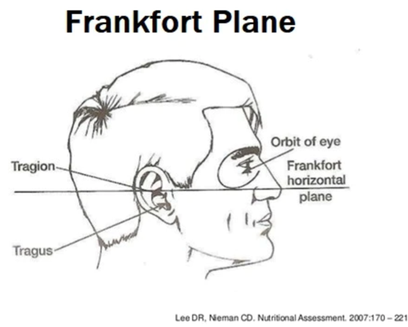

**Image Description:** Text at the top of the image reads "Frankfort Plane". Image displays a diagram of a person's head turned so that the right profile is visible. Text describes parts of head including Tragion, orbit of eye, and Tragus and associated lines point to these parts' location on the head. Text reading "Frankfort horizontal plane" is placed at the end of a horizontal line which divides the head in half. Citation reads Lee DR, Nieman CD, Nutritional Assessment, 2007:170 – 221.

1. **Height**
2. First height measurement: __ __ __.__ cm
3. Second height measurement: __ __ __.__ cm
4. (If needed) Third height measurement: __ __ __.__ cm

**Repeat test a third time if the two values are not within 0.2cm of each other**

**[INTERVIEWER INSTRUCTIONS:** Ask the participant to remove their shoes and heavy clothing (if applicable). Ask the participant to step on the digital scale and be as still as possible. Once the measurement is presented on the screen, record the number in the first weight measurement below. Ask the participant to step off the scale. Recalibrate the scale to 0.0, then ask the participant to step on the scale again. If the first and second measurements agree within 0.1 kg, do not take a third measurement. If the first and second measurements do not agree within 0.1 kg, repeat these steps and record a third measurement. Average the measurements and mark on the tablet.

1. **Weight**
2. First weight measurement: __ __ __._kg.
3. Second weight measurement: __ __ __.__kg.
4. (If needed) Third weight measurement: __ __ __.__kg.

**Repeat test a third time if the two values are not within 0.1kg of each**

[**INTERVIEWER INSTRUCTIONS:** Using a non-elastic tape measure, you will measure the participant’s waist circumference. To do this, ask the participant to remove any heavy clothing (if applicable) and breathe normally. Ask the participant if they are comfortable slightly adjusting their clothing so that you can see their umbilicus. This might require them to lift their shirt up or scoot their pants down. Ask the participant to wrap the tape around their body and hand it to you. If the participant is not comfortable showing their umbilicus, the measurement may be taken over their shirt. Keep the tape measure snug around the waist, but do not compress the body (i.e., do not squeeze the tape measure around the participant’s body). Record the measurement in centimeters where the tape measure crosses at the bellybutton. Remove the tape measure from the participant’s body and repeat these steps for a second measurement. If the first and second measurement agree within 0.5 cm, do not take a third measurement. If the first and second measurement do not agree within 0.5 cm, repeat these steps and record a third measurement. Average the measurements and mark on the tablet.

1. **Waist circumference**
   1. First waist measurement: __ __ __.__ cm
   2. Second waist measurement: __ __ __.__ cm
   3. (If needed): Third waist measurement: __ __ __.__ cm

**Repeat test a third time if the two values are not within 0.5cm of each other**

Entered by:

____________________________ ______________________ _______________________

Staff ID mm/dd/yyyy Signature