Supporting Statement – Part A

HEMP PRODUCTION AND DISPOSITION INQUIRY

OMB No. 0535-0270

The National Agricultural Statistics Service (NASS) is requesting an extension of 3 years to an ongoing annual data collection and publication of data related to Hemp from across the United States. This is a voluntary data collection.

A. JUSTIFICATION

1. Explain the circumstances that make the collection of information necessary. Identify any legal or administrative requirements that necessitate the collection. Attach a copy of the appropriate section of each statute and regulation mandating or authorizing the collection of information.

The 2018 Farm Bill requires USDA to promulgate regulations and guidelines to establish and administer a program for the production of hemp in the United States. As defined in the 2018 Farm Bill, the term “hemp” means the plant species Cannabis sativa L. and any part of that plant, including the seeds thereof and all derivatives, extracts, cannabinoids, isomers, acids, salts, and salts of isomers, whether growing or not, with a delta-9 tetrahydrocannabinol concentration of not more than 0.3 percent on a dry weight basis. Delta-9 tetrahydrocannabinol, or THC, is the primary intoxicating component of cannabis. Cannabis with a THC level exceeding 0.3 percent is considered marijuana, which remains classified as a schedule I controlled substance regulated by the Drug Enforcement Administration (DEA) under the Controlled Substances Act (CSA).

Under the Agricultural Act of 2014 (2014 Farm Bill), Public Law 113-79, State departments of agriculture and institutions of higher education were permitted to produce hemp as part of a pilot program for research purposes. The authority for hemp production provided in the 2014 Farm Bill was extended by the 2018 Farm Bill, which was signed into law on December 20, 2018.

Hemp is a commodity that can be used for numerous industrial and horticultural purposes including fabric, paper, construction materials, food products, cosmetics, production of cannabinoids (such as cannabidiol or CBD), and other products.

In determining the type of data that would need to be collected and the frequency of the data collections, NASS management attended a joint meeting with representatives from the USDA’s Economic Research Service (ERS), Farm Service Agency (FSA), Risk Management Agency (RMA), Agricultural Marketing Service (AMS), and the Office of the Secretary.

The data will be collected under the authority of the Domestic Hemp Production Program, which is mandated by the Agriculture Improvement Act of 2018 (2018 Farm Bill). In addition, the data will be collected under the authority of Title 7 U.S.C. 2204(a). Individually identifiable data collected under this authority are governed by Section 1770 of the Food Security Act of 1985 as amended, 7 U.S.C. 2276, which requires USDA to afford strict confidentiality to non-aggregated data provided by respondents. This Notice is submitted in accordance with the Paperwork Reduction Act of 1995, Public Law 104-13 (44 U.S.C. 3501, et seq.), and Office of Management and Budget regulations at 5 CFR part 1320.

2. Indicate how, by whom, and for what purpose the information is to be used. Except for a new collection, indicate the actual use the agency has made of the information received from the current collection.

The purpose of the survey is to publish national and State estimates of the hemp planted and produced. The survey is conducted annually. The questionnaires used for this survey will collect data for hemp produced in the open as well as under cover (greenhouses, low or high tunnels, hoop houses, etc.). Hemp produced in the open will have data collected for five categories of hemp (flower, grain, fiber, seed, and other). Hemp produced under cover will have data collected for four categories of hemp (flower, clones or transplants, seed, or other). Similar questions will be asked for these different categories relating to amount harvested and prices received for each of the crops. In addition, there will be some demographic questions about the operator.

3. Describe whether, and to what extent, the collection of information involves the use of automated, electronic, mechanical, or other technological collection techniques or other forms of information technology, e.g., permitting electronic submission of responses, and the basis for the decision for adopting this means of collection. Also describe any consideration of using information technology to reduce burden.

Respondents can complete the Hemp questionnaire by any of the following methods: Computer Aided Web Interviewing (CAWI), Computer Assisted Telephone Interview (CATI), FAX, or by paper/mail. NASS will utilize enumerators to do follow-up contacts either by phone or face to face interviews of non-respondents. In 2023, 8.0% of the respondents were by internet.

4. Describe efforts to identify duplication. Show specifically why any similar information already available cannot be used or modified for use for the purposes described in Item 2 above.

The National Agricultural Statistics Service cooperates with State Departments of Agriculture and land grant universities to conduct agricultural surveys. These surveys meet both State and federal needs, thus eliminating duplication and minimizing reporting burden on the agriculture industry. NASS’s Frames Maintenance Group (FMG) worked with NASS’s State and Regional Field Offices, State Departments of Agriculture, and Tribal offices to create a comprehensive listing of hemp producers. FMG removed any duplication of names and addresses to create the master listing of producers for this survey.

5. If the collection of information impacts small businesses or other small entities (Item 5 of OMB Form 83-I), describe any methods used to minimize burden.

This information collection will not have a significant economic impact on small entities. Out of the estimated universe size of 8,500, approximately 90% are estimated to be classified as small operations by the Small Business Administration.

6. Describe the consequence to Federal program or policy activities if the collection is not conducted or is conducted less frequently, as well as any technical or legal obstacles to reducing burden.

Authority for hemp production was provided in the 2014 Farm Bill and was extended by the 2018 Farm Bill. Hemp is a commodity that can be used for numerous industrial and horticultural purposes including fabric, paper, construction materials, food products, cosmetics, production of cannabinoids (such as cannabidiol or CBD), and other products. This is a new commodity to most current farm operators. No comprehensive data sets are available for this commodity. As new consumer markets are developed, the need for annual data on acreage and production are highly sought after. Data collected less than annually would interfere with the mandate stated in the 2018 Farm Bill.

7. Explain any special circumstances that would cause an information collection to be conducted in a manner inconsistent with the general information guidelines in 5 CFR 1320.5.

There are no special circumstances associated with this information collection.

8. Provide a copy and identify the date and page number of publication in the Federal Register of the agency's notice, required by 5 CFR 1320.8 (d), soliciting comments on the information collection prior to submission to OMB. Summarize public comments received in response to that notice and describe actions taken by the agency in response to these comments.

The Federal Register Notice soliciting comments was published on February 23, 2024 on pages 13686 – 13687. No public comment was received.

Describe efforts to consult with persons outside the agency to obtain their views on the availability of data, frequency of collection, the clarity of instructions and record-keeping, disclosure, or reporting format (if any), and on the data elements to be recorded, disclosed, or reported.

The content of the Hemp Production and Disposition Inquiry questionnaire was developed through input sought from NASS Regional Offices, USDA subject matter experts, industry organizations, and numerous data users. NASS Field Enumerators have provided feedback on previous surveys from comments made by respondents as to improvements or clarifications that could be made, to make the questionnaires more user friendly and flow better. Regional and State directors will attend industry meetings or trade shows and seek input from growers.

9. Explain any decision to provide any payment or gift to respondents.

There are no payments or gifts to respondents.

10. Describe any assurance of confidentiality provided to respondents and the basis for the assurance in statute, regulation, or agency policy.

Questionnaires include a statement that individual reports are confidential. U.S. Code Title 18, Section 1905; U.S. Code Title 7, Section 2276; and the Confidential Information Protection and Statistical Efficiency Act of 2018, Title III of Pub. L. No. 115-435, codified in 44 U.S.C. Ch. 35 and other applicable Federal laws. All employees of NASS and all enumerators hired and supervised under a cooperative agreement with the National Association of State Departments of Agriculture (NASDA) must read the regulations and sign a statement of compliance.

The following CIPSEA Pledge statement will appear on all future NASS questionnaires.

The information you provide will be used for statistical purposes only. Your responses will be kept confidential and any person who willfully discloses ANY identifiable information about you or your operation is subject to a jail term, a fine, or both. This survey is conducted in accordance with the Confidential Information Protection and Statistical Efficiency Act of 2018, Title III of Pub. L. No. 115-435, codified in 44 U.S.C. Ch. 35 and other applicable Federal laws. For more information on how we protect your information please visit: https://www.nass.usda.gov/confidentiality.

All individuals who may access these confidential data for research are also covered under Titles 18 and CIPSEA and must complete a Certification and Restrictions on Use of Unpublished Data (form ADM-043) agreement.

11. Provide additional justification for any questions of a sensitive nature.

There are no questions of a sensitive nature.

12. Provide estimates of the hour burden of the collection of information. The statement should indicate the number of respondents, frequency of response, annual hour burden, and an explanation of how the burden was estimated. If this request for approval covers more than one form, provide separate hour burden estimates for each form and aggregate the hour burdens in Item 13 of OMB Form 83-I. Provide estimates of annualized cost to respondents for the hour burdens for collections of information, identifying and using appropriate wage rate categories.

Burden hour calculations are shown below. Cost to the public of completing the questionnaire is assumed to be comparable to the hourly rate of those requesting the data. Reporting time of 2,918 hours is multiplied by $42.75 per hour for a total cost to the public of $124,744.50.

NASS uses the Bureau of Labor Statistics’ Occupational Employment Statistics (most recently published on April 3, 2024 for the previous May) to estimate an hourly wage for the burden cost. The May 2023 mean wage for bookkeepers was $23.84. The mean wage for farm managers was $43.35. The mean wage for farm supervisors was $29.23. The mean wage of the three is $32.14. To calculate the fully loaded wage rate (includes allowances for Social Security, insurance, etc.) NASS will add 33% for a total of $42.75 per hour.

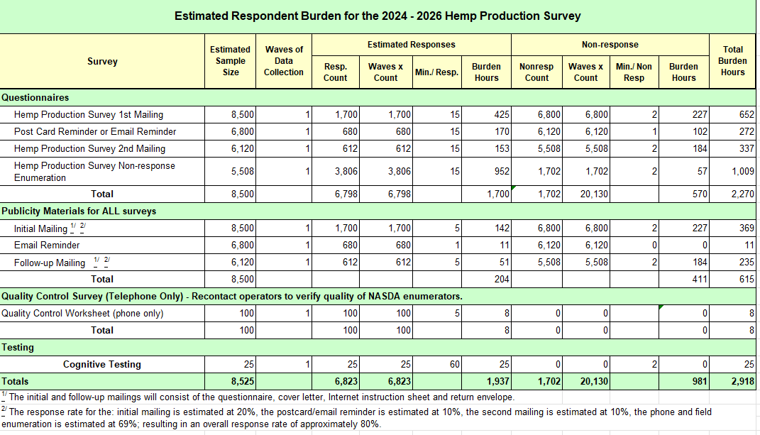
13. Provide an estimate of the total annual cost burden to respondents or record-keepers resulting from the collection of information.

There are no capital/start-up or ongoing operation/maintenance costs associated with this information collection.

14. Provide estimates of annualized cost to the Federal government; provide a description of the method used to estimate cost which should include quantification of hours, operational expenses, and any other expense that would not have been incurred without this collection of information.

The total cost to the Federal Government for the 2023 Hemp Acreage and Production Survey is approximately $1,500,000. About $737,000 is for Federal salaries (includes Social Security, taxes, insurance, etc.), $290,000 for telephone and field enumeration by National Association of State Departments of Agriculture (NASDA) enumerators (includes overhead), and $473,000 for printing, postage, paper, promotional materials, equipment maintenance, data enclave, data processing, etc.

15. Explain the reasons for, any program changes or adjustments reported in Items 13 or 14 of the OMB Form 83-I (reasons for changes in burden).

Program Changes: Sample Size Reduction - By improving the list frame from the original IC in 2021, NASS has been able to reduce the sample size from 20,000 to 8,500.
Adjustments: Presurvey Postcard Discontinued - Previously, NASS sent out postcards to potential growers before the main survey. This practice has been discontinued.

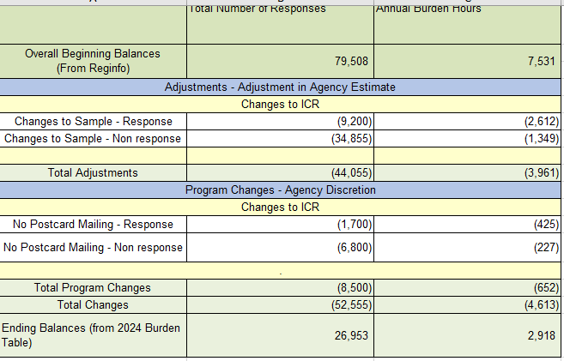

16. For collections of information whose results will be published, outline plans for tabulation and publication. Address any complex analytical techniques that will be used. Provide the time schedule for the entire project, including beginning and ending dates of the collection of information, completion of report, publication dates, and other actions.

The initial mail-out of report forms will occur at the end of January. Tabulations will be generated at the State, Region, and National levels. The publication is available on-line at:

The National Hemp Report

Publication | National Hemp Report | ID: gf06h2430 | USDA Economics, Statistics and Market Information System (cornell.edu)

Timetable for the 2025 Hemp PDI

Questionnaire design September 2024
Systems Development Nov 2024 - Jan 2025
Initial Mail-out End of Jan 2025
Email Reminder Feb 2025
Telephone, Personal Interviews Feb 2025
Review Tables April 2025
Prepare Publication and Review April 2025
Publish Report …………………… April 2025

17. If seeking approval to not display the expiration date for OMB approval of the information collection, explain the reasons that display would be inappropriate.

No approval is requested for non-display of the expiration date.

18. Explain each exception to the certification statement identified in Item 19, “Certification for Paperwork Reduction Act Submissions” of OMB Form 83-I.

There are no exceptions to the certification statement.

May 2024

