0MB No. 0535-0236 Exp. Date XX/XX/20XX



# 24-A0624(PS2)

(02-15-2025)

Dear Producer,

There is still time to complete the 2024 Census of Horticultural Specialties - **the deadline has been extended to April 18**. If you have already responded, thank you. If you are no longer involved in any horticultural operations, or need assistance completing this questionnaire, please call us toll free at 888-424-7828 so we can update our records.

If not, **to avoid further contact by phone or in-person please respond promptly using the directions shown below by April 18, 2025**.

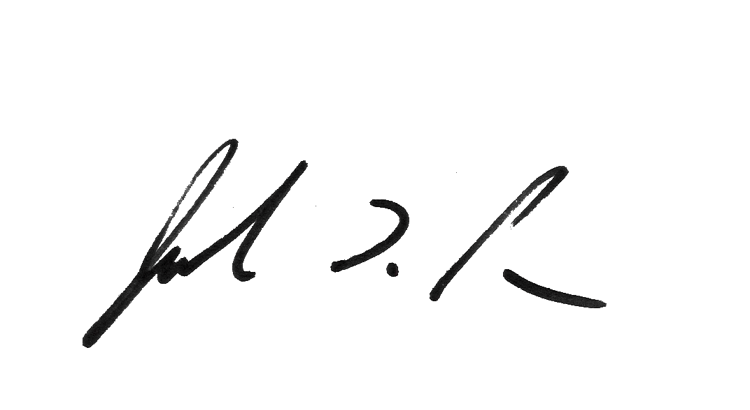Everyone who receives this questionnaire is **required by law** (Title 7 USC 2204(g) Public Law 105-113) to respond. **All information you provide is confidential, protected by federal law** (Title III of Pub. L. No. 115-435, codified in 44 U.S.C. Ch. 35), and will be used for statistical purposes only. We will publish the data at nass.usda.gov on December 16, 2025. To access past data or more information about this survey, visit nass.usda.gov/AgCensus.

Sincerely,

Joe Parsons, Administrator

National Agricultural Statistics Service

U.S. Department of Agriculture

**Online reporting is fast and secure. To complete your survey, follow these steps:**

1. Go to **agcounts.usda.gov**.
2. Enter your Survey Code:
3. Select **Submit & Get Survey(s)**.
4. Find the **2024** **Census of Horticultural Specialties** and select **Start Survey**.
5. Follow the survey prompts.
6. Complete the survey through the conclusion section and select **Submit Survey**.

According to the Paperwork Reduction Act of 1995, an agency may not conduct or sponsor, and a person is not required to respond to a collection of information unless it displays a valid 0MB control number. The valid 0MB number is 0535-0236. The time required to complete this information collection is estimated to average 50 minutes, including the time for reviewing instructions, searching existing data sources, gathering, and maintaining the data needed, and completing and reviewing the collection of information.

# National Agricultural Statistics Service

PRESORTED FIRST-CLASS MAIL

POSTAGE & FEES PAID USDA

Permit No. G-38

1201 E 10th St

Jeffersonville, IN 47133

OFFICIAL BUSINESS

Penalty for Private Use $300

**23-AQ(PS)** (09-2023) **FORWARDING SERVICE REQUESTED**