2023 Workplace and Gender Relations Survey of Military Members
Welcome Screen (expanded links)
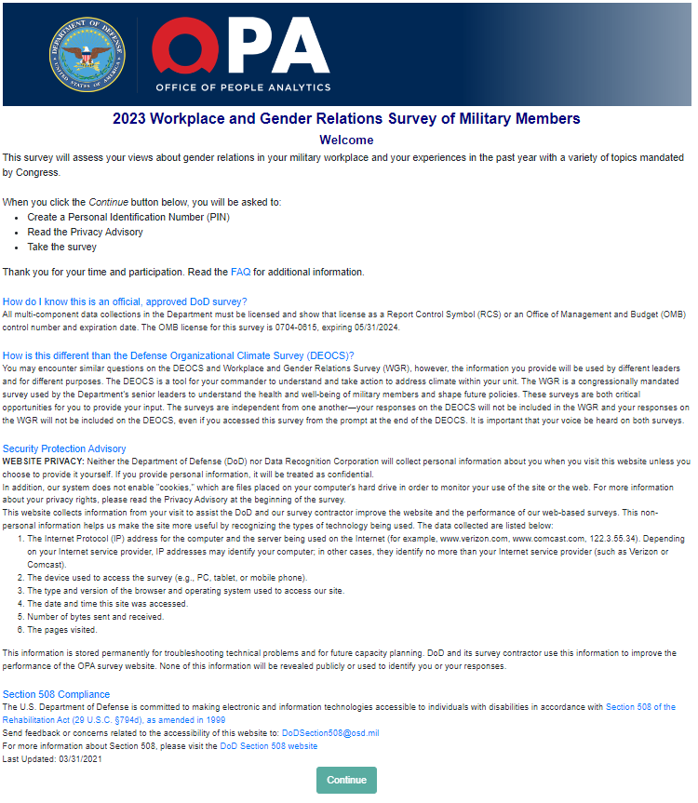

Privacy Advisory
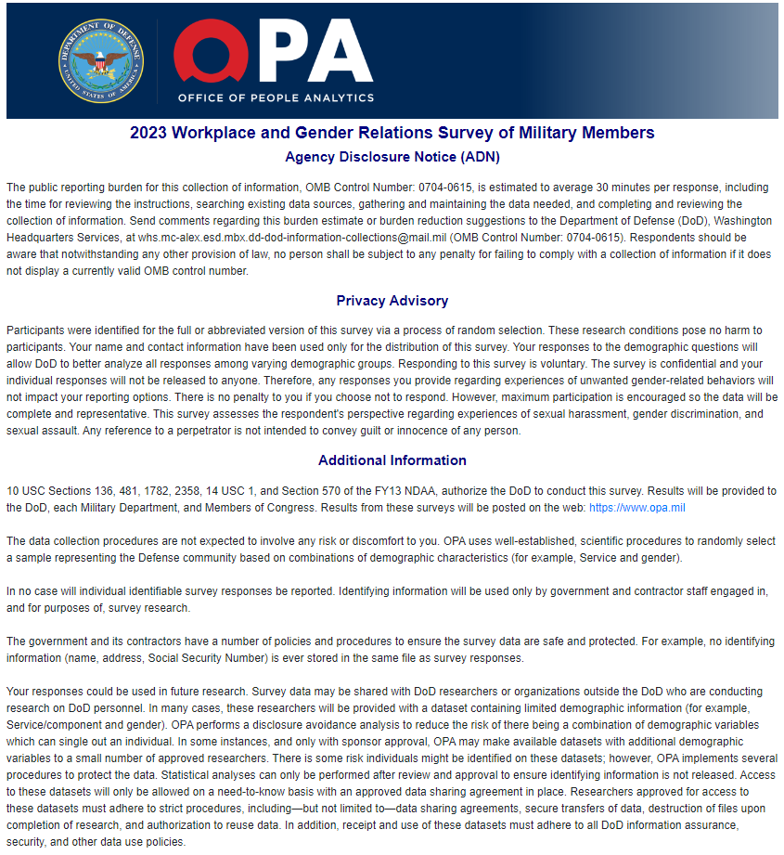

Privacy Advisory (continued)
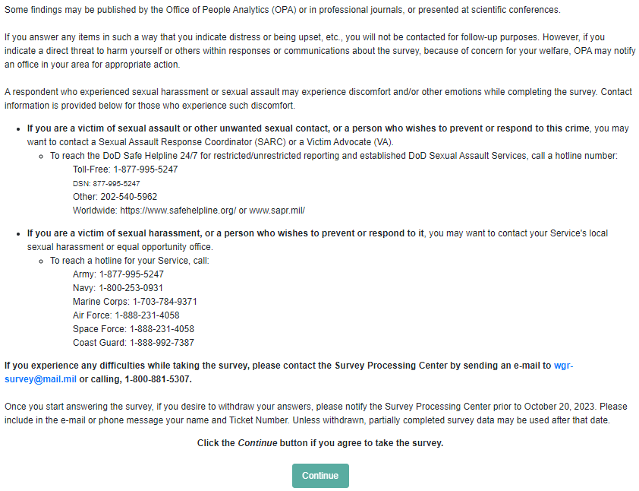

Frequently Asked Questions
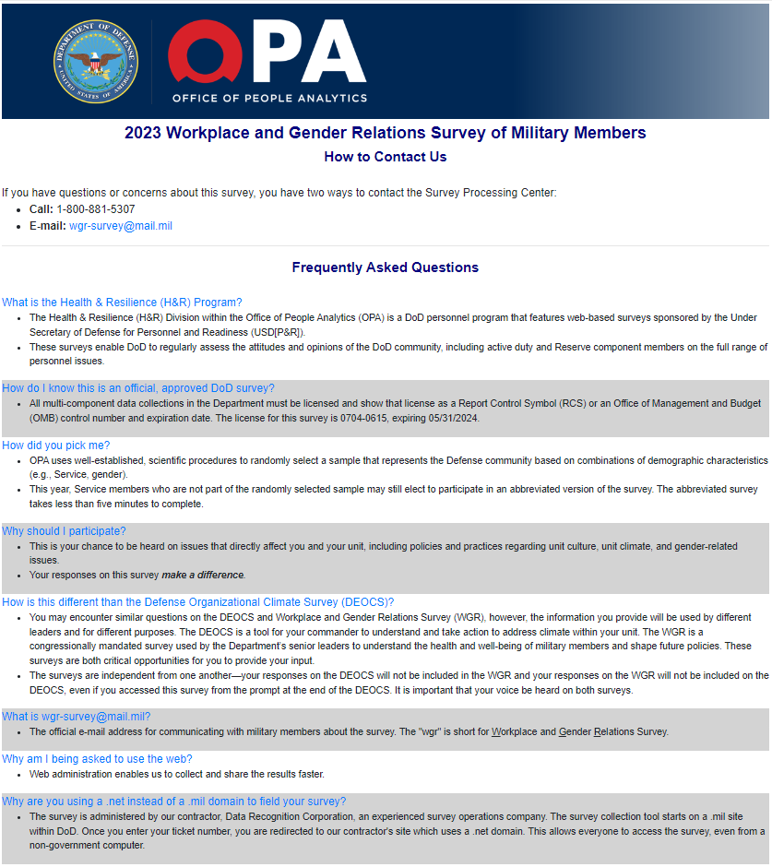

Frequently Asked Questions (Continued)
