Attachment 6a: CRCCP Quarterly Program Update (Screenshots)

Welcome Page and Section 1. Respondent Information

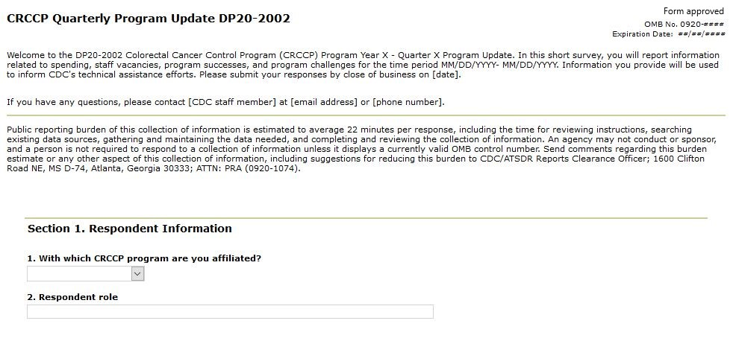

Section 2. Award Spending

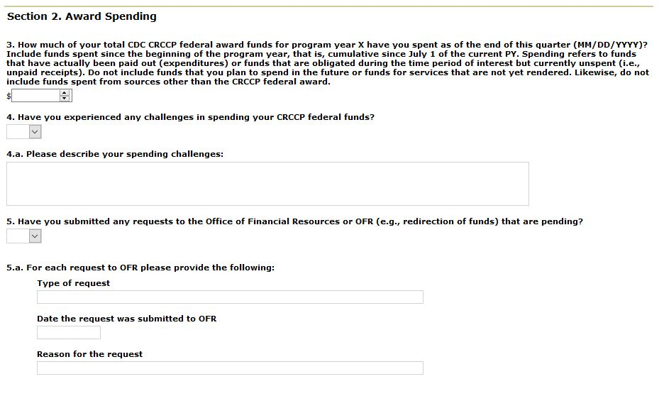

Section 3. Staff Vacancies

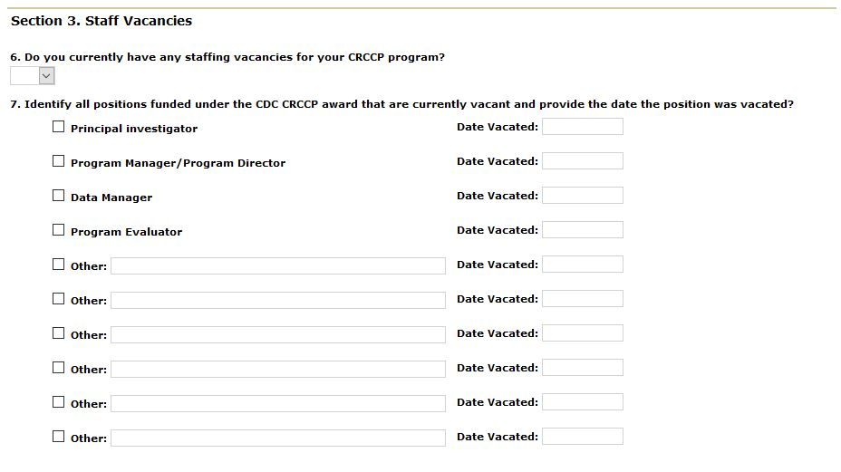

Sections 4-6:

Section 4. Program Success and Challenges
Section 5. Technical Assistances Needs
Section 6. COVID-19

