Attachment 5a: CRCCP Clinic-level Data Collection Instrument (Screenshots)

About Page

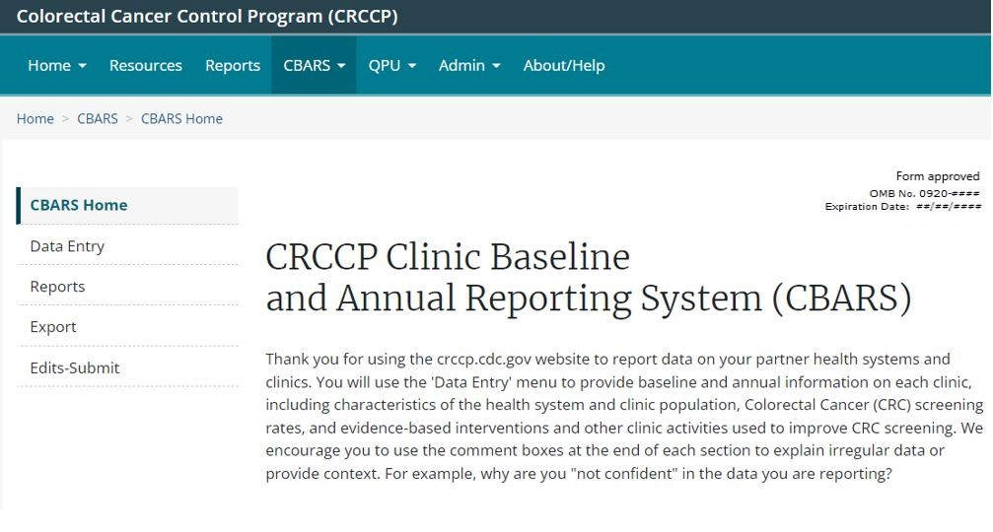

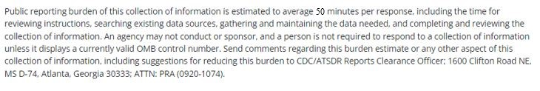

Health System

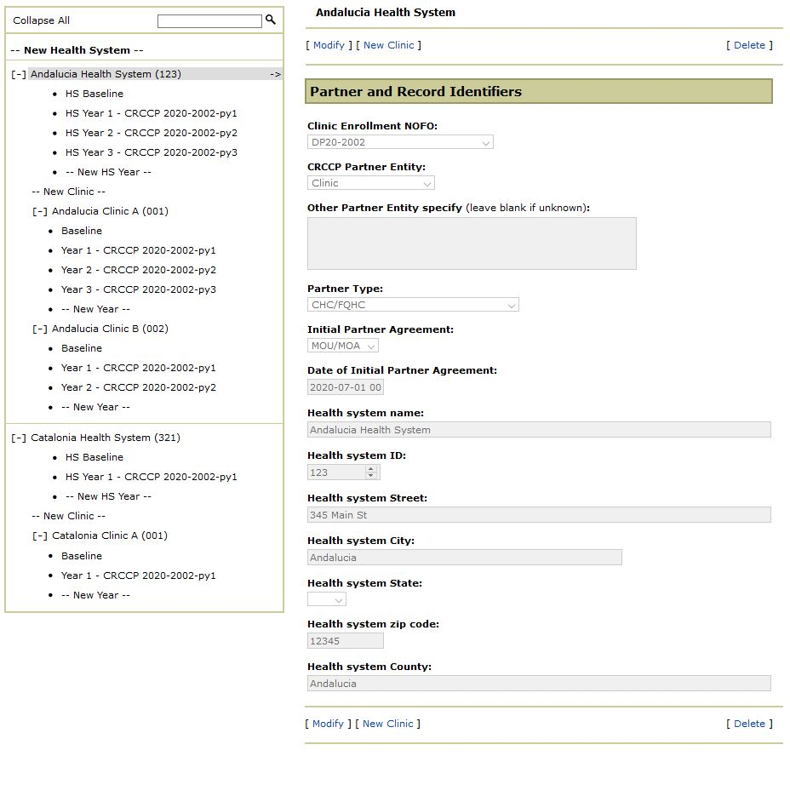

Health System (HS) Baseline

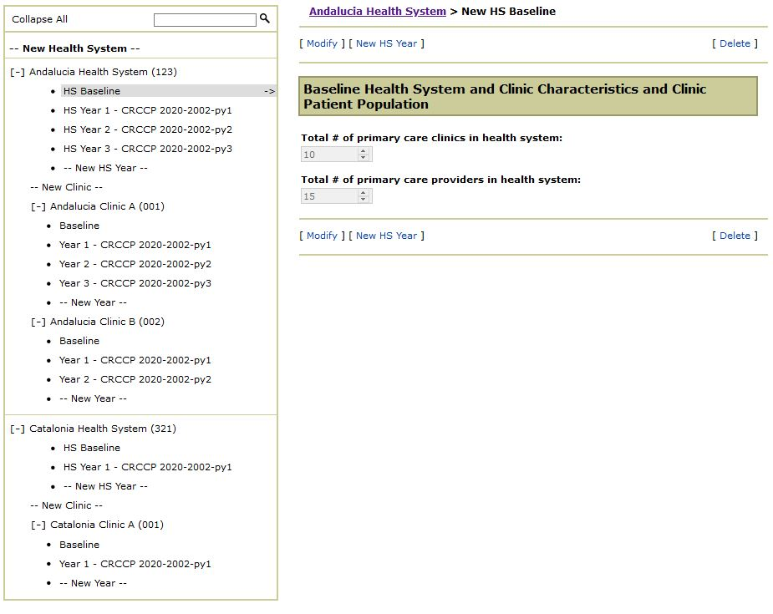

Health System (HS) Annual

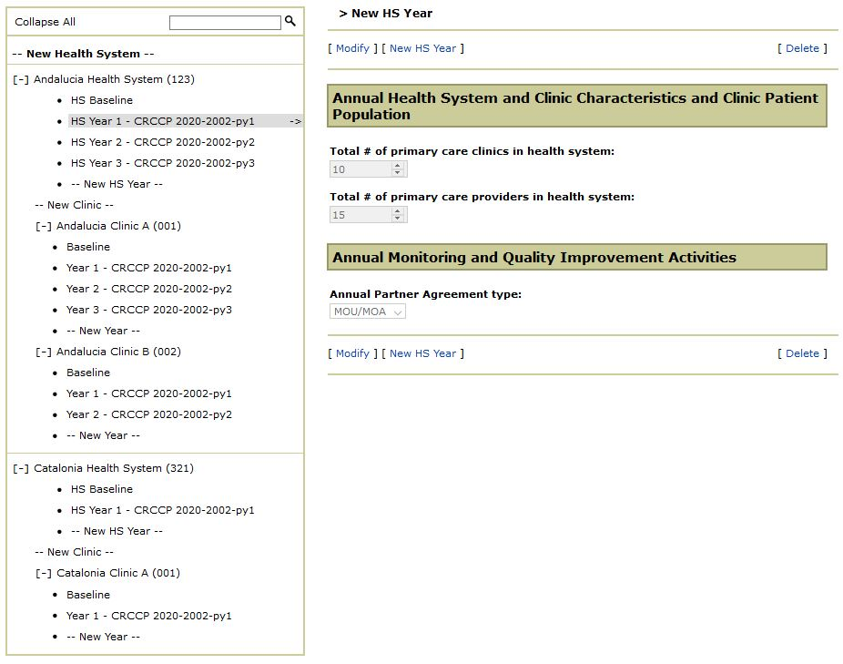

Clinic Information

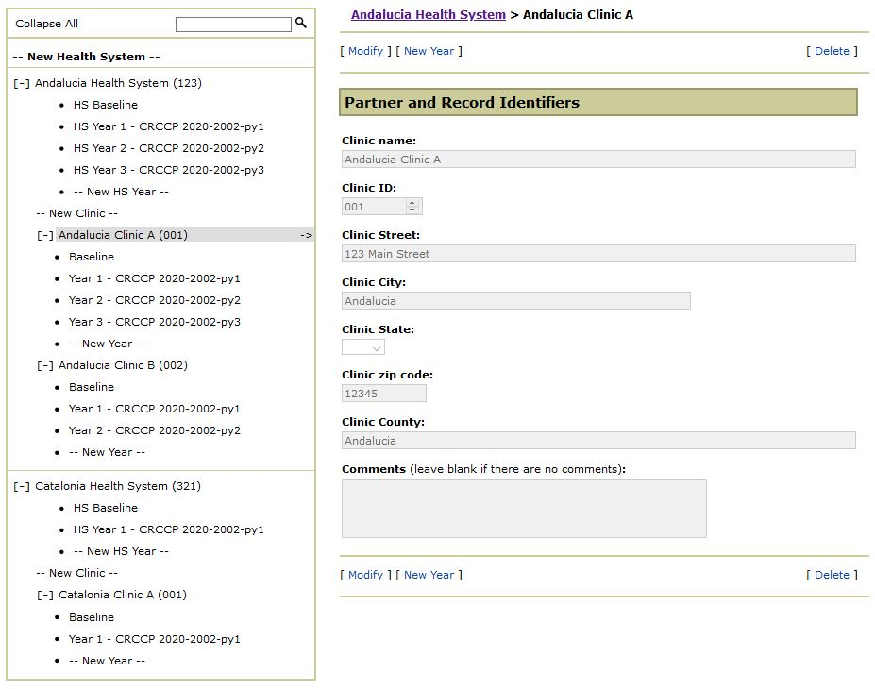

Baseline (part 1 – Clinic CRCCP Activity and Status)

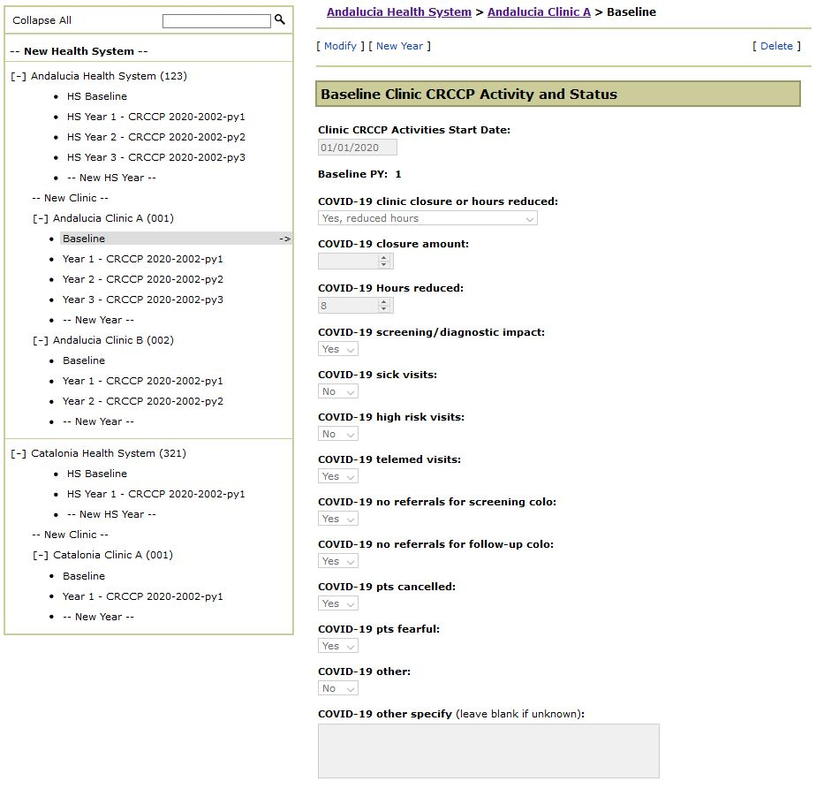

Baseline (part 2 – Clinic CRCCP Activity and Status continued)

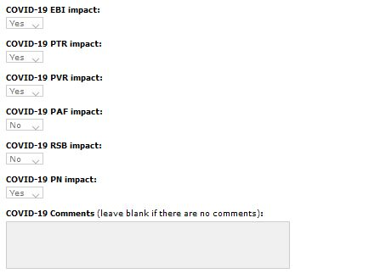

Baseline (part 3 – Health System and Clinic Characteristics and Clinic Patient Population)

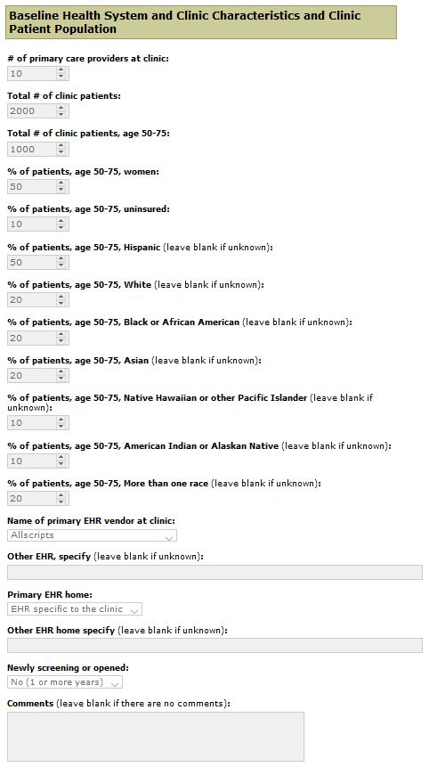
Baseline (part 4 – CRC Screening Rates and Practices)

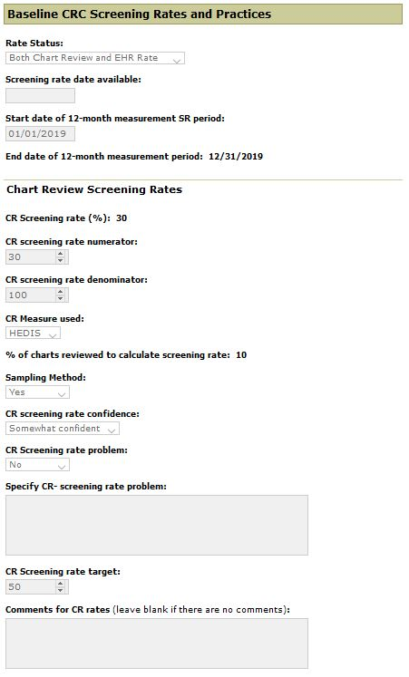

Baseline (part 5 – CRC Screening Rates and Practices continued)

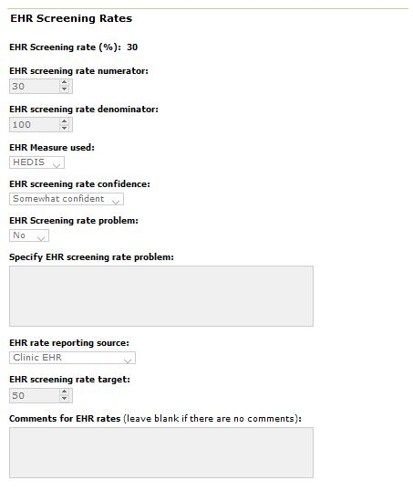

Baseline (part 6 – CRC Screening Rates and Practices continued)
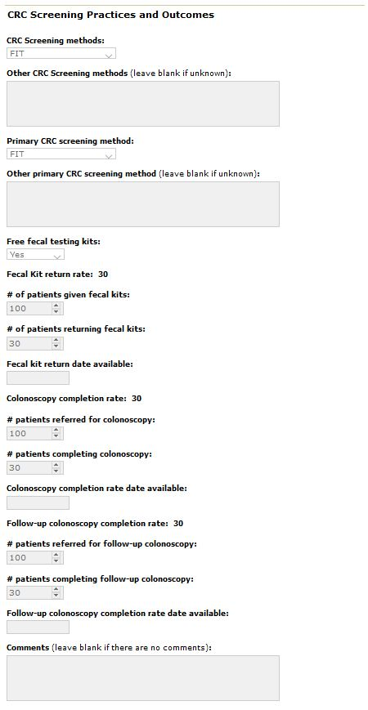
Baseline (part 7 – Monitoring and Quality Improvement Activities and EBIs and Other Clinic Activities)

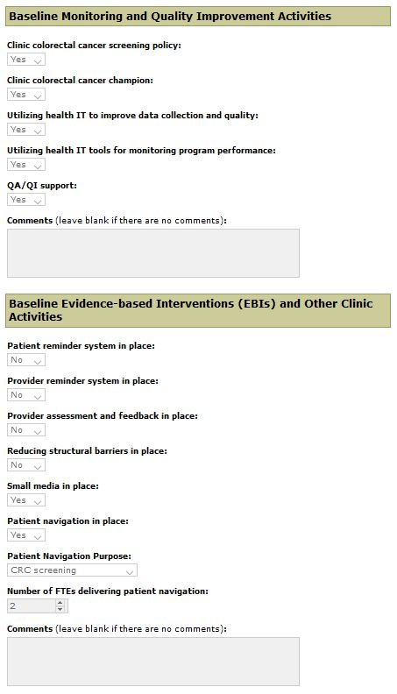

Baseline (part 8 – Other Colorectal Cancer Activities and Comments)

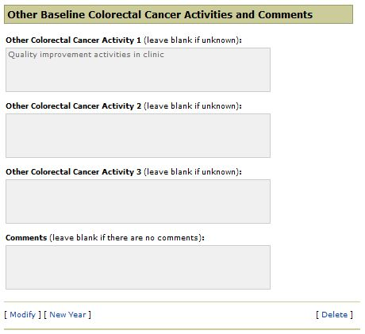

Annual (part 1 – Clinic CRCCP Activity and Status)

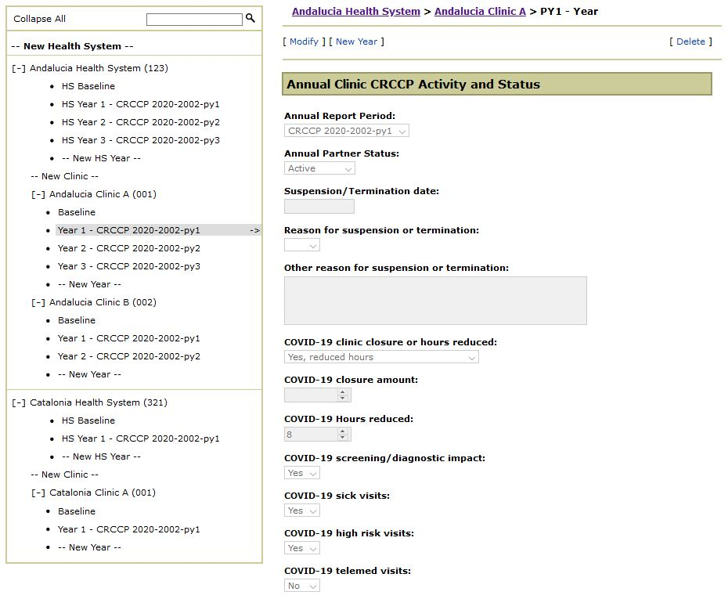

Annual (part 2 – Clinic CRCCP Activity and Status continued)

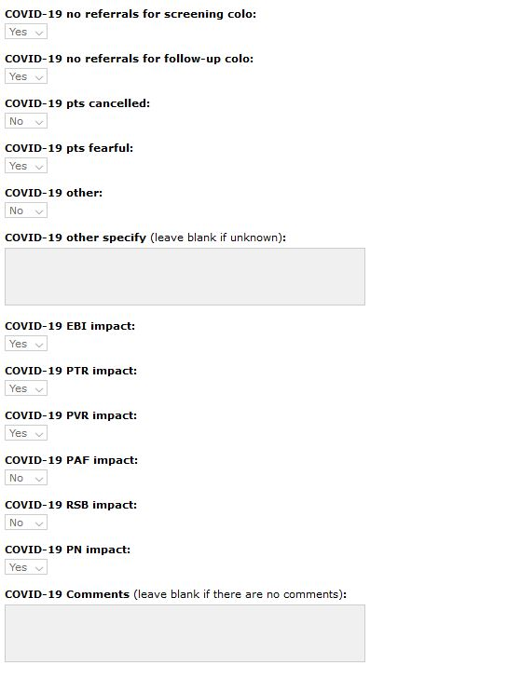

Annual (part 3 – Health System and Clinic Characteristics and Clinic Patient Population)

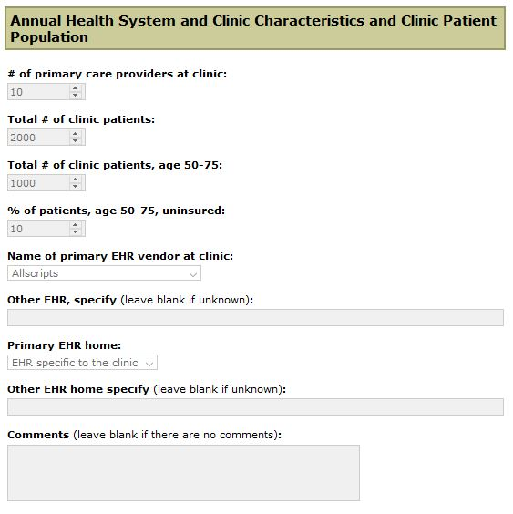

Annual (part 4 – CRC Screening Rates and Practices)
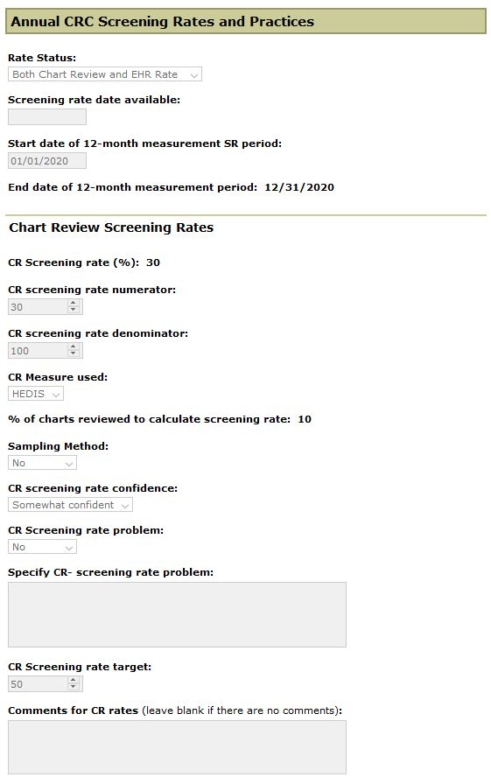
Annual (part 5 – CRC Screening Rates and Practices continued)

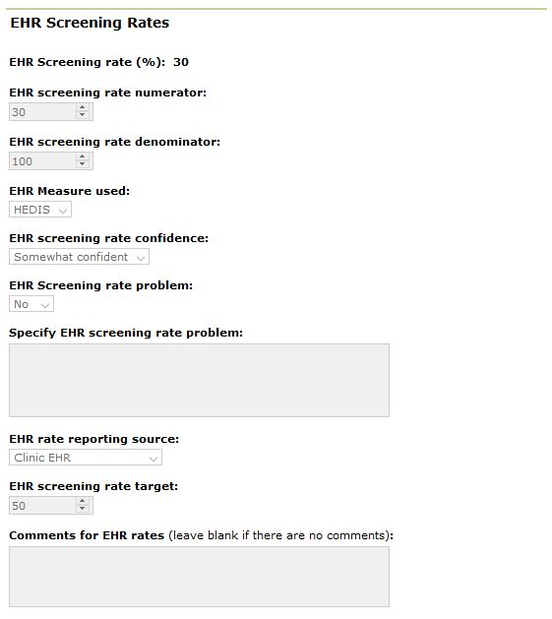

Annual (part 6 – CRC Screening Rates and Practices continued)

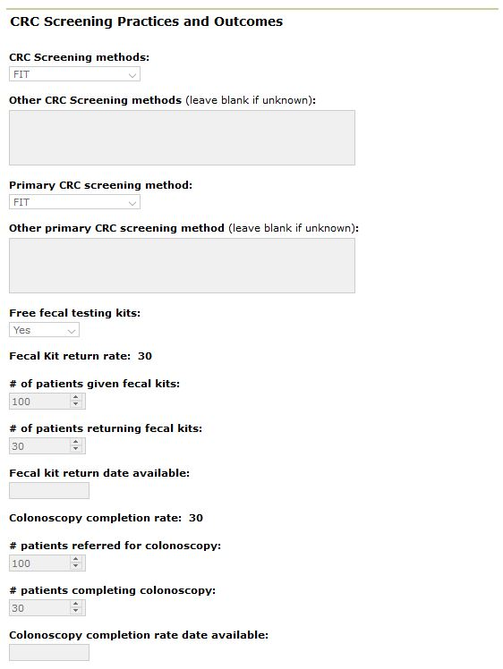

Annual (part 7 – CRC Screening Rates and Practices continued)

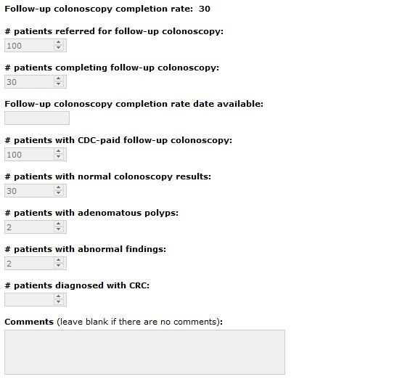

Annual (part 8 – Monitoring and Quality Improvement Activities)

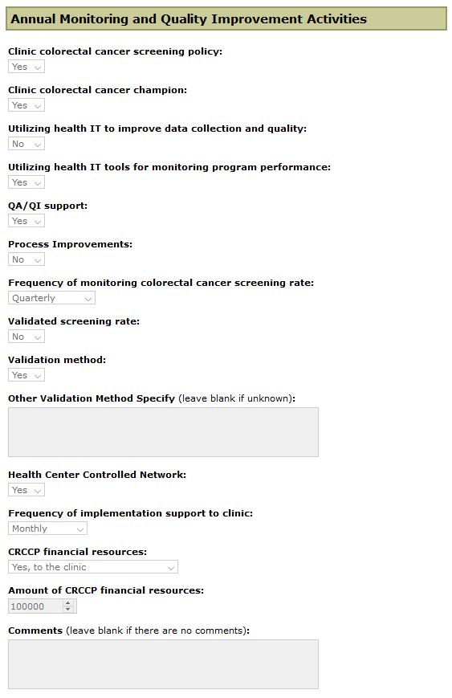
Annual (part 9 – EBIs and Other Clinic Activities)

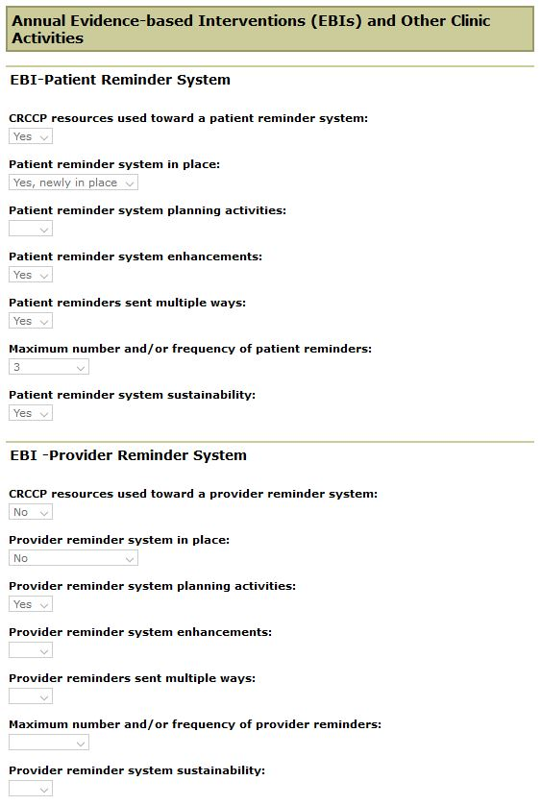

Annual (part 10 – EBIs and Other Clinic Activities continued)

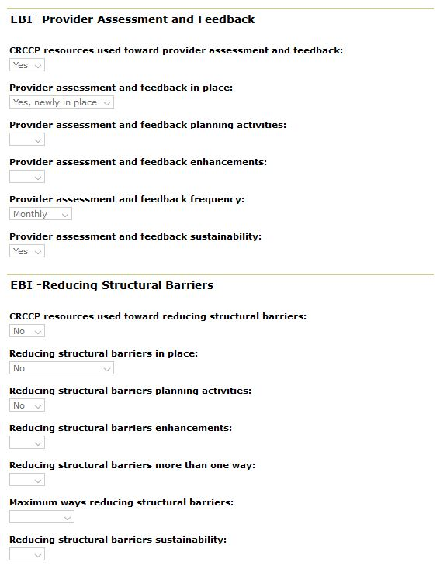

Annual (part 11 – EBIs and Other Clinic Activities continued)
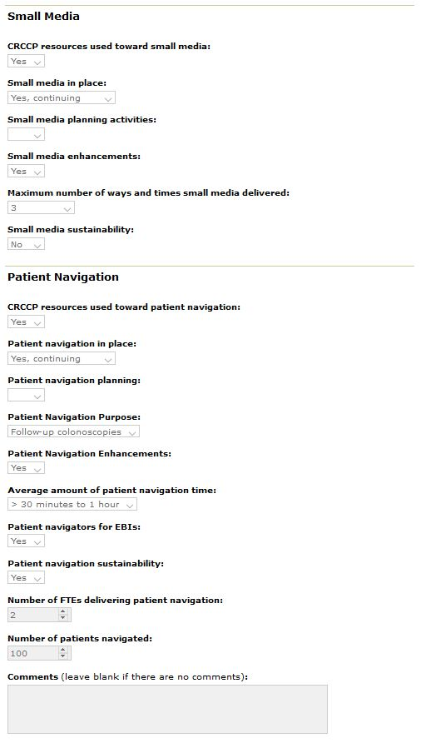
Annual (part 12 – Annual Implementation Factors)

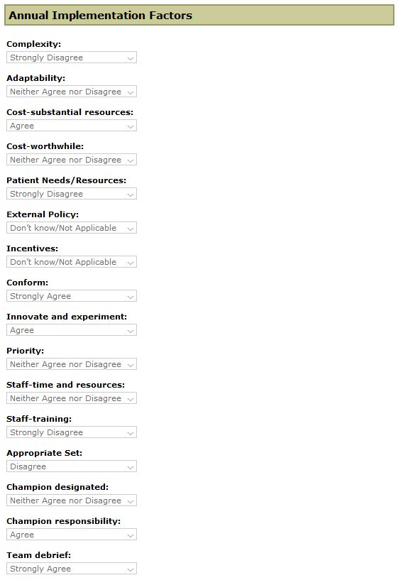

Annual (part 13 – Other Colorectal Cancer Activities and Comments)

