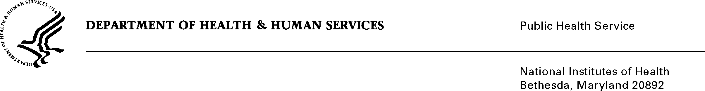
DATE: 22 May 2024

TO: NIH OMB Desk Officer
Office of Management and Budget (OMB)
Reports Clearance Officer, DHHS

FROM: Mikia P. Currie
Chief, Project Clearance Branch

SUBJECT: NIH Office of Intramural Training & Education - Application, Registration, and Alumni Systems
OMB Number: 0925-0299
Expiration Date: 31 March 2027

This is a request for OMB to approve a modification of “NIH Office of Intramural Training & Education (OITE) - Application, Registration, and Alumni Systems”, specifically the “Trainee - Onboarding Survey”. The OITE wishes to update this collection form to use the newly implemented “Revisions to OMB’s Statistical Policy Directive No. 15: Standards for Maintaining, Collecting, and Presenting Federal Data on Race and Ethnicity”. Specifically, the OITE intends to replace all race/ethnicity questions Figure-1 (see below).

Figure-1: What is your race and/or ethnicity?
- American Indian or Alaska Native
For example: Navajo Nation, Blackfeet Tribe of the Blackfeet Indian Reservation of Montana, Native Village of Barrow Inupiat Traditional Government, Nome Eskimo Community, Aztec, Maya, etc…

- Asian
For example: Chinese, Asian Indian, Filipino, Vietnamese, Korean, Japanese, etc…
- Black or African American
For example: African American, Jamaican, Hatian, Nigerian, Ethiopian, Somali, etc…
- Hispanic or Latino
For example: Mexican, Puerto Rican, Salvadoran, Cuban, Dominican, Guatemalan, etc…
- Middle Eastern or North African
For example: Lebanese, Iranian, Egyptian, Syrian, Iraqi, Israeli, etc…
- Native Hawaiian or Pacific Islander
For example: Native Hawaiian, Samoan, Chamorro, Tongan, Fijian, Marshallese, etc…
- White
For example: English, German, Irish, Italian, Polish, Scottish, etc…

Your full consideration is appreciated.

NIH Office of Intramural Training & Education (OITE)
Website: https://training.nih.gov
Email: OITE@nih.gov

