Social Security Administration Logo

Design Specifications Document

PRW Systems Update  
V1.3



**Table of Contents**

1. Design Specification Document Version Information 4

2. About this Document 5

3. Using the Interactive Prototype Associated with this Document 6

4. A Brief Overview of the Proposed Design 7

5. Pages 8

5.1. pin001 - 1 - Personal Information 9

5.2. pin001 - 3 - Personal Information 13

5.3. alg001 - 1 - Conditions 17

5.4. alg001 - 3 - Conditions 19

5.5. alg001 - 1 - Conditions (show metric) 21

5.6. alg001 - 3 - Conditions (show metric) 23

5.7. con001 - 1 - Other Contact 25

5.8. con001 - 3 - Other contact 30

5.9. doc001 - 1 - Doctors Start 35

5.10. doc001 - 3 - Doctors Start 36

5.11. doc002 - 1 - Doctor Information 37

5.12. More Info - Name of Health Care Provider 40

5.13. More Info - conditions 41

5.14. doc002 - 3 - Doctor Information 42

5.15. hos001 - 1 - Hospitals 45

5.16. hos001 - 3 - Hospitals 46

5.17. hos002 - 1 - Hospital Information 47

5.18. More Info - Name of Health Care Provider-facility 50

5.19. More Info - treatments 51

5.20. hos002 - 3 - hospital information 52

5.21. tst001 - 1 - Tests 55

5.22. More Info - Tests 56

5.23. tst001 - 3 -Tests 59

5.24. tst002 - 1 - Test Details 60

5.25. tst002 - 3 - Test Details 61

5.26. med001 - 1 - Medicines 62

5.27. med001 - 3 -Medicines 63

5.28. med002 - 1 - Medicine Details 64

5.29. msc001 - 1 - Other Medical Records 65

5.30. msc001 - 3 - Other Medical Records 66

5.31. msc002 - 1 - Other Med Recs Details 67

5.32. msc002 - 3 - Other Med Recs Details 70

5.33. win001 - 1 - Work/Education Intro 73

5.34. win001 - 3 - Work/Education Intro 74

5.35. wac001 - 1 - cw - Work Activity 75

5.36. More Info - work changes 77

5.37. More Info - work stop reasons 78

5.38. wac001 - 3 - cw - Work Activity 79

5.39. wac001 - 1 - sw - Work Activity 81

5.40. wac001 - 3 - sw - Work Activity 82

5.41. job001 - 1 - cw&sw - Job History 83

5.42. More Info - Task 88

5.43. More Info - Supervisor 89

5.44. More Info - Equipment 90

5.45. More Info - Interaction 91

5.46. job001 - 3 - cw&sw - Job History 92

5.47. edu001 - 1 - Education 97

5.48. edu001 - 3 - Education 102

5.49. rvw-001-1 - Review 107

5.50. rvw-001- 3 - Review 112

6. Additional Design Info 118

6.1. Dialog Boxes / Notices 118

6.2. Error Messages / Error Handling Info 118

6.3. Other 118

7. Style Guides 119

8. Appendix A - UXG Contact Information for Analysts, Developers and Others 120

9. Appendix B – Project-Related Resources 121

10. Appendix C – Reference Materials 122

11. Appendix D – Glossary of Terms, Acronyms 123

1. Design Specification Document Version Information

The first release of this design specifications document as a project deliverable is numbered 1.0.

Subsequent revisions are numbered 1.1, 1.2, 1.3, etc. Content revisions are listed below with corresponding page numbers.

[Any circulating drafts should be noted with a DRAFT watermark and numbered 0.1, 0.2, 0.3, etc.]

|  |  |  |  |  |
| --- | --- | --- | --- | --- |
| **Version  Number** | **Date** | **Content Revisions** | **Page  #** | **Revised by** |
| 1. (First Release) | 1/12/2024 | First version (baseline). First party only. |  |  |
| 1.1 (First Revision) | 2/5/2024 | Response to edits made by Policy on 1/22/2024 First party only. |  |  |
| 1.2 | 2/5/2024 | Updated language on job001 sw&cw. First party only |  |  |
| 1.3 | 3/29/2024 | Added 3rd party screens. Updated 1st party screens. |  |  |

1. About this Document

**Intended Audience**: This design specifications document is intended to serve the needs of SSA developers building user interfaces, especially those working with the User Experience Framework (UEF). It contains information that can also be useful to analysts, validation staff, and other project team members.

**Intended Use**: Use this document in conjunction with the other UXG-related project resources (most notably the online interactive prototype) to guide development of the user interfaces designed by the UXG. See the next section of this document for a link to the prototype.

**What’s Included/What’s Not**: The screen captures and accompanying information included in this design specifications document relate only to the user interface portion(s) of the project that the UXG has been tasked to research, design, prototype and/or evaluate. Therefore, not all project-related web pages, application screens, menus, interactions, conditions and/or variances may be illustrated and explained in this document. In addition, user entries and data displays are simulated. Refer to the related business process documentation and functional requirements for supplemental information. Please contact the UXG Team Lead and your Project Manager regarding design-related issues that are not addressed in this document.

1. Pages
   1. pin001 - 1 - Personal Information

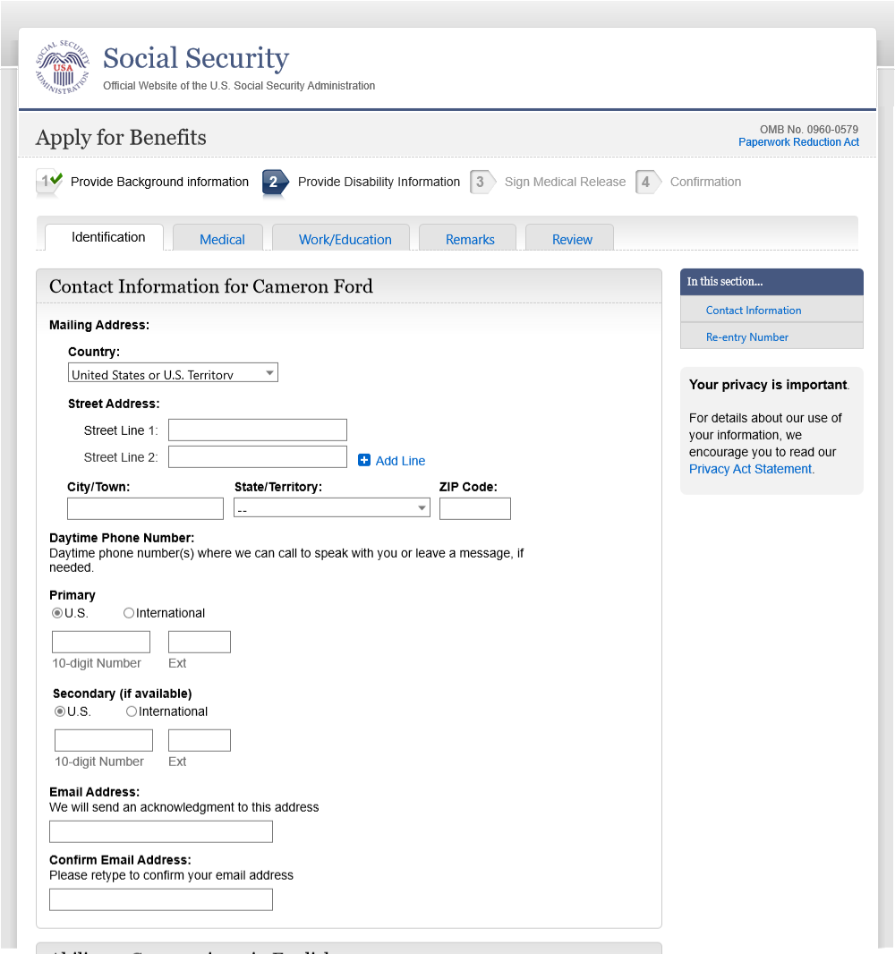

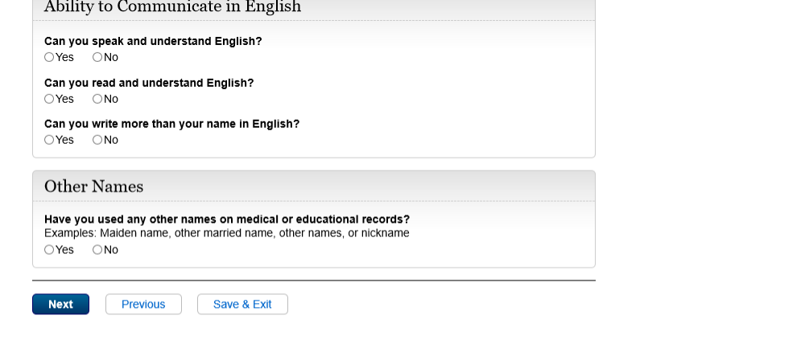

* 1. pin001 - 3 - Personal Information

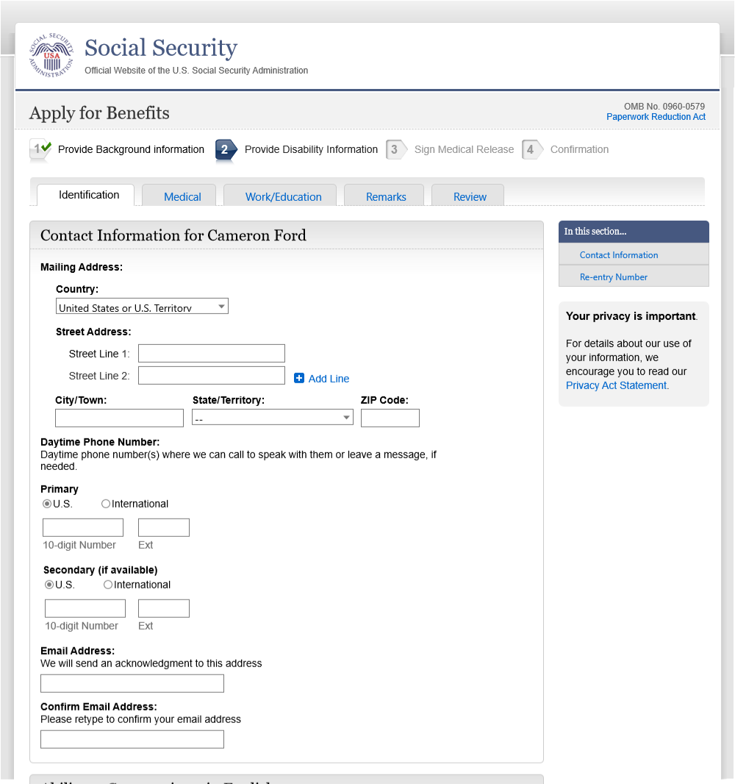



* 1. alg001 - 1 - Conditions

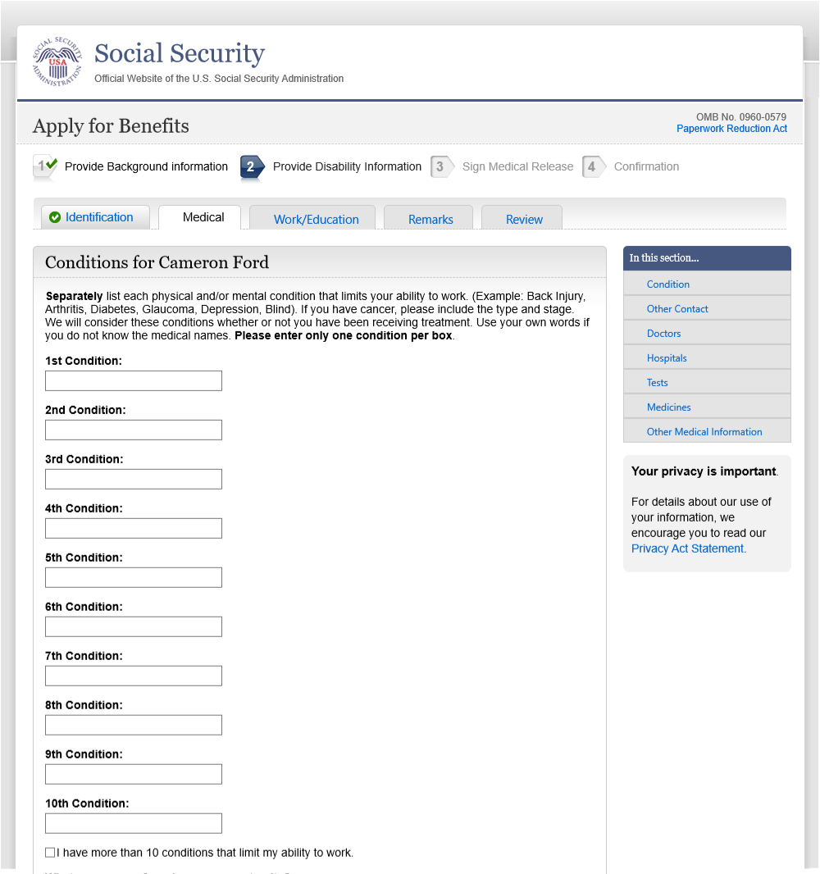

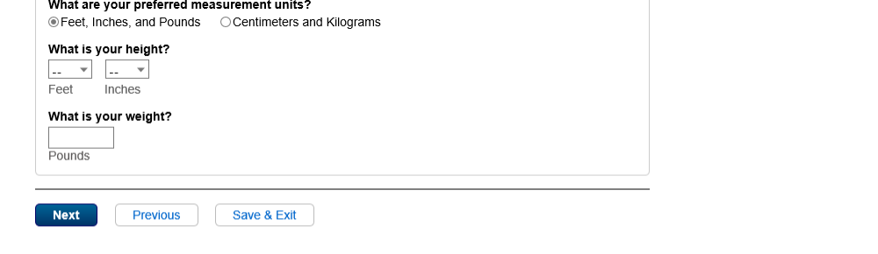

* 1. alg001 - 3 - Conditions

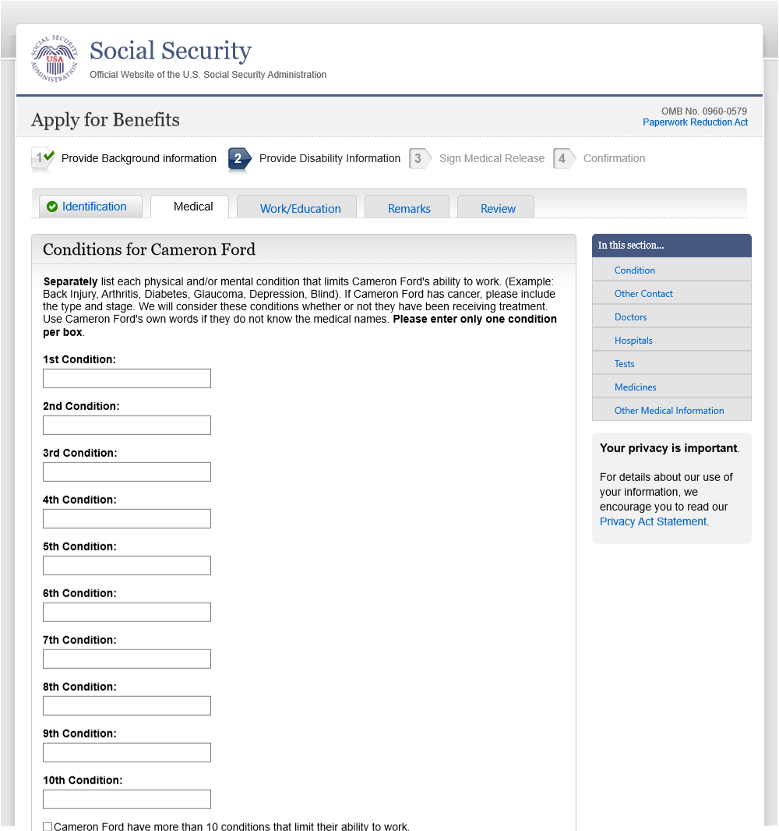

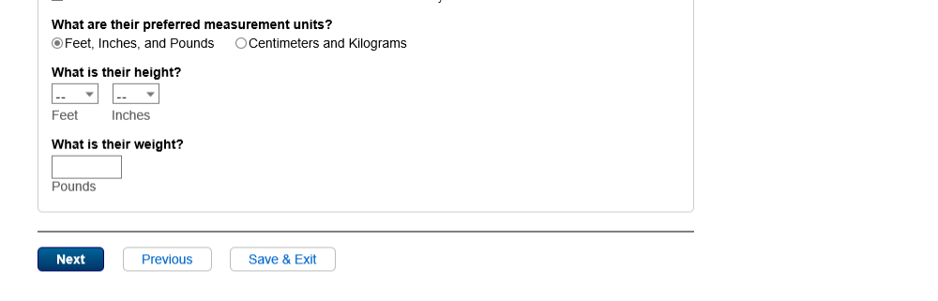

* 1. alg001 - 1 - Conditions (show metric)

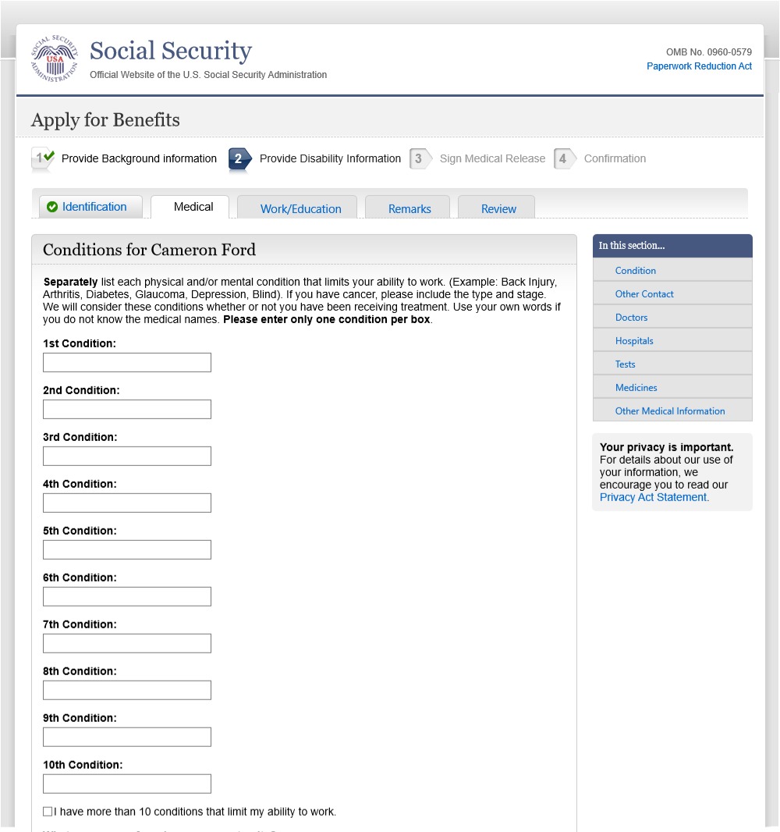

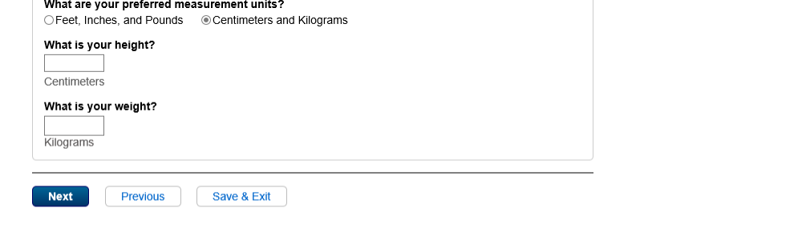

* 1. alg001 - 3 - Conditions (show metric)



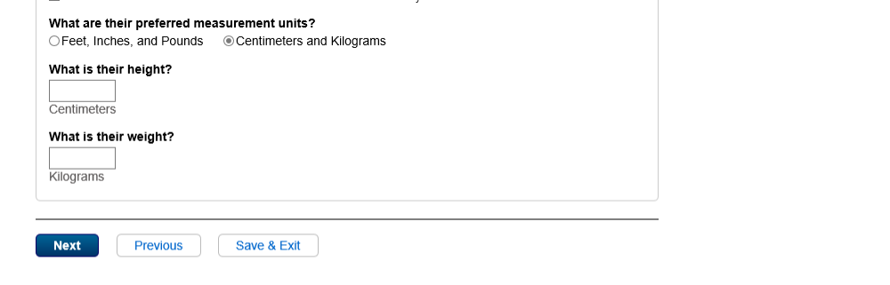

* 1. con001 - 1 - Other Contact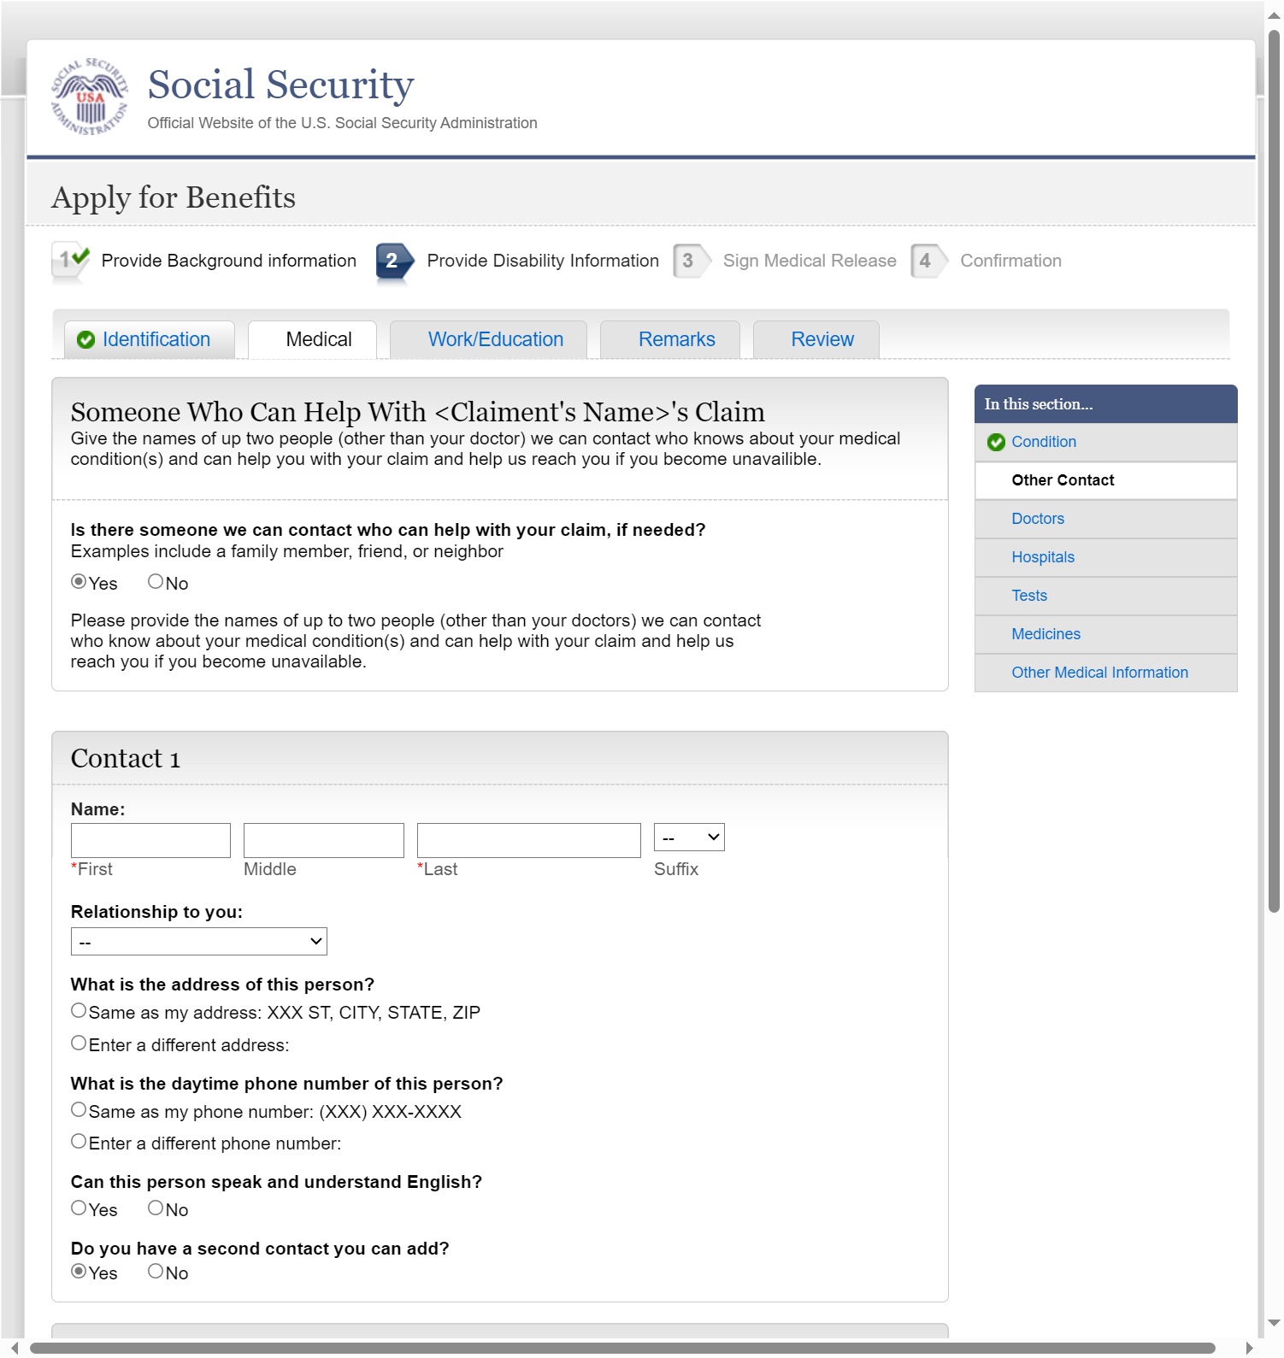

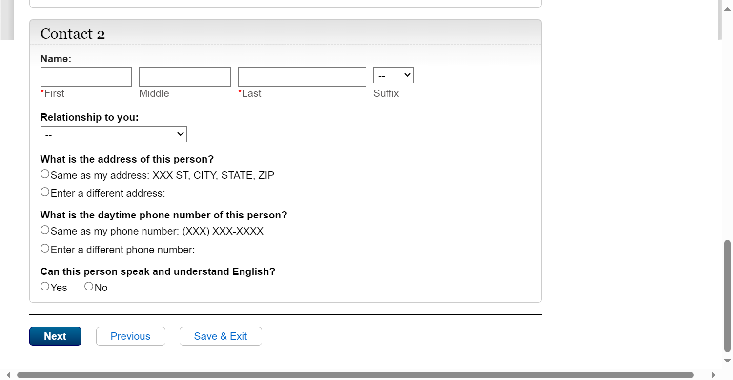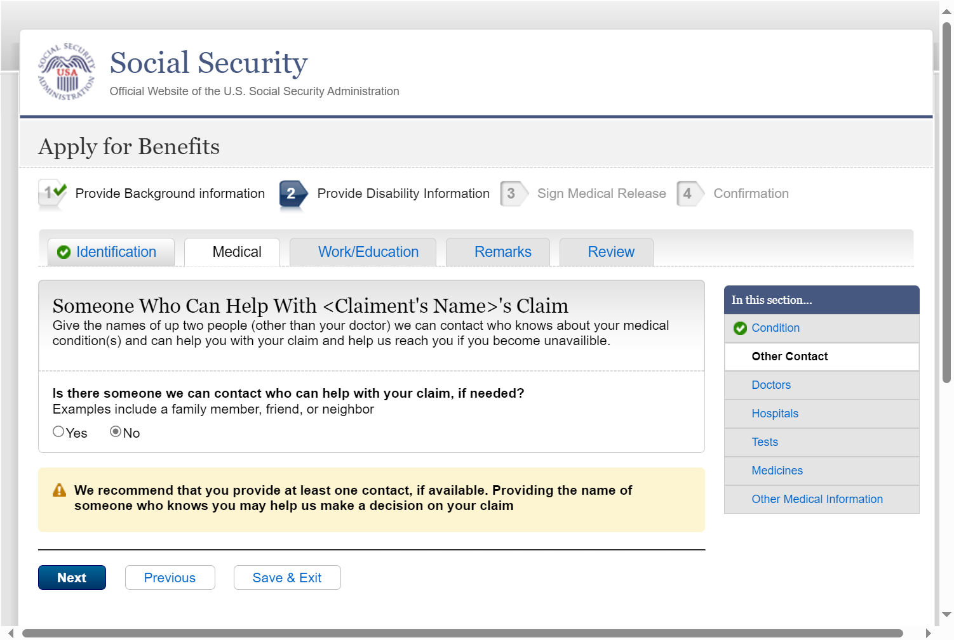

* 1. con001 - 3 - Other contact

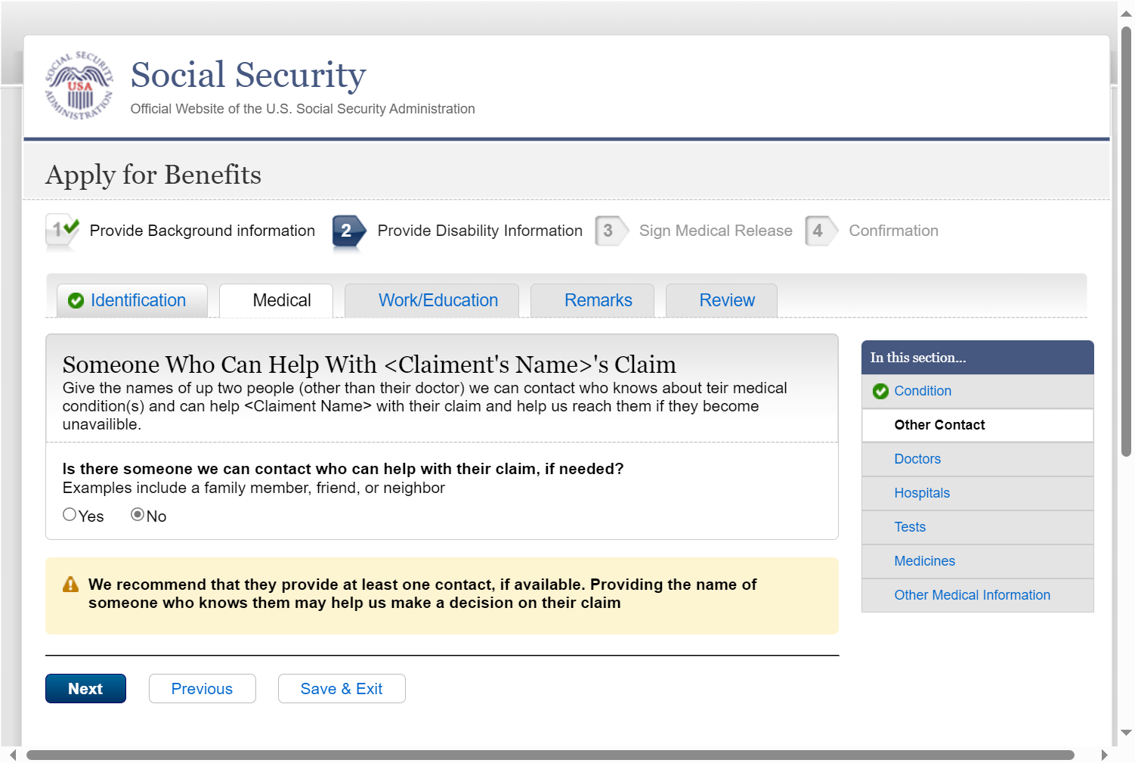

* 1. doc001 - 1 - Doctors Start

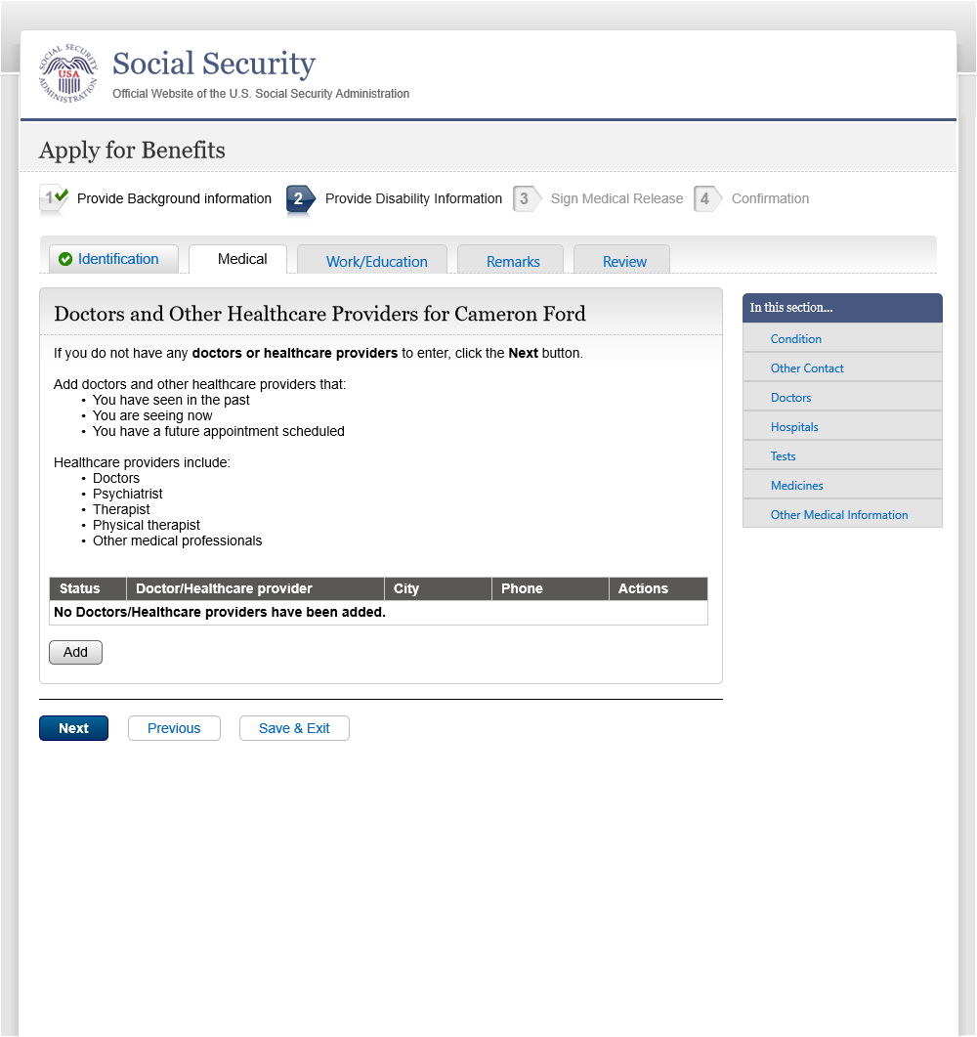

* 1. doc001 - 3 - Doctors Start

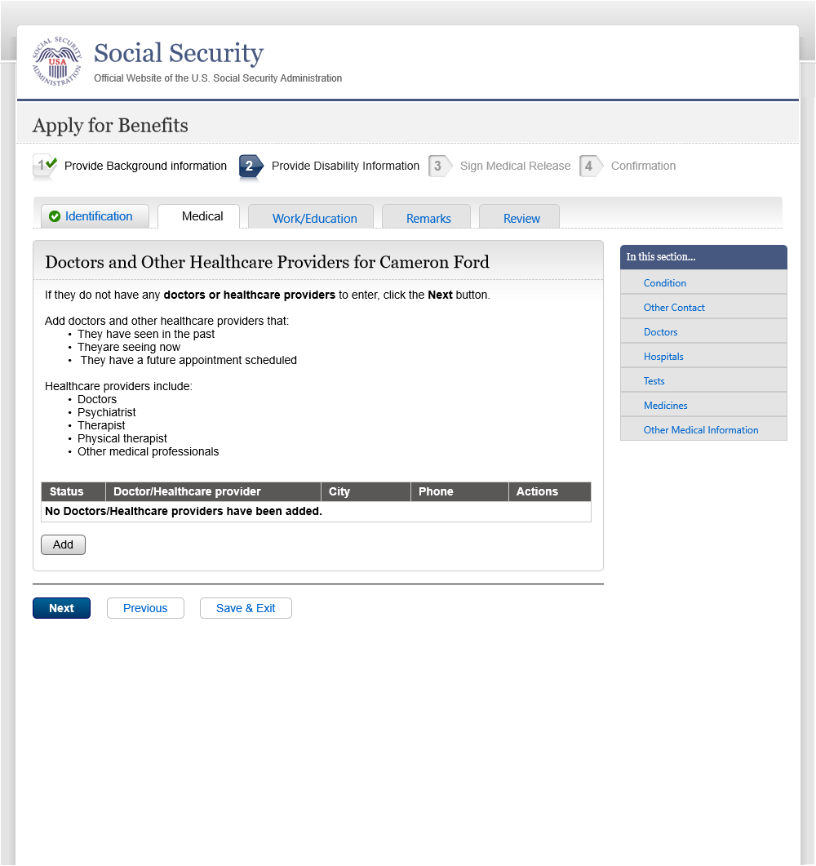

* 1. doc002 - 1 - Doctor Information

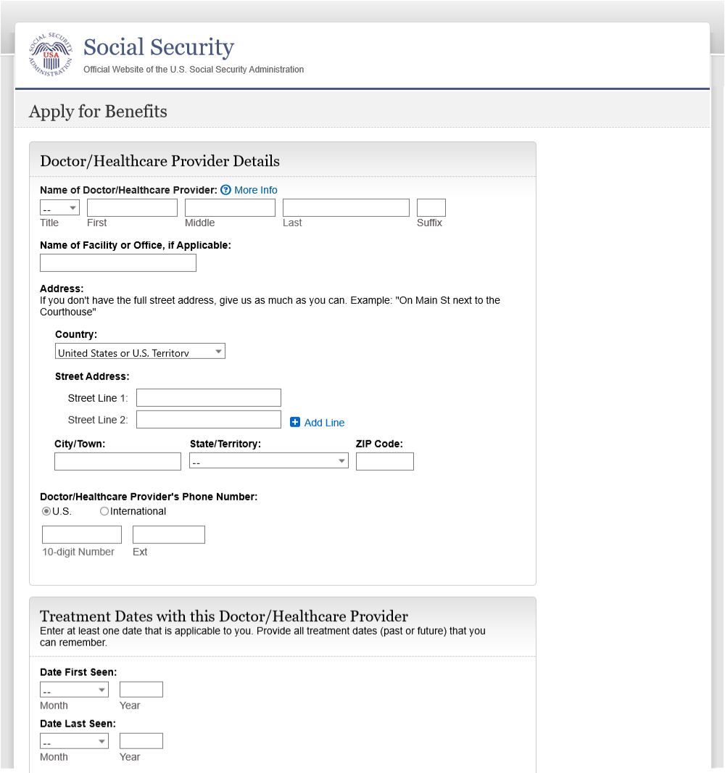

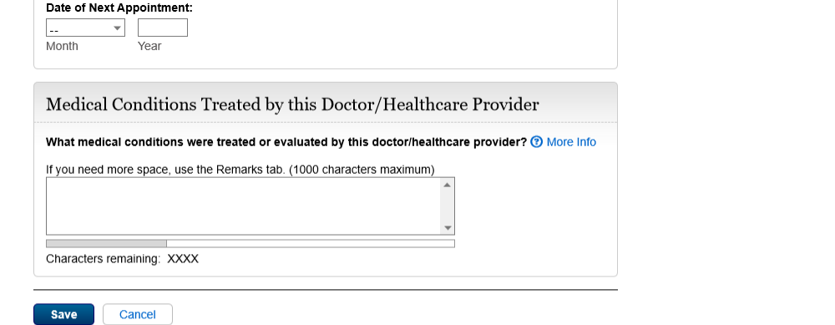

* 1. More Info - Name of Health Care Provider

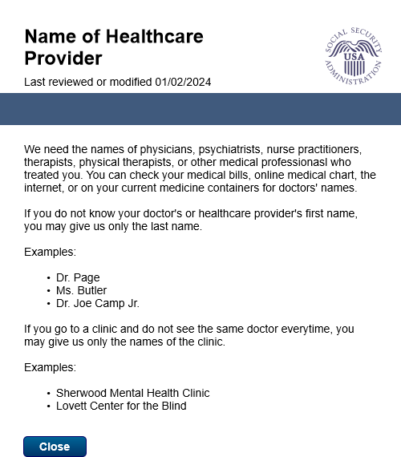

* 1. More Info - conditions

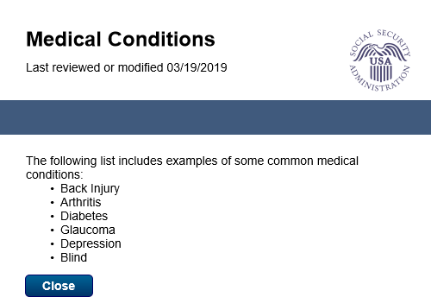

* 1. doc002 - 3 - Doctor Information

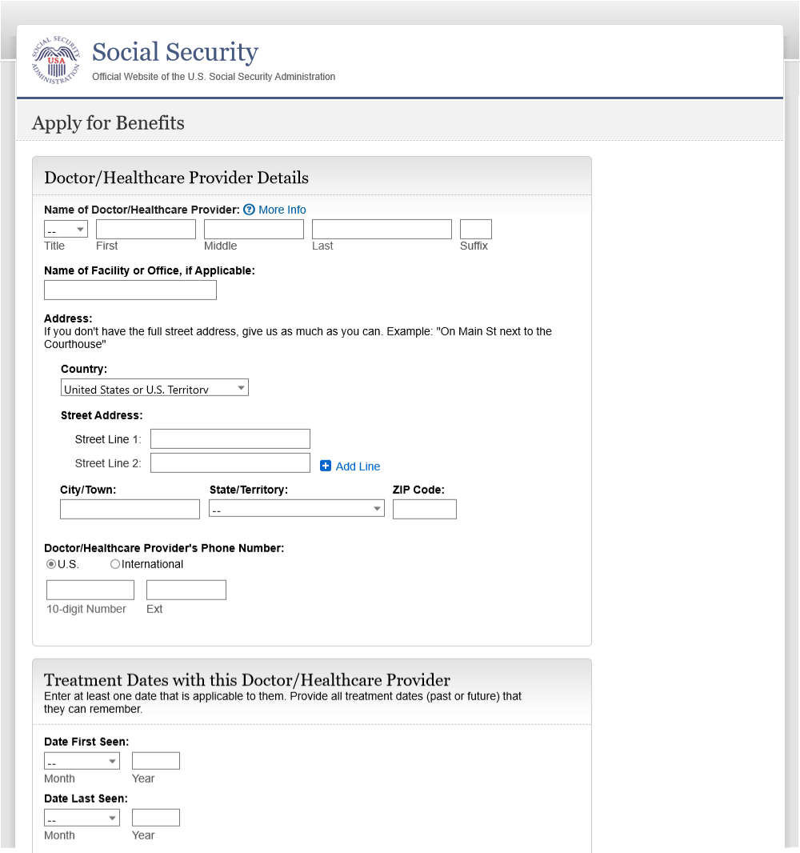



* 1. hos001 - 1 - Hospitals

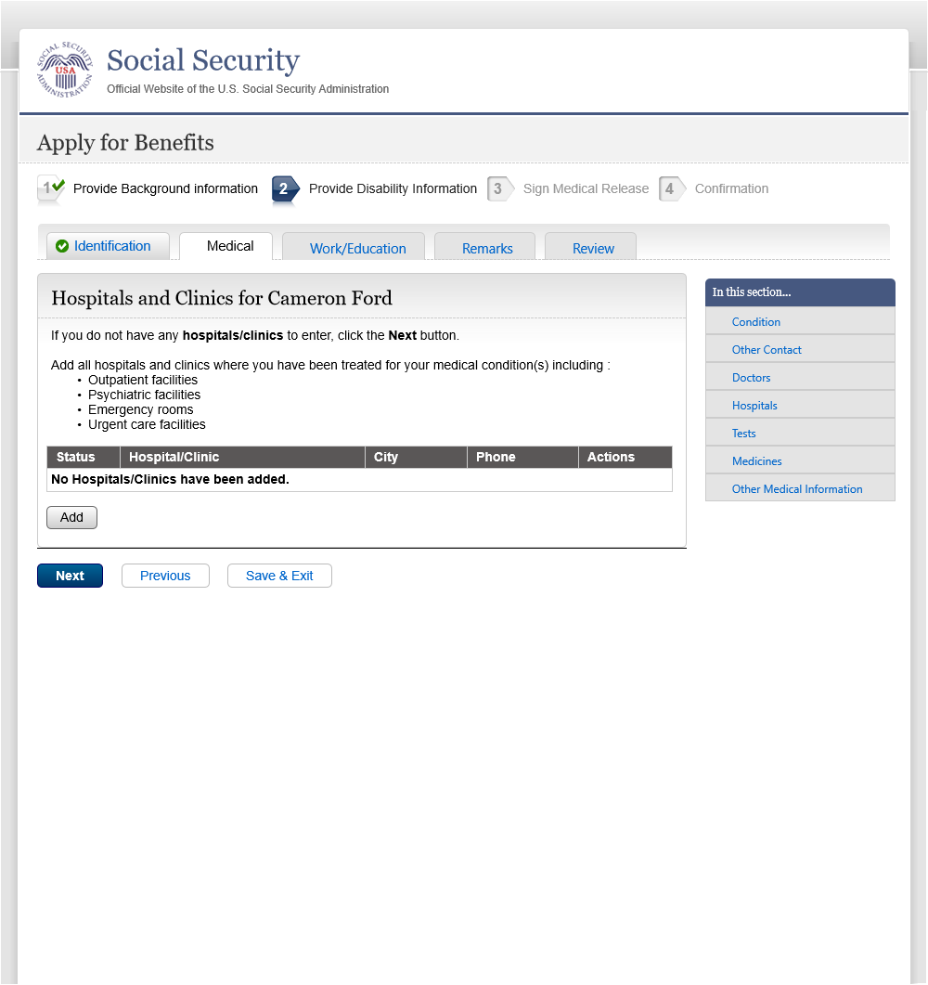

* 1. hos001 - 3 - Hospitals

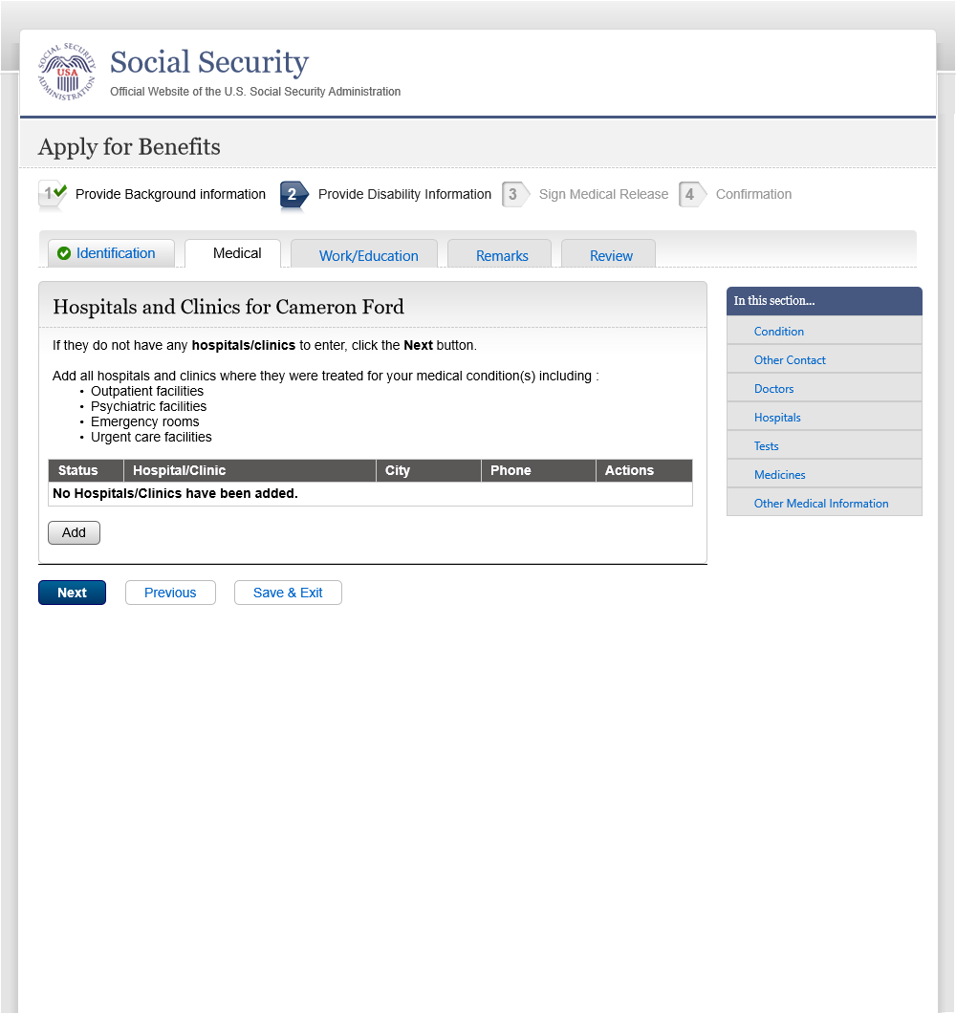

* 1. hos002 - 1 - Hospital Information

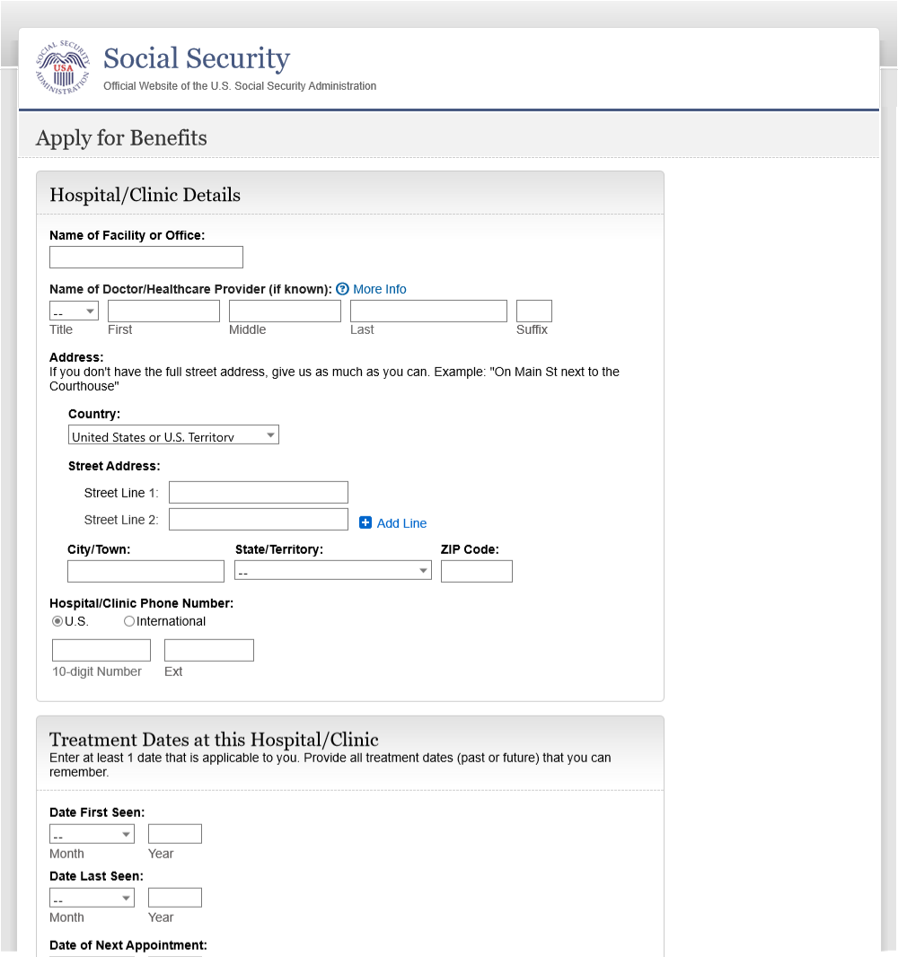

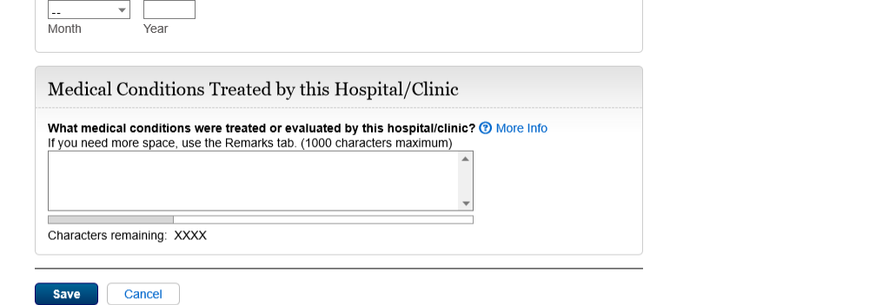

* 1. More Info - Name of Health Care Provider-facility

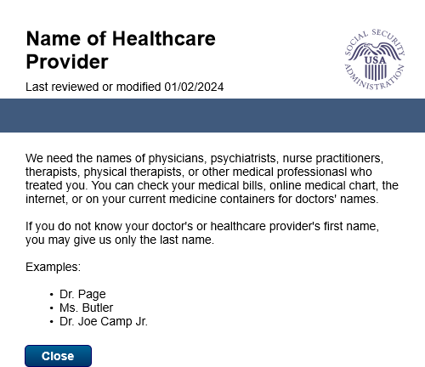

* 1. More Info - treatments

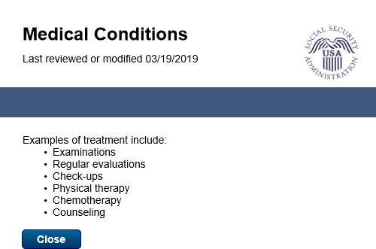

* 1. hos002 - 3 - hospital information

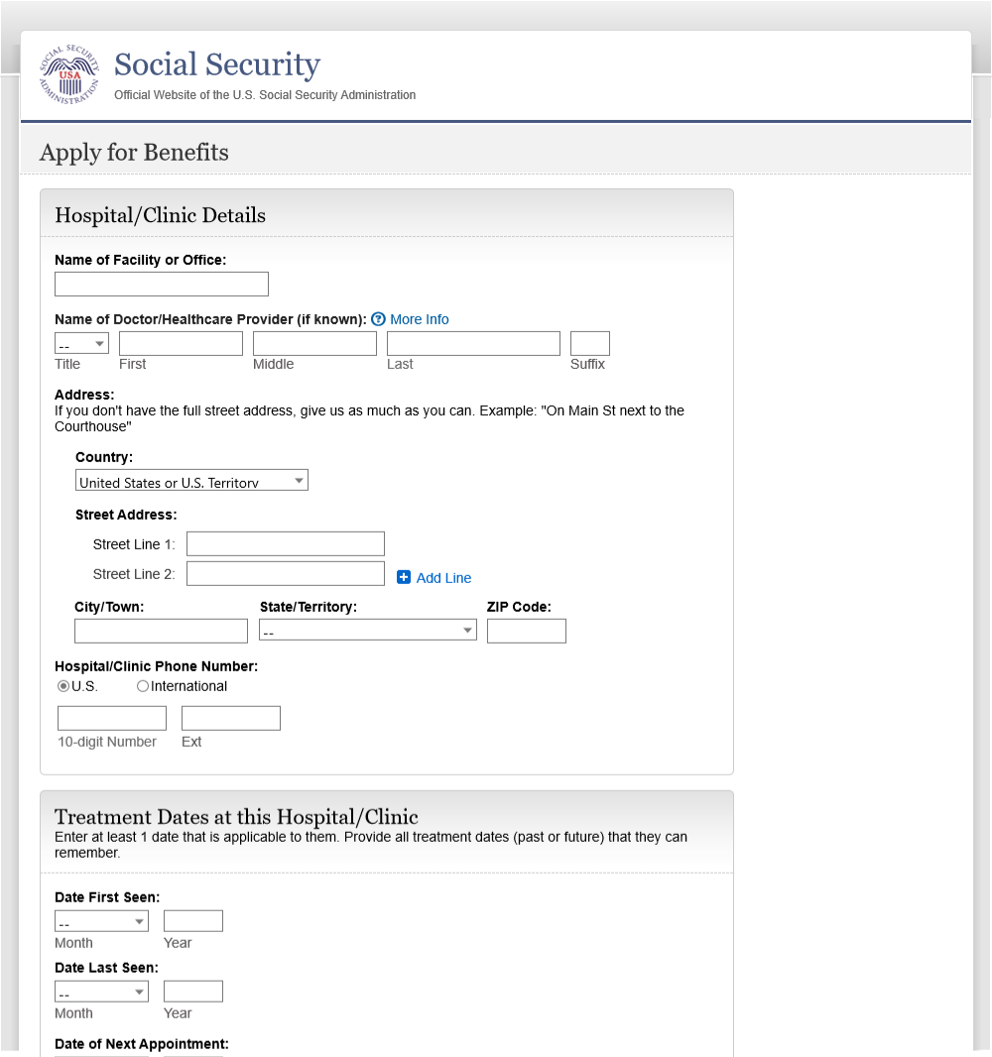



* 1. tst001 - 1 - Tests

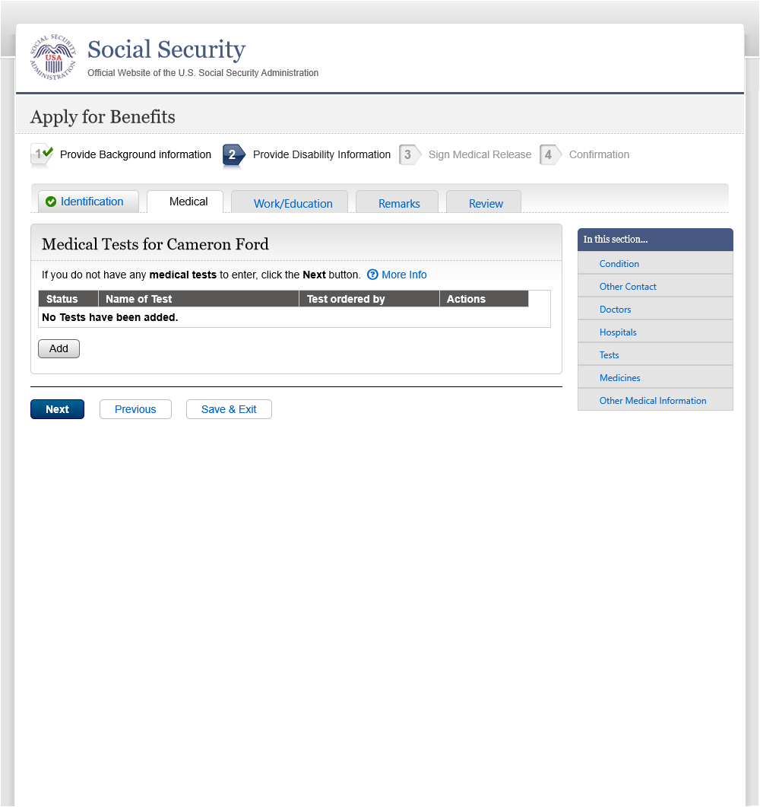

* 1. More Info - Tests

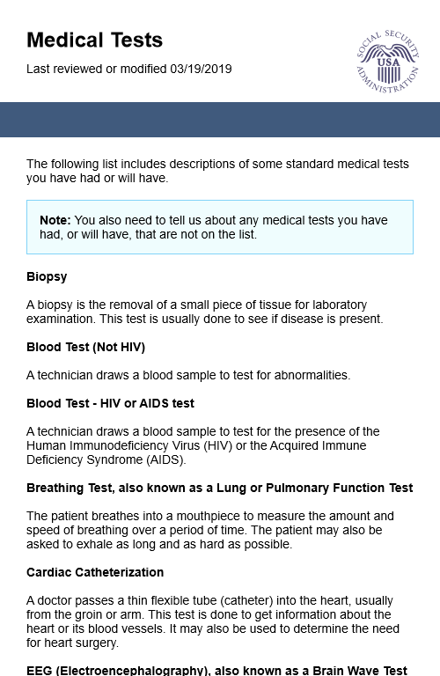

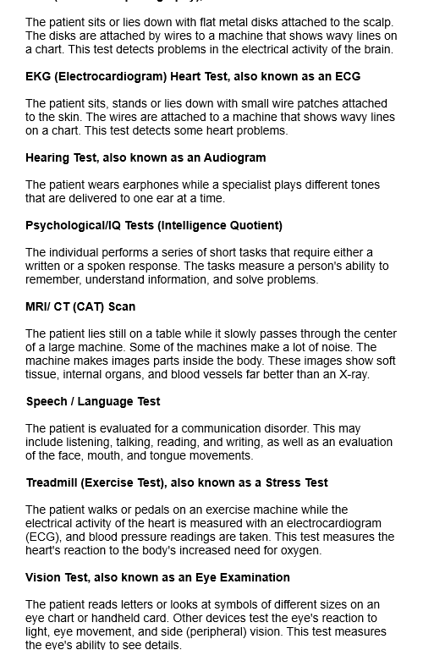

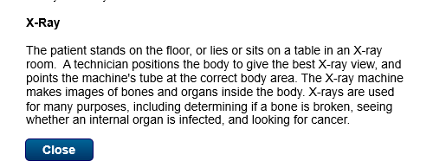

* 1. tst001 - 3 -Tests

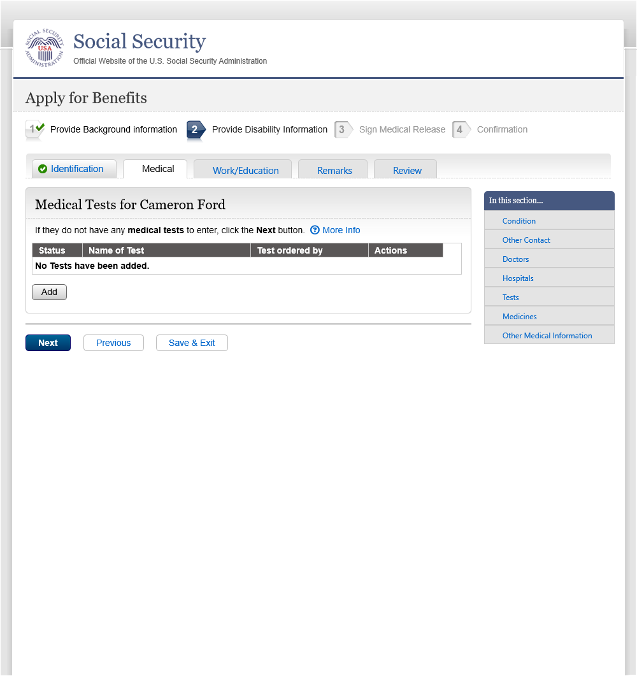

* 1. tst002 - 1 - Test Details

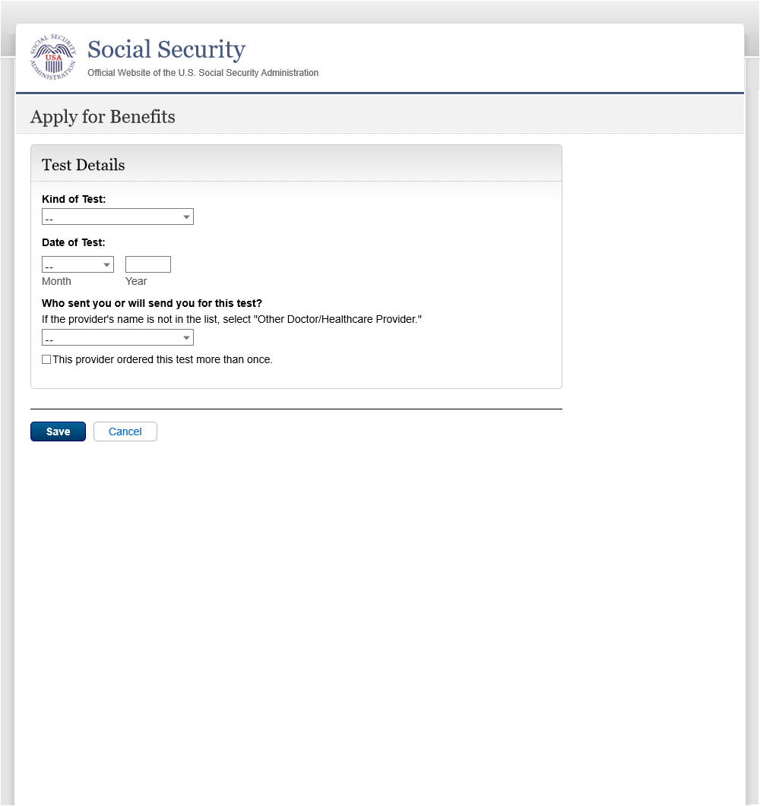

* 1. tst002 - 3 - Test Details

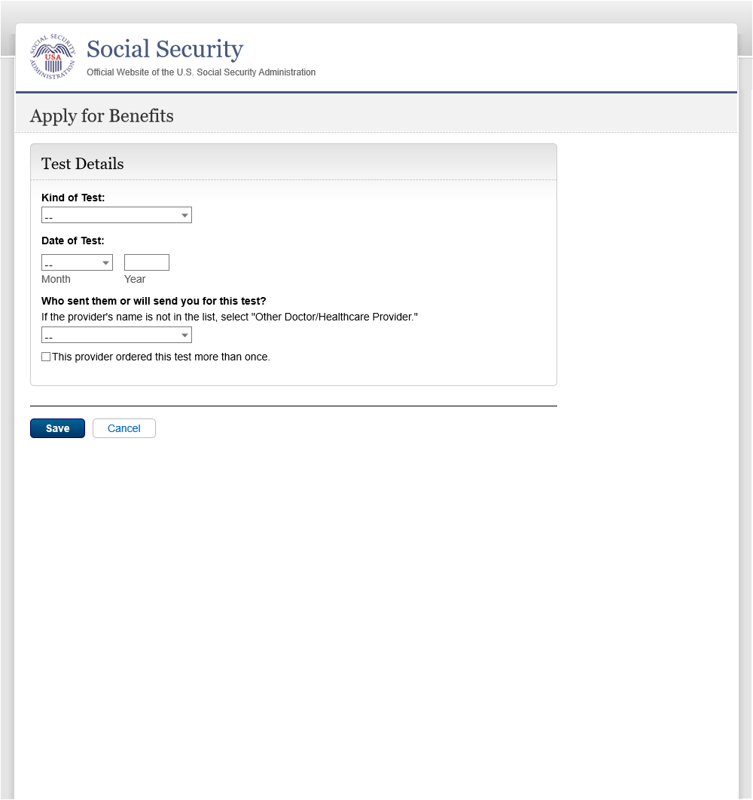

* 1. med001 - 1 - Medicines

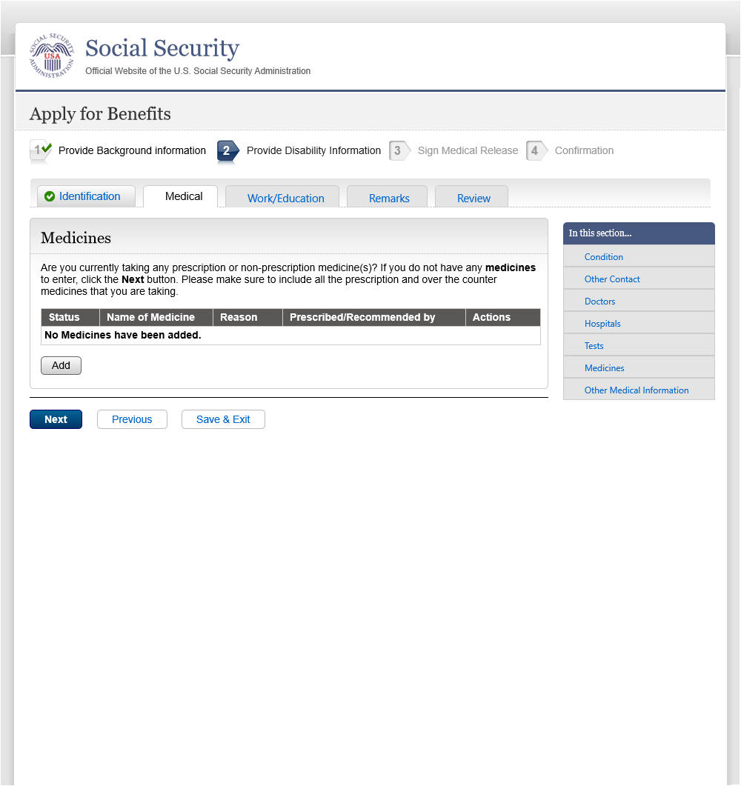

* 1. med001 - 3 -Medicines

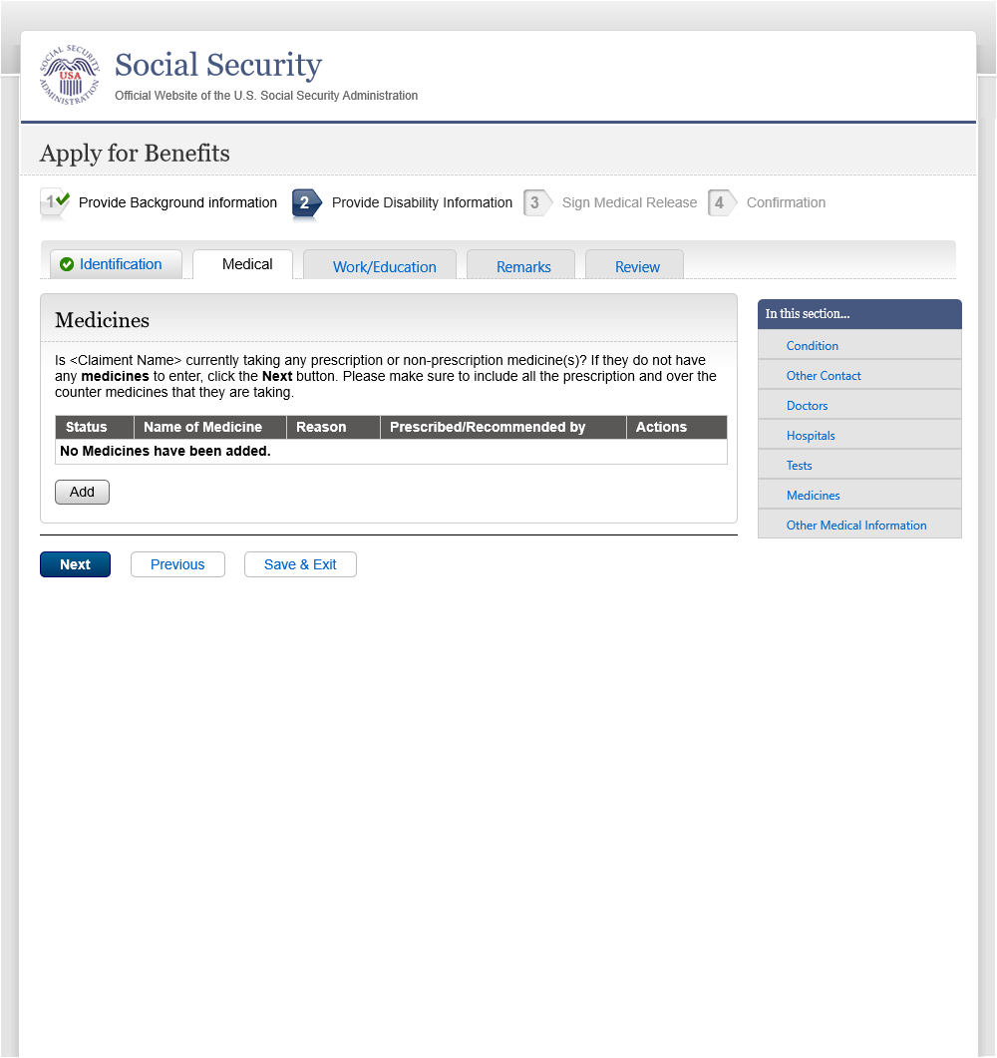

* 1. med002 - 1 - Medicine Details

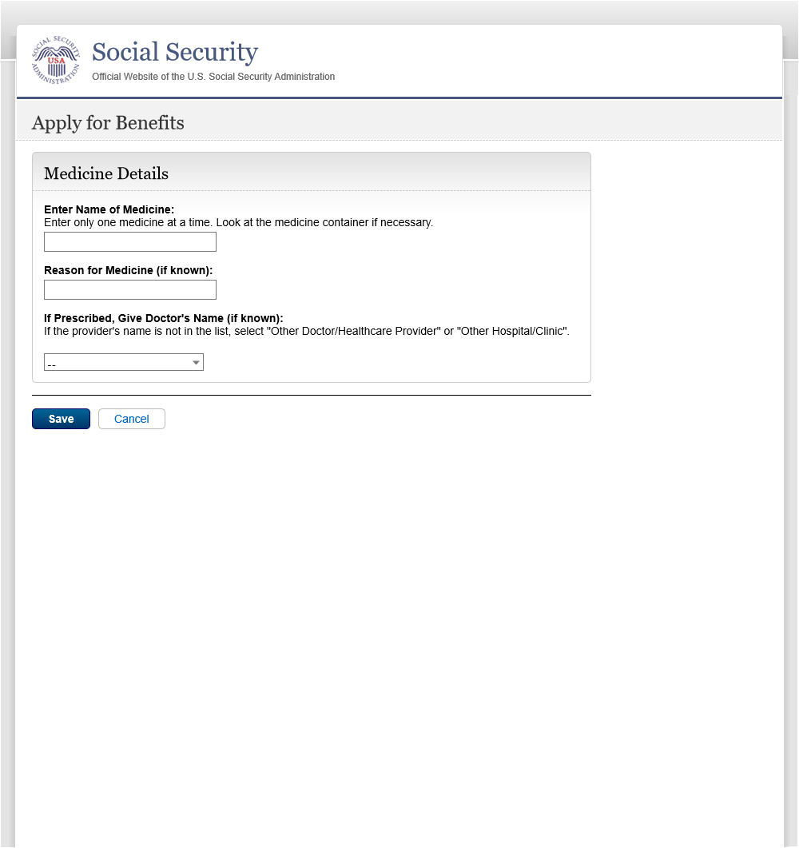

* 1. msc001 - 1 - Other Medical Records

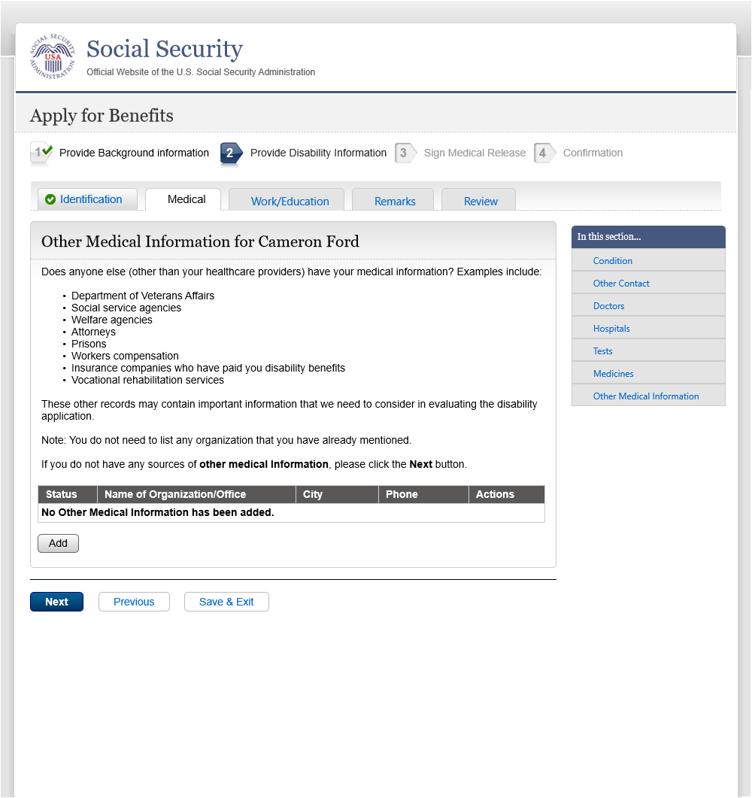

* 1. msc001 - 3 - Other Medical Records

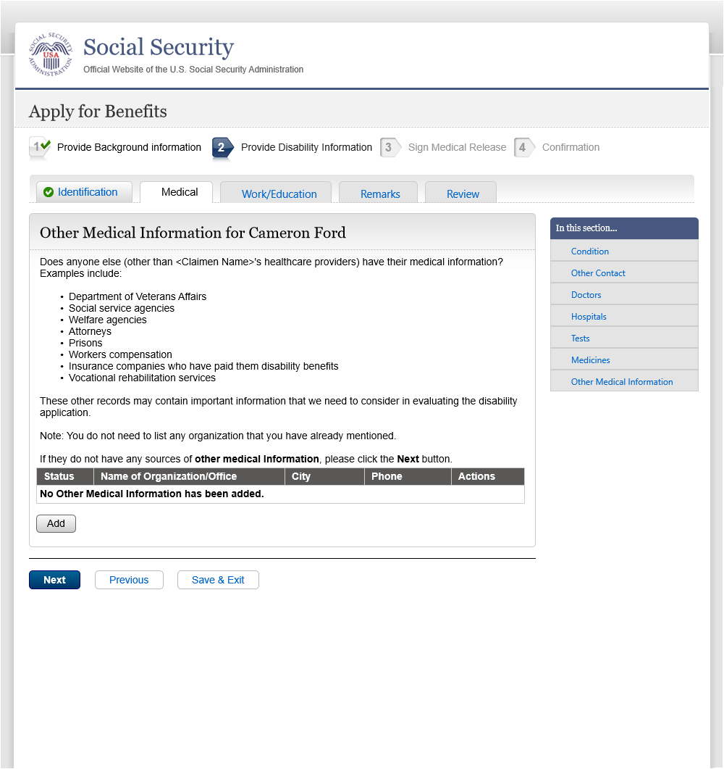

* 1. msc002 - 1 - Other Med Recs Details

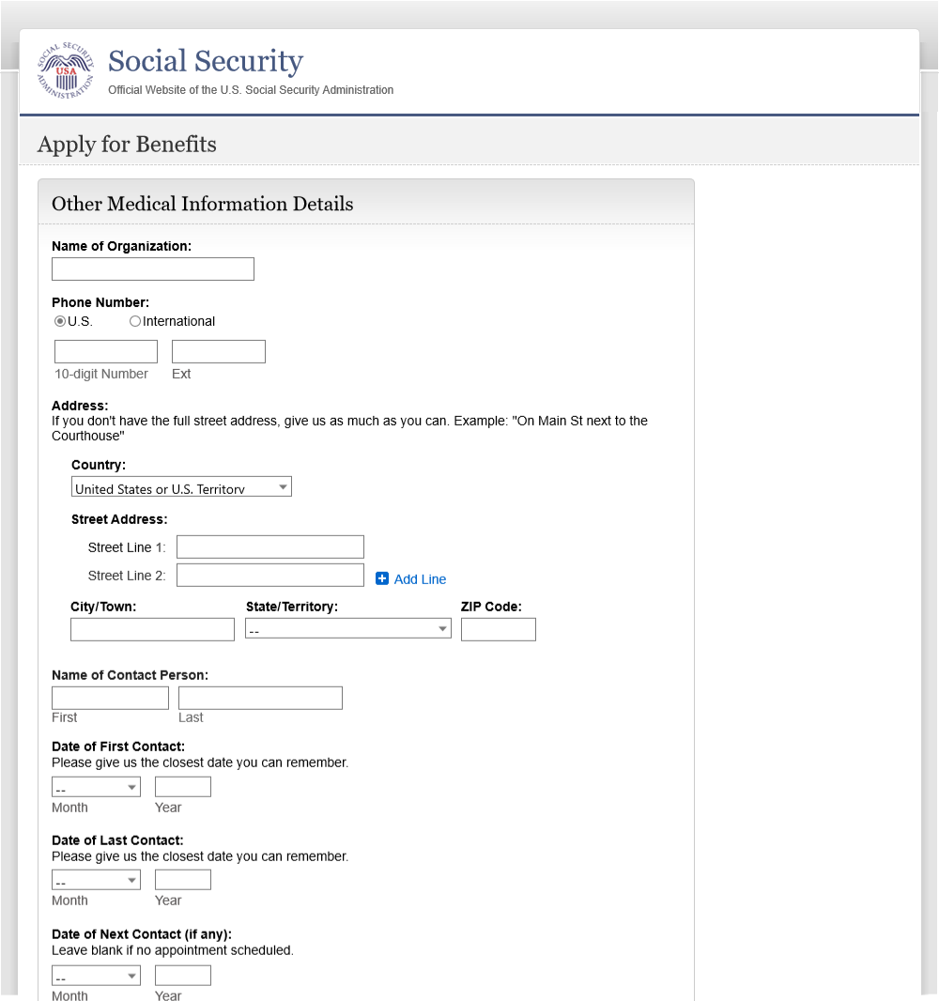

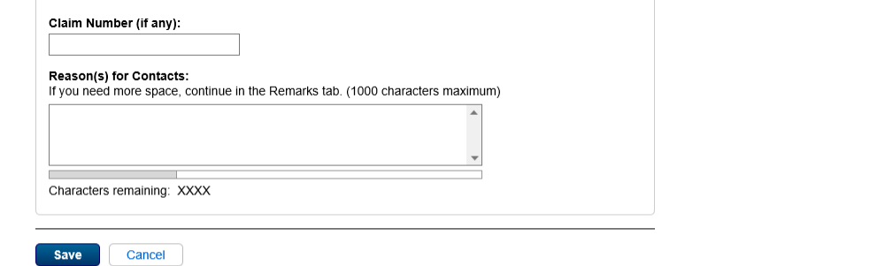

* 1. msc002 - 3 - Other Med Recs Details

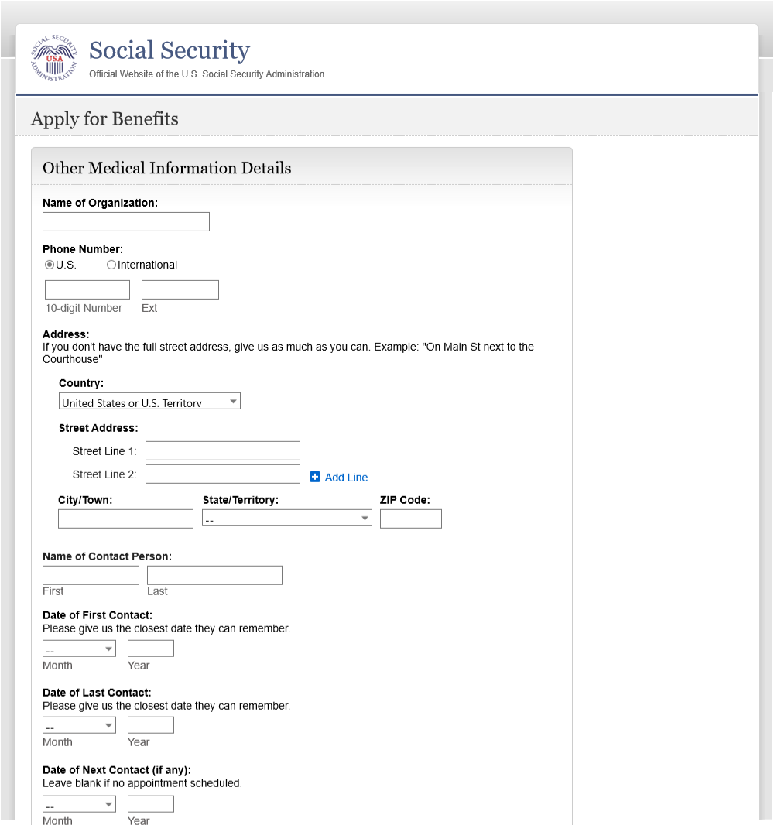



* 1. win001 - 1 - Work/Education Intro

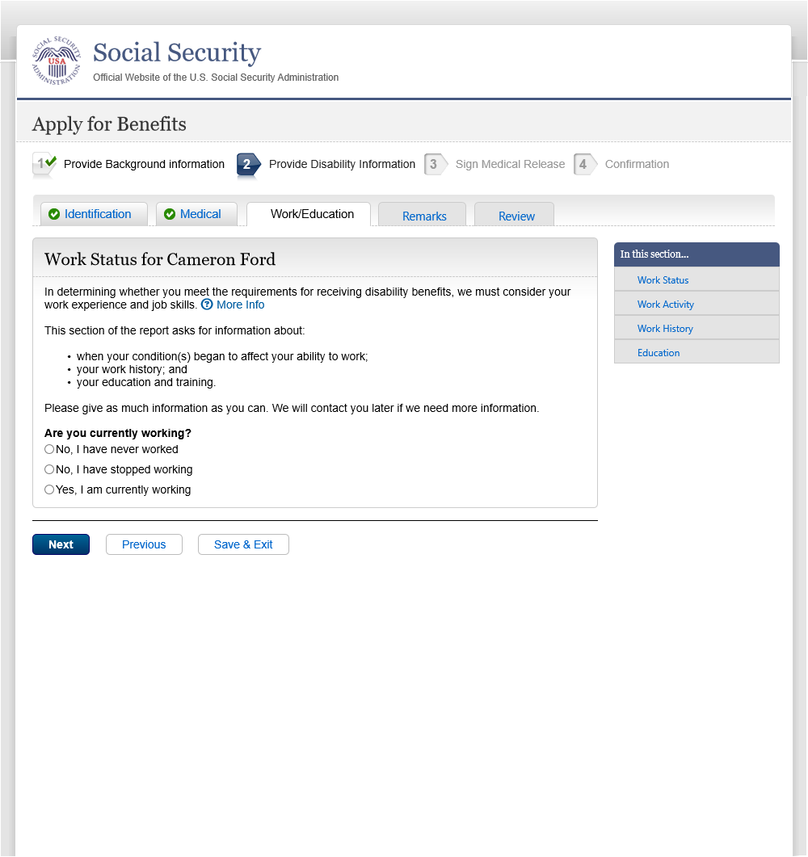

* 1. win001 - 3 - Work/Education Intro

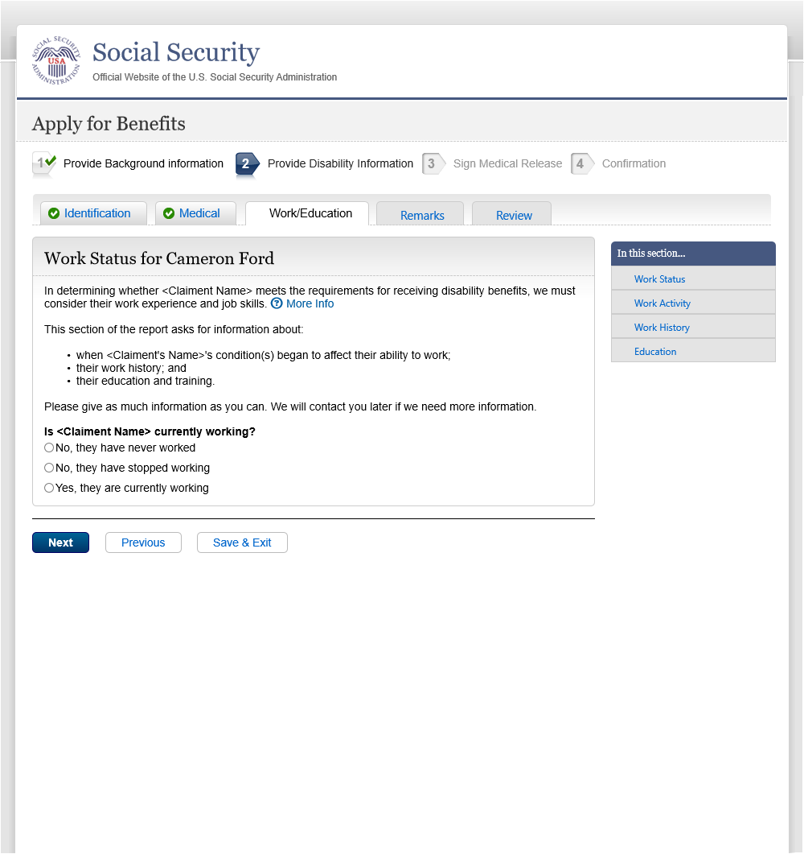

* 1. wac001 - 1 - cw - Work Activity

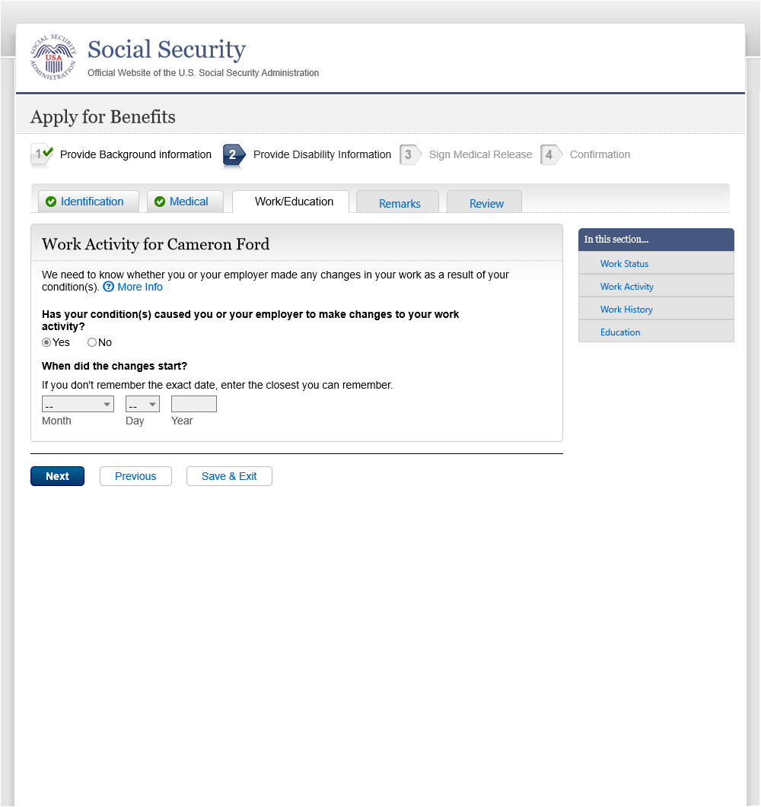

* 1. More Info - work changes

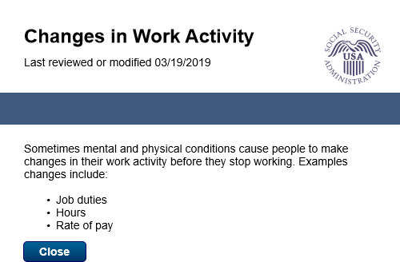

* 1. More Info - work stop reasons

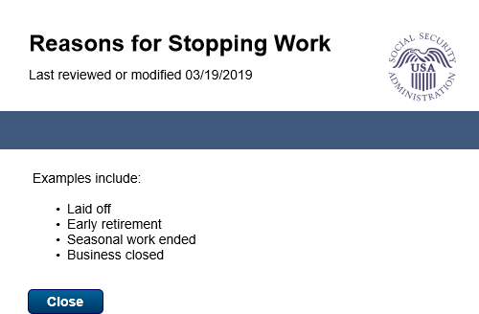

* 1. wac001 - 3 - cw - Work Activity

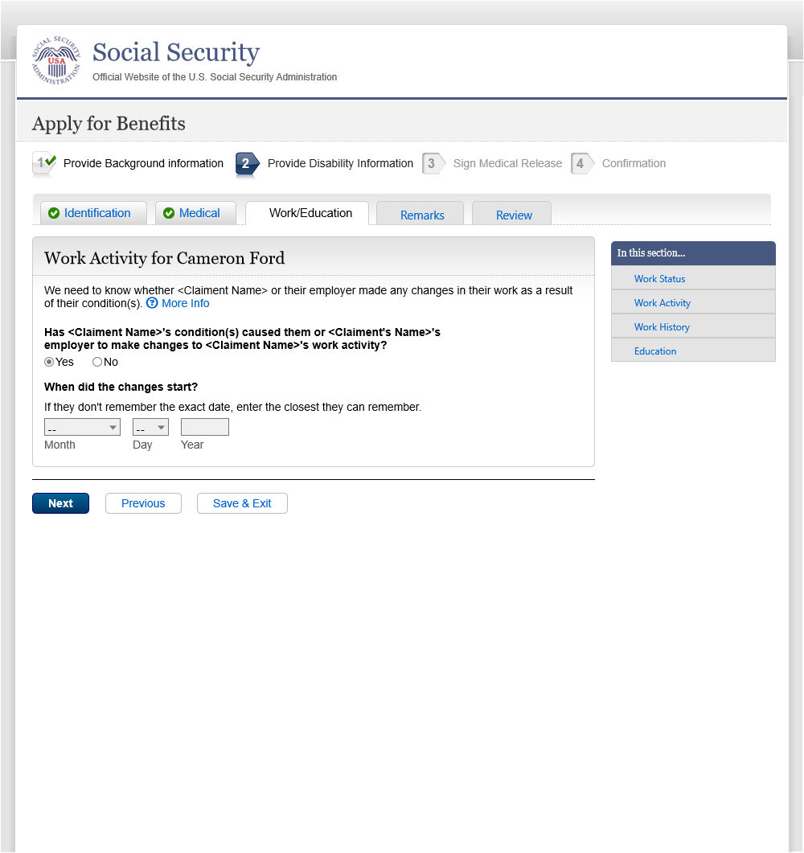

* 1. wac001 - 1 - sw - Work Activity

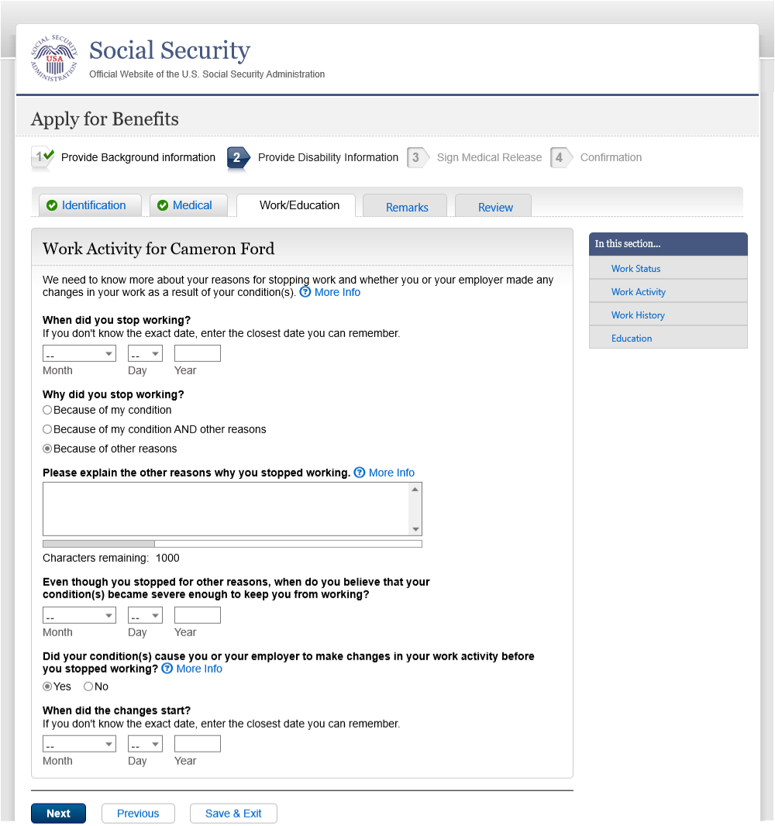



* 1. wac001 - 3 - sw - Work Activity

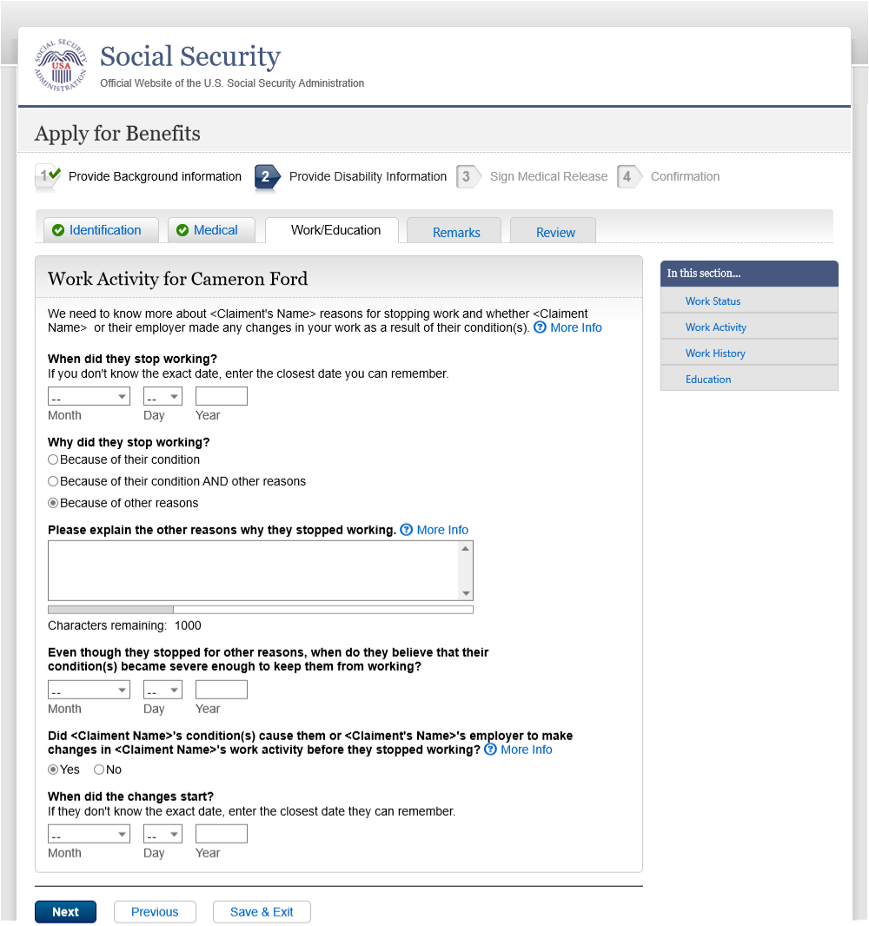



* 1. job001 - 1 - cw&sw - Job History

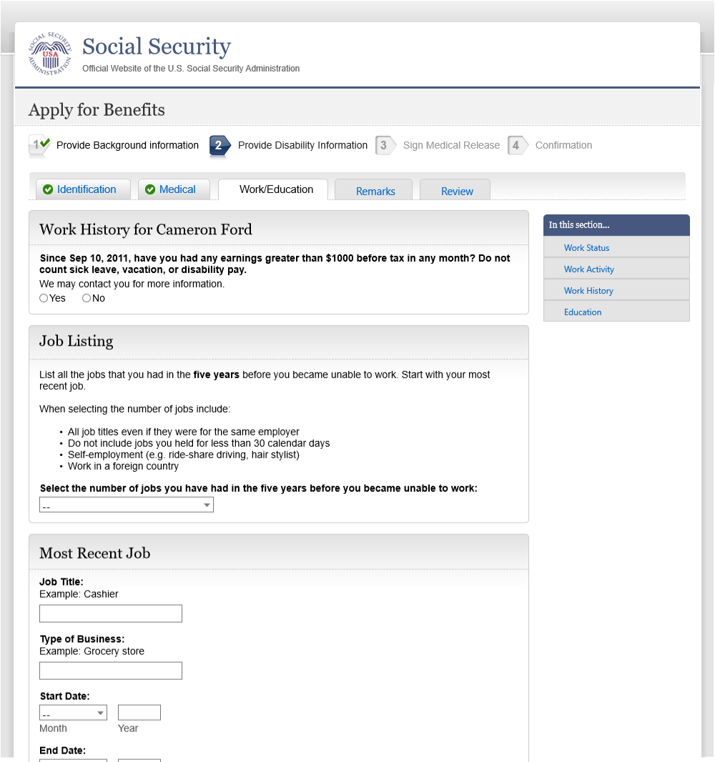

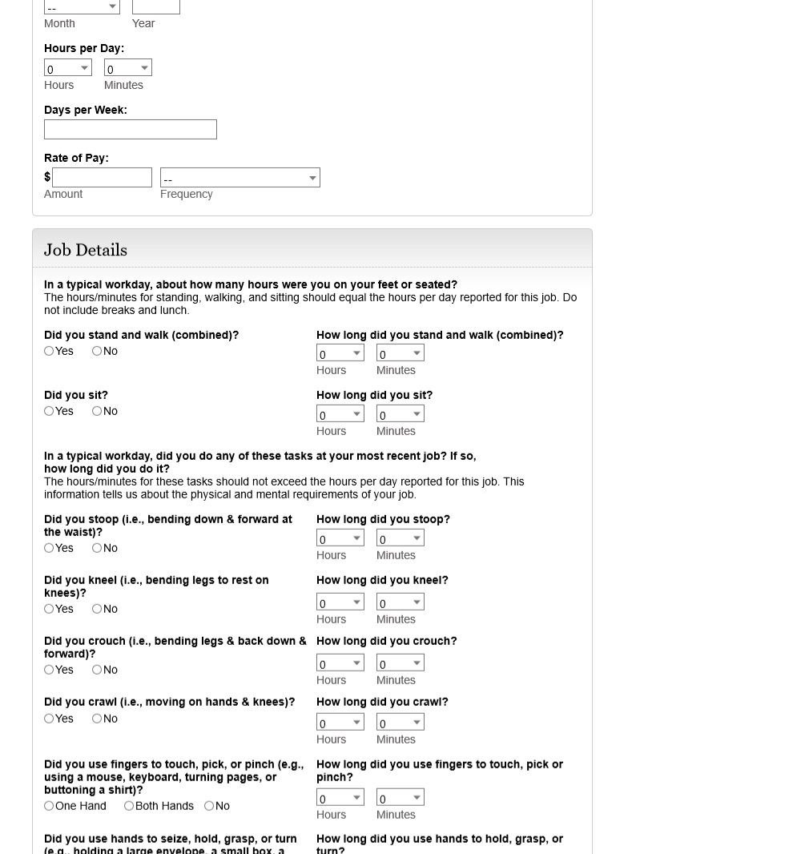

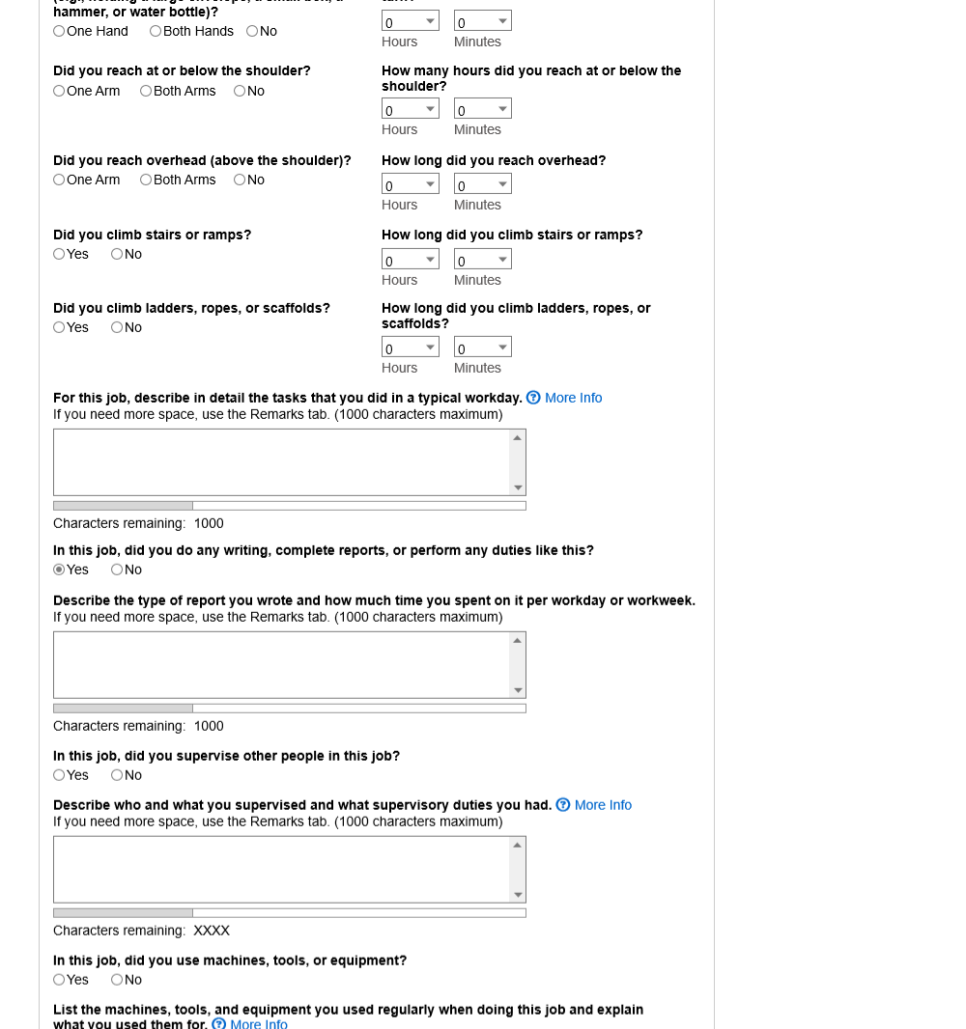

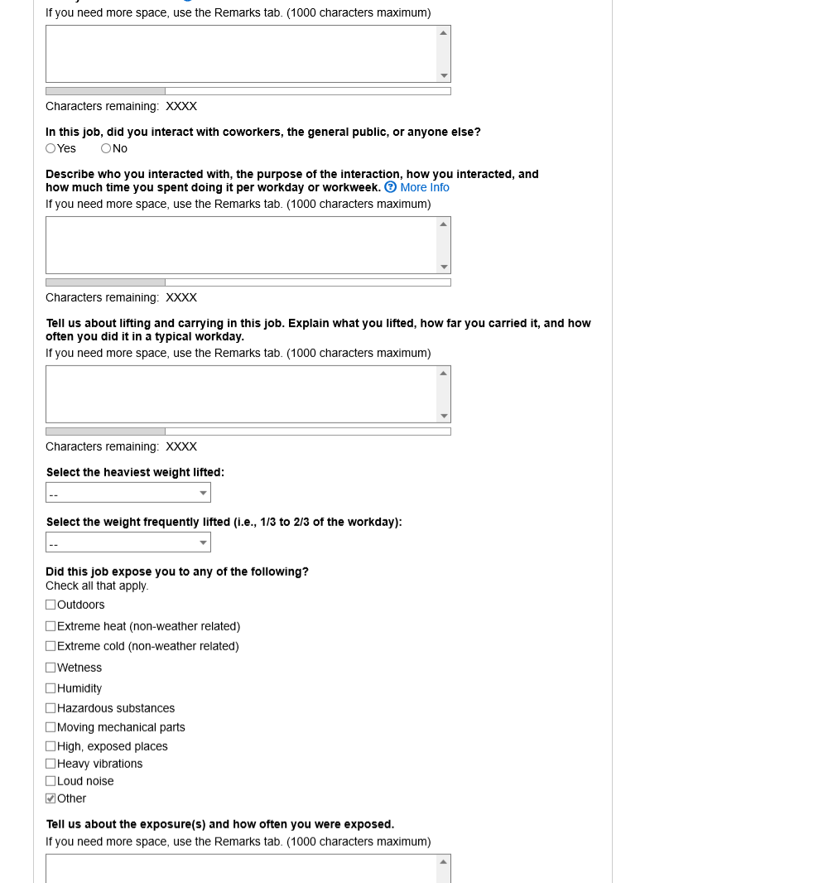

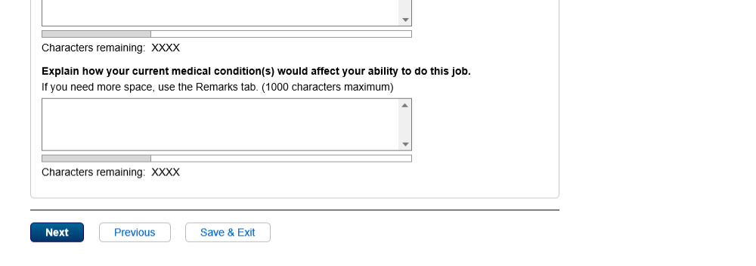

* 1. More Info - Task

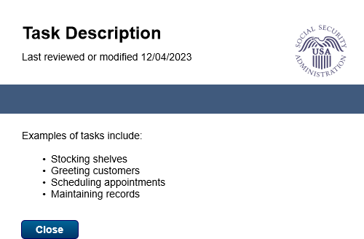

* 1. More Info - Supervisor

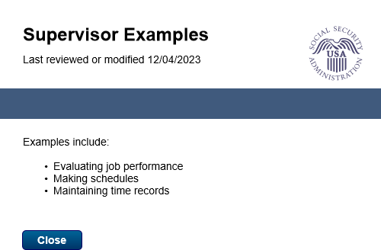

* 1. More Info - Equipment

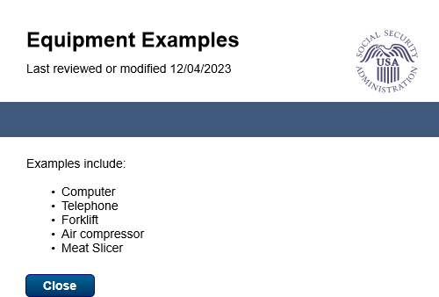

* 1. More Info - Interaction

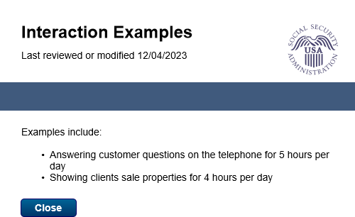

* 1. job001 - 3 - cw&sw - Job History

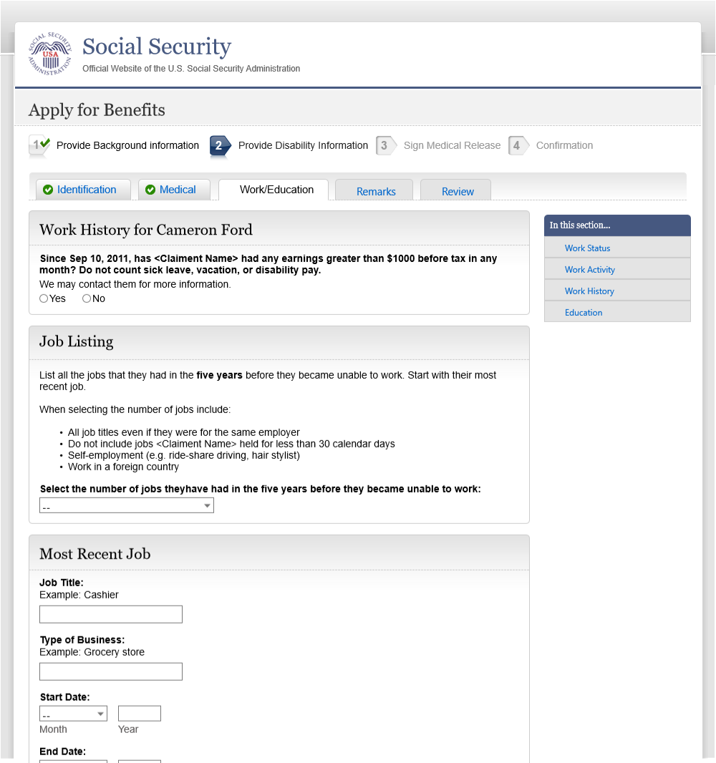

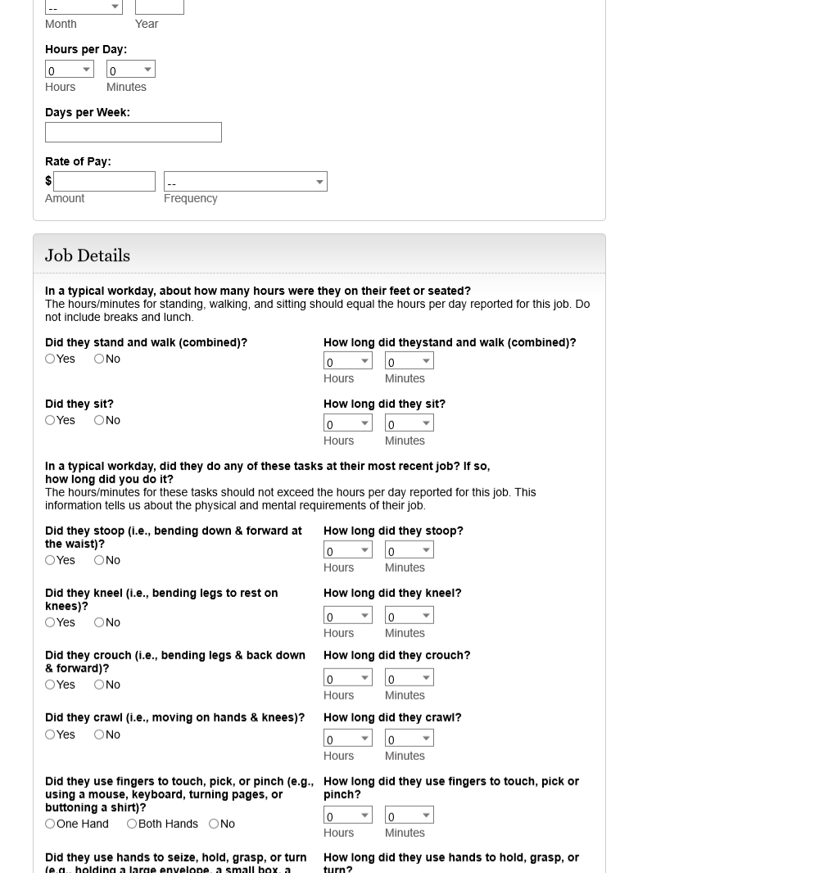

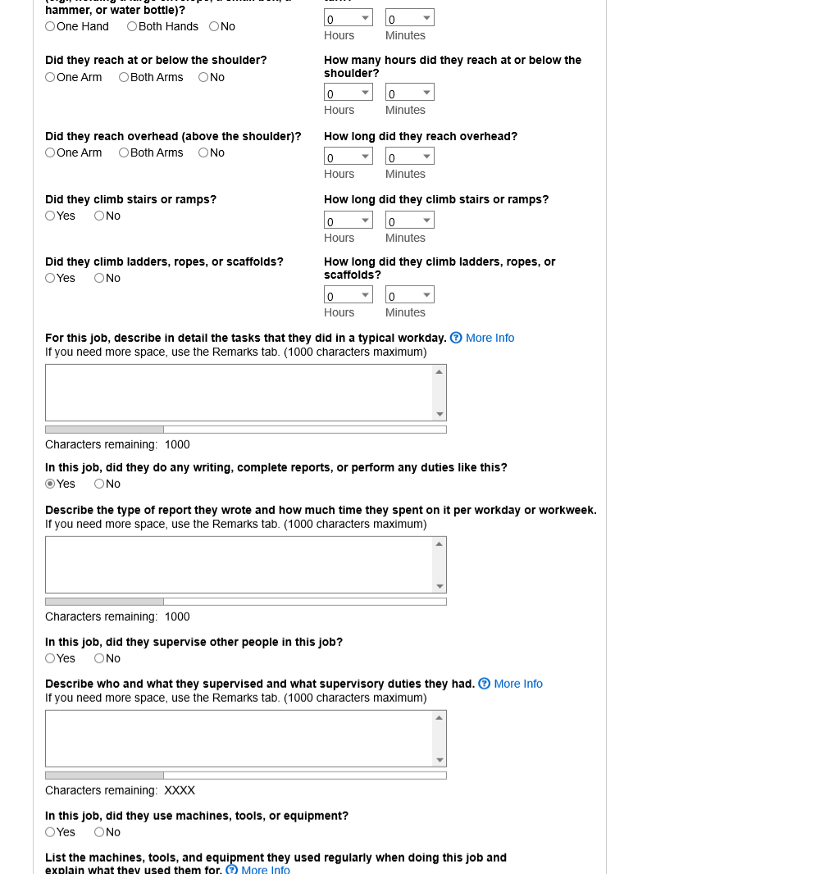

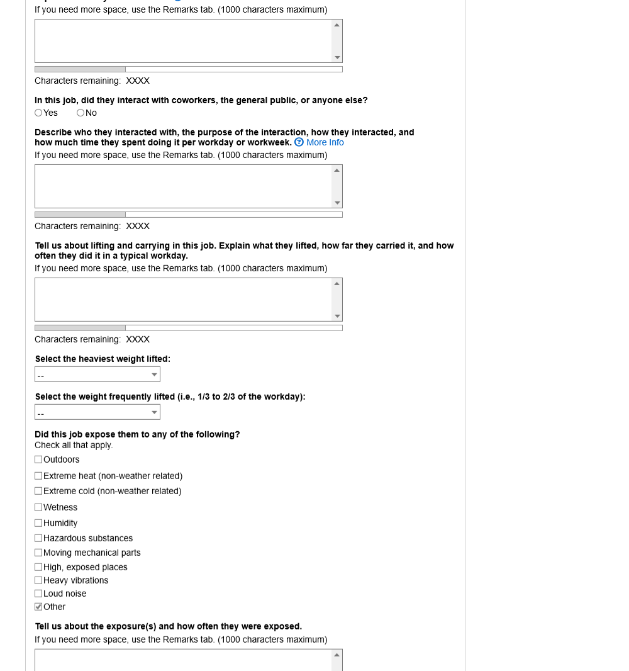

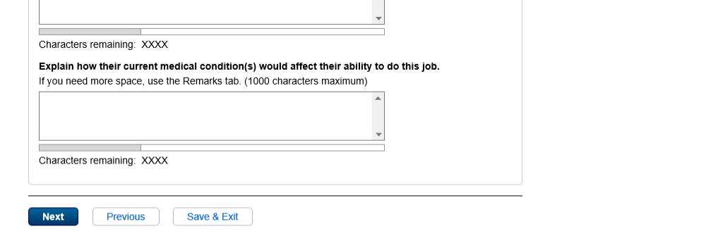

* 1. edu001 - 1 - Education

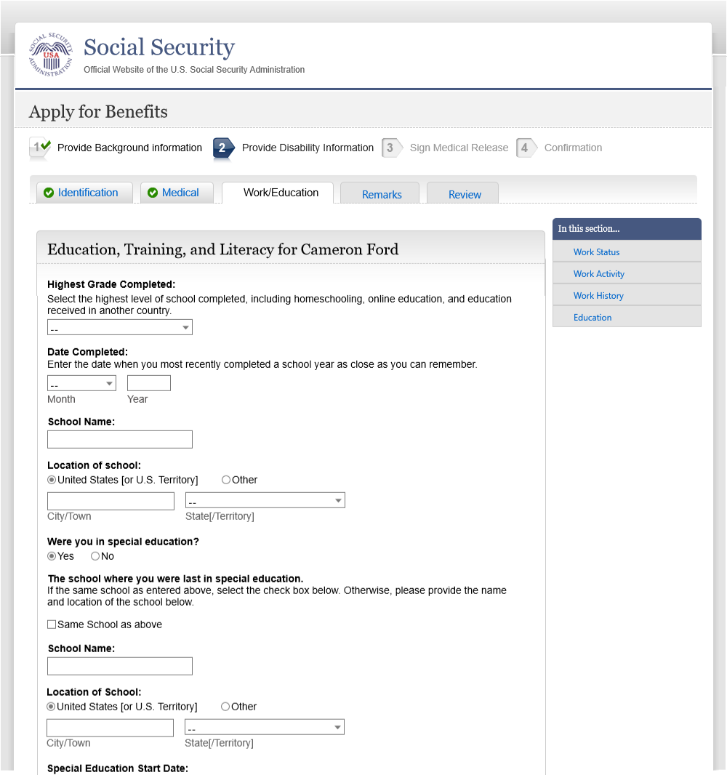

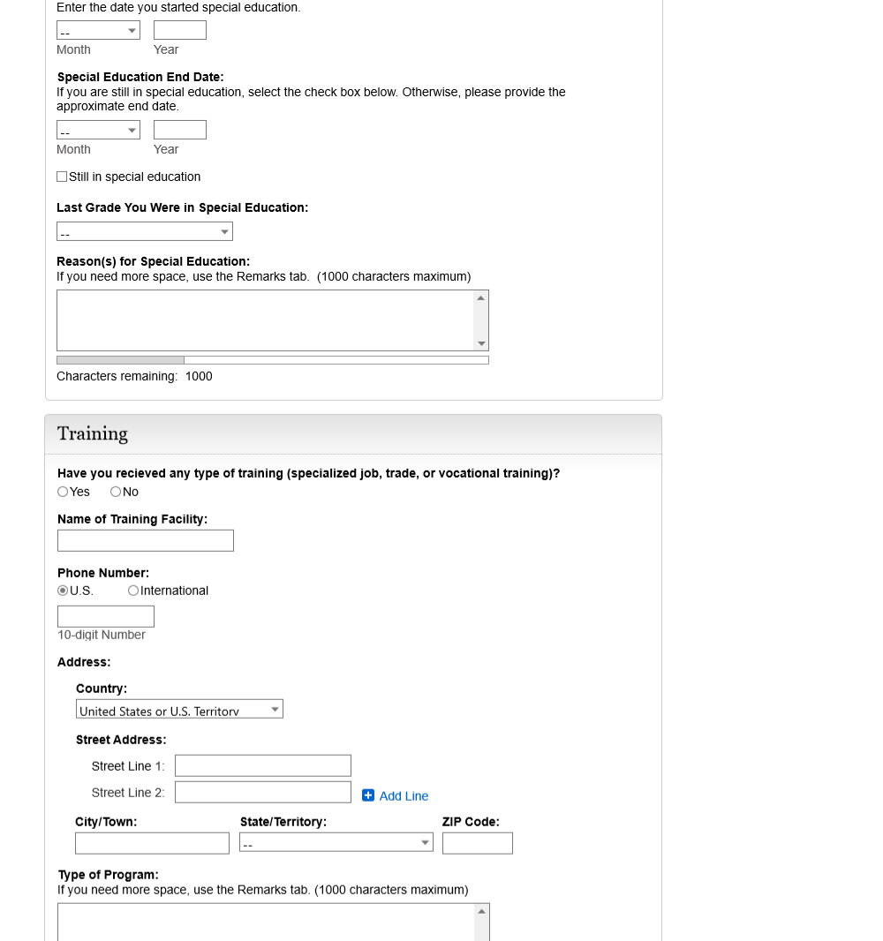

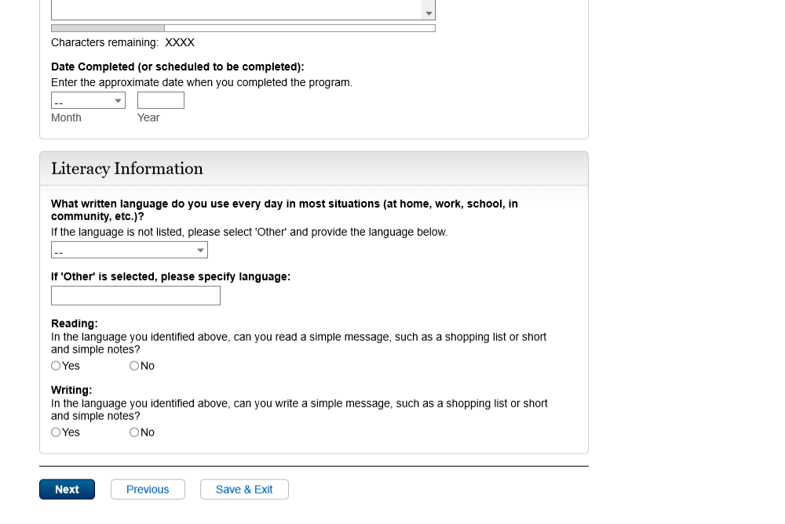

* 1. edu001 - 3 - Education

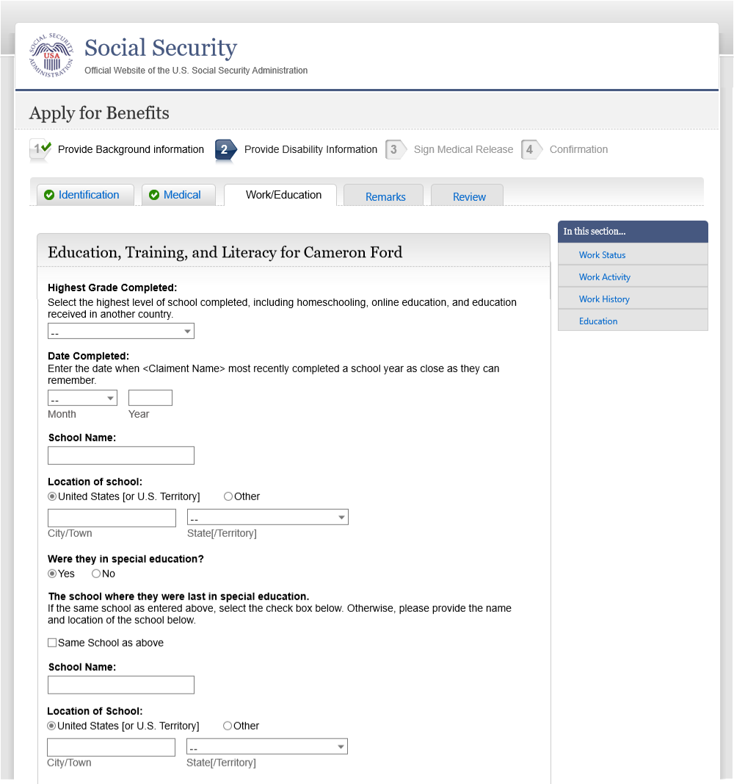

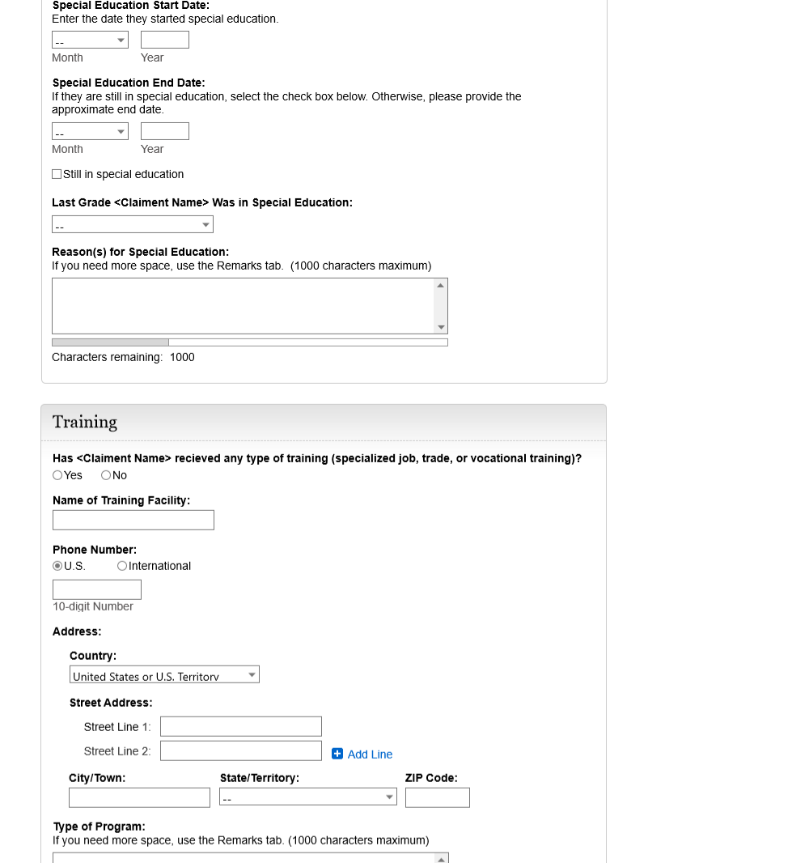

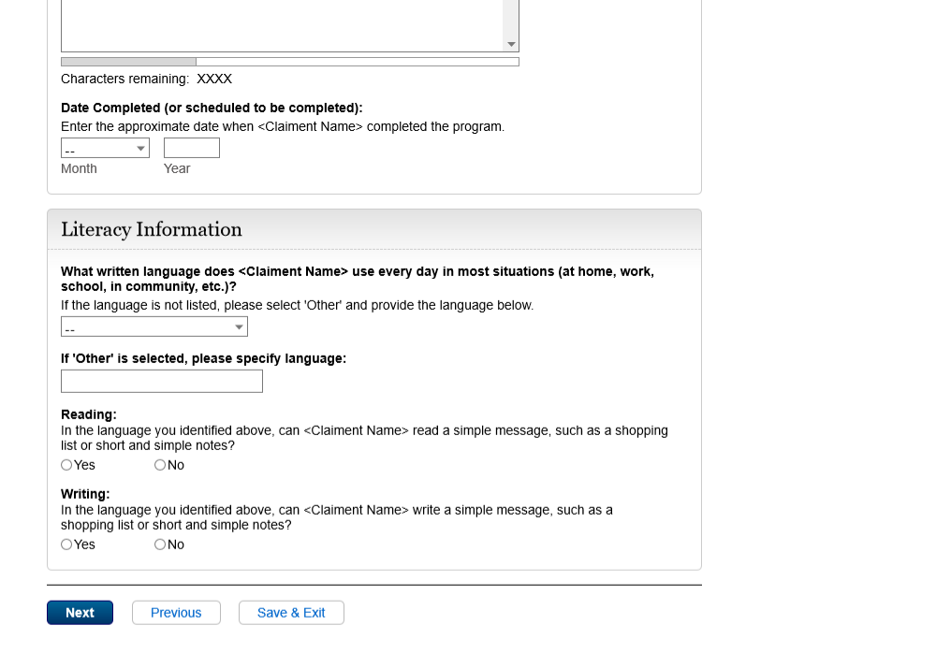

* 1. rvw-001-1 - Review

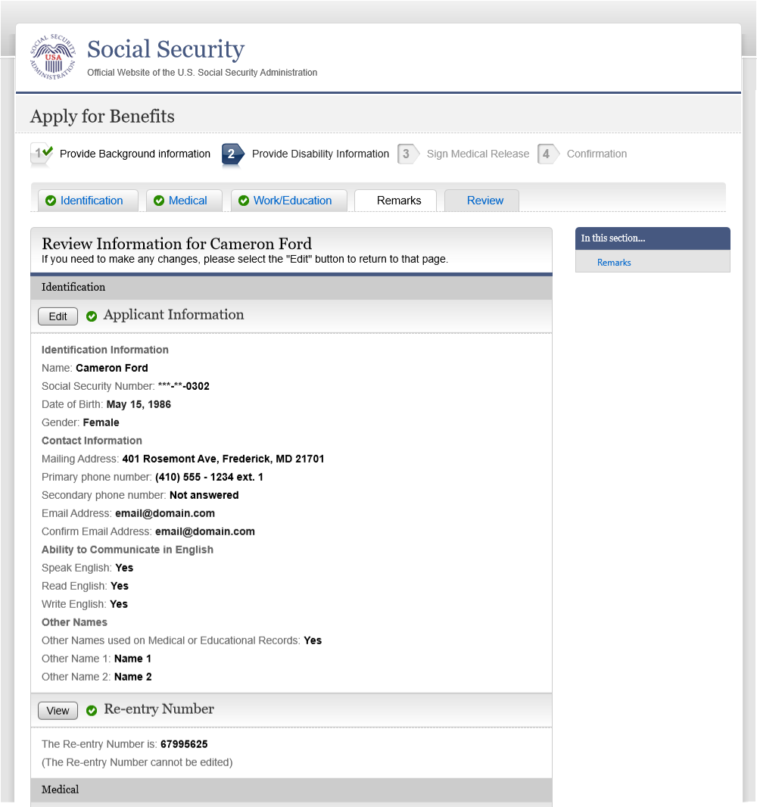

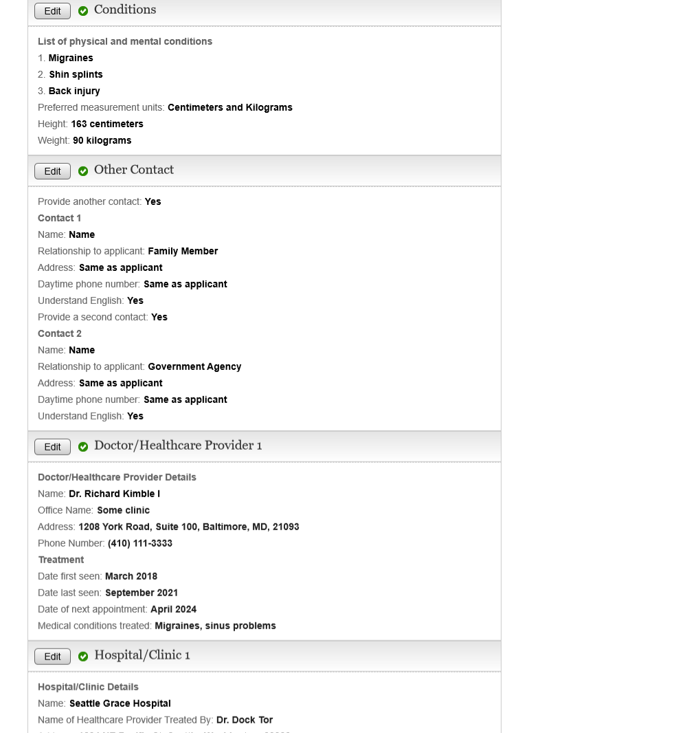

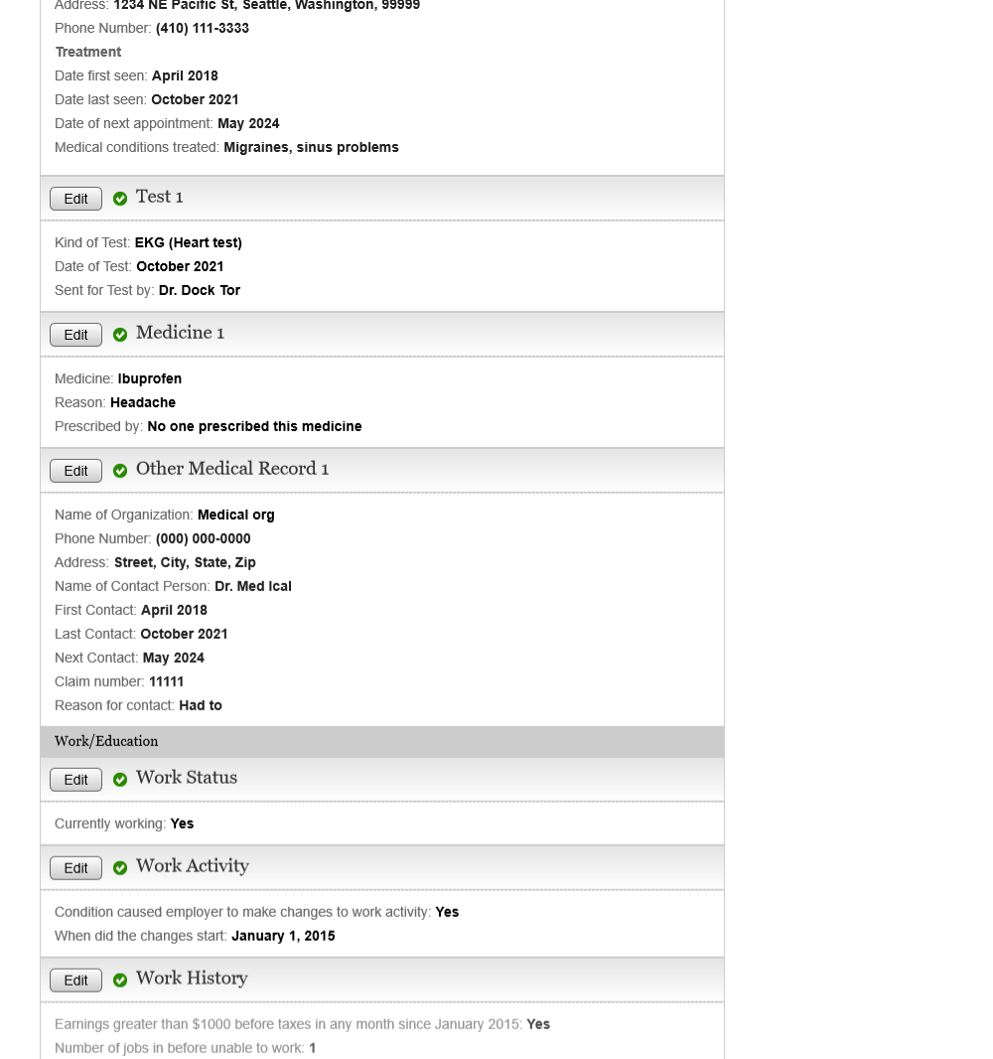

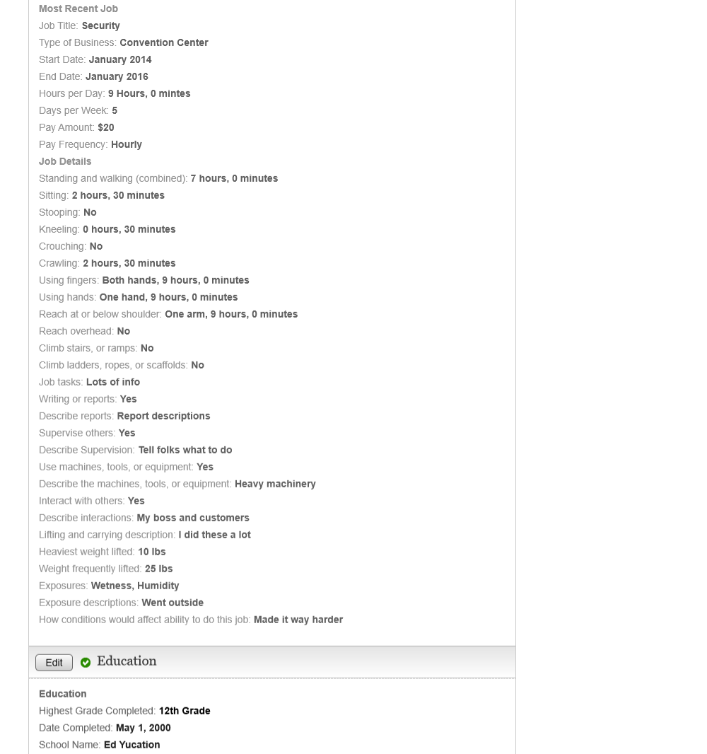

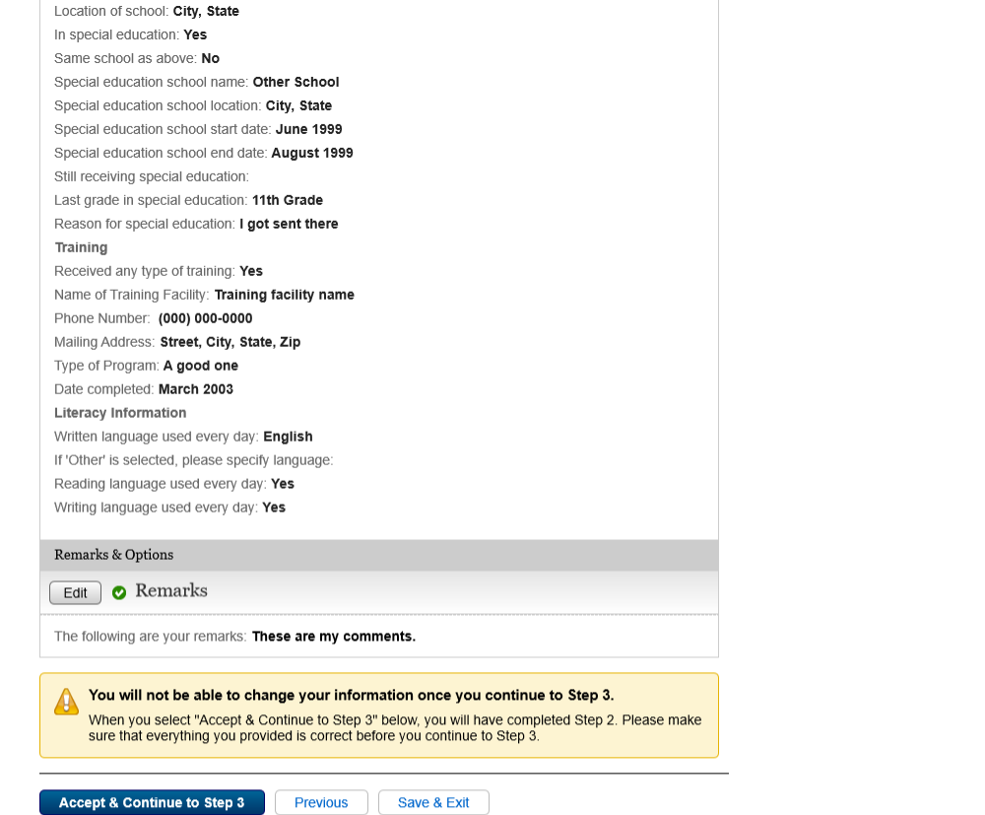

* 1. rvw-001- 3 - Review









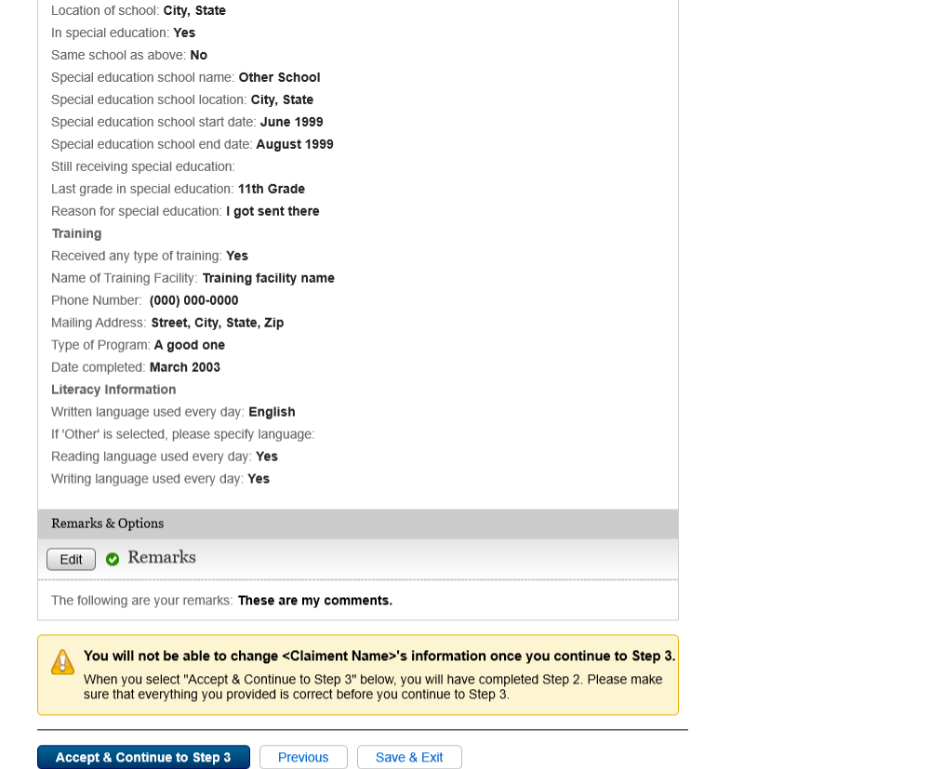

1. Appendix A - UXG Contact Information for Analysts, Developers and Others

For information about any of the content included in this design specifications document, contact the User Experience Group (UXG) Project Lead for this project and/or the appropriate project team member (for some projects a UXG designer may have specialized knowledge of one or more parts of the design).

To ensure a timely response to your inquiry in case of absence, please cc the UXG Team Lead.

|  |  |  |  |  |
| --- | --- | --- | --- | --- |
| **Name** | **Project Role** | **Email** | **Phone** | **Specialized Project Knowledge** |
|  | UXG Team Lead |  |  | All |
|  | UXG Project Lead |  |  | All |
|  | UXG Designer |  |  | All |
|  | UXG Designer |  |  | All |