EDCS SSA-3368 Form updates to EDCS screens
  - SSA-3368 form
  - R56.0

Contents
Background 3
SSA-3368 Layout and Navigation 3
3368 Left Navigation- used for all EDCS 3368 pages 3
EDCS Frame 4
This screenshot shows the layout of all EDCS pages. 4
SSA-3368 Adult EDCS Screenshots 5
SSA-3368 Section 1 – Information About You: 5
SSA-3368 Section 2 – Contacts 6
Contacts Summary page 6
Contacts Information Page 7
SSA-3368 Section 3 – Medical Information 8
SSA-3368 Section 4 – Work Activity 9
INITIAL PAGE - Title change 9
Claimant has never worked 9
Claimant has stopped working 9
Claimant is still working 10
SSA-3368 Section 5 – Education, Training, and Literacy 11
SSA-3368 Section 6 – Work History 12
SSA-3368 Section 7 – Medicines 15
SSA-3368 Section 8 – Medical Treatment 16
Summary Page 16
Dr/Therapist Information page 17
Hospital/Clinic Information Page 18
Bottom of both the Dr/Therapist and Hospital/Clinic Information pages - (no changes) 19
Test Summary Page 20
SSA-3368 Section 9 – Other Medical Information Detail Page 21
SSA-3368 Section 9 – Other Medical Information Summary Page 22
SSA-3368 Section 10 – Support Services 22
Support Services Summary Page 22
Support Services Information page 23
SSA-3368 Section 11 – Remarks (no changes) 23
SSA-3368 Section 12 – Who Is Completing this Report 24

Background
The Electronic Disability Case Processing System (EDCS) is a mature software application that has been in production for over 20 years. Due to the age of the application, any updates triggered by the SSA-3368 form will follow the existing design approach in EDCS. This will help ensure easy adoption of new or updated content while limiting the need for separate training on the implemented features.

SSA-3368 Layout and Navigation

3368 Left Navigation- used for all EDCS 3368 pages
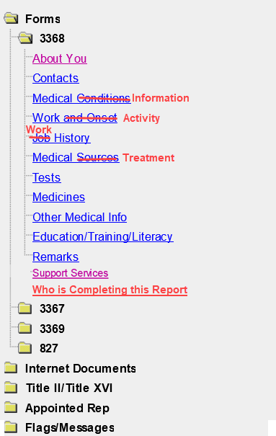

EDCS Frame

This screenshot shows the layout of all EDCS pages.
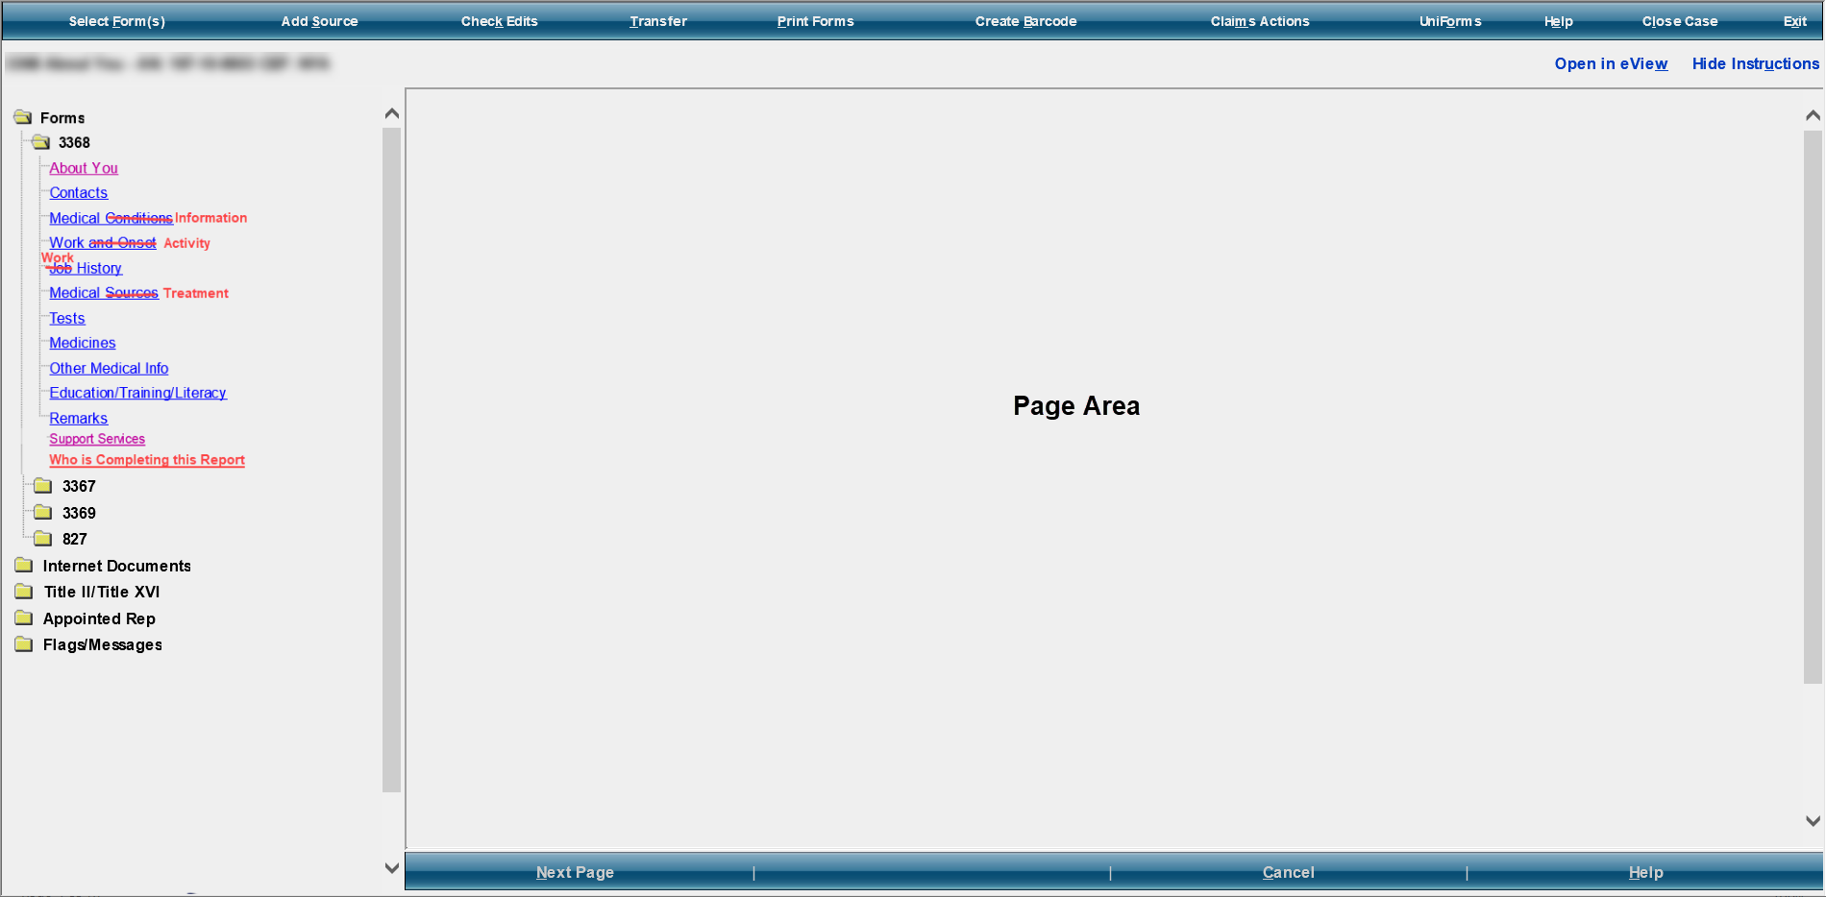

Things to note:

The left-hand navigation tree displays links to each of the SSA-3368 page screens.

Individual page screens display in the Page Area

Next/Previous buttons display at the bottom of the frame.

SSA-3368 Adult EDCS Screenshots

SSA-3368 Section 1 – Information About You:
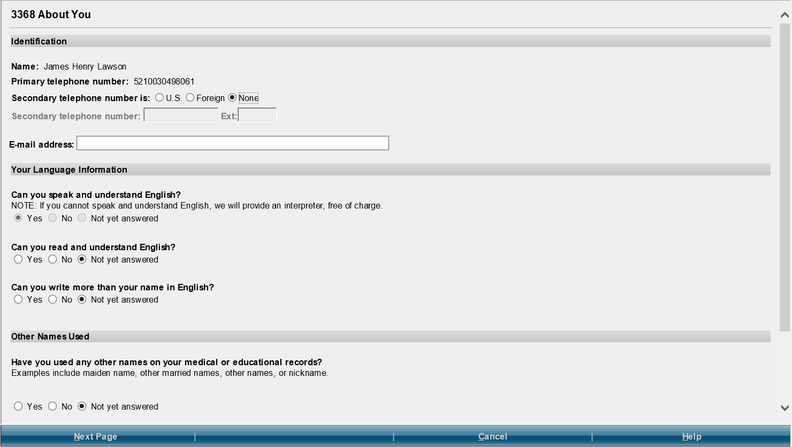

SSA-3368 Section 2 – Contacts

Contacts Summary page
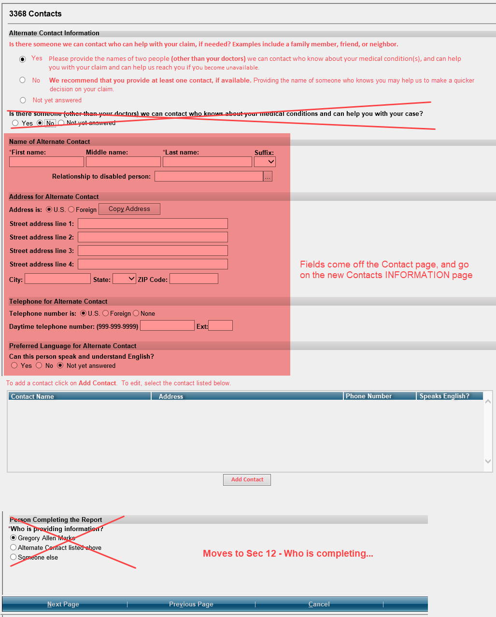

Contacts Information Page
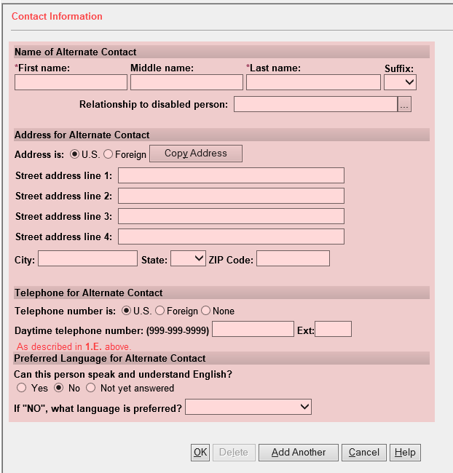

SSA-3368 Section 3 – Medical Information
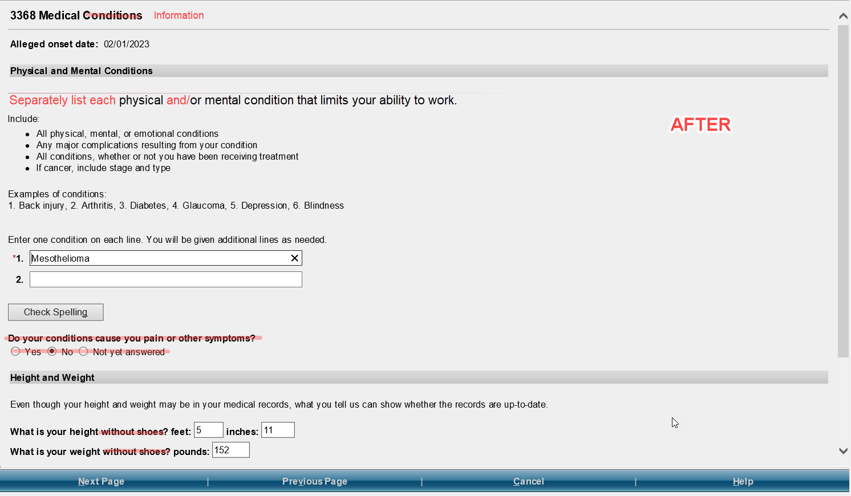

SSA-3368 Section 4 – Work Activity

INITIAL PAGE - Title change
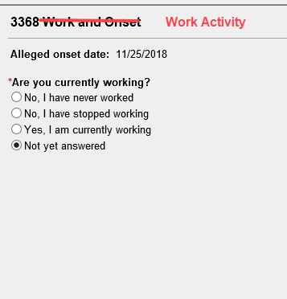

Claimant has never worked
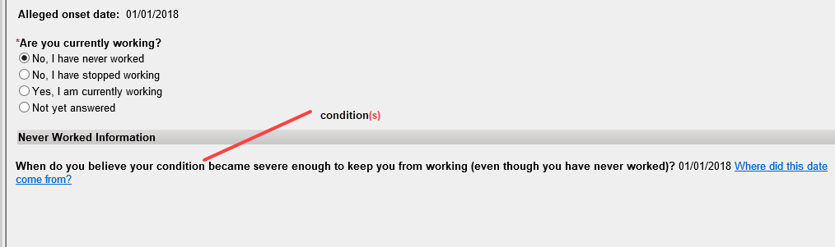

Claimant has stopped working

Because of my condition(s)
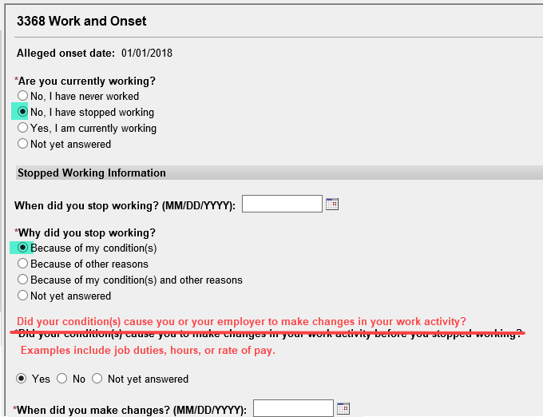

Because of other reasons
and/or

Because of my conditions(s) and other reasons
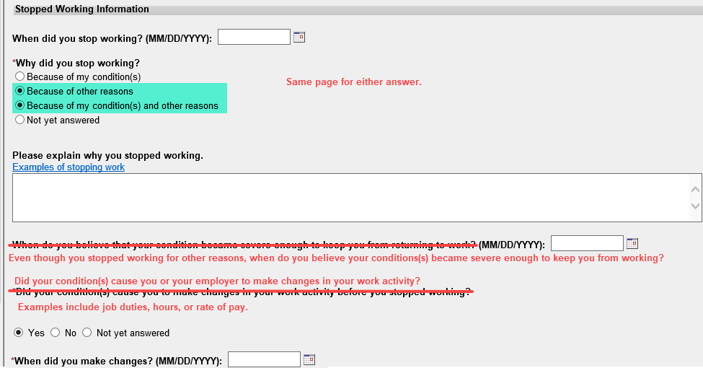

Claimant is still working
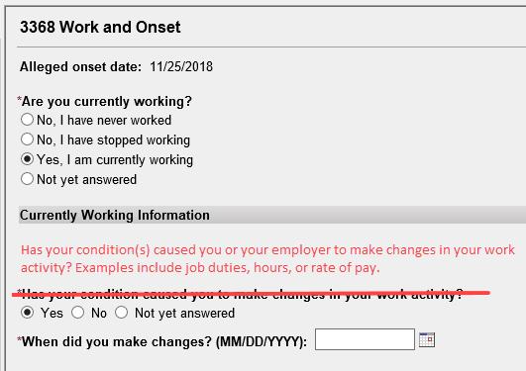

SSA-3368 Section 5 – Education, Training, and Literacy
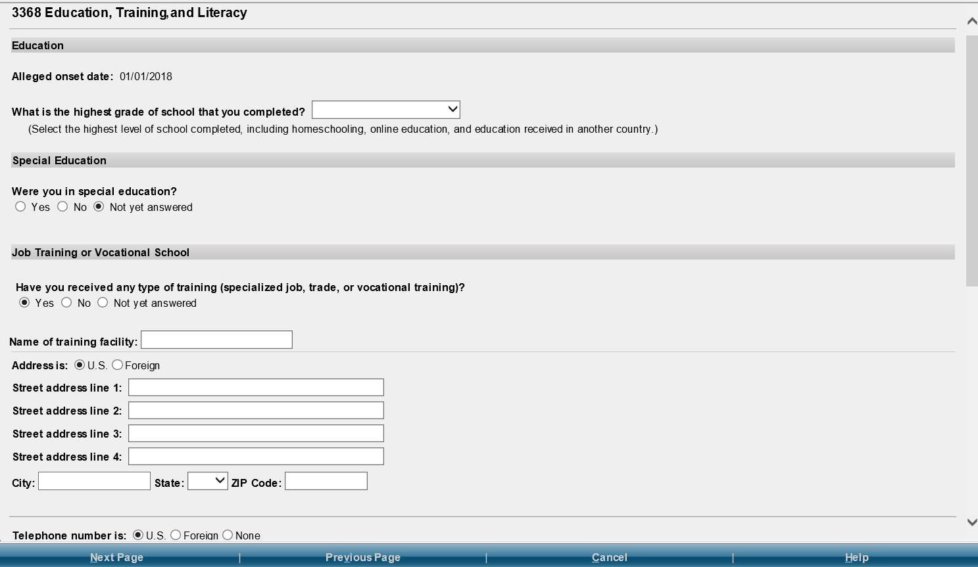
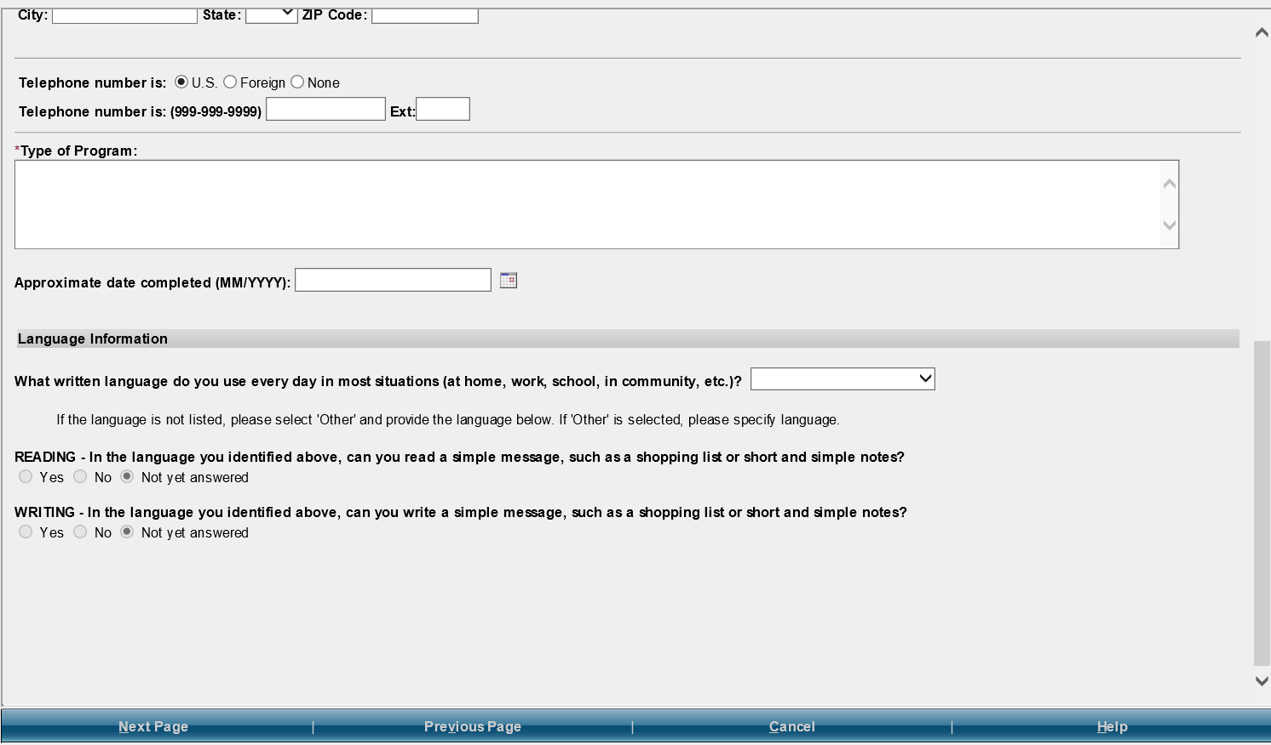

SSA-3368 Section 6 – Work History
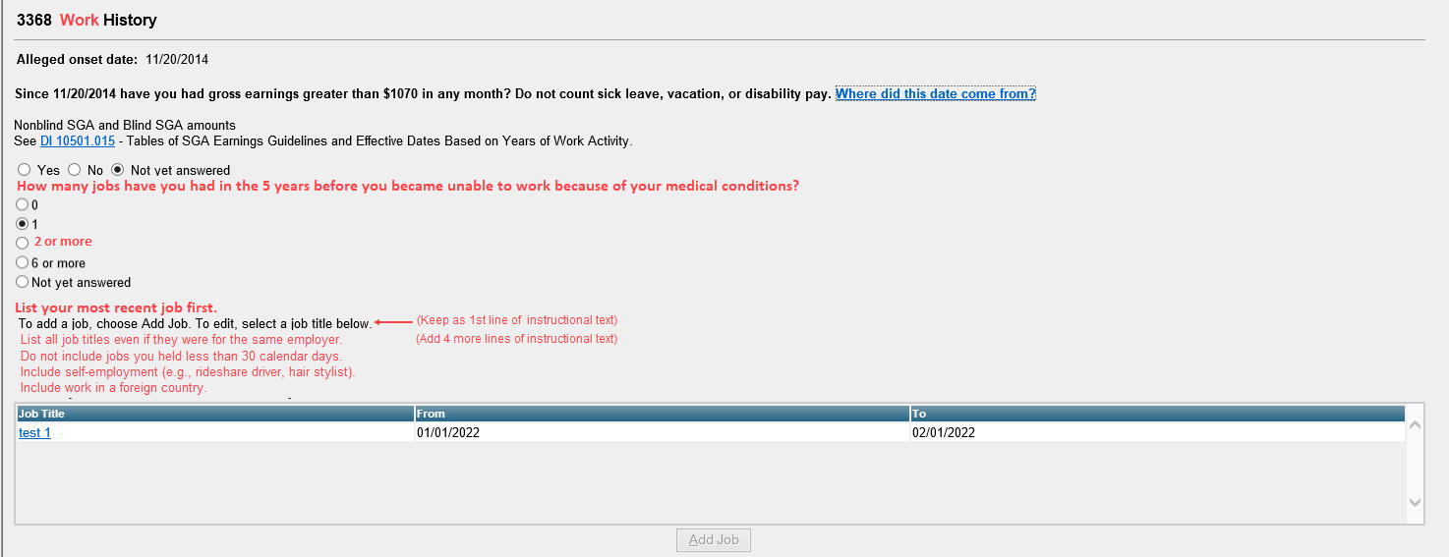
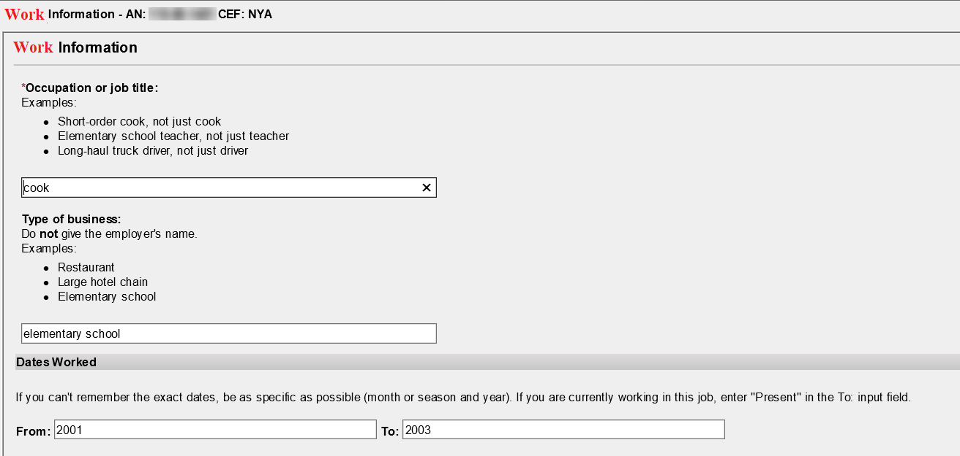
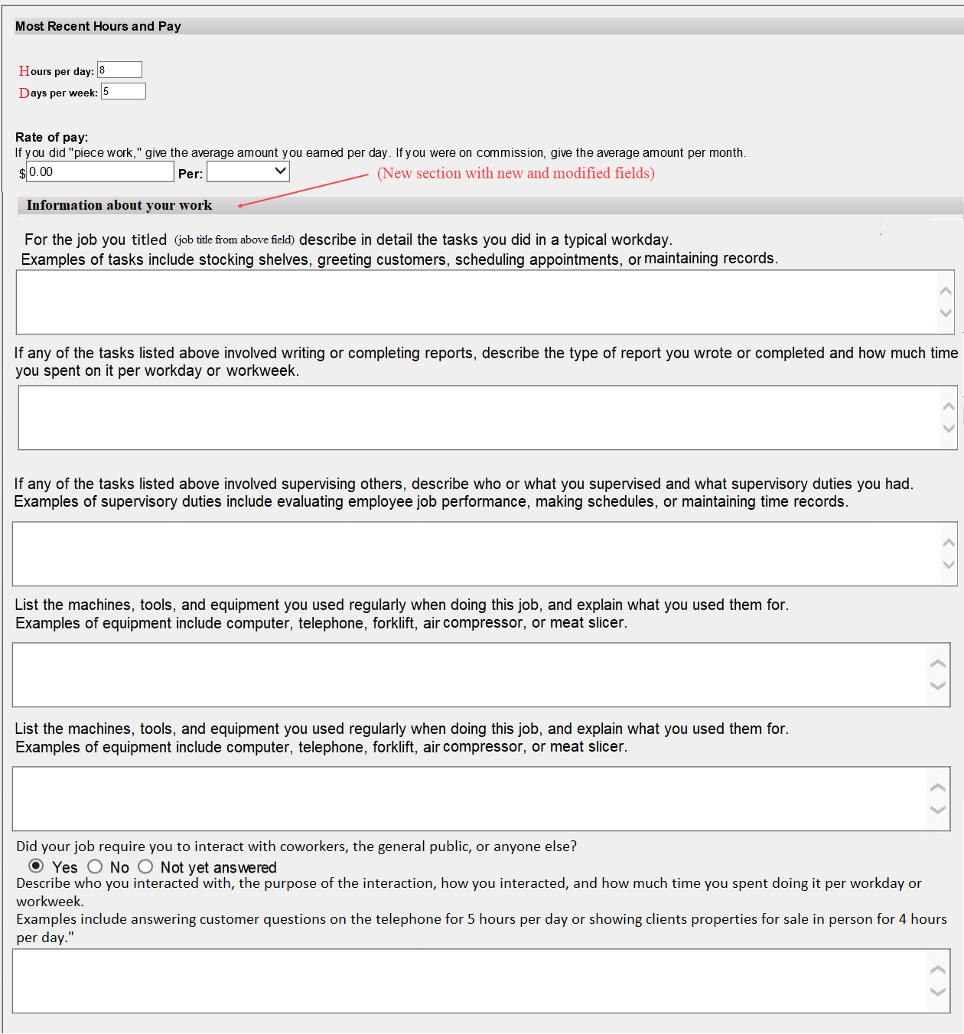
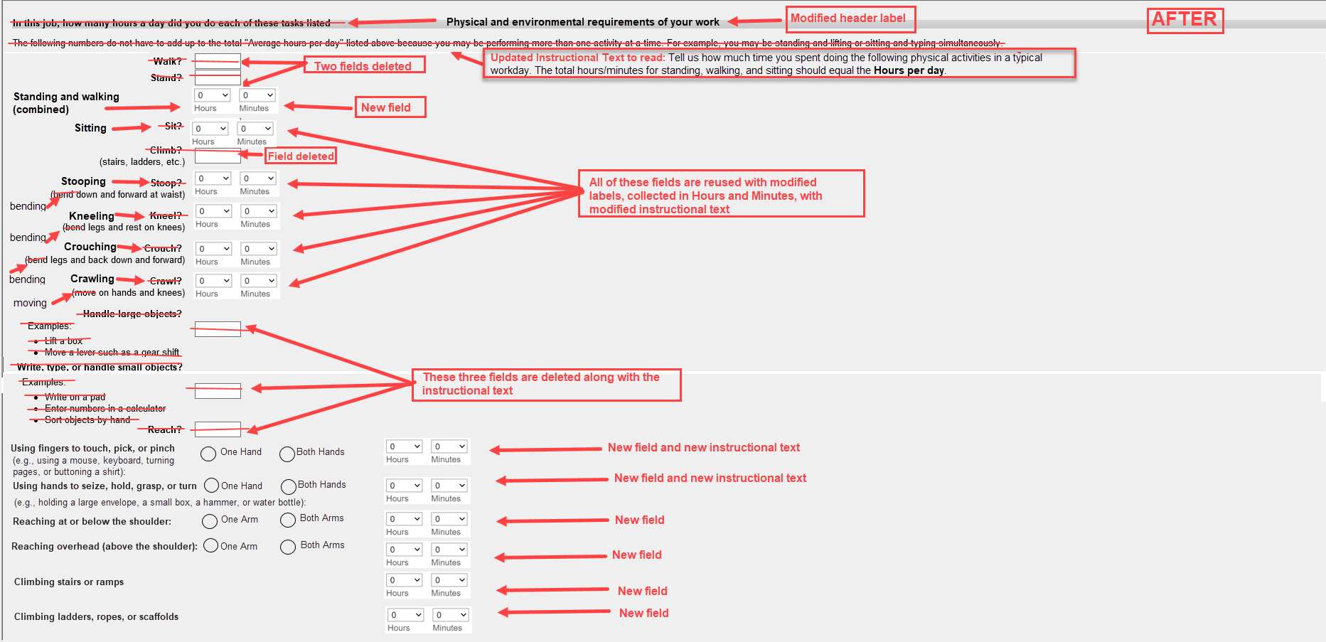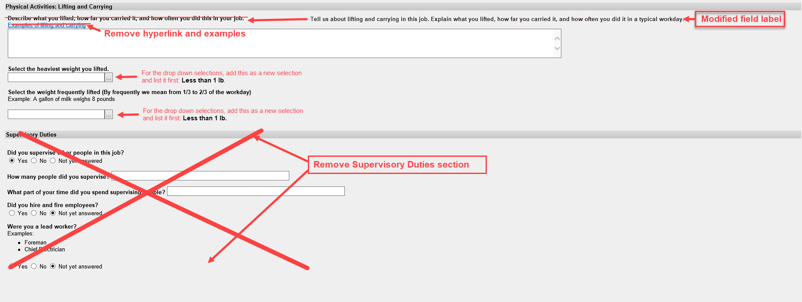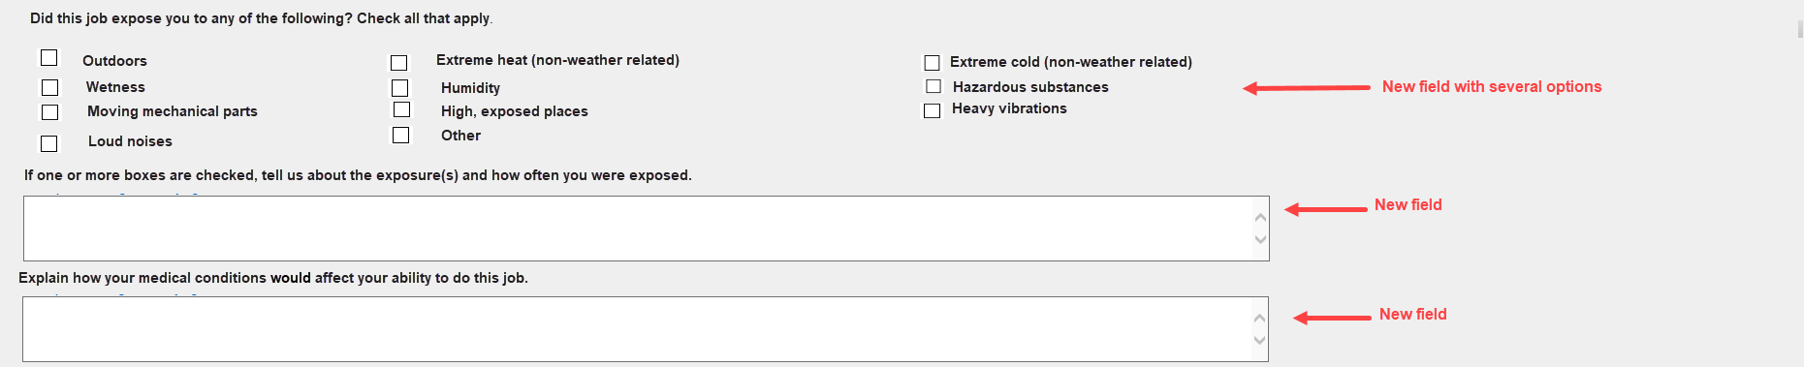

SSA-3368 Section 7 – Medicines
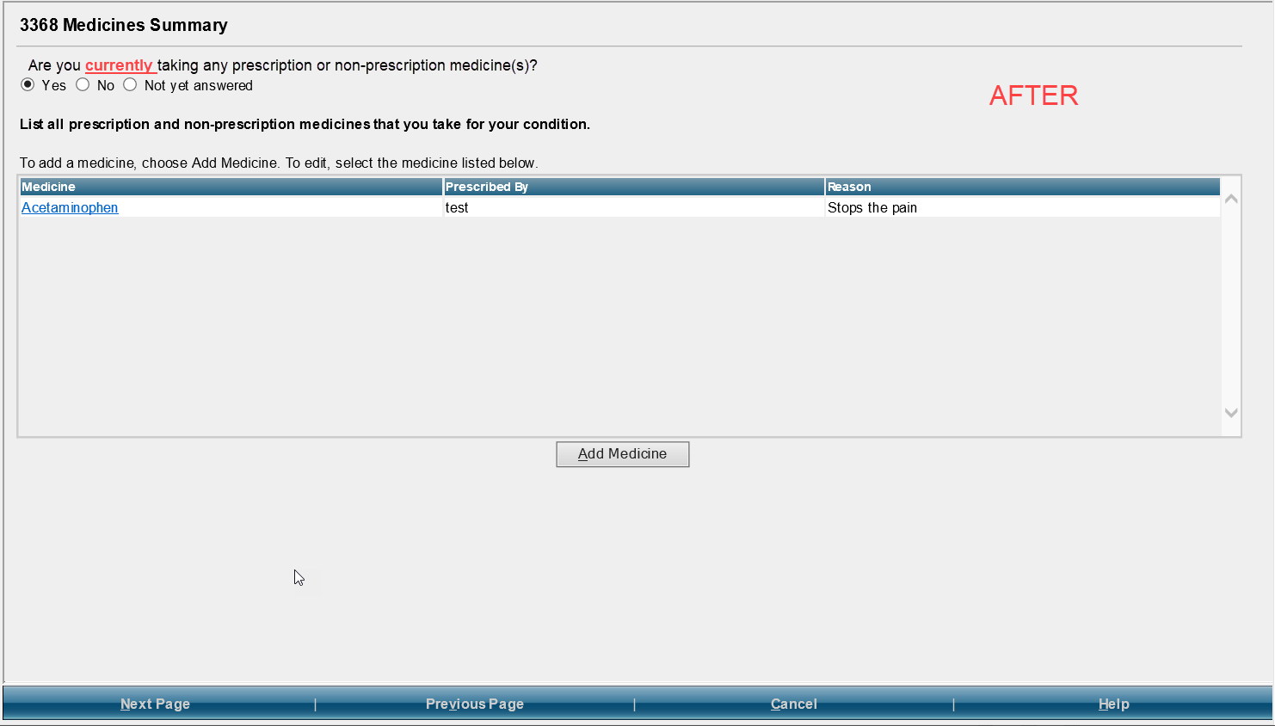

SSA-3368 Section 8 – Medical Treatment

Summary Page
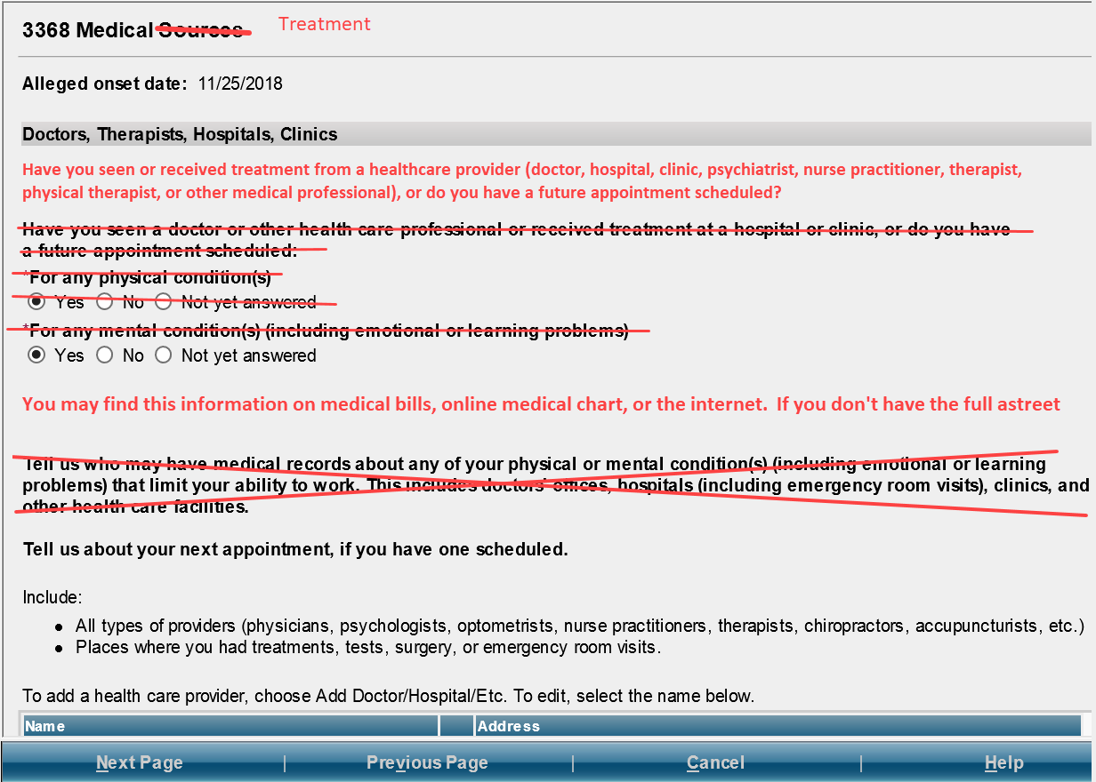

Dr/Therapist Information page
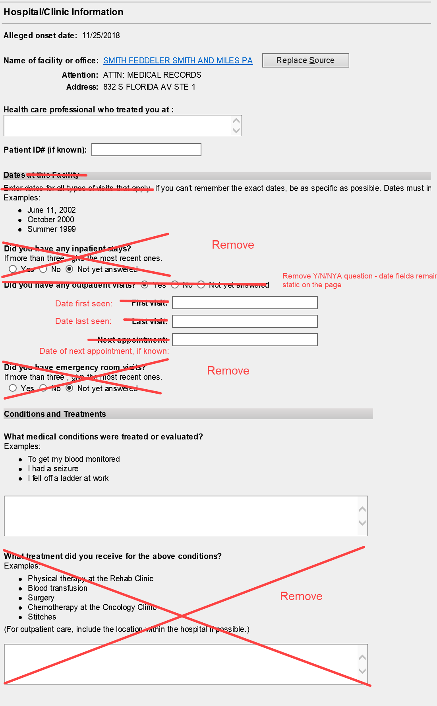

Hospital/Clinic Information Page
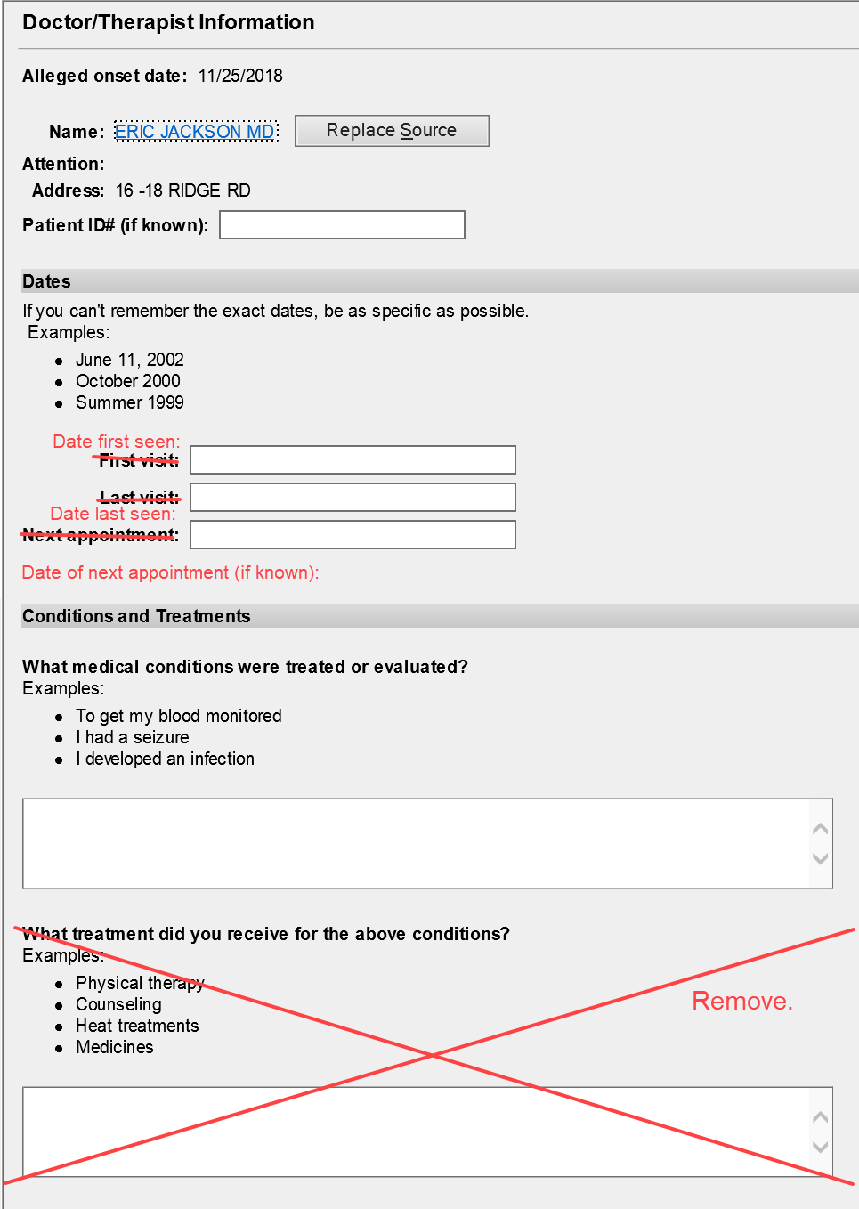

Bottom of both the Dr/Therapist and Hospital/Clinic Information pages - (no changes)
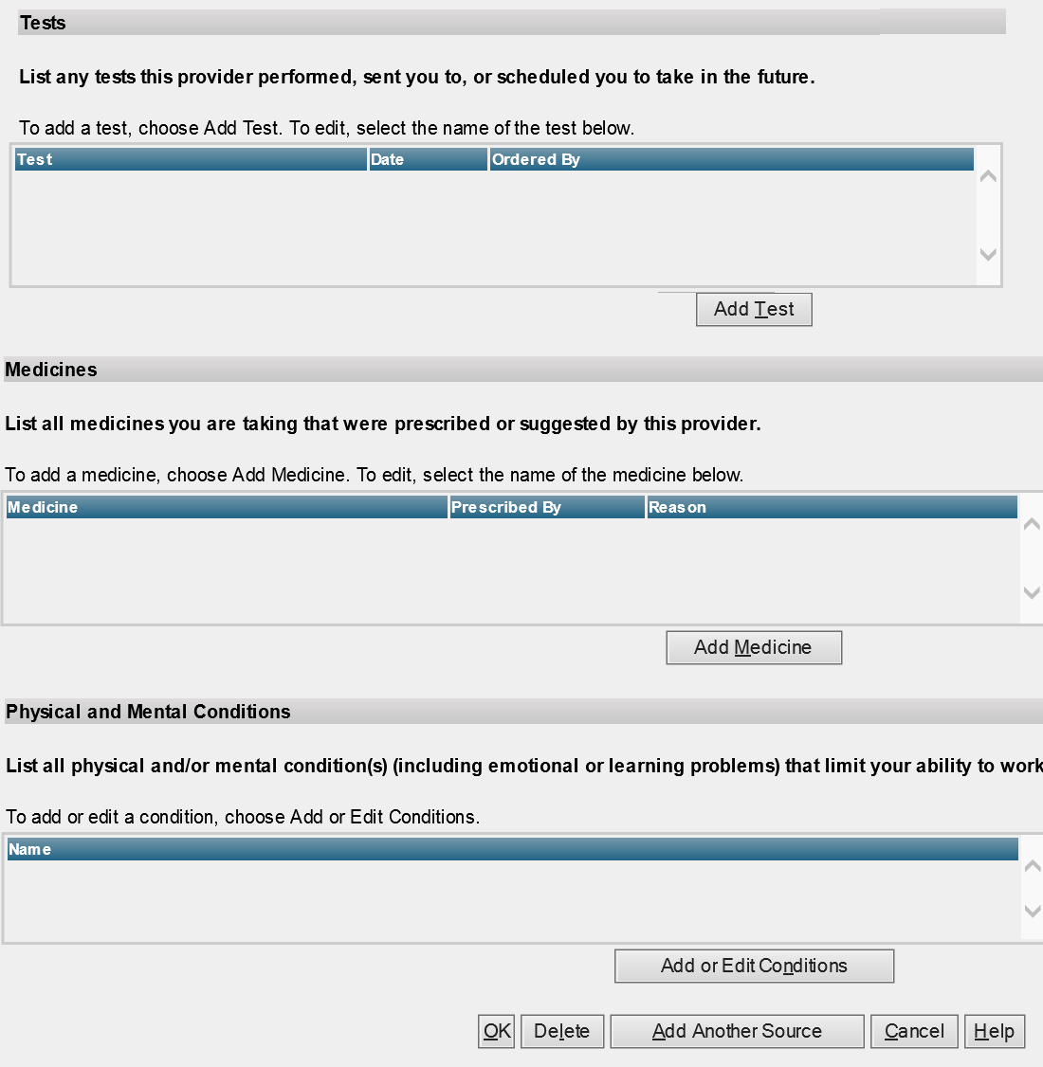

Test Summary Page
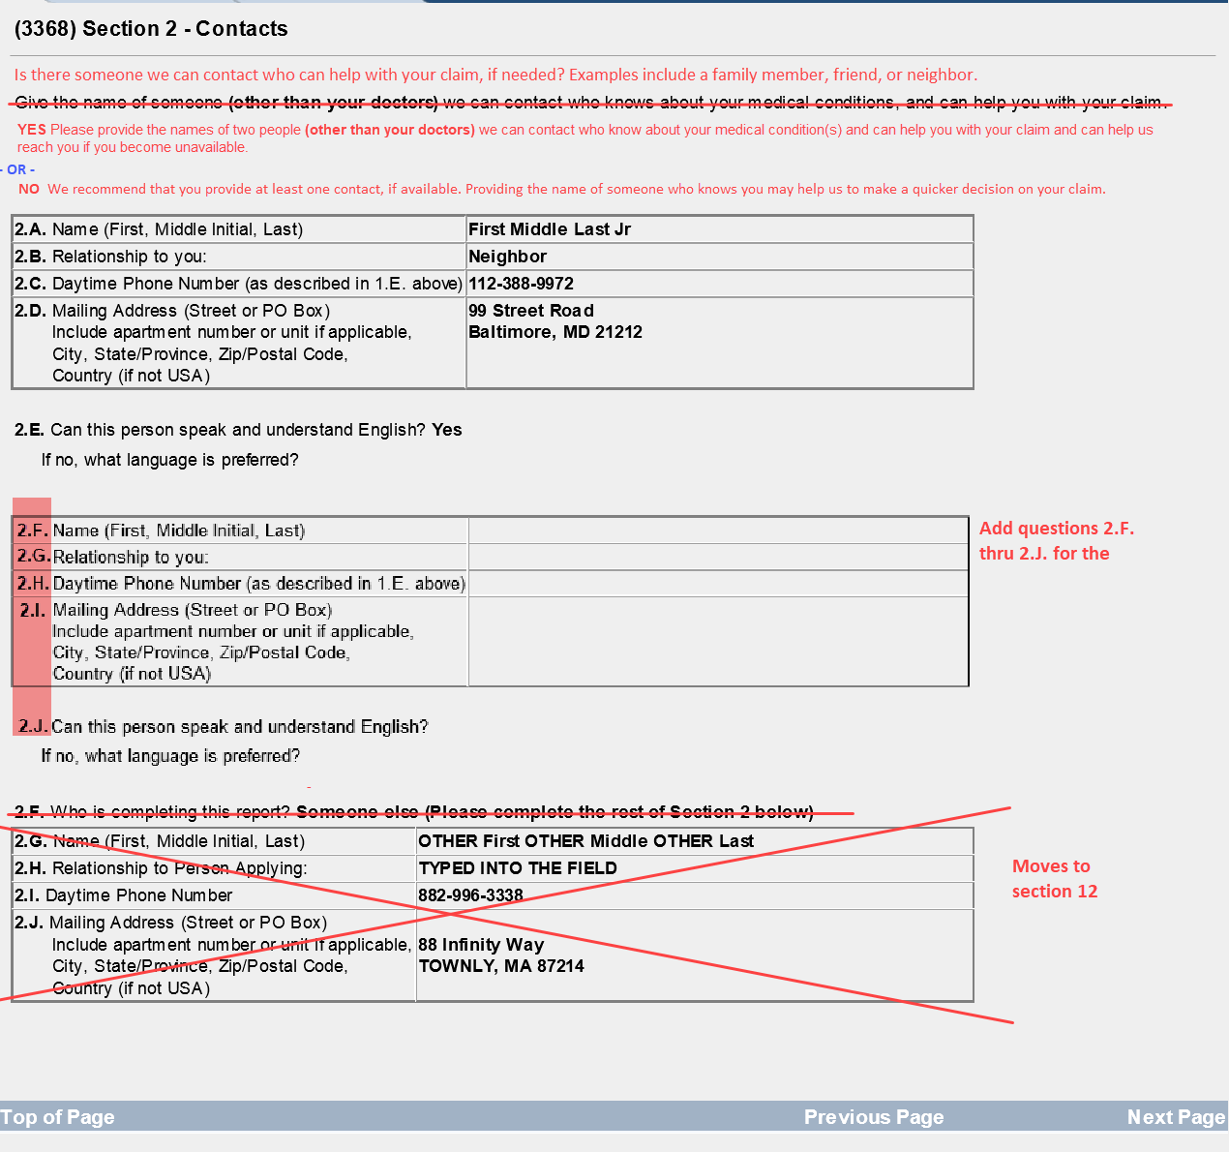

SSA-3368 Section 9 – Other Medical Information Detail Page
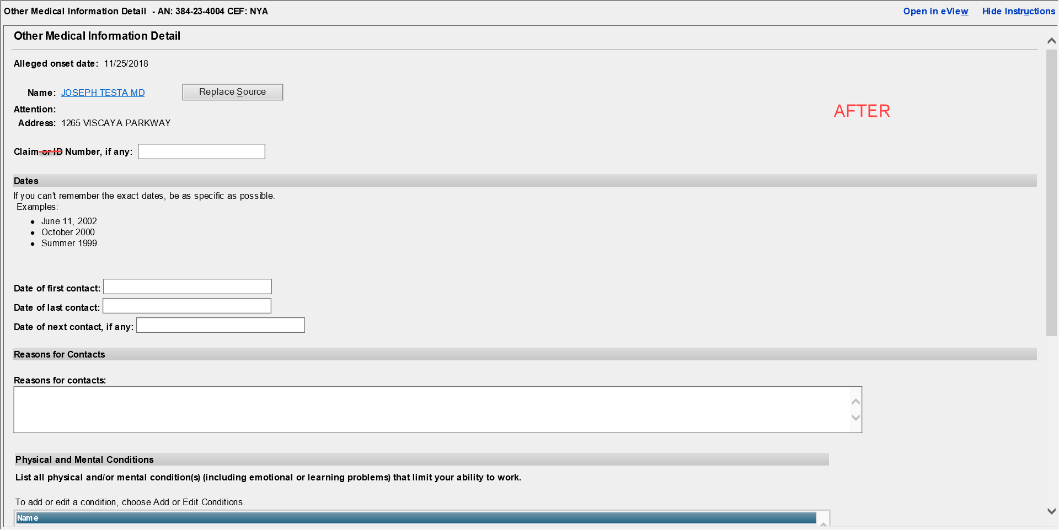
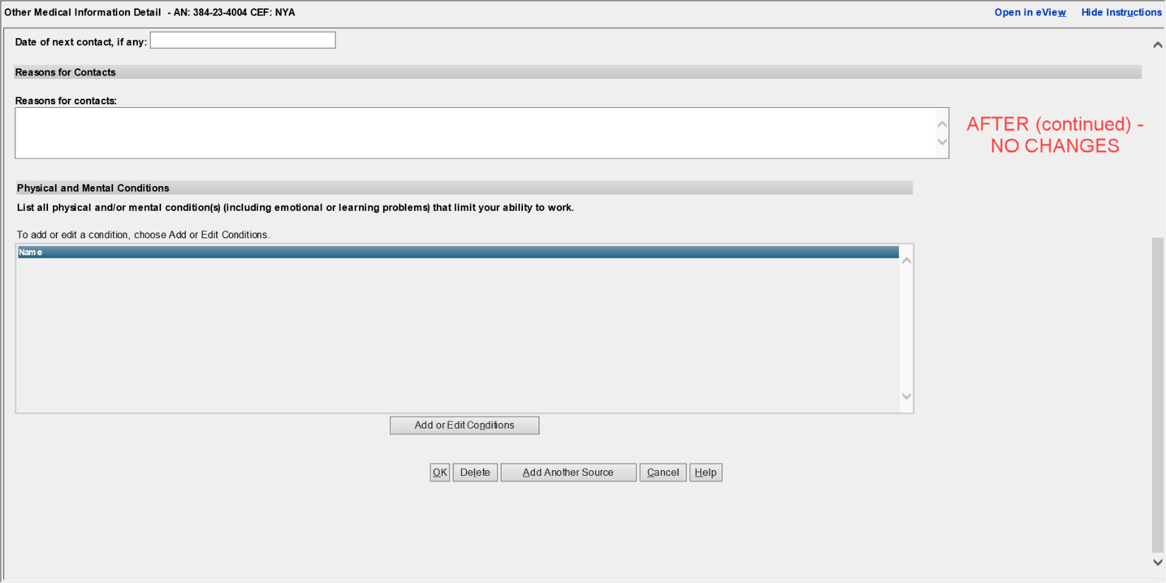

SSA-3368 Section 9 – Other Medical Information Summary Page
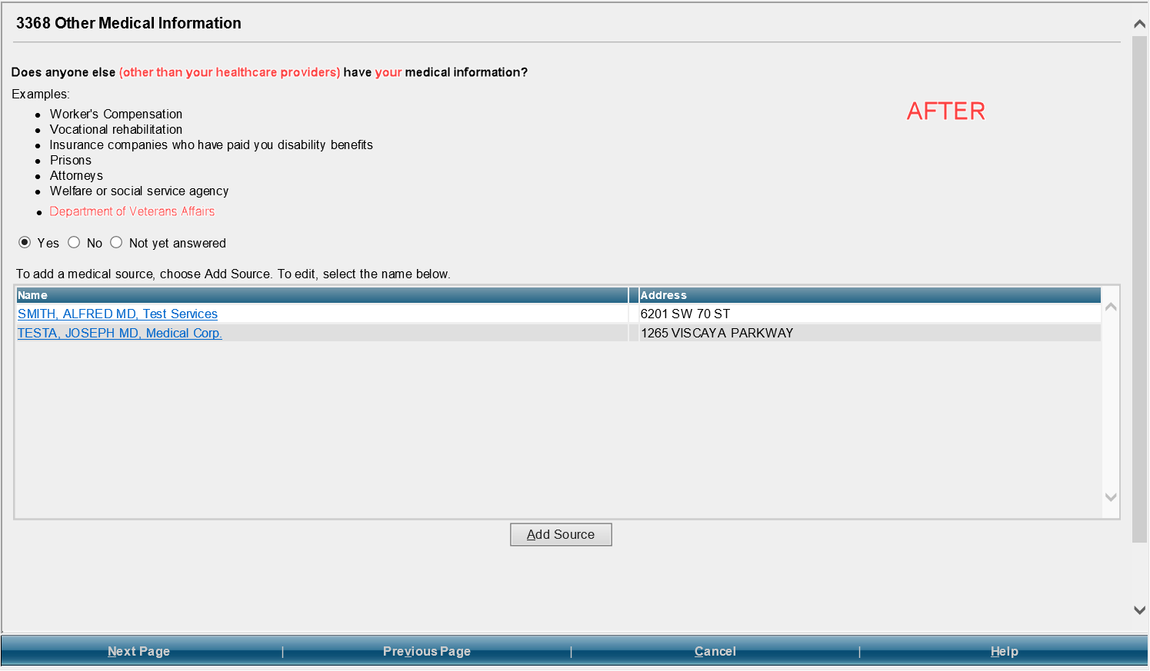

SSA-3368 Section 10 – Support Services

Support Services Summary Page
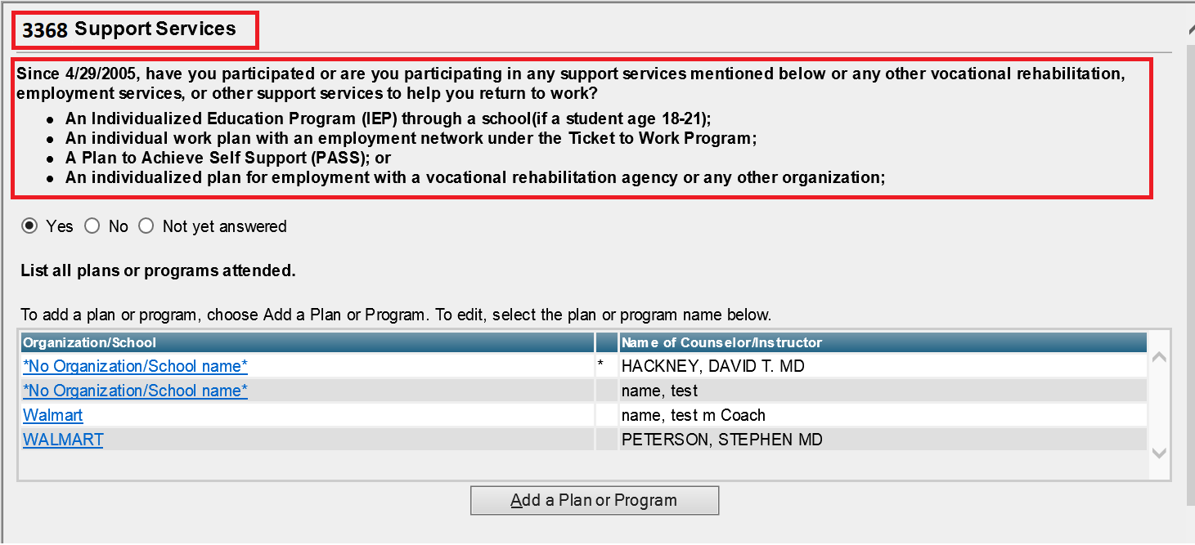

Support Services Information page
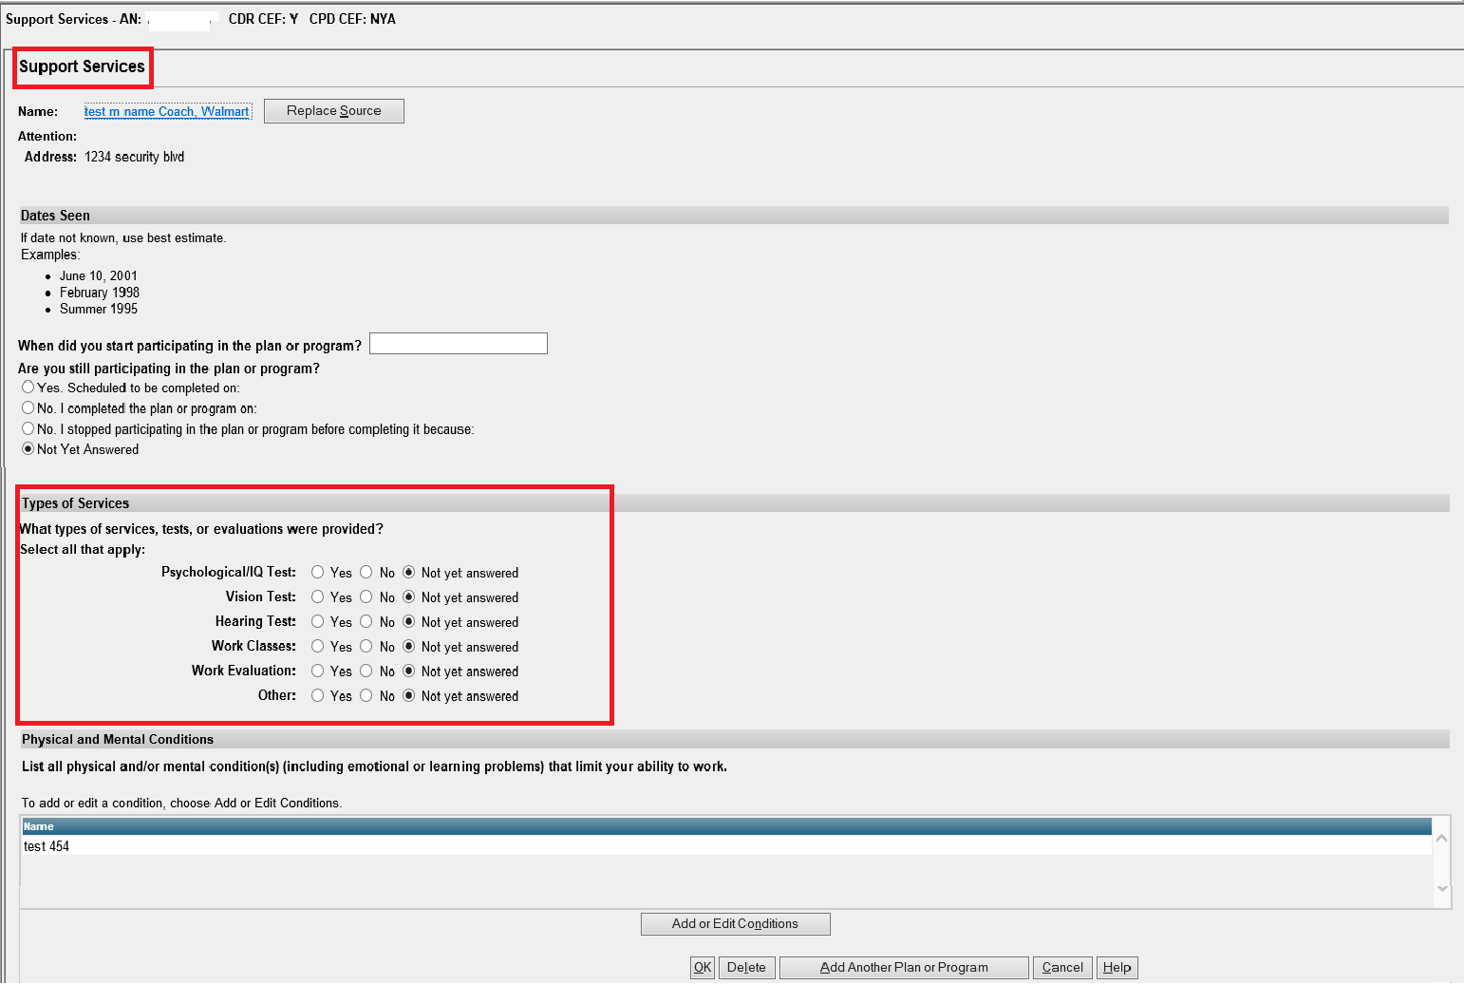

SSA-3368 Section 11 – Remarks (no changes)
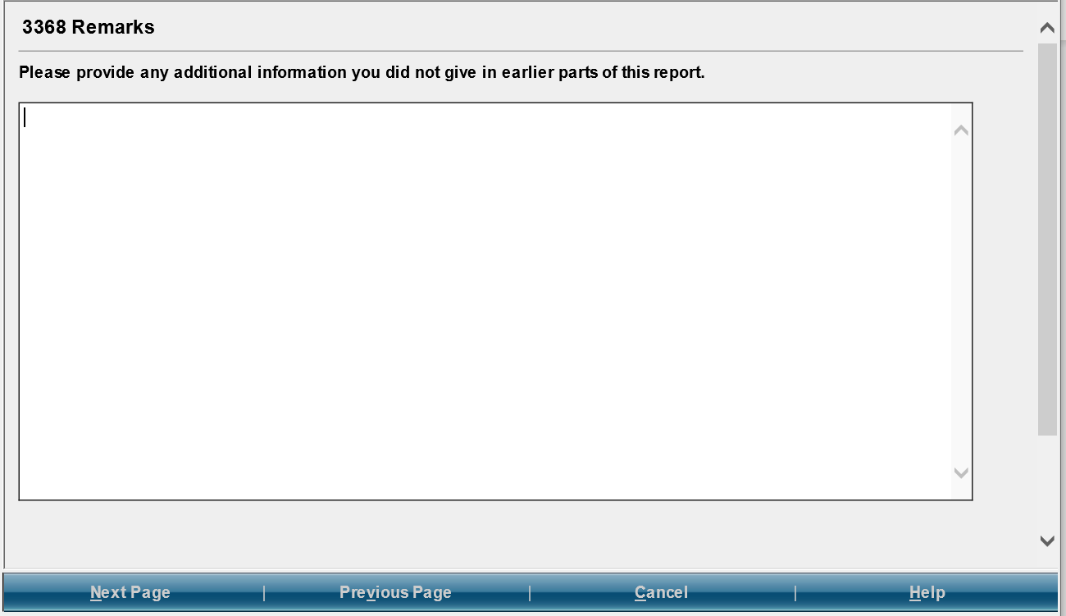

SSA-3368 Section 12 – Who Is Completing this Report
