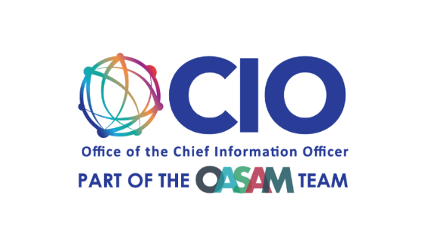

Sampling Plan for collection 1
EBSA Lost and Found Portal

Sampling Plan
The 12 participants will be members of the public ages 30 – 60+, with at least one respondent from each decade. The y will be divided into four groups with three respondents from each decade (30-40, 40-50, 50-60, 60-up). Additionally, participants must have held at least two jobs with employer-provided retirement benefits (ex: a 401K, pension plan, etc.). The selection process will include a random sampling of diverse individuals (background, location, ethnicity, etc.), and at least 1-3 individuals with some form of visual impairment such as color blindness but have some sighted ability. Participants must have access to an internet-capable device (desktop, laptop, tablet, or smartphone) and an internet connection (ethernet or fiber optics, Wi-Fi, data plan, etc.).

Recruitment
A third-party vendor will recruit participants via a web-based survey (see included survey questions) or sending the survey via email, depending on participant preference and access. The estimated additional burden for each individual in filling out the survey is 15 minutes.

