https://dataportal.dol.gov/questionnaire (only reachable from within DOL network)

According to the Paperwork Reduction Act of 1995, no persons are required to respond to a collection of information unless such collection displays a valid OMB control number. Public reporting burden for this collection of information is estimated to average 9 minutes per response, including time for reviewing instructions, searching existing data sources, gathering and maintaining the data needed, and completing and reviewing the collection of information. The obligation to respond to this collection is voluntary. Send comments regarding the burden estimate or any other aspect of this collection of information, including suggestions for reducing this burden, to the U.S. Department of Labor, Office of the Chief Information Officer, Attention: Departmental Clearance Officer, 200 Constitution Avenue, N.W., Room N-1301, Washington, DC 20210 or email DOL_PRA_PUBLIC@dol.gov and reference the OMB Control Number. Note: Please do not return the completed web application to this address.

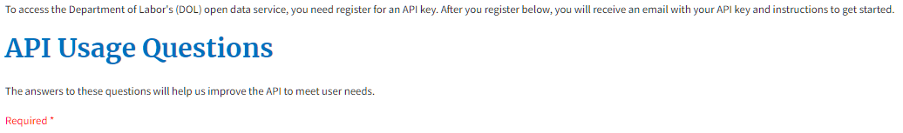
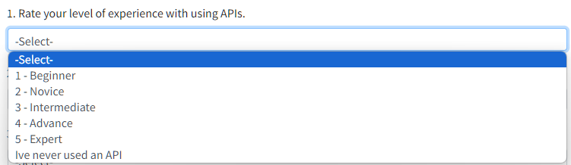

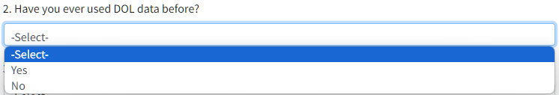

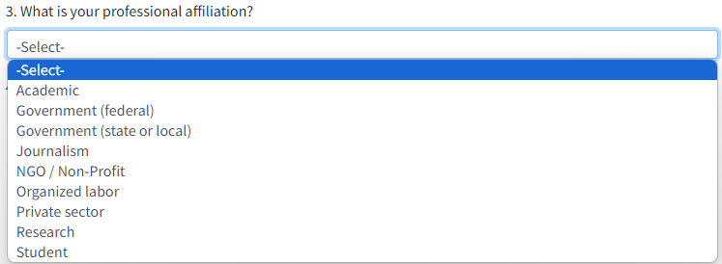

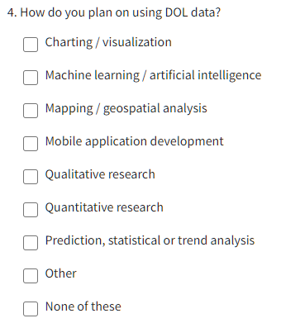

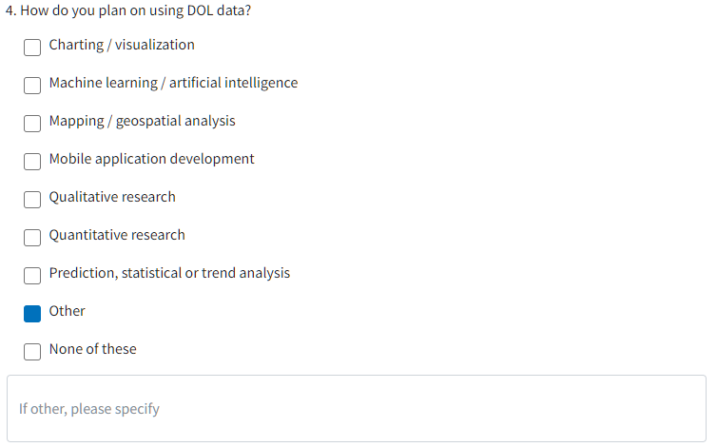

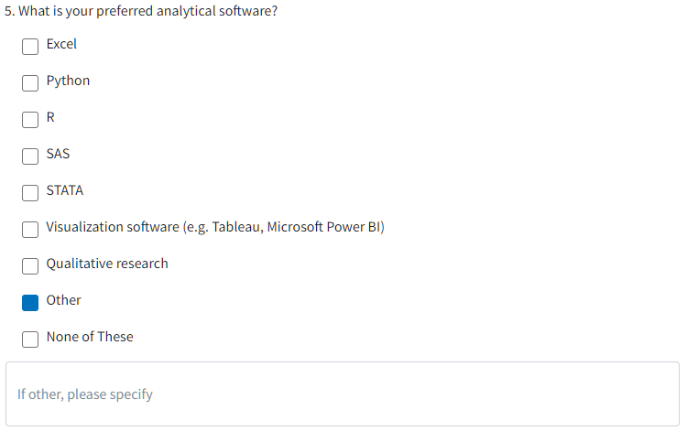

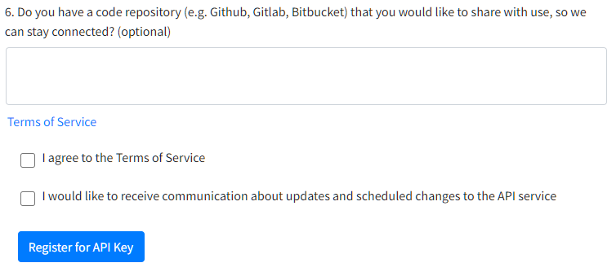

Terms of Service
×Close

Terms of Service Agreement
The U.S. Department of Labor (DOL) offers some of its public data in machine-readable format via an Application Programming Interface ("API"). This service is offered subject to your completion of the API key registration form and acceptance of the terms and conditions contained herein as well as any relevant sections of the dol.gov Website Policies and Notices and Data Protection and Privacy Policy (collectively, the "Agreements").

Scope
All of the content, documentation, code, key registration data, and related materials made available through the API are subject to these terms. Access to or use of the API or its content constitutes acceptance to this Agreement.

Use
You may use the DOL API to develop a service to search, display, analyze, retrieve, view and otherwise "get" information from DOL data.

Attribution
All services, which utilize or access the API, should display the following notice prominently within the application: "This product uses the US Department of Labor API but is not endorsed or certified by the US Department of Labor." You may use the DOL name in order to identify the source of API content subject to these rules. You may not use the DOL name, or the like to imply endorsement of any product, service, or entity, not-for-profit, commercial or otherwise.

Modification or False Representation of Content
You may not modify or falsely represent content accessed through the API and still claim the source is the DOL.

Right to Limit
Your use of the API may be subject to certain limitations on access, calls, or use as set forth within this Agreement or otherwise provided by the DOL. If the DOL reasonably believes that you have attempted to exceed or circumvent these limits, your ability to use the API may be temporarily or permanently blocked. The DOL may monitor your use of the API to improve the service or to insure compliance with this Agreement.

Service Termination
If you wish to terminate this Agreement, you may do so by refraining from further use of the API. The DOL reserves the right (though not the obligation) to: (1) refuse to provide the API to you, if it is the DOL's opinion that use violates any DOL policy; or (2) terminate or deny you access to and use of all or part of the API at any time for any other reason in its sole discretion. All provisions of this Agreement, which by their nature should survive termination, shall survive termination including, without limitation, warranty disclaimers, indemnity, and limitations of liability.

Changes
The DOL reserves the right, at its sole discretion, to modify or replace this Agreement, in whole or in part. Your continued use of or access to the API following posting of any changes to this Agreement constitutes acceptance of those modified terms. The DOL may in the future, offer new services and/or features through the API. Such new features and/or services shall be subject to the terms and conditions of this Agreement.

Disclaimer of Warranties
The API is provided "as is" and on an "as-available" basis. The DOL hereby disclaim all warranties of any kind, express or implied, including without limitation the warranties of merchantability, fitness for a particular purpose, and non-infringement. The DOL makes no warranty that the API will be error free or that access thereto will be continuous or uninterrupted.

Limitations on Liability
In no event will the DOL be liable with respect to any subject matter of this Agreement under any contract, negligence, strict liability or other legal or equitable theory for: (1) any special, incidental, or consequential damages; (2) the cost of procurement of substitute products or services; or (3) for interruption of use or loss or corruption of data.

General Representations
You hereby warrant that: (1) your use of the API will be in strict accordance with the DOL privacy policy, this Agreement, and all applicable laws and regulations; and (2) your use of the API will not infringe or misappropriate the intellectual property rights of any third party.

Indemnification
You agree to indemnify and hold harmless the DOL, its contractors, employees, agents, and the like from and against any and all claims and expenses including attorney's fees, arising out of your use of the API, including but not limited to violation of this Agreement.

Miscellaneous
This Agreement constitutes the entire Agreement between the DOL and you concerning the subject matter hereof, and may only be modified by the posting of a revised version on this page by the DOL.

Disputes
Any disputes arising out of this Agreement and access to or use of the API shall be governed by federal law.

No Waiver Rights
The DOL's failure to exercise or enforce any right or provision of this Agreement shall not constitute waiver of such right or provision.

Updated August 5, 2020

