**Home**

**ESTA PRIVACY ACT STATEMENT**

**Security Notification**

**Disclaimers**

When ‘No’ is selected

When ‘No’ is selected

**UPLOAD YOUR PASSPORT**

**Passport Upload – Regula**

**Review & Confirm – When Passport Upload is successful**

**ERROR – When Passport Upload is unsuccessful**

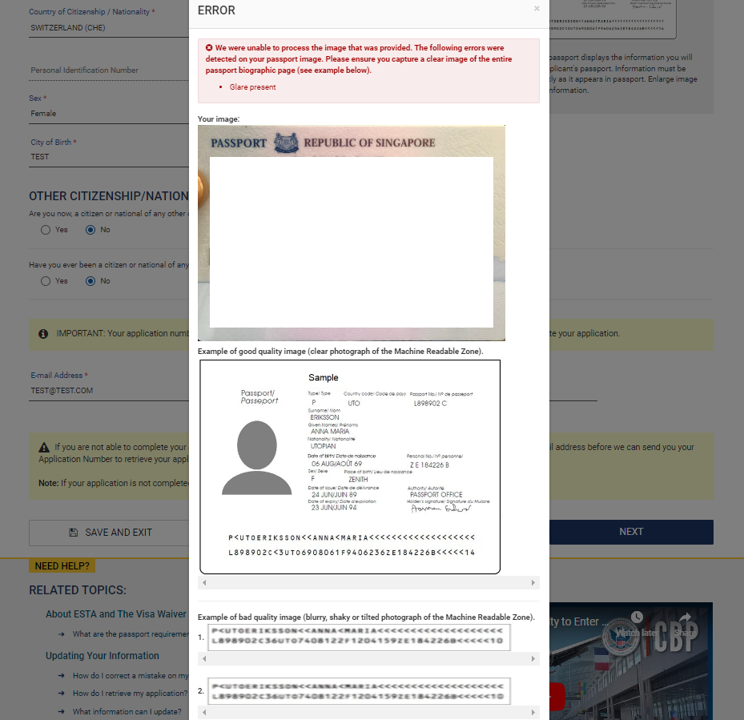

**UPLOAD APPLICANT’S SELFIE**

**UPLOAD APPLICANT’S SELFIE: “From Gallery” option**

**UPLOAD APPLICANT’S SELFIE: “From Camera” option**

**UPLOAD APPLICANT’S SELFIE: SELFIE PREVIEW**

**Enter Applicant Information**

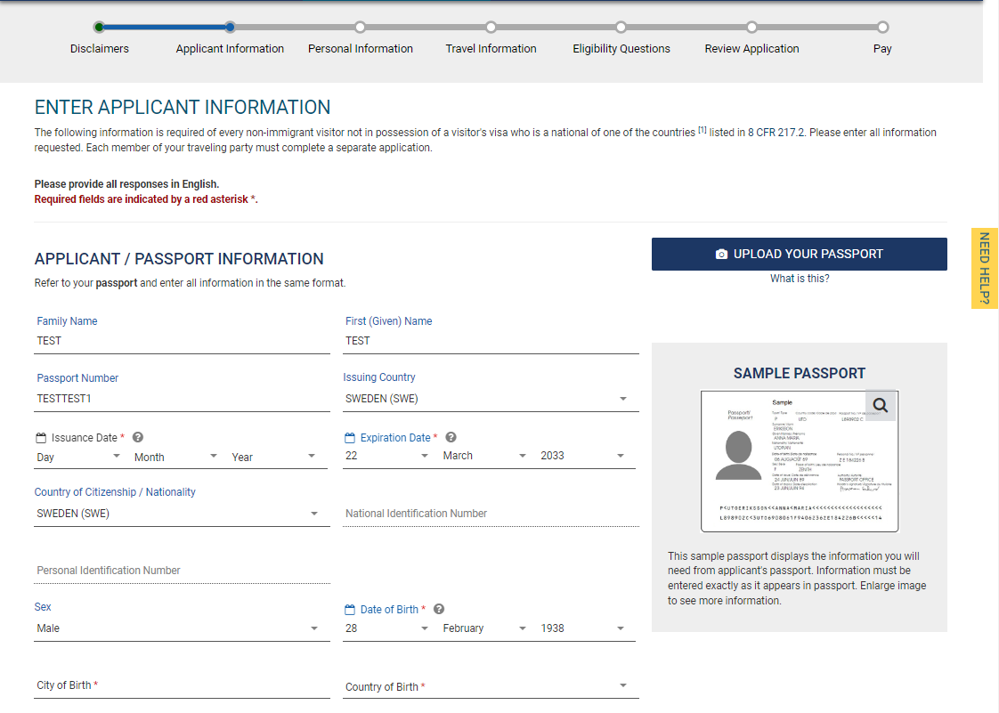

**In case of Country of Birth & Country of Citizenship mismatch for SST Countries**

**VERIFY INFORMATION – Family Name**

**VERIFY INFORMATION – First (Given) Name**

**VERIFY INFORMATION – Passport Number**

**VERIFY INFORMATION – Date of Birth**

**EMAIL VERIFICATION**

**ENTER CODE**

**ENTER PERSONAL INFORMATION**

**ENTER TRAVEL INFORMATION**

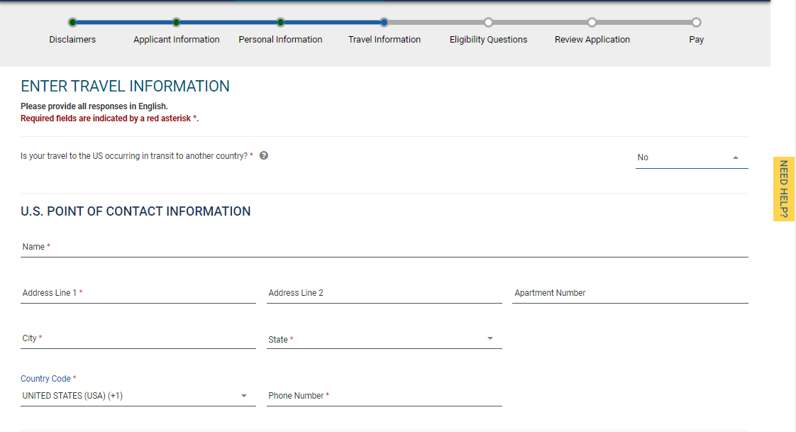

**ELIGIBILITY QUESTIONS**

**Q1**

**When answered ‘Yes’**

**Q2 – Q8**

**When answered ‘Yes’**

**Q9**

**REVIEW YOUR APPLICATION**

**PAY NOW AND COMPLETE APPLICATION**

**PAY.GOV**

