CONSE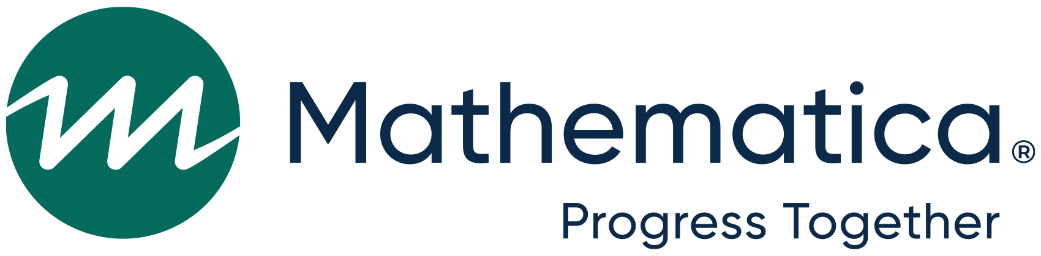NT TO PARTICIPATE IN A STUDY

Subminimum Wage to Competitive Integrated Employment (SWTCIE) projects national evaluation

I understand that:

U.S. Department of Education’s Rehabilitation Services Administration is funding projects in 14 states.

The goal of these projects is to increase employment for people with disabilities.

If you choose to, you will be a part of a research study about [vocational rehabilitation agency name]’s project. If you choose not to be in the study, you can still receive services from the agency.

Mathematica and their partners M. Davis and Company are conducting this research study.

There will be no cost to you to be in the study.

You will be asked questions in a survey at two times. The first time will be now as you enroll in the project. The second time will be in the fall of 2026.You may also be asked to participate in an interview sometime in the next few years.

[If the participant is completing the consent] I give permission for my parent, caregiver or guardian to talk about my experience in the SWTCIE project, in a short interview or focus group.

I do not have to take part if I do not want to. I do not need to answer any questions if I do not want to. I can choose to no longer be in this study at any time.

The personally identifiable information (PII) requested on this form is collected as authorized by Consolidated Appropriations Act, 2022, P.L. 117-103 Rehabilitation Services, March 15, 2022. The researchers conducting this study follow the confidentiality and data protection requirements, as required by law. Your responses will be kept private and used only for research purposes. Your responses will be combined with the responses of other respondents and no individual names will be reported. While there are no direct benefits to participants and participation is voluntary, your participation will help us learn how states can help increase employment for people with disabilities. While your information will not be disclosed outside of the Department, there may be circumstances where information may be shared with a third party, such as a Freedom of Information Act request, court orders or subpoena, or if a breach or security incident would occur affecting the system, etc.

If you have any questions or concerns, please contact Mathematica staff at [ffy22difeval@mathematica-mpr.com](mailto:UPDATE@mathematica-mpr.com). If you have any questions or concerns about your rights as a study participant, please contact the Health Media Lab Institutional Review Board at (202) 753-5040.

*For participants ages 18 and older:*

By checking this box, you agree that you have read and understood the information above and that you agree to take part in this study.

Participant’s email address:

Participant name:

*For participants ages 14-17 enrolling in the program or for participants not able to consent, their parent or guardian should complete this form as well as the survey:*

By checking this box, you agree that you have read and understood the information above and that you agree to take part in this study on behalf of your child.

Participant’s email address:

Participant name:

Parent/guardian name:

*For participants who are under guardianship enrolling in the program or for participants not able to consent, their guardian should complete this form as well as the survey:*

By checking this box, you agree that you have read and understood the information above and that you agree to take part in this study on behalf of the individual in your care.

Guardian’s email address:

Participant name:

Guardian name: