Expires XX/XX/XXXX OMB Control No. 2130-NEW

**Survey on Organizational Culture and Performance Management in Rail**

We greatly appreciate and value any written responses that are provided.

If you are open to being contacted to elaborate on your responses, please email [kianna.pirooz@keatechinc.com](mailto:kianna.pirooz@keatechinc.com).

* Indicate required question

Public reporting burden for this information collection is estimated to average 20 minutes per response, including the time for reading, searching existing data sources, gathering, and maintaining the data needed, and completing and reviewing the collection of information. According to the Paperwork Reduction Act of 1995 and its implementing regulations, a respondent is not required to respond to, conduct, or sponsor a collection of information that does not display a currently valid OMB control number. FRA intends to obtain such OMB approval for all activities within this collection of information. All responses to this collection of information are voluntary. Send comments regarding this burden estimate or any other aspect of this collection, including suggestions for reducing this burden to: Information Collection Clearance Officer, Federal Railroad Administration, Office of Research, Data, and Innovation, 1200 New Jersey Ave S.E., Washington D.C. 20590.

Participation in this survey is voluntary. The survey will ask questions that could be perceived as sensitive as there are questions related to attitudes around diversity, equity, inclusion, and workplace culture. However, those questions need to be asked to meet the goals of this project and all of them focus on matters related to the workplace. We will not be asking questions about religious beliefs or other matters that the public would consider private or sensitive in nature. The data from the survey will be aggregated so that individuals cannot be identified. Individual responses will not be released.

This survey is meant to capture feedback, opinions, and attitudes from rail industry stakeholders on organizational culture and the use of performance management systems in the rail industry. We are taking measures to ensure that the survey responses will remain anonymized, and no linkable/identifiable data will be captured, as described in our introductory email.

Demographics

This section captures key demographic and professional experience information.

# What gender do you identify as? *

## Mark only one oval.

Man Woman Other

# If you selected "other" and would like to elaborate, please use your own words below to describe your gender:

1. What is your age? *

## Mark only one oval.

18 - 24 years old

25 - 32 years old

33 - 40 years old

41 - 48 years old

49 - 56 years old

57 - 64 years old

65+ years old

# What is your race? Do you consider yourself... (Select one or more.) *

*Check all that apply.*

White (For example, English, German, Irish, Italian, Polish, Scottish, etc.)

Black or African American (For example, African American, Jamaican, Haitian, Nigerian, Ethiopian, Somali, etc.)

Asian (For example, Chinese, Asian Indian, Filipino, Vietnamese, Korean, Japanese, etc.)

Native Hawaiian or Other Pacific Islander (For example, Native Hawaiian, Samoan, Chamorro, Tongan, Fijian, Marshallese, etc.)

American Indian or Alaska Native (For example, Navajo Nation, Black Feet Tribe of the Blackfeet Indian Reservation of Montana, Native Village of Barrow Inupiat Traditional Government, Nome Eskimo Community, Aztec, Maya, etc.)

Hispanic or Latino (For example, Mexican, Puerto Rican, Salvadoran, Cuban, Dominican, Guatemalan, etc.

Middle Eastern or North African (For example. Lebanese, Iranian, Egyptian, Syrian, Iraqi, Israeli, etc.)

# What is the highest level of education you have completed? *

## Mark only one oval.

Vocational Training

High School Diploma or GED (high school graduate) Associate Degree (2-year college)

Bachelor’s Degree (4-year college) Graduate degree (Masters, Doctorate, etc.) No Formal Education

# Please indicate your veteran status: *

## Mark only one oval.

Veteran

No Military Service Currently in Military Service

# What is your marital status? *

## Mark only one oval.

Married Divorced Separated Widowed Never Married

Domestic Partnership or Civil Union

# Do you have children? *

## Mark only one oval.

Yes No

# Are you the primary caregiver to a child, elderly relative, spouse, etc.? *

A primary caregiver provides more than 50% of the time required for care i.e., child rearing, health or medication administration/care, meal preparation, etc.

## Mark only one oval.

Yes No

# Choose the position or role that most closely aligns to your current job *

## Mark only one oval.

Operations job (conductor, locomotive engineer, rail traffic controller, yard master, crew dispatcher, etc.)

Managerial or operations support position for rail carrier or transit industry (general manager, supervisor operations, engineering or maintenance contracts, human resources, safety, finance, etc.)

Research or related (CUTR, MTI, etc.)

Professional association staff (WTS, LRW, APTA, etc.)

Rail regulation staff

Other

# If you selected "other" and would like to elaborate, please use your own words below to describe your job:

1. How many years have you been in your current position? *

## Mark only one oval.

0 - 2 years

2 - 5 years

5 - 10 years

10 - 15 years

15 - 20 years

20+ years

# How many years have you worked in the rail industry? *

## Mark only one oval.

0 - 2 years

2 - 5 years

5 - 10 years

10 - 15 years

15 - 20 years

20+ years

# If you are in a leadership or mid-level managerial position with a carrier or *

regulator, have you previously worked in operations or craft positions?

Please choose "Not Applicable" if you are **NOT** in a leadership or mid-level managerial position.

## Mark only one oval.

Yes No

Not Applicable

# Which rail carrier(s) have you worked for? *

If you have worked at multiple carriers, please list all of the carriers you have worked for. If you have **not** worked for a rail carrier, please write "Not Applicable."

# Did **you** hold a position in a similar industry **prior** to entering the rail industry? *

Similar industries include farming/agriculture or other heavy industry (steel, mining, automotive, shipping, etc.)

## Mark only one oval.

Yes No

# Have you worked in industries other than the rail industry? *

If you answered yes to the question above, please answer "yes" here as well indicating that you have worked in another industry.

## Mark only one oval.

Yes No

# If you responded yes to the question above, what other industries have you worked in?

In your response, please include how long (in months or years) you worked in any other industries. If you have not worked in other industries, please write "Not Applicable".

# Did someone you know hold a railroad position prior to you entering the rail *

industry?

## Mark only one oval.

Family member Friend

Both No

1. Did an **immediate family member or friend** hold a position in a similar industry *

# prior to you entering the rail industry?

Similar industries include farming/agriculture or other heavy industry (steel, mining, automotive, shipping, etc.)

## Mark only one oval.

Yes No

# How did you learn about the professional opportunity to work in rail? *

Job Characteristics

This section captures information related to key job characteristics

# What are your typical daily work hours? *

## Mark only one oval.

0 - 4 hours

4 - 8 hours

8 - 12 hours

12+ hours

# How many days a week do you work? *

*Mark only one oval.*

1

2

3

4

5

6

7

# Do you have a reliable schedule week-to-week? *

## Mark only one oval.

Yes No

# How often do you work outside of your normal work hours? *

## Mark only one oval.

More than once a week Weekly

Monthly Rarely

Other (e.g. seasonally, project-based, etc.)

# Are you now or have you ever been a member of a rail union? *

## Mark only one oval.

Yes No

# How many years have you been a member of a rail union? *

## Mark only one oval.

0 - 2 years

2 - 5 years

5 - 10 years

10 - 20 years

20+ years

I am not currently and/or have never been a member of a rail union

# Being a member of a rail union has a positive impact on one's career *

advancement/trajectory.

A rating of 3 is neither agree nor disagree.

*Mark only one oval.*

Strongly Disagree

1

2

3

4

5

Strongly Agree

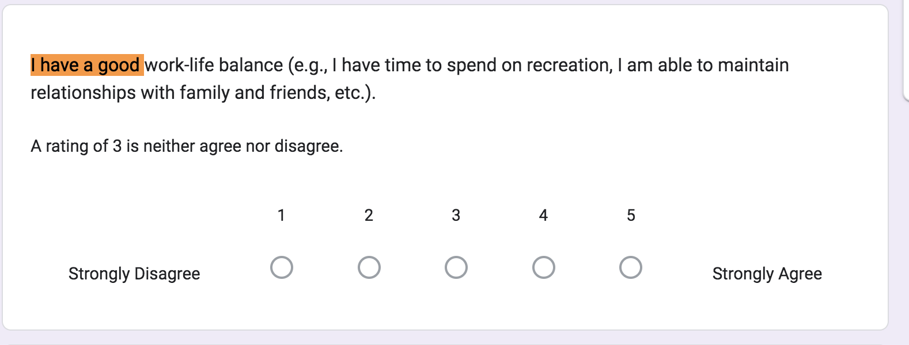

# Employees who are not members of a rail union are treated equally to those that *

hold union membership.

A rating of 3 is neither agree nor disagree.

*Mark only one oval.*

Strongly Disagree

1

2

3

4

5

Strongly Agree



Workplace Culture

This section captures information related to workplace culture.

# I have a good work-life balance (e.g., I have time to spend on recreation, I am able to maintain relationships with family and friends, etc.).

A rating of 3 is neither agree nor disagree.

*Mark only one oval.*

Strongly Disagree

1

2

3

4

5

Strongly Agree



1. I have career advancement opportunities.

A rating of 3 is neither agree nor disagree.

*Mark only one oval.*

Strongly Disagree

1

2

3

4

5

Strongly Agree

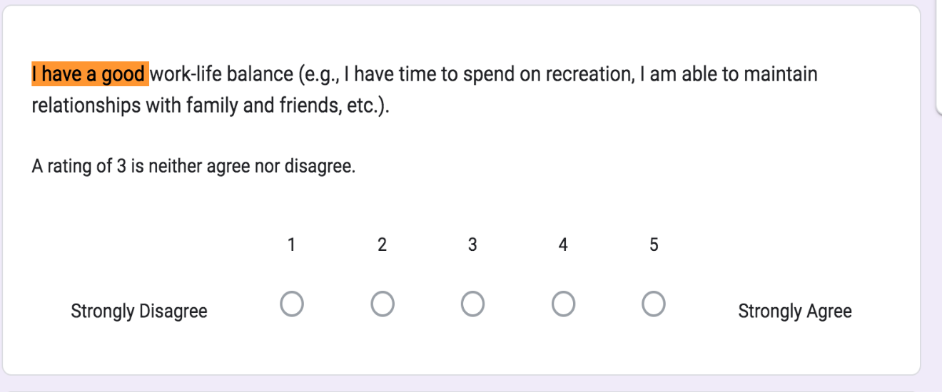

# I currently have a mentor, manager, or supervisor that supports me in the *

workplace.

A rating of 3 is neither agree nor disagree. For the purpose of this survey, support in the workplace could be defined as career advice, new career opportunities, professional development trainings, shadowing opportunities, etc.

*Mark only one oval.*

Strongly Disagree

1

2

3

4

5

Strongly Agree



1. Employees of diverse backgrounds are treated fairly in the internal promotion *

process.

A rating of 3 is neither agree nor disagree.

*Mark only one oval.*

Strongly Disagree

1

2

3

4

5

Strongly Agree



1. My employer takes active measures to seek a diverse candidate pool when hiring. *

A rating of 3 is neither agree nor disagree.

*Mark only one oval.*

Strongly Disagree

1

2

3

4

5

Strongly Agree



# People in the same role are treated **differently** at my place of employment based *

on their race and/or ethnicity.

## Mark only one oval.

Yes No

# People in the same role are treated **differently** at my place of employment based *

on their gender.

## Mark only one oval.

Yes No

# How difﬁcult do you think it is to recruit and retain minority groups to careers in *

rail?

Minority groups in this question refers to non-White/non-Caucasian individuals.

*Mark only one oval.*

Very easy

1

2

3

4

5

Very Difficult

# It would be difﬁcult to recruit and retain women to careers in rail. *

## Mark only one oval.

Yes No

# Please list the top 3 reasons why you think someone of a racial or ethnic minority *

group may choose NOT to pursue a career in rail?

Minority groups in this question refers to non-White/non-Caucasian individuals.

1. Please list the top 3 reasons why you think women may choose NOT to pursue a *

career in rail?

1. What is one change would you suggest to improve employee recruitment and *

retention in rail careers?

Performance Feedback

This section involves questions around receiving feedback on one's job performance

# Do you receive feedback on your performance, documented or otherwise? *

## Mark only one oval.

Yes, documented.

Yes, informal.

*A mix of both*

Neither

# How often do you receive feedback on your performance? *

## Mark only one oval.

Daily Weekly Monthly Quarterly Bi-Annually Annually Other

# My manager provides me with meaningful feedback on my performance. *

A rating of 3 is neither agree nor disagree.

*Mark only one oval.*

Strongly Disagree

1

2

3

4

5

Strongly Agree



Performance Management System Deﬁnition

# Performance Management Systems (PMS) can be formal or informal. Some rely * on software while others are maintained manually, either digitally or in paper form. They usually include some kind of one-on-one conversation between employees and their leadership to discuss individual performance, professional priorities, and concerns or requests for support.

**Which of the following are features of a PMS at your workplace?**

*Check all that apply.*

Collecting and organizing performance data to identify competency, skill, or knowledge gaps and recognize stand-out performance

Recommending or offering paths to advancement and promotion (in compensation or title change) based on strong performance

Invitation to participate in relevant professional development (skill building, mentorship, training, etc.)

Providing an on-the-job performance assessment

Engaging in a one-on-one conversation about job performance Orientation to clear, role-specific performance expectations None of the above

# Did you select "None of the above" in the previous question? *

## Mark only one oval.

Yes No

This section asks more detailed questions about how a performance management system may function in the workplace.

Performance Management System Related Questions

# How often do you receive **documented** performance feedback using a *

performance management system at your place of work?

## Mark only one oval.

Daily Weekly Monthly Quarterly Bi-Annually Annually Other

# If you responded "other" above, please elaborate here:

1. How often do you receive **informal** performance feedback at your place of work? *

## Mark only one oval.

Daily Weekly Monthly Quarterly Bi-Annually Annually Other

1. If you responded "other" above, please elaborate here:
2. Performance management systems have a positive impact on my work *

performance.

*Mark only one oval.*

Strongly Disagree

1

2

3

4

5

Strongly Agree



# Performance management systems have a positive impact on the work *

performance of those around me.

*Mark only one oval.*

Strongly Disagree

1

2

3

4

5

Strongly Agree



# What impact do performance management systems have on employees at your *

place of work?

*Check all that apply.*

Changes in pay Changes in title

Changes in benefits (e.g., vacation time, preferential scheduling, etc.)

Changes in professional development opportunities (access to coaching or trainings) Changes in work performance

Other

No impact

Negative impact

Not sure

1. If you responded "other" and/or "negative impact" above, please elaborate here:
2. What impact does **informal** performance feedback have on employees at your *

place of work?

*Check all that apply.*

Changes in pay Changes in title

Changes in benefits (e.g., vacation time, preferential scheduling, etc.)

Changes in professional development opportunities (access to coaching or trainings) Changes in work performance

Other

No impact Negative impact Not sure

1. If you responded "other" and/or "negative impact" above, please elaborate here:
2. My manager provides me with useful feedback on my performance through a *

performance management system.

A rating of 3 is neither agree nor disagree.

*Mark only one oval.*

Strongly Disagree

1

2

3

4

5

Strongly Agree



# My manager provides me with useful **informal** feedback on my performance. *

A rating of 3 is neither agree nor disagree.

*Mark only one oval.*

Strongly Disagree

1

2

3

4

5

Strongly Agree



# If known, please provide the name of the performance management system at your place of work:

This content is neither created nor endorsed by Google.

[Forms](https://www.google.com/forms/about/?utm_source=product&utm_medium=forms_logo&utm_campaign=forms)