SUPPORTING STATEMENT - PART A

Decision Review Request: Pre and Post Independent Living Assessment – OMB #2900-0681

Summary of Changes from Previously Approved Collection
- Reinstatement of form.
- Change the title of the form.
- Changes to the instructions to incorporate plain language concepts and make them easier to understand.
- Changes to the questions to incorporate plain language.
- Change in burden time which decreased from 1 hour to 30 mins due to removal of several questions.
- No comments were received during the 60-day comment period.

- Need for the Information Collection

The Department of Veterans Affairs (VA) through its Veterans Benefits Administration (VBA) administers an integrated program of benefits and services, established by law, for Veterans, service personnel, and their dependents and/or beneficiaries. Title 38 U.S.C. § 501(a) provides VA the authority to collect this information. Under 38 U.S.C. § 3104(a)(1), § 3109,
§3120 and 38 CFR §21.50, §21.160, and §21.162, the Department of Veterans Affairs (VA) collects information from disabled Veterans to determine the scope of their potential Independent Living (IL) needs under the Veteran Readiness and Employment (VR&E) program.

- Use of the Information

This form will be used by the Vocational Rehabilitation Counselor (VRC) during the initial and post IL evaluations. During this face-to-face meeting, the VRC identifies impairments and or barriers the Veteran may be experiencing with Activities of Daily Living (ADLs). The VRC then uses this information to identify the needs for services. The VRC compares the information obtained from the preliminary and post plan assessments to determine if there are improvements in the Veteran’s activities of daily living.

- Use of Information Technology

VA Form 28-0791 is available on the One-VA website in a fillable electronic format. VBA is currently hosting this form on a secure server and does not currently have the technology in place to allow for the complete electronic submission of the form. Validation edits are performed to assure data integrity. There currently is no utility process in place that will allow the data submitted on the form to be incorporated with an existing centralized legacy database. The VRC completes this form with the Veteran. The VRC reads the questions to the Veteran and completes the form with the responses the Veteran provides.

- Non-duplication

The information obtained through this collection is unique and is not already available for use or adaptation from another cleared source.

- Burden on Small Businesses

This information collection does not impose a significant economic impact on a substantial number of small businesses or entities.

- Less Frequent Collection

VA Form 28-0791 is necessary to identify IL needs for Veterans in the VR&E program. The collection of this information is required by law (38 U.S.C. §3104 (a)(1) and §3109). Without the information gathered on this form, VR&E is not able to identify IL needs and provide needed services. This would negatively impact the Veteran’s participation in his or her rehabilitation program. Failure to collect this information would have a detrimental impact upon the determination of appropriate rehabilitation goals for Veterans participating in the IL program.

- Paperwork Reduction Act Guidelines

This collection of information does not require collection to be conducted in a manner inconsistent with the guidelines delineated in 5 CFR §1320.5(d)(2).

- Consultation and Public Comments

Part A: PUBLIC NOTICE

A 60-Day Federal Register Notice (FRN) for the collection published on Tuesday, July 16, 2024. The 60-Day FRN citation is 89 FRN 57996.

A 30-Day Federal Register Notice for the collection published on Friday, October 11, 2024. The 30-Day FRN citation is 89 FRN 82677.

- Gifts or Payment

No payments or gifts are being offered to respondents as an incentive to participate in the collection.

- Confidentiality

The records are maintained in the appropriate Privacy Act System of Records identified as “Compensation, Pension, Education, and Veteran Readiness and Employment Records-VA (58VA21/22/28),” published at 74 FR 29275 on June 19, 2009, and last amended at 87 FR 8740 (February 16, 2022). This statement is located on the bottom of the VAF 28-0791.

- Sensitive Questions

Veterans are assured of confidentiality of their responses under VA system of records, 58VA21/22/28, Compensation, Pension, Education, and Veteran Readiness and Employment Records, contained in the Privacy Act 1974. This form collects potentially sensitive information. Questions are included which pertain to Activities of Daily Living. The purpose of IL services is to enable the Veteran, to the maximum extent possible, to live independently and participate in family and community life. IL services are also provided to increase the Veteran’s potential to return to work by providing services designed to lessen or accommodate the effects of the disability(ies). Prior to completion of this form, each Veteran signed a Protection of Privacy Information Statement, that is on the VA Form 28-1902w, Veteran Readiness and Employment Questionnaire - Chapter 31.

- Respondent Burden and its Labor Costs

Part A: ESTIMATION OF RESPONDENT BURDEN

- Number of Respondents is estimated at 906 per year.

- Frequency of Response is two times.
- Annual burden hours are 906 hours.

- The estimated completion time for each form is 30 minutes.

- The respondent population for VAF 28-0791 is composed of Veterans who are participants in the VR&E program who are identified to have potential IL needs. IL services are to enable the Veteran to the maximum extent possible, to live independently and participate in family and community life. IL services are also provided to increase the Veteran’s potential to return to work by providing services designed to lessen or accommodate the effects of the disability(ies).

VA cannot make further assumptions about the population of respondents because of the variability of factors such as the educational background and wage potential of respondents. Therefore, VBA used general wage data to estimate the respondents’ costs associated with completing the information collection.

The Bureau of Labor Statistics (BLS) gathers information on full-time wage and salary workers. According to the latest available BLS data, the mean hourly wage is $31.48 based on the BLS wage code – “00-0000 All Occupations.” This information was taken from the following website: https://www.bls.gov/oes/current/oes_nat.htm.

Legally, respondents may not pay a person or business for assistance in completing the information collection. Therefore, there are no expected overhead costs for completing the information collection. VBA estimates the total cost to all respondents to be $28,520.88 (906 burden hours x $31.48 per hour).

- Respondent Costs Other Than Burden Hour Costs

This submission does not involve any recordkeeping costs.

- Cost to the Federal Government

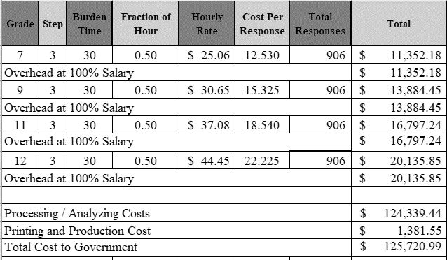

Overhead costs are 100% of salary and are the same as the wage listed above and the amounts are included in the total.

Printing and production costs approximates the cost of printing this information collection per year. (Processing/Analyzing Cost total divided by $90).

Note: The hourly wage information above is based on the hourly 2024 General Schedule (Base) Pay (SALARY TABLE 2024-GS (opm.gov)). This rate does not include any locality adjustment as applicable.

The processing time estimates above are based on the actual amount of time employees of each grade level spend to process to completion a claim received on this form. The within-grade step (3) of each employee represents the average experience of employees within each grade.

- Reasons for Change in Burden

Change in burden time which decreased from 1 hour to 30 mins due to removal of several questions.

- Publication of Results

VA neither tabulates nor makes the information collected available for publication.

- Non-Display of OMB Expiration Date

We are not seeking approval to omit the display of the expiration date of the OMB approval on the collection instrument.

- Exceptions to “Certification for Paperwork Reduction Submissions”

This submission does not contain any exceptions to the certification statement.

