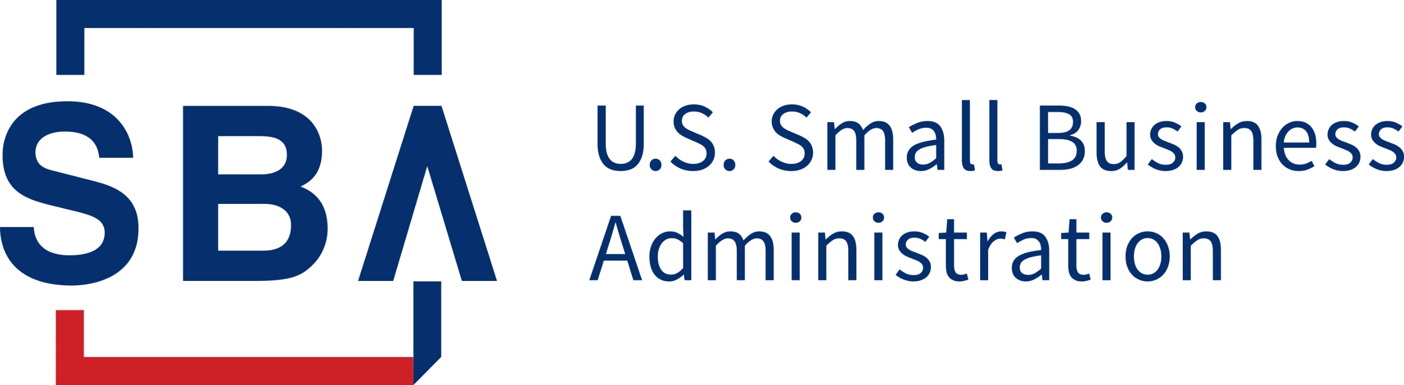 SBG Program Customer Experience Survey

Office of Surety Guarantees

**Objective**

* Analyze the overall underwriting experience of a Surety/Agent.
* Identify opportunities to recapture inactive Agents and Sureties.
* Identify underwriting and claims staff knowledge gaps.
* Identify underwriting and claims process improvement opportunities.

**Distribution Plan and Frequency**

* Bulk distribution: Quarterly for the first year, Semiannual thereafter over a 2-year period.
  + Distributed by:
    - OSG email distribution list
      * Active program user
    - National Association of Surety Bond Producers
    - Surety and Fidelity Association of America
* Transactional distribution: Per interaction and transaction with SBA.
  + Distributed by inclusion in program activity emails and SBA staff signatures.

**Survey Administration**

* Survey Monkey

**Survey Instrument (7 questions per respondent)**

Thank you in advance for taking time to complete SBA's Surety Bond Guarantee Program Customer Experience Survey. This survey is expected to take no more than 5 minutes to complete. Your responses are anonymous, and your participation is voluntary. Your feedback will help SBA improve service for the Surety Bond Guarantee program.   
  
The SBA cannot conduct this survey and you are not required to respond unless the survey is approved by the Office of Management and Budget (OMB). The OMB Control (Approval) number for this survey is XXXX-XXXX; it expires on XX/XX/XXXX. Please do not include any personally identifiable information in your responses. Thank you!

1. *I am a(n)
   1. Active SBA agent
   2. Active customer service representative with an SBA-authority agency
   3. Active Preferred Surety Partner underwriter
   4. Active Prior Approval Surety Partner underwriter
   5. Active Preferred Surety Partner claims professional
   6. Active Prior Approval Surety Partner claims professional
   7. Former SBA Agent
   8. Former Preferred Surety Partner underwriter
   9. Former Prior Approval Surety Partner underwriter
   10. None of the above or not sure.
       1. Please explain. [ENDS SURVEY]

|  |
| --- |
| [Free text response] |

1. [GEOGRAPHY]

* *Please select your location.
  + [Dropdown Menu with each US State/Territory]

1. [ACTIVITY]

|  |  |
| --- | --- |
| *Please indicate the last time you worked with SBA’s Surety Bond Guarantee program. *(Select one)* | |
| 1 | Today. |
| 2 | Within the last 30 days. |
| 3 | Within the last 3 months. |
| 4 | Within the last 6 months. |
| 5 | Within the last 12 months. |
| 6 | Within the last 3 years. |
| 7 | Over 3 years. |

1. [TRUST RATING]

|  |
| --- |
| *This interaction, or experience, with the SBA's Office of Surety Guarantees increased my trust in the SBA. |
| P182C2T1#yIS1 |

5a. [FOR THUMBS UP RESPONSE]



|  |  |
| --- | --- |
| *What about your experience made the difference? *(Select all that apply)* | |
| 1 | My needs were met. |
| 2 | It was easy to complete what I needed to do. |
| 3 | It took a reasonable amount of time to do what I needed to do. |
| 4 | I understand what was being asked of me throughout the submission process. |
| 5 | I was treated fairly. |
| 6 | Employees I interacted with were helpful. |
| 7 | None of the above. |

5b. [FOR THUMBS DOWN RESPONSE] [SELECTIONS SHOULD ALL HAVE OPTIONAL EXPLANATION BOX WHEN SELECTED]

|  |  |
| --- | --- |
| *What could have been better? (*Select all that apply)* | |
| 1 | My need was not addressed. |
| 2 | It was difficult to complete what I needed to do. |
| 3 | It took too long to do what I needed to do. |
| 4 | I did not understand what was being asked of me throughout the process. |
| 5 | I was not treated fairly. |
| 6 | Employees I interacted with were not helpful. |
| 7 | Something else (please specify). |

1. [SBG NUMBER]



|  |
| --- |
| If your response is to a specific SBG, please enter that SBG number below. |
| [16-DIGIT ENTRY] |

1. [ADDITIONAL INFORMATION]

|  |
| --- |
| Is there anything else you want us to know about your selection(s) or your experience? |
| [Free text response] |