**Request for Nonsubstantive Changes**

**OMB No. 0579-0124**

**May 23, 2024**

APHIS conducted a review of PPQ Form 925, Federal SEED Analysis Certificate, and requests approval for the following nonsubstantive changes.

There are several changes to the instructions which do not affect response time or burden. The changes reduce the instructions to 4 pages.

Please note, the form is the first page and does not include a page number.

1. **Instructions Page 1 of 5:**
2. Paragraphs 2 and 3 – Removed unnecessary information and updated the source of information.

CHANGE THIS:

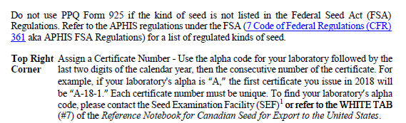

TO THIS:

1. Removed footnote at bottom of page; contact is no longer valid, and facility no longer exists:



1. **Instruction Page 2 of 5:**
2. Block 13 – The links listed under items 1 and 2 were deleted since the link is included in the first sentence.

CHANGE FROM:

TO THIS:

1. Block 14 – Rewritten to provide more clarity.

CHANGE FROM:

TO THIS:

1. **Instruction Page 3 of 5:**
2. Block 16 – Remove duplicate link in paragraph 1; modified paragraph 2.

CHANGE FROM:

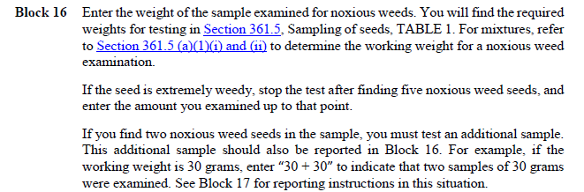

TO THIS:

1. Block 17 – Paragraphs 4 edited to provide clarity and the link was modified to take respondents to the Inert Matter section of the FSA regulations. Paragraph 5 edited to provide clarity.

CHANGE FROM:

TO THIS:

1. **Instruction Page 4 of 5**
2. Block 18 – Edited for clarity since the form would not be issued once a FNW was found; added a hyperlink to the ACIR Facilities section.

CHANGE FROM:

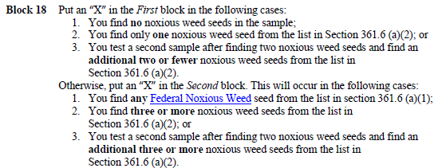

TO THIS:

1. **Instruction Page 5 of 5**
2. Distribution has changed - Customs and Border Protection collects the forms electronically for distribution. Added language to reflect current distribution. Adjusted language to provide clarity.

CHANGE FROM:

TO THIS:

